### **ISO about CTFL**

* ISO29119 -> SW Test (Dynamic)
* ISO25010 -> Quality
* ISO20246 -> Static Test

### **Seven Testing Principles**

* Testing shows the presence, not the absence of defects
* Exhaustive testing is impossible
* Early testing saves time and money
* Defects cluster together -> 缺陷通常群聚在某一小塊功能
* Tests wear out / Pesticide paradox -> 反覆執行相同的測試會越來越無效
* Testing is context dependent -> 測試須依情境而異
* Absence-of-defects fallacy -> 無failure的軟體也可能無法滿足user需求

### **Test Activities**

| Test planning |  | test plan / schedule / criteria / risk |
| --- | --- | --- |
| Test monitoring and control | 度量指標 | test progress report / risk |
| Test analysis | Static Test | test condition / bug report |
| Test design |  | test cases / testware |
| Test implementation |  | test env. / testsuites / script / test data |
| Test execution |  | test log / bug report |
| Test completion |  | test complete report |

### **Test Levels**

1. Components Test (Dev) -> Auto
2. Integration Test (Dev) -> CI/CD
3. System Test (Tester) -> Manua & Auto
4. System Integration Test (Tester) -> Manual & Auto
5. Acceptance Test (User) -> Manual & Tool

### **Quality Aspect**

* Function
* Reliability
* Usability
* Perfoemance
* Maintainability
* Portability
* Security
* Compatibility

### **SLDC**

* Sequential -> Waterfall, V model
* Iterative / Incremental -> Rational Unified Process, Prototyping, Scrum & Kanban

### **Refactor**

降低複雜度，屬於Test Driven Development的過程之一

### **Acceptance testing**

* User aspect
* Validation
* 增進信心
* 4種類型
  + user acceptance testing (UAT)
  + operational acceptance testing
  + contractual and regulatory acceptance testing,
  + alpha testing and beta testing
    - Alpha -> test in dev. env.
    - Beta -> test in user env.

### **Test Type**

* Functional testing (function test in quality aspect)
* Non-functional testing (other tests in quality aspect)
* Black-box testing -> easy to build CI/CD
* White-box testing

### **Confirmation & Regression**

* Confirmation (retest) -> 驗證bug是否被修復
* Regression -> 驗證其他地方是否被這版fix給影響 -> 需透過impact analysis確認範圍

### 

### **Review Process Activities** (靜態測試中的一種子項)

1. Planning
2. Review initiation
3. Individual review
4. Communication and analysis
5. Fixing and reporting

| **Review Types** | **Roles** | **Document** | **Process Activities** |
| --- | --- | --- | --- |
| Informal review | Author  Reviewer |  | Planning  Review initiation |
| Walkthrough | Author  Reviewer  Scribe(recorder, should be objective) |  | Planning  Review initiation |
| Techmical review | Author  Reviewer  Scribe  Moderator(facilitator) | Issue log  Bug report | Planning  Review initiation  Individual review  Communication and analysis  Fixing and reporting |
| Inspection | Author  Reviewer  Scribe  Moderator  Review leader  Manager | Issue log  Bug report  Checklist  Matrix | Planning  Review initiation  Individual review  Communication and analysis  Fixing and reporting |

### **Success Factors for Reviews**

* Defining clear objectives and measurable exit criteria. Evaluation of participants should never be an objective
* Choosing the appropriate review type to achieve the given objectives, and to suit the type of work product, the review participants, the project needs and context
* Conducting reviews on small chunks, so that reviewers do not lose concentration during an individual review and/or the review meeting (when held)
* Providing feedback from reviews to stakeholders and authors so they can improve the product and their activities
* Providing adequate time to participants to prepare for the review
* Support from management for the review process
* Making reviews part of the organization’s culture, to promote learning and process improvement
* Providing adequate training for all participants so they know how to fulfill their role
* Facilitating meetings

### **Test Techniques**

| Test Type | | Coverage items (通常是覆蓋率的分母) |
| --- | --- | --- |
| Black Test | Equivalence Partitioning (EP) | Equivalence Type |
| Boundary Value Analysis (BVA) | Boundaries   * 2-value * 3-value |
| Decision Table Testing | Decision Rules |
| State Transition Testing | * All States * Valid Transitions * All Transitions |
| White Test | Statement testing | All Statements (每行程式碼) |
| Branch testing | All Branchs |
| Experience-based | Error Guessing | Fault Attack |
| Exploratory Testing | designed  executed  evaluated  unscripted test  session-based test -> follow test charter |
| Checklist-Based Testing |  |

### **Collaboration-based Test**

* Collaborative User Story -> by customer, dev. & tester
  + Independent
  + Negotiable
  + Valuable
  + Estimable
  + Small
  + Testable
* Acceptance
  + Define the scope of the user story
  + Reach consensus among the stakeholders
  + Describe both positive and negative scenarios of test
  + As a basis for the user story acceptance testing
  + Accurate planning and estimation
  + Two formats to write acceptance criteria for a user story
    - Scenario-oriented -> BDD, ATDD
    - Rule-oriented -> build rules list

### **Test Plan Column**

* Context of testing (e.g., scope, test objectives, constraints, test basis)
* Assumptions and constraints of the test project
* Stakeholders (e.g., roles, responsibilities, relevance to testing, hiring and training needs)
* Communication (e.g., forms and frequency of communication, documentation templates)
* Risk register (e.g., product risks, project risks)
* Test approach (e.g., test levels, test types, test techniques, test deliverables, entry criteria and exit criteria, independence of testing, metrics to be collected, test data requirements, test environment requirements, deviations from the organizational test policy and test strategy)
* Budget and schedule

### **Test Progress Report Column**

* Test period
* Test progress (e.g., ahead or behind schedule), including any notable deviations
* Impediments for testing, and their workarounds
* Test metrics (see section 5.3.1 for examples)
* New and changed risks within testing period
* Testing planned for the next period

### **Test Completion Report Column**

* Test summary
* Testing and product quality evaluation based on the original test plan (i.e., test objectives and exit criteria)
* Deviations from the test plan (e.g., differences from the planned schedule, duration, and effort).
* Testing impediments and workarounds
* Test metrics based on test progress reports
* Unmitigated risks, defects not fixed
* Lessons learned that are relevant to the testing
* Iteration and Release Planning

### **Release Planning & Iteration Planning**

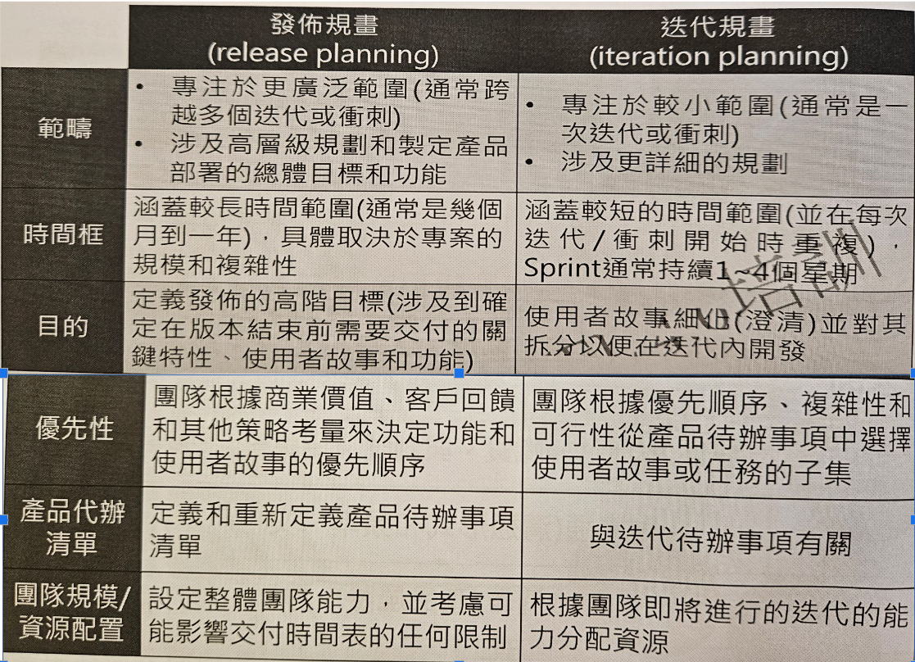

### **Test Quadrants**

|  | User facing | |  |
| --- | --- | --- | --- |
| Support / Dev. | functional test  user story test  user experience prototype  API test | exploratory testing  usability testing  acceptance test  user-oriented  often manual | Product / Critique |
| component test component integration test  CI process  often automated | smoke test  non-functional test  often automated |
|  | Technology facing | |  |