# CSS Layout - Flexbox – Exercise

## Topics Covered

[Flexbox](https://developer.mozilla.org/en-US/docs/Web/CSS/CSS_flexible_box_layout) is a one-dimensional layout method for arranging items in rows or columns. Items *flex* (expand) to fill additional space or shrink to fit into smaller spaces. This article explains all the fundamentals.

## Resources

* **Flexbox MDN**
  + <https://developer.mozilla.org/en-US/docs/Learn/CSS/CSS_layout/Flexbox>
* **A Complete Guide to Flexbox**
  + <https://css-tricks.com/snippets/css/a-guide-to-flexbox/>
* **An Interactive Guide to Flexbox**
  + <https://www.joshwcomeau.com/css/interactive-guide-to-flexbox/>
* **Flexbox cheat sheet**
  + <https://codepen.io/kdankov/pen/QWoVyZJ>

## Tasks

### Layout – 3 columns

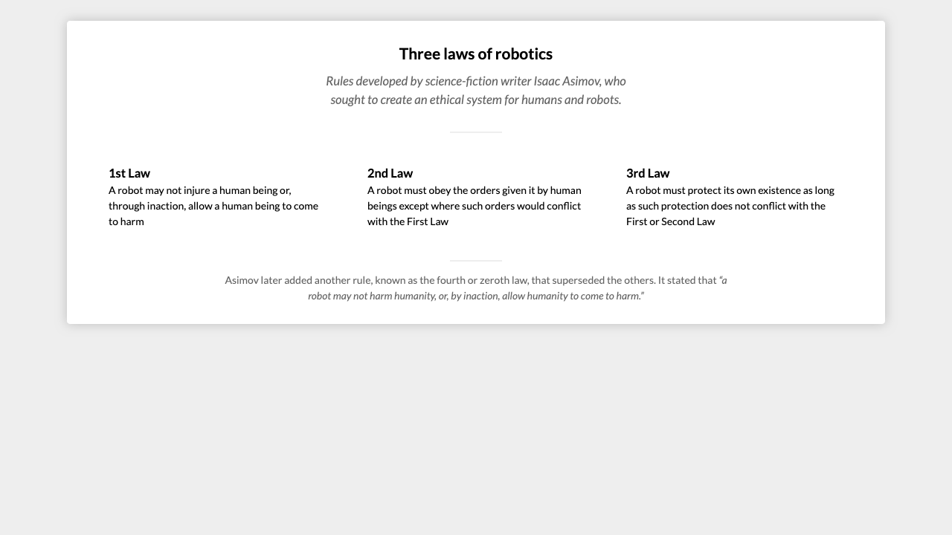

*For full screenshot check the screenshot.png file in the folder for the task*

#### Objective:

Create a webpage that looks like the screenshot above.

#### Requirements:

1. **File Setup**:
   * Create an **HTML** document named **three-columns.html**
   * Create a **CSS** file named **three-columns.css**

### Flex order

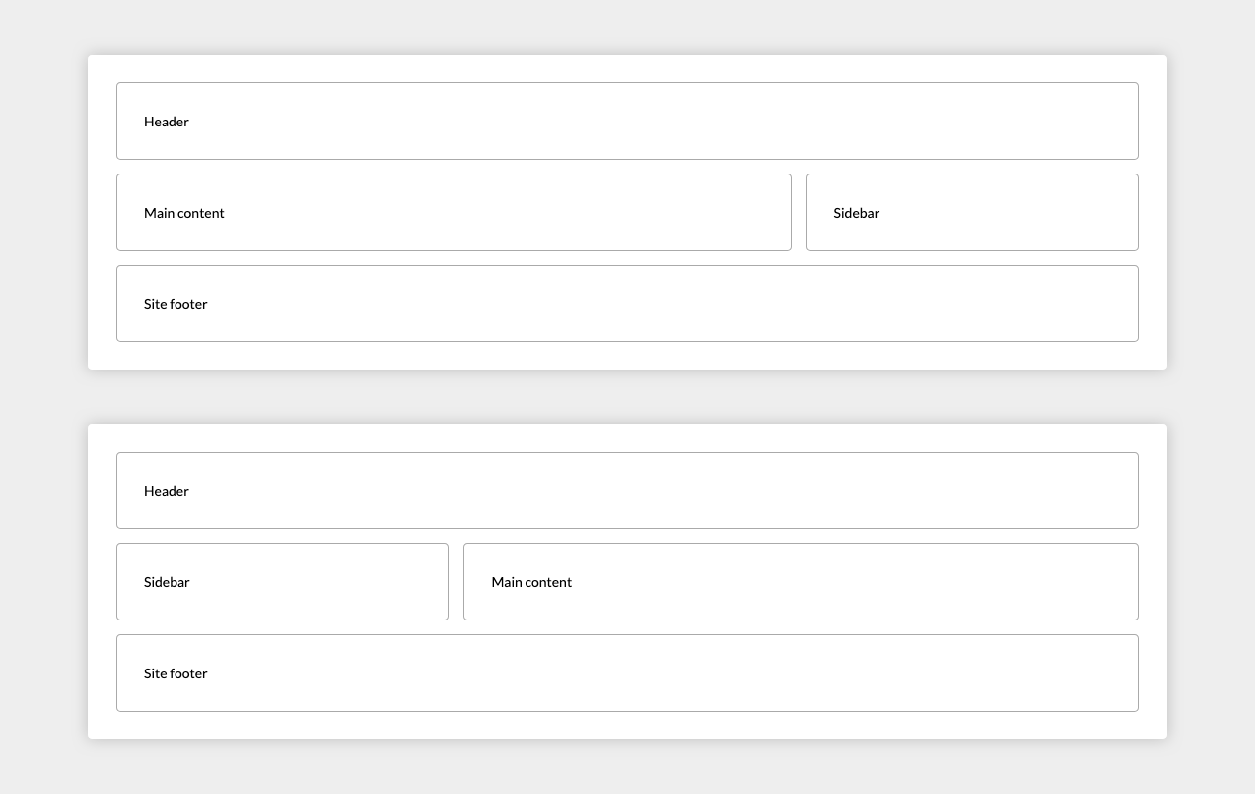

*For full screenshot check the screenshot.png file in the folder for the task*

#### Objective:

Create a webpage that looks like the screenshot above.

#### Requirements:

1. **File Setup**:
   * Create an **HTML** document named **flex-order.html**
   * Create a **CSS** file named **flex-order.css**

### Calendar

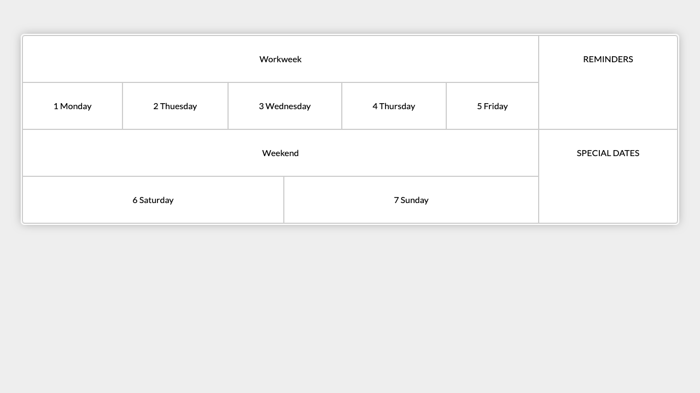

*For full screenshot check the screenshot.png file in the folder for the task*

#### Objective:

Create a webpage that looks like the screenshot above.

#### Requirements:

1. **File Setup**:
   * Create an **HTML** document named **calendar.html**
   * Create a **CSS** file named **calendar.css**

### Main Navigation

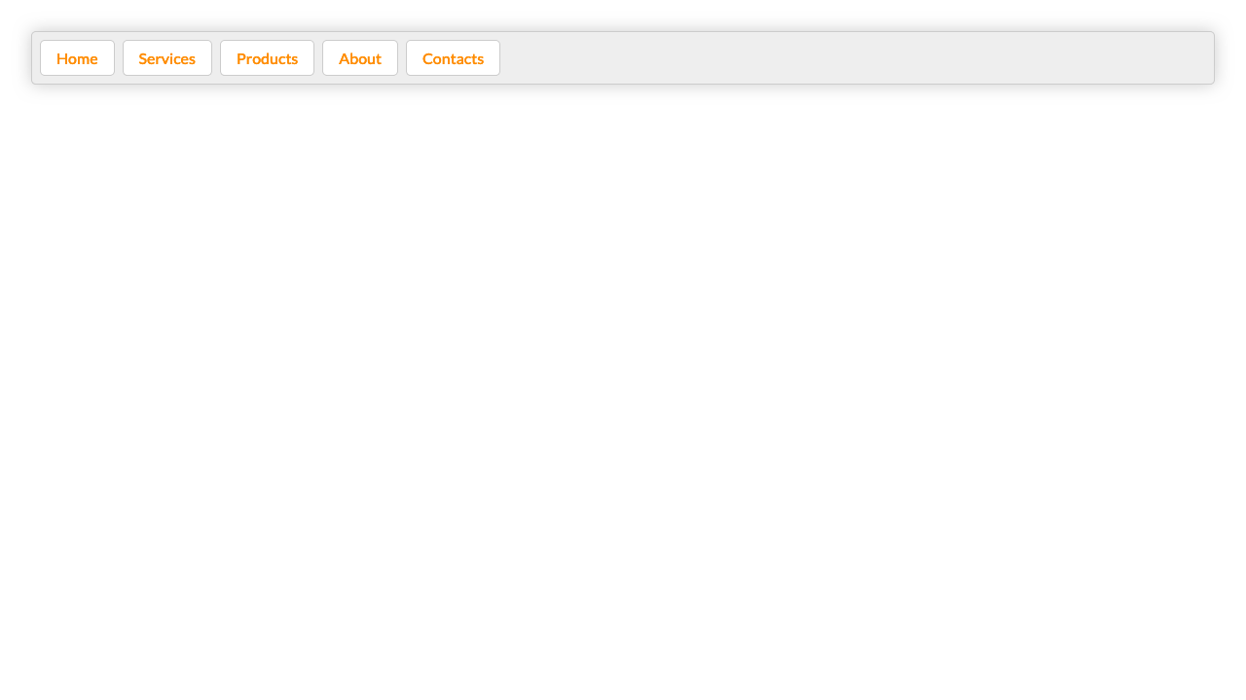

*For full screenshot check the screenshot.png file in the folder for the task*

#### Objective:

Create a webpage that looks like the screenshot above.

#### Requirements:

1. **File Setup**:
   * Create an **HTML** document named **main-navigation.html**
   * Create a **CSS** file named **main-navigation.css**

### Photo Gallery

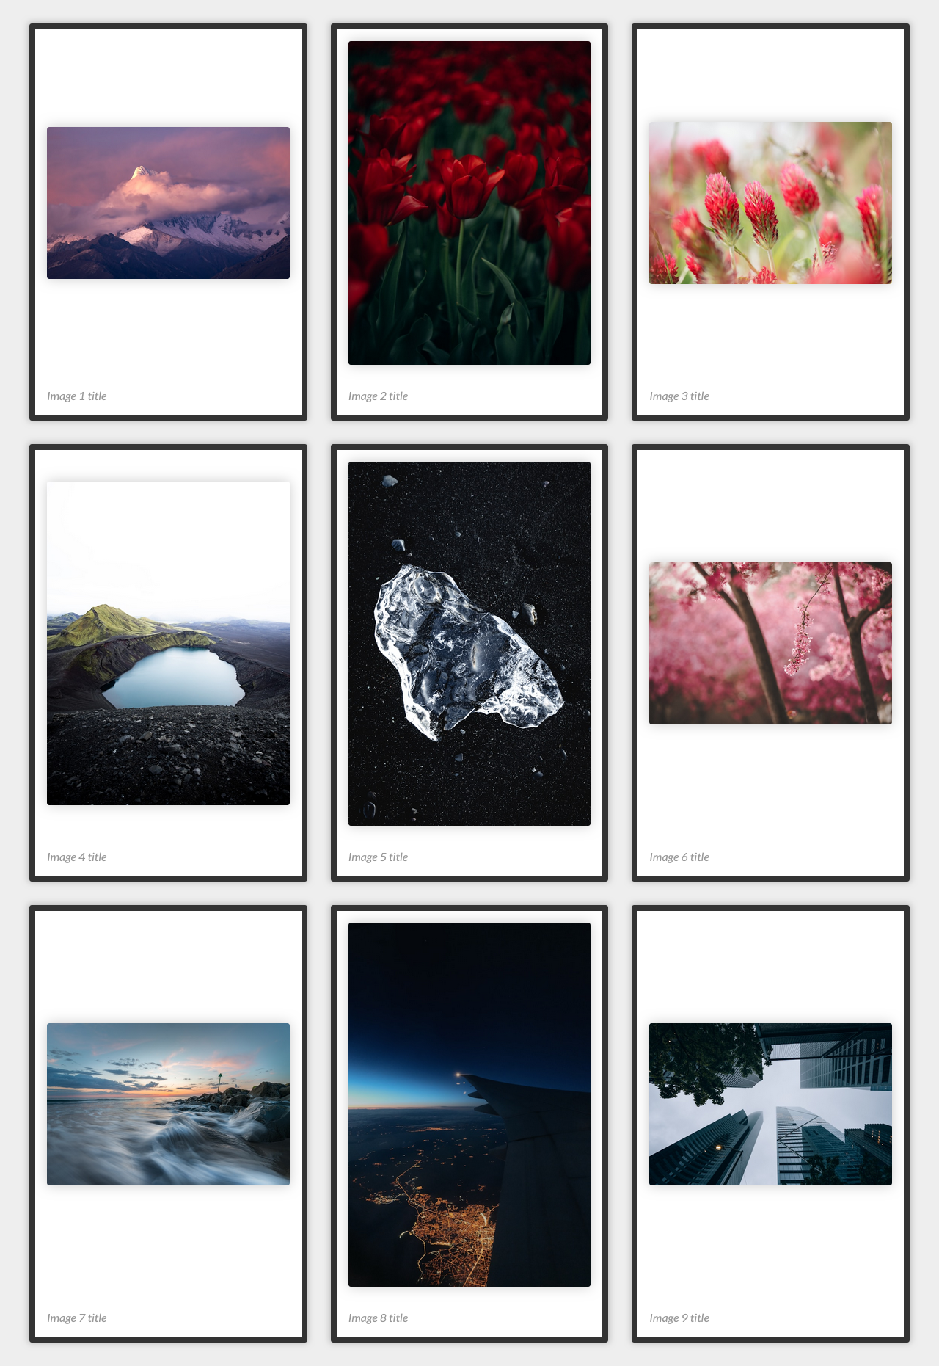

*For full screenshot check the screenshot.png file in the folder for the task*

#### Objective:

Create a webpage that looks like the screenshot above.

#### Requirements:

1. **File Setup**:
   * Create an **HTML** document named **photo-gallery.html**
   * Create a **CSS** file named **photo-gallery.css**
2. **Fancy Quotes**

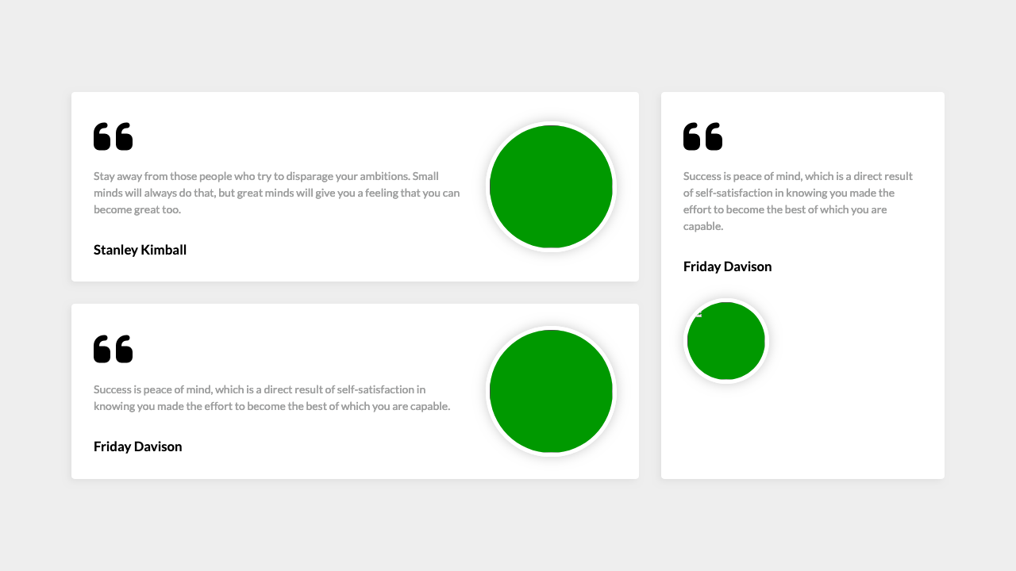

*For full screenshot check the screenshot.png file in the folder for the task*

#### Objective:

Create a webpage that looks like the screenshot above.

#### Requirements:

1. **File Setup**:
   * Create an **HTML** document named **fancy-quotes.html**
   * Create a **CSS** file named **fancy-quotes.css**

### 7.Expandable Tree view

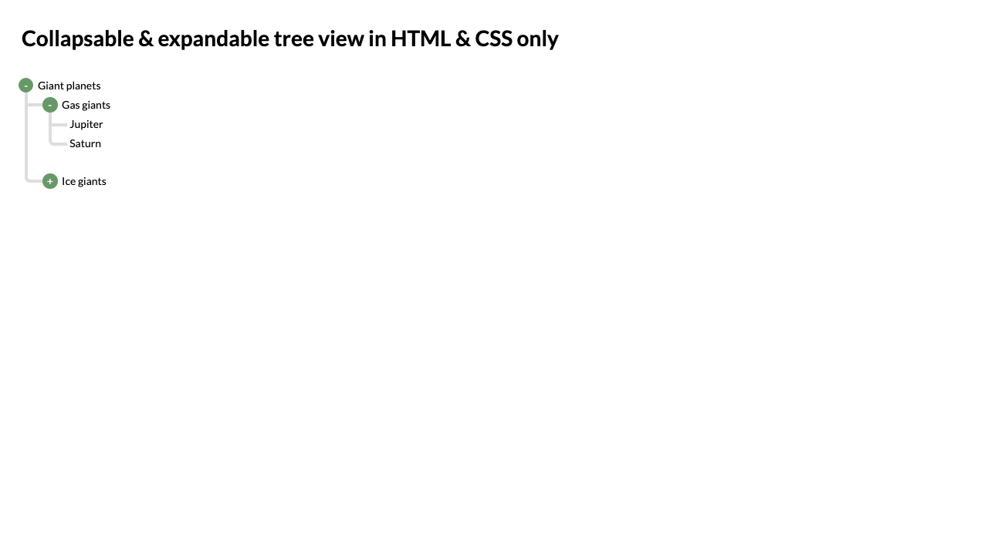

*For full screenshot check the screenshot.png file in the folder for the task*

#### Objective:

Create a webpage that looks like the screenshot above.

#### Requirements:

1. **File Setup**:
   * Create an **HTML** document named **expandable-tree-view.html**
   * Create a **CSS** file named **expandable-tree-view.css**

### Keyboard

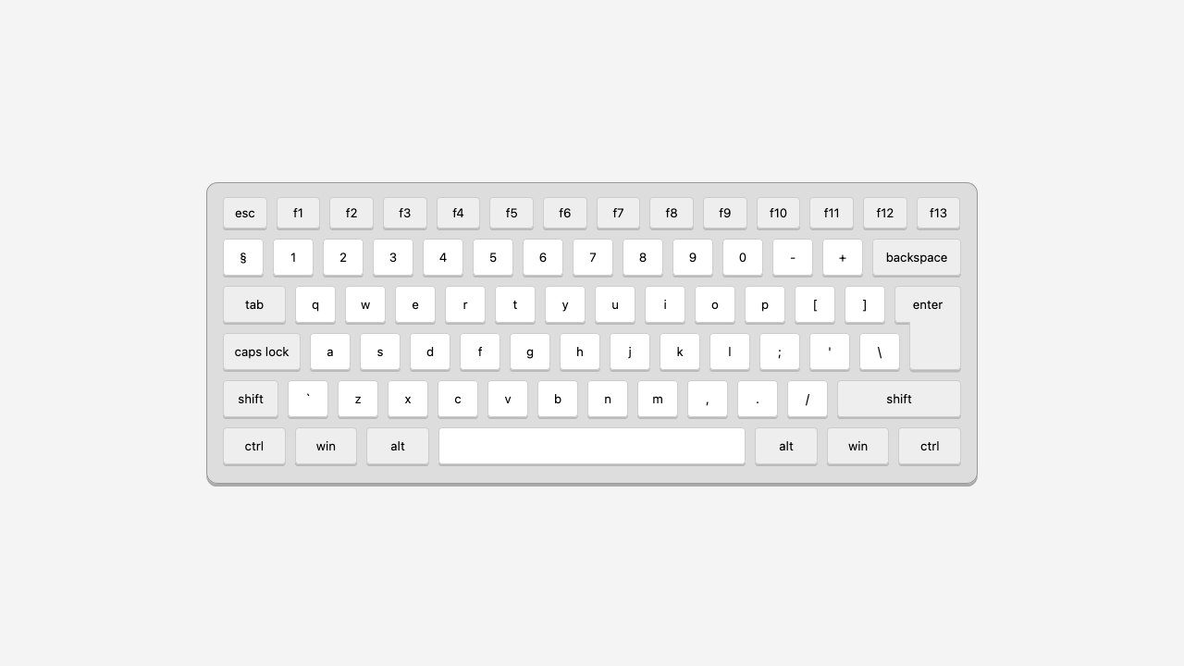

*For full screenshot check the screenshot.png file in the folder for the task*

#### Objective:

Create a webpage that looks like the screenshot above.

#### Requirements:

1. **File Setup**:
   * Create an **HTML** document named **keyboard.html**
   * Create a **CSS** file named **keyboard.css**

### Flexbox Center

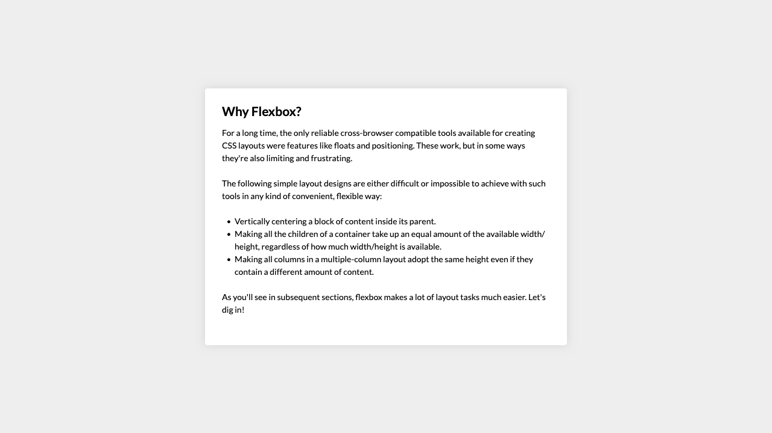

*For full screenshot check the screenshot.png file in the folder for the task*

#### Objective:

Create a webpage that looks like the screenshot above.

#### Requirements:

1. **File Setup**:
   * Create an **HTML** document named **flexbox-center.html**
   * Create a **CSS** file named **flexbox-center.css**

### Layout Sticky Footer

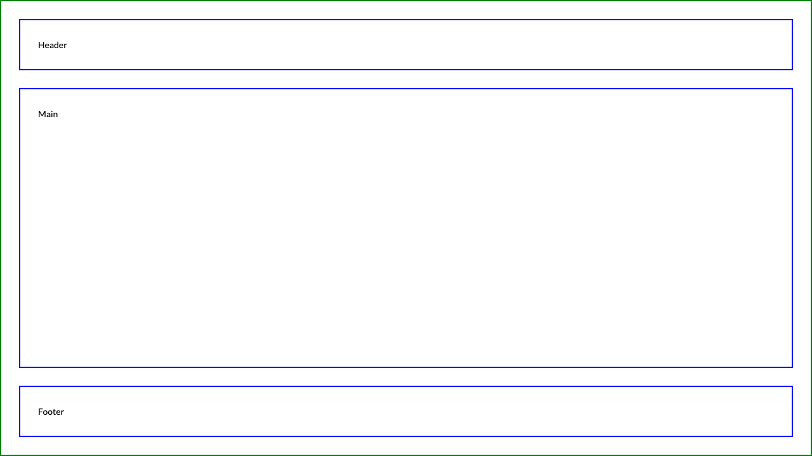

*For full screenshot check the screenshot.png file in the folder for the task*

#### Objective:

Create a webpage that looks like the screenshot above.

#### Requirements:

1. **File Setup**:
   * Create an **HTML** document named **sticky-footer.html**
   * Create a **CSS** file named **sticky-footer.css**

### Section Banner

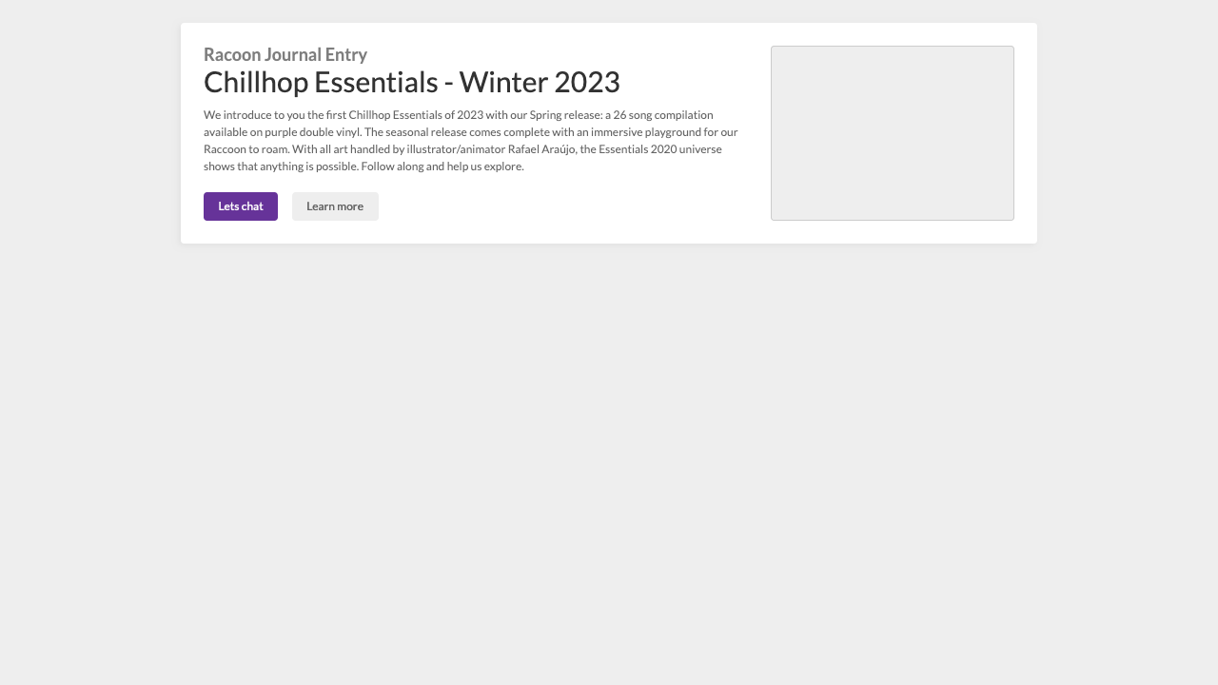

*For full screenshot check the screenshot.png file in the folder for the task*

#### Objective:

Create a webpage that looks like the screenshot above.

#### Requirements:

1. **File Setup**:
   * Create an **HTML** document named **section-banner.html**
   * Create a **CSS** file named **section-banner.css**