

Systems Alliance

VPP-7: Soft Front Panel Specification

Revision 4.2

April 14, 2008
VPP-7 Revision History
This section is an overview of the revision history of the VPP-7 specification.

Revision 1.0, July 15, 1994
This edition reflects a non-technical revision for style and format issues.

Revision 1.1, August 17, 1994
This edition reflects edits to technical omissions and inconsistencies between VPP documents.
Revision 2.0, November 28, 1994
This edition reflects corrections to technical edits done to the Revision 1.0 document and edits discussed at the November 1-4 TWG meeting.
Revision 3.0, February 3, 1995
This edition reflects edits discussed at the Jan-Feb TWG meeting.
Revision 4.0, January 29, 1996
This edition added a rule to avoid name conflicts between the soft front panel and the driver.
Revision 4.1, December 4, 1998
This edition updated this specification to match changes in VPP 4.x VISA (Virtual Instrument Software Architecture) Specifications. The information regarding contacting the Alliance was also updated.
Revision 4.2, February 14, 2008
Updated the introduction to reflect the IVI Foundation organization changes. Replaced Notice with text used by IVI Foundation specifications.
Revision 4.2, April 14, 2008
Editorial change to update the IVI Foundation contact information in the Important Information section to remove obsolete address information and refer only to the IVI Foundation web site.
NOTICE
VPP-7: Soft Front Panel Specification is authored by the IVI Foundation member companies. For a vendor membership roster list, please visit the IVI Foundation web site at www.ivifoundation.org.
The IVI Foundation wants to receive your comments on this specification. You can contact the Foundation through the web site at www.ivifoundation.org.
Warranty
The IVI Foundation and its member companies make no warranty of any kind with regard to this material, including, but not limited to, the implied warranties of merchantability and fitness for a particular purpose. The IVI Foundation and its member companies shall not be liable for errors contained herein or for incidental or consequential damages in connection with the furnishing, performance, or use of this material.
Trademarks
Product and company names listed are trademarks or trade names of their respective companies.
No investigation has been made of common-law trademark rights in any work.

Contents

Section 1
Introduction to the VXIplug&play Systems Alliance and the IVI Foundation 1-1
Section 2
Overview of the Soft Front Panel Specification 2-1
2.1 Introduction 2-1
2.2 Objectives of the Specification 2-1
2.3 Audience for the Specification 2-1
2.4 Scope and Organization of the Specification 2-2
2.5 Assumptions 2-2
2.6 Application of the Specification 2-2
2.7 References 2-3
2.8 Definitions of Terms and Acronyms 2-3
2.9 Conventions 2-3
2.10 Definition of Terms of the Specification 2-3
Section 3
Introduction to Soft Front Panels 3-1
3.1 Introduction 3-1
3.2 The Instrument Control Model 3-1
3.3 Learning to Control VXI Instruments 3-1
3.4 Soft Front Panels 3-2
Section 4
Soft Front Panel Requirements 4-1
4.1 Introduction 4-1
4.2 Implementation 4-1
4.3 Required Elements 4-2
4.4 Panel Characteristics 4-3
Appendix A
Soft Front Panel Design Guidelines A-1
A.1 Development Considerations A-1
A.2 Overall Front Panel Organization A-1
A.3 Fonts A-2
A.4 Colors A-2
A.5 Logo A-3
A.6 Titles A-3
A.7 Icons A-3
A.8 Components A-4
Appendix B
LabVIEW Guidelines B-1
B.1 Soft Front Panel Development using LabVIEW B-1
B.2 Error Reporting B-1
B.3 Online Documentation B-1
B.4 Control and Indicator Descriptions B-2

Section 1
Introduction to the VXIplug&play Systems Alliance and the IVI Foundation

The VXIplug&play Systems Alliance was founded by members who shared a common commitment to end-user success with open, multivendor VXI systems. The alliance accomplished major improvements in ease of use by endorsing and implementing common standards and practices in both hardware and software, beyond the scope of the VXIbus specifications. The alliance used both formal and de facto standards to define complete system frameworks. These standard frameworks gave end-users "plug & play" interoperability at both the hardware and system software level.
The IVI Foundation is an organization whose members share a common commitment to test system developer success through open, powerful, instrument control technology. The IVI Foundation’s primary purpose is to develop and promote specifications for programming test instruments that simplify interchangeability, provide better performance, and reduce the cost of program development and maintenance.
In 2002, the VXIplug&play Systems Alliance voted to become part of the IVI Foundation. In 2003, the VXIplug&play Systems Alliance formally merged into the IVI Foundation. The IVI Foundation has assumed control of the VXIplug&play specifications, and all ongoing work will be accomplished as part of the IVI Foundation.
All references to VXIplug&play Systems Alliance within this document, except contact information, were maintained to preserve the context of the original document.

Section 2
Overview of the Soft Front Panel Specification

2.1 Introduction

This section introduces the Soft Front Panel Specification. It describes the intended audience and usage of the specification. It also provides references and contains general information that the reader may need in order to understand, interpret, and implement aspects of this specification.

2.2 Objectives of the Specification

This specification defines the common elements of all VXIplug&play soft front panels. This definition is explicitly defined with rules that a vendor of soft front panels must follow. Text descriptions add additional clarity to the rules by describing their intent and, in some cases, a preferred implementation.

VXIplug&play soft front panels must provide a user-friendly, familiar user interface for VXI instrument modules. These soft front panels use graphical computer displays and a mouse-driven interface that allow the user to interact with and control the instrument features.

During system integration, VXIplug&play soft front panels are used to verify communication with and correct operation of the instruments. After the system is configured, soft front panels may be used to exercise the instrument functions, thereby building the user’s familiarity with the functions and capabilities of the instruments. Soft front panels may also provide capabilities that are beyond the scope of this document.

2.3 Audience for the Specification

The primary audience for this specification consists of developers of system components—either instrument vendors, system integrators, or end users—who want to implement system components that are compliant with this specification. This specification may also be of interest to end users who want to know the detailed requirements of soft front panels.

2.4 Scope and Organization of the Specification

This specification is organized in sections. Each section discusses a particular independent level of the implementation. The first sections provide background and common framework information, and subsequent sections provide details of the framework components, interfaces and details of individual frameworks.

Section 1 explains the VXIplug&play Systems Alliance and its relation to the IVI Foundation.

Section 2 summarizes this specification and discusses its objectives, scope, organization, application, references, term definitions, acronyms, and conventions.

Section 3 gives an introduction to soft front panels. It gives the general definition of a soft front panel, and explains why soft front panels are necessary and how soft front panels are defined in this specification.

Section 4 defines soft front panel requirements.

Section 5 outlines a preferred method for developing soft front panels based on specific framework-defined ADEs.

2.5 Assumptions

This specification assumes some familiarity with and understanding of VXI modules and PC operating systems, the VISA specification (VPP-4.1), the Instrument Drivers Architecture and Design specification (VPP-3.1), and selected application development environment software applications including LabWindows, LabWindows/CVI, LabVIEW, Microsoft C, Microsoft BASIC languages, and others.

2.6 Application of the Specification

This specification is intended to be used by developers of VXIplug&play system components. It contains definitions and descriptions required for the development of a complete VXIplug&play soft front panel.

2.7 References

Numerous other documents were used as source material in the creation of this specification. In addition, other VXIplug&play documents may be of interest as you read this specification. These other related documents are as follows:

• VPP-2 System Frameworks Specification

• VPP-4.x VISA Virtual Instrument Software Architecture Specifications

• VPP-6 Installation and Packaging Specification

2.8 Definitions of Terms and Acronyms

The following are some commonly used terms within this document.

• ADE Application Development Environment.

• GPIB General Purpose Interface Bus (IEEE 488).

• VXI VMEbus Extensions for Instrumentation (IEEE 1155).

2.9 Conventions

This section describes the conventions of the Soft Front Panel Specification. It describes the style, numbering conventions, terms, and global constraints under which this specification was written. All subsequent changes to this document for future revisions should use these conventions.

2.9.1 Text and Numbering Conventions

None defined.

2.10 Definition of Terms of the Specification

The following headings appear on paragraphs throughout this specification. These headings give special meaning to the paragraphs.

Rules must be followed to ensure compatibility with the system framework. A rule is characterized by the words SHALL or SHALL NOT in bold upper case characters. SHALL and SHALL NOT are not used in this manner for any other purpose.

Recommendations contain advice to implementers. This advice affects the usability of the final device. Recommendations are included in this specification to draw attention to particular characteristics that the authors believe to be important to end-user success.

Permissions authorize specific implementations or uses of system components. A permission is characterized by the word MAY in bold upper case characters. These permissions are granted to ensure that specific system framework components are well defined and can be tested for compatibility and interoperability.

Observations spell out implications of rules and bring attention to things that might otherwise be overlooked. They also give the rationale behind certain rules, so that the reader understands why those rules must be followed.

Section 3
Introduction to Soft Front Panels

3.1 Introduction

This section gives an introduction to VXIplug&play soft front panels. It explains why soft front panels are necessary and describes the implementation philosophy for soft front panels. The specific implementation of soft front panels is described in Section 4, Soft Front Panel Requirements.

3.2 The Instrument Control Model

Monolithic test and measurement instruments give users the ability to measure or generate electronic signals or physical phenomena that can be converted to or from an electronic signal. Front panel knobs and buttons provide the capability to adjust measurement and stimulus parameters controlling signal resolution, amplitude, and other characteristics.

Auxiliary computer control interfaces may also be included in monolithic instruments to provide an alternative automated control mechanism. The most common of these interfaces is the IEEE 488 GPIB interface. Instrument parameters are adjusted by sending ASCII commands to the instrument. Measurement results are returned as ASCII character strings. The instrument may be controlled either by manipulating the front panel controls or by a controller that generates and interprets these ASCII strings.

VXI instruments are specifically designed to be controlled by a computer running a test application program. They do not provide knobs and buttons for direct human control. This significantly reduces the size of the instrument module. Up to 12 VXI instrument modules can be placed in a VXI mainframe that occupies the space required for two or three monolithic instruments. VXI defines its own computer control interface based on the VMEbus standard, and this is the only control mechanism provided.

3.3 Learning to Control VXI Instruments

The user of a monolithic instrument learns to use its functions by interacting with the knobs, buttons, and displays provided on the front panel. Even if the primary use of the instrument will be under automated computer control, the user first builds familiarity and confidence controlling the instrument manually. While learning to program the instrument, the user can verify the correct setup of the instrument by inspecting the front panel indicators and displays.

Because VXI modules provide none of the traditional manual controls or displays, a different approach must be used. The need to learn a VXI instrument is no different than with a monolithic instrument. Further, when a VXI system is integrated and configured, a method to verify correct module configuration is needed.

3.4 Soft Front Panels

Soft front panels provide interactive control of VXI instruments. A soft front panel is a specialized test application program that supplies a surrogate front panel control interface for the VXI instrument module. This control interface appears not on the instrument front panel but on the computer display.

Soft front panels use graphical user interface technology to present the equivalent of knobs, buttons, and controls. The user manipulates these controls with a mouse or with the computer keyboard. Graphical displays present test results and instrument status in a similar fashion to a traditional front panel, allowing the user to control instrument functions in a familiar way.

Section 4
Soft Front Panel Requirements

4.1 Introduction

This section defines specific requirements for VXIplug&play soft front panels. Further framework-specific requirements are defined in VPP-2, System Frameworks Specification.

4.2 Implementation

A soft front panel is provided with each VXIplug&play instrument on the install disk. It enables the user to verify communication and instrument operation without writing a test program. This can significantly reduce the time required to integrate and test a VXI system.

The soft front panel cannot depend on any particular ADE within the system framework. This requires the soft front panel to execute as a stand-alone application, using only the computer, the operating system, and the VISA Library.

RULE 4.1
All VXIplug&play soft front panels SHALL be implemented as stand-alone executable applications.

OBSERVATION 4.1
VXIplug&play soft front panels do not require any ADE to be executed.

A VXIplug&play soft front panel must provide a user-friendly interface that is familiar to the user. It should present the equivalent of knobs, controls, and displays in a manner that allows the user to control the instrument with a minimum of prior knowledge. It should not require the user to read significant portions of product documentation.

RULE 4.2
All VXIplug&play soft front panels SHALL provide a graphical user interface.

RECOMMENDATION 4.1
VXIplug&play soft front panels should provide mouse-driven operation.

4.3 Required Elements

A VXIplug&play soft front panel must provide standard information that identifies VXIplug&play compliance, the VXI module model that it supports, the vendor of the soft front panel, and its revision level.

RULE 4.3
All VXIplug&play soft front panels SHALL display the VXIplug&play logo in the upper right area of the main panel.

RULE 4.4
All VXIplug&play soft front panels SHALL identify the vendor of the soft front panel on the main window or in an About... box.

OBSERVATION 4.2
The vendor of the soft front panel is responsible for its support and maintenance. The vendor may or may not be the company that implemented the soft front panel.

RULE 4.5
All VXIplug&play soft front panels SHALL identify the instrument name and model number at the top of the main window or window banner.

RULE 4.6
All VXIplug&play soft front panels SHALL display the soft front panel revision on the main window or in an About... box.

RECOMMENDATION 4.2
VXIplug&play soft front panels should present and control the major test and measurement capabilities of the instrument.

RECOMMENDATION 4.3
Soft front panels should present a user-friendly interface that is neither overly cluttered nor contains too many levels of hierarchy.

RULE 4.7
All VXIplug&play soft front panels SHALL auto-connect when executed.

RULE 4.8
If more than one candidate device is found during soft front panel auto-connect, the soft front panel SHALL provide a method for the user to select one of the devices to connect with.

RECOMMENDATION 4.4
Soft front panels should verify that the files required for its execution exist prior to execution and provide user friendly diagnostic information if files are missing (example: visa32.dll).

RULE 4.9
All VXIplug&play soft front panels SHALL display the auto-connect active lamp. The active lamp SHALL be labeled "Active". The active lamp color SHALL be neutral (background color) when not connected.

RECOMMENDATION 4.5
The active lamp should be green when connected.

RULE 4.10
All VXIplug&play soft front panels SHALL display auto-connect slot or the logical address or both. The auto-connect slot number is the left most mainframe slot number occupied by the instrument which is being controlled. If the logical address is displayed, it SHALL be displayed in decimal notation.

RULE 4.11
All VXIplug&play soft front panels SHALL display the auto-connect elements in the upper right area of the main panel.

RULE 4.12
If a VXIplug&play instrument provides a self-test capability then the soft front panel SHALL include a control which initiates the instrument self-test. An appropriate text message shall be provided to indicate the result of the instrument self-test.

For some operating systems, executable file names and pre-compiled library names (.dll, .sl, .so) must be unique to ensure correct operation. To ensure interoperability between applications which use the driver and their soft front panel, these names are required to have a different filename prefix. The prefix is the portion of the filename which precedes the first period character.

RULE 4.13
The soft front panel executable filename prefix SHALL NOT be the same name as the late binding driver file prefix.

4.4 Panel Characteristics

VXIplug&play soft front panels must share the computer screen with soft front panels and computer applications. To ensure the usability of the panels certain panel characteristics should be implemented.

RULE 4.14
All VXIplug&play soft front panels SHALL be movable and minimizable.

RECOMMENDATION 4.6
Soft front panel screen size should be less than 800 x 600 pixels. This allows the user to easily switch between multiple soft front panels displayed simultaneously in a cascade fashion.

Appendix A
Soft Front Panel Design Guidelines

A.1 Development Considerations

Soft front panels are designed to function on a variety of different platforms and computer monitors. Every precaution should be taken to ensure that each soft front panel is portable across platforms and monitor types. Consider limiting the soft front panel screen size to be less than 800 x 600 pixels. Once a soft front panel has been developed, it should be tested on other platforms and at a variety of resolutions.

A.2 Overall Front Panel Organization

Many soft front panels consist of the primary panel, which is the main user interface, and the panels that it calls (secondary panels). The primary and secondary panels have different features and styles as outlined below. The primary panel should remain open during execution; it may be inactive, but should remain open and visible throughout the application.

The primary panel contains a title and logo, and the following controls:

• An About... control, which displays interface and instrument version information.

• A Close control, which releases the interface and stops execution.

• A series of application-specific functions.
The controls listed above may be buttons or pull-down menus on the soft front panel.

A.3 Fonts

Font selection should be based on portability and readability. Fonts used should appear the same size and shape on different platforms or monitors, and should have characteristics independent of the monitor or platform. Some fonts may vary in style and pixel size when ported (even between VGA and SVGA) or may not even exist on certain platforms, so select from the default fonts: application, system, or dialog. Every attempt should be made to select a font on all platforms that most closely resembles these choices. Times Roman, Helvetica, and Courier fonts exist on most platforms and port well if you follow the steps outlined in Section 5.9.1, Labels.

A.4 Colors

Color choice should be based on appearance, effectiveness, portability, and printing. Different operating systems and even different window managers handle colors differently. Dark colors may print black on non-color printers. Colors need to appear the same hue between monitors and platforms. Keep color choices to a minimum and only use different colors where they have a functional purpose.

Because of the difference in number of colors available, use colors that look good in the 16 available base colors. Even from these, only a limited set is suggested. Table 5-1 outlines a color group that works well together. You can either use this model or apply your own consistent color scheme to all soft front panels you create. The table contains the use and RGB value for each color listed.

Table A-1. Color Group Recommendations

Color | Purpose | RGB Value
Red | Boolean Indicator | (255,0,0)
Green | Boolean Indicator | (0,255,0)
Yellow | Boolean Indicator | (255,255,0)
Blue | Button text | (0,0,255)
Light Green | Background | (191,255,191)
Light Yellow | Background | (255,255,191)
Light Blue | Background | (191,255,255)
Light Gray | Background | (204,204,204)
Standard LabVIEW Gray | Controls | (179,179,179)
Black |  | (0,0,0)
White |  | (255,255,255)

A.5 Logo

The instrument and/or company logo should appear on the primary front panel. This logo should identify not only the instrument manufacturer, but also the instrument itself. At the very least, it should display the full instrument name (see Section 5.7, Titles). The full instrument name includes the model number, name, and primary feature of the instrument.

The logo should be stored in a standard image format. Common platform independent formats include bit map file (.bmp) and portable network graphics (.png). You can then use the Paste command (under the Edit menu) to paste the image anywhere on the front panel.

A.6 Titles

Both primary and secondary panels should be titled with the instrument name and the name of the panel. The name of the panel should be descriptive. Each title should use the same font and point size used in the rest of the application, but in a different color combination. White text on a black background provides a good contrast for the title and other text on the panel. The only exception is the primary front panel, which should contain the full name of the instrument and may use a larger point size to display the title (this is often sized to match the logo).

A.7 Icons

Create the soft front panel icon to identify VXIplug&play, the manufacturer, the instrument model, and the specific function of the panel in condensed form.

The icon consists of four lines of information, as outlined in Table 5-2.

Table A-2. Icon Components

Position | Information
Top line | 5x4 block letters and symbols representing the VXIplug&play symbol.
2nd line | 5x3 block letters designating the manufacturer.
3rd line | 5x3 block letters designating the instrument.
4th line | 7x4 block letters describing the function of the panel.

Each line in the icon should be separated by 2 pixels.

A.8 Components

Each of the components that make up a soft front panel has special guidelines. The controls and indicators described below are a comfortable and consistent set that can be used between front panels and platforms. Each control and indicator used should maintain a common size and color.

A.8.1 Labels

Label every control and indicator on the panel. The two most important points concerning labels are content and appearance.

Content: All front panel controls and indicators need labels, but the labels need not be visible (for example, a stop button could have a label that is also the Boolean text). Each label should properly describe the action it represents. All labels should be short and meaningful. “Function,” for example, does not provide any useful information as a label.

Appearance: After a label has been created, its color, font, justification, and placement are crucial for portability and appearance. Most labels look best with a transparent background and black text. Choose the font based on the font guidelines in Section 5.4, Fonts. Proper font justification and placement are crucial in order to avoid overlapping labels and labels on controls when porting to other window managers.

Table A-3. Labeling Methods

Label Position | Comments
Label below and center justified | This allows the label to potentially “grow” down without overlapping the control, and equally left and right.
Label right and left justified | This also allows labels to grow right and down without control interference.
Label left and right justified | The label grows down and left without interfering with itself.
Label top and center justified | This is the most common label placement, but can be prone to porting problems. This will not occur if you allow ample space between the label and the control.

A.8.2 Controls and Indicators

Controls and indicators should be uniform and consistent across different front panels, easy to read, and large enough to contain the largest represented number or option. The text should be black with either a white or gray background, except where otherwise indicated. Tables 5-4, 5-5, 5-6, and 5-7 outline groups of standard controls that work well together and provide consistency to panels. The controls are grouped in the following order: numeric, Boolean, strings, and graphs.

Table A-4. Numeric Control/Indicator Group

Numeric | Comments
Numeric Control and Indicator  Text Box | Provides a easy numerical input via direct entry or through pointers and readout.
 | Be sure it is large enough to display all digits.
Text Ring  Text Combo Box | Lists option available to users either by providing a pull-down menu or by incrementing the pointers.
 | Be sure it is wide enough to display all options.
Pict Ring and Text & Pict Ring  Picture Box & Image Control | If an option list requires a graphic or icon, this provides a consistent way to select and view options.
Horizontal and Vertical Pointer Slide  Scroll Bar | Each should have two end values and one intermediate value present.
 | A numeric input field should always be provided.
Horizontal and Vertical Fill Slide  Scroll Bar | Same as pointer slide. Fill color should be blue, red, or black.
Dial | Displays at least five values and provides a numeric input field.
 | The pointer should remain yellow.

Table A-5. Boolean Control/Indicator Group

Booleans | Comments
Vertical and Horizontal Switch  Picture Box & Image Control | These are preferred for switch settings.
 | They give users the opportunity to view both switch options at once and should be used with short labels.
Checkbox | Good for making multiple selections from a list of options.
Round and Square Light | Limit true colors to red, yellow, or green.
Labeled Square Button | Turn on and off a single selection.
 | Show selection name on button.
 | Mechanical action should be Switch When Pressed or Latch When Pressed.
Labeled Rectangular Button | Used as menu or action items.
 | All should be uniform size.
 | Labeled on the button to describe the event or dialog box.
 | Menu labels are proceeded by ellipses (“...”).
 | All labels in black text except primary functions in blue.

Table A-6. String Control/Indicator

Strings | Comments
String Control and Indicator  Text Box | Uses the same font as the entire front panel.
 | Either black text on white or gray background.

Table A-7. Graph Control/Indicator

Graphs | Comments
Waveform and XY Graph | Used in application displaying one waveform and a combination of multiple waveform data.
 | Application-dependent.
 | Axes numbered and tickmarks shown.
 | Grids are optional but give impression of graticule for scope type instruments.
 | Legend not displayed. Palette displayed.

A.8.3 Grouping Controls and Indicators

The user should be able to identify which controls and indicators are part of a functional group. This can be accomplished by using decorations to offset groups of controls or indicators.

Decorations can include the Raised Box, Raised Frame, and Rounded Box. Whichever is chosen should be used consistently throughout the soft front panel and refer to a logical grouping of parameters. For example, all horizontal controls could be placed in one group and all vertical controls in another. Colors of the groups should match the color scheme of the other panels.

A.8.4 Front Panel Layout

The following guidelines suggest a general layout for various front panel components. A common layout for these elements helps users gain familiarity and comfort when using soft front panels. Because there are two types of front panels (primary and secondary), two general panel layouts exist. All panels should provide a way to exit or cancel operations.

The primary front panel is the first interface presented to the user. This should be uncluttered, neat, and uniform. It is divided into several areas as diagrammed in Figure A-1.

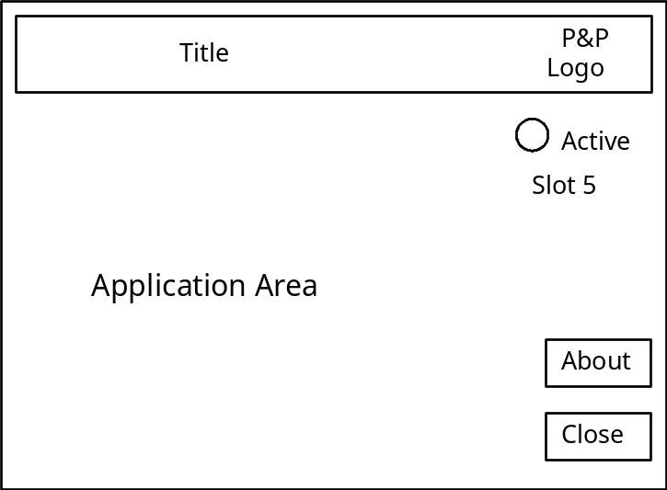

Figure A-1. Primary Front Panel Layout

The logo and title area follow the guidelines outlined earlier. The buttons on the right are grouped and contain the basic functions (About and Close) described earlier. The application-specific buttons perform any single action or call up a dialog box of actions that apply to that particular instrument.

Primary panels call secondary front panels. Secondary panels should also be uncluttered, neat, and uniform. Secondary panels are divided into several areas as diagrammed in Figure A-2.

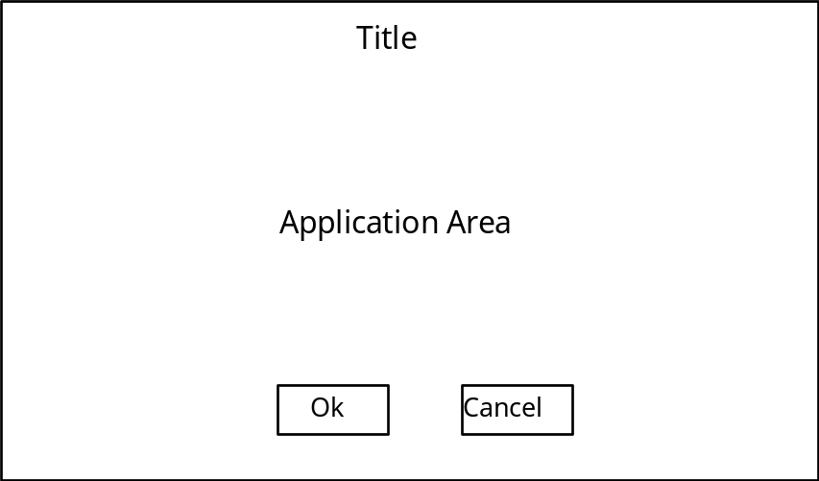

Figure A-2. Secondary Front Panel Layout

The title of the secondary panel follows the conventions outlined earlier. The buttons along the bottom are used depending on the type of secondary display. These buttons are Labeled Rectangular Buttons of uniform size.

Following are some cases in which different buttons are needed for secondary panels:

• A panel that typically contains one indicator or a message would have only an OK button.

• A panel containing a few controls that do not need to be set interactively would have OK and Cancel buttons.

• A panel containing many options the user may want to change interactively should have OK, Apply, and Cancel buttons (the user may want to perform a stimulus-response interaction with the instrument).

The label on the button is not restricted to OK, Apply, or Cancel, but may be changed to a more meaningful label pertaining to the action. For example, you can name a button Connect instead of OK .

Primary front panels also call the About panel. The About panel is a special dialog box that displays revision information. This front panel also should be uncluttered, neat, and uniform. It is divided into several areas as diagrammed in Figure A-3.

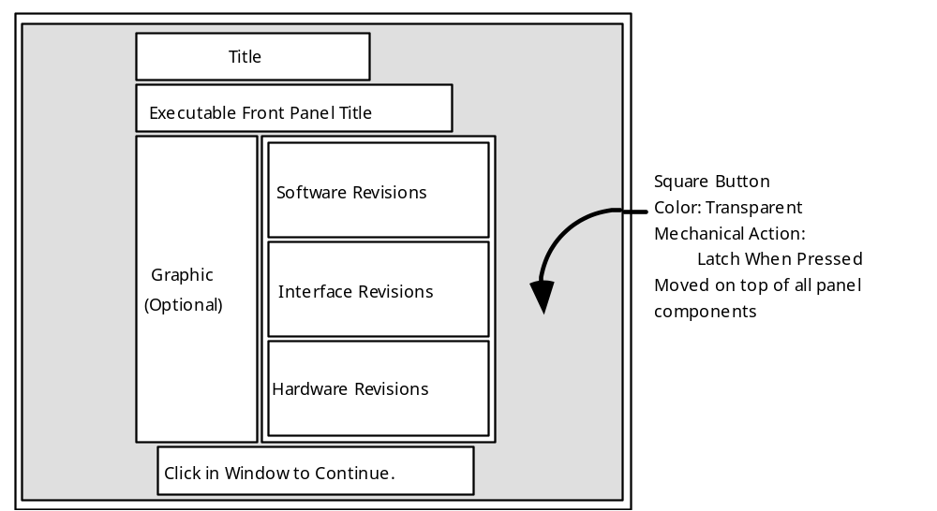

Figure A-3. Layout of the About Panel

The title of the About panel follows the conventions outlined earlier. The revisions box contains all revision information concerning the software, interface, and hardware. Be sure to follow the font and portability conventions given earlier in this document. Optionally, a graphic (bit map) may be inserted to represent the actual instrument. The About panel clears when you click anywhere in the window because a large transparent button covers the entire panel. Clearing the About panel may also be accomplished by including an OK button.

A.8.5 Panel Order

Soft front panels should support keyboard navigation. This navigation is accomplished through a combination of the <Tab> key, the arrow keys, the space bar, or the <Return> key. By setting the panel order, you can guide the user through the settings. Since many users can input data quicker from the keyboard, you should set a logical panel order to develop an intelligent interface. The order should be set to indicate the order in which a user should set each control.

A.8.6 Online Help

Soft front panels should support on-line help. On-line help provides the user with an efficient way to use the panel without referring to printed documentation.

Appendix B
LabVIEW Guidelines

B.1 Soft Front Panel Development using LabVIEW

VXIplug&play soft front panels may be implemented using the LabVIEW application development environment. The following sections describe recommended methods for the implementing soft front panels with LabVIEW.

B.2 Error Reporting

Consistent and accurate error reporting is essential to guide a user through any problems that may occur. Errors reports should reflect the problem and allow a way to cancel operations in case of an error. Two mechanisms are available in LabVIEW to simplify error reporting: the error cluster and the Simple Error Handler VI.

VISA, VXI, and GPIB instrumentation VIs employ the LabVIEW error cluster to identify and control execution based on errors. The error cluster contains three elements: a Boolean indicating if an error has occurred, a 32-bit integer indicating the error number, and text string indicating the function that failed. Upon detection of an error, the LabVIEW subVI notes the failure in the error cluster. Successive VIs with error cluster inputs connected will not execute if an error occurred previously.

The last VI at the end of the error cluster chain is the Simple Error Handler VI. If an error occurs, this VI optionally displays an error window describing the location and possible cause of the error. For soft front panels, the Simple Error Handler VI should display an error dialog box with the type of dialog input set to 2. This version of the dialog box allows the user to stop execution or continue.

B.3 Online Documentation

The primary front panel and all functions, menus, controls, and indicators should be documented. The documentation should include general information concerning the release dates and versions of the software and interfaces used during development. When possible, the panel should query the hardware for its current revision information to determine if the panel is compatible with the instrument.

The LabVIEW Get Info... dialog box (under the File menu) should be the primary location of LabVIEW soft front panel documentation. The end of this file should contain a revision history that documents all changes applied to the soft front panel. The revision history should also include the last date the text was modified. All information in the Get Info... dialog box should be thorough and concise.

B.4 Control and Indicator Descriptions

The LabVIEW help system includes a help window that displays information concerning the object the cursor is over. If the cursor passes over a control or indicator, the help window displays the description for that control or indicator. The Get Info... dialog box should tell the user how to launch the help window (Show Context Help under the Help menu).

Each control description should correctly identify the function of the object. The description should also reflect any default states for the control, and identify if the control invokes another front panel or dialog box. The description can be entered by popping up on the control and accessing Description and Tip ...

B.4.1 About

The About dialog box contains very important information for the user. It contains information on the instrument driver itself and the software used to create it, the platform and interface used to create the driver, and the revision of the hardware driver, and the current instruments name and revision. This information is divided into three categories as shown in Table B-1.

Table B-1. About Dialog Box Categories

Category | Information in About Dialog Box
Software | LabVIEW and creation version  Instrument driver file name  Instrument driver revision
Interface | VXI interface type used for creation  VXI creation platform  NI-VXI creation software revision
Instrument | Full instrument name  Instrument hardware revision

If the instrument is able to return its hardware or firmware revision information programmatically, the About dialog should query the instrument and display that information.

