**GitHub Link**

**Purpose**

**“Storm Guard”. Storm Guard is a weather application used for local weather. This application provides the average temperature for the week and permit users to view detailed information for each day. This application is designed to manage weather conditions weekly.**

**Pseudocode**

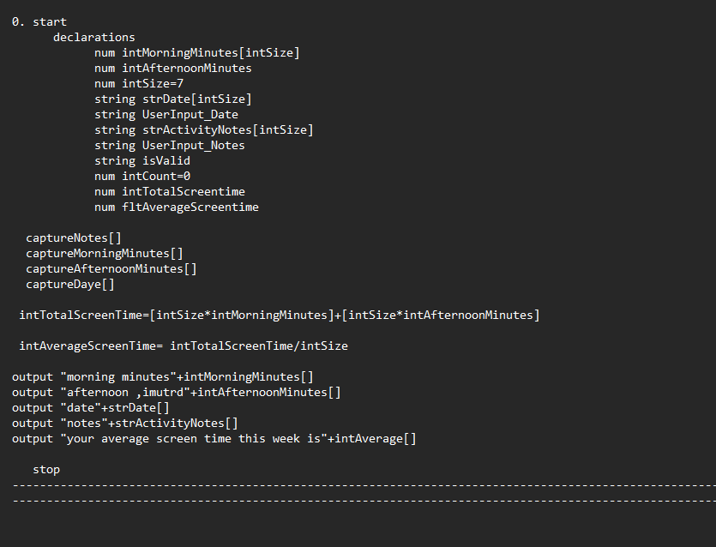

**Screen1.**

* **As you open the app you are greeted with this front page with the logo and two buttons, “Start” used to start the application and go to the next page. “Exit” to leave the application if pressed.**

**Screen2.**

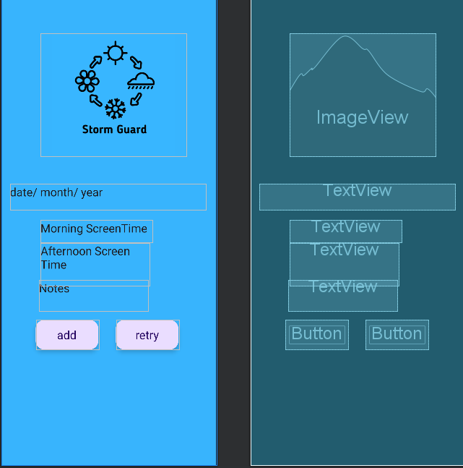

* **After pressing the start button u are brought to the second page where you enter the date and Screen times and your notes obtained.**

**Screen3.**

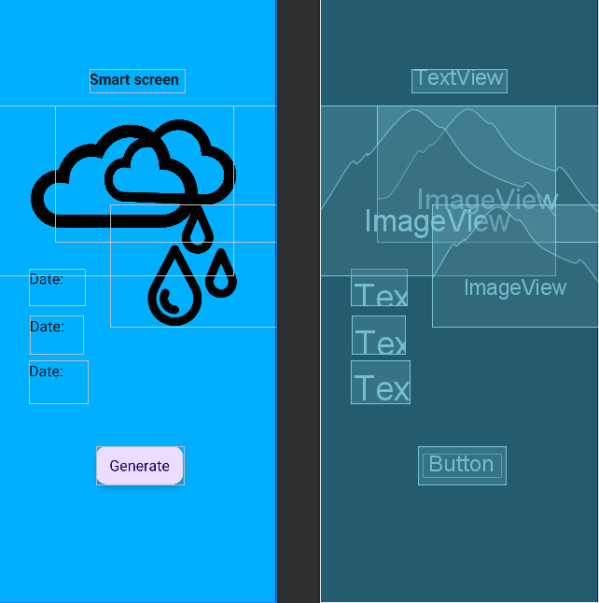

* **This is the 3rd and final page, where you can cucullate the Average, Total and weather.**

**Errors**

