#### Familiarization of Linux Commands

# Aim

To familiarize and understand basic Linux commands and their uses.

# Commands

**Touch** : Used to make new file in a directory



Output:



**Mkdir** : Used to create new folder/ directory



Output:



**Pwd** : Displays the current working directory

Output:

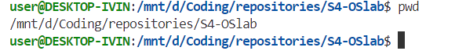

**Cd :** Used to change directory

Output:

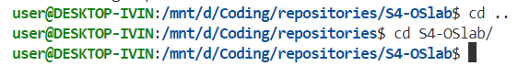

**Cat** : Used to view content of a file

Output:

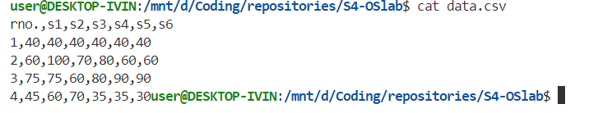

**Ls :** Lists the files in a directory

Output:

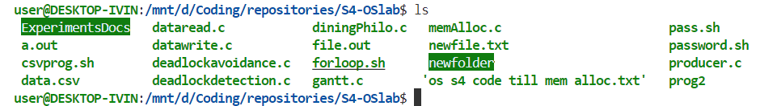

**Rm:** Removes a file

Output:

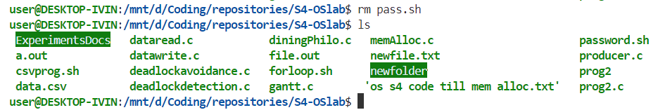

**Rmdir:**  Removes a directory

Output:

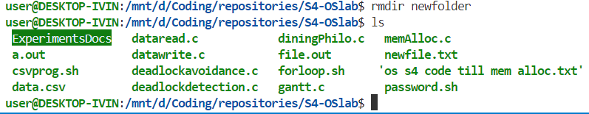

**Clear:** Used to remove the contents of the terminal

Output:

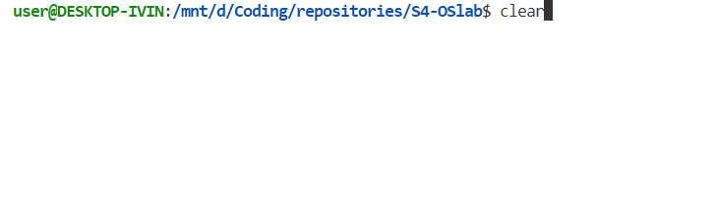

**Chmod:** Used to modify file access

Output:



**Mv:** Used to move files and directories from directory to directory

Output:

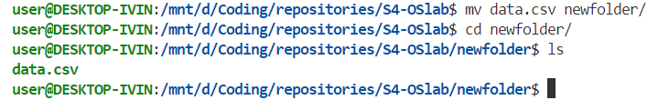

# Results

Basic linux commands have been executed and understood.