#### Shell Programming 1

# Aim

To write a shell script for the following problems.

1. Find the sum and reverse of a number using command line argument

**Algorithm**

1. Start
2. Read the number through command line
3. Initialize variables Sum and Rev
4. For each digit in number
   1. Sum = Sum + digit
   2. Rev = “digit” + Rev
5. Display values of Sum and Rev
6. Stop

**Program**

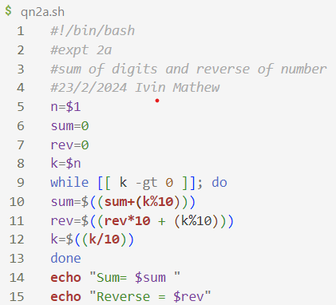

**Sample input and output**

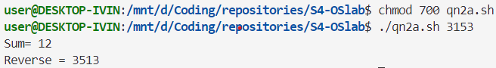

1. Display all armstrong numbers between two given numbers

**Algorithm**

1. Start
2. Read Num1 and Num2 from user through command line, set i=Num1
3. Set sum=0 and temp=i
4. Set s=i and n=0
5. If s>0
   1. Set n=s/10
   2. sum=sum+n^3
   3. s=s/10
6. If sum==temp
   1. Display temp
7. Set i=i+1
8. If i<=n2 , goto step 3
9. Stop

**Program**

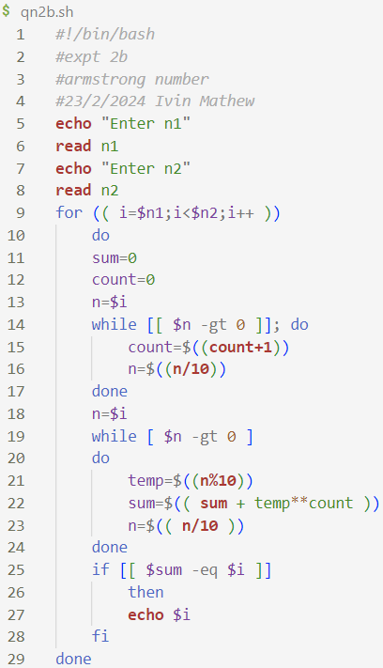

**Sample input and output**

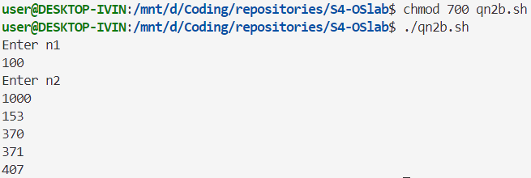

1. Write a menu driven program for converting a positive decimal number to binary, octal or hexadecimal according to the choice of the user.

**Algorithm**

1. Start
2. Display menu of choices
3. Read option opt and input n from user
4. If opt==1
   1. Set bin=0
   2. While n>0
      1. Set bin=bin*10 + n%2
      2. Set n=n/2

End while

* 1. Reverse bin and display bin

End if

1. If opt==2
   1. Set oct=0
   2. While n>0
      1. Set oct=oct*10+n%8
      2. Set n=n/8

End while

* 1. Reverse oct and display it

End If

1. If opt==3
   1. Set hex=””
   2. While n>0
      1. If n%16 <10
         1. Set hex= (char) n%16 + hex
      2. Else If n%16==10
         1. Concatenate A in front of hex
      3. Else f n%16==10
         1. Concatenate B in front of hex
      4. Else If n%16==10
         1. Concatenate C in front of hex
      5. Else If n%16==10
         1. Concatenate D in front of hex
      6. Else If n%16==10
         1. Concatenate E in front of hex
      7. Else If n%16==10
         1. Concatenate F in front of hex

End if

* 1. Set n=n/16

End while

Display Hex

End if

1. Stop

**Program**

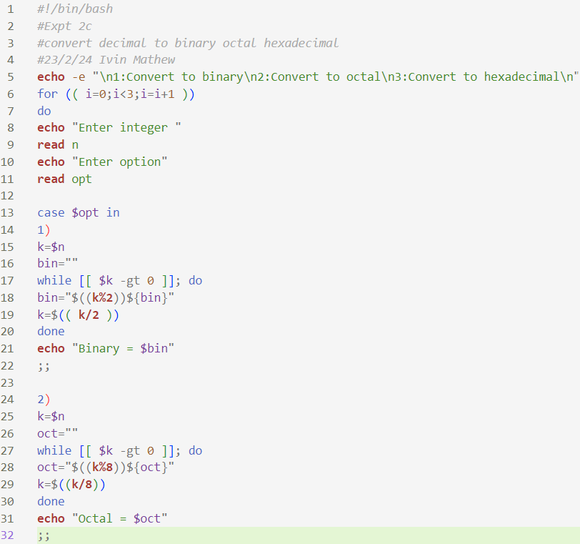

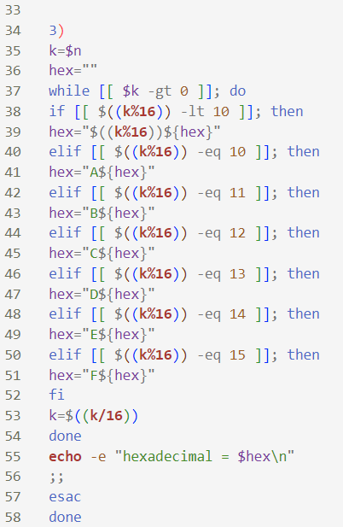

**Sample input and output**

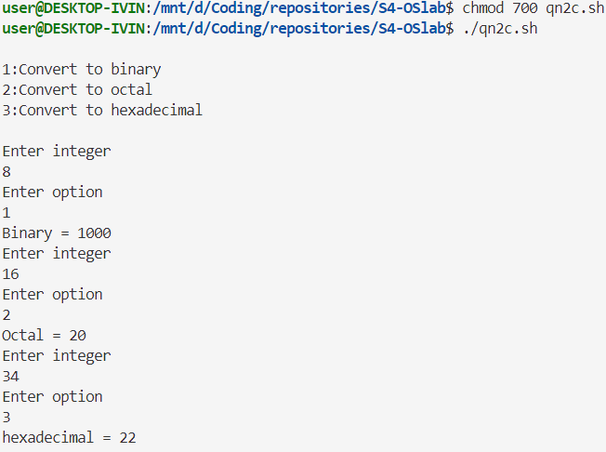

1. Input a date in the form dd/mm/yyyy and check whether it is a valid date in the range 01/01/1951 to 31/12/2025.

**Algorithm**

1. Start
2. Read data from user in the format dd/mm/yyyy
3. Extract date, month, year from input and store it in d, m, y respectively.
4. If 1951>= y OR y >=2025
   1. Goto step 9
5. If m==2
   1. If y%4==0
      1. If d<1 or d>29

Goto step 9

* 1. If d<1 or d>28
     1. Goto step 9

1. If m in {1,3,5,7,8,10,12}
   1. If d<1 or d>31
      1. Goto step 9
2. If m in {4,6,9,11}
   1. If d<1 and d>30
      1. Goto step 9
3. Display “Valid date” and goto step 10
4. Display “Invalid date”
5. Stop

**Program**

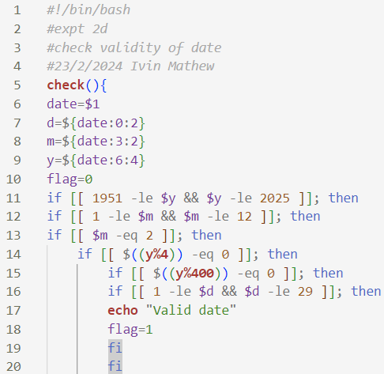

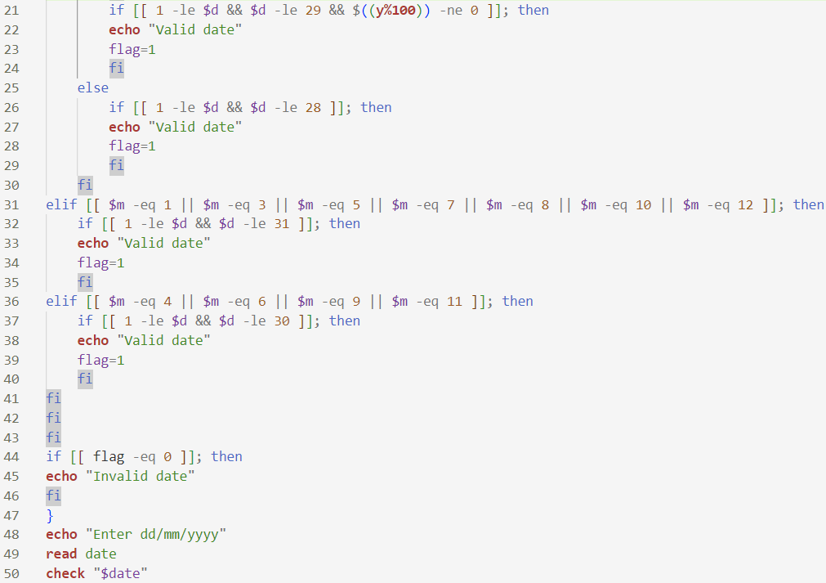

**Sample input and output**

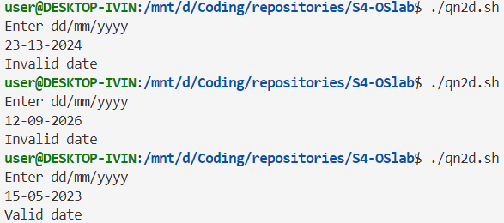

**Result**

Programs have been executed and output has been verified.