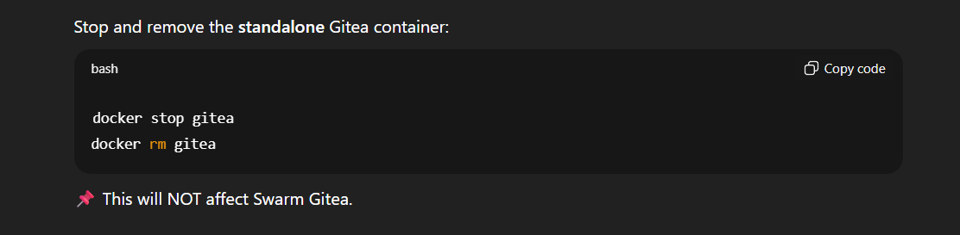
[mailer]
ENABLED = true
FROM = "Gitea <ivishnunath2004@gmail.com>"
PROTOCOL = smtp+starttls
SMTP_ADDR = smtp.gmail.com
SMTP_PORT = 587
USER = ivishnunath2004@gmail.com
PASSWD = YOUR_GMAIL_APP_PASSWORD
Keep only the swarm gitea
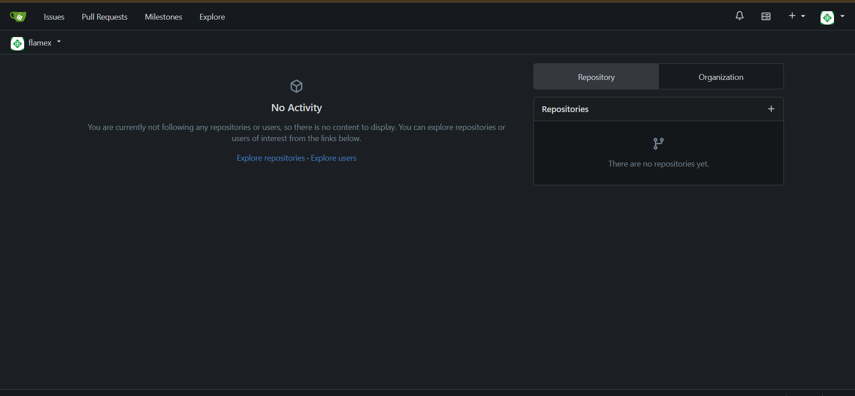
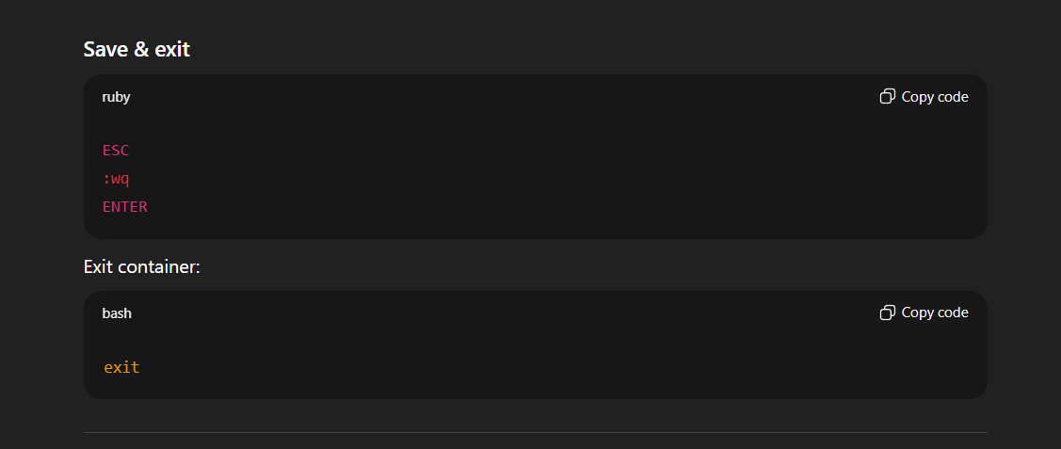
docker service update --force gitea

