- Backend Overview and Purpose
The backend of the AI-powered car rental return app serves as the backbone of all operations, focusing on secure data handling, integration with external services, and AI-assisted evaluation of vehicle condition. The backend is built using Node.js and will rely on PostgreSQL for structured, reliable, and relational data management.
- Backend Objectives
2.1. Authentication and User Management – Node.js Implementation
2.1.1. Securely authenticate users (rental companies and customers)
  - User Registration and Login
    - Implemented using Express.js (part of Node.js stack).
    - Passwords will be hashed using bcrypt before storing them in PostgreSQL.
    - Login flow will verify credentials and issue a JWT Web Token upon success.
    - JWT will be signed with a private secret or RSA key for secure, stateless authentication.
    - Password reset and account verification will be handled via email tokens with expiration.
  - Session Handling
    - Frontend will store the JWT in secure storage (e.g., SecureStore or Keychain).
    - Backend will validate tokens on every protected route using middleware.
  - Account Lockout & Throttling
    - Implement request rate-limiting and login attempt tracking to prevent brute-force attacks. This prevents rapid, repeated login attempts (brute-force attacks). Attackers are delayed or blocked before they can guess valid credentials.
      - Use middleware like express-rate-limit.
      - Define rules (e.g., max 5 login attempts per IP per 15 minutes).
      - On exceeding the limit, the server returns a 429 Too Many Requests response.
      - On each failed login attempt, increment a counter in PostgreSQL (per user or IP).
      - If the number of failed attempts exceeds a threshold (e.g., 5), temporarily lock the account or block the IP.
      - Reset the counter on a successful login.
2.1.2. Support for third-party login (Google, Apple)
  - Use libraries like passport.js or next-auth (hybrid) for OAuth support.
  - Google and Apple sign-ins will redirect the user to authenticate with their provider.
  - Upon successful authentication, the backend will receive an access token or ID token, which will be verified.
  - Once verified, the backend checks whether the user exists:
    - If yes, log in and issue JWT.
    - If no, create a new user and issue JWT.
  - Security Measures
    - Validate tokens with Google/Apple’s public keys (JWT validation).
    - Ensure HTTPS is enforced for all OAuth redirects and token exchanges.
2.1.3. Role-based access (admin, company staff, customer)
- Role Management
  - Each user will have a role field stored in the PostgreSQL user table.
  - Roles: admin, staff, customer. (for starters)
- Authorization Middleware
  - Middleware functions will be written in Node.js to:
  - Check if JWT is present and valid.
  - Decode the token and extract the user's role.
  - Allow or deny access to certain endpoints depending on the required role.
- Granular Access Control
  - Admins: Access to user management, analytics, and system logs. (some parts implemented in the MVP only)
  - Staff: Access to car check-in/out features, image uploads, and inspection records. (some parts implemented in the MVP only)
  - Customers: Access to their own rental records, return process, and notifications. (some parts implemented in the MVP only)
2.2. Car Management System
2.2.1. Maintain a structured database of all registered vehicles (do we do a copy of theirs, do we want to?)
2.2.2. Synchronize with the rental company’s main car database via API
2.2.3. Enable car lookup, assignment, and tracking using SQL queries and indexes
2.3. AI Damage Detection Integration
2.3.1. Store the initial (pre-rental) and return (post-rental) images
2.3.2. Interact with an AI service to:
- Detect damage in the post-rental image
- Compare current and initial state
- Flag new damage
- Store analysis results in structured tables
2.3.3. Return clear decision logs and damage confirmations
2.4. Notification and Reporting System
2.4.1. Notify customers and staff of confirmed damages or clean returns
2.4.2. Generate reports on returned cars, damage status, and history logs
2.4.3. Enable manual overrides or confirmations
2.5. Security and Compliance
2.5.1. Ensure all endpoints are secured with token-based authentication
2.5.2. Follow data privacy standards for handling user data and images
2.6. Scalability and Reliability
2.6.1. PostgreSQL ensures structured and relational data handling
2.6.2. Node.js ensures performant and event-driven request processing
- Screen 1: Login Page
This is the entry point for users into the system. It provides authentication and identity management.
3.1. Screen Components
3.1.1. Customer Header
3.1.2. Login Form
3.1.3. Social Login Options
3.1.4. Footer
3.2. Backend Interaction (on Login)
3.2.1. User enters credentials or clicks social login
3.2.2. Backend actions:
3.2.3. Backend logs:
  - A customizable banner for branding (e.g., company logo, welcome message)
  - Input fields for email/username and password
  - Login button to trigger backend authentication
  - Google and Apple buttons enable OAuth-based login
  - Backend must validate third-party tokens and create/access internal user sessions
  - Contains additional links (e.g., support, privacy policy) or branding
  - Verifies credentials against the user database in PostgreSQL
  - Or verifies OAuth token (Google/Apple)
  - Issues a JWT (JSON Web Token) or session token on success
  - Sends the authenticated session back to the app
  - Timestamps, IPs, and login activity
Triggers session/role assignment
work in progress
4. Screen 2: Dashboard Page
- The Dashboard Page serves as the central interface for users after login. It will be personalized and role-aware (i.e., customer, staff, admin), showing relevant rental data and providing key action points like support access, navigation, and filtering options.
    - 4.1. Screen Components and Backend Logic
      - 4.1.1. Top Navigation Bar
- Logo & Dashboard Redirect
  - Clicking the logo reloads the dashboard.
  - Session-verified request; frontend verifies JWT token validity via backend middleware.
- Hamburger Menu
  - Opens dropdown for:
    - Settings: Triggers backend user preferences API (/api/user/settings)
    - Language Change: Sends preference to backend (/api/user/language), saved in PostgreSQL under users.language
    - Profile View/Edit: Authenticated fetch of user profile from PostgreSQL (/api/user/profile)
  - Backend:
    - Authenticated routes (JWT)
    - Settings stored in PostgreSQL per user ID

4.1.2. Rental Status Toggle (active / history)
- Toggle controls the query context:
  - active: Only rentals where status = 'active' from rentals table.
  - history: Rentals where status IN ('returned', 'cancelled', 'completed').
- Backend Logic:
  - Endpoint: /api/rentals?type=active or ...type=history
  - Filters by user role:
    - Customer: Rentals where user_id = current_user
    - Staff/Admin: Rentals assigned or all rentals depending on scope
  - Pagination and sort parameters will be supported.

4.1.3. Location Label & Cards
- Each card corresponds to a specific rental record, including:
  - Car location
  - Rental start/end
  - Return status or inspection pending
  - Image evidence presence (optional)
- Backend:
  - Endpoint: /api/rentals/active or /api/rentals/history
  - Data joined via SQL across tables: rentals, vehicles, locations
  - Indexing:
    - Ensure location lookups are indexed on location_id
    - Composite index for fast querying: (user_id, status)
- Security:
  - Row-level access control via middleware
  - User JWT is decoded and checked before data is filtered
  - No direct user input in SQL (prevent SQL injection)

4.1.4. Filters (for future implementation)
- UI Placeholder for filter options such as:
  - Time range
  - Vehicle type
  - Damage status
- Future Backend:
  - Filter parameters handled by query string, e.g.:
    - /api/rentals?status=active&type=SUV&dateRange=last30days
  - Backend dynamically constructs parameterized SQL queries.
  - Cache common queries using Redis or query memoization.

4.1.5. Support Button
- Opens a support dialog for direct assistance.
- Backend:
  - Route: /api/support/message
  - Stores message in support_tickets table with user ID and timestamp.
  - Staff/admin notified via email or dashboard view.
  - Initial MVP: store-and-notify
  - Future: integrate with third-party systems (like zendesk)
- Security:
  - Rate limit support submissions (5 messages/hour/user)
  - Input sanitation to avoid XSS in free text

4.1.6. Chat Button (@ icon) – Future Chat API
- Placeholder for real-time messaging or chatbot
- Backend:
  - WebSocket-based or long polling chat API
  - Messages stored in a messages table, linked to conversation ID
  - User access control to ensure messages are only seen by intended users
  - AI Assistant integration possible (e.g., GPT-based FAQ/helpbot)
- Future tech:
  - socket.io or ws for Node.js
  - Secure session-bound socket authentication
  - End-to-end message encryption (optional)

4.2. Backend Technology Stack Recap
Component | Tech Used | Purpose
Web Server | Node.js (Express) | API logic, session/token validation
Database | PostgreSQL | Rental/user/vehicle/support data
Authentication | JWT & OAuth2 | Secure login, access control
Rate Limiting | express-rate-limit | Prevent abuse (login/support)
Storage | Cloud storage / S3 | For rental images if embedded
Future Real-time | WebSockets / socket.io | Live support or chat integration

5. Product Details Page
The Product Details Page provides staff (and optionally customers) with detailed information about a specific rental instance, its vehicle, inspection status, and AR-driven condition reporting. This view is essential for managing check-ins, verifying damages, and completing inspection workflows.

5.1. Car Details and Rent Dates
Backend logic:
- Data is fetched using a secured API endpoint: GET /api/rentals/:rentalId.
- PostgreSQL joins multiple tables: rentals, vehicles, and users.
- Response includes:
  - Vehicle details: make, model, plate_number, vehicle_id
  - Rental period: rented_from, rented_to
  - Current status: active, completed, in_inspection
- Auth middleware ensures the user is authorized (e.g., staff or admin).

5.2. Latest Car State (Return Inspection Snapshot)
Backend logic:
- Data is retrieved from the vehicle_inspections table.
- Each inspection record is tied to a rental_id and includes:
  - area (e.g., "front bumper", "left door")
  - status (ok, damaged, unchecked)
  - inspected_by (user ID)
  - timestamp
- Endpoint: GET /api/inspections/:rentalId/latest
- This allows the frontend to populate the grid with the most recent inspection values.

5.3. Interactive Inspection Grid
Backend interaction:
- When staff mark sections of the car as OK (✔️), Damaged (❌), or leave them blank:
  - Each interaction triggers a POST /api/inspections or PATCH /api/inspections/:id
  - The body includes: rental_id, area, status, and user_id
- PostgreSQL automatically timestamps each inspection entry.
- This allows auditability and future comparison across inspection sessions.

5.4. Picture Upload and Inspection Imaging
Backend logic:
- Endpoint: POST /api/inspections/:rentalId/images
- Each uploaded file is:
  - Validated (type, size, malicious content)
  - Stored in external storage (e.g., Amazon S3 or local filesystem)
  - Linked in PostgreSQL with:
    - rental_id, user_id, filename, inspection_area, upload_time
- PostgreSQL table: inspection_images
Security:
- Only authorized users (staff/admin) can upload images.
- Uploads are rate-limited and scanned.

5.5. Phone Camera AR Software
Backend support (planned):
- While AR rendering occurs client-side, the backend will:
  - Accept coordinates of damage regions via POST /api/ar-inspection
  - Store location metadata per image (bounding_boxes, labels, etc.)
  - Integrate with AI models to suggest damage classification
- PostgreSQL will store:
  - JSON metadata per inspection record
  - Mapped to the car blueprint using standard region names
- Optional integration with AI service for auto-labeling from camera stream

6. AR-Driven Vehicle Inspection Plan
The goal of this module is to enhance the vehicle condition reporting process by integrating an augmented reality (AR) interface that allows users (staff or customers) to tag damage visually on a digital model of the car using a live camera feed. The system captures annotated images, stores them in the database, and optionally runs AI-based damage detection for quality assurance or automation.

6.1. AR Frontend Design
Overview:
- The mobile/web app uses the device camera to display a car overlay with interactive “hot zones” mapped to real-world vehicle parts.
- Users can tap or circle damage regions, which generates bounding boxes and metadata.
Frontend stack:
- AR Framework: 8thWall or WebXR for web-based AR (no app store requirement).
- Camera access: Standard WebRTC APIs or mobile-native camera components (for React Native apps).
- Overlay engine: Three.js or A-Frame for 3D interaction on top of the live camera stream.
Interaction flow:
- User opens the AR camera via the “Picture” or “Inspect via Camera” button.
- Car outline and regions (e.g. door, bumper) are rendered.
- User taps the affected zone or draws on screen.
- App saves:
  - Image frame
  - Bounding box coordinates
  - Region name
  - Optional annotation/note
Data prepared to send to backend:
json
CopyEdit
{
"rental_id": "abc123",
"user_id": "staff01",
"region": "front_bumper",
"bounding_box": {
"x": 0.23,
"y": 0.42,
"width": 0.2,
"height": 0.1
},
"note": "scratched",
"image_file": [binary file]
}

6.2. Backend and Database Structure
New Endpoint:
- POST /api/ar-inspection
  - Handles image + metadata upload
  - Saves inspection image and structured damage metadata
Database Schema:
New table: ar_inspection_images
sql
CopyEdit
CREATE TABLE ar_inspection_images (
id UUID PRIMARY KEY DEFAULT gen_random_uuid(),
rental_id UUID REFERENCES rentals(id),
user_id UUID REFERENCES users(id),
region TEXT,
bounding_box JSONB,
note TEXT,
image_url TEXT,
ai_result JSONB,
created_at TIMESTAMP DEFAULT now()
);
Storage:
- Image files stored in S3 (or local object storage for internal deployments).
- image_url links to stored image.
- Bounding boxes saved in JSONB for future overlay rendering and AI processing.

6.3. AI Integration for Damage Detection
The AI system processes uploaded AR inspection images to auto-detect potential damage and label them for review or auto-approval.
Use Cases:
- Double-check human annotations.
- Auto-flag missed damage.
- Pre-fill reports.

6.4. AI Structure:
The system enables rental agencies to automatically detect visible car damage using AI from standardized vehicle photos taken during check-in and check-out. It leverages Vision Transformer (ViT) models to provide rapid and consistent binary classification ("damage yes/no") and compare photos over time to detect new damage. This reduces manual inspections, ensures fairness, and increases customer trust. The proposed structure is for a POC and will be upgraded as the needs arise.

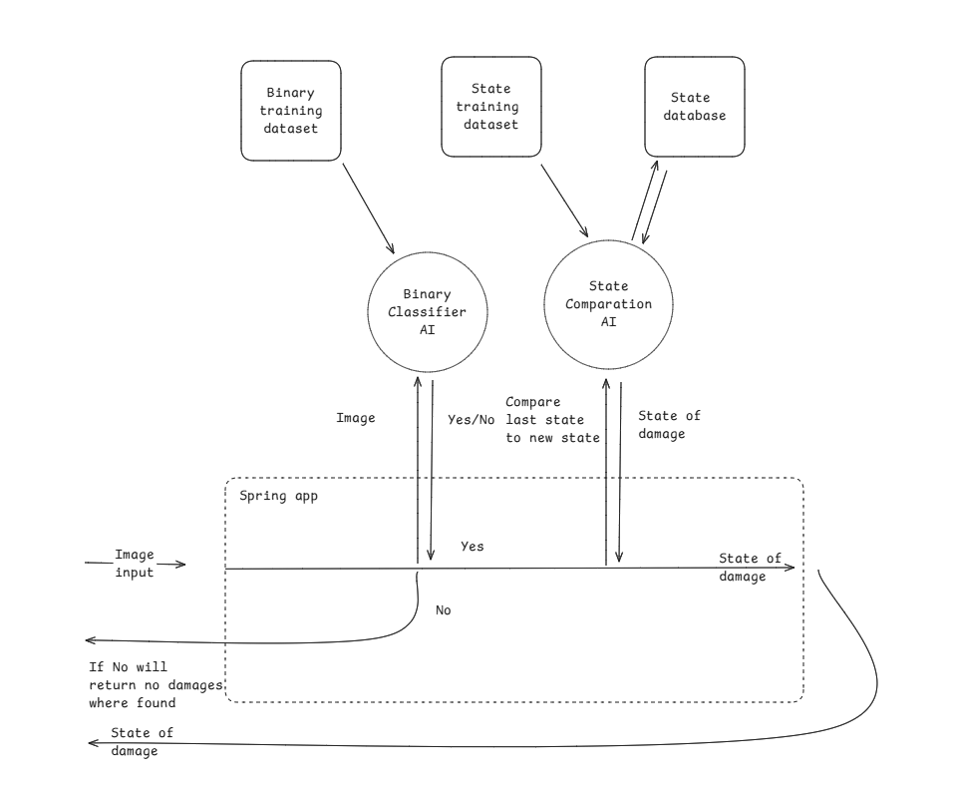
Visual representation of the ai POC structure
Once the structure is sucsesfully tested that it works a

6.4.1. Core AI Technology
Our solution has two transformer-driven subsystems. Damage Classifier: a ViT-base-patch16-224 model fine-tuned on 2 000 balanced rental images. Photos are standardized to 224×224, augmented (flip, crop, color-jitter), and trained for five epochs, giving >92 % F1 on a hold-out lot. The frozen ViT backbone loads in DJL or Vertex AI; Spring passes Base64 JPEG and receives a damage flag plus confidence. Similarity Engine: the same ViT backbone, sans classifier head, converts every image into a 768-d CLS embedding. We keep the latest embedding per car-angle in PostgreSQL/pgvector. A cosine-similarity query (<0.8) signals new damage. Monthly retraining on an A100 costs < $10 and transparently swaps the model artefact. Future iterations upgrade to ViT-large with ViTDet heads for localisation and severity prediction at fleet scal

Damage Detection (Binary Classifier)
- Model Type: Vision Transformer (ViT-base-patch16-224)
- Function: Classifies each vehicle image as damaged or not damaged
- Training: Fine-tuned on labeled car image dataset
  - Input: 224x224 photos from real-world rental inspections
  - Output: Binary classification with confidence score

State Comparison (Similarity Analysis)
- Function: For damage=true images, compare current and previous session photos of the same angle
- Approach: Extract CLS-token embedding vector from ViT
- Method: Use cosine similarity between embeddings
- Output: If similarity < threshold, label as new damage
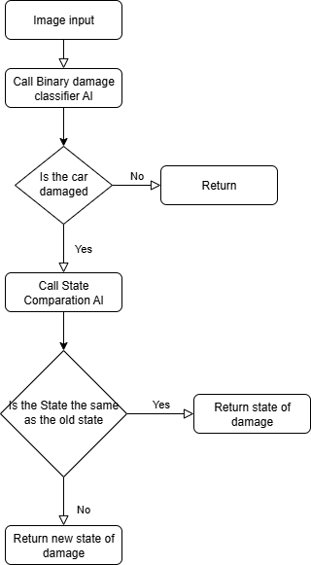

Input Standards
- 6 Photos per Car:
  - Photos should preferably be JPEG (or PNG if lossless needed), sized or resized to 224×224 pixels before inference.
  - Images must be in RGB color mode, properly oriented, and have EXIF metadata stripped on upload.
  - When sending to the backend (e.g., via API), images are Base64-encoded.
  - Uploads happen via REST multipart/form-data, with validations on size, format, and dimension.
- Metadata: car_id, angle, timestamp, rental_session_id
Images metadata is saved in PostgreSQL.
This ensures consistent input quality and reliable AI predictions. Would you like me to do the same detailed treatment for other sections?

6.4.2. Backend & Infrastructure
Spring Boot Backend (Java 21/23)
- Framework: Spring Boot 3.5
- Core Modules:
  - Spring Web – REST controllers for photo upload, rental workflow, and health checks
  - Spring Data JPA – ORM layer for PostgreSQL (car, photo, rental, and embedding tables)
  - Spring Security – Token-based authentication for staff/customer portals
  - OpenFeign / WebClient – HTTP client for calling external services (e.g., Vertex AI)
  - Jackson – JSON (de)serialisation
  - Lombok – Boilerplate reduction (@Getter, @Builder, etc.)
  - MapStruct – Compile-time DTO/entity mapping (optional)
  - Apache Commons IO & Imaging – Utility helpers for file validation and EXIF stripping

6.4.2.1 AI tools for backend
LangChain
LangChain is a powerful open-source framework designed to enhance large language model (LLM) applications by enabling seamless integration with external data sources, APIs, tools, and multi-step workflows. In the backend of this car damage detection project, LangChain can be used to build intelligent agents that combine AI-generated insights with external information—such as vehicle records, repair histories, or insurance data—to provide more context-aware, accurate, and actionable responses. It supports chaining together multiple processing steps, maintaining conversational memory for ongoing interactions, and dynamically deciding when to call external tools or databases. This makes LangChain ideal for creating advanced AI-driven backend services that go beyond simple image classification, enabling richer, more interactive, and automated workflows to support damage assessment, customer communication, and decision-making processes.

6.4.3. Uploading Car Images to the AI Model Using HTTPS and Form-Data
To detect damage on cars using AI, the system needs a way to receive images taken from multiple angles (front, back, left, right, top, and bottom). These images are sent from a client—such as a web frontend, a mobile app, or a testing tool like Postman—to the backend service where the AI model is hosted. This transmission is done securely over HTTPS and uses the standard multipart/form-data format.
The multipart/form-data format is commonly used for uploading files over HTTP. It allows clients to send one or more images in a single request while preserving each file’s name and content. This is especially important in our use case, as the AI model needs to receive six separate images per vehicle, each from a different angle.
When the client prepares the request, it attaches each image as a separate form-data field, all using the same key name (for example, "files"). This tells the server that multiple images belong to the same logical group. The server, built with FastAPI or a similar framework, receives the images, reads their content, and prepares them for analysis by the AI model.
Using HTTPS ensures that the image data is encrypted during transmission, protecting it from interception or tampering. In a production environment, HTTPS is enforced via a secure certificate, often managed by a proxy server like Nginx.
Once the backend receives the images, it can process them one by one using a model like YOLO (for object detection) or ViT (for classification). The results—such as detected damage regions or a yes/no damage flag—can then be returned to the client in a structured format, such as JSON.
This design makes it easy to integrate the damage detection AI into various platforms while keeping the data transfer secure, efficient, and compatible with common web standards.

6.4.4. Data Storage Architecture
PostgreSQL 17 with pgvector Extension
PostgreSQL acts as the central data warehouse for structured metadata and AI results.
Stored:
- Car and rental metadata (UUID, timestamps)
- Image catalog (GCS URI, angle, status)
- Classification results (damage, confidence)
- ViT embeddings (vector(768)) via pgvector

6.4.5. AI Training & Inference Strategy
Training Setup
- Model: ViT-base-patch16-224 (or larger variants later)
- GPU (local): Quadro T1000 (OK for ViT-base only)
- GPU (cloud): A100/V100 recommended for large models
- Data size: 2k–10k labeled images
Training Time & Cost (estimates)
GPU | Model | Time | Cost
T1000 | ViT-base | 45–60 min | Free (local)
A100 | ViT-huge | ~1.5 hrs | ~$6–10
Monthly Inference Cost (MVP)
Component | Cost
ML Inference (Cloud Run) | $10–20
GCS Storage (20–40 GB) | $1–3
PostgreSQL (Cloud SQL) | $10–15
Retraining | $0–10
Total | ~$25–50/month

6.4.6. Testing
Testing the system involves several stages and tools to ensure accuracy, reliability, and performance. Here’s how you can approach it:
Unit Testing:
Start by testing individual components like image preprocessing, model inference, and data handling. Use Python testing frameworks such as junit, pytest or unittest. This helps catch bugs early in your code and usually takes a few hours to a day, depending on the complexity.
Integration Testing:
Test how different parts of the system work together—uploading images via the API, passing them through the model, and returning results. Tools like Postman or HTTPie can simulate API requests and check responses. This phase might take a day or two as you verify end-to-end workflows.
Model Validation:
Evaluate the AI model’s accuracy and robustness using labeled test datasets. Use metrics like precision, recall, F1-score, and confusion matrices. Libraries like scikit-learn help with metric calculations. This step can take several days to weeks, depending on data availability and the need for model retraining.
Performance Testing:
Assess system responsiveness and scalability under load. Tools like Locust or Apache JMeter simulate multiple simultaneous users sending requests. Performance testing typically takes a few days and is essential to ensure the system works well in real-world conditions.
User Acceptance Testing (UAT):
Involve real users or stakeholders to test the system in realistic scenarios, gathering feedback on usability and accuracy. This phase length varies but generally takes a few days to a week.

6.4.7. Scaling Plan
- Phase 1: Single location MVP (~1k images/week)
- Phase 2: Expand to fleet of 10+ locations (~50k images/month)
- Phase 3: Integrate with customer apps, multilingual UI, tamper detection, and visual damage segmentation (optional YOLO/SegFormer models)

6.4.8. Timeline to POC
Phase | Milestone | Duration
1 | Data collection (photos & labels) | 1–2 weeks
2 | Fine-tuning ViT-base | 2–4 weeks
3 | AI Backend Setup | 1–2 weeks
4 | PostgreSQL + pgvector integration | 2–3 days
5 | Internal testing + threshold tuning | 1 week
Total | POC deployment | ~12 weeks
Week →
1 2 3 4 5 6 7 8 9 10 11 12
──────────────────────────────────────────
1: [====Data Collection====]
2: [=======Fine-tuning========]
3: [==Backend Setup==]
4: [Pgvector]
5: [Testing]
──────────────────────────────────────────
Final PoC Deployment at Week ~12
After the testing is finished we iterate on the system by adding extra classification layer or fine tuning the models.

6.4.9. Enhancing Car Damage Detection with YOLO
In the current implementation of our car damage detection system, a Vision Transformer (ViT)-based classifier is used to determine whether a car image shows signs of damage. While this binary classification is useful for detecting if damage exists, it lacks the ability to pinpoint where the damage is or what kind of damage has occurred. To address these limitations, we propose integrating a YOLO (You Only Look Once) model into the system.
YOLO is a family of real-time object detection models designed to detect and localize objects within images using a single neural network. Unlike traditional two-stage detectors, YOLO performs object localization and classification in one pass, making it highly efficient and suitable for real-time applications like our vehicle check-in/check-out system.
By integrating YOLO into our pipeline, we can enhance the system in the following ways:
- Damage Localization: YOLO provides bounding boxes around damaged regions, allowing us to highlight exactly where the issue is.
- Multiple Damage Detection: YOLO can identify multiple damages in a single image (e.g., a dent on the door and a scratch on the bumper).
- Visual Feedback: Bounding boxes can be drawn on the images and shared with end-users or auditors, providing clear, visual evidence of damages.
- Damage Type Classification (optional): With the right labeled dataset, YOLO can also be trained to distinguish between types of damage (e.g., scratches, dents, cracks).
We recommend using YOLOv8 from Ultralytics due to its active development, Python-friendly API, and support for both object detection and segmentation tasks. The model can be trained on a custom dataset with images annotated in the YOLO format. Once trained, the model can be easily integrated into our FastAPI backend to analyze the 6-view images taken during car check-in and check-out. By comparing bounding box outputs across time, we can automatically detect new damages with high accuracy.
YOLO thus transforms our system from a simple classifier into a full damage inspection tool, making it more intelligent, explainable, and valuable for real-world applications like rental fleets, valet services, or insurance claims.
Connection setup:
- AI service hosted at http://ai-service:8000/predict
- Backend calls it asynchronously via:
js
CopyEdit
const aiResult = await axios.post('http://ai-service:8000/predict', {
image_url,
rental_id
});

6.5. Future Enhancements
- Versioning: Keep historical AI and human annotations for review and training feedback loops.
- AR Zone Calibration: Allow staff to define exact zone polygons on car models using an admin tool.
- AI Feedback: Staff can mark AI suggestions as correct/incorrect, feeding back into model retraining.
- Offline Mode: Store AR data locally and sync when online.

6.6. Permissions and Access Control
- Upload access: Staff or trusted customers (validated via JWT token roles).
- AI result view/edit: Staff-only
- Audit log: Record all AI predictions, staff overrides, and image upload actions in a system_logs table.

