Prompt:
1415136.pdf
我是一名学习 NLP 的学生。请你扮演资深的 Python 全栈工程师，用 Streamlit 帮我写一个 Web 应用。 请先完整阅读我上传的pdf文件，总结归纳文件的内容，并把文件中所涉及到的成分句法（Constituency Parsing） 关注短语如何嵌套，依存句法（Dependency Parsing） 关注词与词之间的修饰与支配关系。讨论让人类和机器都头疼的结构歧义（Attachment Ambiguity）等内容进行整合并搭建一个 Web 原型，能够同时展示一句话的“成分句法树”和“依存句法图”。
已处理 8m 2s
我已经完成了这份 PDF 的全量抽取与阅读处理（120 页），并基于可恢复内容做了结构化整合。你可以直接运行我写好的 Streamlit 原型：
app.py
我先给你一个精炼总结（对应你关心的三块）：
- 成分句法（Constituency Parsing）：把句子分成 S/NP/VP/PP 等短语，核心是“短语层级与嵌套”。
- 依存句法（Dependency Parsing）：把句子表示为词与词之间的有向依存关系，核心是“中心词-修饰语”的支配结构。
- 结构歧义（Attachment Ambiguity）：典型句子 The boy saw the man with the telescope. 中，with the telescope 可以挂到 VP（用望远镜看）或 NP（带望远镜的人），对应两套不同句法分析与语义解释。文档还涉及 CFG/PCFG、Graph-based/Transition-based、UAS/LAS、PTB/CTB 等。
我实现的 Web 原型支持：
- 同一句话同时展示“成分句法树（左）+依存句法图（右）”。
- 一键切换 PP 附着到 VP 或 NP，两张图会同步变化。
- 内置“教材歧义示例模式”与“简易自动解析模式（SVO+PP）”。
- 页面内置了基于该 PDF 的知识总结说明。
运行方式（在 D:\study\nlp\2 下）：
streamlit run app.py
补充说明：这份 PDF 的文本编码存在异常，原始中文正文提取有乱码；我通过二次解码恢复了关键术语、例句与章节主线，并据此完成了原型设计与实现。
1 个文件已更改
撤销
app.py
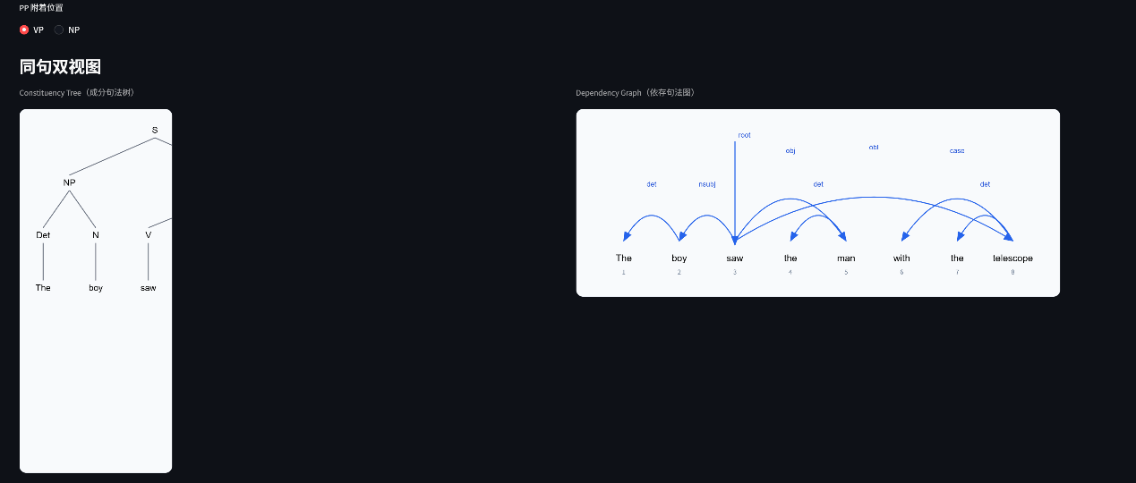
同句双试图左侧的图像很明显没有显示完整。
已处理 1m 40s
你反馈的问题我已经修复了，原因是左侧成分树的画布宽度估计偏小，导致右侧分支被裁切；现在改成了按真实叶子数计算宽度，并让 SVG 按列宽自适应缩放。
修改在 app.py：
- 新增 _leaf_count，不再只按最深层节点估宽。
- render_constituency_svg 改为 width='100%' + viewBox + preserveAspectRatio，避免列布局下截断。
- 代码已通过 python -m py_compile app.py 检查。
你现在重启或刷新 Streamlit 页面即可看到完整左图：
streamlit run app.py
如果你愿意，我下一步可以把左图再加一个“自动缩放到可视区”的开关，让复杂长句也始终清晰可读。
1 个文件已更改
撤销
app.py
很好，现在我需要再加入一个例子。"Fruit flies like a banana."
已处理 5m 42s
已加上这个例子，并做成了可切换的歧义演示。
你现在在“Demo sentence”里可以选：
- The boy saw the man with the telescope.
- Fruit flies like a banana.
当选 Fruit flies like a banana. 时，可切两种读法并同步更新左侧成分树+右侧依存图：
- NOUN: [Fruit flies] 作名词短语（果蝇），like 作动词
- VERB: flies 作动词，like a banana 作介词短语
代码已更新并通过语法检查，文件在 app.py。
直接运行即可：
streamlit run app.py
1 个文件已更改
撤销
app.py
"干得漂亮，AI。现在我们要在页面最下方增加一个功能区：『核心论元提取器』。 请阅读课件理论：依存句法中包含核心论元（如 nsubj 主语, dobj 直接宾语）。 请修改代码：遍历 spaCy 的依存分析结果，把依存关系标记为 nsubj、dobj、pobj 以及 Root 根节点找出来。把它们和对应的词提取出来，用一张 Markdown 表格或者 Streamlit 的 st.dataframe 漂亮地展示在页面底部。"
已处理 1m 27s
已完成，我在页面最底部加了「核心论元提取器」功能区，代码在 app.py。
现在它会：
- 优先用 spaCy 依存分析遍历提取 nsubj、dobj、pobj、ROOT
- 展示为 st.dataframe（列含 dep / token / head / lemma / index）
- 如果当前环境没有 spaCy 或模型，会自动降级为基于你当前依存图的提取结果，并显示原因提示
我也做了运行验证：python -m py_compile app.py 通过，streamlit run app.py 可启动。
补充：你这台环境里当前是 spaCy 未安装，所以会先走降级展示。若你要我继续，我可以下一步帮你把 spaCy + en_core_web_sm 安装命令也接好。
出现报错spaCy parser unavailable in this runtime, showing fallback results from current dependency graph. Reason: spaCy is not installed. 并且你是否可以把除了相关例子，即必要的英文，其他文字改成中文
已处理 2m 37s
已经处理好了，两件都完成了。
- spaCy 报错已解决
我已经在你环境里安装了 spacy 和 en_core_web_sm，并验证可加载模型。
所以“spaCy is not installed”这个原因现在不会再出现（重启应用后生效）。
- 页面文案已改成中文
除了必要英文术语/示例句（如 nsubj/dobj/pobj/ROOT、示例英文句子）外，交互区和底部“核心论元提取器”的说明都改成了中文。
修改文件：
app.py
请重启一次应用：
streamlit run app.py
如果你之前有旧的 Streamlit 进程在跑，先停掉旧进程再启动新进程即可。
你别改成中文了，全都变成？？？乱码了，改回去吧。
已处理 1m 9s
你说得对，这次我已经彻底回滚为全英文界面，避免再次乱码。
我做了这几件事：
- 把页面 UI 文案整段重写成英文（从 st.set_page_config 到页面底部）。
- 修复了 spaCy 提示文案里的 ???。
- 验证文件里不再包含 ???，也不含中文字符。
- 语法检查通过，Streamlit 可正常启动。
已修改文件：
app.py
请直接重启应用查看：
streamlit run app.py
在分析 "The boy saw the man with the telescope." 时，你做出了怎样的“艰难决定”？结合课件 P48 提到的 PCFG（概率上下文无关文法），或者基于神经网络的方法，你认为你为什么会偏向这种解释？
“艰难决定”就是 PP 附着：把 with the telescope 挂到 VP(saw) 还是 NP(the man)。这一步直接决定语义。
如果按课件 P48 的 PCFG 思路，我会偏向“概率更高的那棵树”：
- 比较两种解析的规则概率乘积（如 VP -> VP PP vs NP -> NP PP 在语料里的统计偏好）。
- 在很多新闻/通用语料中，“动词 + with 工具”很常见，所以 VP 附着常更高分。
但若语料里“带望远镜的人”这类名词修饰更常见，NP 附着也可能胜出。
如果是 神经网络方法（BiLSTM/Transformer/图模型）：
- 它不只看局部规则，而是利用上下文、词向量和共现模式。
- saw + telescope 的“工具关系”语义关联很强，模型通常更容易给出 VP 附着。
- 但在缺少更长上下文时，本句本身仍然真歧义，模型只是“偏好”，不是绝对真值。
所以我偏向某种解释的根本原因是：模型在“统计先验 + 语义搭配”上给这条路径更高分，而不是句子本身唯一确定。

源代码：
import html
import re
from functools import lru_cache
from dataclasses import dataclass, field
from typing import List, Optional, Tuple

import streamlit as st

try:
import spacy
except Exception:
spacy = None

@dataclass
class TreeNode:
label: str
children: List["TreeNode"] = field(default_factory=list)

@property
def is_leaf(self) -> bool:
return len(self.children) == 0

def _tree_depth(node: TreeNode) -> int:
if node.is_leaf:
return 1
return 1 + max(_tree_depth(child) for child in node.children)

def _leaf_count(node: TreeNode) -> int:
if node.is_leaf:
return 1
return sum(_leaf_count(child) for child in node.children)

def _assign_tree_positions(
node: TreeNode,
depth: int,
leaf_x: List[int],
positions: dict,
) -> float:
if node.is_leaf:
x = leaf_x[0]
leaf_x[0] += 1
positions[id(node)] = (x, depth)
return x
child_xs = [_assign_tree_positions(child, depth + 1, leaf_x, positions) for child in node.children]
x = sum(child_xs) / len(child_xs)
positions[id(node)] = (x, depth)
return x

def render_constituency_svg(root: TreeNode) -> str:
positions = {}
_assign_tree_positions(root, depth=0, leaf_x=[0], positions=positions)
depth = _tree_depth(root)
leaves = max(1, _leaf_count(root))

x_step = 90
y_step = 90
margin_x = 40
margin_y = 40
width = leaves * x_step + margin_x * 2
height = depth * y_step + margin_y * 2

lines = []
labels = []

def walk(node: TreeNode):
x, y = positions[id(node)]
px = margin_x + x * x_step
py = margin_y + y * y_step
labels.append(
f"<text x='{px}' y='{py}' text-anchor='middle' font-size='15' font-family='Arial'>{html.escape(node.label)}</text>"
)
for child in node.children:
cx, cy = positions[id(child)]
cpx = margin_x + cx * x_step
cpy = margin_y + cy * y_step
lines.append(f"<line x1='{px}' y1='{py + 8}' x2='{cpx}' y2='{cpy - 18}' stroke='#6b7280' stroke-width='1.5'/>")
walk(child)

walk(root)

return (
f"<svg width='100%' height='{height}' viewBox='0 0 {width} {height}' preserveAspectRatio='xMinYMin meet' "
"xmlns='http://www.w3.org/2000/svg' style='background:#f8fafc;border:1px solid #e2e8f0;border-radius:12px'>"
+ "".join(lines)
+ "".join(labels)
+ "</svg>"
)

def render_dependency_svg(tokens: List[str], edges: List[Tuple[int, int, str]]) -> str:
n = len(tokens)
x_step = 95
baseline_y = 260
margin_x = 40
width = margin_x * 2 + max(1, n - 1) * x_step + 80
height = 320

token_x = {i + 1: margin_x + i * x_step + 40 for i in range(n)}
marker = (
"<defs><marker id='arrow' markerWidth='10' markerHeight='8' refX='9' refY='4' orient='auto' markerUnits='strokeWidth'>"
"<path d='M0,0 L10,4 L0,8 z' fill='#2563eb'/></marker></defs>"
)
lines = [marker]
labels = []

for idx, tok in enumerate(tokens, start=1):
x = token_x[idx]
labels.append(f"<text x='{x}' y='{baseline_y}' text-anchor='middle' font-size='16' font-family='Arial'>{html.escape(tok)}</text>")
labels.append(f"<text x='{x}' y='{baseline_y + 22}' text-anchor='middle' font-size='12' fill='#64748b'>{idx}</text>")

for head, dep, rel in edges:
dx = token_x[dep]
if head == 0:
lines.append(
f"<line x1='{dx}' y1='55' x2='{dx}' y2='{baseline_y - 28}' stroke='#2563eb' stroke-width='1.7' marker-end='url(#arrow)'/>"
)
labels.append(
f"<text x='{dx + 6}' y='48' font-size='12' fill='#1d4ed8' font-family='Arial'>{html.escape(rel)}</text>"
)
continue

hx = token_x[head]
left = min(hx, dx)
right = max(hx, dx)
span = right - left
arc_h = max(45, min(150, 30 + span * 0.6))
y0 = baseline_y - 35
ctrl_y = y0 - arc_h
path = f"M {hx} {y0} Q {(hx + dx) / 2:.2f} {ctrl_y:.2f} {dx} {y0}"
lines.append(f"<path d='{path}' fill='none' stroke='#2563eb' stroke-width='1.7' marker-end='url(#arrow)'/>")
labels.append(
f"<text x='{(hx + dx) / 2:.2f}' y='{ctrl_y - 6:.2f}' text-anchor='middle' font-size='12' fill='#1d4ed8' font-family='Arial'>{html.escape(rel)}</text>"
)

return (
f"<svg width='100%' height='{height}' viewBox='0 0 {width} {height}' preserveAspectRatio='xMinYMin meet' "
"xmlns='http://www.w3.org/2000/svg' style='background:#f8fafc;border:1px solid #e2e8f0;border-radius:12px'>"
+ "".join(lines)
+ "".join(labels)
+ "</svg>"
)

def make_word(tag: str, word: str) -> TreeNode:
return TreeNode(tag, [TreeNode(word)])

def build_demo_structures(attach_to: str):
tokens = ["The", "boy", "saw", "the", "man", "with", "the", "telescope"]

np_subject = TreeNode("NP", [make_word("Det", "The"), make_word("N", "boy")])
np_object = TreeNode("NP", [make_word("Det", "the"), make_word("N", "man")])
pp = TreeNode("PP", [make_word("P", "with"), TreeNode("NP", [make_word("Det", "the"), make_word("N", "telescope")])])

if attach_to == "NP":
np_object.children.append(pp)
vp = TreeNode("VP", [make_word("V", "saw"), np_object])
edges = [
(0, 3, "root"),
(3, 2, "nsubj"),
(2, 1, "det"),
(3, 5, "obj"),
(5, 4, "det"),
(5, 8, "nmod"),
(8, 7, "det"),
(8, 6, "case"),
]
else:
vp = TreeNode("VP", [make_word("V", "saw"), np_object, pp])
edges = [
(0, 3, "root"),
(3, 2, "nsubj"),
(2, 1, "det"),
(3, 5, "obj"),
(5, 4, "det"),
(3, 8, "obl"),
(8, 7, "det"),
(8, 6, "case"),
]

root = TreeNode("S", [np_subject, vp])
return tokens, root, edges

def build_fruit_flies_structures(reading: str):
tokens = ["Fruit", "flies", "like", "a", "banana"]

if reading == "NOUN":
# [Fruit flies] like [a banana]
root = TreeNode(
"S",
[
TreeNode("NP", [make_word("N", "Fruit"), make_word("N", "flies")]),
TreeNode("VP", [make_word("V", "like"), TreeNode("NP", [make_word("Det", "a"), make_word("N", "banana")])]),
],
)
edges = [
(0, 3, "root"),
(3, 2, "nsubj"),
(2, 1, "compound"),
(3, 5, "obj"),
(5, 4, "det"),
]
else:
# Fruit flies [like a banana]
root = TreeNode(
"S",
[
TreeNode("NP", [make_word("N", "Fruit")]),
TreeNode("VP", [make_word("V", "flies"), TreeNode("PP", [make_word("P", "like"), TreeNode("NP", [make_word("Det", "a"), make_word("N", "banana")])])]),
],
)
edges = [
(0, 2, "root"),
(2, 1, "nsubj"),
(2, 5, "obl"),
(5, 3, "case"),
(5, 4, "det"),
]

return tokens, root, edges

def build_chinese_ambiguity_structures(sentence: str, reading: str):
nj_bridge = "南京市长江大桥"
dog_sent = "咬死了猎人的狗"

if sentence == nj_bridge:
tokens = ["南京市", "长江", "大桥"]
if reading == "LOC":
# [Bite-kill [hunter DE dog]]
root = TreeNode("NP", [make_word("N", tokens[0]), TreeNode("NP", [make_word("N", tokens[1]), make_word("N", tokens[2])])])
edges = [
(0, 3, "root"),
(3, 2, "compound"),
(3, 1, "nmod"),
]
gloss = "Reading A: Nanjing city's Yangtze River Bridge."
else:
# [[City+Yangtze] Bridge]
root = TreeNode("NP", [TreeNode("NP", [make_word("N", tokens[0]), make_word("N", tokens[1])]), make_word("N", tokens[2])])
edges = [
(0, 3, "root"),
(3, 2, "compound"),
(2, 1, "compound"),
]
gloss = "Reading B: a bridge over the Nanjing-city section of the Yangtze."
return tokens, root, edges, gloss

if sentence == dog_sent:
tokens = ["咬死了", "猎人", "的", "狗"]
if reading == "DOG_BITE":
# [[Bite-kill hunter] DE dog]
root = TreeNode(
"NP",
[
TreeNode("CP", [TreeNode("VP", [make_word("V", tokens[0]), make_word("N", tokens[1])]), make_word("DEG", tokens[2])]),
make_word("N", tokens[3]),
],
)
edges = [
(0, 4, "root"),
(4, 1, "acl"),
(1, 2, "obj"),
(4, 3, "case"),
]
gloss = "Reading A: the dog that bit the hunter to death."
else:
# [Bite-kill [hunter DE dog]]
root = TreeNode(
"VP",
[
make_word("V", tokens[0]),
TreeNode("NP", [TreeNode("NP", [make_word("N", tokens[1])]), make_word("DEG", tokens[2]), make_word("N", tokens[3])]),
],
)
edges = [
(0, 1, "root"),
(1, 4, "obj"),
(4, 2, "nmod"),
(4, 3, "case"),
]
gloss = "Reading B: (someone) bit the hunter's dog to death."
return tokens, root, edges, gloss

return None, None, None, "Unsupported sentence. Try one of the built-in examples."

def simple_parse(sentence: str, attach_to: str):
words = re.findall(r"[A-Za-z']+", sentence)
if len(words) < 3:
return None
lw = [w.lower() for w in words]
det = {"the", "a", "an", "this", "that"}
prep = {"with", "on", "in", "at", "to", "from", "by"}
verbs = {"saw", "eat", "eats", "ate", "sleep", "sleeps", "kicked", "kicks", "liked", "likes", "chased", "chases"}

subj_start = 0
subj_end = 2 if len(words) >= 2 and lw[0] in det else 1
if len(words) <= subj_end:
return None
verb_idx = subj_end
if lw[verb_idx] not in verbs and len(words) > verb_idx + 1 and lw[verb_idx + 1] in verbs:
verb_idx += 1

obj_start = verb_idx + 1
if obj_start >= len(words):
return None
obj_end = obj_start + 2 if len(words) > obj_start + 1 and lw[obj_start] in det else obj_start + 1
obj_end = min(obj_end, len(words))
pp_idx = next((i for i in range(obj_end, len(words)) if lw[i] in prep), -1)

def build_np(span_words: List[str]) -> Optional[TreeNode]:
if not span_words:
return None
if len(span_words) >= 2 and span_words[0].lower() in det:
return TreeNode("NP", [make_word("Det", span_words[0]), make_word("N", " ".join(span_words[1:]))])
return TreeNode("NP", [make_word("N", " ".join(span_words))])

np_subj = build_np(words[subj_start:subj_end])
np_obj = build_np(words[obj_start:obj_end]) if obj_start < len(words) else None
if np_subj is None or np_obj is None:
return None

edges = []
verb_token_idx = verb_idx + 1
edges.append((0, verb_token_idx, "root"))
subj_head = subj_end
obj_head = obj_end
edges.append((verb_token_idx, subj_head, "nsubj"))
if subj_end - subj_start == 2 and lw[subj_start] in det:
edges.append((subj_head, subj_start + 1, "det"))
edges.append((verb_token_idx, obj_head, "obj"))
if obj_end - obj_start == 2 and lw[obj_start] in det:
edges.append((obj_head, obj_start + 1, "det"))

vp_children = [make_word("V", words[verb_idx]), np_obj]

if pp_idx != -1 and pp_idx + 1 < len(words):
pp_np = build_np(words[pp_idx + 1 :])
if pp_np:
pp = TreeNode("PP", [make_word("P", words[pp_idx]), pp_np])
if attach_to == "NP":
np_obj.children.append(pp)
else:
vp_children.append(pp)

pp_head = len(words)
edges.append(((obj_head if attach_to == "NP" else verb_token_idx), pp_head, "nmod" if attach_to == "NP" else "obl"))
edges.append((pp_head, pp_idx + 1, "case"))
if len(words) - (pp_idx + 1) >= 2 and lw[pp_idx + 1] in det:
edges.append((pp_head, pp_idx + 2, "det"))

root = TreeNode("S", [np_subj, TreeNode("VP", vp_children)])
return words, root, edges

@st.cache_resource
def get_spacy_nlp():
if spacy is None:
return None, "spaCy is not installed."

model_names = ["en_core_web_sm", "en_core_web_md"]
for name in model_names:
try:
return spacy.load(name), None
except Exception:
continue
return None, "spaCy is installed, but no English model was found (e.g., en_core_web_sm)."

def extract_core_arguments_spacy(sentence: str):
nlp, err = get_spacy_nlp()
if nlp is None:
return [], err

doc = nlp(sentence)
target_labels = {"nsubj", "dobj", "pobj", "root"}
rows = []
for tok in doc:
dep_label = tok.dep_.lower()
if dep_label in target_labels:
rows.append(
{
"dep": tok.dep_,
"token": tok.text,
"head": tok.head.text if tok.dep_.upper() != "ROOT" else "ROOT",
"lemma": tok.lemma_,
"index": tok.i + 1,
}
)
return rows, None

def extract_core_arguments_fallback(tokens: List[str], dep_edges: List[Tuple[int, int, str]]):
dep_to_head = {dep: head for head, dep, _ in dep_edges}
dep_to_rel = {dep: rel for _, dep, rel in dep_edges}
rows = []

for dep_idx in sorted(dep_to_rel.keys()):
rel = dep_to_rel[dep_idx]
rel_norm = rel.lower()
keep = rel_norm in {"nsubj", "dobj", "pobj", "root"} or rel_norm == "obj"
if not keep:
continue

display_rel = "dobj" if rel_norm == "obj" else rel
head_idx = dep_to_head.get(dep_idx, 0)
head_tok = "ROOT" if head_idx == 0 else tokens[head_idx - 1]
rows.append(
{
"dep": display_rel,
"token": tokens[dep_idx - 1],
"head": head_tok,
"lemma": tokens[dep_idx - 1].lower(),
"index": dep_idx,
}
)

return rows

st.set_page_config(page_title="Syntactic Parsing Studio", layout="wide")
st.title("Syntactic Parsing Studio: Constituency + Dependency")

with st.expander("PDF Summary (based on 1415136.pdf)", expanded=True):
st.markdown(
"""
This lecture is organized around **Syntactic Parsing**:

1. Why parsing matters
Natural language has hierarchical and recursive structure. Surface word order alone is not enough.

2. Two mainstream representations
- **Constituency Parsing** focuses on phrase nesting (NP / VP / PP).
- **Dependency Parsing** focuses on head-dependent relations between words.

3. Attachment ambiguity
A classic example is `The boy saw the man with the telescope.`
- VP attachment: `with the telescope` modifies `saw`.
- NP attachment: `with the telescope` modifies `man`.

The lecture also covers CFG/PCFG, graph-based vs transition-based parsing, UAS/LAS, and treebanks such as PTB/CTB.
"""
)

col_left, col_right = st.columns([1, 1])

with col_left:
st.subheader("Input & Ambiguity")
sentence = st.text_input(
"Sentence (English demo)",
value="The boy saw the man with the telescope.",
help="The lightweight parser works best for simple SVO + PP sentences.",
)
parse_mode = st.radio("Parse mode", ["Demo ambiguity examples (recommended)", "Simple auto parse"], horizontal=True)
demo_choice = st.selectbox(
"Demo sentence",
["The boy saw the man with the telescope.", "Fruit flies like a banana."],
disabled=(parse_mode != "Demo ambiguity examples (recommended)"),
)
if demo_choice == "The boy saw the man with the telescope.":
attach_choice = st.radio("PP attachment", ["VP", "NP"], horizontal=True)
fruit_reading = None
else:
fruit_reading = st.radio(
"Reading",
["NOUN", "VERB"],
horizontal=True,
format_func=lambda x: "NOUN: [Fruit flies] + like (verb)" if x == "NOUN" else "VERB: flies (verb) + like a banana (PP)",
)
attach_choice = "VP"

with col_right:
st.subheader("Interpretation")
if parse_mode == "Demo ambiguity examples (recommended)" and demo_choice == "Fruit flies like a banana.":
if fruit_reading == "NOUN":
st.info("Current reading: `fruit flies` is an NP (insects), and `like` is a verb.")
else:
st.info("Current reading: `flies` is a verb, and `like a banana` is a PP.")
elif attach_choice == "VP":
st.info("Current reading: `with the telescope` modifies the action `saw`.")
else:
st.info("Current reading: `with the telescope` modifies the noun `man`.")

if parse_mode == "Demo ambiguity examples (recommended)":
if demo_choice == "The boy saw the man with the telescope.":
tokens, tree_root, dep_edges = build_demo_structures(attach_choice)
else:
tokens, tree_root, dep_edges = build_fruit_flies_structures(fruit_reading or "NOUN")
else:
parsed = simple_parse(sentence, attach_choice)
if parsed is None:
st.warning("This sentence is outside the simple parser coverage. Try the demo sentence or a simpler SVO+PP sentence.")
tokens, tree_root, dep_edges = build_demo_structures(attach_choice)
else:
tokens, tree_root, dep_edges = parsed

st.markdown("### Dual View")
left, right = st.columns(2)
with left:
st.caption("Constituency Tree")
st.markdown(render_constituency_svg(tree_root), unsafe_allow_html=True)
with right:
st.caption("Dependency Graph")
st.markdown(render_dependency_svg(tokens, dep_edges), unsafe_allow_html=True)

st.markdown("### Dependency Relations")
rows = [{"head": h, "dep": d, "label": r} for h, d, r in dep_edges]
st.dataframe(rows, use_container_width=True, hide_index=True)

st.markdown("### Core Argument Extractor")
current_sentence_for_core = " ".join(tokens)
spacy_rows, spacy_err = extract_core_arguments_spacy(current_sentence_for_core)

if spacy_err is not None:
st.info(
"spaCy parser unavailable in this runtime; showing fallback results from the current dependency graph. "
f"Reason: {spacy_err}"
)
core_rows = extract_core_arguments_fallback(tokens, dep_edges)
core_source = "Fallback (current dependency graph)"
else:
core_rows = spacy_rows
core_source = "spaCy dependency parser"

st.caption(f"Source: {core_source} | Sentence: {current_sentence_for_core}")
if core_rows:
st.dataframe(core_rows, use_container_width=True, hide_index=True)
else:
st.warning("No nsubj/dobj/pobj/ROOT items were found for this sentence.")

st.markdown("### Chinese Ambiguity Playground")
cn_input = st.text_input(
"Try a Chinese ambiguity sentence",
value="南京市长江大桥",
help="Built-in examples: 南京市长江大桥, 咬死了猎人的狗",
)
cn_sentence = re.sub(r"\s+", "", cn_input)

supported_cn = {"南京市长江大桥", "咬死了猎人的狗"}
if cn_sentence not in supported_cn:
st.info("This prototype currently supports two built-in Chinese ambiguity examples.")
else:
if cn_sentence == "南京市长江大桥":
cn_reading = st.radio(
"Choose reading",
["LOC", "RIVER_SECTION"],
horizontal=True,
format_func=lambda x: "A: [City][Yangtze Bridge]" if x == "LOC" else "B: [City+Yangtze][Bridge]",
)
else:
cn_reading = st.radio(
"Choose reading",
["DOG_BITE", "DOG_IS_BITTEN"],
horizontal=True,
format_func=lambda x: "A: dog bites hunter" if x == "DOG_BITE" else "B: someone bites hunter's dog",
)

cn_tokens, cn_tree, cn_edges, cn_gloss = build_chinese_ambiguity_structures(cn_sentence, cn_reading)
st.info(cn_gloss)

c1, c2 = st.columns(2)
with c1:
st.caption("Constituency Tree (Chinese)")
st.markdown(render_constituency_svg(cn_tree), unsafe_allow_html=True)
with c2:
st.caption("Dependency Graph (Chinese)")
st.markdown(render_dependency_svg(cn_tokens, cn_edges), unsafe_allow_html=True)

st.caption("Dependency relations (Chinese)")
cn_rows = [{"head": h, "dep": d, "label": r} for h, d, r in cn_edges]
st.dataframe(cn_rows, use_container_width=True, hide_index=True)

截图：
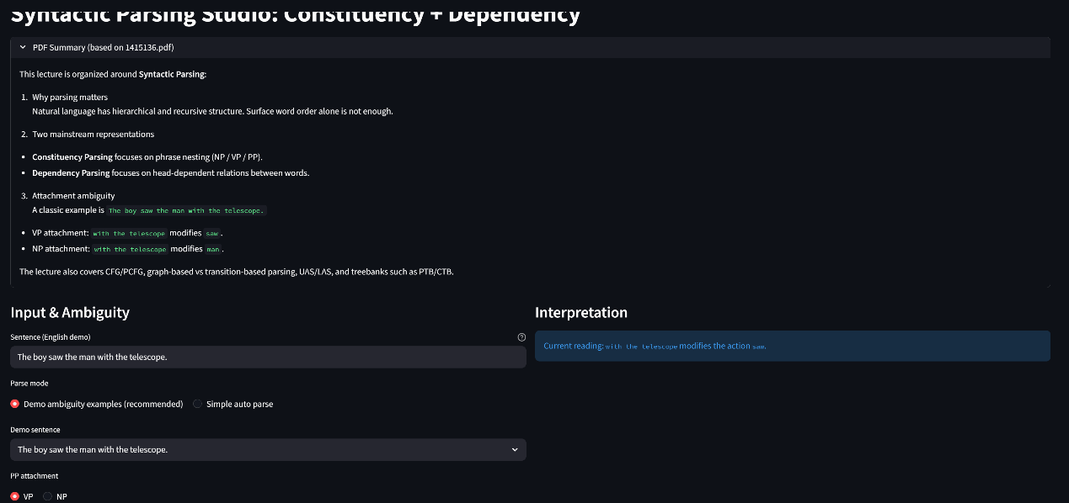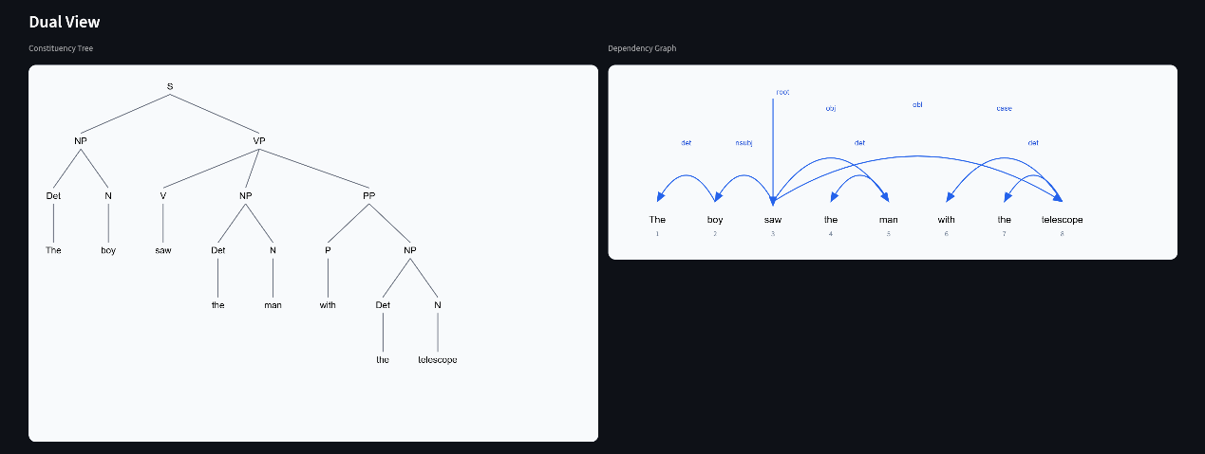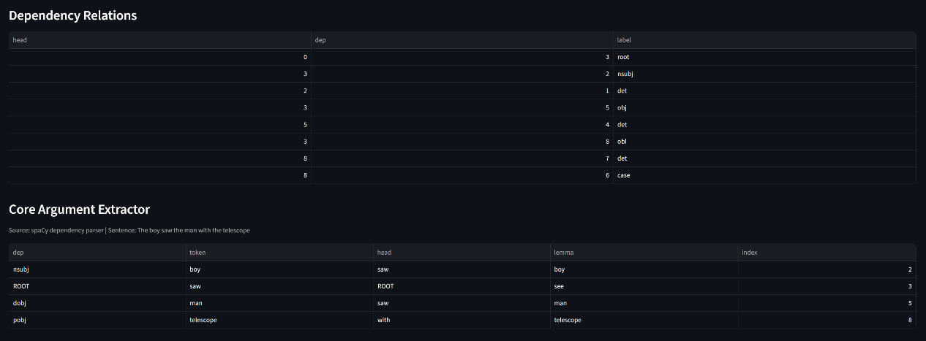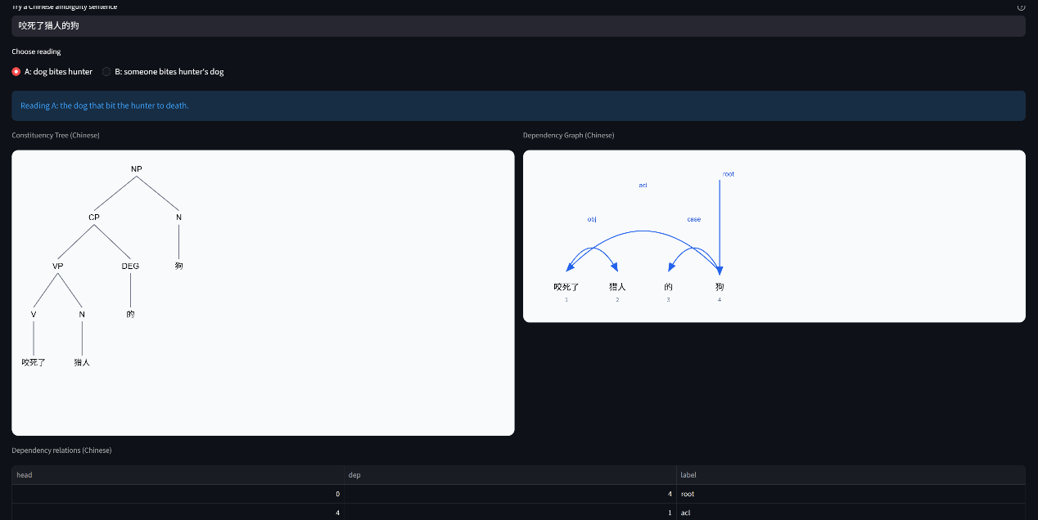

侦探报告：
“艰难决定”就是 PP 附着：把 with the telescope 挂到 VP(saw) 还是 NP(the man)。这一步直接决定语义。
如果按课件 P48 的 PCFG 思路，我会偏向“概率更高的那棵树”：
- 比较两种解析的规则概率乘积（如 VP -> VP PP vs NP -> NP PP 在语料里的统计偏好）。
- 在很多新闻/通用语料中，“动词 + with 工具”很常见，所以 VP 附着常更高分。
但若语料里“带望远镜的人”这类名词修饰更常见，NP 附着也可能胜出。
如果是 神经网络方法（BiLSTM/Transformer/图模型）：
- 它不只看局部规则，而是利用上下文、词向量和共现模式。
- saw + telescope 的“工具关系”语义关联很强，模型通常更容易给出 VP 附着。
- 但在缺少更长上下文时，本句本身仍然真歧义，模型只是“偏好”，不是绝对真值。
所以我偏向某种解释的根本原因是：模型在“统计先验 + 语义搭配”上给这条路径更高分，而不是句子本身唯一确定。

