## DIY Judge System

### Idea overview

Our first task is to **implement** a simple “**judge**” system which we will later **use** **to** **test** our **solutions**. Why not use the good old judge? Well he’s taken the week off and we still need a way to test our code. The idea is simple – **create a program which will read a text file** (your output for a given problem) and **compare** its **contents** to the contents of another text file (expected output for that problem), **if** the contents are **identical** then the files are identical and your **output is correct** and everything’s smooth. **If** the files **differ** in any way then an extra file called “**Mismatches.txt**” is **created** which **holds detailed information about the lines that do not match**. Let’s start off.

### Set up our Tester Class

Create a new Visual Project Solution and a new Console Application called “SimpleJudge”. In the SimpleJudge project **add** a **new** **class** called “**Tester**”. Mark it as **public static** class and **declare** a **new** **public static void** method called **CompareContent(string userOutputPath, string expectedOutputPath)**:

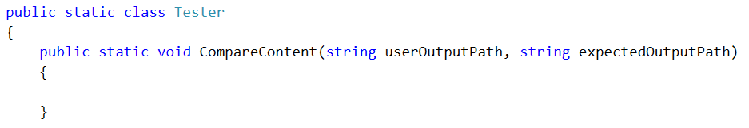

The idea here is that using **userOutputPath** and **expectedOutputPath** we can find the **files** **holding** the **user output** and **expected output respectively**, **read** the **user output** and **the expected output** and **compare** them **line by line** to see if they are identical.

As we mentioned above, however, we will also need a path to **create** the **Mismatches.txt** text file which will **hold** the **mismatches** (if any). In order to do that efficiently we can **use** the **expectedOutputPath** and simply **create** the **Mismatches.txt in the same folder**. How can we go about this? First we need to **extract the path** to the directory **of** the **expected output file**. We achieve this by creating a helper method:

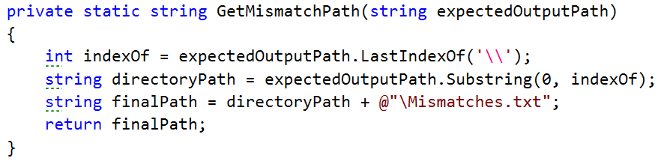

What this method does is simply **get the path** **to** the directory of the **expected** **output** **file** **by finding the index of the last ‘\’** in the path of the expected output file. For example if the path is *C:\OutputFiles\OddLinesExpectedOutput.txt* we **find** the **index** of the second **‘\’** (14 in our case) then we simply **get a substring of that path up until that index** and we end up with *C:\OutputFiles* which is the path to the directory of the output file. Then we finally **append** the **name of** our **file** **and** a **slash *“\Mismatches.txt”*** and we finally end up with a path looking something like this “*C:\OutputFiles\Mismatches.txt”*. You might wonder how come we use a path to a file that does not currently exist. We’ll get to that in a moment, but first let’s call out helper method up in our main method.

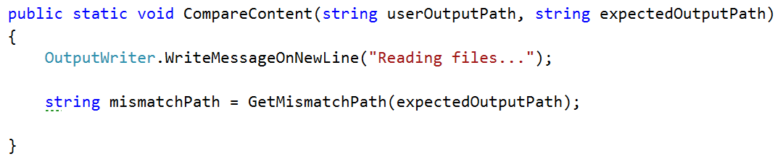

### Read from and create files

Next up we need to **read** the **two files** – the user output and the expected output. This is done again in just one line of code. We call the **File** class and invoke the **.ReadAllLines(string path)** method. However this time around we need a variable in which we can actually store the contents of the files we read from. The **File.ReadAllLines(string path)** function **returns a string array** so our code will look something like this:

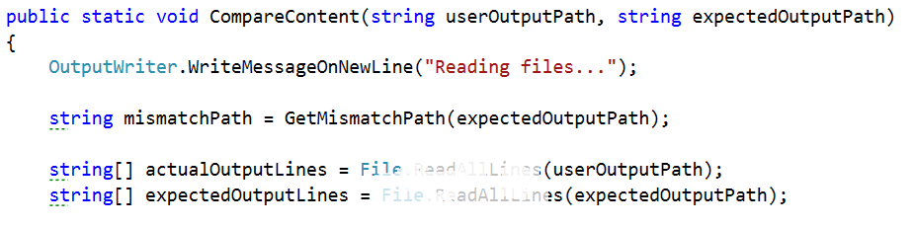

We end up with a variable input which holds all the **user output**, read from the user output text file line by line, and a variable called **expectedOutput** which holds the… expected output, again read from the expected output text file line by line. We are ready to start the **comparison of the two** **files**. The information we will need while comparing the files is whether there are any mismatches and also the result of the comparison of two corresponding lines. So we can **make** one **Boolean** for the **mismatches** **and** **one** **string** **array** called **mismatches** which **gets** it’s **value** **from** the **method** **GetLineWithPossibleMismatches** with it’s three parameters shown in the picture below:  
  
  
  
 We’ll get to the implementation of this method in a moment. First we need to finish the **CompareContent** method so that we can focus our attention on the other functionality waiting to be written.   
The last thing we can do **after** **all** the **checks** **for** **mismatches** is to **write** them **on** the **set** **output** **writer** **and** **in** the **mismatches.txt file** which is in the same folder as the first file given for comparison and that is done by the **PrintOutput** method. And finally print on the output writer that the files are read:

  
As you can see the **method for printing** the output of the comparison **takes** **3 parameters**, which are **related** **to** the **possible** **mismatches** We will discuss the implementation of this method after the previous one, so it is last on the queue now.

Finally the **CompareContent** method should look like something pretty similar to this:

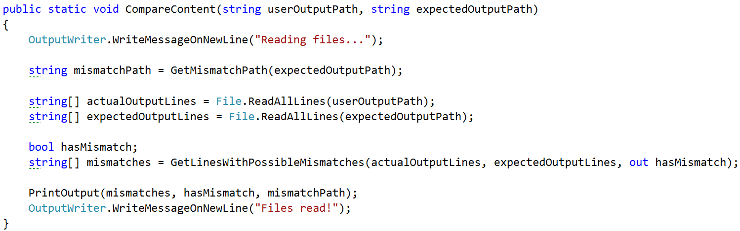

### Find mismatches of two files line by line

Since we are going to **compare** **two** **files**, and that is a separate task, we will use a separate **method** to do so. It’s **called** **GetLinesWithPossibleMismatches** and **takes** **three** **parameters** which are the **strings** **array** **from** the **first** **file**, the **string** **array** **from** the **second** **file** **and** an **out** **parameter** **for** whether there are any **mismatches**, **so** that the following **method** **can** **change** **a** **variable** **outside** **of it’s scope**. The method **returns** a **new** **string** **array** which **represents** the **result** **after** the **comparison** of each line.



Before we start the actual comparison and matching it’d be a good idea to **declare** **one** **helper** **variable** which will come into play a bit later. A **string** that has an **initial** **value** of an **empty** **string** and is later **used** **for** the line by line **comparison** **of** the **two** **output** **files** that are given for comparison. Another thing we might want to **set** is the **hasMismatch** **variable** to **false** and **only** **if** on some place **two** **lines** are found **with** a **difference** between them, the **hasMismatch** variable is **set** **to** **true** **and** the one that is **outside** of the method **will** **also** **be** **set** **to** **true**.



Now that we have that sorted out we can safely get to the actual comparison. How do we go about that? Well we will need a few things in order to do effective comparison and write down our mismatches. In order to **compare** the **lines** we can **simply** **run** a **single** **for** **loop** which iterates **through** both **user** **generated** output **and** the **expected** **output** **comparing** each **line** **at** **every** **iteration** and writes the result of each comparison in a new string array called mismatches which we create in after creating the two variable above.

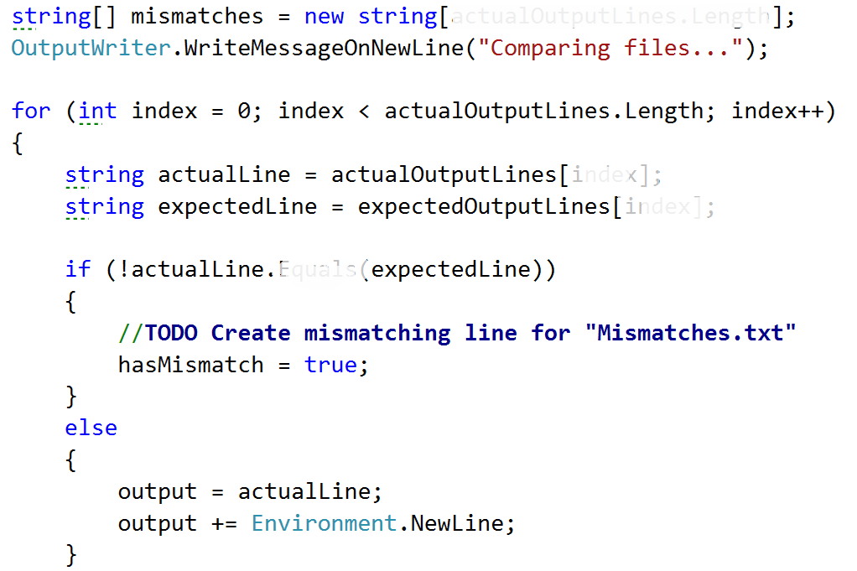

What’s going on here is pretty straightforward. We simply **iterate** **over** **all** the **lines** from both the files by **assigning** the **current** **line** **to** the **actual line** variable **and** the **expected** **line** **to** the **expectedItem** **and** **comparing** **them**. **If** they are **not** **matching** we **mark** **mismatch** as **true**, and we willset the output to the following message:



And after that append a new line like shown in the else clause in the code above

. **If** however we **don’t** **get** a **mismatch**, **if** the **lines** are **identical** then we simply **write** **down** the **line** in **Mismatches.txt**. Why? Well because **if** we get an eventual **mismatch** down the line or if we’ve gotten one already, it’ll be **easier** **to** **see** **where** **it** **occurred** **if** we also **have** the **rest** **of** the **text** written down. Finally, on **each** **iteration** you **put** the **output** **in** the **corresponding** **cell** **in** the **mismatches** **array** **and** **after** the **for** **loop** we should **return** the **mismatches** **array** and now we are sure to have the mismatches and also the **hasMismatch** **variable** **to** **be** **changed** **to** the **corresponding** **value**, because it’s an out parameter.

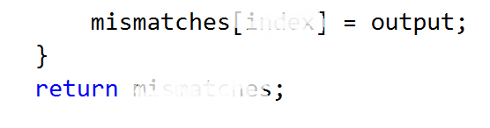  
Here is a final version of the GetLinesWithPossibleMismatches method:  
  
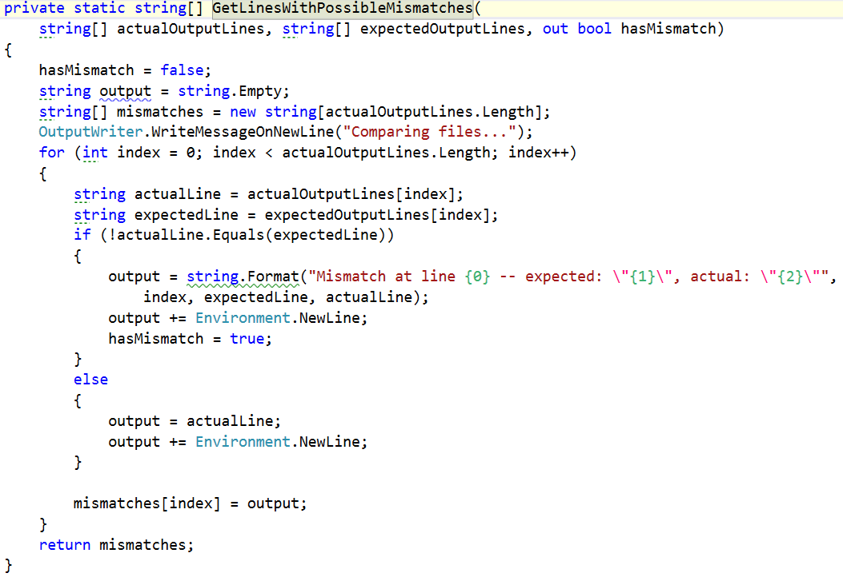

### Printing the data from the comparison to the output writer and to a mismatch file created.

We’ve gotten to the place where we need to **implement** the **PrintOutput** **method**. It **has** **3** **parameters** **in** it’s **declaration**. The **first** **one** is the **array** that we just generated **with** the **mismatches** from the previous method. The **second** **parameter** is whether there are **any** **mismatches** **and** the **third** **one** is the **path** **to** the **mismatches** **file**. All we have to do is **write** **all** **the** **lines** **from** the **mismatches** **on** the **output** **writer** **if** there **has** a **mismatch**, **append** all the **lines** **to** the **mismatch** **file** using the given path **and** **return** so that we exit the method. **If** the **hasMismatch** is **not** **true**, we do not enter in the body of the if and all we do is **write** a **message** **on** a **new** **line** which is the following:   
“Files are identical. There are no mismatches.”   
Here is a how the implementation of what we just described above, should look:

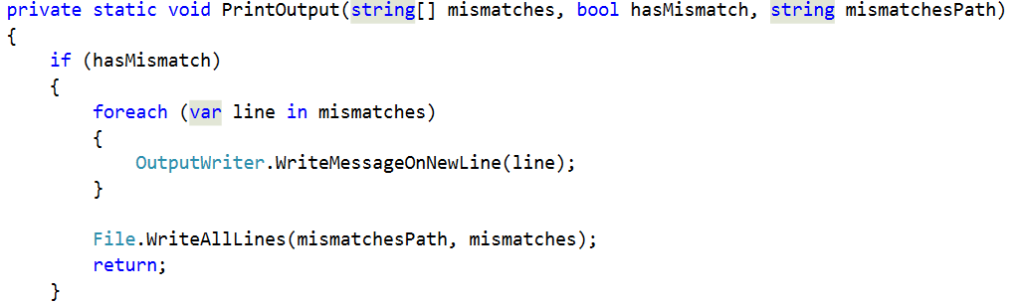

Now we should be ready for testing. You are given three files with the current story piece called **test1.txt, test2.txt, test3.txt**. **First** **compare** the **content** **of** **test1.txt**, **test2.txt**, see what log is written in the mismatches file (mismatch file should not be existing, because there are no mismatches) and **then** compare **test2.txt and test3.txt** and again see the mismatches file to see what has changed.  
  
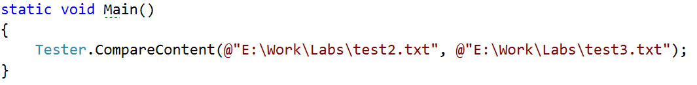

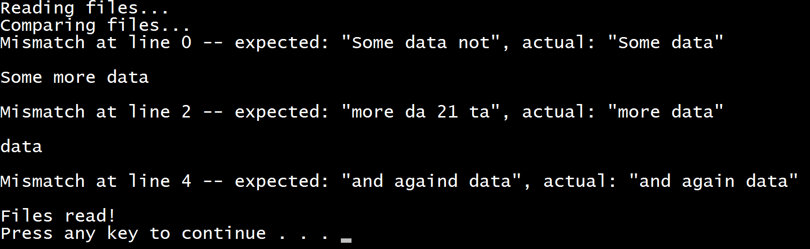

## Saving some data for our current session

The story doesn’t end here. We have to make some modifications to some existing classes and also add some new.

The first new class we are going to write will hold the data for the current session. For now our only purpose is to have a place where we can save out current location and then move using only relative paths.

So we make our public static class called **SessionData** and our only variable in it will be the **currentPath**, which starts with a value of, the application’s directory in the file system.

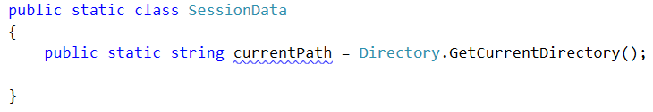

This variable can be very useful in the **IOManager**, because we can use it for different operations like **traversing the current folder**, **creating files** in the current folder, **moving up and down in the folder tree** and also as a starting point in order to navigate to the “resources” folder and **read the** **Database** from a **file** and not from the **console**…

We are going to go through each of these steps in big details so you would be able to understand how each component works.

So enough chit chat, let’s start extending the current classes we have.

## Making directories

First we are going to stop in the **IOManager** and make a method for making a directory. Since we have our **currentPath** in the **SessionData** class al we need is the name of the folder we are going to create.

Our method can be called **CreateDirectoryInCurrentFolder** (string <the name of the folder>) and it’s implementation should look like this.

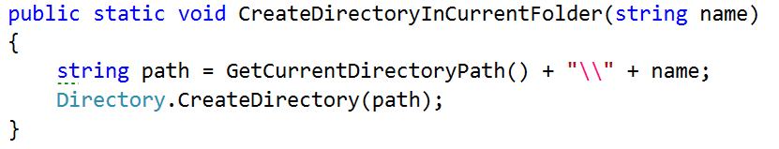

We use the method given fro the directory class, which takes an absolute an creates.

So now if we call it from the main method like this

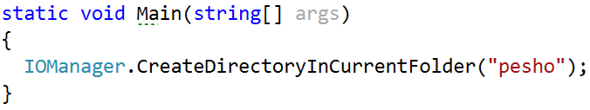

And since the folder that our application is currently running in the bin\Debug debug folder of the application, there a folder with a name “pesho” should be added.

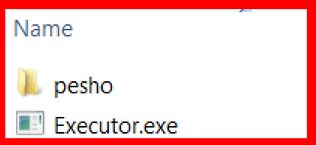

## Modifying the traversal

Now that we are done with that and since we now have some space where we can save the current folder, we are going to start our traversal method, using the current folder. All we have to do is **remove** the **string** **path** **argument** and also change it with **Session.currentPath**

Your traverse method should now start like this:

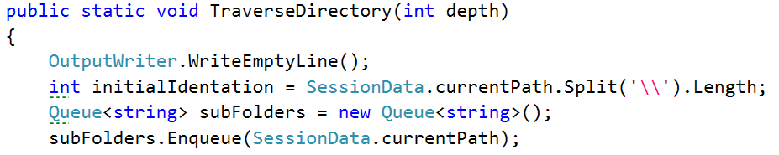

Try testing the functionality now!



If this is your result you’ve done your job well.

Another thing we might want to add to the current implementation of the traversal, the display of the files in the current folder. It is pretty similar to the adding of the subfolders. All we need is a **foreach** **loop** and to **use** the **Directory**.**GetFiles**(**path**) to get all the files and display them. The display of the files should be **between** the **display** **of** the **current** **path** **and** the **adding** **of** the **subfolders**.

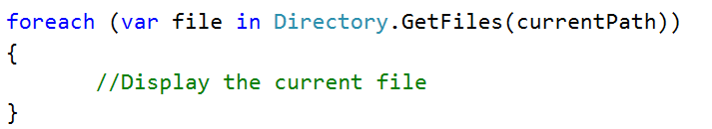

In order **to** **display** the **file**, we will **change** the **path** **to** the **given** **file** with **dashes**, because we can see the folder we are in on the line before the display of the files and this way we can focus on the file names.  
To get the whole path, we will get the index of the last ‘\’(backslash) and print a string with such a length of dashes, followed by the file name like shown below:

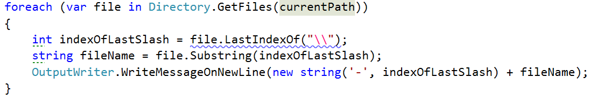and the output of traversal with depth 0 should now be similar to the given:

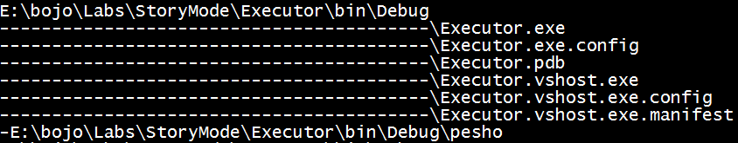

There is just one final piece of code we need to add to this method and it should be tip top. Bearing in mind that we added a parameter for the depth of the traversal, maybe we should **include** it as some kind of a **condition** in our code **so** that **it** **would** **be** **easier** **to** **know** **when** **to** **stop** **traversing** if we’ve gone deep enough and in order to check how deep we’ve gone, we can use the indentation variable that gives us exactly this. So after the assigning of a value to this variable, you can add the following line of code:  
  
 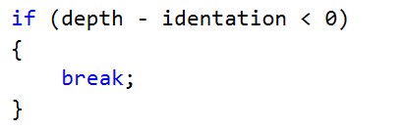

This way we are sure to **stop** the **traversal** **before** we **print** the **current** **folder**, **if** we’ve gone **deep** **enough**.

Now the question remains, how do we change the starting folder and can we do it with relative and absolute paths. Well we should be able to implement it and the only thing we should probably keep in mind is whether the given path exists.

## Changing directories

So again using the **IOManager**, we make two functions. One that moves forwards and backwards in the folders and one that gets an absolute path and goes directly there(***Note***: there are many machine specific things in the path if it is absolute).

**In** the **relative** **change** of **folder** **method**, we may won’t to check **if** the **user** would like to **go** **one** **folder** **back**, and the **command** for this **is** “**cdRel** **..”** in the command prompt, so we will use **“..”** for a string that **indicates** **that** **the** **user** **wants** **to** **go** **one** **folder** **up** **the** **file** **tree**. **If** he **wants** **to** **go** **into** one **folder**, the **string** for **path** should be the **current** **session** **path** **+** **‘\’ + the name of the folder** we want to enter. **Using** the **relative** **path** and the current path of the traverser, we can easily **create** an **absolute** **path** an by **using** the **method change for absolute path**, we can **reuse** the **check** whether the given path exists or not.

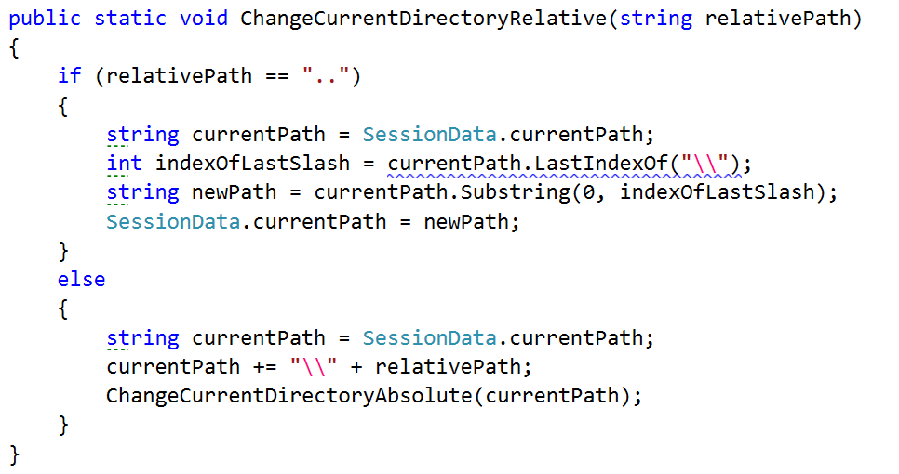

Note that for going to the previous path, we **take** the **last** **index** **of** the **backslash** which is right after the previous folder and after that we **take** a **substring** **from** **0** with the given **index** representing the **number** **of** **elements** before the backslash, so if we take that substring, we have the absolute path to the parent folder of the current one, so we take it as a current folder.  
However **if** the **command** **is** **not** “**..**”, but a path, we add **make** a **new** **absolute** **path** and **reuse** **some** **code** by calling the other method. This way we have less code duplicates in the two methods.

The change directory with absolute path method is actually not very complicated. All we do is **using** the **API** from the **Directory** **class**, **check** **whether** such a **path** **exists** in the operating system. **If** it **does** **not**, we **display** an **error** **message** for **invalid** **Path** which we should first add in the ExceptiionMessages class, called **InvalidPath** **and** a **message** containing the following text: “The folder/file you are trying to access at the current address, does not exist.” and after that **return** so that it can exit the method. **If** the **device** **has** a **folder** **with** **such** a **path**, it is **set** **to** the **currentPath** at the end of the method.

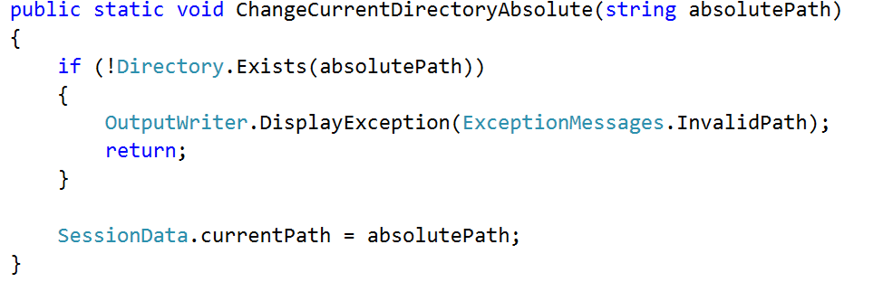

By now we should be ready with everything in the **IOManager** **class**, so we can test the whole functionality. Now you can **test** the **functionality** of everything we’ve written today and more specific the part with the **IOManager** and if there is something wrong with the whole picture, you may want to fix it, so that everything it according to the documents, for the next exercise.