Hiring Manager: “Hi Ivonne! Thanks for joining us today. Did you have any trouble with traffic on your way here?”
Ivonne: “Not at all! I planned for it, and everything went smoothly. I appreciate the warm welcome.”
Hiring Manager: “Fantastic! Alright, let’s get started. Could you give me an overview of your background and what drew you to embedded software engineering?”
Yes. Not a problem at all., thank you very much for giving me the opportunity to be interviewed for this position. My name is Ivonne Lemus I’m a Mechatronics Engineer. I specialised in Computing and Electronics and I have a Master’s degree in Mechatronics.

-In my first role as an Embedded Software Engineer at CIDESI, I was involved in several projects, including the modernization of the Mexico City urban railway system. During this project, I gained experience developing embedded software using C with a Real-Time Operating System (RTOS) and implemented control algorithms in C++ to manage the speed and acceleration of the driving system. Additionally, I analyzed analog electronic schematics to perform reverse engineering, conducted software testing directly on railway tracks, and provided troubleshooting support during system start-up to ensure proper functionality.

-At CIDEC, I gained over two years of experience as an Embedded Software Engineer, where I developed software components in C within the AUTOSAR architecture to monitor the temperature of the Electronic Control Unit (ECU) for Ford projects. These developments were according with the ASPICE process, covering the entire Software Development Life Cycle—from software requirements and architectural design to development, unit testing, integration testing, and validation—while adhering to established guidelines and Agile sprint methodologies.
I also performed debugging by identifying and resolving software issues through root cause analysis, using tools such as Ozone and the JTAG interface.

-Finally, at BorgWarner, I was responsible for verifying the integration of code changes and managing version control using tools such as Bitbucket, Git, GitHub, and Plastic. I ensured the correct startup of both the bootloader and application by validating part numbers and performing testing with CANoe and CANalyzer. Additionally, I had the opportunity to collaborate with a global cross-functional team to develop customized solutions aligned with specific software requirements.

Yes. Not a problem at all., thank you very much for giving me the opportunity to be interviewed for this position. My name is Ivonne Lemus I’m a Mechatronics Engineer.

Yes, not a problem at all. Thank you very much for the opportunity to interview for this position.
My name is Ivonne Lemus, and I am a Mechatronics Engineer. I’ve been involved with embedded systems since my time at university, where I developed software using C and assembly language. Then, I studied a Master's degree at CIDESI, during which I designed an FPGA architecture to read Hall sensor signals from an inspection robot.
In the final semester of my Master's program, I was hired by CIDESI and had the opportunity to contribute to the modernization of the Mexico City urban railway system. In that project, I gained hands-on experience developing embedded software in C using a Real-Time Operating System (RTOS), and I implemented control algorithms in C++ to manage speed and acceleration. I also performed reverse engineering by analyzing analog schematics to understand the system’s logic. Additionally, I developed embedded C software compliant with DO-178 standards (Development Assurance Level E) to control the speed of an inspection robot used in fuel jet pipeline.
Afterward, I joined CIDEC, an automotive company, where I developed embedded software in C following the AUTOSAR architecture. I participated in all stages of the software development life cycle—from requirements definition to unit testing and integration. I used debugging tools such as Ozone and JTAG to identify and resolve software issues. My work their supported projects for clients such as Ford.
My last position was, at BorgWarner, where I was responsible for verifying code integration and managing version control using tools like Bitbucket, Git, GitHub, and Plastic SCM. I also validate bootloader and application startup by verifying part numbers and conducting tests with CAN protocol.

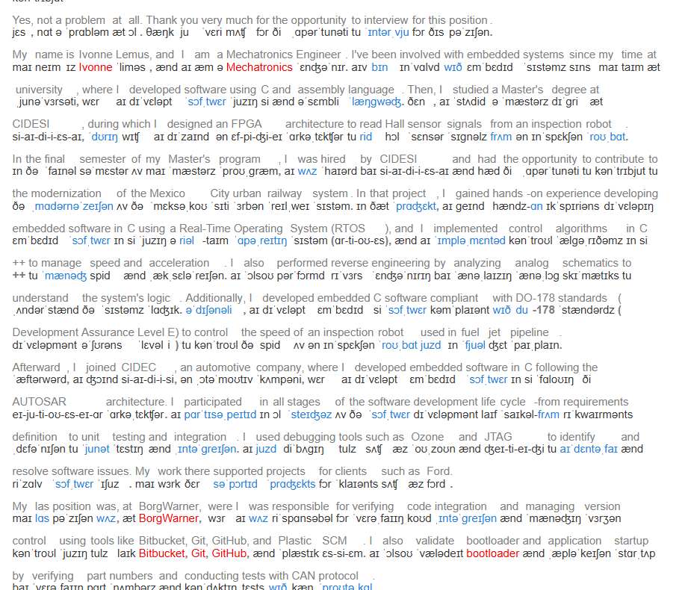

Development Assurance Level (DAL) | Failure Condition | Number of Objectives | Number of Objectives with Independence
A | Catastrophic failure condition for the aircraft — potentially fatal injuries and loss of aircraft airworthiness | 71 | 30
B | Hazardous or severe failure condition — multiple injuries or fatalities possible, significantly impacts crew or performance of aircraft | 69 | 18
C | Major failure condition — passenger discomfort or minor injury, significant action is required by crew, and safety margins are reduced | 62 | 5
D | Minor failure condition — slightly reduces safety margins, slightly increases crew workload, and causes minor passenger inconvenience, including flight plan change | 26 | 2
E | No safety effect — no impact on aircraft operation, safety, or crew workload | 0 | 0

- The software planning process defines and coordinates the activities of the software development and integral processes for a project.
- The software development processes produce the software product.
- The integral processes ensure the correctness, control, and confidence of the software life cycle processes and their outputs. The integral processes are:
  - Software verification
  - Software configuration management
  - Software quality assurance
  - Software liaison

What´s your work authorization status for United States?
I am legally authorized to work in the USA

Well, I have all my documents in to obtain my TN VISA. I can handle the process myself. I do not need sponsorship.
The only thing I need to complete the visa process is a job offer letter. If you provide me with one, all my documentation will be in order. Then, within 2 weeks I will be ready to start working for your company.

TN Visas are for Mexican and Canadian graduate engineers that want to work in the USA. It is part of the North American Free Trade Agreement, so no sponsorship is required to get this visa, ever. The only thing I need to complete the visa process is a job offer letter. If you provide me with one, all my documentation will be in order. Then, within 2 weeks I will be ready to start working for your company. (Note: No sponsorship is needed. All I need is a Job offer letter).
Visit the US Embassy Website for more info: https://mx.usembassy.gov/es/visas-es/nafta/

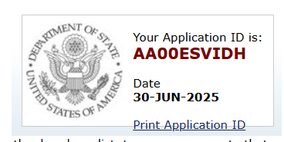
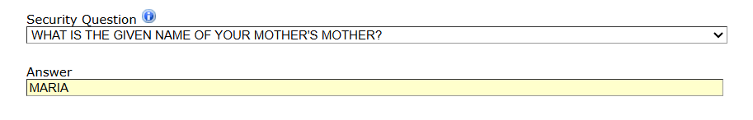
- What is your biggest strength?
"My biggest strength lies in my problem-solving abilities and technical expertise in embedded systems. Because I more focus on how the this work, specialy in technological products, for example a celphone, how does it works, how you can manage the communication or devices controlled by voice. How the devices get the signals. For example in CIDESI I solve issues durig the railway system update in real condition. I debug the software during the testing.

Throughout my career, I've consistently demonstrated a passion for finding innovative solutions to complex challenges. Because I am more focus on how the thingks work, that’s the reason I studied mechatronics, becase

For instance, at CIDEC, I optimized software development by 80% through precise requirement specification and adherence to Agile methodologies.
Additionally, my deep understanding of AUTOSAR, ECU architecture, and software development processes (as highlighted in my experience at CIDEC) enables me to efficiently navigate and deliver projects within tight deadlines. I'm confident in my ability to contribute significantly to your team's success by leveraging these strengths to tackle challenging tasks and drive project outcomes."

My biggest strength lies in my problem-solving skills and technical expertise in embedded systems. I have a strong curiosity about how things work, especially technological products like cell phones — how they process signals, enable communication, or respond to voice commands. This curiosity drives me to understand and improve the systems behind them. For example, at CIDESI, I helped resolve issues during a real-time railway system update. I was responsible for debugging the software during field testing to ensure everything functioned correctly.

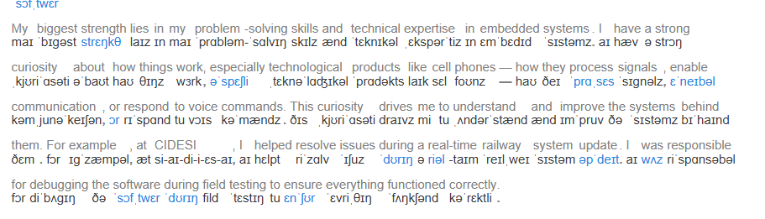

What’s you biggest weakness?
I’m a perfectionist person, who always sets high standards in everything I do, however I sometimes invest too much time in small details when isn’t necessary, for this reason I’ve created a check list which helps me to prioritize the essential specifications of my assignments, finishing them properly and on time.

How do you handle pressure?
I understand that pressure is part of the job, and I actually perform very well under it.
For example, in my previous role at CIDESI, I participated in a project to develop a system that monitors and controls key parameters of the Mexico City Metro, such as speed and acceleration. During testing, we discovered that the system wasn’t working correctly. At that moment, the entire team was on board the subway, and we needed to solve the issue immediately because another train was approaching, making it unsafe to stay there for long.
I was under significant pressure, as I had to modify some lines of the main code quickly, but there wasn’t much time to do it. Fortunately, I documented flowcharts of the entire software system. Thanks to that preparation, I was able to execute the necessary modifications efficiently, safely, and on time.

4.- Why should we hire you instead of someone else?
R= You should hire me because I’ll learn the job quickly and I’ll start contributing to the team as fast as possible. As a matter of fact, I believe I have the necessary skills and attributes to perform the job.
8.- What would you do if you didn’t get along with someone in your team?
I don’t like conflict at all, but I would handle the situation with the goal of resolving it quickly and peacefully. I always conduct myself professionally and do everything I can to collaborate effectively and maintain good relationships with everyone as a committed team member.

17.- Think about a specific moment in your professional life in which you have committed a mistake. How did you solve it?

In my first weeks working at CIDEC, I had to update some code. I made my changes and integrated them into the overall project, but others software engineer noticed that due to the changes I uploaded, the project didn’t compile. So, I rolled back my changes, corrected them, ensured that the project compiled, and then integrated them again. Since then, I have developed a checklist of crucial steps to guarantee the proper functioning of the program, which includes the compilation phase. This is now the process I employ across all my projects.
How familiar are you with the AUTOSAR architecture, standards, and tools? Can you describe a specific project where you applied AUTOSAR principles?
Answer "I have a solid understanding of the AUTOSAR architecture, standards, and tools. During my time at CIDEC, I was involved in a project where I generated over 50 code templates for an Electronic Control Unit (ECU) in accordance with the AUTOSAR standard. I used the Davinci tool to configure the templates and ensured they adhered to the specified requirements. This experience provided me with a deep understanding of the AUTOSAR methodology and its practical application in embedded software development."

