ivy_mooncake Technical White Paper
目录
Ivy_mooncake技术白皮书 1
一、 产品定位 1
二、 应用场景 2
三、 产品特点 3
四、 技术架构 4
五、 部署形态 6
六、 Roadmap 7

1. Product Positioning
ivy_mooncake is a Postgres real-time analytics extension that delivers sub-second data freshness, targets open lakehouse formats, and provides end-to-end support for both PostgreSQL native types and IvorySQL Oracle-compatible types.

- In-database columnstore mirror + real-time CDC synchronization, for more efficient mixed transactional/analytical workloads, with no ETL data movement.
- DuckDB columnar vectorized execution engine for high-performance OLAP.
- Apache Iceberg open-format persistence, free of format lock-in.
- End-to-end support for IvorySQL Oracle-compatible types, enabling real-time analytics after Oracle migration.
- Supports both PostgreSQL native types and Oracle-compatible types.

ivy_mooncake is a Postgres real-time analytics extension built for multi-core real-time analytics with extreme columnar performance, open-lakehouse data interoperability, and end-to-end type compatibility for Oracle migration — fully open and friendly, and co-built with community partners.
ivy_mooncake is the IvorySQL distribution of pg_mooncake. It deeply integrates IvorySQL's engineering expertise in Oracle compatibility with DuckDB's R&D experience in real-time columnar analytics, and continuously builds competitive features around enterprise-grade migration and near-real-time analytics scenarios.

Use Cases
- Near-real-time operational analytics
Hybrid scenarios with high write throughput, low-latency visibility, and a balance of OLTP-dominant transactions and analytics demand. Examples include e-commerce operations dashboards, financial risk control, O2O real-time dispatching, and telecom CRM/billing reports. The business database handles transactions as usual while the columnstore mirror handles aggregation queries; dashboards and decisions read sub-second fresh data, and the analytical workload does not contend for resources with row-store transactions.

- Real-time analytics after Oracle migration
Core systems in finance, government/enterprise, and telecom migrated from Oracle to IvorySQL whose business tables heavily use Oracle-specific types (DATE, NUMBER, RAW, etc.), needing to preserve Oracle semantics while connecting to modern analytics and lakehouse. Business tables containing Oracle types are mirrored directly to Iceberg via CDC and consumed by downstream engines, with compatible-type semantics preserved end to end, closing the post-migration analytics gap.

- Open lakehouse federated analytics
Scenarios where data is scattered across object storage (S3/OSS), existing Iceberg warehouses, and Postgres business databases, requiring a single entry point for ad-hoc read-only analytics while avoiding new engines and format lock-in. In simplified mode (ivy_duckdb only), IvorySQL serves as a query entry point that reads Parquet/CSV/Iceberg directly, performing cross-source federated queries over existing data lakes with a short path and no background process.

- IoT and time-series append-only data
In scenarios such as industrial monitoring, connected vehicles, and smart cities, there are many sensor devices with high sampling rates, data is written mostly via append, and writes and analytics are equally important. High-frequency appends are continuously landed as columnar Iceberg via CDC; row store handles real-time point lookups and latest state, while the columnstore mirror handles scans and aggregations over massive history.

Product Features
Compared with the generic "transactional database + external data warehouse" approach, ivy_mooncake offers the following key features:

- High-performance columnar analytics
- DuckDB columnar, vectorized execution engine that performs parallel scans and aggregations across multiple cores.
- The mirror is landed as Apache Iceberg / Parquet columnar storage, giving analytical scans an order-of-magnitude advantage over row store.
- The analytical workload runs on the columnstore mirror, physically isolated from the row-store transactional workload, so they do not contend for resources.

- Real-time, ETL-free latency
- moonlink reads WAL through a logical replication slot for persistent storage.
- Decode → Arrow columnar → Iceberg writer continuously land data, so the mirror follows source-table updates in real time.

- Open lakehouse format
- The mirror is stored in the Apache Iceberg open format, free of format lock-in.
- Integrated as a PostgreSQL extension, natively fused with the Postgres privilege, connection, and tooling ecosystem, with no new query language.

- Oracle compatibility (based on IvorySQL)
- End-to-end support for IvorySQL Oracle-compatible types.
- Supports both PostgreSQL native data types and Oracle-compatible types.

Technical Architecture
ivy_mooncake is an in-process extension system within Postgres and introduces no separate data-warehouse service node. In this architecture, business data still resides in Postgres row-store tables; data changes are captured in real time by the moonlink background process through a logical replication slot and mirrored in columnar format to an Iceberg warehouse; analytical tasks are pushed down to the in-process DuckDB engine and executed via columnar vectorized scans, achieving fast response for analytical workloads. Meanwhile, the mirror is landed in the Apache Iceberg open format, which both guarantees openness for external engines to read the data and supports horizontal scaling of the read path.

ivy_mooncake is organized along two data paths, read and write, and supports two deployment forms: the full edition (including ivy_moonlink) and the simplified edition (pg_duckdb read-only). Its logical architecture is shown below.
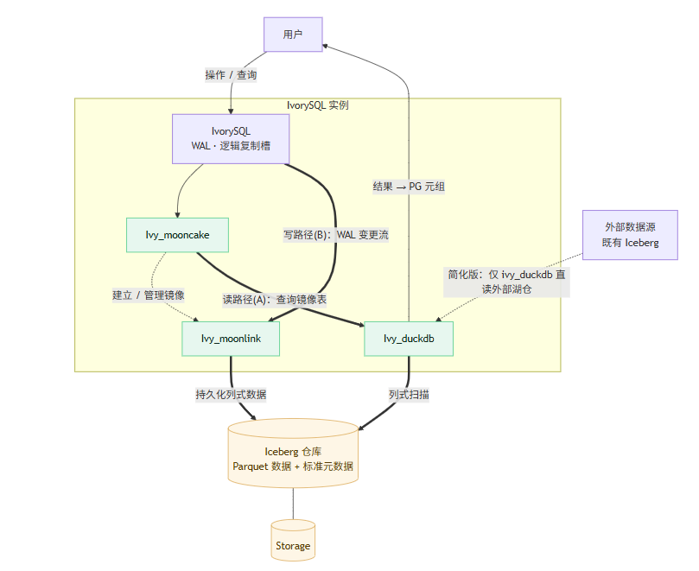
Name | Description
IvorySQL kernel | The business database kernel (IvorySQL / Postgres). It stores business data in row-store tables, handles online transactions, produces WAL logs, and provides a change stream to downstream via logical replication slots; in Oracle compatibility mode it provides Oracle syntax and type support.
Ivy_mooncake | The extension entry module. It registers the mooncake table access method (USING mooncake) and drives moonlink to create and manage columnstore mirrors; it is the unified entry point for users to operate on mirror tables.
Ivy_moonlink | The real-time CDC module (a Rust background process, Background Worker). It reads WAL through a logical replication slot, pulls table schemas, and decodes and persists changes.
Ivy_duckdb | The analytics execution module. It translates the Postgres plan tree into a DuckDB plan, invokes the in-process DuckDB engine to scan the Iceberg mirror, and performs bidirectional type mapping between PG and DuckDB.
Iceberg warehouse | Persistent storage for the columnstore mirror (Apache Iceberg open format: Parquet data + standard metadata).

Deployment Forms
ivy_mooncake supports two deployment forms: the full edition and the simplified edition.

Common Concepts

- Full edition
The full edition refers to deploying ivy_mooncake + ivy_duckdb + the ivy_moonlink background process together. It supports mirroring Postgres tables to Iceberg in real time and accelerating analytics with DuckDB.

- Simplified edition
The simplified edition refers to deploying only ivy_duckdb. There is no ivy_moonlink background process and no writing to Iceberg; it performs read-only federated analytics over external Iceberg or PG tables only.

- Background process
The background process refers to the ivy_moonlink CDC engine, which handles the write path. Whether it is registered is controlled by the GUC parameter pg_mooncake.enable_bgworker (takes effect after restart); turning it off degrades to simplified-edition capability.

- Columnstore mirror
A columnstore mirror is an Iceberg-format table created with the USING mooncake access method and synchronized in real time with the source row-store table via CDC.

See the table below for an overview of the full and simplified deployment forms:
Dimension | Full edition | Simplified edition (ivy_duckdb only)
Extension set | Ivy_mooncake,ivy_duckdb | ivy_duckdb
Background process | Required (moonlink_service) | Not required
Persist to Iceberg | Supported | Not supported (read-only over existing Iceberg/PG row store)
Primary use | OLAP mirror, near-real-time analytics | Read-only analytics
Deployment footprint | Larger | Smaller

Roadmap
- Integrate cloud storage (S3, R2) and the Iceberg REST catalog
- Secondary indexes on columnstore tables (full-text index, vector index)

