Conditioning and Non-Convexity of Semantic Decoding by Inversion of Deep Brain Encoding Models

Submitted in partial fulfillment of the requirements for the degree of

Bachelor of Technology
in
Electronics and Communication Engineering (specialisation in Biomedical Engineering)

by
ABHRANIL SARKAR (23BML0077)
TANISHA CHOUDHURI (23BML0081)

Under the guidance of Dr. Sharmila Nageswaran
School of Electronics Engineering (SENSE), VIT, Vellore.



October, 2026

DECLARATION

We hereby declare that the thesis entitled “Conditioning and Non-Convexity of Semantic Decoding by Inversion of Deep Brain Encoding Models” submitted by us, for the award of the degree of Bachelor of Technology in Electronics and Communication Engineering (specialisation in Biomedical Engineering) to VIT is a record of bonafide work carried out by us under the supervision of Dr. Sharmila Nageswaran.
We further declare that the work reported in this thesis has not been submitted previously to this institute or anywhere for the consideration of the degree/diploma.

Place : Vellore Date :
Signature of the Candidates
CERTIFICATE

This is to certify that the thesis entitled “Conditioning and Non-Convexity of Semantic Decoding by Inversion of Deep Brain Encoding Models” submitted by Abhranil Sarkar (23BML0077) and Tanisha Choudhuri (23BML0081), School of Electronics Engineering (SENSE), VIT, for the award of the degree of Bachelor of Technology in Electronics and Communication Engineering (specialisation in Biomedical Engineering), is a record of bonafide work carried out by them under my supervision during the period July 2026 to October 2026, as per the VIT code of academic and research ethics.

The contents of this report have not been submitted either in part or in full, for the award of any other degree or diploma in this institute or any other institute or university. The thesis fulfills the requirements and regulations of the University and in my opinion meets the necessary standards for submission.

Place : Vellore
Date : Signature of the Guide

Internal Examiner

ACKNOWLEDGEMENTS
We express our sincere gratitude to our guide, Dr. Sharmila Nageswaran, Associate Professor, School of Electronics Engineering (SENSE), VIT Vellore, for her guidance, encouragement and critical feedback at every stage of this project.
We thank the Dean and the Head of the Department, School of Electronics Engineering, and the members of the review panels for their suggestions, which shaped the final form of this work, in particular the questions on the data behind the TRIBE v2 model and on the choice of fMRI over EEG.
We thank Meta FAIR for releasing the TRIBE v2 model and code openly, the authors of the LeBel et al. natural-language fMRI dataset for making their data public on OpenNeuro, and the developers of the open-source tools on which this work depends.
Finally, we thank our families and friends for their constant support.

Abhranil Sarkar Tanisha Choudhuri
Executive Summary

Brain encoding models now predict fMRI responses to natural stimuli with high accuracy, and decoding meaning from brain activity is often assumed to follow. This project tests that assumption directly by inverting TRIBE v2, Meta's open-weight 177-million-parameter trimodal brain encoder, by gradient descent on its 1 152-dimensional stimulus representation. A differentiable entry point after feature aggregation was identified, and the inverse was characterised with exact synthetic ground truth and then on real fMRI from a held-out story (LeBel et al., 2023). Encoding error fell 28.4-fold while recovery saturated at cosine 0.944. Equally good fits from different starting points disagreed (minimum pairwise cosine 0.817), and forward-only tests showed barriers between solutions rather than a null space: the inverse is non-convex and its errors lie in the operator's least-sensitive directions. Across six cortical networks, the most responsive (visual) was the hardest to decode from and the least responsive (somatomotor) the easiest. On real fMRI, inversion identified the heard segment in 4 of 5 cases among 45 (chance 2.2%) while recovering little of the representation (cosine 0.02). Encoding accuracy does not certify decoding: recoverability must be measured.
CONTENTS
1. INTRODUCTION 1
1.1 Literature Review 1
1.2 Research Gap 2
1.3 Problem Statement 3
2. RESEARCH OBJECTIVE 4
3. RELEVANCE OF PROBLEM STATEMENT W.R.T SDG 5
4. PROPOSED SYSTEM 6
4.1 Design Approach / Materials & Methods 6
4.1.1 The forward operator: TRIBE v2 6
4.1.2 What TRIBE v2 was trained on 6
4.1.3 Why fMRI and not EEG 7
4.1.4 Inversion method 8
4.2 Codes and Standards 9
4.3 Constraints, Alternatives and Tradeoffs 9
5. PROJECT DESCRIPTION 10
5.1 Instrumentation of the encoder 10
5.2 Synthetic evaluation with exact ground truth 10
5.3 Discriminating the causes of incomplete recovery 10
5.4 Regional analysis 10
5.5 Real-fMRI validation 11
6. HARDWARE/SOFTWARE TOOLS USED 12
7. SCHEDULE AND MILESTONES 13
8. RESULT ANALYSIS 14
8.1 Encoding accuracy does not certify decoding 14
8.2 Equally good fits give different answers 14
8.3 Barriers, not a null space 15
8.4 Errors lie in the operator's weakest directions 16
8.5 Further conditioning results 17
8.6 Predictable is not recoverable, region by region 19
8.7 Real fMRI 21
8.8 Discussion 22
9. CONCLUSION 24
9.1 Obtained Results 24
9.2 Future improvement/work 24
9.3 Individual contribution from team members 25
10. SOCIAL AND ENVIRONMENTAL IMPACT 26
11. COST ANALYSIS 27
12. PROJECT OUTCOME PUBLICATION/PATENT 28
13. REFERENCES 29
APPENDIX A: CODE AND REPRODUCTION 32
LIST OF FIGURES
Figure 4.1: Inversion pipeline: the network is re-entered after feature aggregation; only the representation x is optimised, the network stays frozen 6
Figure 8.1: Encoding error against recovery cosine across independent step budgets 14
Figure 8.2: Agreement among fit-matched solutions across four ground truths (left) and fit versus recovery per initialisation (right) 15
Figure 8.3: Left: prediction error along the straight line between fit-matched blind solutions (blue, ten pairs) and from the best blind solution to the near-truth solution (orange). Right: final error and recovery for each of the eight starts 16
Figure 8.4: Directional sensitivity of the operator in the original run: solution-difference directions against 200 random directions (the corrected pair gives 2.1×) 17
Figure 8.5: Output change under rescaling of the ground truth relative to the optimiser's noise floor 17
Figure 8.6: Recovery, relative error and retrieval against measurement noise 18
Figure 8.7: Recovery against the number of observed cortical vertices 18
Figure 8.8: Effect of ℓ₂ and temporal-smoothness priors in the under-determined regime (500 vertices) 18
Figure 8.9: Gradient inversion against the best ridge decoder 19
Figure 8.10: The six anatomical networks on the inflated fsaverage5 surface 20
Figure 8.11: Forward-sensitivity share of the text-, audio- and video-derived dimensions across cortex 20
Figure 8.12: Recovery from each network versus size-matched random vertex sets 20
Figure 8.13: Forward sensitivity against recoverability across networks 21
Figure 8.14: Participation ratio of each network's responses against size-matched controls 21
Figure 8.15: Real fMRI, held-out story: alignment (A), encoding accuracy by network (B) and identification accuracy (C) 22
LIST OF TABLES
Table 1.1: Summary of the literature most relevant to this project 2
Table 1.2: Novelty: closest prior work against the four properties combined here (● yes, ○ no) 3
Table 3.1: Mapping to specific SDG targets 5
Table 4.1: TRIBE v2 training data: who was scanned and what they were exposed to 7
Table 4.2: TRIBE v2 evaluation data (never used for training) 7
Table 4.3: fMRI versus EEG for this project 8
Table 4.4: Standards and frameworks the project follows 9
Table 4.5: Constraints and the trade-offs adopted 9
Table 6.1: Hardware and software 12
Table 7.1: Schedule and milestones 13
Table 8.1: Encoding error and recovery across optimisation budgets 14
Table 8.2: Agreement among fit-matched solutions, four ground truths, 14 000 steps 15
Table 8.3: Straight-path barrier between fit-matched blind solutions (ground truth 0, 14 000 steps) 16
Table 8.4: Further characterisation of the inverse (whole cortex unless stated) 19
Table 8.5: Network sensitivity and recoverability (synthetic, 8 000 steps) 21
Table 8.6: Real-fMRI validation, held-out story wheretheressmoke (UTS03) 22
Table 9.1: Individual contributions 25
Table 11.1: Estimated and incurred cost 27
Table A.1: Map from report results to code 32
LIST OF ABBREVIATIONS
BCI Brain–Computer Interface
BIDS Brain Imaging Data Structure
BOLD Blood-Oxygen-Level-Dependent (signal)
CER Character Error Rate
CNeuroMod Courtois Project on Neuronal Modelling
DMN Default Mode Network
EEG Electroencephalography
FAIR Findable, Accessible, Interoperable, Reusable
fMRI functional Magnetic Resonance Imaging
GPU Graphics Processing Unit
HCP Human Connectome Project
HRF Haemodynamic Response Function
IEM Inverted Encoding Model
LLM Large Language Model
MEG Magnetoencephalography
MNI Montreal Neurological Institute (template space)
MSE Mean Squared Error
PR Participation Ratio
ROI Region of Interest
SDG Sustainable Development Goal
TR Repetition Time
TRIBE TRImodal Brain Encoder
WK / WP Knowledge profile / Problem attribute (Washington Accord)
SYMBOLS AND NOTATIONS
x Aggregated stimulus representation, x ∈ ℝ^(T×H), T = 32 (synthetic) or 200 (real), H = 1 152
x̂ Representation recovered by inversion
f(·) Frozen TRIBE v2 forward operator from x to predicted fMRI
y Observed or target cortical response, y ∈ ℝ^(V×T′), V = 20 484, T′ = 100
d Difference between two fit-matched solutions
s(v) Directional sensitivity of f along unit direction v
ε Finite-difference step size
λ Regularisation weight
r Pearson correlation coefficient
α Gain (rescaling) factor applied to x

1. INTRODUCTION
A brain encoding model predicts the brain response that a stimulus evokes; decoding runs the other way, from measured brain activity back to the stimulus. For fifteen years the dominant route to decoding has been through encoding: fit a forward model, then identify or reconstruct the stimulus whose predicted response best matches what was measured [1], [2]. Encoding models have since grown from linear maps on hand-built features [3], [4] to deep networks trained on hundreds of hours of fMRI, and their accuracy keeps improving with model size and data [5], [6].
Decoding meaning from non-invasive brain recordings matters clinically. Amyotrophic lateral sclerosis, brainstem stroke, locked-in syndrome and severe aphasia can leave comprehension intact while removing speech and writing. A non-invasive decoder would restore a communication channel without neurosurgery. It also raises ethical questions of mental privacy, so the limits of what can be decoded matter as much as the successes.
This project asks a question that the field has largely skipped: when an encoder becomes very accurate, does it become invertible? A forward model can be highly predictive and still have an inverse that is non-unique or unstable [7], [8]. The question became answerable in 2026, when Meta released TRIBE v2, an open-weight foundation encoder that predicts fMRI at 20 484 cortical locations from video, audio and language [6].

1.1 Literature Review
Encoding models. Mitchell et al. predicted fMRI responses to nouns from word co-occurrence statistics [3]; Huth et al. mapped semantic selectivity across the whole cortex during natural speech [4]; and Antonello et al. showed that encoding accuracy with language-model features rises log-linearly with model size [5]. TRIBE won the Algonauts 2025 challenge [9], [10] and TRIBE v2 extends it to a foundation model trained on 451.6 h of fMRI and evaluated on 1 117.7 h from 720 subjects [6].
Decoding. Kay et al. identified which image a person was viewing by comparing measured responses with responses predicted for candidate images [2]. Tang et al. reconstructed continuous language from fMRI by searching word sequences with a language model and scoring them with an encoder [11]. With MEG and EEG, contrastive decoders identify perceived speech segments [12], and Brain2Qwerty decoded typed sentences with a 32% character error rate from MEG but 67% from EEG with the same architecture [13]. Shared-subject models reduce the data each subject needs for image reconstruction [14]. All of these evaluate decoding by proxies such as rank, retrieval or word error, because the true representation behind real fMRI is unknown.
Inverting encoders. Inverted encoding models reconstruct channel responses from voxel patterns [15]. Gardner and Liu proved that such linear models recover the stimulus only up to an invertible linear transform [16]. In computer vision, inverting deep networks from their activations shows which information each layer keeps [17]. Two 2026 follow-ups use TRIBE v2: Bladon and Bent optimise inputs to maximise a region's predicted response (feature visualisation) [18], and Benchetrit et al. use TRIBE v2 forwards to synthesise training data for image decoders [19].
Table 1.1: Summary of the literature most relevant to this project
Work | Contribution | Limitation relevant here
Mitchell et al., 2008 | Linear model predicts fMRI for unseen nouns | Single words, hand-built features
Kay et al., 2008 | Identifies viewed images via predicted responses | Identification, not recovery
Naselaris et al., 2011 | Encoding models as the route to decoding | Assumes invertibility
Huth et al., 2016 | Semantic maps across cortex from natural speech | Linear; no inverse analysis
Antonello et al., 2023 | Encoding accuracy scales with model size | Scaling shown for encoding only
Tang et al., 2023 | Continuous language from fMRI via LM search | Per-subject decoder; search, not inversion
Gardner & Liu, 2019 | Linear IEMs identifiable only up to a transform | Linear models only
Lévy et al., 2025 | Typed sentences from MEG (CER 32%) and EEG (67%) | Shows EEG's limits for language
d'Ascoli et al., 2026 (TRIBE v2) | Open foundation encoder, 720 subjects | Encoder only; inverse never studied
Bladon & Bent; Benchetrit et al., 2026 | Feature visualisation; synthetic training data | Neither tests uniqueness of the inverse

1.2 Research Gap
Encoders keep improving, decoders are trained separately and judged by proxies, and the inverse of a deep encoder has never been characterised: no study measures whether its solution is unique, how it is conditioned, or which parts of cortex carry recoverable information. A literature search on 9 October 2026 (arXiv, Google Scholar, general web; queries combining “TRIBE v2”, invert / inversion / identifiability / conditioning / non-convex and “brain encoding model”) found no published inverse or identifiability analysis of a deep foundation brain encoder. Table 1.2 places the closest work against the four properties this project combines.
Table 1.2: Novelty: closest prior work against the four properties combined here (● yes, ○ no)
Study | Nonlinear deep encoder | Optimises encoder input | Tests uniqueness / conditioning | Region-wise recoverability
Kay et al., 2008 | ○ | ○ | ○ | ○
Gardner & Liu, 2019 | ○ | ● | ● | ○
Tang et al., 2023 | ○ | ● | ○ | ●
TRIBE v2, 2026 | ● | ○ | ○ | ○
Bladon & Bent, 2026 | ● | ● | ○ | ○
Benchetrit et al., 2026 | ● | ○ | ○ | ○
This work | ● | ● | ● | ●

1.3 Problem Statement
Characterise semantic decoding from fMRI as the inverse of a frozen, differentiable deep brain encoder (TRIBE v2): measure whether the inverse is unique, how it is conditioned, and where in cortex the stimulus representation is recoverable, first with exact synthetic ground truth and then on real naturalistic fMRI.

2. RESEARCH OBJECTIVE
1. Formulate semantic decoding as inversion of a frozen brain encoding operator and locate the point in the TRIBE v2 pipeline where the operator becomes differentiable.
2. Build a synthetic framework with exact ground truth, so that recovery error is measured exactly rather than through proxies.
3. Characterise the inverse with respect to optimisation budget, measurement noise, cortical extent, temporal rate of change and regularising priors.
4. Discriminate the causes of incomplete recovery: information loss (a null space), non-convexity, an optimiser artefact, or unidentifiable gain.
5. Benchmark gradient inversion against a linear decoder and map recoverability across six anatomical cortical networks.
6. Validate on real naturalistic fMRI (LeBel et al., 2023) with a held-out story, using text and audio features.
All six objectives were achieved. Their evidence is presented in Chapter 8 and summarised in Chapter 9.

3. RELEVANCE OF PROBLEM STATEMENT W.R.T SDG
Table 3.1: Mapping to specific SDG targets
SDG target | Link to this project | Evidence from this project
SDG 3, Target 3.4 (promote mental health and well-being) | People with ALS, brainstem stroke or locked-in syndrome often keep comprehension but lose speech; non-invasive decoding could restore communication | Quantitative limits on what fMRI decoding can and cannot recover tell clinicians what to expect
SDG 9, Target 9.5 (enhance research, upgrade technological capability) | Methodological contribution to neural-interface engineering with open models and data | Fully reproducible pipeline on free compute; public code, results and notebooks
SDG 10, Target 10.2 (inclusion irrespective of disability) | Communication access is a precondition for social and economic inclusion | Identifies which approaches are worth pursuing for assistive communication

The scope is stated honestly: this is enabling research, not a deployed assistive device. Its contribution to these targets is evidence about what non-invasive semantic decoding can achieve and what limits it.

4. PROPOSED SYSTEM
The proposed system treats a published brain encoder as a measurement device whose inverse is to be characterised. Figure 4.1 shows the complete pipeline.
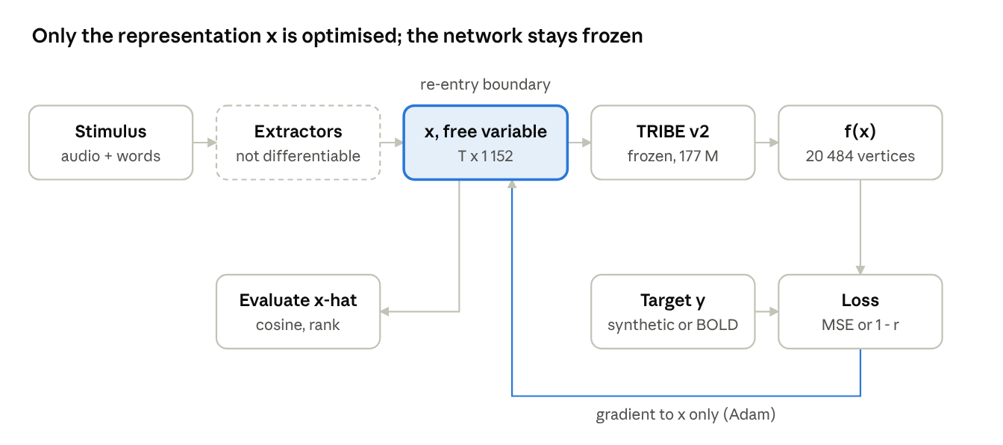
Figure 4.1: Inversion pipeline: the network is re-entered after feature aggregation; only the representation x is optimised, the network stays frozen

4.1 Design Approach / Materials & Methods

4.1.1 The forward operator: TRIBE v2
TRIBE v2 [6] maps a multimodal stimulus representation x ∈ ℝ^(T×1152), made of text, audio and video slots of 384 dimensions each sampled at 2 Hz, to a predicted response at V = 20 484 vertices of the fsaverage5 cortical surface [20], 100 output steps at 1 Hz. The network has 177.21 M parameters: a transformer encoder (127.47 M), a low-rank head (1 152 → 2 048), a subject-layer predictor (41.97 M) and a temporal pooler. The public release ships a single averaged “unseen subject” layer. All weights are frozen in this work.

4.1.2 What TRIBE v2 was trained on
Because every conclusion depends on the encoder, it matters what data it learned from. TRIBE v2 was trained on four public datasets totalling 25 healthy adults and 451.6 hours of 3T fMRI, recorded while participants passively watched or listened to naturalistic stimuli with no task (Table 4.1). The figures come from Table 1 of the TRIBE v2 paper [6] and the study definitions shipped with its code.
Table 4.1: TRIBE v2 training data: who was scanned and what they were exposed to
Dataset | What participants did in the scanner | Subjects | Sessions | fMRI (h) | TR (s)
CNeuroMod / Algonauts 2025 [10] | Watched the sitcom Friends (seasons 1–6) and four feature films; video, audio and dialogue | 4 | 1 408 | 268.7 | 1.49
BOLD Moments [21] | Watched 1 102 three-second naturalistic video clips (1 000 training clips; 102 test clips repeated 10 times) | 10 | 520 | 61.9 | 1.75
LeBel et al. 2023 [22] | Listened to spoken autobiographical stories (podcasts); 82 stories for three subjects, 26–27 for the others | 8 | 432 | 85.8 | 2.0
Wen et al. 2018 [23] | Watched natural movie clips in 8-minute segments; test segments repeated 10 times | 3 | 258 | 35.2 | 2.0
Training total | All 3T, passive viewing or listening | 25 | 2 618 | 451.6 | —

The model was then evaluated, without further training, on four datasets it had never seen (Table 4.2), bringing the total to 720 subjects, 5 094 sessions and 1 117.7 hours of fMRI [6].
Table 4.2: TRIBE v2 evaluation data (never used for training)
Dataset | Stimuli | Scanner | Subjects | fMRI (h)
NNDb (Aliko et al., 2020) | Full-length films (audio, video, text) | 3T | 86 | 160.6
Le Petit Prince (Li et al., 2022) | Audiobook (audio, text) | 3T | 112 | 180.2
Narratives (Nastase et al., 2021) | Spoken stories (audio, text) | 3T | 321 | 146.6
HCP (Van Essen et al., 2013) | Movie clips (audio, video, text) | 7T | 176 | 178.7
Evaluation total |  |  | 695 | 666.1

Two consequences for this project follow. First, our real-data subject (UTS03) is one of the eight LeBel training subjects, but the story we test on, wheretheressmoke, is TRIBE v2's own held-out test split, so the encoder never saw the responses we invert. Second, because the release averages subjects, we invert the population model rather than a subject-specific one.

4.1.3 Why fMRI and not EEG
EEG is cheaper, portable and has millisecond resolution, so the choice of fMRI needs justification. It rests on five points (Table 4.3). (1) Spatial detail: fMRI resolves millimetre-scale cortical patterns at 20 484 vertices [24], while 32–128 scalp electrodes see a spatially blurred mixture because of volume conduction. (2) A foundation encoder to invert exists only for fMRI; no open whole-brain encoder of naturalistic EEG at comparable scale exists. (3) Decoding through EEG would add a second ill-posed inverse problem, source localisation [25], in front of the one this project studies. (4) Empirically, the same decoder reaches a 32% character error rate from MEG but 67% from EEG [13]. (5) Open naturalistic language data with fMRI is plentiful (LeBel: 85.8 h), whereas the open simultaneous EEG–fMRI dataset contains rest, an abstract animation and short movie clips but no sustained speech [26]; this ruled out the EEG–fMRI fusion option considered in Report I.
Table 4.3: fMRI versus EEG for this project
Criterion | fMRI (this work) | EEG
Spatial detail | ≈2–3 mm voxels; 20 484 cortical vertices | 32–128 scalp channels; centimetre-scale, blurred
Foundation encoder to invert | TRIBE v2: 177 M parameters, 1 117.7 h, 720 subjects | None at comparable scale
Number of inverse problems | One: response → representation | Two: scalp → sources (ill-posed) → representation
Measured language decoding | Continuous language from fMRI [11] | 67% character error vs 32% with MEG [13]
Open naturalistic language data | LeBel 2023: 8 subjects, 85.8 h | No open EEG–fMRI set with sustained speech [26]
Temporal resolution | 1.5–2 s samples, ≈5 s haemodynamic lag (cost) | Milliseconds (advantage)
Cost and portability | Scanner-bound (cost) | Wearable, low cost (advantage)

EEG's advantages matter for a deployed device, not for measuring how invertible an encoder is. The method developed here transfers to EEG once an EEG encoder of comparable scale exists.

4.1.4 Inversion method
The public TRIBE v2 inference path is not differentiable end to end: stimuli pass through speech synthesis, transcription and frozen feature extractors, and prediction runs under PyTorch's inference mode. Inspection of the forward pass showed that the input batch is consumed at one point only, the aggregation of extractor features into x; everything after it is tensor arithmetic. We therefore take x as the free variable and re-enter the network at that boundary, f(x) = pool(predictor(head(encoder(x)))). Gradients reach every entry of x (‖∂y/∂x‖ = 7.97 × 10³, no zero entries), and re-entering at this boundary reproduces the released model's predictions exactly (r = 1.0000). The representation is recovered by
x̂ = argmin_x ‖f(x) − y‖² + λ R(x) (4.1)
using Adam [27] with learning rate 5 × 10⁻² and cosine annealing over the step budget, initialisation 0.01·N(0, I), and R an ℓ₂ or temporal-smoothness penalty where tested (λ = 0 otherwise). On real fMRI, where the scale and offset of the measured response are arbitrary, the loss is one minus the Pearson correlation over time, averaged over observed vertices.

4.2 Codes and Standards
Table 4.4: Standards and frameworks the project follows
Standard / framework | Scope | How this project aligns
BIDS [28] | Neuroimaging data organisation | Real data from OpenNeuro ds003020, a BIDS dataset
IEEE P2731 [29] | Unified BCI terminology (functional model) | Pipeline described as acquisition → features → decoding → output
IEEE P2794 (draft) | Reporting standards for in-vivo neural interface research | Report states model, data, preprocessing, metrics and failures
FAIR principles [30] | Findable, accessible, interoperable, reusable research outputs | Seeded scripts, logged results, public code and notebooks
OECD Recommendation [31]; UNESCO Recommendation [32] | Responsible innovation and ethics of neurotechnology | Mental-privacy implications discussed; no new human data collected
Licences | TRIBE v2 (CC BY-NC 4.0), Llama 3.2 licence, OpenNeuro data | Non-commercial academic use; gated access obtained

4.3 Constraints, Alternatives and Tradeoffs
Report I compared three solutions: an end-to-end supervised decoder (needs large per-subject training data and gives little insight into why decoding fails), inversion of a pretrained encoder (selected), and a simultaneous EEG–fMRI fusion decoder (blocked by the lack of open simultaneous data with sustained language). The main constraints and the trade-offs taken are listed in Table 4.5.
Table 4.5: Constraints and the trade-offs adopted
Constraint | Effect | Trade-off adopted
No local GPU | Large models cannot run on the team's laptops | Free Colab T4 for GPU work; CPU for regional analysis; Llama in half precision
12 GB RAM / 15 GB GPU on Colab | Llama-3.2-3B and w2v-BERT cannot be loaded together | One story per process; audio and text features in separate passes
Released pipeline not differentiable | Raw stimuli cannot be optimised | Invert the aggregated representation x (one stage after the extractors)
No ground truth in real fMRI | Recovery error cannot be measured directly | Exact synthetic evaluation, plus identification with a known chance level
Only an averaged subject layer released | No per-subject analysis | Invert the population model; state as a limitation
Synthetic x in a random subspace | Absolute values may not transfer | Real-data validation confirms the qualitative pattern

5. PROJECT DESCRIPTION
The project was carried out in five stages, each building on the previous one.

5.1 Instrumentation of the encoder
TRIBE v2 was loaded directly from its configuration and checkpoint, bypassing the text-to-speech and transcription pipeline. The forward map was rebuilt from the aggregation boundary (encoder, low-rank head, predictor, pooler), gradient flow to x was verified, and the rebuilt map was checked against the released predictions on real stimuli (r = 1.0000).

5.2 Synthetic evaluation with exact ground truth
Ground-truth trajectories (T = 32 time steps) were drawn in a random 8-dimensional subspace of ℝ^1152 with smooth temporal variation (two cosine cycles), or as white noise as an off-manifold control. The target is y = f(x), so recovery error is known exactly. Recovery is the mean per-time-step cosine between x̂ and x; relative error, encoding error and retrieval rank among other time steps are also reported. Directional sensitivity along a unit direction v is a finite-difference probe of the Jacobian:
s(v) = ‖f(x + εv) − f(x)‖ / ε (5.1)

5.3 Discriminating the causes of incomplete recovery
Four explanations were tested, each with a signature that would appear if it were true. (H1) Information loss: fit-matched solutions differ along a null-space direction the operator ignores. (H2) Non-convexity: distinct minima at equal fit, separated by a barrier. (H3) Optimiser artefact: recovery keeps rising with budget. (H4) Unidentifiable gain: a rescaled x gives the same output. Inversions were started from eight initialisation distributions and compared only when within 2× of the best fit, so under-converged runs could not pose as alternative solutions; the analysis was replicated over four ground truths. For two fit-matched solutions, a null space predicts that the prediction error stays flat along the straight line between them, while separate minima predict a rise in between; this test and the sensitivity probe use forward passes only and do not depend on the optimiser. Two further starts placed near the truth serve as a control for whether a deeper minimum exists.

5.4 Regional analysis
Six disjoint networks were defined on fsaverage5 from the Destrieux atlas [33] (Figure 8.10): left language network [34] (1 282 vertices), its right-hemisphere homologue (1 368), auditory cortex (277), default-mode network [35] (1 224), visual cortex (1 582) and somatomotor cortex (1 487) as a low-semantic control. For each network we measured forward sensitivity per input modality against 2 000 random vertex sets of equal size, recovery when only that network is observed (8 000 steps) against size-matched random vertex sets with a second random seed as the control spread, and the participation ratio [36] of its responses to 128 random input directions.

5.5 Real-fMRI validation
Data. Subject UTS03 of the LeBel et al. corpus [22] (OpenNeuro ds003020): six stories, 66.6 minutes of speech, 10 363 words, TR 2 s. The held-out story wheretheressmoke is the mean of ten repeats; the other five stories are used for every tuning choice.
Surface projection. The authors' preprocessed responses (95 556 cortical voxels) were mapped to fsaverage5 with TRIBE v2's own projector settings: a 3-mm ball of 20 points around each mid-cortical vertex, trilinear weights inside the cortical mask. Vertices were carried from MNI space to the subject's T1 by an ANTs SyN registration [37] and into functional voxels by the pycortex transform [38], giving a sparse 20 484 × 95 556 sampling matrix; the series were then detrended and z-scored. Validation: the left–right homotopic correlation was 0.635 against −0.017 for heterotopic pairs (above 97% of alternative pairings), and a scrambled-vertex control fell to chance.
Features and alignment. Stimulus features came from TRIBE v2's own pipeline with the dataset's word timings: w2v-BERT 2.0 for audio [39] and Llama-3.2-3B for text [40], grouped into 100-s segments (45 across six stories). The offset between model time and BOLD was the lag maximising prediction–response correlation on the five training stories; the 2 000 analysis vertices were those best predicted on the training stories.
Evaluation. (i) Encoding accuracy per vertex on the held-out story, against a split-half noise ceiling from the ten repeats. (ii) Forward identification: each 20-s window of held-out BOLD matched to predictions for all 194 windows of the six stories. (iii) Inversion: each held-out 100-s segment inverted from measured BOLD, and x̂ ranked against the true representations of all 45 segments (chance 1/45). (iv) An oracle that inverts the model's own noise-free prediction under the same budget, separating the operator's conditioning from measurement noise.

6. HARDWARE/SOFTWARE TOOLS USED
Table 6.1: Hardware and software
Category | Tool | Use in this project
Compute (GPU) | Google Colab, NVIDIA T4 (15 GB), 12 GB RAM | Synthetic characterisation; real-data text + audio features and inversion
Compute (CPU) | Linux workstation / cloud CPU | Regional analysis, surface projection, audio-only real-data run, figures
Deep learning | PyTorch [41], HuggingFace Transformers and Hub | Autograd through the frozen encoder; Llama-3.2-3B and w2v-BERT
Encoder | TRIBE v2 code and weights (Meta FAIR) | Frozen forward operator
Neuroimaging | nilearn [42], nibabel, ANTsPy, pycortex transforms | Atlas, surfaces, registration, surface projection
Scientific Python | NumPy, SciPy, scikit-learn, h5py, pandas, Matplotlib | Analysis, ridge baseline, data I/O, figures
Data | OpenNeuro ds003020 (LeBel et al. 2023) | Real naturalistic fMRI
Documentation | GitHub, Colab notebooks, PowerPoint, Word | Code release, reproducibility, reviews and reports

No hardware was built: the project is computational. All code, results and notebooks are public at github.com/Ivxn404/semantic-decoding-tribe-inversion (Appendix A).

7. SCHEDULE AND MILESTONES
Table 7.1: Schedule and milestones
Stage | Activity | Period (2026) | Outcome
S1 | Literature review and problem formulation | Aug | Scoped problem statement (Review I)
S2 | Model instrumentation; inversion boundary | Aug – Sep | Working differentiable inverse
S3 | Synthetic characterisation (budget, noise, extent, priors) | Sep | Dissociation and conditioning results
S4 | Controls and hypothesis tests | Sep – Oct | Non-convexity shown; null space rejected (Review II)
S5 | Regional analysis on six networks | Oct | Predictable-vs-recoverable dissociation
S6 | Real-fMRI validation (LeBel 2023) | Oct | Identification on a held-out story (Review III)
S7 | Manuscript, report, poster, code release | Oct | IEEE-format manuscript; public repository; final review

Reviews: Review I (problem and plan), Review II on 14 October 2026 (40% milestone), Review III (60–70% milestone), and the final review with poster, viva and demonstration on 29 October 2026.

8. RESULT ANALYSIS

8.1 Encoding accuracy does not certify decoding
Independent inversions at budgets from 250 to 32 000 steps show encoding error falling 28.4-fold while recovery saturates (Figure 8.1, Table 8.1). The final halving of encoding error (5.65 × 10⁻³ → 2.66 × 10⁻³) buys only +0.015 in recovery cosine. Forward accuracy and decodability are separate quantities.
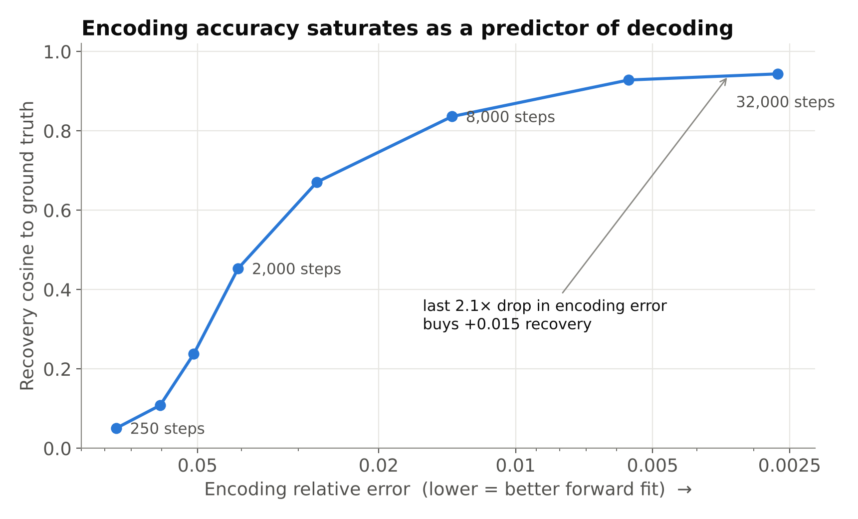
Figure 8.1: Encoding error against recovery cosine across independent step budgets
Table 8.1: Encoding error and recovery across optimisation budgets
Steps | Encoding relative error | Recovery cosine
250 | 7.546 × 10⁻² | 0.0505
500 | 6.043 × 10⁻² | 0.1081
1 000 | 5.098 × 10⁻² | 0.2374
2 000 | 4.073 × 10⁻² | 0.4529
4 000 | 2.733 × 10⁻² | 0.6708
8 000 | 1.380 × 10⁻² | 0.8362
16 000 | 5.649 × 10⁻³ | 0.9282
32 000 | 2.658 × 10⁻³ | 0.9436

8.2 Equally good fits give different answers
At 16 000 steps, seven of eight initialisations reached matched fit (2.52–2.96 × 10⁻⁷; one was excluded at 3.4× the best fit). Their mean pairwise cosine was 0.927, minimum 0.835, and mean cosine to the truth 0.914. The effect replicated across four ground truths with the same worst pair each time (Figure 8.2, Table 8.2); recovered norm ratios clustered by initialisation to within about 0.01, so distinct solutions are reached systematically, not by chance.
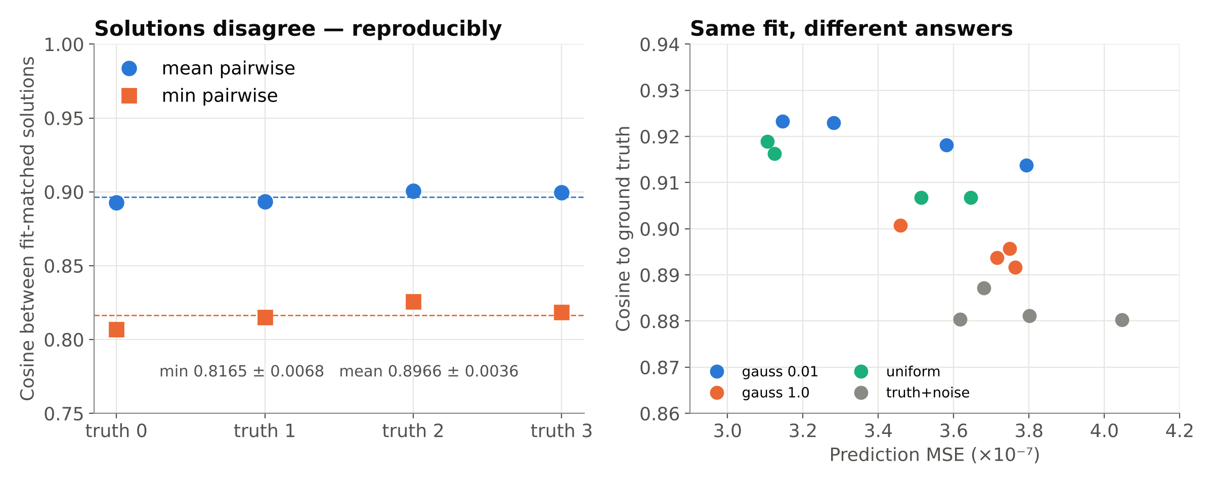
Figure 8.2: Agreement among fit-matched solutions across four ground truths (left) and fit versus recovery per initialisation (right)
Table 8.2: Agreement among fit-matched solutions, four ground truths, 14 000 steps
Ground truth | Best fit (MSE) | Mean pairwise cosine | Min pairwise cosine
0 | 3.51 × 10⁻⁷ | 0.893 | 0.807
1 | 3.65 × 10⁻⁷ | 0.893 | 0.815
2 | 3.11 × 10⁻⁷ | 0.901 | 0.826
3 | 3.13 × 10⁻⁷ | 0.900 | 0.819
Mean ± SD |  | 0.897 ± 0.004 | 0.817 ± 0.007

8.3 Barriers, not a null space
The straight line between two fit-matched solutions distinguishes the hypotheses. If the solutions lay in one flat valley (a null space), the prediction error would stay at the endpoints' level all along the line; if they are separate minima, the error rises in between. The test uses forward passes only. It was run on 19 October 2026 with notebooks/Verification_Tests.ipynb (14 000 steps, ground truth 0), comparing only the five starts that were blind to the truth and fit-matched (3.57–3.90 × 10⁻⁷, within 1.1× of each other; agreement mean 0.954, minimum 0.890).
The error rose between every one of the ten pairs, to 1.5–6.0× the worse endpoint (median 3.8×), and the rise grew as the two solutions became less similar (Figure 8.3, Table 8.3). Two control starts placed near the truth reached a 4.6× lower error and higher recovery (0.951–0.976, against 0.894–0.918 for the blind starts), and the straight path from the best blind solution to the near-truth one rose 7.2× above the blind end. The blind solutions are therefore distinct local minima, separated by barriers from one another and from a deeper minimum near the truth: the inverse is non-convex, and the information-loss hypothesis is rejected.
Correction. An earlier version of this test chose the least similar pair among all eight starts and compared the change along d with random directions. That rule paired an under-converged solution (Gaussian s.d. 5, error 1.15 × 10⁻⁶, recovery 0.62), so its numbers (2.6× falling to 0.6×) are withdrawn. With a fit-matched pair, the change along d stays far below random directions at every scale (2.6×, 6.0×, 13×, 258× at 0.1, 0.25, 0.5 and 1.0 of the gap), as it must when both ends fit the target; that comparison cannot detect a barrier, which is why the straight-path error is reported instead. The selection rule in scripts/synthetic_characterisation.py has been corrected.
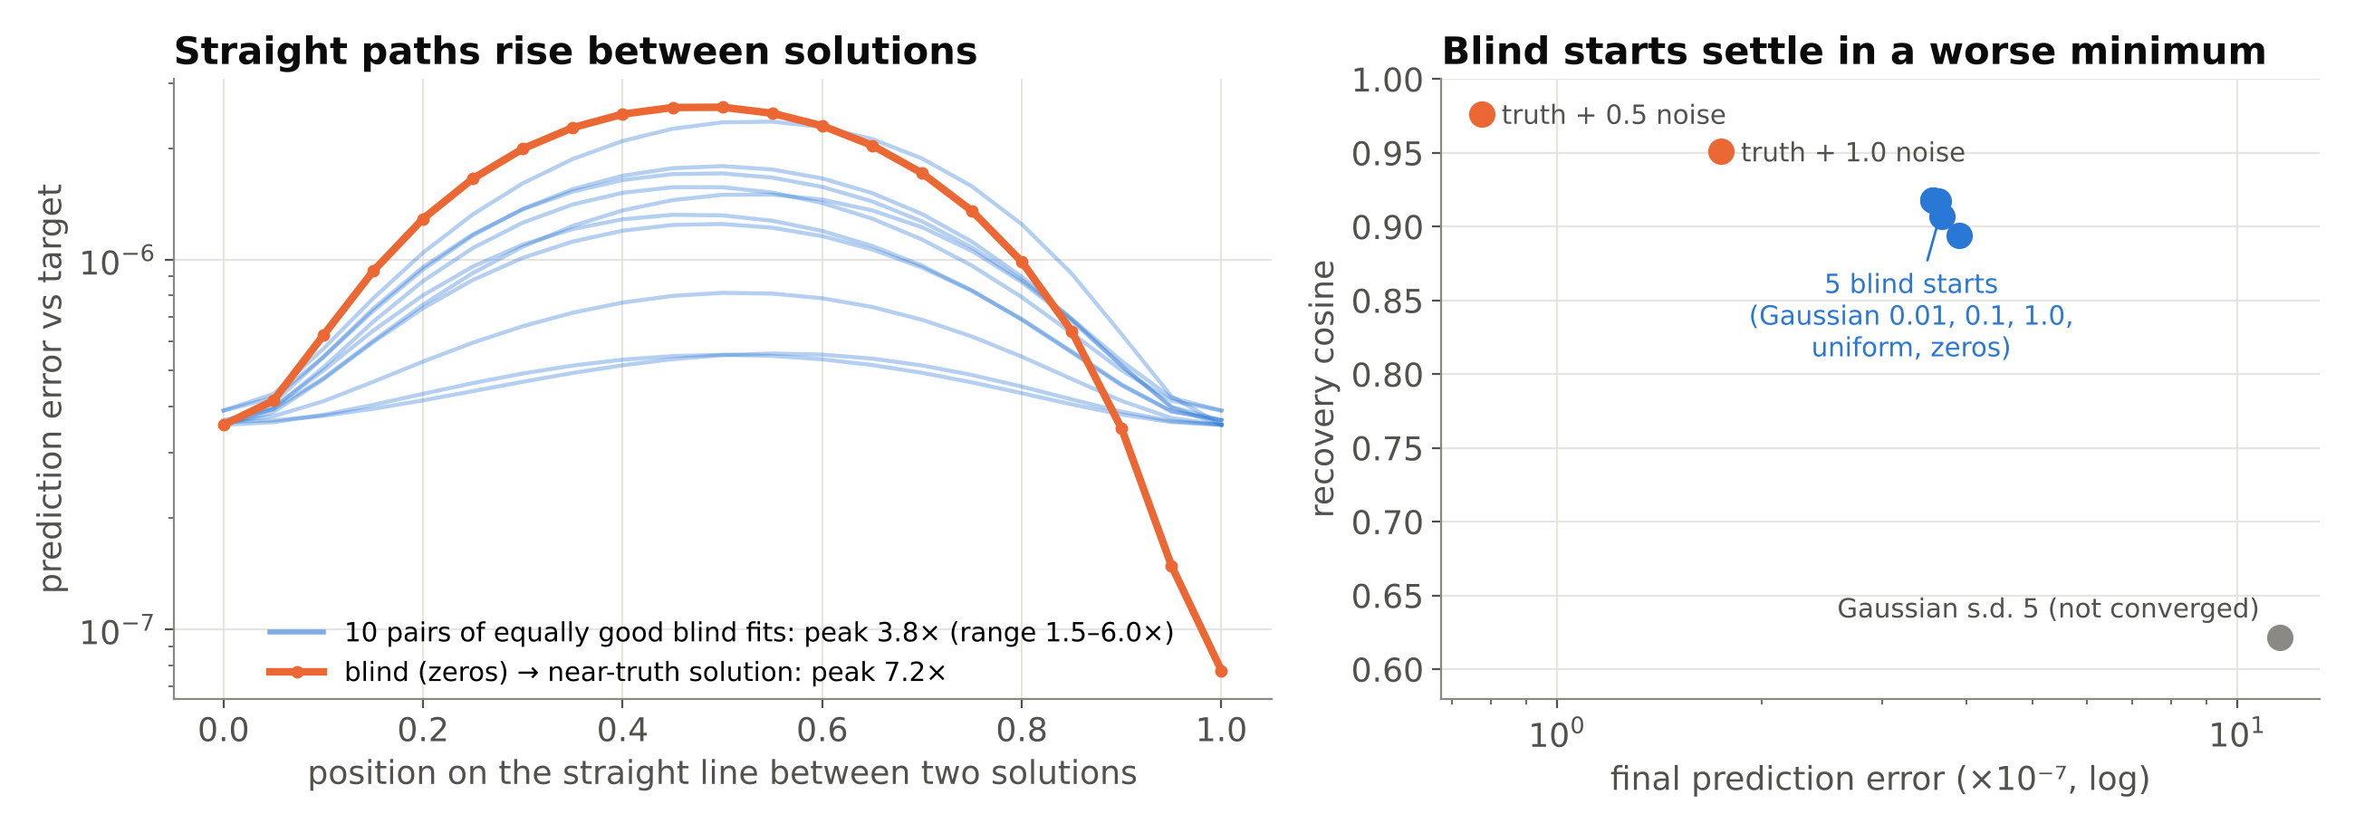
Figure 8.3: Left: prediction error along the straight line between fit-matched blind solutions (blue, ten pairs) and from the best blind solution to the near-truth solution (orange). Right: final error and recovery for each of the eight starts
Table 8.3: Straight-path barrier between fit-matched blind solutions (ground truth 0, 14 000 steps)
Solution pair | Agreement (cosine) | Peak error on the path | Peak / worse end
Gaussian 1.0 – zeros | 0.927 | 2.36 × 10⁻⁶ | 6.0×
Gaussian 1.0 – uniform | 0.890 | 1.79 × 10⁻⁶ | 4.6×
Gaussian 0.01 – Gaussian 1.0 | 0.927 | 1.71 × 10⁻⁶ | 4.4×
uniform – zeros | 0.958 | 1.50 × 10⁻⁶ | 4.1×
Gaussian 0.1 – Gaussian 1.0 | 0.940 | 1.57 × 10⁻⁶ | 4.0×
Gaussian 0.01 – uniform | 0.957 | 1.32 × 10⁻⁶ | 3.6×
Gaussian 0.1 – uniform | 0.956 | 1.25 × 10⁻⁶ | 3.4×
Gaussian 0.01 – Gaussian 0.1 | 0.992 | 8.12 × 10⁻⁷ | 2.2×
Gaussian 0.1 – zeros | 0.993 | 5.52 × 10⁻⁷ | 1.6×
Gaussian 0.01 – zeros | 0.999 | 5.57 × 10⁻⁷ | 1.5×
Best blind (zeros) – near-truth | — | 2.58 × 10⁻⁶ | 7.2×

8.4 Errors lie in the operator's weakest directions
On the corrected fit-matched pair (Gaussian 1.0 and uniform), sensitivity along their difference d was 8.10 × 10⁻², against a median of 1.68 × 10⁻¹ over 200 random directions (range 1.22–2.39 × 10⁻¹): 2.1× below the median and below every random direction sampled. Along the actual error x̂ − x it was 1.8× below the median. Nine of the ten blind pairs lay below the median (1.1–2.1×); the exception is the pair of almost identical solutions from the zero and 0.01 starts (agreement 0.999), whose difference is too small to probe reliably. The original run (Figure 8.4) gave 1.9×. The inverse is anisotropically ill-conditioned: the operator responds about half as strongly to the components that inversion fails to recover.
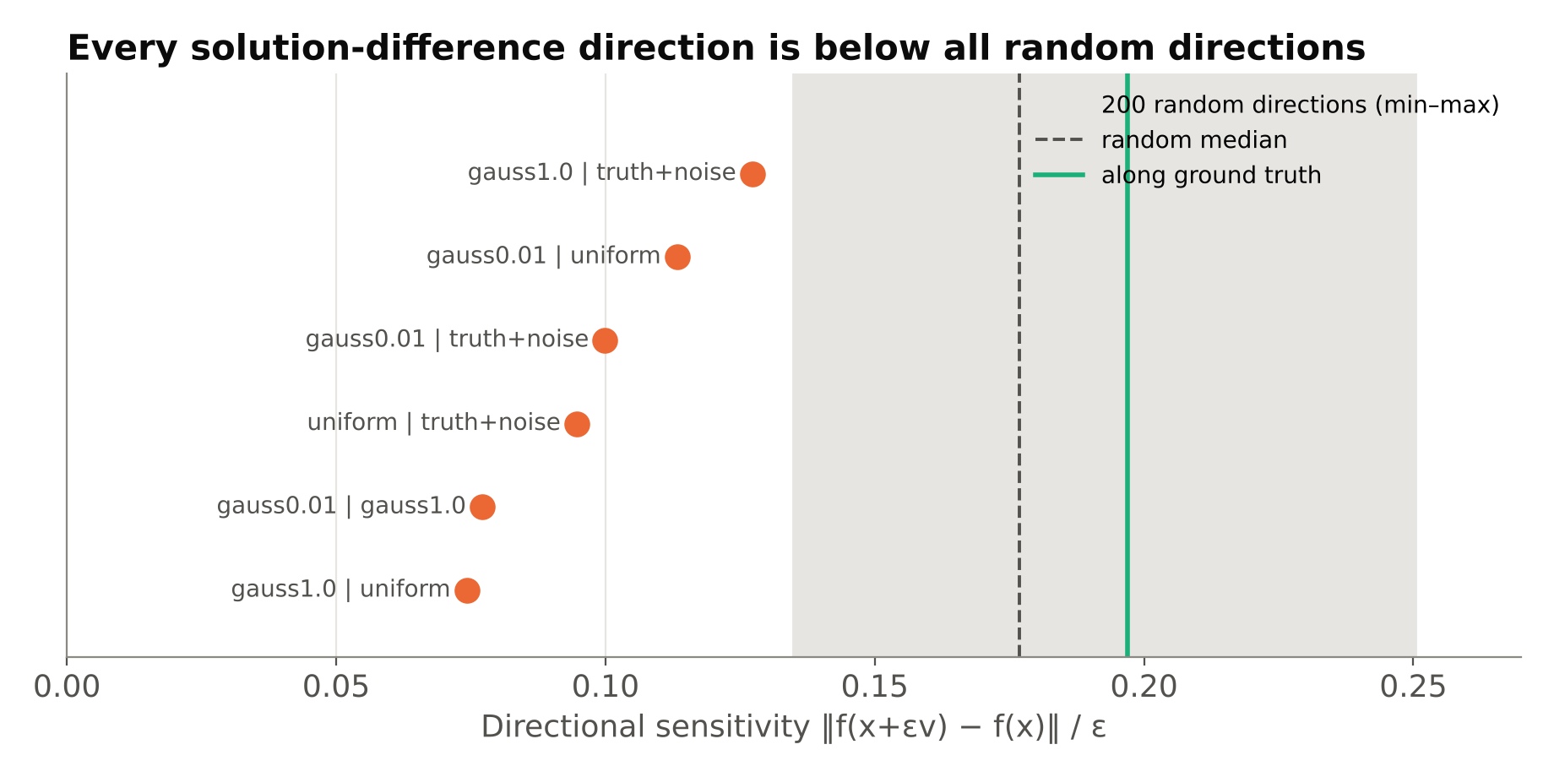
Figure 8.4: Directional sensitivity of the operator in the original run: solution-difference directions against 200 random directions (the corrected pair gives 2.1×)

8.5 Further conditioning results
Gain is identifiable: only the true scale lies within the optimiser's residual floor, and a 10% rescale already produces 7.5× the floor (Figure 8.5). The inverse degrades smoothly with measurement noise while retrieval stays near 0.99 (Figure 8.6), and about 10% of cortex (2 000 random vertices) carries most of the recoverable signal (Figure 8.7). Generic priors do not help: an ℓ₂ penalty gives at most +0.032 and temporal smoothness destroys recovery (Figure 8.8). A ridge decoder fitted on the same forward model reaches only 0.060, against 0.918 for gradient inversion (Figure 8.9). Table 8.4 collects these results.
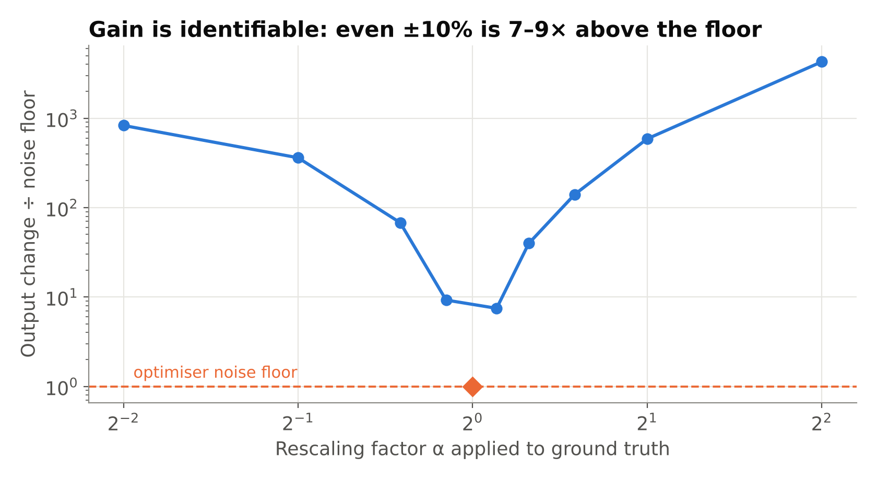
Figure 8.5: Output change under rescaling of the ground truth relative to the optimiser's noise floor
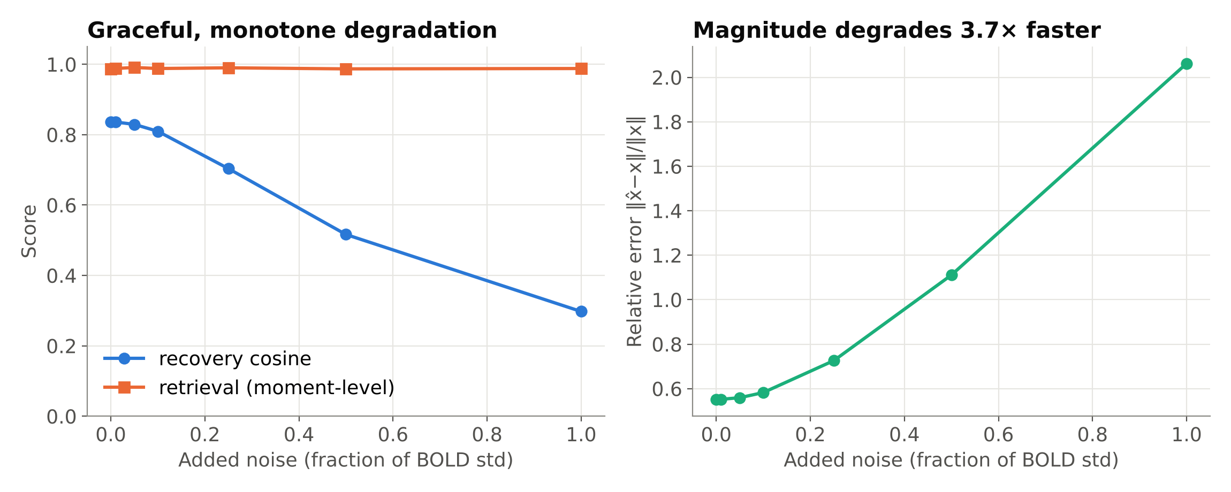
Figure 8.6: Recovery, relative error and retrieval against measurement noise
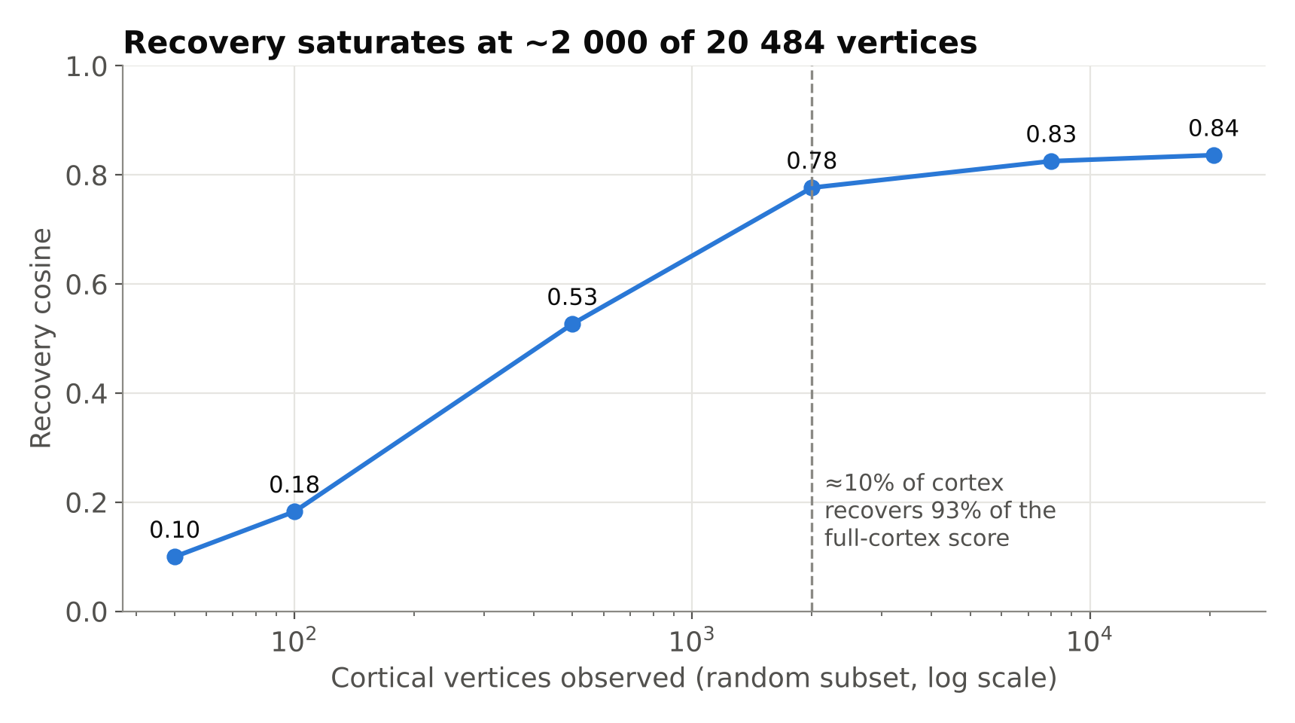
Figure 8.7: Recovery against the number of observed cortical vertices
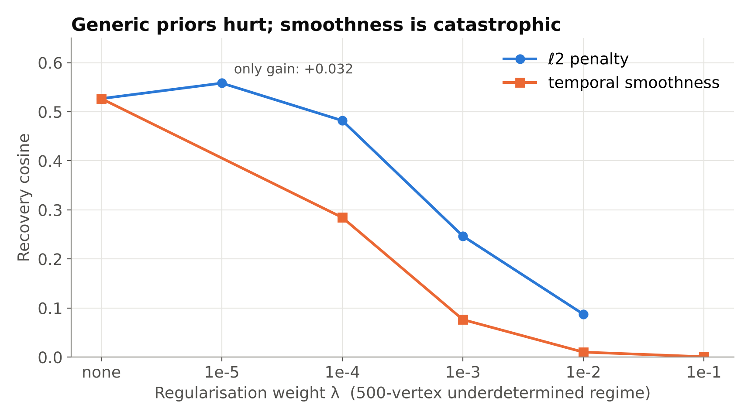
Figure 8.8: Effect of ℓ₂ and temporal-smoothness priors in the under-determined regime (500 vertices)
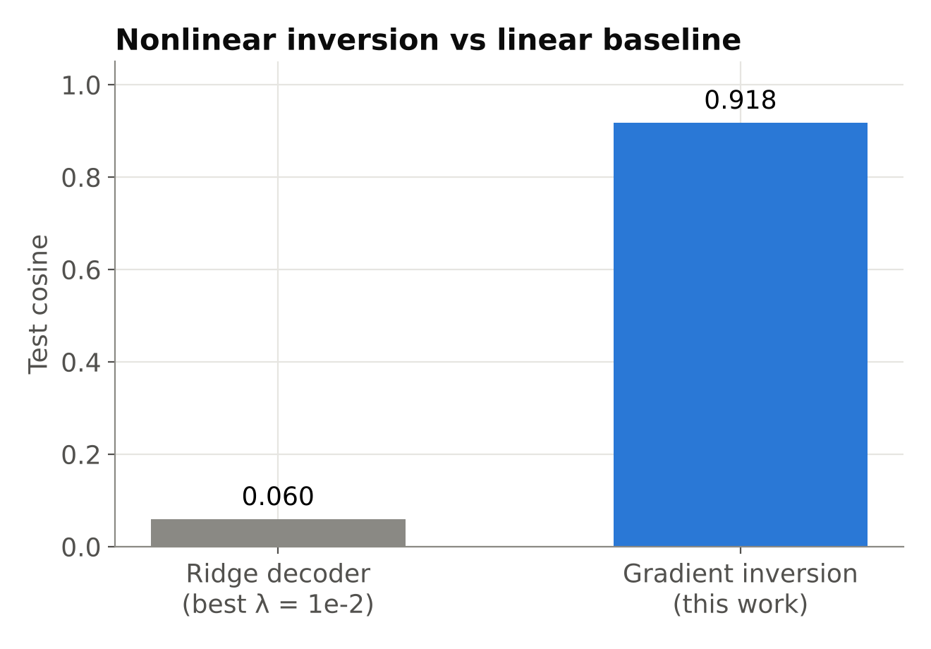
Figure 8.9: Gradient inversion against the best ridge decoder
Table 8.4: Further characterisation of the inverse (whole cortex unless stated)
Test | Result
Gain (rescale x by α) | Only α = 1 within the residual floor; a 10% rescale gives 7.5× the floor
Measurement noise, 0 → 100% of BOLD SD | Recovery 0.836 → 0.298, monotone; retrieval stays ≈0.99
Observed cortex, 50 → 20 484 vertices | Recovery 0.100 → 0.836; 2 000 random vertices (10%) reach 0.777
ℓ₂ prior (500 vertices) | Best +0.032 at λ = 10⁻⁵, harmful above
Temporal-smoothness prior (500 vertices) | Recovery 0.527 → 0.0008; retrieval to chance
Ridge decoder (240 train, 60 test pairs) | Best test cosine 0.060 vs 0.918 for gradient inversion (time-averaged target: a lower bound)
Stimulus manifold | White noise 0.947 ± 0.004 vs smooth 0.942 ± 0.005
Rate of semantic change, 64-fold range | 0.836–0.858, no trend (no haemodynamic operator in the release)
Optimiser control (SGD, L-BFGS) | Did not converge (1.4 × 10⁻⁴, 2.8 × 10⁻⁵ vs 3.5 × 10⁻⁷); reported as a limitation

8.6 Predictable is not recoverable, region by region
Forward sensitivity follows anatomy (Figure 8.11): language and default-mode networks are dominated by text-derived dimensions (z = +26.6 to +28.5), auditory cortex by audio (+34.7) and visual cortex by video (+40.7). Recoverability does not follow sensitivity (Figure 8.12, Table 8.5). Observing only its own vertices, visual cortex, the most responsive network (1.60× the cortical mean), recovered 0.125 worse than size-matched random vertices; somatomotor cortex, the least responsive (0.73×), recovered 0.102 better and exceeded the whole cortex at the same budget (0.851 vs 0.836). Both effects are about ten times the control spread (second random seed: 0.0014 and 0.0126). Response diversity explains the extremes: somatomotor alone is more diverse than its control (participation ratio 18.6 vs 15.2), while visual cortex is concentrated (10.3; top direction 27% of variance; Figure 8.14).
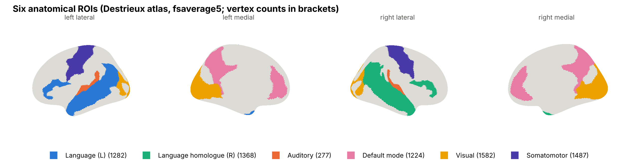
Figure 8.10: The six anatomical networks on the inflated fsaverage5 surface
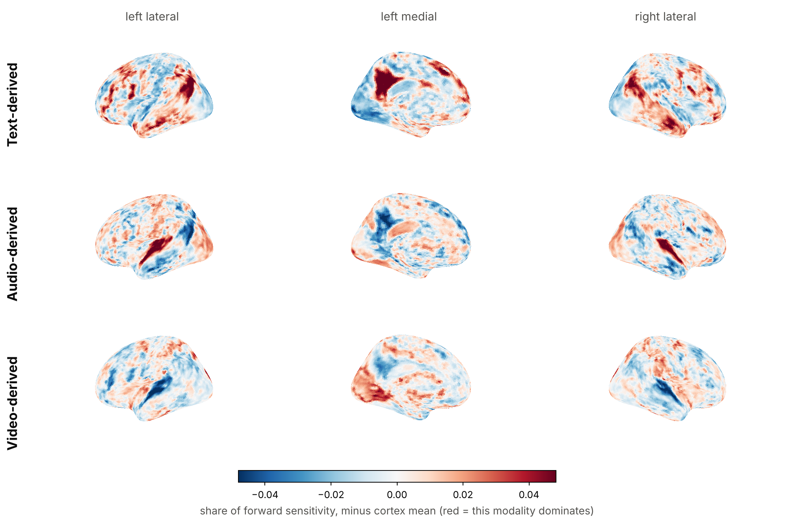
Figure 8.11: Forward-sensitivity share of the text-, audio- and video-derived dimensions across cortex
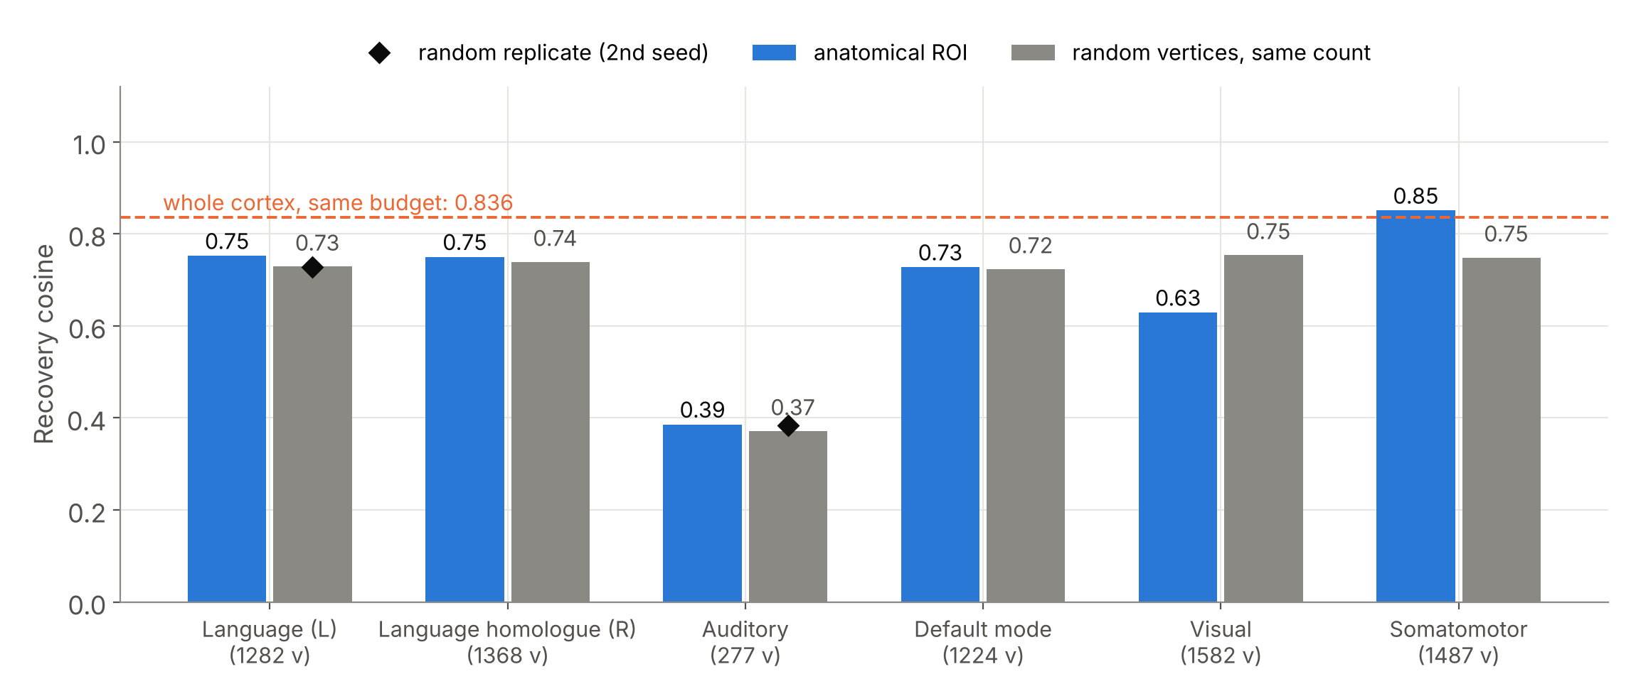
Figure 8.12: Recovery from each network versus size-matched random vertex sets
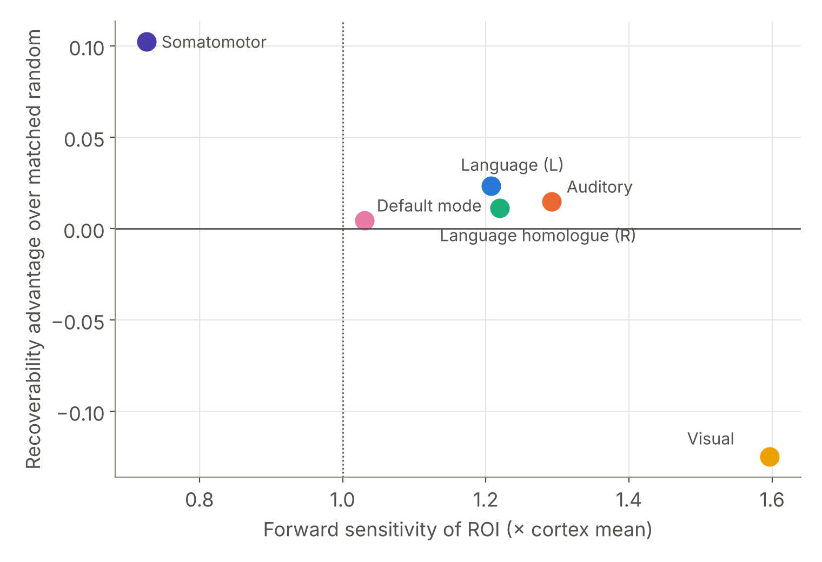
Figure 8.13: Forward sensitivity against recoverability across networks
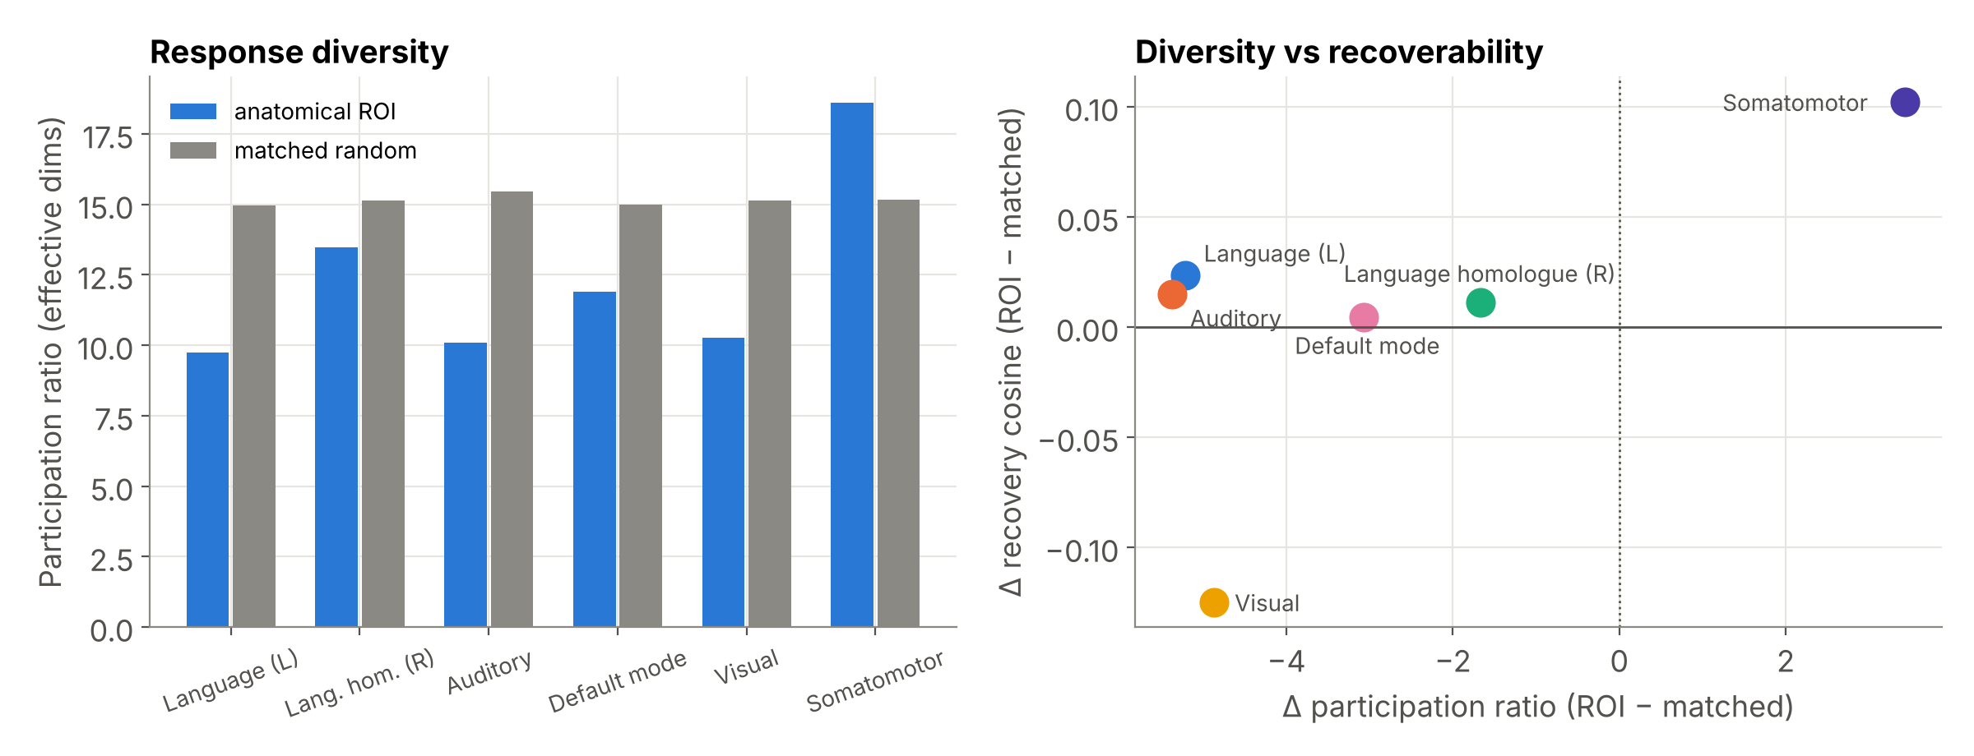
Figure 8.14: Participation ratio of each network's responses against size-matched controls
Table 8.5: Network sensitivity and recoverability (synthetic, 8 000 steps)
Network | Vertices | Sensitivity (× cortex) | Dominant slot (z) | Recovery: network | Recovery: random | Difference | PR (network / control)
Somatomotor | 1 487 | 0.73 | none | 0.851 | 0.748 | +0.102 | 18.6 / 15.2
Language (L) | 1 282 | 1.21 | text +26.6 | 0.752 | 0.729 | +0.023 | 9.7 / 15.0
Auditory | 277 | 1.29 | audio +34.7 | 0.386 | 0.371 | +0.015 | 10.1 / 15.5
Language (R) | 1 368 | 1.22 | text +28.5 | 0.750 | 0.739 | +0.011 | 13.5 / 15.1
Default mode | 1 224 | 1.03 | text +26.9 | 0.727 | 0.723 | +0.004 | 11.9 / 15.0
Visual | 1 582 | 1.60 | video +40.7 | 0.629 | 0.754 | −0.125 | 10.3 / 15.1

8.7 Real fMRI
The alignment offset fitted on the training stories was 4 s with text and audio features. On the held-out story the encoder reached r = 0.478 on the 2 000 vertices chosen from the other stories, 56% of the split-half noise ceiling (0.859), led by auditory (0.405), right-language (0.348) and default-mode (0.348) networks (Figure 8.15, Table 8.6). Adding language features more than doubled encoding accuracy compared with audio alone and nearly tripled forward identification of 20-s windows (58.6% against a chance level of 0.5%).
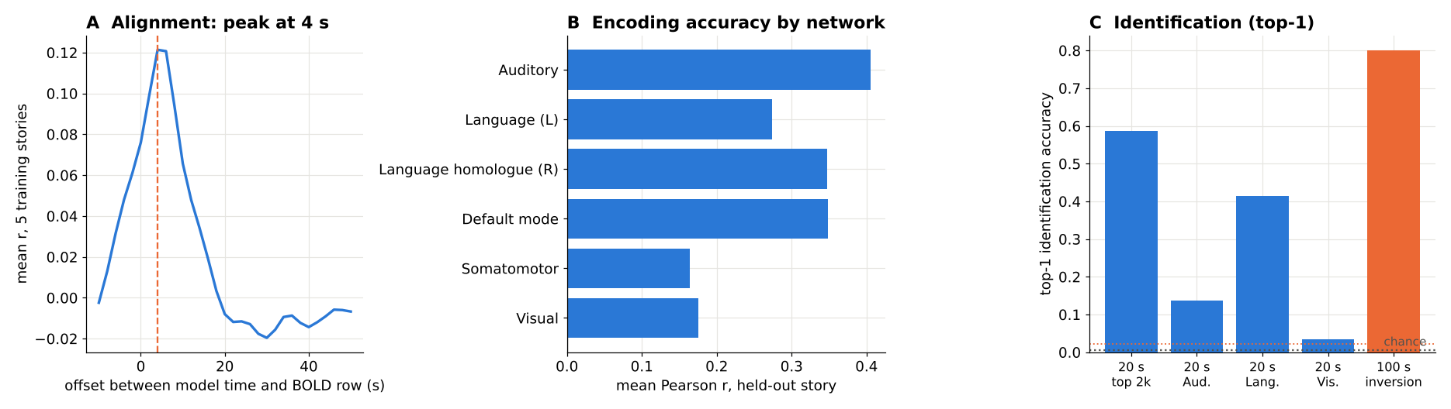
Figure 8.15: Real fMRI, held-out story: alignment (A), encoding accuracy by network (B) and identification accuracy (C)
Table 8.6: Real-fMRI validation, held-out story wheretheressmoke (UTS03)
Measure | Text + audio | Audio only | Chance / ceiling
Encoding r, whole cortex | 0.199 | 0.062 | 0
Encoding r, top 2 000 vertices | 0.478 (56% of ceiling) | 0.273 (32%) | ceiling 0.859
Encoding r, auditory / language L / language R | 0.405 / 0.274 / 0.348 | 0.263 / 0.193 / 0.200 | 0
Encoding r, default mode / somatomotor / visual | 0.348 / 0.164 / 0.176 | 0.103 / 0.039 / −0.020 | 0
Forward identification, 20-s windows, top-1 (top-5) | 58.6% (86.2%) | 20.7% (41.4%) | 0.5% (194 windows)
Inversion of measured BOLD, 100-s segments, top-1 | 4 / 5 (ranks 0, 0, 6, 0, 0) | 5 / 5 | 2.2% (45 segments)
Cosine of x̂ to the true x | 0.024 | 0.062 | —
Oracle: inverting the model's own prediction | 5 / 5, cosine 0.224 | — | —

Inverting measured BOLD ranked the true segment first in 4 of 5 held-out queries (the fifth ranked seventh of 45), including against the six other segments of the same story, while x̂ kept a cosine of only 0.02 to the truth. The oracle separates two limits: without noise, inversion identifies every segment yet recovers only 0.22 of the representation, so most of the loss is the operator's conditioning, not measurement noise; noise then lowers recovery further while leaving identification largely intact, as in the synthetic noise sweep. On real data, as in simulation, the inverse identifies which moment was heard but does not reconstruct its representation.

8.8 Discussion
Identification is robust; reconstruction is not. Identification needs only the high-sensitivity components that separate one moment from another, and those are the components the operator transmits well; the components it transmits weakly are where recovery fails (Section 8.4). Decoding claims built on identification accuracy should therefore not be read as reconstruction of the underlying representation.
Why better encoders need not decode better. A better fit can come almost entirely from high-sensitivity directions, leaving low-sensitivity ones as ill-determined as before. This is the dissociation of Section 8.1, and it means scaling laws for encoding [5] cannot be assumed to carry over to decoding.
The limit is geometry, not lost information. Fit-matched solutions are separate minima, not points on a flat valley, and magnitude is identifiable. Recovery is limited by a non-convex, anisotropically conditioned landscape, which better optimisation, initialisation or priors matched to the operator's weak directions could improve; generic priors do not. For linear inverted encoding models the stimulus is recovered only up to an invertible transform [16]; a deep encoder replaces that closed-form ambiguity with a non-convex, direction-dependent one that must be measured, as done here.
Limitations. Synthetic ground truth lies in a random low-dimensional subspace; inversion targets the aggregated representation; all solutions use Adam; the release has no explicit haemodynamic operator and only the averaged subject layer; regional z-scores use a random-vertex null that ignores spatial autocorrelation; and the real-data test covers one subject and five held-out inversion queries. A per-network test on real data needs held-out stories from more subjects, because the other five stories were in TRIBE v2's training set.

9. CONCLUSION
A near-perfect deep brain encoder does not by itself make meaning recoverable from fMRI. Inverting TRIBE v2 is a non-convex, direction-dependently conditioned problem: it identifies which stimulus was presented, on synthetic and real data alike, but reconstructs only the components the operator transmits well. Recoverability has to be measured, not inferred from predictivity, and it differs across cortex in ways predictivity does not reveal.

9.1 Obtained Results
• A differentiable re-entry point into TRIBE v2 that reproduces its predictions exactly (r = 1.0000).
• Encoding error falls 28.4× while recovery saturates at cosine 0.944: encoding and decoding dissociate.
• Fit-matched solutions disagree (minimum pairwise cosine 0.817 ± 0.007 over four ground truths): the inverse is non-convex.
• The prediction error rises 1.5–6.0× (median 3.8×) between every pair of fit-matched blind solutions, and 7.2× towards a deeper minimum near the truth: barriers, not a null space.
• Solution differences lie 2.1× below the median sensitivity of 200 random directions (1.9× in the original run): anisotropic ill-conditioning.
• Gain is identifiable; generic priors hurt; gradient inversion beats a linear decoder about 15-fold.
• Visual cortex, the most responsive network, is the worst to decode from (−0.125 vs random); somatomotor, the least responsive, the best (+0.102).
• Real fMRI, held-out story: encoding r = 0.48 (56% of the noise ceiling); inversion identifies 4 of 5 segments among 45 (chance 2.2%) with cosine 0.02; the noise-free oracle recovers 0.22.

9.2 Future improvement/work
• Real-data inversion across all eight LeBel subjects and a per-network real-data test on genuinely held-out stories.
• Optimisers and priors matched to the operator's weak directions; multiple restarts and ensembling over minima.
• Inversion of the raw extractor features (one stage earlier) and an explicit haemodynamic model.
• Transfer of the method to EEG and MEG encoders as they appear, and spin-permutation tests for the regional statistics.

9.3 Individual contribution from team members
Table 9.1: Individual contributions
Member | Contribution
Abhranil Sarkar (23BML0077) | Model instrumentation and the differentiable boundary; inversion engine and optimisation; design and execution of the synthetic and control experiments; real-fMRI pipeline (registration, surface projection, features, evaluation); figures, code release, manuscript and reports
Tanisha Choudhuri (23BML0081) | Functional neuroanatomy and definition of the six cortical networks from the Destrieux atlas; curation of the LeBel dataset; interpretation of the regional and real-data findings; contribution to reports, reviews and the poster

10. SOCIAL AND ENVIRONMENTAL IMPACT
Social impact. The work concerns people who keep comprehension but lose speech, for whom a non-invasive communication channel would be transformative. By measuring what fMRI decoding can and cannot recover, it helps direct effort towards approaches that can work and away from over-promising. It also bears on mental privacy: the finding that a near-perfect encoder identifies stimuli but does not reconstruct their representation is relevant to policy discussions of neural data [31], [32]. No new human data were collected; the public data used were released for research with consent obtained by the original studies.
Environmental impact. The project re-used a pretrained model rather than training a new one, which avoids the large energy cost of training a foundation encoder. All computation ran on a single shared cloud GPU and CPUs for a modest number of GPU-hours, and the public release lets others reproduce the results without repeating the experiments from scratch.

11. COST ANALYSIS
The project is computational and required no hardware purchase. Table 11.1 gives the budget estimated in Report I and the cost actually incurred.
Table 11.1: Estimated and incurred cost
Item | Estimate in Report I (INR) | Incurred (INR) | Remark
Hosted GPU compute (subscription) | 5 500 | 0 | Free Colab T4 tier was sufficient
Additional on-demand GPU credits | 4 000 | 0 | Memory-saving changes avoided paid tiers
Cloud storage (≈200 GB) | 1 500 | 0 | Free Google Drive quota and local storage
Neuroimaging datasets | 0 | 0 | Open licence (OpenNeuro)
Pretrained encoder weights | 0 | 0 | Open-weight, non-commercial licence
Documentation and reprographics | 1 500 | As per printing | Report binding and A3 poster printing
Contingency (≈15%) | 2 000 | 0 | Not required
Total | 14 500 | Printing only

Manpower: 580 planned person-hours (330 and 250 hours for the two members), as set out in Report I.

12. PROJECT OUTCOME PUBLICATION/PATENT
• Manuscript: “Predictable Is Not Recoverable: Conditioning and Non-Convexity of Inverting a Foundation Brain Encoding Model”, A. Sarkar*, T. Choudhuri* (joint first authors) and S. Nageswaran; complete in IEEE format and ready for submission to a journal or conference (venue to be decided).
• Open-source release: github.com/Ivxn404/semantic-decoding-tribe-inversion, with all scripts, logged results, figures, a demonstration video and two Colab notebooks that reproduce the synthetic and real-data analyses.
• Patent: none filed; the contribution is a scientific characterisation and an open method.

13. REFERENCES
[1] T. Naselaris, K. N. Kay, S. Nishimoto, and J. L. Gallant, “Encoding and decoding in fMRI,” NeuroImage, vol. 56, no. 2, pp. 400–410, 2011.
[2] K. N. Kay, T. Naselaris, R. J. Prenger, and J. L. Gallant, “Identifying natural images from human brain activity,” Nature, vol. 452, pp. 352–355, 2008.
[3] T. M. Mitchell et al., “Predicting human brain activity associated with the meanings of nouns,” Science, vol. 320, no. 5880, pp. 1191–1195, 2008.
[4] A. G. Huth, W. A. de Heer, T. L. Griffiths, F. E. Theunissen, and J. L. Gallant, “Natural speech reveals the semantic maps that tile human cerebral cortex,” Nature, vol. 532, pp. 453–458, 2016.
[5] R. Antonello, A. Vaidya, and A. G. Huth, “Scaling laws for language encoding models in fMRI,” in Proc. Advances in Neural Information Processing Systems (NeurIPS), vol. 36, 2023.
[6] S. d’Ascoli, J. Rapin, Y. Benchetrit, T. Brooks, K. Begany, J. Raugel, H. Banville, and J.-R. King, “A foundation model of vision, audition, and language for in-silico neuroscience,” arXiv:2605.04326, 2026.
[7] J. Hadamard, “Sur les problèmes aux dérivées partielles et leur signification physique,” Princeton University Bulletin, vol. 13, pp. 49–52, 1902.
[8] P. C. Hansen, Discrete Inverse Problems: Insight and Algorithms. Philadelphia, PA, USA: SIAM, 2010.
[9] S. d’Ascoli, J. Rapin, Y. Benchetrit, H. Banville, and J.-R. King, “TRIBE: TRImodal Brain Encoder for whole-brain fMRI response prediction,” in Proc. Int. Conf. Learning Representations (ICLR), 2026.
[10] A. T. Gifford et al., “The Algonauts Project 2025 challenge: How the human brain makes sense of multimodal movies,” arXiv:2501.00504, 2025.
[11] J. Tang, A. LeBel, S. Jain, and A. G. Huth, “Semantic reconstruction of continuous language from non-invasive brain recordings,” Nature Neuroscience, vol. 26, pp. 858–866, 2023.
[12] A. Défossez, C. Caucheteux, J. Rapin, O. Kabeli, and J.-R. King, “Decoding speech perception from non-invasive brain recordings,” Nature Machine Intelligence, vol. 5, pp. 1097–1107, 2023.
[13] J. Lévy, M. Zhang, S. Pinet, J. Rapin, H. Banville, S. d’Ascoli, and J.-R. King, “Brain-to-text decoding: A non-invasive approach via typing,” arXiv:2502.17480, 2025.
[14] P. S. Scotti et al., “MindEye2: Shared-subject models enable fMRI-to-image with 1 hour of data,” in Proc. Int. Conf. Machine Learning (ICML), 2024.
[15] G. J. Brouwer and D. J. Heeger, “Decoding and reconstructing color from responses in human visual cortex,” Journal of Neuroscience, vol. 29, no. 44, pp. 13992–14003, 2009.
[16] J. L. Gardner and T. Liu, “Inverted encoding models reconstruct an arbitrary model response, not the stimulus,” eNeuro, vol. 6, no. 2, ENEURO.0363-18.2019, 2019.
[17] A. Mahendran and A. Vedaldi, “Understanding deep image representations by inverting them,” in Proc. IEEE Conf. Computer Vision and Pattern Recognition (CVPR), 2015, pp. 5188–5196.
[18] Bladon and Bent, “Feature visualization recovers known cortical selectivity from TRIBE v2,” arXiv:2605.13904, 2026.
[19] Y. Benchetrit et al., “Boosting brain-to-image decoding with TRIBE v2 data augmentation,” arXiv:2606.06345, 2026.
[20] B. Fischl, M. I. Sereno, R. B. H. Tootell, and A. M. Dale, “High-resolution intersubject averaging and a coordinate system for the cortical surface,” Human Brain Mapping, vol. 8, no. 4, pp. 272–284, 1999.
[21] B. Lahner et al., “Modeling short visual events through the BOLD Moments video fMRI dataset and metadata,” Nature Communications, vol. 15, art. 6241, 2024.
[22] A. LeBel et al., “A natural language fMRI dataset for voxelwise encoding models,” Scientific Data, vol. 10, art. 555, 2023.
[23] H. Wen, J. Shi, Y. Zhang, K.-H. Lu, J. Cao, and Z. Liu, “Neural encoding and decoding with deep learning for dynamic natural vision,” Cerebral Cortex, vol. 28, no. 12, pp. 4136–4160, 2018.
[24] N. K. Logothetis, “What we can do and what we cannot do with fMRI,” Nature, vol. 453, pp. 869–878, 2008.
[25] C. M. Michel, M. M. Murray, G. Lantz, S. Gonzalez, L. Spinelli, and R. Grave de Peralta, “EEG source imaging,” Clinical Neurophysiology, vol. 115, no. 10, pp. 2195–2222, 2004.
[26] Q. K. Telesford et al., “An open-access dataset of naturalistic viewing using simultaneous EEG-fMRI,” Scientific Data, vol. 10, art. 554, 2023.
[27] D. P. Kingma and J. Ba, “Adam: A method for stochastic optimization,” in Proc. Int. Conf. Learning Representations (ICLR), 2015.
[28] K. J. Gorgolewski et al., “The brain imaging data structure, a format for organizing and describing outputs of neuroimaging experiments,” Scientific Data, vol. 3, art. 160044, 2016.
[29] IEEE P2731 Working Group, “A functional model for unifying brain–computer interface terminology,” IEEE Open Journal of Engineering in Medicine and Biology, vol. 2, 2021.
[30] M. D. Wilkinson et al., “The FAIR Guiding Principles for scientific data management and stewardship,” Scientific Data, vol. 3, art. 160018, 2016.
[31] OECD, Recommendation of the Council on Responsible Innovation in Neurotechnology, OECD/LEGAL/0457, 2019.
[32] UNESCO, Recommendation on the Ethics of Neurotechnology, adopted 12 November 2025.
[33] C. Destrieux, B. Fischl, A. Dale, and E. Halgren, “Automatic parcellation of human cortical gyri and sulci using standard anatomical nomenclature,” NeuroImage, vol. 53, no. 1, pp. 1–15, 2010.
[34] E. Fedorenko, A. A. Ivanova, and T. I. Regev, “The language network as a natural kind within the broader landscape of the human brain,” Nature Reviews Neuroscience, vol. 25, pp. 289–312, 2024.
[35] R. L. Buckner, J. R. Andrews-Hanna, and D. L. Schacter, “The brain’s default network: Anatomy, function, and relevance to disease,” Annals of the New York Academy of Sciences, vol. 1124, pp. 1–38, 2008.
[36] P. Gao, E. Trautmann, B. Yu, G. Santhanam, S. Ryu, K. Shenoy, and S. Ganguli, “A theory of multineuronal dimensionality, dynamics and measurement,” bioRxiv 214262, 2017.
[37] B. B. Avants, C. L. Epstein, M. Grossman, and J. C. Gee, “Symmetric diffeomorphic image registration with cross-correlation,” Medical Image Analysis, vol. 12, no. 1, pp. 26–41, 2008.
[38] J. S. Gao, A. G. Huth, M. D. Lescroart, and J. L. Gallant, “Pycortex: An interactive surface visualizer for fMRI,” Frontiers in Neuroinformatics, vol. 9, art. 23, 2015.
[39] Y.-A. Chung et al., “W2v-BERT: Combining contrastive learning and masked language modeling for self-supervised speech pre-training,” in Proc. IEEE Automatic Speech Recognition and Understanding Workshop (ASRU), 2021, pp. 244–250.
[40] A. Grattafiori et al., “The Llama 3 herd of models,” arXiv:2407.21783, 2024.
[41] A. Paszke et al., “PyTorch: An imperative style, high-performance deep learning library,” in Proc. Advances in Neural Information Processing Systems (NeurIPS), vol. 32, 2019.
[42] A. Abraham et al., “Machine learning for neuroimaging with scikit-learn,” Frontiers in Neuroinformatics, vol. 8, art. 14, 2014.

APPENDIX A: CODE AND REPRODUCTION
Repository: github.com/Ivxn404/semantic-decoding-tribe-inversion (MIT licence for the code). TRIBE v2 weights and the fMRI data are downloaded from their original sources and are not redistributed.
Table A.1: Map from report results to code
Result | Script (scripts/) | Output
Sections 8.1–8.5 (synthetic) | synthetic_characterisation.py | results/synth_*.json (logged numbers: docs/Methods_and_Results.md)
Section 8.3–8.4 verification | notebooks/Verification_Tests.ipynb, make_verification_fig.py | results/verification/
Section 8.6 (regional) | roi_sensitivity.py, roi_share_stats.py, roi_inversion.py, roi_dimensionality.py | results/roi_*.json
Section 8.7 (real fMRI) | lebel_register.py, lebel_sampler.py, lebel_project.py, lebel_features.py, lebel_apply.py, lebel_eval.py | results/realdata_audio_text.json
Figures | make_figures.py, make_roi_figs.py, make_brain_figs.py, make_topo_grid.py, make_realdata_fig.py | figures/
Demonstration video | demo_run.py, make_demo_video.py | demo/demo_inversion.mp4

Four Colab notebooks in the notebooks folder run on a free T4 GPU, step by step: Demo_and_Synthetic.ipynb (all synthetic analyses), RealData_TextAudio.ipynb (the real-fMRI analysis), Live_Demo.ipynb (a ten-minute live inversion for demonstrations) and Verification_Tests.ipynb (the corrected barrier and sensitivity tests of Sections 8.3–8.4).

