WOMM — Self-Evolving Multi-Agent Regulatory Impact Assessment

1. What are we solving?
Regulatory Impact Assessment (RIA) is about understanding what a proposed regulation changes and what effects those changes may have.
Analysts need to answer:
- What changes?
- Who is affected?
- What legal, fiscal, workforce and stakeholder impacts may follow?
- What evidence supports those impacts?
- What important impacts might be missing?
- What is still uncertain?
This requires combining legislation with historical cases, official reports and external evidence.
WOMM aims to make this analysis grounded, traceable and able to improve over time.
LLMs reason. Sources ground the analysis. Small judges handle bounded decisions. Evaluation drives improvement.

2. What are we building?
WOMM is a self-evolving multi-agent system for Regulatory Impact Assessment.
A regulatory proposal enters the system. Specialist agents analyse different types of impact using official and external evidence.
Agents share useful findings through a common board rather than receiving all context from everyone.
Small decision models such as Jev handle bounded decisions like routing, selective sharing and escalation. Larger LLMs handle open-ended legal and impact reasoning.
The system evaluates its own output. Repeated failures can lead to changes in agent instructions, research strategy, routing, collaboration and agent composition.
Every system change is tested before it is adopted.
Analyse → Evaluate → Improve → Test → Promote

3. Architecture
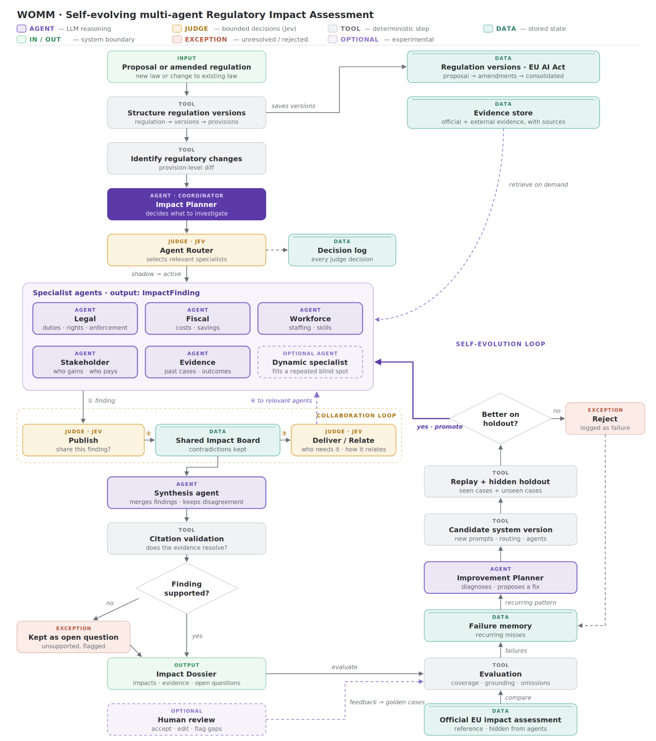

The system has three main loops:
RIA loop
Proposal → Agents → Impact Dossier
Collaboration loop
Agent → Shared Impact Board → Relevant Agents
Self-evolution loop
Evaluation → Failure → Improvement → Candidate → Validation → Promotion

4. Data
For the MVP, we focus on EU regulation, starting with the EU AI Act.
The system needs to support both new regulatory proposals and changes to existing regulation. Regulatory documents are stored as structured versions so that changes between versions can be identified and analysed.
The data is exposed to agents through structured JSON, a database or retrieval tools instead of passing full documents into context.
A regulation can contain:
Regulation
- ID
- Title
- Versions
  - Version ID
  - Date
  - Status
  - Source
  - Provisions
    - Provision ID
    - Article
    - Paragraph
    - Text
This allows WOMM to analyse both a new proposal and changes between regulatory versions.
The provenance chain is:
Impact → Regulatory Change → Provision → Evidence → Source

5. Evidence
We use two types of evidence.
Official sources tell us what the regulation says:
- legislation
- proposals
- amendments
- guidance
- official impact assessments
External research helps us understand what may happen because of it:
- academic studies
- regulator reports
- industry evidence
- historical outcomes
- stakeholder material
External search such as Exa can be used for discovery.
Every piece of evidence keeps its source and provenance.

6. Multi-agent analysis
The Impact Planner decides what needs investigation.
The Jev Router decides which specialist agents are relevant for the current proposal.
Initial specialists:
Legal Agent
Duties, rights, powers, enforcement and institutional effects.
Fiscal Agent
Costs, savings, incentives and economic effects.
Workforce Agent
Staffing, skills, processes and implementation capacity.
Stakeholder Agent
Who benefits, who carries the burden, objections and unintended consequences.
Evidence Agent
Comparable regulation, historical outcomes and supporting evidence.
The system may later create a Dynamic Specialist if repeated failures reveal a blind spot that existing agents do not cover well.
Agents return structured findings:
ImpactFinding:
agent:
provision:
affected_actor:
impact:
mechanism:
evidence:
confidence:
The basic reasoning chain is:
Regulatory change → Actor → Mechanism → Impact → Evidence

7. Agent collaboration
Agents do not automatically receive everything produced by every other agent.
Findings go to a Shared Impact Board.
Jev handles three bounded decisions:
Publish
Is this finding useful enough to share?
Deliver
Which other agents need this finding?
Relate
Does this finding support, contradict or replace another finding?
Possible relations:
supports
contradicts
supersedes
Contradictions are kept instead of being silently removed.
This keeps agent context smaller and makes collaboration selective.

8. Synthesis
The Synthesis Agent combines findings, removes duplication, keeps meaningful disagreements and connects related impacts.
Example:
Reporting requirement
↓
New compliance process
↓
Additional staffing
↓
Higher cost
↓
Greater burden on SMEs
Citation validation checks that evidence can actually be resolved.
Unsupported findings are removed or left as open questions.
The final output is the Impact Dossier.

9. Evaluation
Evaluation uses historical regulatory cases and official EU impact assessments where available.
For the MVP, we can take a proposal with an existing official impact assessment, hide that assessment from the agents, run WOMM on the same proposal, and compare the generated impacts against a relevant subsection of the official assessment.
Each evaluation case contains:
Golden Case
- Proposal
- Regulation version
- Important changes
- Expected impacts
- Affected actors
- Expected evidence
- Important omissions
- Reference impact assessment
We mainly evaluate:
Coverage
Did we find the important impacts?
Grounding
Are findings supported by evidence?
Omissions
What important things were missed?
Reasoning
Does the regulatory change → mechanism → impact chain make sense?
Efficiency
How much time and model/search cost did the analysis require?

10. Self-evolution
Evaluation failures are stored in Failure Memory.
Example:
Fiscal Agent misses indirect compliance costs in 4 of 8 cases.
The Improvement Planner looks for recurring problems and proposes a change.
Failure
↓
Likely cause
↓
Improvement proposal
↓
Candidate system
↓
Replay
↓
Hidden holdout
↓
Promote or Reject
A candidate is kept only if it performs better on cases that were not used to create the change.

11. What can evolve?
The system can improve several parts of itself.
Agent strategy
Change how a specialist analyses its task.
Research strategy
Change when, where and how deeply agents search.
Routing
Change which specialists are used for different proposals.
Collaboration
Change which findings are shared between agents.
Agent architecture
Create, merge or remove specialists.
Example:
Administrative burden is repeatedly missed
↓
No current specialist clearly owns it
↓
Create Administrative Burden Agent
↓
Replay and holdout
↓
Keep it only if it improves the system
Evaluation
The system can propose new evaluation criteria if existing evaluation repeatedly misses problems found by human review.
Evaluator changes must also be validated before adoption.

12. Decision modes
Bounded decisions support three modes:
off
shadow
active
Off
The decision is disabled.
Shadow
The model makes and logs a decision but does not affect the workflow.
Active
The decision controls the workflow.
For example, agent routing can first run in shadow mode while all specialists still execute.
This allows us to check whether routing is reliable before trusting it.

13. Decision logging
Every bounded decision is recorded.
DecisionRecord:
decision_point:
input:
decision:
probability:
mode:
system_version:
This lets us inspect why the system routed, shared or escalated something.
The same data can later support self-improvement.

14. Human review
Keep human interaction simple.
Accept
Reject
Edit
Missing impact
Weak evidence
Feedback goes into the golden cases and Failure Memory.

15. MVP scope

Must build
- EU regulatory data and retrieval
- Stable provisions and provenance
- Specialist multi-agent analysis
- Structured impact findings
- Shared Impact Board
- Synthesis and citation validation
- Golden cases and evaluation
- Failure Memory
- Improvement Planner
- Candidate system versions
- Replay and hidden holdout
- Promote/reject loop

Adaptive features
- Jev agent routing
- Jev publish/deliver/relate decisions
- Shadow → active decision rollout
- Agent-level improvement
- Research policy improvement

Experimental features
- Automatic specialist creation
- Agent merge/removal
- Graph restructuring
- Evaluator improvement
All of these use the same self-improvement loop.

16. Demo
The demo should show one clear improvement cycle.
Run RIA
↓
Evaluation finds a repeated blind spot
↓
Improvement Planner identifies the problem
↓
System proposes a change
↓
Candidate system is created
↓
Replay
↓
Hidden holdout
↓
Metrics improve
↓
PROMOTE
The strongest version shows an architecture change:
Existing agents repeatedly miss one impact type → WOMM proposes a new specialist → the candidate system improves → the new specialist is promoted.
A second useful demo can show selective agent collaboration:
Agents create findings → Jev decides what should be shared and who needs it → only relevant information moves between agents.

17. Build order
1. Data
Start with the EU AI Act and represent its proposal and later regulatory versions in a common structured format.
Original proposal
↓
Later versions / changes
↓
Consolidated version
↓
Structured regulation versions
↓
Provision-level changes
↓
Searchable evidence
First prove:
Regulatory Change → Provision → Evidence → Source
2. Multi-agent RIA
Build specialist agents → findings → Shared Impact Board → synthesis → dossier.
3. Jev decision layer
Add routing and publish/deliver/relate decisions.
Start in shadow mode before allowing Jev decisions to control the workflow.
4. Evaluation
Create the first evaluation cases using historical proposals and, where available, official EU impact assessments.
Start with a manageable subsection of an official impact assessment rather than trying to reproduce the entire document.
Establish a baseline for coverage, grounding, omissions and reasoning quality.
5. Self-evolution
Build:
Failure Memory → Improvement Planner → Candidate → Replay → Holdout → Promote/Reject
6. Adaptive architecture
Add automatic specialist creation, agent merge/removal and evaluator improvement.

One-line definition
WOMM is a self-evolving multi-agent system for Regulatory Impact Assessment that learns from failures and can improve its agents, collaboration, research strategy and architecture over time.

