

A REPORT FOR A THREE-MONTH INDUSTRIAL ATTACHMENT AT DEDAN KIMATHI UNIVERSITY OF TECHNOLOGY, NYERI.

FROM MAY TO AUGUST 2025
PRESENTED BY:
NAME: IVY NYAMBURA KABURA
REGISTRATION NUMBER: SC232/0350/2022

REPORT SUBMITTED IN PARTIAL FULFILLMENT OF THE REQUIREMENTS FOR THE FULL COMPLETION OF THE DEGREE IN BACHELOR OF BUSINESS AND INFORMATION TECHNOLOGY(BBIT)

DECLARATION
I, Ivy Nyambura Kabura, hereby declare that this report is my original work and that it has not been submitted before for any academic reward in this institution or any other institution of higher learning.

NAME: Ivy Nyambura Kabura Reg No: SC232/0350/2022

SIGNATURE: ………………. DATE: ……….…………

Industrial Supervisor: Alex Kuria

SIGNATURE: ………………. DATE: ……….…………

University Supervisor: Dr. Makupi

SIGNATURE: ………………. DATE: ……….…………

ACKNOWLEDGEMENTS
I would like to express my sincere gratitude to Dedan Kimathi University of Technology for providing me with the opportunity to undertake my industrial attachment as part of the Bachelor of Business and Information Technology program. I’m grateful to the ICT Department and my supervisor, Alex Kuria, for their guidance and support throughout the period.
Special thanks to the team and fellow interns for their collaboration and encouragement, and to my family and friends for their continued support.

DEDICATION
I dedicate this attachment report to my beloved family, whose unwavering support, encouragement, and prayers have been the cornerstone of my academic journey. To my mentors and supervisors, thank you for your guidance and for creating an environment that fostered growth, learning, and professionalism.
This report is also dedicated to all aspiring students who believe in the power of hard work, resilience, and continuous learning. May it serve as a testament that every experience, no matter how challenging, is an opportunity to grow and shine.

Table of Contents
DECLARATION i
ACKNOWLEDGEMENTS ii
DEDICATION ii
Table of Figures iv
List Of Tables iv
LIST OF ABBREVIATIONS AND ACRONYMS v
DEFINITION OF TERMS v
EXECUTIVE SUMMARY vi
SECTION 1: INTRODUCTION-ORGANIZATION PROFILE; 1
1.1 GEOGRAPHICAL LOCATION 1
1.2 HISTORICAL BACKGROUND 1
1.3 VISION 1
1.4 Mission 1
1.5 Core Values 1
1.6 Organizational Structure 2
1.7 Details of Placement Department 2
SECTION 2: ATTACHMENT EXPERIENCES: 5
2.1 General activities undertaken: 5
2.2 Special activities Undertaken: 5
2.3 An analysis of learnt knowledge and applied skills: 7
2.4 Profile of Skills and Competencies Gained: 8
2.5 Observation and Critique: 8
SECTION 3 9
3.1: Summary 9
3.2: Conclusion 9
3.3: Recommendations 9
References: 9
Appendices 10

Table of Figures
Figure 1.1: Dekut ICT Organizational Structure 2
Figure 2:Server upclose view 3
Figure 3:Network Monitoring interface 4
Figure 4:Network Traffic monitoring system 4
Figure 5:Netorking tools 4
Figure 6:Networking tools 5
Figure 7:Network switch setup 5
Figure 8: Wi-Fi Access Point 7

List Of Tables
Table 1:Operational Hours 10

LIST OF ABBREVIATIONS AND ACRONYMS
- ICT – Information and Communication Technology
- DEKUT – Dedan Kimathi University of Technology
- LAN – Local Area Network
- WAN – Wide Area Network
- Wi-Fi – Wireless Fidelity
- VLAN – Virtual Local Area Network
- IP – Internet Protocol
- CLI – Command Line Interface
- PuTTY – A free and open-source terminal emulator
- ping – Packet Internet Groper
- tracert – Trace Route
- IT – Information Technology

DEFINITION OF TERMS
- Network Troubleshooting – The process of diagnosing and resolving issues affecting network connectivity, performance, or configuration.
- Switch Configuration – Setting up network switches to manage data flow, including assigning IP addresses and creating VLANs.
- VLAN (Virtual Local Area Network) – A logical subdivision of a network that groups devices regardless of their physical location to improve security and efficiency.
- IP Addressing – Assigning unique numerical identifiers to devices on a network to enable communication.
- Serial Console Tools – Software used to access and configure network devices via serial connections; e.g., PuTTY.
- Technical Documentation – Written records of procedures, configurations, and troubleshooting steps used for audits, planning, and knowledge sharing.
- Cybersecurity Protocols – Rules and procedures designed to protect digital systems from unauthorized access, attacks, or data breaches.
- Command Line Interface (CLI) – A text-based interface used to interact with software and operating systems by typing commands.
- Ping – A network utility that tests connectivity between devices by sending packets and measuring response time
- Tracert (Trace Route) – A diagnostic tool that shows the path data takes from one device to another across a network.

EXECUTIVE SUMMARY
This report provides a comprehensive overview of the industrial attachment undertaken at Dedan Kimathi University of Technology, within the ICT Department, from May 12, 2025, to August 8, 2025. The attachment was a critical component of my academic program, aimed at bridging the gap between theoretical knowledge and practical application in a real-world work environment.
During the attachment period, I was exposed to various operational procedures, technical tasks, and administrative responsibilities that enhanced my understanding of Information Technology. Key activities included Technical Troubleshooting & Network Support, Hands-On IT Infrastructure Tasks, and Documentation & Reporting
The experience provided valuable insights into workplace dynamics, professional ethics, time management, and teamwork. It also allowed me to develop essential skills such as problem-solving, communication, and adaptability. Challenges encountered during the attachment were met with resilience and support from supervisors, contributing to both personal and professional growth.
Overall, the industrial attachment was a transformative experience that reinforced my academic foundation and prepared me for future career opportunities in the industry.

SECTION 1: INTRODUCTION-ORGANIZATION PROFILE;

1.1 GEOGRAPHICAL LOCATION
Dedan Kimathi University of Technology (DEKUT) is located in Nyeri, Kenya, approximately 160 kilometers north of Nairobi. The main campus is situated along the Nyeri-Mweiga road, about 6 kilometers from Nyeri town. It is strategically located, serving as a regional business and administrative hub. It's surrounded by several counties, including Kirinyaga, Meru, Embu, Murang'a, Tharaka Nithi, Laikipia, and Nyandarua. The campus sits on approximately 1,000 acres, with a mix of natural forest, coffee plantations, and open spaces for expansion

1.2 HISTORICAL BACKGROUND
Dedan Kimathi University of Technology (DEKUT) has a rich history rooted in the community's desire for technical education and the legacy of Field Marshal Dedan Kimathi. Initially established as the Kimathi Institute of Technology (KIT) by community leaders in 1972, it aimed to provide skills and knowledge to young Kenyans. Over time, it evolved, becoming a constituent college of Jomo Kenyatta University of Agriculture and Technology (JKUAT) in 2007, and finally, a full-fledged university in 2012

1.3 VISION
To be a premier Technological University excelling in Quality education, Research, and Technology Transfer for National Development.

1.4 Mission
To provide an academically stimulating, culturally diverse and quality learning environment that fosters research, innovation and technology development towards producing relevant technical and managerial human resource and leaders to contribute to attainment of national development goals.

1.5 Core Values
- Innovation
- Scholarship
- Diversity
- Integrity
- Teamwork

1.6 Organizational Structure

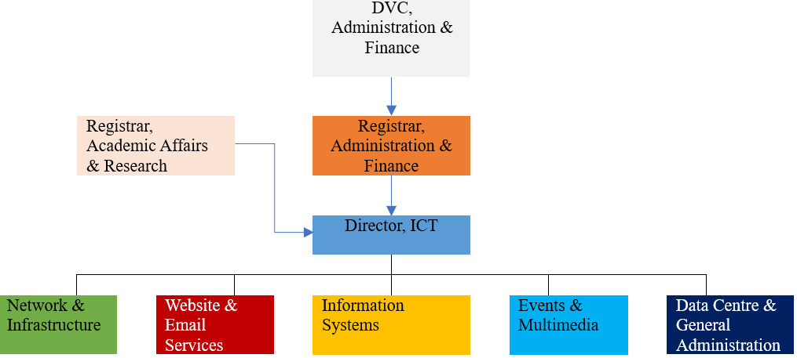
Figure 1.1: Dekut ICT Organizational Structure

1.7 Details of Placement Department
Department Name:
Information and Communication Technology (ICT) Department – Dedan Kimathi University of Technology
Location:
Main Campus, ICT Offices – Administration Block, Nyeri, Kenya
Reporting Supervisor:
Mr. Alex Kuria– Network Administrator
Department Overview:
The ICT Department at Dedan Kimathi University of Technology is responsible for the planning, implementation, and maintenance of the university’s digital infrastructure. It supports academic, administrative, and research functions by ensuring reliable connectivity, secure systems, and responsive technical support.
Core Functions of the Department:
- Installation and maintenance of network infrastructure (LAN/WAN)
- Configuration and management of switches, routers, and access points
- User support and helpdesk services for staff and students
- System updates, cybersecurity protocols, and data backup
- Technical documentation and reporting for audits and planning
My Role Within the Department:
During my attachment, I actively participated in:
- Diagnosing and resolving Wi-Fi and switch-related issues in key locations such as the Examination Office and Origin Library
- Configuring switches using serial console tools like PuTTY, including IP addressing and VLAN setup
- Monitoring network performance and documenting technical procedures
- Drafting professional emails and internal communications
- Creating troubleshooting checklists and contributing to departmental documentation

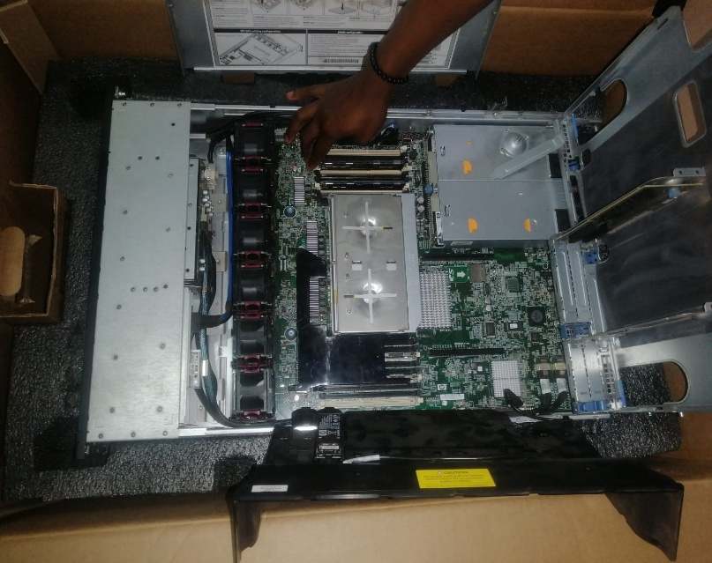
Figure 2:Server up-close view
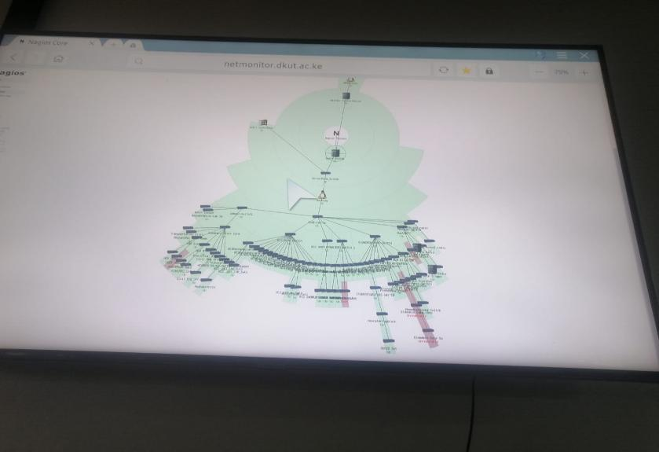
Figure 3:Network Monitoring interface
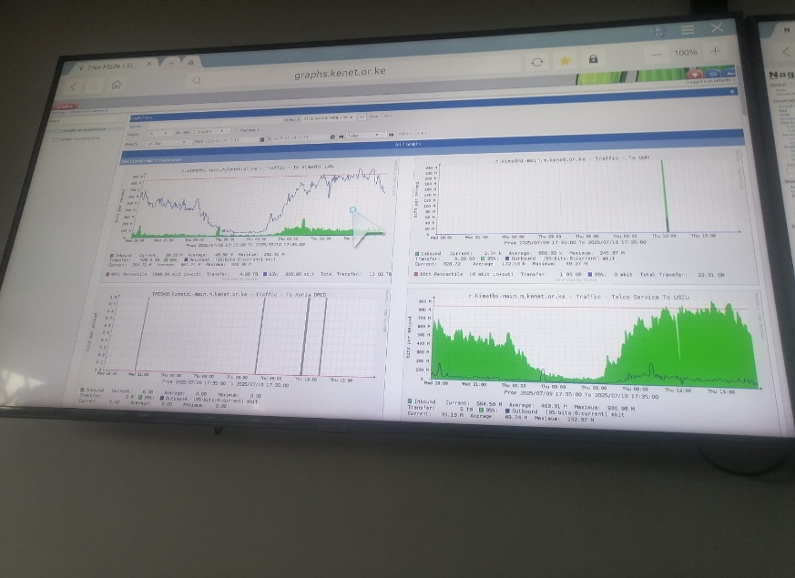
Figure 4:Network Traffic Monitoring System

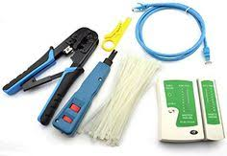
Figure 5:Networking tools
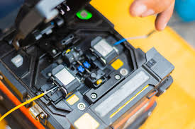
Figure 6:Networking tools

SECTION 2: ATTACHMENT EXPERIENCES:

2.1 General activities undertaken:
During my attachment, I participated in a range of routine ICT operations that supported the university’s digital infrastructure. These included:
- Diagnosing and resolving network connectivity issues across various departments.
- Assisting in the configuration and maintenance of switches, routers, and access points.
- Providing basic user support for staff experiencing hardware or software challenges.

2.2 Special activities undertaken:
Beyond routine tasks, I was entrusted with more specialized responsibilities that deepened my technical exposure:
- Configured network switches using serial console tools such as PuTTY, including IP addressing and VLAN segmentation.
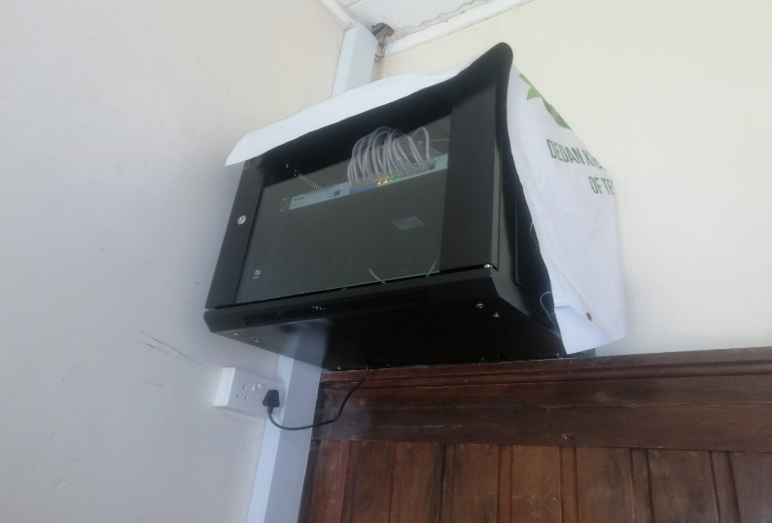
Figure 7:Network switch setup
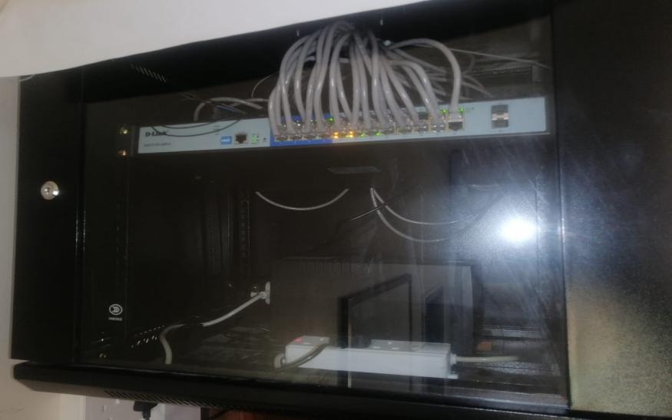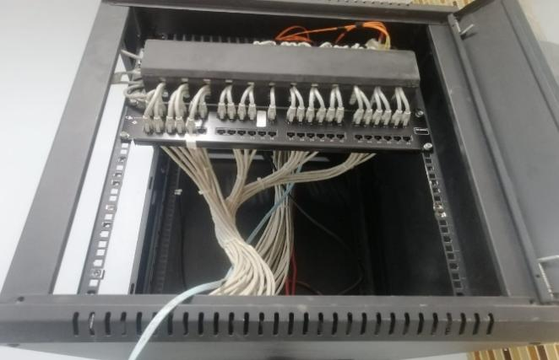
- Conducted Wi-Fi signal optimization in high-traffic areas like the Examination Office and Origin Library.
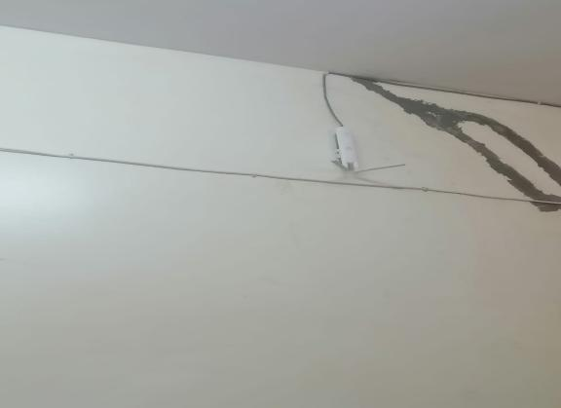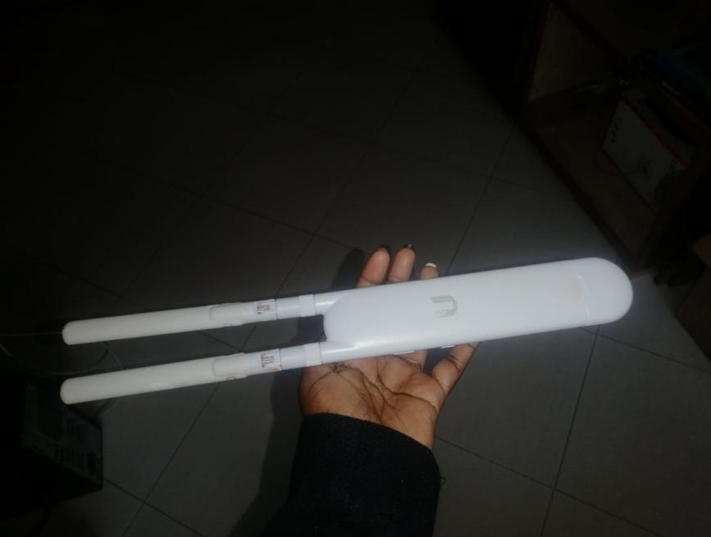
Figure 8:Wi-Fi Access Point
- Developed a troubleshooting checklist to streamline future diagnostics and reduce response time.

2.3 An analysis of learnt knowledge and applied skills:
This attachment provided a practical platform to apply theoretical knowledge gained in class. Key areas of learning and application included:
- Networking Concepts: Applied IP addressing, subnetting, and VLAN configuration in real-world scenarios.
- Troubleshooting Techniques: Used diagnostic tools (ping, tracert, CLI commands) to identify and resolve faults.
- Technical Communication: Drafted professional emails and reports tailored to both technical and non-technical audiences.
- Documentation Practices: Maintained structured logs and summaries that enhanced traceability and accountability.
- Security Awareness: Observed basic cybersecurity protocols during system updates and access control procedures.
- Team Collaboration: Worked alongside ICT officers, learning to coordinate tasks and communicate effectively under supervision.

2.4 Profile of Skills and Competencies Gained:
By the end of the attachment, I had strengthened the following competencies:
- Technical Proficiency: Confident in switch configuration, network diagnostics, and basic infrastructure setup.
- Professional Communication: Skilled in drafting formal and informal messages and reporting technical findings.
- Problem-Solving: Developed a methodical approach to identifying and resolving ICT-related issues.
- Adaptability: Learned to navigate dynamic work environments and respond to emerging technical challenges.

2.5 Observation and Critique:
What I Learned:
- Practical application of networking principles and hands-on troubleshooting.
- Importance of documentation and clear communication in technical environments.
- How to balance technical precision with user-friendly support.
What I Did Not Learn:
- Limited exposure to advanced cybersecurity tools and protocols.
- Minimal involvement in server-side management or cloud-based systems.
Relevance to Training:
This experience was highly relevant to my academic training in Business and IT. It bridged classroom theory with field practice, especially in areas like network configuration, digital communication, and infrastructure support. It also reinforced my interest in cybersecurity and highlighted areas for future learning, such as ethical hacking and advanced system administration.

SECTION 3

3.1: Summary
My industrial attachment at the ICT Department of Dedan Kimathi University of Technology provided a valuable opportunity to apply theoretical knowledge in a practical setting. I engaged in a wide range of activities, including network diagnostics, switch configuration, Wi-Fi optimization, and professional documentation. Through hands-on tasks and collaborative problem-solving, I gained technical proficiency, improved my communication skills, and deepened my understanding of ICT infrastructure. The experience reinforced my interest in cybersecurity and network management while highlighting areas for future growth.

3.2: Conclusion
The attachment period was both enriching and transformative. It allowed me to bridge academic learning with real-world application, particularly in networking and troubleshooting. I developed confidence in handling technical tasks, learned the importance of clear documentation, and appreciated the role of ICT in supporting institutional operations. This experience has strengthened my resolve to pursue a career in cybersecurity and IT infrastructure.

3.3: Recommendations
- For Future Attachments: Institutions should provide structured onboarding and exposure to advanced systems, such as server management and networking tools, to broaden student learning
- For Students: Attachment students should proactively document their tasks and seek feedback to enhance learning and build professional portfolios
- For the University: Dedan Kimathi University should continue strengthening its ICT mentorship programs to support skill development and career readiness among students.

References:
1. https://www.dkut.ac.ke/

Appendices
Table 1:Operational Hours
Days | Working Hours
Monday | 8:00 AM – 5:00 PM
Tuesday | 8:00 AM – 5:00 PM
Wednesday | 8:00 AM – 5:00 PM
Thursday | 8:00 AM – 5:00 PM
Friday | 8:00 AM – 4:30 PM
Saturday | Closed
Sunday | Closed

