TYPOGRAPHY NOTES
- You can make something stand out more by changing these things:
  - Shape or Size
  - Spacing / Proximity
  - Colour or Transparency
  - Weight or Font
- You can use these aspects to make groups more obvious/make them stand on their own, so there is no confusion.
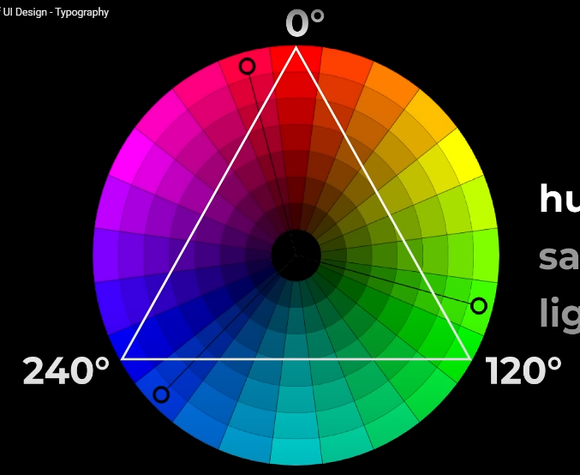
- HSL
  - Hue, Saturation, Lightness
  - 100% gives the most intense version of the colour
  - 0% turns into a greyer variant of the colour
  - 50%, is base colour.
  - 100% is white.
  - 0% is black.
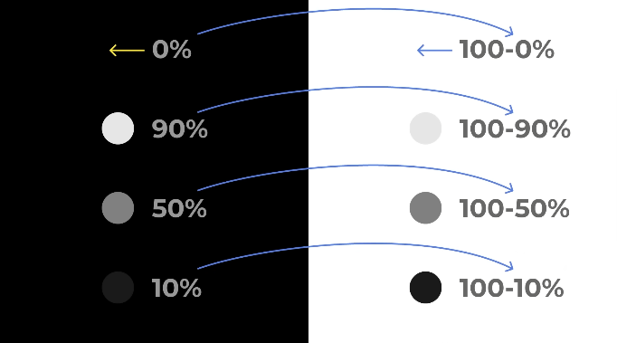
- ALWAYS WORK WITH HSL
- So instead of grabbing a new colour, you can change these aspects.

- TYPSCALE
  - 24px – 1.5 rem
  - 20px – 1.25 rem
  - 18px – 1.125 rem
  - 16px – 1 rem
  - 14px – 0.875 rem
  - 12px – 0.75 rem

- You can pick any of these 3 to make an UI. You can mix colours, fonts and weight (Or anything I’ve stated before.)
- Use common sense whether something needs to stand out. If not sure ask for someone else’s opinion.

COLOUR THEORY
- Hue can be interpreted as origin of a colour. Such as primary and secondary colours.
- Shade is how much black is added to a hue.
- Tint of how much white is added to a hue.
- Tone is a mix of both. Being a mix of a neutral grey to a hue.

- Warm colours:
  - Red.
  - Yellow.
- Cold colours:
  - Blue.
  - Green.
  - Purple.
- Neutral colours:
  - Brown.
  - Gray.
  - White.
  - Black.

- The temperature you use can have a significant impact on your emotion response.

