

**KENYATTA UNIVERSITY**

**DEPARTMENT OF COMPUTING AND INFORMATION**

**TECHNOLOGY**.

BSc Computer Science.

Final Year Project Report.

**ELIM GUIDANCE AND COUNSELING THERAPY ANDROID APPLICATION**

AKINYI A. I AGWANDA

J17/4493/2016

PROJECT SUPERVISOR: MR. DAN OJWANG’

Project Report submitted to the Department of Computing and Information Technology, Kenyatta University, in partial fulfillment of the requirements for the award of Bachelor of Science degree in Computer Science.

2019/2020

# **DECLARATION**

I certify that this project report is my original work and all material herein which is not my own work has been identified. I further certify that no material herein has previously been submitted and approved for the award of a degree in Computer Science by Kenyatta University or any other university.

SIGNATURE: ………………………. DATE………………………

NAME: AKINYI A. I AGWANDA

REG NO: J17/4493/2016

**TITLE OF PROJECT: ELIM GUIDANCE AND COUNSELING THERAPY ANDROID APPLICATION.**

**SUPERVISOR CONFIRMATION:**

This project report has been submitted to the Department of Computing and Information Technology, Kenyatta University, with my approval as the University supervisor:

SIGNATURE: ……………………. DATE: ……………………….

NAME: MR. DAN OJWANG’

**ACKNOWLEDGEMENT**  
I would like to thank the Almighty God for enabling me reach this far and granting me knowledge to complete this project report. I would also wish to convey special gratitude to my able supervisor Mr Dan Ojwang’ for always being there for me and assisting me in whatever aspect I needed not forgetting his words of encouragement. I would also like to express my gratitude to my parents who have supported me both financially and morally to ensure that my research work is a success. I owe special thanks to my lecturers and classmates at Kenyatta University who has been of great support through my studies and have been able to squeeze their time out of their busy schedule to talk to me even on short notice. Lastly I would also like to thank everyone else who made sure that this project reports was a success. God bless you all

# **DEDICATION**

I dedicate my project work to my family and friends. A special feeling of gratitude to my loving parents and siblings whose word of encouragement and push for tenacity rings in my ears. I also dedicate my project work to all my lecturers who have guided me throughout my academic endeavors and imparted critical analytical skills that have enabled me to develop this research.

**ABSTRACT**

Project development is a crucial and fundamental unit in Computer Science. This is because it is used to gauge the practical understanding of the student in most of the units taught during the curriculum. It tests the student’s skills in system analysis and design during project development, entrepreneurship in terms of what solution the student is trying to provide in the current market and system skills development in the language of the student’s choice together with tools used. This project is a Therapy android application. It is an application meant to simplify and automate the mental health services offered in psychological counseling centers including providing support. The system links the client with the therapists by allowing the clients to view the services being offered in the system and allowing them to place their bookings by selecting the therapist of their choice and confirming time and date for counselling. The clients receive notifications as per their bookings after which they are counseled in relation to the mode of service of their choice. The system also provides information related to mental health and wellbeing of human to help people live a healthy and productive life. It also automates report generation for the clients, therapist and the admin in relation to the service requirement.

Table of Contents

DECLARATION i

ACKNOWLEDGEMENT ii

DEDICATION iii

ABSTRACT iv

CHAPTER 1 1

1.1 Introduction 1

1.2 Background Study 2

1.3 Problem Statement 2

1.4 Research objectives. 3

1.5 Project Scope and Limitation of the Study 4

1.6 Justification 5

CHAPTER 2 6

LITERATURE REVIEW 6

2.1 Previous studies on E-therapy. 6

2.2 Discussion and Suggestion 8

2.2 CASE STUDIES: 9

2.2.1 Elim guidance and counseling center. 9

2.2.1.1: Elim Guidance and Counselling System 9

2.4.1.1.1 Functionalities of Elim guidance and counselling system. 10

2.4.1.1.2 Advantages of Elim guidance and Counselling system 10

2.4.1.1.3 Disadvantages of Elim counselling system 10

2.2.2 Therapy software 10

2.2.2.1 Functionalities of CentralReach Software 11

2.2.2.2 Advantages of CentralReach Software 11

2.2.2.3 Limitation of CentralReach Software 11

2.3 The Proposed system 12

CHAPTER THREE 14

METHODOLOGY 14

3.1 Introduction 14

3.2 Application Methodology 14

15

3.3 The stages of SSADM 15

3.3.1 Stage 0: Feasibility Study: 15

3.3.2 Stage 1: Requirement Analysis 16

3.3.4 Stage 4: Physical Design 16

3.3.5 Stage 5: System Testing 16

3.4 Data Collection Techniques 17

3.5 Testing and Implementation Tools 17

3.6 Data Analysis Tool 17

3.7 Time plan/schedule and project budget 17

3.7.1 Gantt Chart 18

3.7.2 Project Cost 18

CHAPTER 4 19

SYSTEM ANALYSIS AND REQUIREMENT MODELLING. 19

4.0 INTODUCTION 19

4.1 ANALYSIS STRATEGY 19

4.1.1 Description of working of Current Systems 19

4.1.2 Tools used for System Analysis 20

4.1.3 Analysis of the Elim manual system 20

4.2 MODELLING OF THE CURRENT SYSTEM. 21

4.2.1 Flowchart modelling of the current system. 21

4.2.3 Use case diagram for the Elim system. 22

4.3 FACT FINDING METHODS 22

4.3.1 Observation 23

4.3.2 Documents and records review 23

4.3.3. Interviews 23

4.4 DATA FLOW DIAGRAMS 26

4.4.1 Logical Data Flow Diagram of the current existing system. 26

4.4.2 Physical Data Flow Diagram of the current existing system 27

4.5 PROPOSED SYSTEM 27

4.6 Feasibility Study. 28

4.7 Requirement definitions and specifications of the proposed system. 28

4.7.1 The User requirements of the proposed system 28

4.7.2 Business requirements of the proposed system. 29

4.7.3 Functional Requirements of the proposed system. 29

4.7.4 Non-Functional Requirements for the proposed system. 29

4.8 DIAGRAMS FOR THE PROPOSED SYSTEM. 30

4.8.1 Use case Diagram for the Proposed System. 30

4.8.2 Flowchart Diagram for the proposed system 31

4.8.3 Logical Data Flow Diagram for the proposed system. 32

4.8.4 Physical Data Flow Diagram for the Proposed System. 33

CHAPTER 5 34

SYSTEM DESIGN. 34

5.0 INTODUCTION 34

5.1 Architecture of the proposed system 34

5.1.1 Components. 34

5.2 System processes 35

5.2.1 Sequence diagram of the proposed system 35

5.3 Database Design for the proposed system 36

5.4.1 Entity Relation Diagram for the proposed system. 39

Entities 40

5.4.2 Physical database design for the proposed system 41

CHAPTER SIX 46

SYSTEM IMPLEMENTATION 46

6.1 INTRODUCTION 46

6.2 Tools Used For Coding. 46

6.2 Testing 46

6.2.1 Functional Testing. 46

6.2.2 Mental Health Self-care application User Interface Testing. 47

6.2.3 Network Testing 47

6.2.4 Performance Testing: 47

6.3 PROPOSED CHANGE-OVER TECHNIQUES. 48

6.3.1 Direct implementation 48

6.3.3 Phased implementation 48

6.3.4 Pilot system 49

CHAPTER SEVEN: LIMITATIONS, RECOMMENDATIONS AND CONCLUSIONS 50

7.1 Limitations 50

7.2 Recommendations 50

7.3 Conclusion 50

4.0 References 52

# **CHAPTER 1**

## **1.1 Introduction**

In the past years, rapid development of E-therapy technology has played decisive roles in changing people’s way of thinking and lifestyles by making it easier to access pertinent information and obtain resources on wellbeing education, awareness and even treatment. The implications of the technology are profound for not only clients’ side but also the counsellors/therapists. Results of empirical studies have indicated that the mental healthcare technology innovation has significantly positive impact on client’s satisfaction and behavioral when dealing with their problems. This could, in turn, improve peoples’ lifestyle by changing the way they deal with their problems. Lately, different applications are helping people to improve on their well-being. Web-based interventions have shown effectiveness across a broad range of mental health outcomes” (Mohr et al., 2013, p. 1). To better service quality there was need of an application which will be able to connect the clients and the counsellors remotely, easy information dissemination and provide effectiveness on data storage and retrieval to maintain a smooth flow of activities.

## **1.2 Background Study**

Mental healthcare and wellbeing are most of the global challenges for humanity. According to the constitution of the World Health Organization (WHO) the highest attainable standard of wellbeing is a fundamental right for an individual. Healthy individuals reduce the pressure on the already overwhelmed psychological counseling centers and even hospitals. They also reduce the allocated budgets from the government and reduce workloads on charity organizations. To keep all individuals healthy an effective, affordable and readily accessible modern E-therapy system is therefore important.

Due to gradual technological improvements, a continuous change is occurring in most industries including the psychological counseling industry. In recent times the counseling system used in this centers was normally based on face to face communication where the therapist and the client had to share the same physical space. This proved to be difficult since the clients had to visit the vicinity and wait in long queues to get the counselling services and also for the underprivileged the services proved to be expensive hence large number of deaths. The therapists also invested lots of their time updating reports about each client’s health after counselling and also recording information about their clients’ progress by filling out their reports by hand. The systems used were not easily portable and consumed lots of power. They also required to be used next to the client hence the mobility of the client was limited and occupied a large floor space. This increased burden to the therapists and slowed down the counselling processes.

Lubomira, R (2015) states that, “digital is really transformative in the way companies operate today, it has a big impact on business and on the way you interface with consumers.”

A study was therefore conducted in Elim guidance and counseling center at Kahawa Sukari environs to investigate on these issues and identify a better solution.

**1.3 Problem Statement**

The distance travelled by some clients to reach the center to get help on wellbeing was long and they also had to wait for long queues before they were taken care of. In addition, the counselling services were expensive and for the underprivileged, this type of treatment remained unaffordable. Therapists also passed through hard time providing treatment to their clients because all records were kept manually and therefore retrieval of information became more difficult. Relying on face to face mode of service was also unproductive because taking care of emergency cases was difficult. Use of manual system to store information was tedious, unreliable, space consuming, insecure, data inconsistency, limited data sharing, high cost, prone to damage, misplacing and time wasting.

## **Research objectives.**

* To carry out literature survey on the related existing systems to know their functionalities, strength and weaknesses.
* To explore the mental health-care solutions used in different psychological counseling centers.
* To design, implement and test a therapy android application that would evaluate the most important and critical information to be accessed by the clients and the therapist and provide online counseling.
* To validate the developed android application as an efficient E-therapy system.

## 

## **1.5 Project Scope and Limitation of the Study**

This project was aimed to cover the requirements of psychological counseling centers to serve as a counselling therapist by linking people to the therapist, keeping track of the counselling sessions, easy dissemination of information and providing an environment which would be user-friendly to enable clients to interact with it freely. It also uses notifications, audio calls, video calls and chart services. The completed system aims at reducing the troubles the clients went through when using the manual system. In recent technology, there is use of several gadgets and apps that help to attack stress such as headspace, Pacifa, Muse and Stress Thermometer. The use of these gadgets and apps is very expensive and due to the high cost, the project did not authenticate using them.

## **1.6 Justification**

Therapy android application was developed to address the manual system that the center was using. The android application provides automated data input and storage. It has a database which is able to keep track of the counselling sections and providing easy update of information

Primarily this system provides order in relation to psychological counseling services that are quickly scheduled in the database and reduce time wasted in the storage and retrieval of information concerning the therapists, clients, and counselling sessions that have already taken place. The system provides a user-friendly environment that ensures that each client’s experience is easy, effortless and pleasant. Clients’ problems and information are secure, private and confident hence no fear of mistrust. Clients are also able to give a feedback if they have been helped or how to improve to improve the system. People can also book appointments with the therapist in case of major challenge within their vicinity and services are rendered anywhere at a small fee. This has led to improvement in psychological counseling centers hence benefiting the Elim guidance and counseling center as a whole.

# **CHAPTER 2**

# **LITERATURE REVIEW**

**2.0 Overview**  
The reflection and collection of the literature review to this chapter attempts to present a  
review of various previous studies that have been undertaken in relation to improvement of mental healthcare and controlling deaths to reasonable ratios in developing countries. Various studies on this subject are reviewed herein to provide a broad perspective on how to  
technologically improve and efficiently offer better mental healthcare services in psychological counseling centers in Kenya.

## **2.1 Previous studies on E-therapy.**

E-therapy is defined as a licensed mental health care professional providing mental health services via e-mail, video conferencing, virtual reality technology, chat technology or any combination of these, Sucula and colleagues (2012). In e-therapy (Bloom, 1998; Ainsworth, 2000 in Manhal-Baugus, 2001:4): ..*client and counselor are in separate or remote locations and utilize electronic means to communicate with each other.*

Mental health refers to people cognitive, behavioral, and emotional wellbeing - it is all about how people think, feel, and behave. Mental health is a state of well-being in which the individual realizes his or her own abilities, can cope with the normal stresses of life, can work productively and fruitfully, and is able to make a contribution to his or her community (World Health Organization, 2008).

Many people, if not all will have no doubt that lack of information – including lack of awareness on basic information, is having profound and adverse impacts on mental healthcare in the developing countries. The average lifetime risk of deaths in the developed world is 1 in every 8,000 and 1 in every 450 for developing countries, less than 0.4% of the world’s deaths occur in the developed countries. Francis Bacon acknowledges that “education is power”, and as per the scientific studies published by The World Health Organization (2004) explains the main causes of deaths and compare the burden of each cause. It states that depression, anxiety and stress are the major causes to death in the developing countries due to death of close family members, divorce, financial obligations, lack of, losing, failing, relationship issues, emotional problems such as anger, guilt, social misfits due to low self-esteem etc. The main factors that led to all these problems mentioned were the socioeconomic variables, lack of published information about the cultural and political determinants on mental health problems. It’s very evident that the power of knowledge is a an important resource for preserving valuable heritage, learning new things, solving problems, creating core competences, and initiating new situations for both individual and organizations now and in the future.

In a report by Dr. Jennie Odhiambo, a psychologist in a mental hospital in London (Daily Nation, 2013) claims that most Kenyans don’t trust each other. They prefer keeping to themselves and this leads to adverse effects when they can’t manage and hold up their feelings anymore they let it out and the results are always devastating. People do not routinely report their mental health problems to medical and mental health practitioners.3,4 Patients often withhold information because of shame or fear of stigmatization, with the result that many people with mental health problems will never seek or engage in treatment.5–7 The gap between need and actual treatment received for mental disorders is universally large. Kohn et al.5 examined this treatment gap in the regions studied by the World Health Organization. Gaps were estimated to be 32.2% for schizophrenia, 56.3% for depression, 56.0% for dysthymia, 50.2% for bipolar disorder, 55.9% for panic disorder, 57.5% for generalized anxiety disorder,57.3% for obsessive–compulsive disorder, and with 78.1% the widest for alcohol abuse and dependence. Reasons for not receiving treatment were access barriers, delay in treatment, stigma associated with treatment, patients not having time, and/or not knowing where to go for services.

Internet – based treatment was found to reduce panic, general anxiety levels, and fear of panicking for individuals with panic disorder (Richards, J., Klein, B., & Carlbring, P., 2006). The Internet offers opportunities for improving access to therapeutic interventions that are easy to engage in and are without threshold requirements.8–10 Moreover, the Internet serves a larger and more diverse segment of the population with mental health problems, compared to regular face-to-face treatment services.11–14 As of 2007, 69.7% of people in the United States, and about the same percentage in West European countries have Internet access (www.internetworldstats.com). Involvement in therapy via the Internet arouses some resistance, because of the idea that anonymity interferes with the development of a meaningful therapeutic relationship. However, it has been reported that, in general, patients as well as therapists experience a positive relationship during Internet therapy, 11, 15, 16 suggesting that it is possible to form a meaningful relationship.

In the recent times therapy services in Elim involved the use of manual system and a web-based system. In manual usage a counsellor and a client shared same physical space and counselling was done through face to face. This proved to be very inconvenient and inaccessible due to clients facing a lot of difficulties in reaching the mental health care center and the services being unaffordable for the underprivileged people.

The storage of these clients’ records was also manual and therefore, the therapist would have to go through a lot of files and other documents before they could get a specified information they needed for a given client. Since there was a large number of clients as compared to therapist’ ratio, a lot of errors were experienced which led to confusion and hence proved hard to track a client that needed special treatment. Manual storage which was prone to destruction and loss made the process of referencing problematic.

The web-based system used in Elim was not user friendly, there was no linkage between the clients and the therapists in that they could not have a one-to-one communication and it also contained little information in relation to mental health self-care hence people still had to visit the center.

The advances in computer technologies have affected everybody’s daily life. Computers support and assist almost every single human activity. Traditional decision support systems (DSS) focus on computerized support for making decisions with respect to managerial problems (Turban 2005). With introduction of android technology, one may reconsider the existing methods and redesign or modify existing systems to meet new challenges. These changes have not left behind mental health self-care center activities which have been affected in a great way. This makes them to adapt to new technologies and modify their systems to handle various tasks in a simpler way.

**2.2 Discussion and Suggestion**  
Major Concern in the current mental healthcare system is the relationship between the numbers of clients versus the therapists’ ratio and mental healthcare centers limits. Through a report carried out by the Kenya National Bureau of Statistics done in 2019, indicated that there were 179 therapists per 100,000 clients which is way below the standard therapist patient ratio of 1 to 400 clients. More mental health problems have increased even with more and more cases of youths suffering from murder and suicidal cases while the healthcare centers and therapists remain at constant rates. This brings about imbalance and increase in clients per doctor ratio hence proving it hard for efficiency and quality of service in the psychological counseling centers. However, adoption of modern android technology platforms, in my opinion may help to reduce these imbalances to greater degree. While determining the characteristics of the peoples’ population that will be best served by the system – including both demographic and psychographic characteristics, it is realized that the estimate of the total size of that population has a great potential of growth. Also considering the estimate of the degree to which this mental health centers already serve this population and the size of the opportunity if the current system was able to accommodate this growing population with a better and improved system, no doubt hospitals will be able to better meet the needs of their core objectives.

## **2.2 CASE STUDIES:**

## **2.2.1 Elim guidance and counseling center.**

Elim guidance and psychological counselling center was using the manual based system computerized in a building hence needed lot of effort and consumed a lot of time. Therapists and clients shared the same physical space and counselling was done through face-to-face method. This therefore meant that all activities were maintained in the building and therefore clients had to travel to get treatments. Maintaining the procedures was also a challenge since all records were handwritten on paper.

When it comes to storage, records and information were stored in hard copy in form of papers or files in different places. In this case transferring of data was difficult as the therapists had to carry them everywhere and also getting the records of a client with emergency problems was difficult. Due to the tangible nature of the manual storage, maintenance was difficult since they had to be taken care of regarding many external environment factors. More shortcomings from the use of manual system include taking a lot of space, damage and misplacing, a lot of access time, lack of security and high cost (Philip, 2016 September 10.)

### **2.2.1.1: Elim Guidance and Counselling System**

Elim guidance and counselling system <http://www.elimpsychologicalservices.org>



Figure 1: Elim guidance and counselling system

#### **2.4.1.1.1 Functionalities of Elim guidance and counselling system.**

Elim guidance and Counselling System as shown in Figure 1, provided information in relation to the services provided by the center, its location and information about the center. It also included some of the mental health self-care notes to be assessed by the clients.

#### **2.4.1.1.2 Advantages of Elim guidance and Counselling system**

As shown in figure 1, the system had visible buttons and check boxes which enabled the clients to get access to information easily and also allowed for easy navigation.

#### **2.4.1.1.3 Disadvantages of Elim counselling system**

It’s clearly evident in Figure 1 that the system had very poor customer service because there was no connection between the clients and the therapists and therefore treatment of those clients with emergency problems was very challenging. The software was also unrealistic and incomplete because several programs couldn’t open when one clicked the icons. There was also poor email program and therefore there was no immediate feedback. Database and accounting were not integrated therefore keeping clients’ record and billing records were manual. The software also crashed frequently while trying to print reports due to runtime errors.

### **2.2.2 Therapy software**

CentralReach Therapy Software <https://www.softwareadvice.com/mental-health/centralreach-profile/>

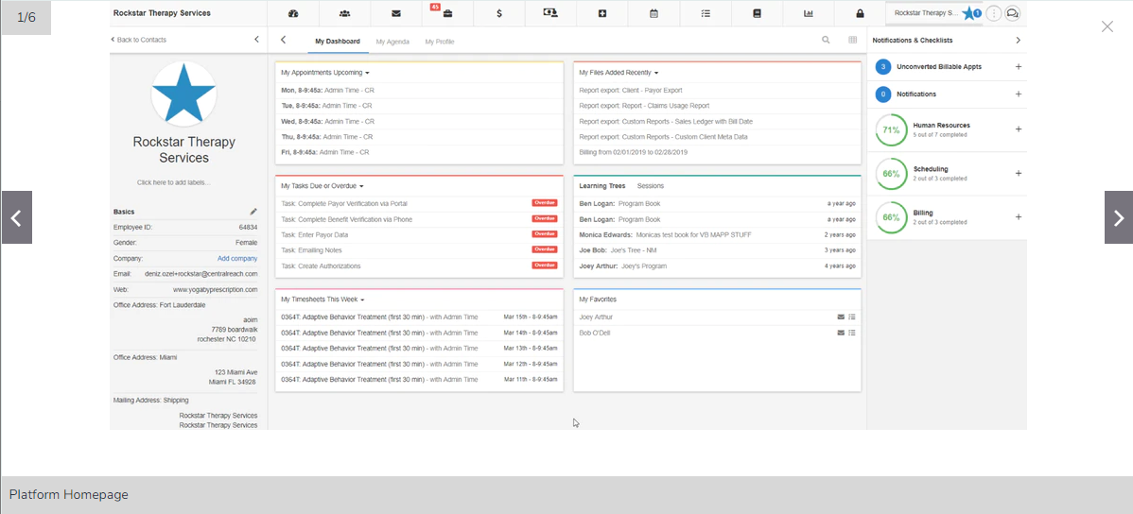

Figure 2: Therapy Software

#### **2.2.2.1 Functionalities of CentralReach Software**

CentralReach is a provider of electronic health records and practice management solution for the behavioral health industry. It includes features to manage billing, claims, scheduling, reporting, clinical documentation, credentialing, client intake and a patient portal on a single platform.

#### **2.2.2.2 Advantages of CentralReach Software**

This software is advantageous because it increases efficiency by automating Scheduling. It is designed to automate time-consuming scheduling tasks for example it allows clients to book appointments online, therein reducing time wasted moving to the therapy centers.

#### **2.2.2.3 Limitation of CentralReach Software**

The system has too many buttons and check boxes hence taking up a lot of space on the software. The organization of the interface also looks complicated and not user friendly, making it difficult for the clients to understand and also appears as a low-quality system. The font is not user friendly and therefore does neither attract nor hold the clients / therapist attention.

In the proposed project, the goal is to have user friendly interface hence all these limitations from the previous software shall all be solved.

Developers have some challenges developing some of these interfaces, due to incompatibility, cost, time and complexity (Dix, Dix, Finlay, Abowd & Beale, 2013.) .The mental healthcare application developed was able to cover all shortcomings and the areas of requirements making it useful and reliable

## **2.3 The Proposed system**

The proposed system was the use of an android application to provide mental health treatment by providing counselling sessions and any related services online. Any user interested with the software would access it through downloading from the Google play store and installing it in their smartphones. The system is intended to link the therapist with the client. Client will signup /login, view the services being offered in the system and book a session through selecting a therapist of their choice and confirming the time and date for the session. The client would get notification from the Admin one hour before the counselling session and then would be counseled by the therapist depending on the chosen service mode. The therapist will also be able to generate reports to the client’s as per the medication provided to the client. The system contains different service modes for example chart and video services through the use of whatsapp and audio calls. The therapist and the clients will use it for sharing and communication. It also contains a face to face service mode so that the clients who book the service mode will be able to meet the therapists efficiently and effectively without waiting for long queues. The system also enables use of audio calls, notifications and reminders to notify the clients one hour prior to the start of session. Data is in firebase database and therefore the clients will get easy access and review of the relevant information in relation to the problem they are facing hence problems solved effectively.

Organization is the key to electronic file management (Susan, 2018 November 05.) It is very important to know where a document is stored and whether it is up to date. The application helps to find what information someone is looking for even after a long time of initial storage

The application helps mental health care through the following ways;

* Manage the whole counselling process and keeping track of counselling sessions.
* The system saves both clients’ and the attached therapists’ time as they won’t be needing to meet physically. All they need is to download and install the application in their smartphones.
* The system also enables clients to book appointments for the counseling sessions, receive notifications and counseling sessions online.

**CHAPTER THREE**

# **METHODOLOGY**

## **3.1 Introduction**

This chapter mainly covers the methodology used, techniques used to collect data,

tools used to analyze data and processes, tools to implement, schedule, the budget and sources of information. The development methodology used was the Structured Systems Analysis and Design Method. This methodology sets out a cascade or waterfall view of a system development in which there are a series of steps, each of which leads to the next step. SSADM also insists on improved quality, detailed documentation of the development stages and reusability for similar projects that follow.

SSADM methodology was developed in Britain in the 1980s and is used in logical data modelling, entity event modelling and dataflow modelling in a six-step process to determine how a system must be created and updated (Bizfluent, 2017). The reason as to why this methodology was chosen is that, the deep and thorough analysis of the system greatly reduces the chance of any information being misunderstood at the beginning stages of the project and user involvement. It also puts emphasis on analyzing the user needs.

### **3.2 Application Methodology**

There are several types of methodologies used in software development. They include spiral, waterfall, Rapid, SSADM, DSDM, prototyping, RAD and others. Each methodology has its advantages and drawbacks. SSADM methodology was considered to be more advantageous than the other methodologies for the project. The spiral methodology is a risk-driven model. It is based on risk pattern of a given project. Waterfall methodology is a sequential design approach. Waterfall methodology does not provide room for communication between the stakeholders and the developers in between the phases. Agile methodology assists teams in response to the unpredictably of developing software. It uses sprints which are period allocated to a particular phase. This limits the project thus no additional information could help.

Structured systems analysis and design method (SSADM) methodology was the proposed methodology for the project because it divides the project development process into; stages, steps, modules and simplified tasks thereby availing a framework for describing projects in a fashion suited to effectively managing a project contrary to waterfall software development life cycle. SSADM Reduces any chance of information being misunderstood at the early stages of the project due to deep and thorough analysis of the system. It also improves project management control by simplifying the use of computer-based tools to offer project support. ItEnsures creation of maintainable and resilient systems and code supported through prototyping and progressive development of systems.

Requirement Specification

Analysis

Implementation (Coding)

Design

Testing

## 

## 

Figure 3: diagram illustrating SSADM

### **3.3 The stages of SSADM**

#### **3.3.1 Stage 0: Feasibility Study**:

Refers to an assessment of the practicality of a proposed plan or method. The feasibility methods considered in the study were:  
- ***Technical feasibility***- investigates the technical requirements of the proposed system  
development process. Here the developer did set out to incorporate the necessary technical tools and materials necessary in development of a functioning E-therapy system. These included: Materials such a computer and the software programs required to develop the software product, research materials etc  
- ***Economic feasibility***- checked the profitability of the proposed project, in terms of whether the proposed system would be able to effectively handle the counselling sessions in an efficient and professional manner without incurring any problems with the clients or losses thus in the long term benefitted all stakeholders associated with the proposed system.  
- ***Operational feasibility***-tested whether the proposed new system met its intended requirements as well as solving the existing problems. The developer undertook operational analysis, through gathering requirements from the end users such as the manager, customers and therapists, offering insight on how the proposed system was to be improved to solve the problems and issues that were existing.

#### **3.3.2 Stage 1: Requirement Analysis**

Involved identifying the requirements and needs of the system and modelling these needs  
in terms of the processes carried out. For the proposed system, the developer investigated the use of Therapy system in Elim, noting how they worked and how they could possibly be improved.

**3.3.3 Stage 2&3: Requirement and Logical System Specification**

Emphasized on determining system events, functions and data through citing and implementing the functional and non-functional requirements of the proposed system. It also entailed the creation and assessment of the technical options and logical design of the system. Tools such as Data Flow and Entity Relationship diagrams were used to create the logical structure of the proposed system.

#### **3.3.4 Stage 4: Physical Design**

The logical system specification and technical system specifications was put in use to  
design and create a physical database as well as a set of program specifications. Firebase  
was used to create and implement the system’s database.

#### **3.3.5 Stage 5: System Testing**

System Testing was conducted on a complete, integrated system to evaluate the system's  
compliance with its specified requirements. The Testing methods that were carried out on the developed system included Unit Testing, Functional Testing and Performance Testing. In addition, Maintenance was carried out to ensure smooth and consistent running of the developed system.

### **3.4 Data Collection Techniques**

The following are the forms of data collection to be used;

**Interviews**

During the data collection of the user requirements, the developer had a face to face conversation with the mental health care specialists, clients and the people involved in the mental health care for more information and there take on the application.

**Observation**

The developer carried out an observation on how the Elim guidance and counseling center ran its operations without the computerized method and what order they followed.

**Documents and Records.**

Documents and records included going through the data stored in files when counselling takes place, meeting minute’s attendance details, finance book.

### **Testing and Implementation Tools**

* **Operating System**  
  Microsoft Windows 10 Pro
* **Development Platforms**  
  Android Studio to write code for the android application. This is because it offers various tools and libraries hence once can easily integrate and tweak a mobile app according to his/her business needs. Firebase for creating database, analyzing, storing and hosting because it helps in building rich, collaborative applications by allowing secure access to the database directly from client-side code. Data is also persisted locally, while offline and real-time events continue to fire hence giving the end user a responsive experience.
* **Hardware Tools**  
  Dell Laptop, USB Drive for storing backups and a Printer for producing hard copy documentation.

### **3.6 Data Analysis Tool**

The developer used excel worksheet to compute data.

### **3.7 Time plan/schedule and project budget**

The developer proposed time schedule and the budget for the proposed system would be as follows;

### 3.7.1 Gantt Chart

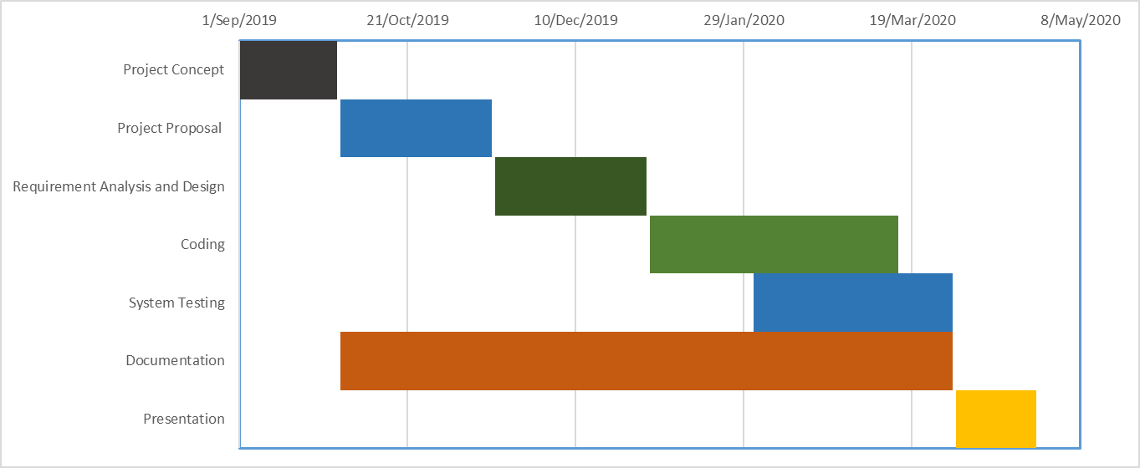

Figure 4: Project Schedule

### 3.7.2 Project Cost

|  |  |  |
| --- | --- | --- |
| NUMBER | ITEM NAME | COST (Ksh) |
| 1 | Commuter | 3,000.00 |
| 2 | Research Material | 4,000.00 |
| 3 | Laptop | 40,000.00 |
| 4 | Printing and Binding Services | 1000.00 |
| 5 | Flash Disk | 750.00 |
| 6 | Internet Services | 3,000.00 |
| 7 | Miscellaneous | 1500.00 |
| TOTAL AMOUNT |  | **53,250.00** |

# **CHAPTER 4**

# **SYSTEM ANALYSIS AND REQUIREMENT MODELLING.**

## 4.0 INTODUCTION

System analysis is the process of gathering and interpreting related facts, identifying the challenges and breaking down a system into components. System analysis was performed to study a system or parts of the system to identify its aims. System analysis was also used as a problem-solving technique to improve the system and ensure that all the sub systems were working properly to meet their goals.

This chapter describes requirement modelling techniques and the methods used to visualize and document the new system. It also describes the system requirements and the fact-finding techniques which included observation, documentation review and interviews.

The analysis phase has two stages:

1. **Analysis Strategy** – Involved the study of the current situation and entailed envisioning  
ways of developing the android application.  
2. **Requirements Gathering**– Involved the analysis of information gathered bringing about the concept of the new developed system

The developer used the structured systems analysis and design method (SSADM) methodology. The reason of adapting SSADM is because it involved investigating the Elim guidance and counseling system that was being used and determining the functional requirements and non-functional requirements of the proposed system. Listed below are the SSADM stages as discussed in CHAPTER 3:

1. **Feasibility Study**: Stage 0
2. **Requirements Analysis**: Stages 1
3. **Requirements and Logical System Specification**: Stage 2&3
4. **Physical Design**: Stage 4
5. **System Testing:** Stage 5

# **4.1 ANALYSIS STRATEGY**

# **4.1.1 Description of working of Current Systems**

Elim guidance and counselling center had several clients seeking for counselling services on a daily basis. The center was using manual system and web-based system. For the manual system, counselling was done through face to face where both shared same physical space. Clients booked appointments for the counselling sessions and the management had to keep the records for the appointments made by clients and assigning them to the available therapists. Data was obtained manually, stored manually and file traversing also done manually hence in case of any retrieval the therapists had to go through all the documents one by one.

Each and every clients’ details, were obtained through filling a book that required their name, mobile number, gender, residence, and age. When the counselling session took place all the records were kept on file and cash payment method was used.

The web-based system in Elim provided only information relating to the center, services offered by the center, its location and the contacts to enable clients to reach the center.

**4.1.2 Tools used for System Analysis**Tools that were used to analyze the system used were; Data Flow, Flow Chart and Use Case diagrams. They were used to describe the current system and to determine the requirements of the proposed system through analysis of what was happening in and out of the existing system.

### **4.1.3 Analysis of the Elim manual system**

The Elim manual system was running its activities manually which raised a concern due to several inconveniences. The client had to visit the center and checked with the manager the availability of a given therapist to provide counselling sessions. The manager then noted down the appropriate time or day the client would have to meet the therapist for counselling services. The clients made their payments in cash after receiving the counselling services. These financial records were kept manually in a financial book of which it was only updated by the cashier.

The current system has the following problems;

1. One had to visit the center and wait for long queues before he/she could get the services he/she needed. This proved to be very inconvenient.
2. Records were kept manually on a book which at times got misplaced hence loss of productivity.
3. The management could receive proper feedback about their services and therefore the chance for expansion and improvements were limited.
4. At times clients who made appointments and bookings couldn’t get their services due to some unread messages and emails concerning booking.

## 4.2 MODELLING OF THE CURRENT SYSTEM.

### 4.2.1 Flowchart modelling of the current system.

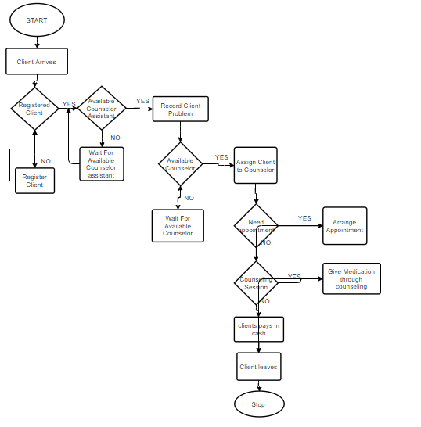

Figure 5:Elim Flowchart Diagram.

Figure 1 shows the main activities that took place in Elim guidance aand counseling center. When a client arrived to the center, he/ she went through registration process and when was confirmed as a registered client, the receptionist checked the availability of available counselor assistance and the client was directed to her. The counselor assistance recorded client problems and assigned the client to the available counselor. Counseling session took place to the client who needed treatment through counseling process after which he/she payed for the counseling session to the cashier. The client then leaved to provide space for the next available client.

### **4.2.3 Use case diagram for the Elim system.**

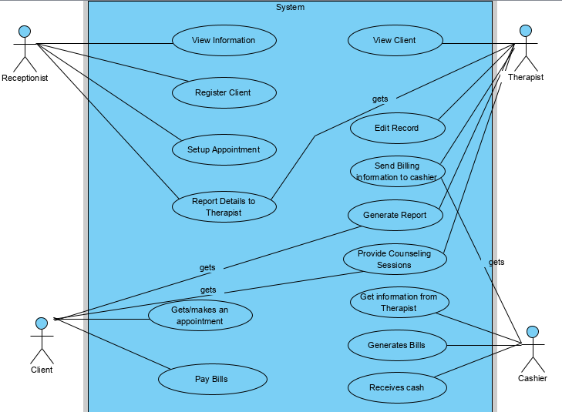

Figure 6: Use Case Diagram of Elim Mental Health care system

Figure 2 is a simplified depiction of how the Elim system was working. It showed the step by step process that took place in Elim guidance and counseling center.

The receptionist registered clients, viewed any information related to the clients, sets up client appointment and also reported all the client details to the therapist. The clients’ booked appointment depending on the day or time they wanted to receive counseling sessions and the appointment was approved by the receptionist. The clients got the counseling sessions and after, payment process took place through the cashier. The therapist viewed client information, edited client record and health condition, provided counselling sessions to the clients, generated reports and sent billing information to the cashier. The cashier got client information from the therapist, generated bills and received cash.

## **4.3 FACT FINDING METHODS**

The following data collection tools were used to collect information on the existing system.

### **4.3.1 Observation**

This technique involved taking note of the on-going activities in the mental health-care center without having to interact with the various individuals. The researcher went to Elim guidance and counselling center and made the observations that were necessary. The various observations included taking note of how counseling sessions were taking place, how the client’s details were noted down in book and kept, how payments were made. The whole process was noted to be manually functioning where clients have to visit the mental health care to make their appointments or rather get their counselling session if there was no other client being served. The clients paid for their services to the cashier in cash. Those who booked were informed on the time and dates for the counseling services.

### **4.3.2 Documents and records review**

This technique involved analyzing the existing system by having to go through various documents which were found necessary for instance the clients counseling health records to know how the client’s details were recorded and kept, the registration book held by the receptionist to know how the registration process took place, receipts that were issued to the customers. Some of the documents that were reviewed by the researcher were; the spread sheets and the receipts.

### **4.3.3. Interviews**

This technique involved asking the necessary stakeholders that used the manual system. This method was useful since the researcher got to know the system well from the people who underwent through the whole process. The following were the parties interviewed: the clients, the therapist, the receptionist and the cashier.

The various questions asked were;

To Client:

1. How long do you travel for counseling medication?
2. Do you always get the service you needed at your preferred time?
3. What total cost do you incur for both travelling and counseling services?
4. What do you do when you have an emergency problem that need to be solved immediately and you are not within the counseling vicinity?
5. What do you think should be done to improve on the services?

To the Therapist;

1. Which method do you use to counsel clients especially those with emergency problems?
2. How much time do you take when looking for a given record?
3. How do you keep clients records safe from catastrophe?
4. How does counseling sessions take place normally?
5. Is there any social media platform you use to communicate with clients apart from visiting the vicinity? And if yes, how effective it is?
6. What challenges do you experience when dealing with the clients?
7. How do you maintain clients’ privacy and confidentiality?

To Receptionist.

1. How do you keep your daily schedule organized?
2. What type of software do you use to keep the client’s records?
3. Do you schedule appointments?
4. What difficulties do you face with clients and how do you handle them?

To Cashier.

1. How do you handle your clients’ money?
2. Do you maintain client accounts? If so, what type of system do you use?
3. Do you provide receipt after payment?

From the interview it was noted that;

Most clients incurred a lot of cost travelling to Elim guidance and Counselling center for the counselling sessions. The payment of this counseling services was also unaffordable for some clients and therefore not getting the required services as they only got the services according to what they could manage to pay for. Due to high client ratio to that of therapist ratio, clients at times did not get the services they needed because therapist were forced to increase their counseling speed in order to take care of a large number of clients. The long-distance clients claimed that they consumed a lot of time travelling to the center. Those clients with emergency problems used to call the therapist where by some of them claimed it wasn’t effective because the business phone number provided to them was always busy and also consumed a lot of time.

The therapist used face to face counseling method where they shared the same physical space with the client. This proved to be time consuming because both the client and the therapist had to meet physically. The therapist also stored the clients’ records in files and filled them in cabinets hence lacking a secure way to store the records in case of catastrophe. The therapist took quite some time in order to locate given files that were needed for the clients and therefore dealing with emergency problems according to them was somehow difficult because there some issues that needed attention immediately (suicide cases). The manager used a lot of resources buying materials for example books and files for record keeping. The center only used email as a social media platform to counsel their clients and according to the therapist the media platform was not that much effective because sending multiple replies and feedbacks to clients was difficult and tiresome.

The registration process by the clients took place in a computer and the receptionist stored the registration details in excel worksheet. Scheduling appointment was done manually. This proved to be time consuming when a receptionist had to search for a client registration details before he/she was given an appointment. The receptionist claimed to have been facing lots of problems with the clients when scheduling appointments because the registration details of each and every client have to be located before, she could set an appointment.

The cashier received cash payment and also a receipt written manually. The cashier claimed to have lots of problem because handling all the client’s money was a challenge due to theft cases and also one was needed to be more careful not to misplace any amount. All the client payment records were stored in a financial book hence prone to damage and misplacement.

## 4.4 DATA FLOW DIAGRAMS

### 4.4.1 Logical Data Flow Diagram of the current existing system.

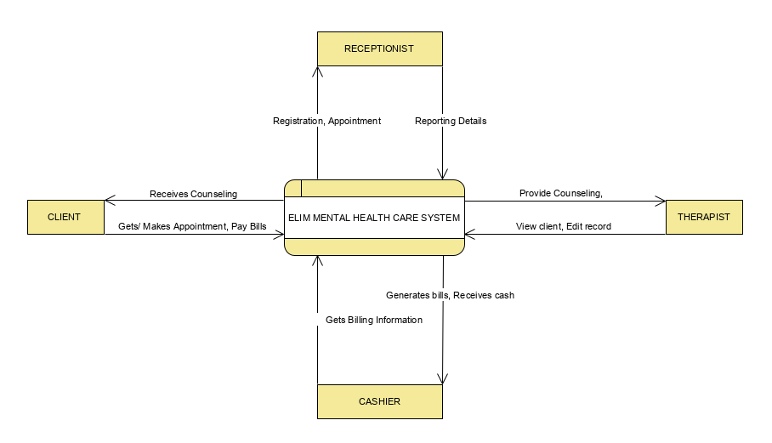

Figure 7: Logical Data Flow diagram of the Current Existing System

Figure 3 shows how the external entities in Elim guidance and counseling center interacted. The Receptionist registered clients, scheduled appointment and reported the details to the therapist. The therapist viewed and edited all the client details and recorded them. He also provided counseling session. The client made and got appointment, got treatment through counseling and paid the bills to the cashier. The cashier generated bill after getting the billing information from the therapist and also received cash from the client.

## 4.4.2 Physical Data Flow Diagram of the current existing system

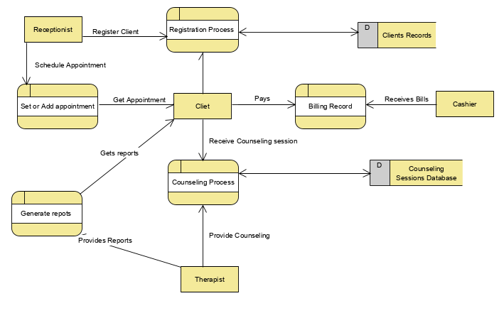

Figure 8: Physical Data Flow Diagram for the Current Existing System

Figure 4 shows the activities that took place in Elim center. When a new client arrived, the receptionist registered him/her and kept the records in a file that acted as a database. The client asked for appointment depending on the day he/she wanted to meet the therapist. The receptionist scheduled the appointment and directed the client to the therapist for counseling. After counseling, the client generated report and gave them to the client. The cashier then received the cash from the client after counseling process had taken place.

## **4.5 PROPOSED SYSTEM**

The proposed system was an automated therapy android application that would enable manage the data and provide counselling sessions online. The android application helps to maintain a smooth flow of activities within the system. Clients’ details are collected, but instead of manually inputting, the process is automated. Counselling Sessions also take place online and the therapist keeps track of the counselling sessions hence easy dissemination of information.

## **4.6 Feasibility Study.**

1. **Economic feasibility of the proposed system**

This was measured by the extent to which the utility value was received during the entire project or product life that exceeded the proper cost incurred in creating the utility value. With the implemented system it is of economic importance in that it saves on the cost incurred in the purchases of records books as well as there will be more increased clients due to the online bookings and counseling hence increasing the revenues earned.

1. **Technical feasibility of the proposed system**

The implemented system simplifies the way clients use the system by making the interfaces easy to use and fast to learn. The interfaces are user friendly thus reducing the inefficiency brought about by the complex user interface.

1. **Operational feasibility of the proposed system.**

The implemented system ensures smooth running of operations for the mental health-care clients through the use of simple user interfaces. Reducing the number of interfaces that one has to click to get the counseling sessions and also to view information through the knowledge-based system was one of the main aims taken into place by the implemented system. Therefore, navigating through the system is easier for the users.

# **4.7 Requirement definitions and specifications of the proposed system.**

System Requirements refer to what is expected from using the system. The Use requirements describes what the users do with the system, such as what activities that users must be able to perform. The business requirements describe why the organization were undertaking the project. The Functional requirements refer to technical details that define what a system is supposed to accomplish while the non-functional requirements refer to what the system should have in order to run efficiently in terms of operation, performance and security.  
The objectives of the proposed system were:

### **The User requirements of the proposed system**

* Need of users to comfortably make their appointments for the counseling services and also get the counseling sessions regardless of their location at the time.
* Need of users to send their feedback about the services they received.

### **Business requirements of the proposed system.**

* Need for a system to automate the booking and counseling process.
* Need for a system to ensure efficient keeping of records.
* Need for a system that will ensure client feedback.

### 4.7.3 **Functional Requirements of the proposed system.**

* Need of the system to allow the user to create a new account with the first name, last name, email, username, and password.
* Each client must be a registered user and therefore must use the username and the password.
* Each client of the user’s address must have a name that is unique and emails must be valid.
* Each client must be a registered member to view the mental health self-care list.
* The administrator must register therapists using their first name, last name, email, username, and password.
* Each registered client must have access to a private space (my position).
* System should accept payments via the mobile money payment method namely M-PESA.
* Need of the system to send notification to the client before the counselling session takes place.
* System Manager must be able to edit both the client and the therapist.

### 4.7.4 **Non-Functional Requirements for the proposed system.**

**Performance**: This mental health self-care application provides good performance. Information can be retrieved from any android mobile easily.

**Security**: The application provides high security. It helps the clients and the therapist to keep their data secure and confidential. For database security, the developer will use firebase Database because without authentication firebase does not allow to anonymous to read and write data in database.

**Reliability**: The mental health self-care will track all the counselling sessions using the knowledge base and therefore easy dissemination of information to clients.

**Usability**: In this mental health self-care system degree of usability is very high. This is because the app is useful and friendly for user.

**Adaptability**: This app can be installed on devices having android operating system.

# **4.8 DIAGRAMS FOR THE PROPOSED SYSTEM.**

### **4.8.1 Use case Diagram for the Proposed System.**

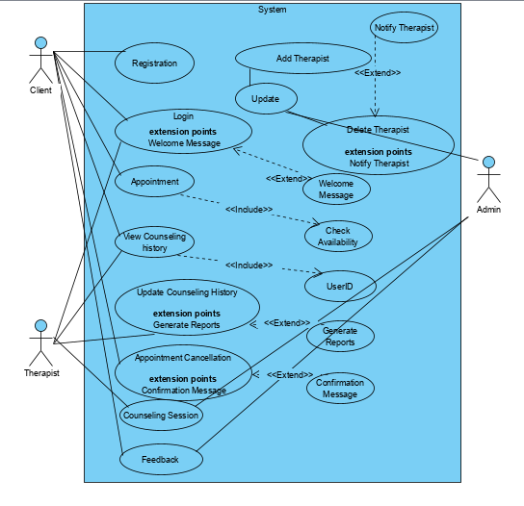

Figure 9: Use case diagram for the proposed system

Figure 5 shows the step by step process of the proposed system. The client registers in the system, logs in and receives a welcoming message. He/she then decides to either book appointment by checking the availability of a therapist at a given time. In viewing counseling history, the client will be permitted to enter a UserID. The client is also allowed to cancel his/her appointment if there are inconveniences with the time booked for counselling sessions. Client receives counselling session from the therapist online and also provides feedback to the system in relation to how he /she have been served. The therapist logs in the system, provides counseling session to the client, views counseling history and also updates them that includes generating reports to the clients. Through the firebase, the admin is able to control the system by updating all the records which include adding or deleting the therapist. The therapist gets a message notification when added or deleted. The admin also views counselling sessions and provides feedback.

### 4.8.2 Flowchart Diagram for the proposed system

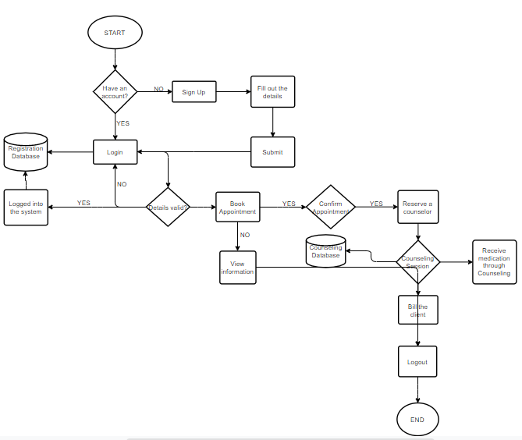

Figure 10: Flowchart Diagram for the proposed system

Figure 6 provides detailed activities of the proposed system. When a client downloads and installs the android application, for the first time he/she will be required to sign up with his/her correct details after which the details will be stored in the database. The client will then login in to his account and the details will be matched with the one in the database. If the details are correct, he/she will be directed to another use interface either to book an appointment with the therapist or to just view information from the knowledge-based system. Those clients who have booked appointment will receive appointment from the client online, billing information will be send to them and after payment, reports will be sent to them where they will decide to print or just view them online.

### 4**.8.3 Logical Data Flow Diagram for the proposed system.**

E-therapy system is the point of consideration. In figure 7, it is represented as a single high-level process.

The therapists and the clients will access the system by creating and login into their personal accounts. The clients will then be able to view the therapist and all the details regarding their counselling processes. The therapist will also be able to view a client who is logged in, provide counselling accordingly and generate the clients’ reports. All the records will be stored in the mental health-care database.

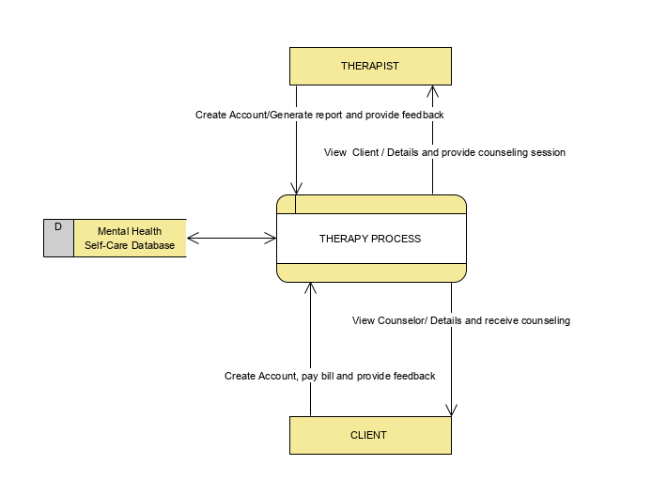

Figure 11: Logical Data Flow Diagram for the proposed Mental Health Self-Care System

### **4.8.4 Physical Data Flow Diagram for the Proposed System.**

Data flow within Elim mental health self-care system is represented in the DFD below.

.

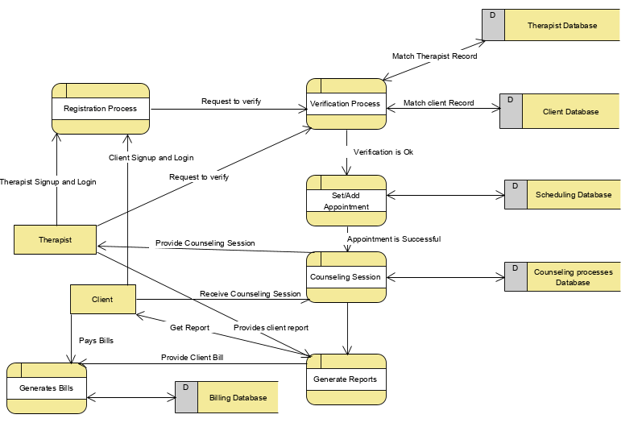

Figure 12: Physical DFD for the proposed Mental Health Self-Care System

In figure 8, the client signs up/ logs in the system, then verification takes place by matching the details entered by the client with the one in the database. When the details are found to be correct, the client is allowed to make appointment on the date or time of counseling. The client receives the counseling sessions and pays for the bills after which he/she is sent the reports. The therapist also signs/ logs in the system and verification takes place. After that he views the client records and also provides the counseling sessions to the client. The counseling sessions are stored in the database for later viewing.

**CHAPTER 5**

**SYSTEM DESIGN.**

**5.0 INTODUCTION**

Systems design entails defining the systems architecture based on the business needs. The  
objective of the design is to define, organize, and structure the components of the final solution  
system that will serve as the blueprint for construction. This is done by understanding the system requirements, both functional and non-functional, gotten from the system analysis process.  
The design phase decides how the system will operate in terms of hardware, software, and network infrastructure that will be in place; user interface, forms, and reports that will be used; and the specific programs, databases and files that will be needed. (ALAN DENNIS, 2012).  
These requirements also include the business requirements and user requirements. System design will entail several diagrams, which will describe the database design, process design and user interface design. It will also include the system architecture both the hardware and the software. The section is divided into three parts namely:

* **Process design –** This describes the movement of data into, through and out of the system.
* **Database Design –** This is concerned with how data is represented and stored within the system.
* **User Interphase Design –** This describes how the users input information and how the system outputs the information back to the users

**5.1 Architecture of the proposed system**

**5.1.1 Components.**

This comprised of both the software and hardware parts of the system. The software part of the system comprised the data storage where information would be retrieved and stored and then documented in entity relation diagrams. It would also have data access logic that will be using a query language to access data from the database and application logic that will be documented in data flow diagrams, use cases etc. The presentation logic will include information display and the commands of the user. The four basic building blocks will ensure whole system integrates.

The hardware components will comprise the client, server and the network that is used to connect both the client and the server. At the client level, the system will be accessed through a device specifically with android operating system. A network connection of various speed will be ample to gain access into the system and only authenticated persons will get access to the system server.

The most suitable architecture design to be used is the three-tiered client-server architecture due to its simplistic nature which allows the three tiers which include presentation tier, application tier and data tier to work as separate modules hence making tiers to be developed separately which can drastically reduce development time faster. It also allows for re-use in case part of the system needs to be integrated.

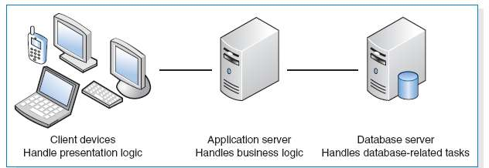

*Figure 13: Three-Tiered Client–Server Architecture (Dennis, Wixom, p. 285)*

**5.2 System processes**

**5.2.1 Sequence diagram of the proposed system**

This section identifies the various processes that shall be done by the system to accomplish various tasks.

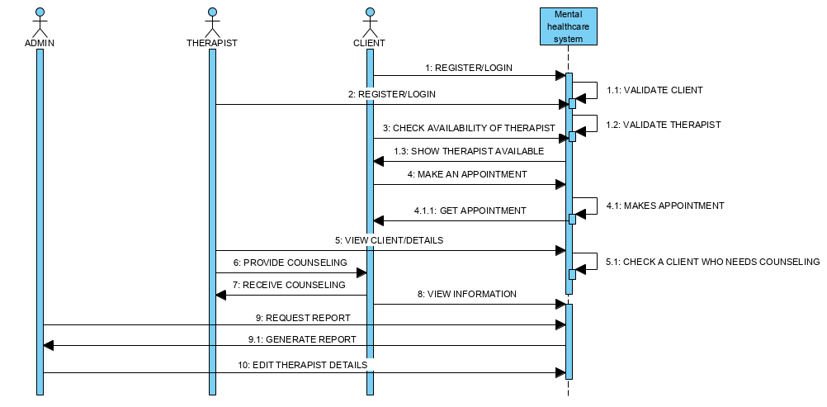

*Figure 14: Mental health self-care sequence diagram*

Figure 2 shows how the client and the therapist is enabled to submit their credentials into the system that validates the details from what the user fills in the registration form. The client is also able to check for the availability of the therapists and if they are available, he/she makes appointment and if it’s possible the client gets appointment. The system notifies the client one hour before counseling session begins and the therapist provides counselling session. The client is also able to view information in the system. After the services, the client logs out the system. In the second phase the administrator is able to know that someone has made an appointment, he is also able to request for report from the system where the system generates it for him. The administrator can also edit the details of the therapists in relation to the counseling services they offer and so on.

**5.3 Database Design for the proposed system**

This involves the design of the structure of data and the methods to be used to store the customers’ information and other input data from the system users. The data to be collected is first identified then the tables to capture that information are designed, normalized and finally implemented.

Below is the database design of the proposed system.

|  |  |  |  |  |
| --- | --- | --- | --- | --- |
| **Column** | **Type** | **Nullable** | **Key** | **Default** |
| First_Name | VACHAR(255) | NO |  | None |
| Last_Name | VACHAR(255) | NO |  | None |
| Id_No | INT(25) | NO | Primary | None |
| Phone_Number | INT(25) | NO | Unique | None |
| Address | INT(25) | YES |  | None |
| Password | VACHAR(255) | YES | Unique | None |

*Table 1: Admin Table*

|  |  |  |  |  |
| --- | --- | --- | --- | --- |
| **Column** | **Type** | **Nullable** | **Key** | **Default** |
| First_name | VARCHAR (255) | NO |  | None |
| Last_name | VARCHAR (255) | NO |  | None |
| Id_no | INT(10) | NO | Primary | None |
| Gender | VARCHAR (255) | NO |  | None |
| Email | VARCHAR (255) | NO | Unique | None |
| Phone_number | INT(25) | NO |  | None |
| Password | VARCHAR (255) | NO | Unique | None |

*Table 2: Client’s table*

|  |  |  |  |  |
| --- | --- | --- | --- | --- |
| **Column** | **Type** | **Nullable** | **Key** | **Default** |
| Name | VARCHAR (255) | NO |  | None |
| ID_NO | INT(11) | NO |  | None |
| Gender | VARCHAR (255) | NO |  | None |
| Email | VARCHAR (60) | NO | Unique | None |
| Phone_no | INT(25) | NO |  | None |
| Password | VACHAR(255) | NO | Unique | None |
| Type of counselling | VARCHAR (255) | NO |  | None |

*Table 3: Therapist’s table*

|  |  |  |  |  |
| --- | --- | --- | --- | --- |
| **Column** | **Type** | **Nullable** | **Key** | **Default** |
| ID_NO | INT(11) | NO |  | None |
| Name | VARCHAR (255) | NO |  | None |
| Email | VARCHAR (255) | NO | Unique | None |
| Phone_number | INT(25) | NO | Unique | None |
| Date | DATE | NO |  | None |
| Service | VARCHAR (255) | NO |  | None |
| Status | TEXT | NO |  | None |

*Table 4: Booking/Appointment table*

|  |  |  |  |  |
| --- | --- | --- | --- | --- |
| **Column** | **Type** | **Nullable** | **Key** | **Default** |
| Billing_Id | INT(15) | NO | Primary | None |
| Client_id | INT (15) | NO |  | None |
| Booking_id | INT(11) | NO |  | None |
| Amount | INT(10) | NO |  | None |
| Date_served | Date | NO |  | None |

*Table 5: Billing table*

|  |  |  |  |  |
| --- | --- | --- | --- | --- |
| **Column** | **Type** | **Nullable** | **Key** | **Default** |
| Id | INT(11) | NO | Primary | None |
| Name | VARCHAR(255) | NO |  | None |
| Email | VACHAR(255) | NO | Unique | None |
| Phone_number | INT(30) | NO |  | None |
| Message | VARCHAR(255) | NO |  | None |
| Posted_on | Time_stamp | NO |  | Current_timestamp |
| Status | VARCHAR(255) |  |  | None |

*Table 6: Feedback table*

|  |  |  |  |  |
| --- | --- | --- | --- | --- |
| **Column** | **Type** | **Nullable** | **Key** | **Default** |
| Name | VACHAR(255) | NO |  | None |
| Type | VACHAR(255) | NO |  | None |
| Location | VACHAR(255) | NO |  | None |
| Phone_Number | INT(25) | YES |  | None |
| Address | INT(25) | YES |  | None |
| Email | VACHAR(255) | NO |  | None |

*Table 7: Mental health self-care system*

**5.4 DIAGRAMS OF THE DATABASE DESIGN FOR THE PROPOSED SYSTEM.**

**5.4.1 Entity Relation Diagram for the proposed system.**

This ER diagram depicts the relationship between the entities. That is the therapist, the mental health self-care center, the administrator, Billing, booking and client.

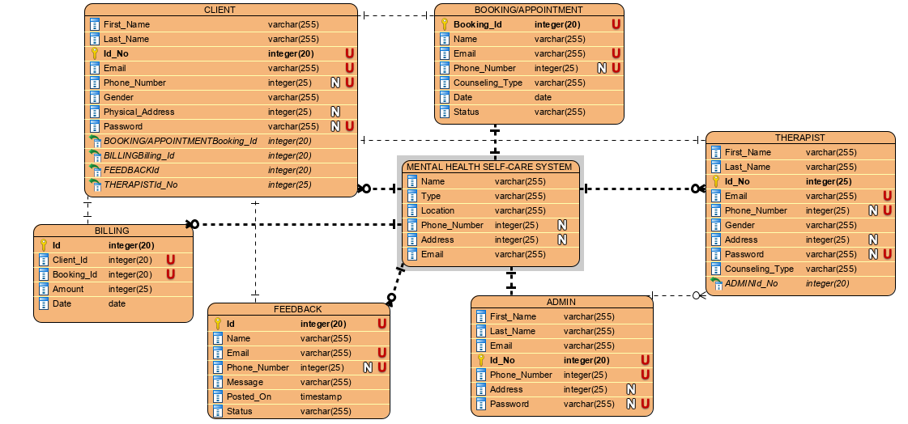

*Figure 15: Entity Relation Diagram for the proposed system*

**Entities**

* Customers/ Clients - These individuals will make use of the proposed system to book appointment, receive counseling sessions and to view information in the system.
* Therapist – These individuals will make use of the proposed system to provide counseling sessions, to view client details and to generate clients’ reports.
* System Administrator – This is the individual responsible for adding and removing the counseling sessions from the system. The administrator also has privileges that enable him to manage the therapists and the clients. The administrator will control the whole system using the firebase database.
* Booking/ appointment – This is the site’s main object. They are listings, which detail given activities intended to happen in the near future.
* Billing – It inputs the client bill paid by the customer when booking a counseling session and provides a confirmation message to the client.

**5.4.2 Physical database design for the proposed system**

The Physical database is further depicted in the Class UML diagram shown below.

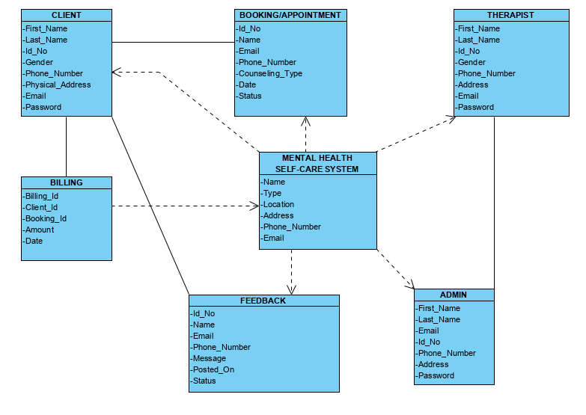

*Figure 16: Class Diagram for the proposed system*

The class diagram depicted in figure 4 shows how the external entities interact with each other. The E-therapy system is dependent on the Administrator, the therapists, the clients, the bookings, billings and the feedback provided by the client. That means that any change caused by any of the entities affects the whole system. There is also an association between the admin and the therapist since the admin’s responsibility is to control the whole system and therefore have the ability to view, edit or delete a therapist. The client’s responsibility is to make an appointment, pay for the counselling sessions and to provide feedback to the system in relation to the services provided to him/her.

**5.5 User Interphase Design**  
Targets the look and feel of the proposed system. Specifies on the interphases that will be used by the users to interact with the proposed system. The screenshots displayed are from the early stages of development.  
**5.5.1 Users home page**Activities posted will be displayed in a grid layout as shown below. An additional navigation bar will be added to hold company branding and other app-level elements such as contact information, Account settings and Search options.

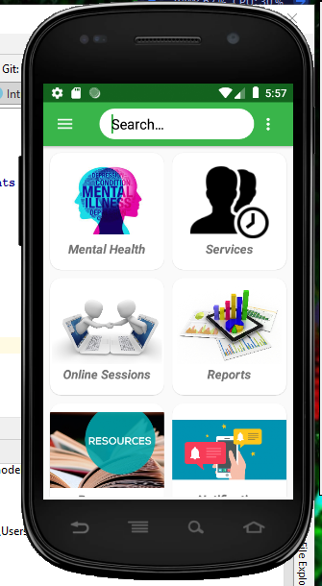

*Figure 17: Client’s homepage.*

Figure 5 enables the client administrator to easily access other interfaces to perform various tasks.

**5.5.2 Users Registration, Login and Logout Forms**  
In the proposed mental health self-care system, forms will be used to collect user information. Forms comprise of various components such as labels, text boxes, text fields, checkboxes, and  
radio buttons. They provide a simple and efficient way for users to input their information that will be stored in the system’s database.

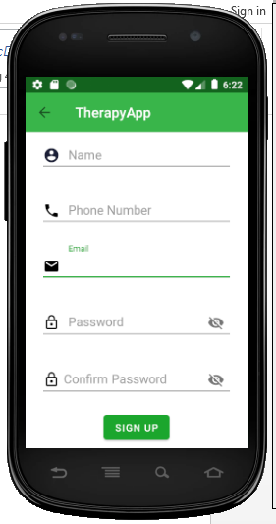

*Figure 18: Client's registration form.*

Figure 6 is where the client registers to be part of the clients who needs the mental health self-care system services.

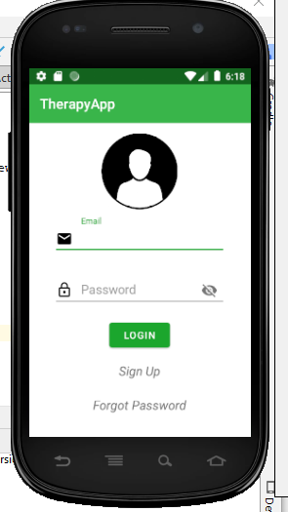

*Figure 19: Client’s login form*

Figure 7 authenticates the user before they can access other interfaces in the system.

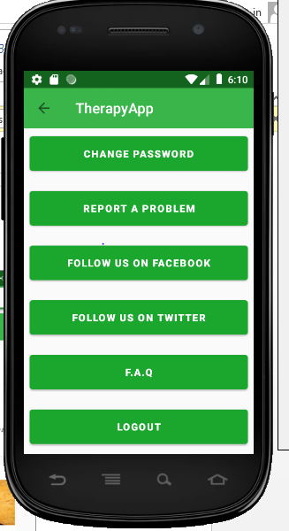

*Figure 20: Client’s Logout form*

Figure 8 shows the client’s profile. It also contains the logout button which enables the client to logout out from the system after he/she receives the services he/she needed in the mental health self-care application.

## 

# **CHAPTER SIX**

# **SYSTEM IMPLEMENTATION**

# **6.1 INTRODUCTION**

While developing software, bugs are expected to be found in the code in any module. This is not caused by carelessness or poor knowledge of coding or irresponsibility of the programmer but mainly because of the complexity. Human is prone to errors, this chapter will discuss the implementation and testing of the solution system.

## **6.2 Tools Used For Coding.**

Android Studio – It is the official integrated development environment (IDE) for Android Application Development.  It is based on the IntelliJ IDEA, a Java integrated development environment for software, and incorporates its code editing and developer tools. The software was used in writing android application codes.

Android Virtual Device Manager(AVD) – This is an emulator used to run android apps on a computer. This allowed the developer the ability to work with all types of Android devices to test responsiveness and performance on different versions, screen sizes, and resolutions.

* Firebase Realtime database – Is a cloud- hosted NoSQL database that allowed the developer to store and sync data between the users and in realtime.

# 6.2 Testing

The system was subjected to a variety of testing at each stage this was to ensure it was bug free. Some of the testing carried out were:

### 6.2.1 Functional Testing.

This was achieved by user interface initiated workflow. Both the flow of use case and the various business rules were also tested. This was done by certifying the requirements e.g. whether the application was working based on the requirements. The testing mainly involved:

* Valid input- acceptable inputs must be accepted by the system.
* Invalid inputs- Here all invalid inputs not required by the system have to be rejected by the system.
* Outputs –Identified outputs must be produced by the system after a function has been initiated.
* Functions –All functions have to be met for the system to be fully functional.
* Procedures – Proper procedure must be invoked by certain events occurring in the system.

### **6.2.2 Mental Health Self-care application User Interface Testing.**

This is a user-centric testing of the application. In this test phase, items such as visibility of text in various screens of the app, interactive messages, alignment of data, and the look and feel of the app for different screens and size of the fields were tested under this.

### **6.2.3 Network Testing**

This mainly involved:

* Testing if the app was communicating with the intermediate services so as to carry out the processes.
* Testing for various conditions for example request/response to/from the service. This test was mainly done to verify the response time in which the activity was performed like refreshing data after sync or loading data after login.
* Testing was also done for both strong Wi-Fi connection and the mobile data network.

### **6.2.4 Performance Testing:**

Performance of the application under some peculiar conditions were checked. Those conditions included:

* Low memory in the device.
* The battery in extremely at a low level.
* Poor/Bad network reception.

Performance was basically tested from two ends; application end, and the application server end.

**6.2.5 Unit Testing.**

Here the system was divided into different modules and dummy data was used to test the result of each module. Any bugs found was easily isolated and fixed to produce the required output. The modules included; user Module, administrator module, therapist module and transaction module.

**6.2.6 Maintenance of the system**

The system will have to be constantly monitored to ensure that there is proper information flow and in case of any changes it will have to be promptly investigated and corrected. The system will mostly be built to adapt to any changes necessary to users of the system. The system should be maintained regularly to reduce any transactional errors and keep it functional at an acceptable state. There may be a few adjustments to make it meet its market requirements. The system has been designed to fit specific users’ needs on the basis of rotating savings and credit hence it might be a bit rigid to change.

## **6.3 PROPOSED CHANGE-OVER TECHNIQUES.**

The implementation of project is quite a difficult task because organization have to move from an old set technology, methods and procedures to new one. Implementation involves integrating software based service or component into the work flow of an organizational structure or an individual end-user. There were several ways to implement a system, this was according to what the client really wanted. It included:

### **6.3.1 Direct implementation**

In this implementation method the users stop using the manual system and start using the computer system at a given date. The advantage of this method is that it is less costly in effort and time than any other method of implementation. The disadvantage is that if problems occur the users do not have any alternative apart from returning to manual system which may prove difficult if it has been discontinued.

**6.3.2 Parallel Changeover.**

In a parallel changeover, the new system runs simultaneously with the old for a given period of time. This is preferable mainly because it carries the lowest risk. If something goes wrong at any point, the entire system can be reverted back to its original state. A primary disadvantage in running two systems at the same time is higher costs. The parallel changeover process also can be quite time-consuming.

### **6.3.3 Phased implementation**

In this implementation method enables us to break our project into smaller milestones. Major disadvantage is that it’s difficult to achieve due to interdependencies between modules.

### **6.3.4 Pilot system**

The pilot system involves implementing the system for a while to establish problems with the system. A little amount of money and time is required. This method was used to implement the system since it is easier to run the program and test its full functionalities. After identifying that there were no operational issues and all the system outputs can be generated as expected live run was started.

# **CHAPTER SEVEN: LIMITATIONS, RECOMMENDATIONS AND CONCLUSIONS**

## **7.1 Limitations**

This section describes some of the features that the system has not been able to meet and why it was impossible implementing these features.

1. Any illiterate person will need to be trained first before using the system.
2. Users using the system will have to constantly be connected to the internet in order to access the system.
3. The system is only built for English literate people. Translation to other languages needed a third party software implementation and this would have made the system totally dependent on the third party software.
4. The system also requires internet to allow the end user to have access to it and be able to reserve a room and make any payment.
5. The system allows for third party software such as WhatsApp and Duo. This was integrated to enable those who needed to contact the therapist through charts and video.

## 7.2 Recommendations

The system was implemented but there are some recommendations for future improvements.

* To include a payment gateway that will be able to handle all the different kind of payment system available in the country to easy payment processes.
* The system can be improved to include chart rooms and video service mode in the system instead of using third party software.

## **7.3 Conclusion**

The reason for developing this system was to make it easy for clients to make appointments and get counseling services online at their comfort. The system provides information to the clients that is, the number of appointments of the week and in a particular date which would have been difficult to find through making a telephone call or having to email.

It provides the administration with an easy way to be able to generate reports used in decision making and can also get feedback from clients about their services. The use of manual methods might be helpful to just keep the records but not efficient. Since recorded information on papers or books is prone to damage and this is a great loss to the management. Clients may also find it uneconomical visiting the salon to make appointments.

Therefore the development of an automated system that can handle both stakeholder who need the access to the salon management system, is of great use. With portability of computer devices the clients as well as the management will have access to the system remotely. It will reduce the cost of paper resources to the management and be efficient in making appointments by the client

# **4.0 References**

Bizfluent. (2017). *Advantages and Disadvantages of SSADM*. Retrieved from Bizfluent:  
 https://bizfluent.com/list-6781448-advantages-disadvantages-ssadm.html

Dix, A., Dix, A. J., Finlay, J., Abowd, G. D., & Beale, R. (2013). Human-computer interaction (3rd ed.). London, England: Pearson Education.

Sucala, M., Schnur, J. B., Constantino, M. J., Miller, S. J., Brackman, E. H., & Montgomery, G. H. (2012). The therapeutic relationship in e-therapy for mental health: a systematic review. Journal of medical Internet research, 14(4), e110.

Hinton, J. (2012). *Data collection techniques*. Retrieved from [https://9REcyfar.org/data collection-techniques](https://9REcyfar.org/data%09collection-techniques)

Kennedy, G. J. (2012). *Geriatric mental health care*: A treatment guide for health professionals New York, NY: Guilford Press.

Lucid, C. (2017). *The stages of agile system development cycle* <https://www.lucidchart.com/blog/agile-software-development-life-cycle>

Mohr, D. C., Burns, M. N., Schueller, S. M., Clarke, g., & Kinkman, M. (2013*). Behavioral intervention technologies:* Evidence review and recommendations for future research in mental health. General Hospital Psychiatry, 35, 332–338. Retrieved from <https://www.ncbi.nlm.nih.gov/pubmed/23664503>

Philip, A. (2016). *Computer files vs. manual file: what’s the difference*? Retrieved from <https://www.difference.wiki/computer-file-vs-manual-file/>

Susan, W., (2015). *File management tips for digital files*. Retrieved from [https://www.thebalancesmb.com/computer- file-management-tips-2948083](https://www.thebalancesmb.com/computer-%20file-management-tips-2948083).

World Health Organization. (2008). *Integrating mental health into primary care:* A global

perspective. Geneva, Switzerland: Author.

Richards, J., Klein, B., & Carlbring, P. (2006). Internet-based treatment for panic disorder.

*Cognitive Bahaviour Therapy*, 32(3), 125-135.  
Ainsworth, M.(2000). Metanoia: The ABC’s of internet counselling. Retrieved from

http://www.metanoia.org/imhs