1. What is scorerun?

It’s a tool collect performance logs and pmlogs.

1. How to run scorerun?
2. Copy \\hfs\share\Wen Yan\python\scorerun to your local folder
3. Run testcase: scheduler MNC5_performance -NV33.json
4. Run .\scorerun.exe –-help review usage;

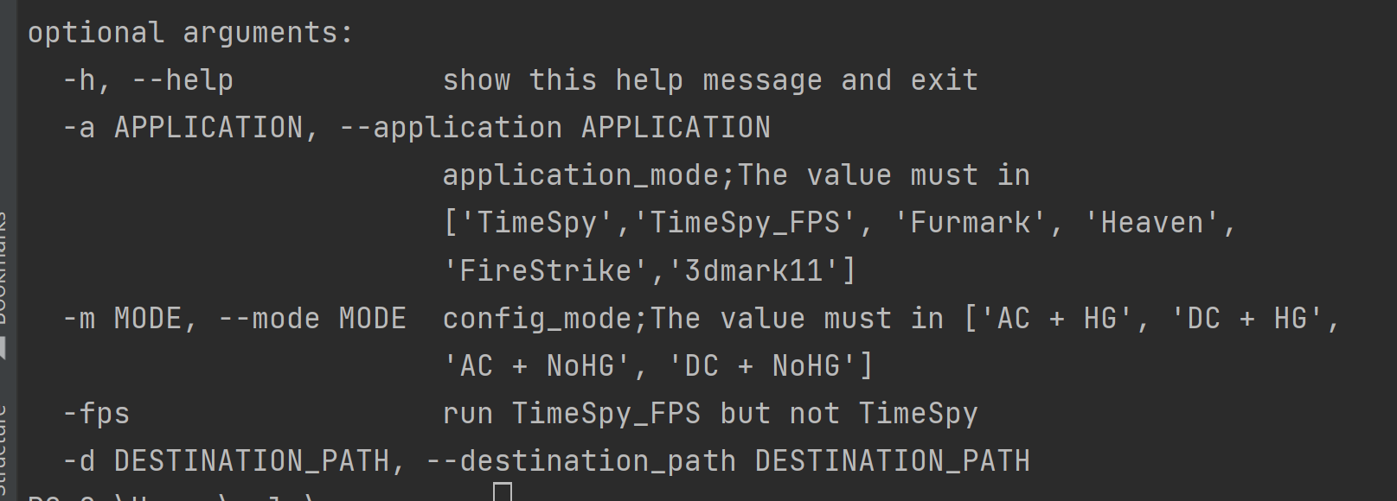

-m : Required parameter; The mode of the machine you set when you last ran the test;eg:

.\scorerun.exe –m AC+NoHG

-a: The application you ran, It will collect the logs for all applications by default,

(contain:'TimeSpy', 'Furmark', 'Heaven','FireStrike','3dmark11']);eg:

Run all apps: .\scorerun.exe –m AC+HG (contain:'TimeSpy', 'TimeSpy_FPS', 'Furmark', 'Heaven','FireStrike','3dmark11']);

Run part apps: .\scorerun.exe –m AC+HG -a TimeSpy,FurMark

Run one apps: .\scorerun.exe –m AC+HG -a TimeSpy

-d: The destination path of data,default: C:\Users\gvle\tmp

1. Notice:

This tool is currently only suitable for collecting logs that after running follow cases successfully.

If you have any questions during use, please contact me~~~