* Making sure you have a TXT record with a value that begins with :

*google-site-verification= "random code here"*

* Make sure you only have 2 IPs on the custom domain A records, feel free to use the [dig tool](https://toolbox.googleapps.com/apps/dig/#ANY/):  (Right now you’re missing them both IPs in both domains)

IPs

151.101.1.195 and 151.101.65.195

* These are your registrar settings required:

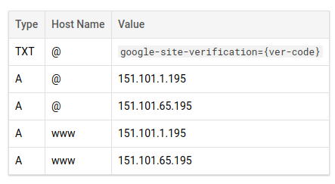

* Verify your domain on:

[https://www.google.com/webmasters/verification/verification?domain={enter_domain_here}](https://www.google.com/webmasters/verification/verification?domain=%7Benter_domain_here%7D)

* Please give the DNS 24hrs to propagate on the internet; feel free to check our [custom domain documentation](https://firebase.google.com/docs/hosting/custom-domain#domain-key).