Inner Cup Model 6/28/2011 5:18 PM

# Inner Cup Design (ICD) Coordinates

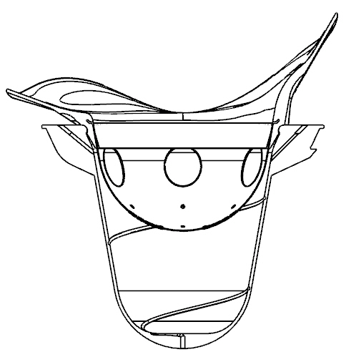

Z

Y

X

1. X+,Y+,Z+ form a right-handed coordinate system.
2. Origin: any point along the rotation axis
3. X+: cup tongue direction (leaving the patient body)
4. Y: the rotation axis; Y+: up direction of the treatment couch.

# Components

1. Two paths, inside and outside wall, of each outer cup in the XY-plane are under interest. The directions of the paths are show in blue. Each path must start from the bottom of the inside/outside, and follow the Path2D format defined in Path2DFormat.docx.
2. Outer cup assembly parameter *Dinout*: The distance in mm between the inside bottom of the inner cup and the inside bottom of the outer cup.

# Table [.icpparam]

Encoding: US-ASCII



# Code

1. **Main file:** IcpGen.m
2. **Usage:** IcpGen(RadiationUnitType, OuterCupType, InnerCupType)
3. **Example:** IcpGen(1, 1, ’A’)
4. **Dependency:**
   1. CwLoadIcpParam.m
      * CwReadPath2D.m (subroutine for reading Path2D script)
      * dpsimplify.m (subroutine for curve simplification)
   2. CwSaveAsDotIcp.m
5. **Input** from directory InnerCups\\In\\
   1. R%dO%dI%d.icpparam file (Encoding: US-ASCII)
6. **Output** to directory InnerCups\\Out\\
   1. R%dO%dI%s.icp (Encoding: US-ASCII)

inner cup file (for TPS use)

%d RadiationUnitType, %d OuterCupType, %s InnerCupType

Format:

|  |  |
| --- | --- |
| **Radiation Unit Type** | Integer 1-99999999 |
| **Outer Cup Type** | Integer 0-99 (0 reserved for imaginary phantom outer cup) |
| **Inner Cup Type** | US-ASCII alphanumeric string. Maximum length = 31 |
| **Dinout** | The distance in mm between the inside bottom of the inner cup and the inside bottom of the outer cup |
| **# of vertices of the inside generating curve** |  |
| **z0 r0** | (in mm, z-vector strictly decreasing in outer cup coordinates) |
| **z1 r1** |  |
| **…** |  |
| **zN-1 rN-1** |  |
| **# of vertices of the outside generating curve** |  |
| **z’0 r’0** | (in mm, z-vector strictly decreasing in outer cup coordinates) |
| **z’1 r’1** |  |
| **…** |  |
| **z’N’ r’N’** |  |

* 1. Text files for verification in SolidWorks (In ICD Coordinates)
     1. Verify_R%dO%dI%s_InsideWall.txt (Encoding: US-ASCII)
     2. Verify_R%dO%dI%s_OutsideWall.txt (Encoding: US-ASCII)
  2. Graphics file for visual verification (In ICD Coordinates)
     1. Verify_R%dO%dI%s.fig (matlab .fig file)

1. **Remarks:**
2. Precision = 0.05mm, can be tuned in the code
3. Directory structure must be set up in advance.