Kernel Dose Distributions 6/28/2011 4:23 PM

# The Kernel Dose Distribution (KDD) Coordinates

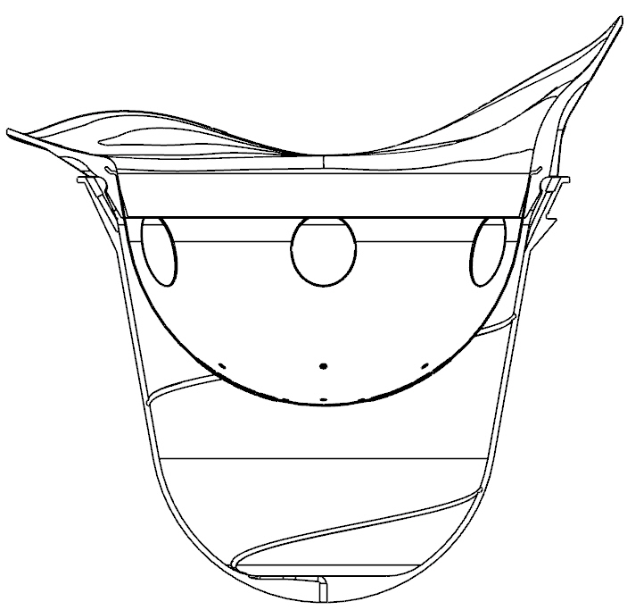

(A) (B)

For a given outer cup and inner cup, the actual assembly is shown in Fig (A). To compute the kernel dose distributions associated with the given (1) outer and inner cups or (2) phantom, we set up the KDD coordinate system as follows:

1. X+, Y+, Z+ form a right-handed coordinate system
2. Origin lies on the rotation axis and is above the COUCH REFERENCE POINT (refer to RadiationUnit.docx) by $UpperMargin$. The two values of $UpperMargin$ (one for cups, one for phantom) are given in Phantom Param Sheet (refer to RadiationUnit.docx). Remark: For the phantom, we always assume treating the right breast.
3. Y+: cup tongue direction (leaving the patient body)
4. Z: rotation axis; Z+: down direction of the treatment couch.

# Cup Geometry Information

The following geometric information is provided for kernel dose calculations:

1. Curve A: the generating curve of the inner cup inside wall
2. Curve B: the generating curve of outer cup inside wall
3. Curve C: the generating curve of outer cup outside wall

All three curves A, B, C lie on the Z-Y plane (first quartet) and are vectorized as piece-wise linear curves. Each curve will be stored in a US-ASCII text file, where each line specifies the (z,y)-coordinates (in mm) of the joint points defining the curves. The z-coordinates of the joint points of each curve are guaranteed to be in strictly decreasing order.

# Cup Geometry Code

1. Main file: KddCupsGeoGen.m
2. Usage: KddCupsGeoGen(RadiationUnitType, OuterCupType, InnerCupType, UpperMargin)
3. Example: KddCupsGeoGen(1, 1, ’A’, 25.0)
4. Dependency:
   1. CwLoadDotOcp.m
   2. CwLoadDotIcp.m
   3. CwSaveAsKddParam.m
5. Inputs
6. .ocp File (output of OcpGen.m, refer to OuterCup.docx) under OuterCups\Out
7. .icp File (output of IcpGen.m, refer to InnerCup.docx) under InnerCups\Out
8. Output to directory Kdd_CupGeometry\Out
9. R%dO%dI%s_KddCurveA.txt (Encoding: US-ASCII)
   * Format: Each line : (z y) pair in mm, in KDD-Coordinates
10. R%dO%dI%s_KddCurveB.txt (Encoding: US-ASCII)

* Format: same as R%dO%dI%s_KddCurveA.txt

1. R%dO%dI%s_KddCurveC.txt (Encoding: US-ASCII)
   * Format: same as R%dO%dI%s_KddCurveA.txt
2. R%dO%dI%s_Kdd.fig
   * matlab .fig file
   * in KDD-Coordinates
3. R%dO%dI%s.kddparam (Encoding: US-ASCII)
   * Intermediate file which will be used later by KddConvert.m
   * Format

|  |  |  |
| --- | --- | --- |
| Line # |  |  |
| 1 | 1 | Radiation Unit Type |
| 2 | 1 | Outer Cup Type |
| 3 | A | Inner Cup Type (US-ASCII string) |
| 4 | 78.0 | ziboc_kdd. The z-Coordinate in mm in KDD Coordinates of the inside bottom of the outer cup. |

1. For the phantom, the only output is the R%dO%dI%s.kddparam file. Outer Cup Type = 0 always. Note that the phantom has an imaginary outer cup whose inside bottom is at the Couch Reference Point.

# Conversion Code

1. Main file: KddConvert.m
2. Usage: RefDose = KddConvert (RadiationUnitType, OuterCupType, InnerCupType, XSymmetryFlag, PtmParam);
   1. Reference dose is collected at a set of sample points defined in Phantom Param.
3. Example: RefDose = KddConvert(1, 1, ‘A’, 1, PtmParam);
4. Dependency:
   1. CwLoadKddParam.m
   2. CwLoadDot3ddose.m
   3. CwSaveAsDotd3d.m
   4. CwSaveAsDotD3difo.m
5. Inputs
   1. A set of .3ddose files under directory Kdd_Convert\In
      * Computed by the Dose Calculation engines
      * In KDD-Coordinates
      * Naming requirement: R%dO%dI%s_Y%03dZ%03dC%03d.3ddose
        + Use Rename3ddoseFiles.m to meet naming requirements
      * Encoding requirement: US-ASCII
      * Format [**http://www.irs.inms.nrc.ca/BEAM/user_manuals/statdose/node12.html**](http://www.irs.inms.nrc.ca/BEAM/user_manuals/statdose/node12.html)

*The simulation geometry and 3D dose results are stored the following format:*

*Row/Block 1 -- number of voxels in x,y,z directions (e.g., nx, ny, nz)*

*Row/Block 2 -- voxel boundaries (****cm****) in x direction (nx+1 values)*

*Row/Block 3 -- voxel boundaries (****cm****) in y direction (ny+1 values)*

*Row/Block 4 -- voxel boundaries (****cm****) in z direction (nz+1 values)*

*Row/Block 5 -- dose values array (nxnynz values)*

*Row/Block 6 -- error values array (relative errors, nxnynz values)*

*General Rules of reading the dose and statistical uncertainty (error) results:*

*read one by one (across columns) to get dose (error) readings in x direction*

*read every nx-th value to get readings in y direction*

*read every nxny-th value to get readings in z direction*

* 1. R%dO%dI%s.kddparam under directory Kdd_CupGeometry\Out

1. Outputs to directory Kdd_Convert\Out
   1. A set of .d3d files
      * Each .d3d file has the same name as the corresponding .3ddose file
      * Main features of the .d3d format:
        + d3d files are in binary format (little-endian) to save space
        + No error information is stored to save space
        + Support for x,y,z-symmetric dose distributions to save space
        + The voxels are stored in z-y-x order, with z changes the fastest to improve performance (.3ddose format stores data in x-y-z order)
        + Using the Outer Cup Coordinates; Unit: mm
      * Format (binary)

*Int32 xsymmetric, ysymmetric, zsymmetric -- if non-zero, x/y/z-symmetric;*

*Int32 nx ny nz -- number of voxels in x,y,z directions*

*Float32 xboundary[] -- voxel boundaries (****mm****) in x direction(nx +1 values)*

*Float32 yboundary[] -- voxel boundaries (****mm****) in y direction (ny +1 values)*

*Float32 zboundary[] -- voxel boundaries (****mm****) in z direction (nz +1 values)*

*Float32 dosedata[] -- dose values array (nxnynz values)*

*General Rules of reading the dose data results:*

* *read one by one (across columns) to get dose (error) readings in x direction*
* *read every nx -th value to get readings in y direction*
* *read every nx ny -th value to get readings in z direction*

*For x/y/z-symmetric cases, the x/y/z-boundaries only need to cover the principle dose region (x>=0 and/or y>=0 and/or z>=0).*

* 1. R%dO%dI%s.d3difo file (Encoding: US-ASCII)
     + Format

%d Radiation Unit Type

%d Outer Cup Type

%s Inner Cup Type

%d Total number of .d3d files

%d %e %e %e %e %s [for each line: each .d3d file]

Collimator type (diameter in mm)

Shot spot location x-coordinate in mm in Outer Cup Coordinates

Shot spot location y-coordinate in mm in Outer Cup Coordinates

Shot spot location z-coordinate in mm in Outer Cup Coordinates

Reference dose in Gy/min

.d3d file name, US-ASCII string