Outer Cup Model 9/27/2011 3:44 PM

# Outer Cup Design (OCD) Coordinates

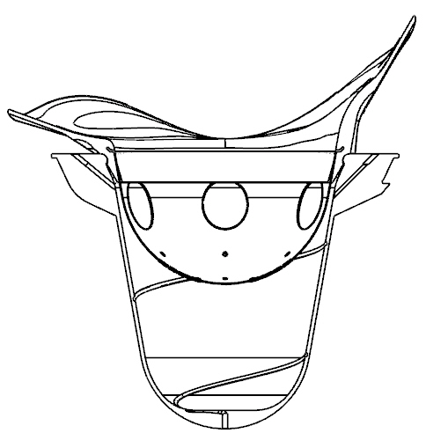

Z

Y

X

1. X+,Y+,Z+ form a right-handed coordinate system.
2. Origin: any point along the rotation axis
3. X+: cup tongue direction (leaving the patient body)
4. Y: the rotation axis; Y+: up direction of the treatment couch.

# Components

1. Inside and outside wall. Two paths, inside and outside wall, of each outer cup in the XY-plane are under interest. The directions of the paths are show in blue; each path must start exactly from the inside/outside bottom, and follow the Path2D format defined in Path2DFormat.docx.
2. 3D fiducial curve on the inside wall. The 3D fiducial curve script should be defined as follows

|  |  |
| --- | --- |
| Key commands: | Comments |
| **newfc** | Initialize the fiducial curve |
| **newfcsegment** x y z | Initialize the fiducial curve segment and set the current point to (x,y, y). i.e., the starting point of the curve segment |
| **lineto** x y z | Append a straight line segment to the current curve segment, starting from the current point and ending at (x,y,z); the current point will be moved to (x,y,z) after this command |
| **arcto** x1 y1 z1 x2 y2 z2 | Append an arc segment to the current curve segment, starting from the current point , passing through (x1,y1,z1), and ending at (x2,y2,z2); the current point will be moved to (x2,y2,z2) after this command |
| **spiralto** n x1 y1 z1 x2 y2 z2 … xn yn zn | Append a spiral curve to the current curve segment, starting from the current point, passing through (n-1) points (x1,y1, z1), (x2,y2,z2),..,(x{n-1},y{n-1},z{n-1}), and ending at (xn,yn,zn) ; the current point will be moved to (xn,yn,zn) after this command. Adjacent points must be of angular distance of no more than 180 degrees. |
| **closefcsegment** | Close current fiducial curve segment |
| **closefc** | Close the fiducial curve |

1. Couch assembly parameter D: The signed distance in mm between the inside bottom of the outer cup and the **COUCH REFERENCE POINT** (refer to RadiationUnit.docx). D is positive if the **COUCH REFERENCE POINT** is above the outer cup inside bottom, and negative otherwise. Remark: for phantom, D=0 (imaginary phantom-outer-cup).

# Table [.ocpparam]

Encoding: US-ASCII



# Code

1. **Main file:** OcpGen.m
2. **Usage**: OcpGen(RadiationUnitType, OuterCupType)
3. **Example**: OcpGen(1, 1)
4. **Dependency**:
   1. CwLoadOcpParam.m
      1. CwReadPath2D.m (subroutine for reading Path2D script)
      2. CwReadFiducialCurve.m (subroutine for reading fc script)
      3. CwMonotonize.m (subroutine to avoid singular situations by making curves monotone, for robustness)
      4. dpsimplify.m (subroutine for curve simplification)
   2. CwSaveAsDotOcp.m
5. **Input** from directory OuterCups\In\
   1. R*%d*O*%d*.ocpparam (Encoding: US-ASCII)
6. **Output** to directory OuterCups\Out\
   1. R*%d*O*%d*.ocp (Encoding: US-ASCII)

Outer cup file for TPS use

%d Radiation Unit Type, %d Outer Cup Type

|  |  |  |
| --- | --- | --- |
| Part1 | RadiationUnitType | Integer 1 - 99999999 |
| **OuterCupType** | Integer 0 – 99 [0 reserved for imaginary phantom outer cup] |
| **D** | the signed distance in mm from inside bottom of the outer cup to the Couch Reference Point. Positive if the inside bottom is below the CRP, and negative otherwise. |
| Part2 (Inside Wall GC) | **N1** | # of vertices of the inside generating curve |
| **z0  R0** | In mm, in the Outer Cup Coordinates |
| **…** | z-Vector is strictly decreasing |
|  |  |
| **zN1-1 RN1-1** |  |
| Part3 (Outside Wall GC) | **N2** | # of vertices of the outside generating curve |
| **z0  R0** | In mm, in the Outer Cup Coordinates |
| **…** | z-Vector is strictly decreasing |
| **zN2-1 RN2-1** |  |
| Part4 (Fiducial Curve) | **N3** | # of vertices of the fiducial curve |
| **x0 y0 z0** | vertex coordinates in mm in the Outer Cup Coordinates |
| **….** |  |
| **xN3-1 yN3-1 zN3-1** |  |
| **N4** | # of edges of the fiducial curve |
| **Start0 End0** | vertex index pair, ranges from 0 to N2-1 |
| **…** |  |
| **StartN4-1 EndN4-1** |  |

* 1. Text files for verification (in OCD Coordinates)
     1. Verify_R%dO%d_InsideWall.txt (Encoding: US-ASCII)
     2. Verify_R%dO%d_OutsideWall.txt (Encoding: US-ASCII)
     3. Verify_R%dO%d_Fiducial_Seg%d.txt (Encoding: US-ASCII)
  2. Matlab .fig files (in OCD Coordinates)
     1. Verify_R%dO%d_Fiducial.fig
     2. Verify_R%dO%d_Walls.fig

1. **Remarks**:
   1. For curve simplification, the error is controlled within 0.05mm, which can be tuned in the matlab code.
   2. Directory structure must be set up in advance