PROJECT UPDATE

Presentation Outline

1. Introduction
   1. Background
      1. Rationale: Story behind the project
      2. Significance: Proposed impact of the program to its end user
   2. Members
      1. Introduction of Members
      2. Division of Labor: Quick Explanation
         1. Roles: PM, DEV, QA, UID
         2. Pairings: Game Menu, Song Selection, Start Round
2. Body
   1. Project Goal: To create a program that blah blah chuhcuhuchu
   2. How did we achieve the goal?
      1. Breaking Down the Problem
         1. Project Phases
            1. Brainstorming
            2. Flowcharting
            3. Development
            4. Testing
            5. Revision (?): Fixing code bugs/errors
            6. Deployment (?): Publishing program to GitHub
         2. In-Depth Role Descriptions
            1. PM
            2. DEV (Game Menu, Song Selection, Start Round)
            3. UID
            4. QA
      2. Utilizing Tools for Efficiency
         * 1. Figma, Draw.io
           2. GitHub
           3. Confluence
           4. Discord, GMeet
   3. Timeline of Progress: Maybe use a Gantt chart

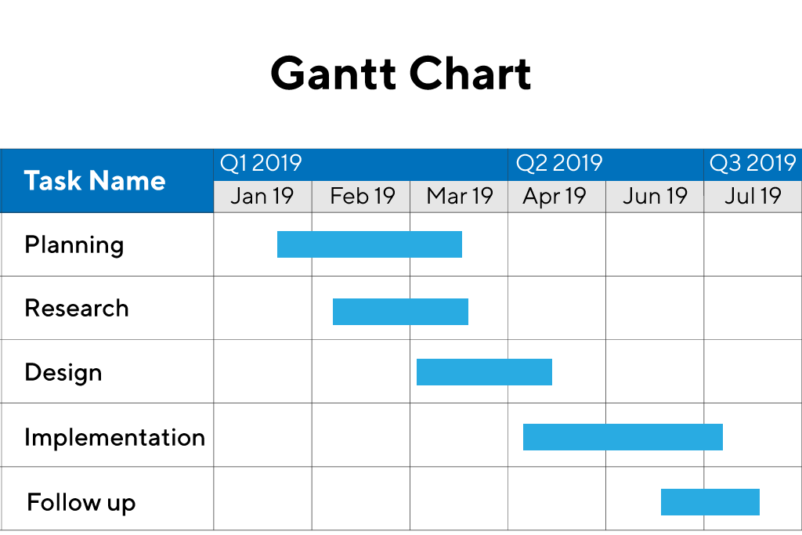

* 1. Difficulties Encountered (and How They Were Resolved)
     1. Program-wise: Bugs, Errors
     2. Team-wise: Conflicts, Lapses

1. Conclusion
   1. Results
      1. Code Presentation: Display code (Programmer’s perspective)
      2. Final Product: Run code (User’s perspective)
   2. Recommendations
      1. Points for Improvement
         1. Program-Wise: Ideas for Future Development
         2. Team-Wise: Hard & Soft Skills to Improve, etc.
   3. Questions / Defense