Algorithm & Logic Formulation

Project update WEEK 0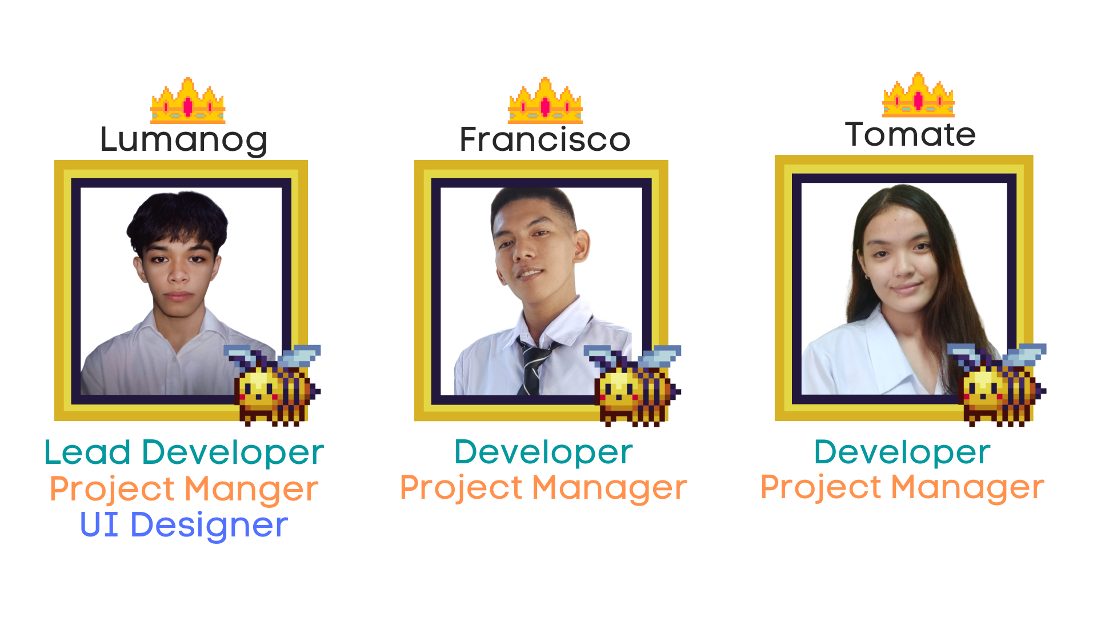

Group 1

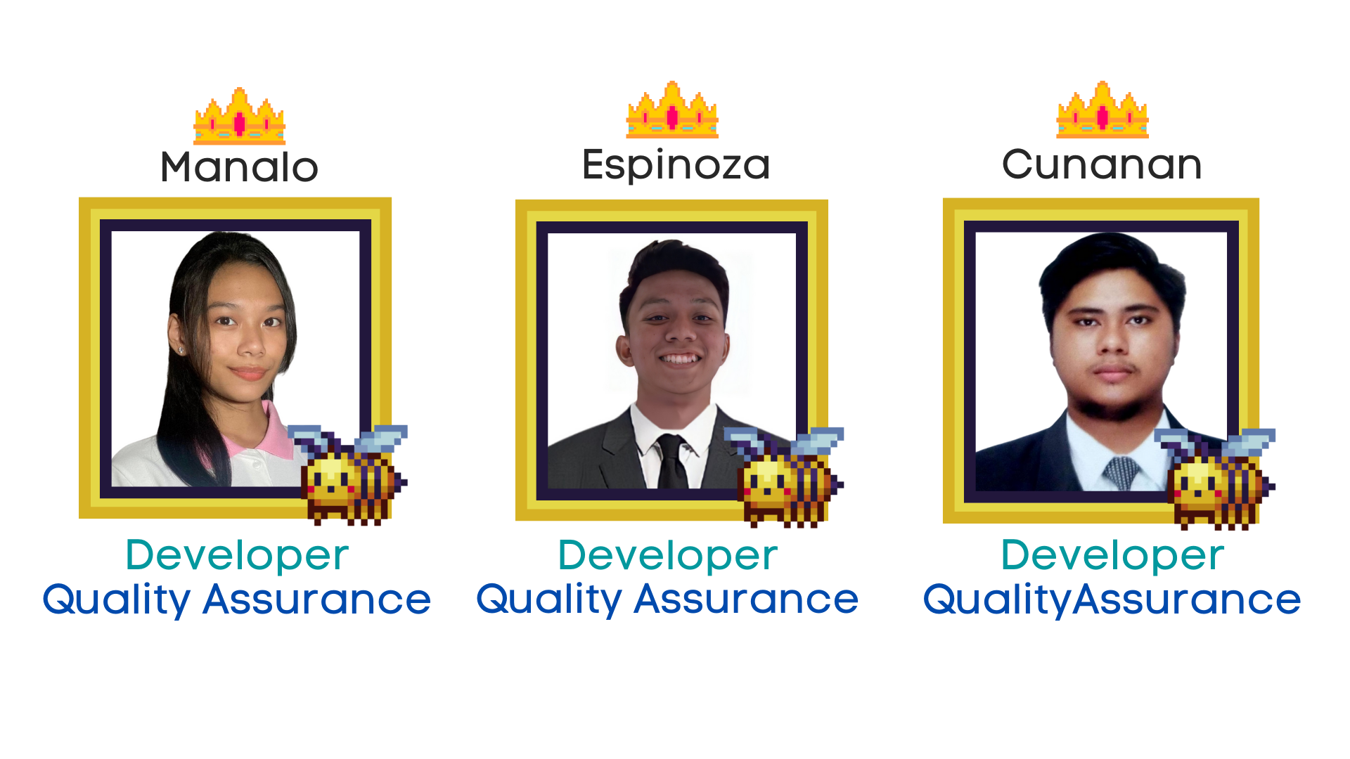

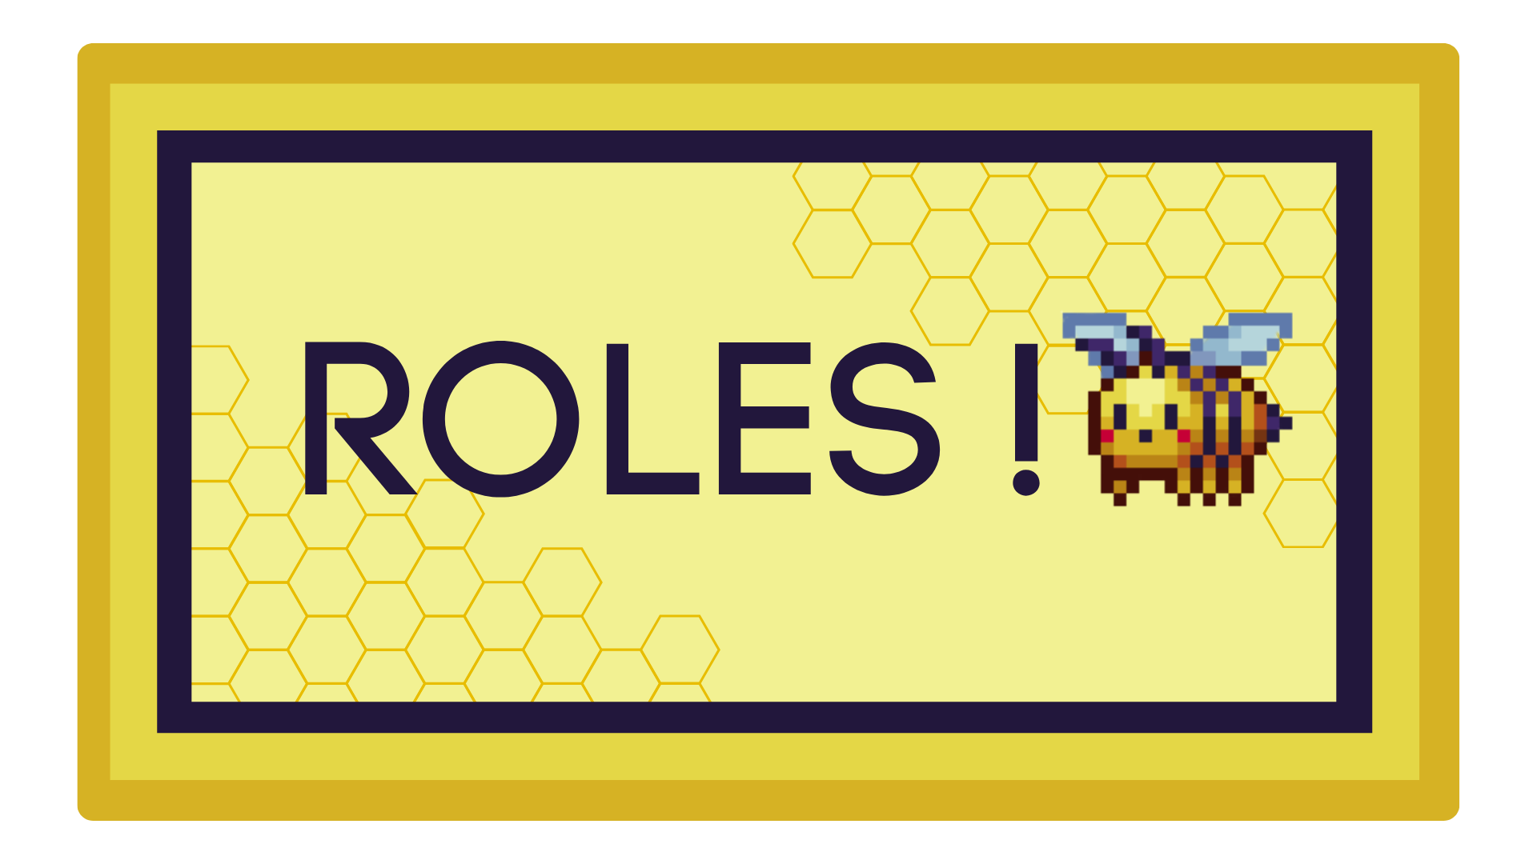

Updates:

* user flowchart

We created a user flowchart at first. Every action that the user can do is all stated in here.

* program flow

mainly the flowchart itself. but need some update

* key reps

It’s stated in here on how will the user can interact with the system. this is done

by mapping a specific keys to every possible action.

* documentation

Ofcourse, documentation to keep it professional and we can save it for our future purpose.

* survey

Conducting a survey once the final output is done and has been verified by our

Quality Assurance. This is for, our own good and we can see what else we can

improve in the future.

Changes on the program:

* user can now choose n number of song
* user can now choose based on year release
* pointing system
* 3 hints whole game

Removed:

* Leaderboards

**Project Design**

* Game Mechanics
  + User can choose n songs based on the year: 70’s 80’s 90’s 20’s 2010’s 2020’s. there will be 6 songs per year. = 36 songs
  + The player should guess the missing word on that specific stanza of the chosen song.
  + Player has a 3 hints whole game.
  + Player choice will be: A,B,C,D,H
  + Correct answer without using hint is 1000 points each. With using hint, it’s 500 points each. If your answer is wrong, you get 0 points on that round.
  + After the n songs is done, system will print out the total score of the user, and will ask if the user wants to quit or play again and score should go back again to 0.

What to do next:

* dividing of works from start to finish
* finalize flowchart & pseudocode
* development

Suggestions:

major portions

umi idea

Start menu

* about
* quit
* play

Play section

* start game
* help

Start game

* song picking