Iyad Shobaki

[FALL 2018 Microsoft SQL Server Database](https://blackboard.starkstate.edu/webapps/blackboard/execute/courseMain?course_id=_25348_1) (CPD222)

Professor Shanda-lyn Yaeger

T-SQL Lab, Week 2 assignment

9/3/2018

1. Write a statement to select all data from the employees table in the Northwind database.

Q)

SELECT *

FROM Employees

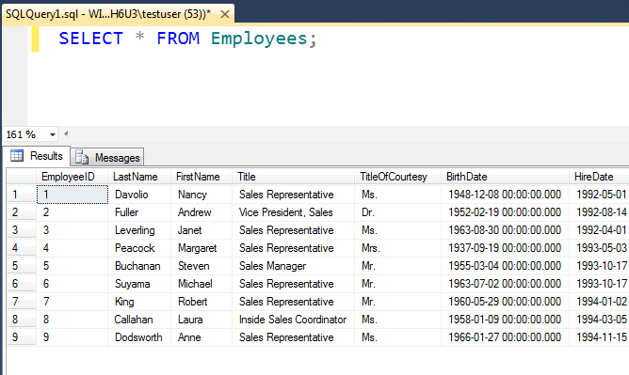

1. Modify the query written for #1 above to only include Sales Representatives.

Q)

SELECT *

FROM Employees

WHERE Title = 'Sales Representative';

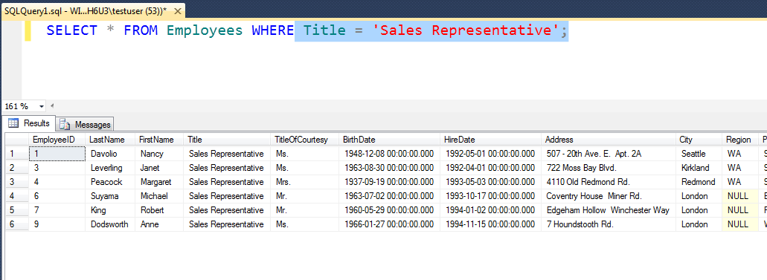

1. Insert a new employee into the employees table with the following information:

Q)

INSERT INTO Employees(LastName,FirstName,Title,TitleOfCourtesy,BirthDate,HireDate,Address,City,Region,PostalCode,Country,Extension,Notes,ReportsTo)VALUES('Smith','Janet','Sales Manager','Mrs','12-30-1974','08-05-2000','123 My Street','Canton','OH','44720','USA','4632',' MBA from Ashland University',2);

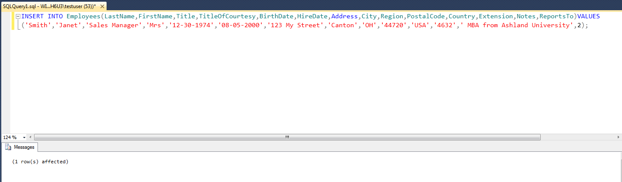

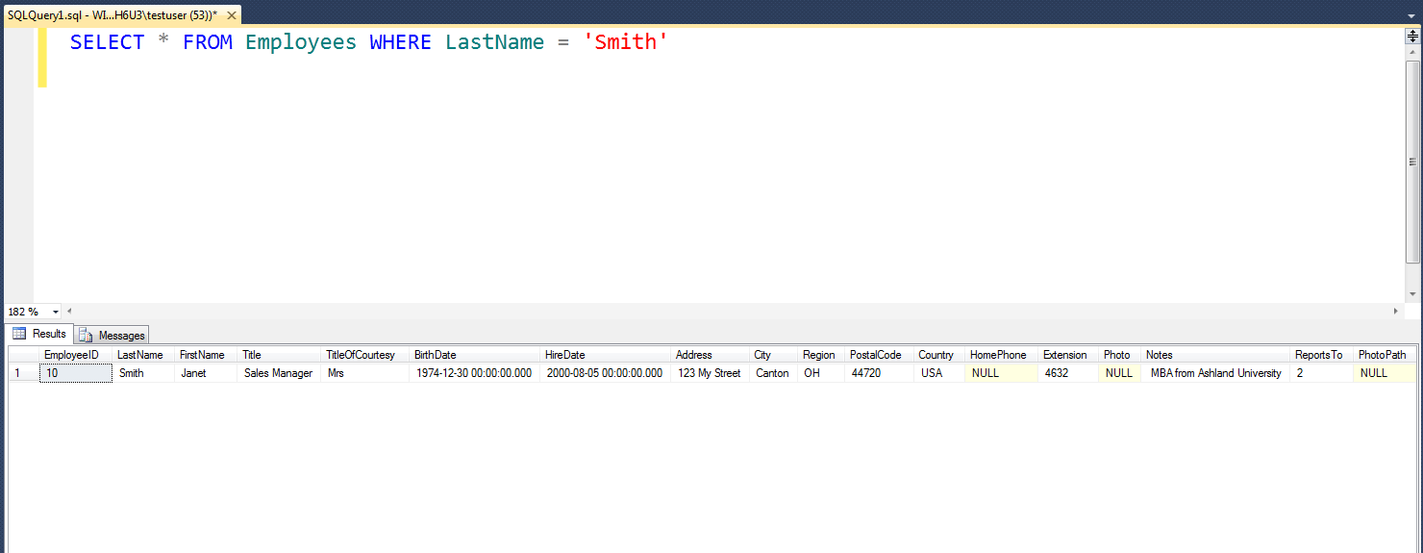

1. Update the new row you just inserted and change the title to 'Sales Representative'.

Q)

UPDATE Employees

SET Title = 'Sales Representative'

WHERE EmployeeID = 10;

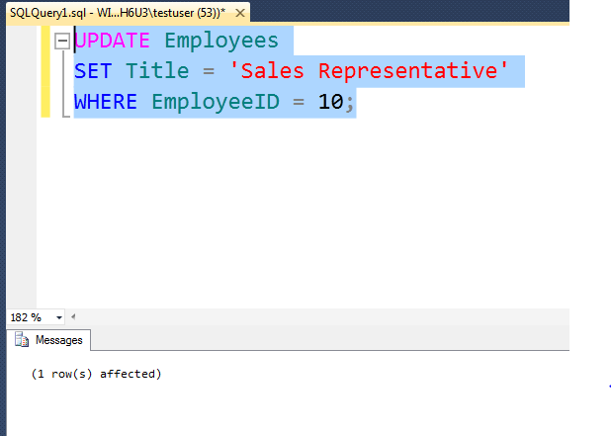

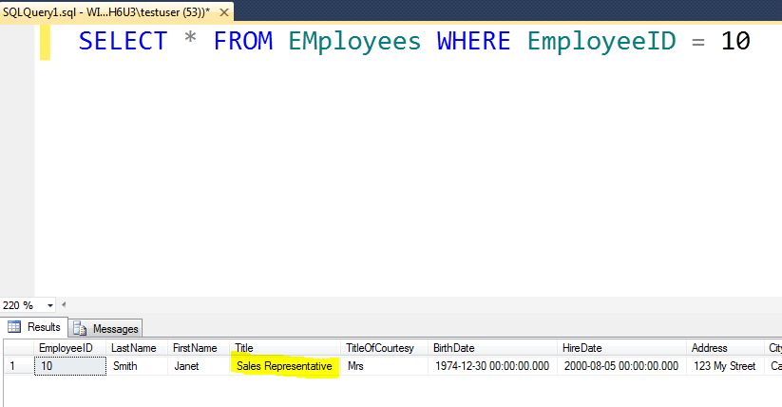

PERFECT!!! Typically the ReportsTo value gets students on the INSERT.  You are off to a great start!  Very few get a 100% the first time on this.