DESIGN AND IMPLEMENTATION OF A MACHINE LEARNING-BASED STUDENT DROPOUT PREDICTION SYSTEM FOR NIGERIAN UNIVERSITIES

BY

IYIMOGA JOSEPH NANA
20/61871U/1

A FINAL YEAR PROJECT PROPOSAL SUBMITTED TO THE
DEPARTMENT OF COMPUTER SCIENCE,
FACULTY OF COMPUTING,
ABUBAKAR TAFAWA BALEWA UNIVERSITY BAUCHI,

IN PARTIAL FULFILMENT OF THE REQUIREMENTS FOR THE AWARD OF
BACHELOR OF TECHNOLOGY (B.TECH.) DEGREE IN COMPUTER SCIENCE

SUPERVISOR:
DR. BALA M. YAKUBU

APRIL, 2026
1.0 PROJECT TITLE
Design and Implementation of a Machine Learning-Based Student Dropout
Prediction System for Nigerian Universities.
2.0 BACKGROUND AND MOTIVATION
Student dropout has remained one of the most stubborn problems confronting higher education across the world, and Nigeria is not left out. Every year, thousands of students who gain admission into Nigerian universities through the Joint Admissions and Matriculation Board (JAMB) fail to complete their degree programmes. Some withdraw on their own, others are dismissed on academic grounds, while a sizeable number simply stop attending lectures without giving any formal notice. Whatever the route, the outcome is usually the same: wasted resources, unused potential, and a heavy emotional burden on the student and the family that paid the bills.
The scale of the problem is troubling. Recent reports suggest that completion rates in many Nigerian federal universities sit below sixty-five percent, meaning that more than one out of every three students who begin a degree do not finish it within the expected time. The situation is even worse in courses with high failure rates such as Engineering, Medicine and Computer Science. The reasons behind dropout fall into both academic and non-academic categories, and recent African studies have shown that non-academic factors actually contribute more than purely academic ones (Mukooyo & Kasse, 2024). Financial hardship caused by the rising cost of living and unstable family income pushes many students out of school. Frequent academic disruptions, including the long ASUU strikes of 2020 and 2022, have also broken study momentum and made some students lose interest entirely. Add poor academic preparation from secondary school, weak counselling structures on campus, peer pressure, social commitments and personal challenges like illness or early marriage, and the picture becomes clearer (Alarape, 2021; Mukooyo & Kasse, 2024).
What makes the situation more frustrating is that most universities only realise a student is at risk after the damage is done, usually when results are released and the student is already on probation or has been advised to withdraw. By then, it is often too late to intervene meaningfully. The existing approach in many Nigerian universities depends on manual observation by lecturers and student affairs officers, which is reactive, slow and unable to scale across the large student populations on most campuses (Bashiru & Malgwi, 2026). Some universities now have more than fifty thousand students on a single campus, which makes manual monitoring practically impossible.
Recent advances in machine learning yield a promising way out of this problem. Studies in different parts of the world have shown that machine learning models are able to analyse a student's academic, demographic and financial information and flag those who are likely to drop out before the situation gets worse (Hassan et al., 2024; Mduma et al., 2019). Closer to home, work done in Nigerian universities has demonstrated that classification algorithms such as Logistic Regression, Random Forest along with Support Vector Machine can predict student outcomes with very high accuracy being trained on the right features (Bashiru & Malgwi, 2026; Osemwegie & Amadin, 2023). When such predictions are made early enough, schools can step in with focused support such as counselling, scholarships, coaching or remedial classes. This project is inspired by the need to bring this kind of data-focused early-warning system into the Nigerian university context, where it is currently absent or poorly developed.

3.0 PROBLEM STATEMENT
Nigerian universities currently lack an automated system that can predict, with reasonable accuracy, which students are likely to drop out of their degree programmes. The existing approach depends heavily on manual observation by lecturers and student affairs officers, which is slow, subjective and unable to scale across the large student populations on most campuses (Bashiru & Malgwi, 2026). By the time a struggling student is noticed, intervention is usually too late to make any real difference.
There is therefore a clear gap between the volume of student data already collected by university registries (admission records, semester results, fee payment status, demographic information) and the absence of an analytical tool that can convert that data into implementable predictions. This gap is even more pronounced in developing countries, where research on the use of machine learning for dropout prediction continues to be limited compared to Europe and North America (Mduma et al., 2019). This project sets out to close that gap by building a machine learning model that classifies students into dropout-risk categories and exposes the predictions via a simple web interface that even non-technical staff can use.

4.0 AIM AND OBJECTIVES
4.1 Aim
The aim of this project is to design, implement and deploy a machine learning-based system that predicts the likelihood of student dropout in Nigerian universities and presents the predictions via a user-friendly web application.
4.2 Specific Objectives
To achieve the above aim, the following specific objectives will be pursued:
- To collect, clean and prepare a structured dataset of student academic, demographic and financial records suitable for dropout prediction.
- To apply feature selection techniques in identifying the variables that contribute the most to dropout risk.
- To train and compare three machine learning classifiers, namely Logistic Regression, Random Forest along with Support Vector Machine, on the prepared dataset.
- To evaluate the performance of the three models using accuracy, precision, recall, F1-score and ROC-AUC, and select the best-performing one for deployment.
- To deploy the selected model as a web-based prediction system using Streamlit, with input fields adapted to the Nigerian university context.

5.0 PROPOSED SYSTEM / METHODOLOGY
This section explains how the project will be carried out. It begins with the conceptual architecture of the proposed system, then lists the tools and technologies that will be used, and ends with a step-by-step description of the technique.
5.1 System Architecture / Conceptual Model
The proposed system is built around a three-layer architecture made up of a data layer, a model layer and a presentation layer. This kind of layered structure is consistent with early warning systems that have been proposed for similar dropout prediction tasks in African universities (Bashiru & Malgwi, 2026). The data layer is responsible for storing the cleaned student dataset and supplying it to the next stage. The model layer handles all the machine learning operations, including preprocessing, feature selection, training and prediction. The presentation layer, built with Streamlit, is what the end user actually interacts with. Through this layer, a student affairs officer, course adviser or even the student can enter a student's information and receive a real-time prediction of dropout risk.
When a user submits information through the web form, the data is passed through the same preprocessing pipeline that was used during training (scaling, encoding and feature selection). The cleaned input is then fed into the trained model, which outputs a probability between zero and one. This probability is converted into a risk band (Low, Moderate or High) and displayed on the screen alongside a recommendation. The system is designed to be lightweight enough to run on free cloud services like Streamlit Community Cloud, so it does not require any expensive infrastructure to host.
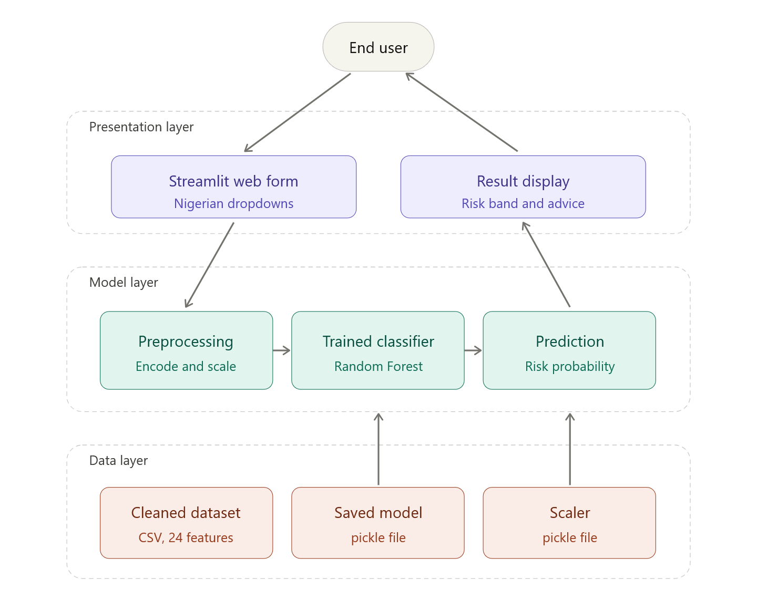Figure 5.1: Proposed System Architecture
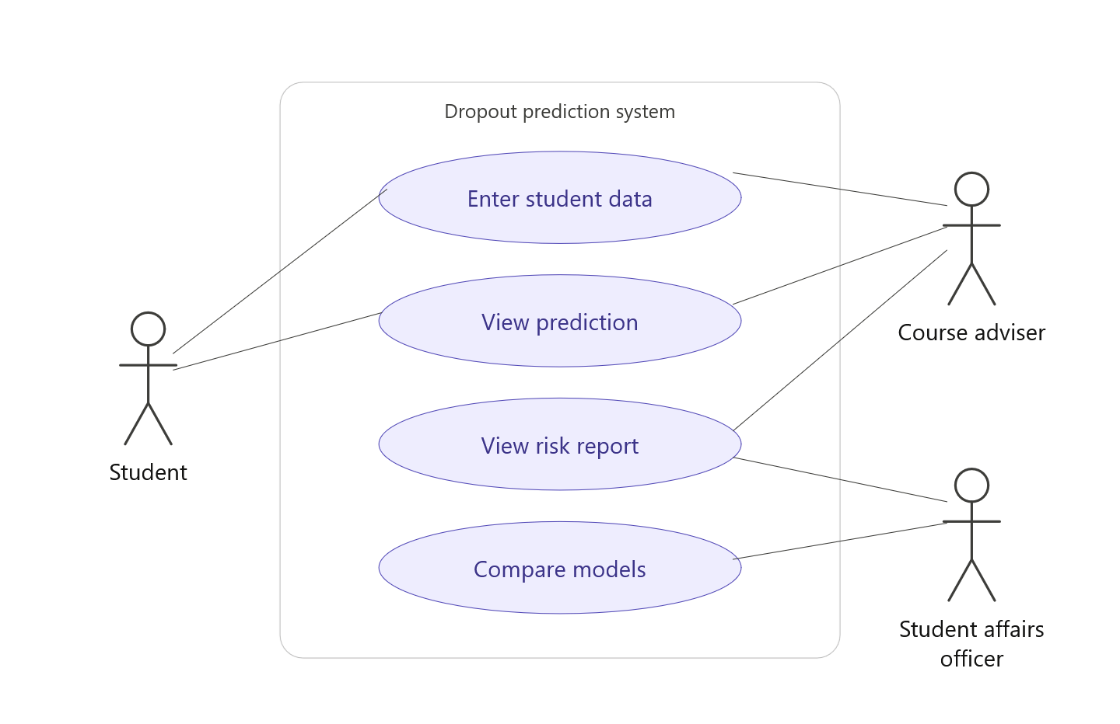Figure 5.2: Use Case Diagram of the Proposed System
5.2 Tools, Technologies and Frameworks
The development of this project will base on a combination of open-source tools that are widely used in machine learning and web development. Choosing open-source tools also keeps the project affordable, which is an important consideration for most Nigerian undergraduate projects. The tools and their purposes are summarised in Table 5.1

Tool / Technology | Category | Purpose in the Project
Python 3.10 | Programming language | Main language for data preprocessing, model training and the web app
Jupyter Notebook | Development environment | Interactive notebook for writing, running and documenting Python code, exploring the dataset and visualising results
Pandas, NumPy | Data libraries | Loading the dataset, cleaning, handling missing values and feature engineering
Scikit-learn | Machine learning library | Implementation of Logistic Regression, Random Forest and SVM, plus evaluation metrics
Matplotlib, Seaborn | Visualization | Plotting confusion matrices, ROC curves, feature importance and other charts
Joblib | Model persistence | Saving and loading the trained model and the scaler
Streamlit | Web framework | Building and deploying the prediction interface for end users
Git and GitHub | Version control | Tracking code changes and hosting the project repository
draw.io | Diagramming tool | Drawing the system architecture, flowcharts and UML diagrams
Streamlit Community Cloud | Hosting platform | Free deployment of the finished web application for public access
Table 5.1: Tools, Technologies and Frameworks for the Project
5.3 Methodological Steps
The project will follow a workflow inspired by the Knowledge Discovery in Databases (KDD) process, adapted for the dropout prediction task. A similar staged approach has been used in earlier dropout prediction approaches and has proved effective for handling messy real-world educational data (Nicoletti & de Oliveira, 2020). The steps are described below.
1. Data collection and preparation. The project will use the publicly available "Predict Students' Dropout and Academic Success" dataset from the UCI Machine Learning Repository as its base, since collecting a fresh dataset from a Nigerian university within the project period is difficult due to data privacy rules and the bureaucratic approval processes typical of most Nigerian university registries. Indeed, the limited availability of public student datasets in developing countries has been identified by previous researchers as one of the major obstacles to ML research in African education (Mduma et al., 2019). The dataset contains over 4,400 student records with 35 attributes covering demographic, socio-economic and academic features. To make the system more relevant to the Nigerian context, the user-facing web form will translate the original set of feature labels into Nigerian equivalents (for example, JAMB instead of the Portuguese national entrance exam) before mapping them back to the model's expected codes.
2. Data cleaning. The raw dataset will be checked for duplicate rows, missing values and outliers. As pointed out by Nicoletti and de Oliveira (2020), proper preprocessing is essential because instance-based and other learning algorithms are very sensitive to noisy data and irrelevant attributes. The ambiguous "Enrolled" class, which represents students who were still studying when the data was collected, will be removed so that the problem becomes a clean binary classification of Dropout versus Graduate. Outliers in the "Age at enrolment" column will be trimmed at the first and ninety-ninth percentiles to avoid distortion.
3. Feature selection. Mutual Information will be used to score each feature against the target. Features with very low predictive value (a Mutual Information score of 0.01 or less) will be dropped to reduce noise and improve model effectiveness. From early experiments, this is expected to leave around twenty-four useful features out of the first thirty-four. Feature selection techniques such as filter methods are preferred for this kind of work because they are computationally very cheap and can handle the mixed data types found inside educational datasets (Nicoletti & de Oliveira, 2020).
4. Model training and comparison. Three classifiers will be trained on the cleaned data: Logistic Regression as a linear baseline, Random Forest as a non-linear ensemble method, and Support Vector Machine as a kernel-based approach. Choosing models from three different families allows a fair comparison across algorithm types instead of just within one family. This kind of multi-model comparison is consistent with the approach used in previous studies, where six or more classifiers are typically trained and the best one selected on the basis of the evaluation metrics (Hassan et al., 2024; Osemwegie & Amadin, 2023). Each model will be trained on eighty percent of the data and tested on the remaining twenty percent, with stratified five-fold cross-validation applied to the training set to check for stability and overfitting.
5. Evaluation. The performance of the three models will be measured using accuracy, precision, recall, F1-score and ROC-AUC. Confusion matrices and ROC curves will also be plotted for visual comparison. The best-performing model will be selected mainly on the basis of ROC-AUC and recall, because in a dropout-intervention setting, missing a student who is actually at risk is more costly than raising a false alarm (Bashiru & Malgwi, 2026). The selected model will then be saved for deployment.
6. Deployment. The selected model will be wrapped in a Streamlit web application. The interface will be organised into seven sections: personal information, educational background, family background, financial status, first semester performance, second semester performance and economic context. Users will pick options from dropdowns rather than typing numeric codes, which makes the form usable for people with no technical background. The app will be hosted free on Streamlit Community Cloud and the code will be maintained on GitHub for version control and easy sharing.
7. Documentation and reporting. All steps, decisions, results and limitations will be documented in the final project report following the departmental guidelines. The source code, trained models, datasets and screenshots will be uploaded to a public GitHub repository for reproducibility along with future reference.
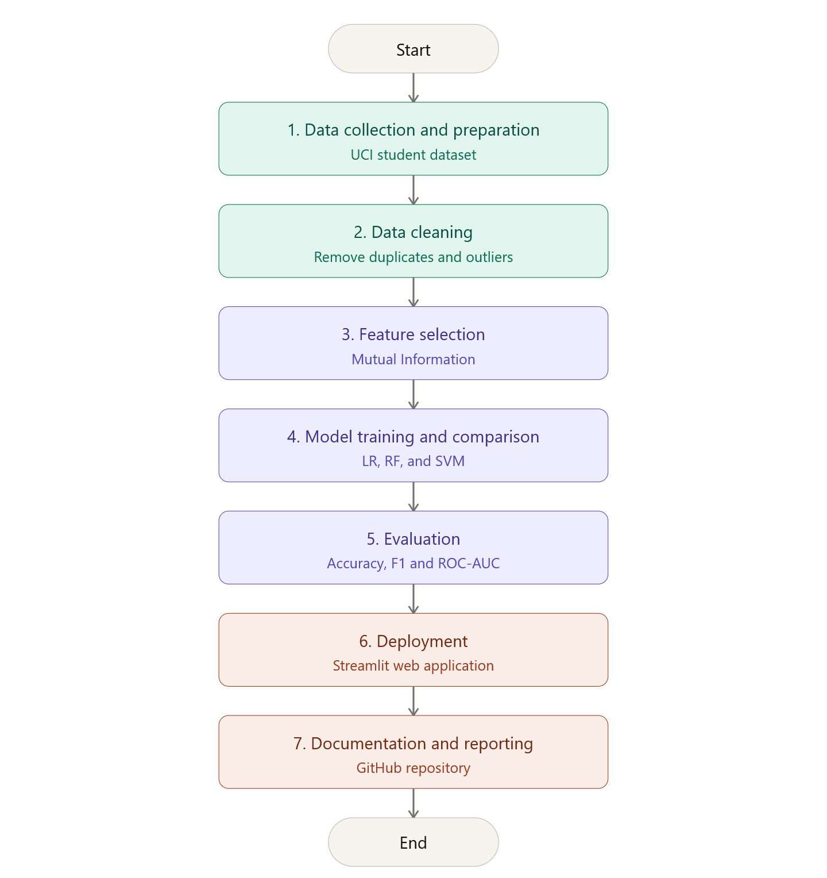Figure 5.3: Flowchart of the Project Methodology

6.0 EXPECTED RESULTS
By the end of the project, the following deliverables and outcomes are expected:
- A cleaned and properly preprocessed dataset suitable for dropout prediction, with all noisy and irrelevant features removed.
- Three trained machine learning models (Logistic Regression, Random Forest along with Support Vector Machine) along with a clear comparison of the performance using standard classification metrics.
- A best-performing model with an expected accuracy of at least eighty-five percent and a ROC-AUC score above 0.90. These targets are realistic when judged against the results reported in the literature, where Random Forest models have been found to reach 95% accuracy on similar dropout datasets (Hassan et al., 2024), and Logistic Regression has reached close to 99% accuracy on Nigerian university data (Osemwegie & Amadin, 2023).
- A working Streamlit web application that takes student information through a Nigerian-friendly form and returns a dropout-risk prediction in real time.
- Comparison plots, confusion matrices and a feature-importance chart that explain why the model makes the decisions it does.
- A complete project report and a public GitHub repository containing all source code, datasets and documentation, so that future students can extend the work.
The success of the project will be measured by three things: the correctness and reliability of the final model on the test set, the usability of the deployed web app (which will be tested informally on classmates and a few volunteer students), and the completeness of the documentation.

7.0 IMPORTANCE OF THE STUDY
This project carries both academic as well as practical importance. On the academic side, it adds to the small but growing body of work on educational data mining in African higher institutions, an area that is still under-researched compared to Europe and North America (Mduma et al., 2019; Mukooyo & Kasse, 2024). It additionally builds on earlier Nigerian work in this space, such as the hybrid model developed by Alarape (2021) at the University of Ilorin and the recent early warning system work by Bashiru and Malgwi (2026) at Taraba State University, by combining classifier comparison with a deployable user interface. This is something that students and lecturers in the Department of Computer Science can build on for future work.
On the practical side, the system has the potential to help Nigerian universities reduce dropout rates by identifying at-risk students early enough for meaningful intervention. Student affairs units, course advisers and counsellors will be able to use the tool as part of their routine work without needing any background in programming or statistics. For students themselves, the system offers a way to self-check their risk and seek assistance before things get worse. Parents and guardians, who often pay heavy fees and make sacrifices to support their children's education, also stand to benefit from these early warnings.
Beyond the university campus, the method used in this project can be adopted by polytechnics, colleges of education and even secondary schools that wish to track student progress more carefully. Policymakers at the National Universities Commission and the Federal Ministry of Education could also use insights from such systems to plan support programmes and scholarship schemes more effectively. Finally, the project opens the door to future research in more advanced techniques such as deep learning, explainable artificial intelligence (XAI) and the integration of dropout prediction frameworks with existing university management software, which have all been identified as promising future directions in the literature (Mduma et al., 2019).

8.0 PROJECT SCOPE AND LIMITATIONS
8.1 Scope
The project will cover the full machine learning pipeline from data preprocessing to web deployment. Three classification algorithms will be trained and compared, and the best-performing one will be deployed through a Streamlit web app with input fields adapted to the Nigerian university context. The system will predict only two outcomes for each student: "Likely to Graduate" or "At Risk of Dropout", along with a numerical risk probability. The web app will be hosted online so that anyone with the link can use it.
8.2 Limitations
A few honest limitations should be stated upfront. First, the project will rely on the publicly available UCI dataset from a Portuguese university because collecting fresh data from a Nigerian institution within the project schedule is constrained by data privacy regulations and the long approval processes typical of Nigerian university registries. This is a known challenge for ML research in developing countries, and it has been highlighted by several previous reviewers (Mduma et al., 2019). Although the user interface will be carefully adapted to Nigerian terminology, the fundamental patterns the model learns will reflect Portuguese student behaviour, which may not transfer perfectly to Nigerian conditions. This will be acknowledged in the limitations segment of the final report and recommended as an area for future research.
Second, the model uses some features (such as first and second semester results) that are only available after a student has completed at least one academic year. This means the system predicts dropout after the first year, not at the point of admission. Building an admission-time predictor would require a different feature set and a separate training run.
Third, the Streamlit app will be deployed on a free hosting plan, which limits the number of concurrent users it can handle and the amount of memory available. This is acceptable for an academic demonstration but not for full production use. Fourth, this project will not cover deep learning models, since the dataset size does not justify their use and they are harder to interpret. Finally, hyperparameter tuning will be limited to a small grid due to computing limitations on the student's personal laptop.

9.0 TIMELINE (GANTT-STYLE OUTLINE)
The project will be executed over a period of about six months, from January to June 2026. The major activities and their planned schedule are summarised in Table 9.1.

Activity | Jan | Feb | Mar | Apr | May | Jun
Proposal writing and approval
Literature review
Data collection and cleaning
Feature selection and preprocessing
Model training and comparison
Web app development with Streamlit
System testing and evaluation
Project documentation and write-up
Final defense preparation
Table 9.1: Project Schedule (Gantt-Style Outline)
10.0 REFERENCES
The references below follow the APA 7th edition format.

Alarape, M. A. (2021). Hybrid models for students' academic performance and dropout prediction using machine learning algorithms [Doctoral dissertation, University of Ilorin]. Department of Computer Science, Faculty of Communication and Information Sciences, University of Ilorin, Nigeria.
Bashiru, S., & Malgwi, Y. M. (2026). A machine learning-based early warning system for identifying at-risk university students in Nigerian higher education. Mambilla Journal of Science and the Environment, 10(1), 41–46.
Hassan, M. A., Muse, A. H., & Nadarajah, S. (2024). Predicting student dropout rates using supervised machine learning: Insights from the 2022 National Education Accessibility Survey in Somaliland. Applied Sciences, 14(17), 7593. https://doi.org/10.3390/app14177593
Mduma, N., Kalegele, K., & Machuve, D. (2019). A survey of machine learning approaches and techniques for student dropout prediction. Data Science Journal, 18(1), 14. https://doi.org/10.5334/dsj-2019-014
Mukooyo, H., & Kasse, J. P. (2024). Towards sustainable education: A machine learning model for early student dropout prediction in higher education institutions. The Uganda Higher Education Review, 11(2), 57–68. https://doi.org/10.58653/nche.v11i2.5
Nicoletti, M. C., & de Oliveira, O. L. (2020). A machine learning-based computational system proposal aiming at higher education dropout prediction. Higher Education Studies, 10(4), 12–24. https://doi.org/10.5539/hes.v10n4p12
Osemwegie, E. E., & Amadin, F. I. (2023). Student dropout prediction using machine learning. FUDMA Journal of Sciences, 7(6), 347–353. https://doi.org/10.33003/fjs-2023-0706-2103

