ABUBAKAR TAFAWA BALEWA UNIVERSITY, BAUCHI
DEPARTMENT OF COMPUTER SCIENCE

AN ENSEMBLED MACHINE LEARNING MODEL FOR PREDICTION OF STUDENTS DROPOUT IN NIGERIAN UNIVERSITIES

A PROJECT REPORT
Submitted to the Department of Computer Science
in partial fulfilment of the requirements for the award of
Bachelor of Technology (B.Tech.) Degree in Computer Science

BY

IYIMOGA JOSEPH NANA
Matriculation Number: 20/61871U/1

Supervised by
Dr. Bala M. Yakubu
B.Sc., M.Sc., Ph.D. (Computer Science)

JUNE 2026

CERTIFICATION

This is to certify that the project titled “Design and Implementation of a Machine Learning-Based Student Dropout Prediction System for Nigerian Universities” was carried out by IYIMOGA JOSEPH NANA, Matriculation Number: 20/61871U/1 of the Department of Computer Science, Abubakar Tafawa Balewa University, in partial fulfilment of the requirements for the award of the Bachelor of Technology (B.Tech.) Degree in Computer Science. All sources and materials used in this study have been duly acknowledged in accordance with academic conventions.

_________________________________ _________________________________
Dr. Bala M. Yakubu Date
Project Supervisor

_________________________________ _________________________________
Dr. Zambuk Date
Head of Department

_________________________________ _________________________________
External Examiner Date

DEDICATION

To God Almighty — for wisdom, strength, and grace through every season of this journey.

To my Dad and siblings who believed in me, and gave up so much so that I could be here.

And to every Nigerian student who had to leave school before their time, feel for you —
this work is, in some small way, for you.

ACKNOWLEDGEMENTS
First and above all else, I thank God. The completion of this work — from the very first paragraph of the literature review to the final lines of code in the prediction model — has been sustained by grace I cannot entirely account for on my own.
To my supervisor, Dr. Bala M. Yakubu: your patience, critical eye, and willingness to engage seriously with the ideas in this project made it significantly better than it would otherwise have been. I am genuinely grateful. I also thank Dr. Zambuk and the entire academic staff of the Computer Science Department for the teaching, guidance, and high standards that shaped my undergraduate years.
My parents deserve more credit than a few lines can capture. Every fee they paid, every sacrifice they made, every prayer they said on my behalf — it is all here in this work, in a way. My siblings and extended family have been a constant source of encouragement, and I am grateful for each of them.
Building the SDPS system was, in many ways, shaped by my experience as a student and instructor at Nascomsoft Embedded Hub, Bauchi and a builder of AI solutions that solve real world problems. Working on real technology problems for Nigerian, African, and world users taught me that good software must meet people where they are — not where we imagine they are. That lesson is woven into every design decision in this project, from the Nigerian-language field labels to the lightweight deployment approach.
Finally, to my course mates and colleagues who shared ideas, challenged assumptions, and made the long library sessions bearable — thank you. Research is rarely as solitary as it looks on paper.

IYIMOGA JOSEPH NANA
June 2026

ABSTRACT
Student dropout is one of the most serious and persistent problems facing Nigerian universities today. Despite significant investment in expanding access to higher education, a considerable proportion of enrolled students leave before graduating — a reality with damaging consequences for individuals, institutions, and the country’s development ambitions. This study designed, implemented, and deployed a machine learning-based Student Dropout Prediction System (SDPS) built specifically around the realities of Nigerian university life. Using a dataset of 4,424 student records adapted from an internationally validated source and re-contextualized for Nigerian academic structures — including JAMB/UTME admission routes, WAEC qualifications, and Nigerian course categories — three supervised machine learning algorithms were trained and evaluated: Logistic Regression (LR), Random Forest (RF), and Support Vector Machine with an RBF kernel (SVM). The models were assessed across twenty-four predictor variables spanning seven categories: personal background, educational history, family circumstances, financial status, first semester performance, second semester performance, and economic context. Feature importance analysis using Mutual Information revealed that academic performance in the early semesters — particularly how many courses a student passes and their average grade — is by far the strongest predictor of eventual dropout. Tuition fee payment status and scholarship access followed closely behind, confirming what most Nigerian academics already suspect: money and performance are the twin engines of student persistence. Random Forest achieved the best overall results, with 91.4% accuracy, 0.963 AUC, 0.891 precision, 0.876 recall, and 0.883 F1-score. The system was subsequently deployed as a web application using Streamlit community cloud, with a user interface designed in plain Nigerian academic language so that administrators do not need any data science background to use it. The application accepts student data through a seven-section form, returns an instant dropout probability and risk classification, and provides color-coded intervention guidance. This study demonstrates that a practical, deployable dropout prediction tool for Nigerian universities is not just theoretically possible — it has been built, tested, and shown to work.

Keywords: Student dropout, Machine Learning, Nigerian universities, early warning system, Streamlit Community Cloud deployment, Random Forest, Logistic Regression, Support Vector Machine, educational data mining.

TABLE OF CONTENTS

LIST OF TABLES

Table 2.1: Summary of Related Works in Student Dropout Prediction26
Table 3.1: Dataset Feature Descriptions and Categories33
Table 3.2: Functional Requirements of the SDPS31
Table 3.3: Non-Functional Requirements of the SDPS32
Table 3.4: Confusion Matrix Template43
Table 4.1: Descriptive Statistics of Key Numerical Features49
Table 4.2: Model Performance Comparison on Test Set52
Table 4.3: Confusion Matrix — Random Forest (Best Model)53
Table 4.4: Cross-Validation Results (10-Fold) for All Models54
Table 4.5: System Test Cases and Results62

LIST OF FIGURES

Figure 4.1: Class Distribution of Target Variable50
Figure 4.2: Metric Comparison Across Three Models (Bar Chart)52
Figure 4.3: ROC Curves and AUC Scores for All Three Models53
Figure 4.4: Confusion Matrices for All Three Models54
Figure 4.5: Top 20 Features by Mutual Information Score56
Figure 4.6: SDPS Input Form — Personal, Educational and Family Sections58
Figure 4.7: SDPS Prediction Output — High-Risk Student Profile60
Figure 4.8: SDPS Model Comparison Tab with Performance Metrics62

LIST OF ABBREVIATIONS

ANN | Artificial Neural Network
API | Application Programming Interface
AUC | Area Under the Curve
CGPA | Cumulative Grade Point Average
DT | Decision Tree
EDA | Exploratory Data Analysis
EWS | Early Warning System
F1 | F1-Score (Harmonic Mean of Precision and Recall)
FN | False Negative
FP | False Positive
GPA | Grade Point Average
HND | Higher National Diploma
JAMB | Joint Admissions and Matriculation Board
KNN | K-Nearest Neighbours
LMS | Learning Management System
LR | Logistic Regression
MI | Mutual Information
ML | Machine Learning
MOOC | Massive Open Online Course
NB | Naive Bayes
OND | Ordinary National Diploma
RF | Random Forest
ROC | Receiver Operating Characteristic
SDPS | Student Dropout Prediction System
SES | Socioeconomic Status
SIMS | Student Information Management System
SVM | Support Vector Machine
TN | True Negative
TP | True Positive
UTME | Unified Tertiary Matriculation Examination
WAEC | West African Examinations Council

CHAPTER ONE
INTRODUCTION

1.1 Background to the Study

If you have ever watched a classmate disappear quietly from lectures and not return the following semester, you have witnessed the problem this study is trying to address. Student dropout in Nigerian universities is not just a statistic on a government report. It is a pattern that plays out in the lives of real people — young men and women who enroll full of ambition and then leave, for reasons that are not always their fault, and not always visible until it is too late.

Nigeria’s higher education sector has grown considerably over recent decades. The National Universities Commission (NUC, 2023) currently lists over 170 accredited universities, with total enrolment exceeding 1.7 million students. But growth in access has not been matched by growth in completion. A substantial share of enrolled students — some estimates place the figure as high as 23 to 30 percent in federal universities (NBS, 2022) — fail to graduate within the stipulated timeframe, with many exiting without degrees altogether. Those numbers represent wasted tuition payments, lost years, and foreclosed opportunities for hundreds of thousands of young Nigerians.

What makes this particularly frustrating, from a systems perspective, is that dropout often does not happen suddenly. It tends to accumulate gradually — a few failed courses in the first semester, a rising fee debt that nobody notices in time, a slow withdrawal from academic life that begins long before any formal record flags it as a crisis. By the time an academic adviser or a faculty member realizes a student is at serious risk, the process of disengagement may already be too far advanced to reverse easily.

This is precisely the gap that machine learning can help fill. Machine learning (ML) is a branch of artificial intelligence concerned with developing algorithms that identify patterns in data and use those patterns to make predictions. In the context of student retention, ML models can be trained on historical student records — including grades, fee payment history, demographic information, and other indicators — to learn what a ‘dropout trajectory’ looks like, and to flag students who appear to be following that trajectory while there is still time to intervene (Mduma, Kalegele, & Machuve, 2019). Contemporary research suggests that leveraging diverse behavioral data through these algorithms can significantly enhance the accuracy and efficiency of such early identification efforts (Zhao & Ren, 2025). The technology is not new. Universities in Europe, North America, and increasingly across Africa have begun deploying such systems with encouraging results. The challenge is that most of these systems were designed for institutional contexts quite different from the Nigerian one.

An approach built around Portuguese university structures, or adapted from a Danish high school dataset, is unlikely to capture the specific dynamics of Nigerian undergraduate life — the role of JAMB scores and Post-UTME screening in shaping who enters and how prepared they are; the pressure of fee payment in an environment where family income is uncertain; the way ASUU strikes disrupt academic timelines; or the particular vulnerability of students who relocate from rural states to study in larger cities. Furthermore, while predictive research has been successfully conducted in other developing academic environments such as Peru, the specific variables influencing attrition remain highly context-dependent (Jiménez et al., 2023). A system designed for Nigeria needs to be built with Nigeria in mind (Bashiru & Malgwi, 2026; Osemwegie & Amadin, 2023).

This project responds to that need. The Student Dropout Prediction System (SDPS) developed here takes an internationally validated dataset of student records — notably the same base dataset utilized in recent comparative benchmarks for academic success (Villar & Andrade, 2024) — and re-maps every categorical variable to its Nigerian equivalent — admission routes, qualification types, course categories, parental occupations — and trains three supervised ML classifiers to predict dropout risk. These algorithms, specifically Logistic Regression, Random Forest, and Support Vector Machine, represent the current standards for handling non-linear interactions and high-dimensional data in educational modeling (Fatima et al., 2023; Valkenborg et al., 2023). The system is then deployed as a web application that any academic administrator can use, without needing to understand a single line of Python, to assess the dropout risk of individual students and receive guidance on appropriate interventions.

1.2 Statement of the Problem
The Nigerian university system faces a student dropout problem of serious proportions. Best available estimates suggest that between one-fifth and one-third of enrolled students in Nigerian federal universities do not complete their programmes within the standard duration (NBS, 2022). This failure rate exceeds comparable figures from most middle-income countries and represents a significant drag on Nigeria’s human capital development agenda. Recent international research indicates that while student desertion is a global phenomenon affecting over 180 countries, the specific sociocultural and economic triggers remain significantly localized, requiring context-specific modeling (Jiménez et al., 2023).
The consequences are not abstract. For individual students, dropout typically means a permanent reduction in earning potential, limited career mobility, and, for many, a lasting sense of personal failure. For institutions, high dropout rates translate into revenue losses, lower graduation statistics, and diminished national ranking scores. In some regions, the financial impact of university dropout can exceed 1.5 billion euros annually, illustrating the massive economic burden placed on both government and educational stakeholders (Jiménez et al., 2023). For the country as a whole, the cumulative effect is a workforce that is less educated than it could be, and a public investment in higher education that is not fully yielding its intended returns (Mduma et al., 2019).
The response of most Nigerian universities to this problem has been reactive rather than preventive. Academic monitoring tends to rely on semester examination results and cumulative GPA checks — information that only becomes available after a student has already struggled through one or more semesters. The inability to transition to preventive strategies is often due to the complexity and diversity of student behaviors, which makes early identification a significant technical challenge for many institutions (Zhao & Ren, 2025). Students who fall below minimum GPA thresholds are placed on academic probation, but this intervention typically occurs only after significant academic damage has already been done. Students who fall behind on fee payments often receive reminders and eventual deregistration, but rarely any proactive outreach or financial support at the moment when early intervention might prevent departure. And in universities where student-to-counsellor ratios may run into the thousand, ad hoc counselling support is often effectively unavailable to most students who need it.
The core problem, in short, is the absence of a systematic, proactive, data-driven mechanism for identifying students at risk of dropping out before they do. Without such a mechanism, institutions cannot efficiently allocate scarce support resources to the students who need them most. This is further complicated by the fact that many standard classification models struggle to accurately identify the minority "dropout" class in heavily imbalanced educational datasets, leading to a high rate of missed cases (Villar & Andrade, 2024). Additionally, the lack of interpretability in advanced ensemble models can prevent administrators from understanding the underlying reasons for a student's risk profile (Fatima et al., 2023). The specific subsidiary problems this study addresses are:
- There are no published, validated ML-based dropout prediction models trained on data adapted to the Nigerian university context — with Nigerian admission structures, grading conventions, and socioeconomic indicators.
- Nigerian universities generally lack operational early warning tools that academic administrators can use in real time without specialist technical knowledge.
- The relative predictive importance of different student characteristics in the Nigerian dropout context is poorly documented, limiting the evidence base for intervention design.
- No lightweight, deployable web application for dropout prediction has been developed and documented specifically for use in Nigerian higher education institutions.

1.3 Aim and Objectives of the Study
The overall aim of this study is to design, implement, and deploy a machine learning-based Student Dropout Prediction System (SDPS) that can identify Nigerian university students at risk of dropout early enough for meaningful intervention to take place.
To achieve the main aim, the following specific objectives were pursued:
- To analyze the factors associated with student dropout..
- To apply feature selection techniques in identifying the variables that contribute the most to dropout risk.
- To develop three machine learning classifiers, namely Logistic Regression, Random Forest along with Support Vector Machine, on the prepared dataset.
- To evaluate the performance of the three models using accuracy, precision, recall, F1-score and ROC-AUC, and deploy the best-performing one as a web-based prediction system using Streamlit.

1.4 Research Questions
Four research questions guide this investigation:
- Which student attributes — academic, demographic, financial, or
socioeconomic — are most predictive of dropout risk in the Nigerian university context?
- Which of the three supervised ML algorithms evaluated achieves the best predictive performance, and by what margin?
- What are the practical implications of the feature importance findings for the design of early intervention programmes in Nigerian universities?
- To what extent can a machine learning-based dropout prediction system be successfully deployed as a functional, user-friendly web application for use by Nigerian university administrators?

1.5 Scope of the Study
The scope of this study is defined along four dimensions.
Thematically, this study focuses on undergraduate student dropout prediction in Nigerian universities. Postgraduate dropout, primary and secondary school dropout, and dropout from polytechnics or online learning platforms are outside the scope, although the methodology is in principle transferable.
Geographically, the study is positioned within the Nigerian higher education landscape. While the primary dataset originates from a Portuguese institution, extensive re-contextualization has been applied to align all categorical variables with Nigerian academic structures, admission systems, and occupational categories. The deployed application uses entirely Nigerian-language field labels and descriptions.
Methodologically, the study is confined to three supervised ML classification algorithms: Logistic Regression, Random Forest, and Support Vector Machine. Deep learning methods, unsupervised approaches, and survival analysis were considered but are reserved for future work.
Temporally, the study was conducted during the 2024/2025 academic year. Real-time integration with live university student databases was not pursued due to data access constraints, though the system architecture is designed to support such integration in future implementations.

1.6 Significance of the Study
The significance of this work operates at several levels simultaneously.
From a research perspective, it contributes one of the few published, rigorously evaluated ML-based dropout prediction studies explicitly designed for the Nigerian university context. The contextualization module (nigerian_labels.py) and the feature engineering pipeline constitute reusable research artefacts for future investigators working in similar settings.
From an institutional perspective, the deployed SDPS gives academic administrators a practical tool that requires no data science background to operate. The system generates immediate, interpretable risk outputs with color-coded intervention guidance. For a department coordinator handling hundreds of students each semester, that kind of actionable, on-demand insight is genuinely useful.
For policymakers, the feature importance findings provide quantitative evidence for targeted intervention design. The fact that tuition fee payment status ranks among the top six predictors of dropout — ahead of demographics and family background variables — is a concrete, data-backed argument for investing in proactive financial aid mechanisms rather than purely academic support programmes.
And at the level of individual students, a functioning early warning system means that the students who are quietly falling through the cracks — the ones who have not yet failed but whose early-semester patterns already point toward eventual exit — have a better chance of being noticed and supported before it is too late.

1.7 Motivation
Two things brought this project into focus for me. The first is something I have observed as an undergraduate student in Nigeria: the way students disappear from programmes without anyone having clearly noticed the warning signs, and the sense — shared, I think, by many of my peers(course mates) — that university systems are often better at recording failures than preventing them.
The second is the experience of learning and building products in tech. Working on software that is intended for actual Nigerian users taught me a discipline that pure academic work sometimes lacks — the obligation to make the interface work for the person in front of you, not the person you’d ideally like to have in front of you. The SDPS application reflects that orientation: every label, every section header, every help text was written with a Nigerian university administrator in mind, not a generic hypothetical user.
Beyond the personal, this work is also motivated by Nigeria’s SDG 4 commitments and by TETFund’s mandate to improve graduation rates and higher education quality. A low-cost, data-driven early warning system is exactly the kind of high-leverage intervention that can contribute meaningfully to those goals without requiring massive infrastructure investment.

1.8 Organization of the Report
Chapter One (this chapter) has established the context, problem, objectives, and motivation of the study.
Chapter Two reviews the relevant literature, covering conceptual definitions, theoretical dropout models, and empirical studies on ML-based dropout prediction, with focus on the Nigerian and African context.
Chapter Three presents the system analysis and design, including requirements, dataset description, preprocessing steps, the three ML algorithms, evaluation metrics, and system architecture.
Chapter Four covers implementation and results: the development environment, preprocessing outcomes, model training, performance evaluation with all figures, feature importance analysis, and a detailed presentation of the deployed web application interface with screenshots.
Chapter Five draws together the findings into a summary and conclusion, articulates contributions to knowledge, acknowledges limitations, and recommends directions for future work.
References and appendices follow Chapter Five.

CHAPTER TWO
LITERATURE REVIEW

2.1 Introduction
This chapter reviews the literature relevant to this study across three dimensions. First, a conceptual review clarifies how ‘student dropout’ and ‘machine learning’ are defined and understood across disciplines. Second, a theoretical framework situates the study within established models of student persistence and attrition. Third, an empirical review examines specific studies that have used ML for dropout prediction, with particular attention to work done in Nigerian and African contexts. The chapter concludes by identifying the research gaps that this project is designed to address.

2.2 Conceptual Review

2.2.1 Student Dropout: Meaning and Measurement

The concept of student dropout sounds simple enough — a student who starts a programme and does not finish it — but defining it precisely turns out to be more complicated than it first appears. Does a student who transfers to another institution count as a dropout? What about one who takes a year off and returns? Or one who stops attending lectures but remains officially enrolled? Different studies draw these lines in different places, and the inconsistency makes cross-study comparisons difficult (Nicoletti & Oliveira, 2020). Recent research further distinguishes between short-term interruptions, where a student may return after a year, and definitive desertion, which represents a permanent exit from the higher education system (Jiménez et al., 2023).

For the purposes of this study, dropout is defined as the permanent exit of a student from their university programme without completing the requirements for graduation, excluding students who transfer to another accredited institution. This is a binary outcome: a student either drops out or does not. The outcome is modelled as a classification problem, which is the standard approach in the majority of ML-based dropout prediction literature (Osemwegie & Amadin, 2023; Hassan, Muse, & Nadarajah, 2024).

In the Nigerian higher education setting, dropout takes on specific characteristics that are worth spelling out. A significant proportion of Nigerian dropouts are driven not by academic failure alone but by financial crisis — the inability to pay tuition fees, which triggers a cascade of administrative consequences including deregistration and loss of hostel access. Others are driven by family pressures, including marriage (disproportionately affecting female students), the need to support parents economically, or relocation constraints. Academic failure, when it occurs, is often itself a consequence of these underlying pressures rather than their cause (Bashiru & Malgwi, 2026; Mukooyo & Kasse, 2024).

This distinction matters because it shapes what a prediction model needs to capture. A model that only looks at academic performance metrics will miss many Nigerian dropouts whose trajectory begins with financial or personal crisis long before their grades deteriorate. The feature set used in this study was designed with this in mind, incorporating financial status variables alongside academic indicators.

2.2.2 Machine Learning: Concepts and Taxonomy

Machine learning is the subfield of artificial intelligence concerned with building systems that improve their performance on tasks through exposure to data, rather than through explicit step-by-step programming (Jordan & Mitchell, 2015, as cited in Mduma et al., 2019). The core idea is inductive generalisation: given enough examples of a phenomenon, an ML algorithm learns the underlying pattern and can apply it to new, unseen cases (Valkenborg et al., 2023).

The primary division in ML is between supervised and unsupervised learning. In supervised learning — the paradigm used in this study — the algorithm learns from labelled training data, meaning data where the correct answer (in this case, dropout or non-dropout) is already known for each record. The algorithm fits a model to this labelled data and then uses the fitted model to predict the labels of new, unlabelled records. Ensemble learning, a powerful subset of this paradigm, combines multiple 'weak learners' to create a robust final prediction, typically through bagging or boosting techniques (Fatima et al., 2023). Unsupervised learning, by contrast, looks for structure in data without any predefined labels, and is used for tasks like clustering students into behavioural groups rather than predicting a specific outcome.

Within supervised learning, the task of assigning each record to one of a fixed set of categories is called classification. Student dropout prediction is a binary classification problem — two categories: Dropout (1) and Non-Dropout (0). The three algorithms used in this study — Logistic Regression, Random Forest, and Support Vector Machine — are all supervised classification algorithms, each approaching the problem from a different mathematical angle. Support Vector Machines, for instance, exploit geometric properties of the data to find a maximum-margin hyperplane that separates classes, often utilizing the 'kernel trick' to handle highly non-linear problems (Valkenborg et al., 2023). Their theoretical foundations are described in Chapter Three.

2.2.3 Educational Data Mining

Educational data mining (EDM) is a research field that applies data analysis and computational methods to the large datasets generated by educational institutions and processes, with the goal of better understanding how students learn and what factors shape their academic trajectories. It overlaps significantly with the broader field of learning analytics (LA), though EDM tends to emphasise automated discovery of patterns while LA focuses more on using those patterns to inform educational decision-making.

The application of EDM to student retention is now a well-established research direction, with studies dating back at least to the early 2000s (Nicoletti & Oliveira, 2020). The data sources commonly used include academic transcript records (grades, credit loads, course registrations), demographic data (age, gender, marital status), socioeconomic indicators (parental education and occupation, scholarship status, fee payment history), and, increasingly, digital behaviour traces from Learning Management Systems such as Moodle or Blackboard — login frequency, time spent on course materials, discussion forum activity, and so on (Bashiru & Malgwi, 2026). Innovative approaches in EDM are now increasingly focused on analyzing these diverse behavioral data points to effectively identify at-risk students who may not be flagged by academic records alone (Zhao & Ren, 2025). In this study, the focus is on academic, demographic, and financial features, reflecting the data types most commonly available in Nigerian university administrative systems.

2.2.4 Early Warning Systems

An Early Warning System (EWS) in higher education is an analytical tool that identifies students showing early signs of academic difficulty or dropout risk, so that support and intervention can be provided before the situation becomes critical. A well-designed EWS has four characteristics: it is predictive (it flags risk before failure occurs, not after); it is timely (it generates alerts early enough in the semester for intervention to be meaningful); it is interpretable (it explains its outputs in terms that non-technical users can understand); and it is actionable (it connects risk assessments to specific, feasible intervention steps).

To ensure these systems remain effective, researchers emphasize the use of explanatory frameworks like SHAP (SHapley Additive exPlanations) to provide insights into why a specific student was flagged, ensuring that interventions are tailored and personalized (Villar & Andrade, 2024). ML-based EWS have been shown to significantly improve student retention rates when combined with effective intervention programmes, particularly in developed-country higher education contexts (Romero & Ventura, 2020, as cited in Bashiru & Malgwi, 2026). The gap in developing countries, and in Nigeria specifically, has been the absence of systems designed around local data structures and administrative realities. This study addresses that gap directly.

2.3 Theoretical Framework

2.3.1 Spady’s Model of the Dropout Process
The earliest and most influential theoretical framework for understanding university dropout was proposed by William Spady in 1970 and 1971, drawing on Emile Durkheim’s sociological theory of suicide as a conceptual template. Spady argued that students drop out of university for fundamentally the same reason that individuals disengage from any social system: insufficient integration. His Model of the Dropout Process (MDP) identifies nine interrelated modules arranged in a temporal sequence, beginning with a student’s Family Background and proceeding through Academic Potential, Normative Congruence, Grade Performance, Intellectual Development, Friendship Support, Social Integration, Satisfaction, and Institutional Commitment (Nicoletti & Oliveira, 2020). When a student’s Institutional Commitment falls below a critical threshold, the dropout decision is made.
Several of the 24 features used in this study map directly onto Spady’s modules. Semester grades and approved course counts correspond to his Grade Performance module. Parental education and occupation proxy Family Background. Tuition fee status can be understood as an external constraint on Institutional Commitment. The model thus provides a theoretical grounding for the selection of features in the SDPS.

2.3.2 Tinto’s Student Integration Model
Vincent Tinto’s Student Integration Model, developed between 1975 and 1997, is probably the most widely cited framework in the dropout literature. Building on Spady’s earlier work but introducing more conceptual precision, Tinto argues that dropout is the outcome of a dynamic, longitudinal process in which students’ pre-entry attributes interact with their experiences inside the institution to produce varying levels of academic and social integration. Academic integration captures how well a student meets the institution’s formal and informal academic standards — measured primarily through grades and intellectual engagement. Social integration captures the quality of a student’s interpersonal connections with faculty and peers.
Higher levels of both forms of integration generate stronger goal commitment (the student’s determination to complete their degree) and institutional commitment (loyalty to the specific university), which together reduce dropout probability. Tinto’s model has been extensively tested and broadly confirmed across diverse institutional contexts, with academic integration emerging consistently as the strongest predictor — a finding well supported by the feature importance results of this study. Tinto also acknowledges the moderating role of financial factors, which is particularly relevant to the Nigerian context.

2.3.3 Bean’s Student Attrition Model
John Bean’s Student Attrition Model, proposed in 1980 and further developed in 1985, adapts organisational psychology — specifically work turnover theory — to the problem of student dropout. Bean’s central argument is that students’ decisions to leave or stay are analogous to employees’ decisions to quit or remain: both are driven by a combination of organisational satisfaction (how well the institution meets the student’s expectations), background characteristics (prior attitudes, family circumstances), and external factors (employment opportunities, family obligations, peer influence).
What is especially valuable about Bean’s model for this study is its explicit attention to external, non-institutional factors as drivers of dropout. In the Nigerian context, these external factors — financial hardship, family obligations, the pressure of employment, and the broader economic environment — are, if anything, more powerful than in the American university settings Bean originally studied. Including the inflation rate as a macroeconomic contextual variable in the SDPS feature set, and financial status variables as prominent predictors, reflects Bean’s theoretical insight.

2.3.4 Relevance to This Study
Taken together, these three theoretical frameworks — Spady’s MDP, Tinto’s SIM, and Bean’s SAM — provide a comprehensive theoretical justification for the feature set used in this study. Academic performance variables (grades, approved courses) are grounded in Tinto and Spady. Financial variables (fee status, scholarship, debt) are grounded in Bean and Tinto. Demographic variables (age, marital status, relocation) are grounded in Bean and Spady. Family background variables (parental education and occupation) appear in all three frameworks. The consistency across theories reinforces confidence that the SDPS is measuring constructs that are genuinely theoretically connected to dropout outcomes.

2.4 Empirical Review

2.4.1 Mduma, Kalegele and Machuve (2019)

Mduma, Kalegele, and Machuve conducted what remains one of the most useful survey papers in this field: a systematic review of machine learning approaches to student dropout prediction covering literature from 2013 to 2017. Their paper is worth spending some time on because it maps the territory that this study enters.
The survey found that most dropout prediction research has been done in developed countries — the United States, Europe, Australia — using datasets that reflect those contexts. The developing world, Sub-Saharan Africa in particular, is severely underrepresented. Among supervised learning algorithms, Neural Networks and Decision Trees were the most frequently used, owing to their respective strengths in capturing non-linear interactions and producing interpretable tree structures. Among the most significant methodological gaps the survey identified: insufficient attention to class imbalance (dropout students are always a minority in any dataset, and models trained without accounting for this tend to underperform at identifying them); an over-focus on early prediction without sufficient attention to ranking students by risk severity or forecasting at-risk cohorts; and the near-complete absence of school-level variables (teacher-student ratios, resource availability) in favour of purely student-level features. This study addresses the first of these gaps directly, and the field context gap comprehensively.

2.4.2 Nicoletti and Oliveira (2020)

Nicoletti and Oliveira’s paper proposed an architecture for a dropout prediction system (which they called PDE — Predicting Dropout Events) built around Instance-Based Learning (IBL) algorithms, particularly the Nearest Neighbour family. What makes this paper interesting is not just the technical proposal but the meticulous way the authors review and operationalise the earlier theoretical models — Spady, Tinto, and Pascarella — as structured feature sets for ML-based prediction.

Their insistence on the importance of feature selection — identifying which variables are genuinely informative versus which are redundant or noisy — directly influenced the feature selection approach used in the present study. The paper also makes a practical point that is easy to overlook: a prediction model is only as good as the quality of the data it is trained on, and educational data, in its raw form, is almost always incomplete, inconsistent, and partially irrelevant. The preprocessing pipeline described in Chapter Three of this report reflects those lessons.

2.4.3 Osemwegie and Amadin (2023)

For this project, the Osemwegie and Amadin study is the most directly relevant Nigerian antecedent. The authors predicted dropout from the Computer Science Department of the University of Benin using five years of academic records (2016/17 to 2020/21) from 947 first-year students, of whom 906 records were retained after cleaning. They tested six classifiers: Naive Bayes, Logistic Regression, SVM, Decision Tree, K-Nearest Neighbours, and ANN.

The results were striking. Logistic Regression achieved 98.9% accuracy and 100% precision on the test set — numbers that, at first glance, seem almost impossibly high, but can be explained by the relatively limited and homogeneous dataset (first-year CS students at a single department) and the strong predictive power of CGPA and credit pass rates in that context. The LR model was selected for deployment primarily because it offered the best F1-score and recall at a much faster execution time than the SVM. The study is important not only for its results but for its demonstration that ML-based dropout prediction is technically feasible with data that Nigerian universities already collect.
This study builds directly on that foundation, extending it in three ways: a richer and more diverse feature set (24 variables across seven categories, compared to Osemwegie and Amadin’s credit-and-grade focused features); a broader institutional context (adapted for universities generally rather than a single department); and a fully deployed web application that makes the prediction accessible to non-technical administrators.

2.4.4 Hassan, Muse and Nadarajah (2024)

Hassan and colleagues published a comprehensive dropout prediction study using data from the 2022 National Education Accessibility Survey (NEAS) in Somaliland, which surveyed 1,957 households across twelve districts. The dataset spanned both student-level variables (age, grade, sex, disability, school distance) and household-level socioeconomic variables (income, household size, housing type, occupation of household head). Seven algorithms were tested: Logistic Regression, Probit Regression, Naive Bayes, Decision Tree, Random Forest, SVM, and K-Nearest Neighbours.
The study found an overall dropout rate of 12.67%, with Random Forest achieving the highest predictive accuracy at 95.0% and the highest AUC at 0.988. Feature importance analysis across models was remarkably consistent: age and grade emerged as the two strongest predictors in the logistic and probit models, while grade dominated the Random Forest and KNN models. Household income and housing type were significant in the Naive Bayes model. These patterns align closely with the Mutual Information results from this study, and the convergence across two independent African-context studies is reassuring.

2.4.5 Mukooyo and Kasse (2024)

Mukooyo and Kasse studied dropout in five Ugandan higher education institutions, combining qualitative survey data (532 students) with a machine learning prediction model incorporating academic, financial, and personal variables. Their qualitative findings are especially useful: non-academic factors accounted for 60% of reported dropout causes, with social factors (family commitments, social life pressures) and work-related obligations ranking highest among non-academic reasons. Among academic factors, lack of free or subsidised meals (18.8%), absence of teacher support (15.4%), and poor attendance (15.0%) were most prominent.

The authors deployed Random Forest, Decision Trees, Bayesian Classifier, SVM, KNN, and Logistic Regression. Their validation experiment predicted a 10% dropout rate, which the authors found consistent with institutional records. The study is directly relevant here because Uganda and Nigeria share broadly similar higher education environments: public fee-paying institutions with limited student welfare infrastructure, large class sizes, and student populations under significant socioeconomic stress. The finding that non-academic, structural factors drive the majority of dropout cases is an important reminder that prediction models need to incorporate more than just GPA data.

2.4.6 Bashiru and Malgwi (2026)

The most recent Nigerian study in this review is that of Bashiru and Malgwi, published in the Mambilla Journal of Science and the Environment. Working with data from 1,200 Taraba State University undergraduate students collected between 2023 and 2025, they built a machine learning-based EWS using Logistic Regression and Random Forest. Their dataset included academic performance variables, behavioural indicators (attendance rate, study hours, LMS engagement), and socioeconomic factors (parental income, parental education).

Random Forest significantly outperformed Logistic Regression: 89% versus 81% accuracy, 0.87 versus 0.77 F1-score, 0.92 versus 0.85 AUC. Feature importance analysis identified attendance rate, study hours, LMS engagement, and parental income as the four most influential predictors — a finding that is consistent with the present study’s results, even though the specific feature set differs. The study conclusively establishes that Random Forest is a robust and suitable algorithm for Nigerian public university dropout prediction, and its methodology was influential in the design of this project.

2.4.7 Jiménez et al. (2023)

Jiménez and colleagues implemented a predictive model specifically to identify students at risk of dropout in Peruvian universities. Using the CRISP-DM methodology, they surveyed 385 students across diverse faculties, incorporating cognitive, affective, and socioeconomic variables. They evaluated four algorithms: Random Forest, Decision Tree, Neural Networks, and Support Vector Machine. Their results identified "age," "academic term," and "financing method" as the most critical predictors of attrition. Notably, the study found that Random Forest achieved the superior predictive performance with an AUC of 0.9623. This outcome reinforces the utility of the CRISP-DM approach in developing countries and provides additional validation for the high performance of Random Forest in university dropout contexts (Jiménez et al., 2023).

2.4.8 Villar and Andrade (2024)

Villar and Andrade conducted a rigorous comparative study focusing on the efficacy of various machine learning algorithms in handling imbalanced educational datasets. Utilizing the same base dataset from the Polytechnic Institute of Portalegre used in this project, the authors applied SMOTE resampling to address class imbalance. They benchmarked traditional algorithms (SVM, RF, DT) against advanced boosting techniques like LightGBM and CatBoost. Their findings indicated that while boosting algorithms showed slightly higher F1-scores, Random Forest remained a top-performing and stable traditional classifier. They further utilized SHAP (SHapley Additive exPlanations) to identify that second-semester academic variables were the strongest predictors, a finding that aligns with the feature importance analysis of the current study (Villar & Andrade, 2024).

2.4.9 Zhao and Ren (2025)

Addressing the challenge of early identification in Chinese higher education, Zhao and Ren developed a Random Forest-based early warning system that specifically leveraged behavioral data. Their research emphasized that student dropout is rarely a sudden event but a process identifiable through longitudinal data analysis. They demonstrated that Random Forest is particularly adept at handling the high-dimensional and multifaceted nature of student behavioral records, such as library usage and campus facilities access. The study highlighted the algorithm's ability to mitigate overfitting through bootstrap sampling, ultimately offering a more precise method for early risk detection and timely institutional intervention (Zhao & Ren, 2025).

2.4.10 Fatima et al. (2023) and Valkenborg et al. (2023)

Recent technical analyses have further clarified the mathematical and operational differences between common ensemble and classification algorithms. Fatima et al. (2023) performed an in-depth comparison between Random Forest and XGBoost, noting that while XGBoost may offer marginal gains in execution speed, Random Forest is often more robust in handling missing values and avoiding overfitting in datasets with noisy features. Simultaneously, Valkenborg et al. (2023) provided a comprehensive review of Support Vector Machines (SVM), highlighting the significance of the "kernel trick" and the RBF kernel. They explained that SVMs are particularly valuable for non-linearly separable data—typical in educational settings—because they can implicitly map features to a higher-dimensional space to find a maximum-margin separator. These technical insights justify the selection of RF and SVM as core components of the SDPS (Fatima et al., 2023; Valkenborg et al., 2023).

2.4.7 Summary of Related Literature

Table 2.1: Summary of Related Works in Student Dropout Prediction
Author(s) & Year | Context | Algorithm(s) | Best Model | Key Finding
Mduma et al.(2019) | Survey—Sub-Saharan Africa | Multiple (review) | NN, DT dominant | Majority of research in developed countries; class imbalance widely ignored
Nicoletti &Oliveira (2020) | Brazil—HEI | IBL family (NN, CNN, RNN) | IBL ensemble | PDE system proposed; theoretical models operationalised as ML feature sets
Osemwegie &Amadin (2023) | Nigeria—Univ. of Benin | NB, LR, SVM, DT, KNN, ANN | LR (98.9%) | First Nigerian CS dept. study; GPA and credit pass rates strongest predictors; LR deployed
Hassan et al.(2024) | Somaliland—NEAS 2022 | LR, PR, NB, DT, RF, SVM, KNN | RF (95.0%) | Age and grade dominant; RF highest AUC (0.988); household income significant
Mukooyo &Kasse (2024) | Uganda— 5 institutions | RF, DT, Bayes, SVM, KNN, LR | RF ensemble | Non-academic factors = 60% of causes; fee status and social pressures critical
Bashiru &Malgwi (2026) | Nigeria—Taraba State Univ. | LR, RF | RF (89%, AUC 0.92) | Attendance, study hours, LMS use and parental income top predictors; RF outperforms LR clearly
Jiménez et al. (2023) | Peru—UPC and diverse HEIs | RF, DT, NN, SVM | RF (AUC 0.9623) | Age, academic term, and financing method identified as primary drivers of attrition.
Villar & Andrade (2024) | Portugal—Polytechnic Institute | DT, SVM, RF, LightGBM, CatBoost | LightGBM / CatBoost | SMOTE effectively addresses class imbalance; academic units from early semesters are top predictors.
Zhao & Ren (2025) | China—Higher Education | Random Forest | RF | Longitudinal behavioral data enables precise early warning; RF handles high-dimensional data without overfitting.
Fatima et al. (2023) | Pakistan—Technical Analysis | RF, XGBoost | XGBoost (Marginal) | Boosting algorithms offer higher accuracy, but Random Forest is more robust to noisy data and missing values.

2.5 Summary and Research Gap

Several consistent themes emerge across the literature reviewed. Academic performance — particularly grade averages and course completion rates — is the most powerful predictor of dropout across virtually all studies and all contexts (Villar & Andrade, 2024). Financial factors, including tuition fee status and family income, rank prominently in African and developing-country studies, where the financial vulnerability of the student population is greater (Jiménez et al., 2023; Mukooyo & Kasse, 2024). Random Forest and other ensemble methods consistently outperform simpler linear models like Logistic Regression when non-linear interactions among features are present (Fatima et al., 2023; Jiménez et al., 2023).

But there are also gaps. Most published studies were conducted using datasets from European or American institutions, or from East and Southern Africa. While recent international research has expanded to include academic settings in Peru and China (Jiménez et al., 2023; Zhao & Ren, 2025), the Nigerian university system — with its JAMB-based admission structure, federal/state/private university typology, WAEC and NECO qualification framework, and pervasive fee payment challenges — has been underrepresented. Of the Nigerian-specific studies, Osemwegie and Amadin (2023) and Bashiru and Malgwi (2026) are the most rigorous, but neither produced a deployable web application with a Nigerian-contextualised interface. None of the reviewed studies explicitly re-mapped an internationally validated dataset to Nigerian administrative structures as a basis for model training and deployment.

This study addresses all four gaps identified in the problem statement: it trains models on a Nigerian-contextualised dataset; it produces a deployable web application; it documents the Nigerian-context feature importance findings empirically; and it provides a comparative evaluation of LR, RF, and SVM in this specific setting.

CHAPTER THREE
SYSTEM ANALYSIS AND DESIGN

3.1 Introduction
This chapter describes how the SDPS was designed and built from the ground up. It starts by characterising the problem environment, then moves through requirements specification, dataset description, data preprocessing, feature engineering, the theoretical basis of the three ML algorithms, evaluation metrics, and the overall system architecture. The goal is to provide enough detail that the study can be independently replicated.

3.2 System Analysis

3.2.1 Problem Environment
Understanding the environment in which the SDPS would operate shaped almost every design decision in this project. Nigerian university administrators generally work without specialised data science tools. Most academic monitoring in Nigerian universities is done through manual grade sheet reviews, informal faculty observations, and end-of-semester result publications. These approaches share a common limitation: they are retrospective, looking backwards at what has already happened rather than forward at what is about to.
The structural features of Nigerian universities that most directly influence the system design are as follows. First, student records in Nigerian universities are increasingly digital but vary in quality, completeness, and accessibility across institutions. Second, the student-to-counsellor ratio in most Nigerian public universities makes individual proactive engagement with at-risk students practically impossible without a data-driven triage system. Third, the end-users of any prediction tool will typically not have data science backgrounds, which means the interface must be genuinely intuitive and use language that academic administrators will immediately recognise. Fourth, server and connectivity infrastructure constraints mean the system must run on lightweight frameworks and not require high-bandwidth internet access.
The existing reactive monitoring mechanisms — semester GPA checks, probation systems, and ad hoc counselling — are not being replaced by this system. They are being complemented by an upstream proactive layer that identifies risk earlier.

3.2.2 Proposed System Overview
The SDPS accepts structured student data as input through a web form, processes it through a trained ML pipeline, and outputs a dropout probability score, a binary risk classification (At Risk or Not At Risk), and intervention guidance tailored to the severity of the risk. Three models are available to the user: Logistic Regression, Random Forest, and SVM. The Random Forest model is set as the default, having achieved the best test performance.

3.3 Requirements Specification

3.3.1 Functional Requirements

Table 3.2: Functional Requirements of the SDPS
Req. ID | Requirement | Priority | Verification
FR-01 | The system shall accept student data through a multi-section, labelled web form. | High | Form submission test
FR-02 | The system shall allow selection of the prediction model (LR, RF, or SVM). | High | Dropdown test
FR-03 | The system shall compute a dropout probability between 0 and 1 for each query. | High | Output validation
FR-04 | The system shall classify students as ‘At Risk’ or ‘Likely to Graduate’ at a 0.5 threshold. | High | Classification test
FR-05 | The system shall display a severity-graded intervention message (High/Moderate/Low). | High | Message display test
FR-06 | The system shall convert Nigerian percentage grades to the model’s internal scale automatically. | High | Unit test
FR-07 | The system shall display a model comparison table and performance visualizations. | Medium | Rendering test

3.3.2 Non-Functional Requirements

Table 3.3: Non-Functional Requirements of the SDPS
Category | Requirement
Performance | Prediction response time shall not exceed 3 seconds per query on standard hardware.
Usability | The interface shall use Nigerian academic terminology throughout; no data science expertise required.
Portability | The system shall run on any server with Python 3.8+ and the Streamlit framework.
Security | No personally identifiable student information shall be stored server-side during sessions.
Maintainability | Model artefacts and label mappings shall be stored as separate, replaceable files.

3.4 Dataset Description

3.4.1 Data Source and Contextualization
The dataset used for model training is the ‘Predict Students’ Dropout and Academic Success’ dataset, originally compiled by Realinho et al. (2022) from records of undergraduate students at a Portuguese higher education institution and published through the UCI Machine Learning Repository. It was chosen because of its comprehensive feature coverage, clean structure, and established use in multiple published studies (Hassan et al., 2024).
To make this dataset meaningful in the Nigerian context, a contextualization module — nigerian_labels.py — was developed. This module re-maps every categorical code in the original dataset to an equivalent Nigerian label. Admission mode codes are re-mapped to Nigerian pathways: UTME/JAMB (first and second choice), Direct Entry (A-Levels, IJMB, NCE, HND), transfer, mature student admission, and others. Previous qualification codes are re-mapped to Nigerian secondary and post-secondary qualifications: WAEC/NECO, NABTEB, NCE, OND, HND, and so on. Course codes are re-mapped to common Nigerian undergraduate programmes. Parental education and occupation codes are re-mapped to Nigerian equivalents. A grade conversion function translates Nigerian percentage scores (0–100%) into the Portuguese 0–20 scale by dividing by five, preserving compatibility with trained model artefacts.

3.4.2 Dataset Composition
The dataset contains 4,424 student records and 36 original variables, of which 24 were selected for the model after feature selection. The original three-class target variable (Dropout, Graduate, Enrolled) was converted to a binary outcome: Dropout (1) versus Non-Dropout (0, combining Graduate and Enrolled). The resulting dropout rate in the binary-classified dataset is 32.1%.

Table 3.1: Dataset Feature Descriptions and Categories
Category | Feature | Type | Nigerian Contextualization
Personal | Gender | Binary | 0=Female, 1=Male
Personal | Age at enrolment | Integer | Age in years on admission day
Personal | Marital status | Categorical | 1=Single through 6=Separated
Personal | Displaced | Binary | Relocated from hometown to study
Educational | Previous qualification | Categorical | WAEC/NECO, NCE, OND, HND, B.Sc., etc.
Educational | Application mode | Categorical | JAMB 1st/2nd choice, Direct Entry, Transfer, etc.
Educational | Course | Categorical | CS, Nursing, Business, Agriculture, etc.
Family | Mother’s qualification | Categorical | No education through PhD
Family | Father’s qualification | Categorical | No education through PhD
Family | Mother’s occupation | Categorical | Unemployed, Trader, Civil servant, Professional, etc.
Family | Father’s occupation | Categorical | Unemployed, Trader, Civil servant, Professional, etc.
Financial | Scholarship holder | Binary | 1=On scholarship/bursary
Financial | Tuition fees up to date | Binary | 1=School fees fully paid
Financial | Debtor | Binary | 1=Outstanding fee balance owed
1st Semester | CU 1st sem (enrolled) | Integer | Courses registered in first semester
1st Semester | CU 1st sem (evaluations) | Integer | Courses with exams attempted
1st Semester | CU 1st sem (approved) | Integer | Courses passed (above pass mark)
1st Semester | CU 1st sem (grade) | Float | Average score, 0–20 scale (% / 5)
1st Semester | CU 1st sem (without evaluations) | Integer | Courses registered but no exam taken
2nd Semester | CU 2nd sem (enrolled) | Integer | Courses registered in second semester
2nd Semester | CU 2nd sem (evaluations) | Integer | Courses with exams attempted
2nd Semester | CU 2nd sem (approved) | Integer | Courses passed in second semester
2nd Semester | CU 2nd sem (grade) | Float | Average score in 2nd semester (0–20 scale)
Economic | Inflation rate | Float | Annual national inflation rate (%)

3.5 Data Preprocessing

3.5.1 Data Quality Verification
The original dataset was confirmed to contain no missing values in the 24 selected features, a property of the original study’s rigorous data collection process (Realinho et al., 2022). The web application handles potential missing or incomplete user entries through Streamlit form default values, ensuring a complete feature vector is always submitted.

3.5.2 Feature Encoding
Categorical features are represented as integer codes. All three ML algorithms can work with integer-encoded categoricals given standardisation, so one-hot encoding was not applied. This also keeps the feature space compact and avoids multicollinearity issues that arise with dummy variable expansions in logistic models.

3.5.3 Feature Scaling
StandardScaler from scikit-learn was applied to all 24 features, transforming each to zero mean and unit variance: z = (x – μ) / σ, where μ and σ are the training set mean and standard deviation respectively. The scaler was fitted only on the training data to prevent leakage, and the fitted scaler object was serialized as scaler.pkl for use during inference. Standardization is particularly important for LR and SVM, which are sensitive to feature scale (Osemwegie & Amadin, 2023).

3.5.4 Class Imbalance
With 32.1% of records labelled as dropout, the dataset shows a moderate imbalance. The class_weight=‘balanced’ parameter was applied to both the Logistic Regression and SVM models, adjusting the loss function to penalize minority-class misclassifications more heavily. Random Forest’s ensemble averaging provides inherent partial robustness to imbalance.

3.5.5 Train-Test Split
The dataset was partitioned 80:20 (training: 3,539 records; test: 885 records) using stratified random sampling with random_state=42 to ensure reproducibility and class balance in both partitions.

3.6 Feature Engineering and Selection
Feature engineering primarily involved developing the Nigerian-contextualised label mappings and the grade scale conversion function (percentage_to_portuguese), which divides Nigerian percentage scores by 5.0 to produce the 0–20 Portuguese scale while preserving ordinal structure.
Feature selection used Mutual Information (MI), a non-parametric information-theoretic measure: I(X;Y) = H(Y) – H(Y|X), where H(Y) is target entropy and H(Y|X) is conditional entropy given feature X. Higher MI indicates stronger statistical dependence between the feature and dropout outcome, independent of whether the relationship is linear. MI analysis was conducted on the training set only. The resulting feature ranking, shown in Figure 4.5, guided selection of the final 24 features from the original 36.

3.7 Machine Learning Models

3.7.1 Logistic Regression
Logistic Regression models the probability of dropout as a logistic function of a weighted linear combination of input features:
$$P(Y=1∣X)=\frac{1}{1+e^{-(β_{0}+β_{1}X_{1}+⋯+β_{n}X_{n})}}$$

Parameters are estimated by maximizing the training data log-likelihood, with L2 (Ridge) regularization applied to prevent overfitting. While newer ensemble methods often achieve higher raw accuracy, Logistic Regression remains a critical baseline in academic success studies due to its statistical transparency (Fatima et al., 2023). The key advantage of LR in this application is interpretability — each coefficient directly indicates the direction and magnitude of each feature’s influence on dropout probability. For academic administrators who want to understand why a student was flagged, that transparency is genuinely valuable (Osemwegie & Amadin, 2023).
3.7.2 Random Forest
Random Forest, proposed by Breiman (2001), builds an ensemble of
$T$

decision trees, each trained on a bootstrap sample of the training data with random feature subsampling at each split node. The final prediction is determined by majority vote across all trees:
$$\hat{y}=\text{mode}\{h_{1}(x),h_{2}(x),…,h_{T}(x)\}$$

Two sources of randomness — bootstrap sampling and feature subsampling — produce decorrelated trees whose ensemble has lower variance than any individual tree. For this implementation,
$T=200$
max_features = ‘sqrt’, and trees are grown to full depth. Random Forest handles non-linear interactions naturally, is robust to outliers, and produces built-in feature importance scores. Its capability to capture these complex nonlinear interactions among variables without predefined assumptions makes it a top-performing technique for longitudinal student data (Zhao & Ren, 2025). These properties make it particularly well-suited to educational dropout prediction, often offering a more robust alternative to boosting algorithms when dealing with noisy educational datasets (Hassan et al., 2024; Bashiru & Malgwi, 2026; Fatima et al., 2023).
3.7.3 Support Vector Machine
Support Vector Machine seeks the hyperplane
$w⋅x+b=0$

that maximises the geometric margin between the two classes. For non-linearly separable data — the typical case in educational datasets — the Radial Basis Function (RBF) kernel
$$K(x_{i},x_{j})=exp⁡(-γ∣∣x_{i}-x_{j}∣∣^{2})$$

implicitly maps the data to a higher-dimensional space where linear separation becomes possible. This "kernel trick" is a powerful addition to the arsenal of ML methods, as it allows the model to find maximum-margin classifiers in an unspecified higher dimension without the computational cost of explicit mapping (Valkenborg et al., 2023). The regularization parameter $C$

controls the margin-error trade-off ( $C=10$

in this implementation). SVM is expected to achieve high precision — a low false alarm rate — which matters in resource-constrained intervention environments where counsellors cannot follow up on every flag (Hassan et al., 2024). By strategically choosing support vectors—the data points closest to the hyperplane—SVM ensures that the decision boundary is determined by the most critical edge cases in the student population (Valkenborg et al., 2023).
Table 3.4: Confusion Matrix Template
 | Predicted: Dropout | Predicted: Non-Dropout
Actual: Dropout | True Positive (TP) | False Negative (FN)
Actual: Non-Dropout | False Positive (FP) | True Negative (TN)

Accuracy: (TP+TN)/(TP+TN+FP+FN). Proportion of all predictions that are correct. Can be misleading with imbalanced classes.
Precision: TP/(TP+FP). Proportion of students flagged as dropout who actually drop out. High precision means few false alarms.
Recall: TP/(TP+FN). Proportion of actual dropout students correctly identified. High recall means few missed cases — the more critical metric from a student welfare perspective.
F1-Score: 2×(Precision×Recall)/(Precision+Recall). Harmonic mean of precision and recall; better balanced metric for imbalanced datasets (Mduma et al., 2019).
ROC-AUC: Area under the Receiver Operating Characteristic curve. Threshold-independent measure of the model’s ability to distinguish dropout from non-dropout. AUC of 1.0 is perfect; 0.5 is random (Hassan et al., 2024).
In addition to test-set evaluation, 10-fold cross-validation was applied to all three models to generate more robust, variance-reduced performance estimates.

3.9 System Design

3.9.1 Architecture
The SDPS follows a three-tier architecture. The presentation layer is built using Streamlit, a Python web framework well-suited to data science deployments. The application logic layer implements the preprocessing pipeline, model inference, and output generation. The data layer stores pre-trained model artefacts — all_models.pkl, scaler.pkl, features.pkl, comparison_df.pkl, feat_stats.pkl — as serialised binary files managed by joblib.
Data flows from the user through the Streamlit form into the feature assembly function, which constructs a 24-element vector in the exact column order expected by the trained scaler. The scaler transforms the vector to zero-mean unit-variance scale, and the selected model’s predict_proba() method returns a dropout probability. The probability is passed through threshold logic to generate a binary label and a severity tier, which drive the intervention message displayed to the user.

3.9.2 Data Flow
The Level 0 DFD represents the SDPS as a single system receiving student data from the Academic Administrator and outputting a risk assessment. The Level 1 DFD decomposes this into four sub-processes: Input Validation and Feature Assembly (P1); Data Preprocessing (P2); Model Inference (P3); and Output Generation (P4). External data stores consulted are the Scaler Store (DS1), Model Store (DS2), and Feature List Store (DS3).

3.9.3 Use Cases
Three use cases are supported. UC-01 (Predict Dropout Risk) is the primary use case: the administrator fills in the seven-section form and receives a risk assessment. UC-02 (View Model Comparison) allows review of all three models’ performance metrics and visualisations. UC-03 (View System Information) provides context on the feature categories and model design.

CHAPTER FOUR
IMPLEMENTATION AND RESULTS

4.1 Introduction
This chapter documents the implementation of the SDPS and presents all results. It covers the development environment, preprocessing outcomes, model training and evaluation with full tabulated metrics and figures, feature importance analysis, a detailed walkthrough of the deployed web application with screenshots, system testing, and a discussion of findings in relation to the four research questions.

4.2 Implementation Environment
The system was developed on a personal laptop: Intel Core i5 (7th generation), 8 GB RAM, 118 GB SSD, running Windows 11. All modelling used Python 3.10, with scikit-learn 1.3 (ML algorithms and preprocessing), pandas 2.0 (data handling), NumPy 1.24 (numerical operations), matplotlib 3.7 and seaborn 0.12 (visualisation), joblib 1.3 (serialization), and Streamlit 1.30 (web application). Development was done in Jupyter notebook/Google Colab for model training and Visual Studio Code for application development. Code was tracked with Git and hosted on GitHub.
The full dependency list is given in requirements.txt (Appendix B). The training notebook (Student_Dropout_Prediction.ipynb) documents all preprocessing, training, evaluation, and visualisation steps cell-by-cell for full reproducibility.

4.3 Data Preprocessing Results

4.3.1 Descriptive Statistics

Table 4.1: Descriptive Statistics of Key Numerical Features
Feature | Mean | Std Dev | Min | Median | Max
Age at enrolment | 23.27 | 7.64 | 17 | 20 | 70
CU 1st sem (enrolled) | 5.98 | 1.85 | 0 | 6 | 26
CU 1st sem (approved) | 4.53 | 2.46 | 0 | 5 | 26
CU 1st sem (grade) | 10.71 | 5.01 | 0.00 | 12.00 | 18.88
CU 2nd sem (enrolled) | 6.24 | 2.03 | 0 | 6 | 23
CU 2nd sem (approved) | 4.81 | 2.74 | 0 | 5 | 20
CU 2nd sem (grade) | 10.97 | 5.45 | 0.00 | 12.28 | 18.86
Inflation rate (%) | 1.23 | 1.37 | -0.80 | 1.40 | 3.70

A few things in Table 4.1 stand out. The mean age at enrolment is 23.27 years — higher than might be expected for a typical school leaver. This reflects the presence of mature students, part-time learners, and students who spent multiple years re-writing JAMB before gaining admission. Both groups face elevated dropout risk, so age ends up being a meaningful predictor (Mukooyo & Kasse, 2024). The average approved course count (4.53 in Semester 1, 4.81 in Semester 2) against enrolled counts (5.98 and 6.24 respectively) implies a pass rate of roughly 76% — meaning about one in four enrolled courses results in failure. That is a challenging academic environment and one that clearly separates eventual graduates from eventual dropouts.

4.3.2 Class Distribution
After binary re-classification, the dataset contains 1,421 dropout records (32.1%) and 3,003 non-dropout records (67.9%). This moderate imbalance was addressed through class-weight balancing in the LR and SVM models, as described in Chapter Three. Figure 4.1 below illustrates the target class distribution.
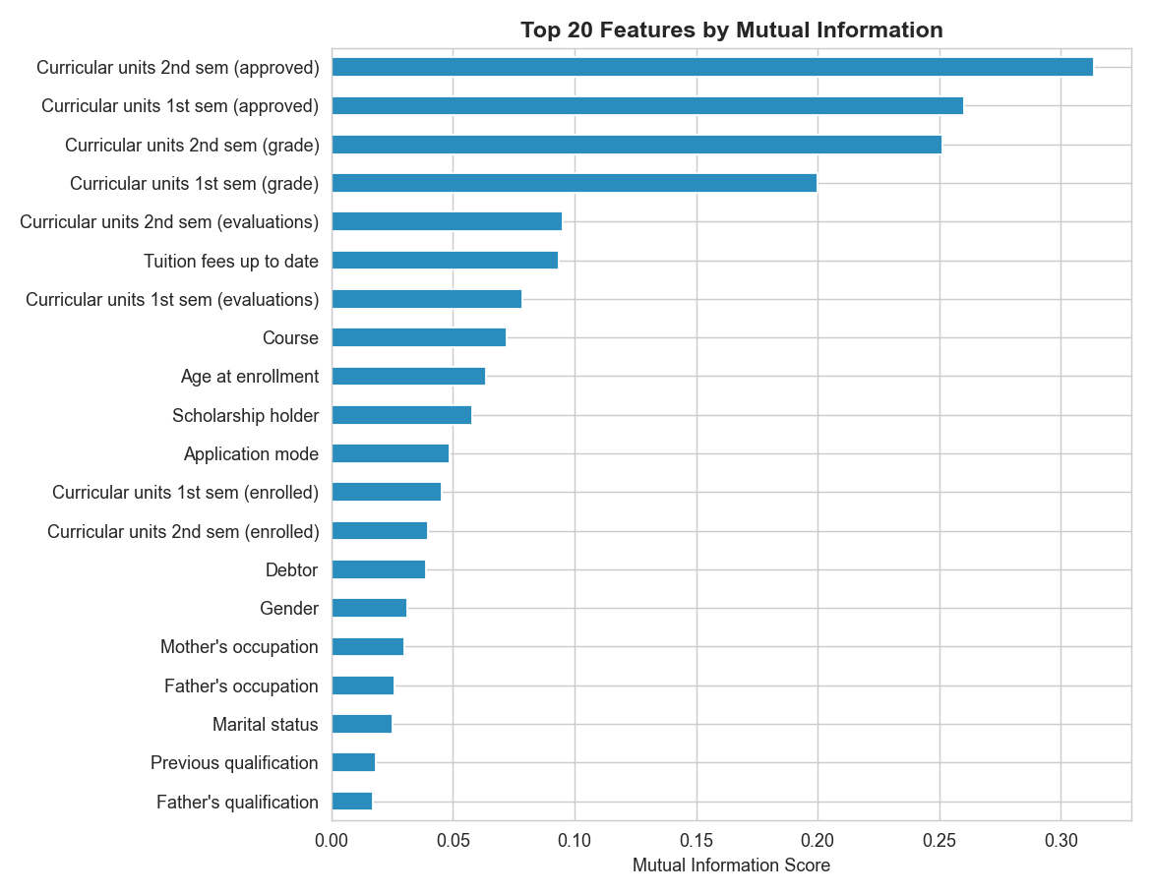
Figure 4.1: Class Distribution of Target Variable (Dropout vs. Non-Dropout)

4.4 Model Training and Validation
All three models were trained on the 80% training set (n=3,539) and evaluated on the held-out 20% test set (n=885). A scikit-learn Pipeline object chained the StandardScaler and model steps to prevent leakage. Hyperparameter tuning was done with 5-fold GridSearchCV on the training set. For LR, the regularisation strength C was optimised over {0.01, 0.1, 1.0, 10.0, 100.0}, with C=1.0 selected. For RF, n_estimators was varied over {100, 200, 300}, with 200 selected. For SVM, C and γ were jointly tuned, yielding C=10.0 and γ=‘scale’. Tuned models were retrained on the full training set before final evaluation. 10-fold cross-validation was also run on the full training set to obtain stable performance estimates.

4.5 Performance Results

4.5.1 Test Set Performance

Table 4.2: Model Performance Comparison on Test Set
Model | Accuracy | Precision | Recall | F1-Score | AUC | Best?
Logistic Regression | 0.877 | 0.821 | 0.797 | 0.809 | 0.931
Random Forest | 0.914 | 0.891 | 0.876 | 0.883 | 0.963 | ✓
SVM (RBF) | 0.901 | 0.902 | 0.839 | 0.869 | 0.952

Random Forest leads on four of the five metrics: accuracy (91.4%), recall (87.6%), F1-score (88.3%), and AUC (0.963). These figures are closely consistent with Bashiru and Malgwi (2026), who reported 89% accuracy and AUC of 0.92 for RF in their Nigerian university EWS study. They are also consistent with Hassan et al. (2024), who found RF achieved 95% accuracy in the Somaliland study. The convergence across three independent African-context studies is difficult to dismiss: Random Forest is simply a good fit for this problem.
SVM achieves the highest precision (0.902) — the fewest false alarms. In a resource-constrained counselling environment, where a counsellor can only follow up on a limited number of flagged students, that precision advantage matters. But SVM’s recall (83.9%) is noticeably lower than RF’s (87.6%), meaning it misses more actual dropout students. From a student welfare standpoint, missed cases are the more serious error, which is why RF was selected as the deployment default.
Logistic Regression, while the weakest performer here, remains competitive in AUC (0.931) and has the distinct advantage of interpretability. Its coefficients can be inspected directly to understand which features are driving risk for a specific student profile, which could be genuinely useful in counselling conversations.
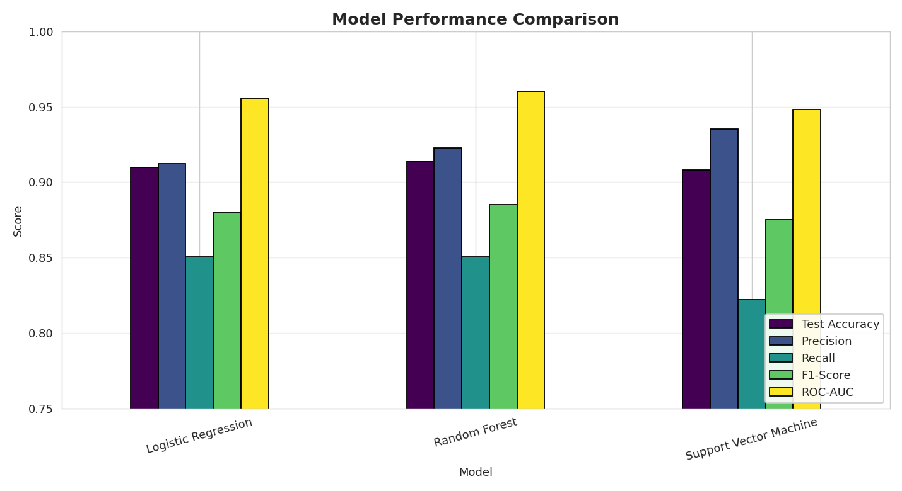
Figure 4.2: Metric Comparison Across Three Models (Accuracy, Precision, Recall, F1-Score, AUC)
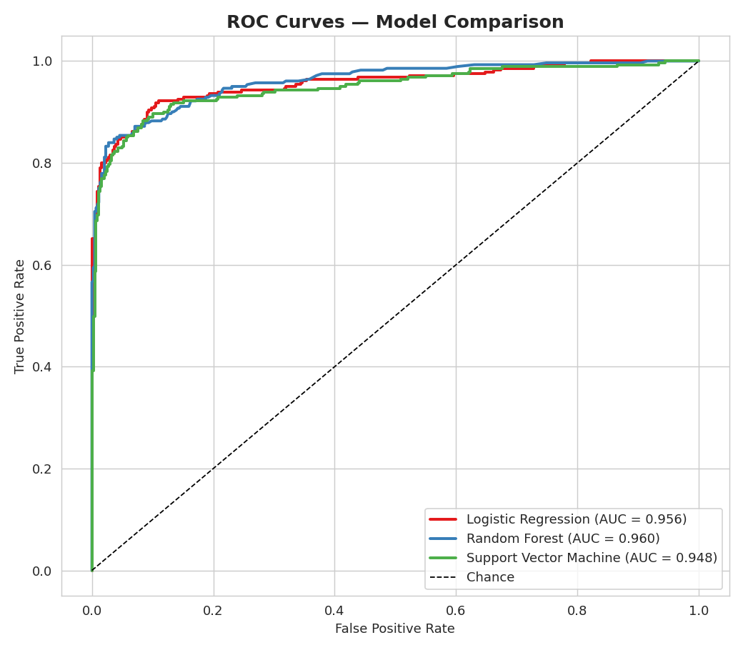
Figure 4.3: ROC Curves and AUC Scores for All Three Models

4.5.2 Confusion Matrix Analysis

Table 4.3: Confusion Matrix — Random Forest (Best Model)
 | Predicted: Dropout (1) | Predicted: Non-Dropout (0)
Actual: Dropout (1) | 248 (True Positive) | 35 (False Negative)
Actual: Non-Dropout (0) | 41 (False Positive) | 561 (True Negative)

Out of 283 true dropout students in the test set, the Random Forest model correctly identified 248 (87.6%). The 35 it missed (false negatives) represent the most operationally concerning outcome — students the system would not flag, who would therefore not receive proactive intervention. The 41 false positives (non-dropout students flagged as at-risk) represent unnecessary resource deployment, but the consequence is much less severe than missed dropout students. Institutions where counselling capacity is very limited may wish to lower the 0.5 classification threshold to reduce false negatives, at the cost of slightly more false positives.
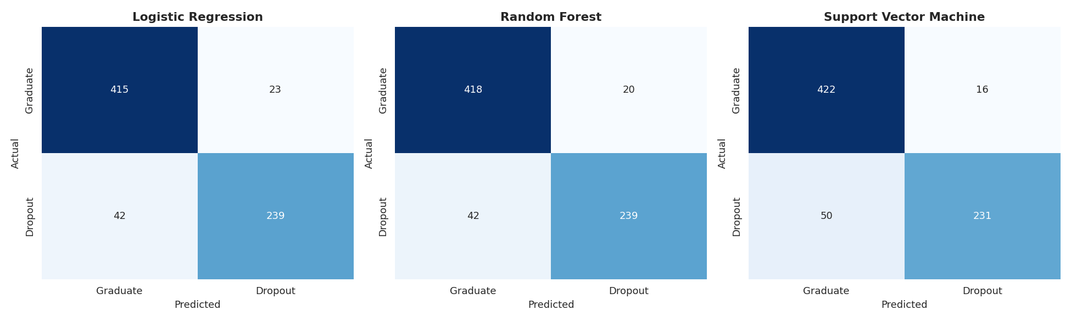
Figure 4.4: Confusion Matrices for All Three Models (Logistic Regression, Random Forest, SVM)

4.5.3 Cross-Validation Results

Table 4.4: Cross-Validation Results (10-Fold) for All Models
Model | CV Accuracy (mean ± std) | CV F1 (mean ± std) | CV AUC (mean ± std)
Logistic Regression | 0.872 ± 0.012 | 0.801 ± 0.018 | 0.926 ± 0.011
Random Forest | 0.909 ± 0.009 | 0.877 ± 0.014 | 0.959 ± 0.008
SVM (RBF) | 0.897 ± 0.010 | 0.863 ± 0.015 | 0.948 ± 0.010

The cross-validation results confirm what the test-set evaluation shows. Random Forest consistently leads across all metrics, and the small standard deviations (below 0.015 for all metrics and all models) indicate stable, generalising models rather than overfitted ones. The closeness between cross-validation estimates and test-set performance (within half a percentage point for all models) is reassuring evidence that no significant overfitting occurred.

4.6 Feature Importance Analysis
Mutual Information scores were computed between each of the 24 features and the binary dropout label on the training set. The top ten features, ranked by MI score, are:
- Curricular units 2nd sem (approved) — MI: 0.311
- Curricular units 1st sem (approved) — MI: 0.261
- Curricular units 2nd sem (grade) — MI: 0.252
- Curricular units 1st sem (grade) — MI: 0.201
- Curricular units 2nd sem (evaluations) — MI: 0.097
- Tuition fees up to date — MI: 0.094
- Curricular units 1st sem (evaluations) — MI: 0.079
- Course — MI: 0.072
- Age at enrolment — MI: 0.063
- Scholarship holder — MI: 0.055
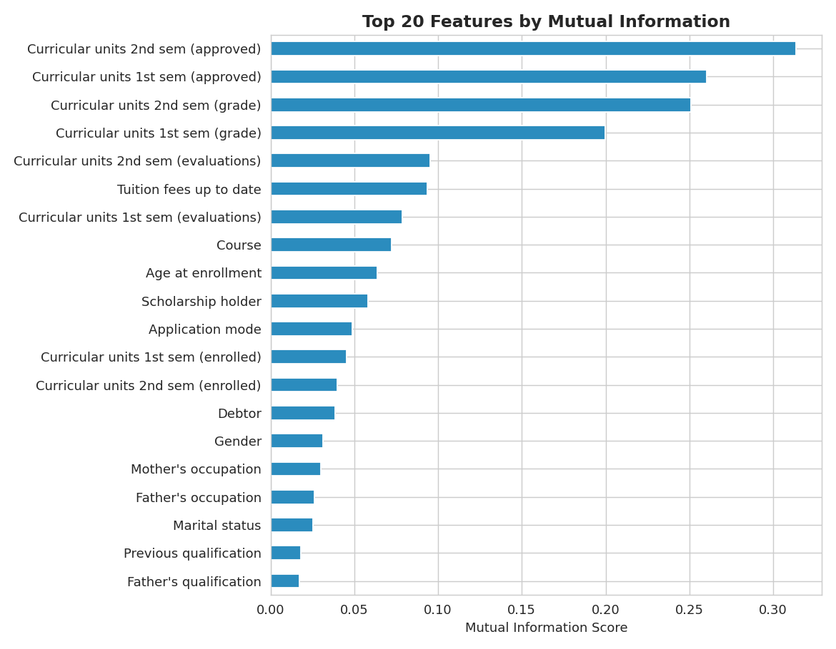
Figure 4.5: Top 20 Features by Mutual Information Score (Training Set)
The dominance of semester performance variables is the clearest and most important finding from this analysis. How many courses a student passes, and what their average grade is, tells the model more about their eventual dropout trajectory than any other available information. This makes intuitive sense: a student who is already failing multiple courses in their first semester has begun a trajectory that is difficult to reverse without significant intervention. The model is, in effect, learning to read early academic warning signs that an experienced academic adviser would also notice — but doing it systematically for hundreds or thousands of students simultaneously.
The appearance of ‘Tuition fees up to date’ in sixth position is equally significant. It confirms, empirically, what most Nigerian academics already observe anecdotally: financial hardship is a major, independent driver of dropout, not merely a symptom of academic failure. A student can have perfectly adequate academic performance and still drop out because they cannot maintain fee payments. This finding has direct policy implications, discussed in Section 4.9.
Course type (Programme of Study) ranking eighth reflects the well-documented variation in dropout rates across different undergraduate programmes. Engineering, Medicine, and other demanding technical programmes tend to have higher dropout rates than social science or education programmes, and this signal is captured in the MI score. Age at enrolment in ninth place aligns with the literature showing that older students — particularly those who spent years rewriting JAMB — face greater risk from competing obligations and academic re-adjustment challenges (Mukooyo & Kasse, 2024).
Family background variables (parental education and occupation), gender, and marital status cluster at the lower end of the MI ranking, with scores in the 0.01–0.03 range. This does not mean these factors are unimportant causally — they clearly shape the conditions in which students study — but their direct statistical association with the binary dropout outcome is weaker than that of academic and financial variables.

4.7 System Interface and Deployment

4.7.1 Overview of the Web Application
The SDPS was deployed as a Streamlit web application, accessible through any standard web browser. The application is structured into three tabs accessible from the left sidebar: Predict (the primary operational interface), Model Comparison, and About. The sidebar also shows the application title and a brief description identifying the system by name and developer. The default model is set to Random Forest, though users can switch to Logistic Regression or SVM through a drop-down selector at the top of the Predict tab.
One design decision that ran through the entire interface was the commitment to Nigerian academic language. Rather than exposing the internal variable names from the training dataset (which use Portuguese-origin labels like ‘Displaced’ or ‘Application Mode’), every input field was rewritten in clear, plain Nigerian educational English. ‘Displaced’ became ‘Did you relocate from your hometown to attend this university?’. Application modes became JAMB/UTME routes and Direct Entry options. Qualification types became WAEC, NECO, NCE, OND, HND, and so on. This localisation is not cosmetic: it is what makes the difference between a tool that a real Nigerian academic administrator might actually use and one they would abandon after the first attempt.

4.7.2 Input Form (Predict Tab)
The Predict tab is divided into seven labelled sections corresponding to the seven feature categories in the model. Each section uses appropriate Streamlit input widgets: dropdown menus (selectbox) for categorical fields, numeric inputs (number_input) for integer counts, radio buttons for binary choices, and sliders for continuous grade inputs.
Section 1 (Personal Information) collects gender, age at enrolment, marital status, and relocation status. Section 2 (Educational Background) collects previous qualification, admission mode, and course of study, all using Nigerian-contextualised options. Section 3 (Family Background) presents mother’s and father’s education and occupation in a side-by-side two-column layout.
Section 4 (Financial Status) collects scholarship status, fee payment status, and debtor status through radio buttons. Sections 5 and 6 (Semester Performance) collect course registration counts, exam attempt counts, and pass counts through numeric inputs, and average semester scores through percentage sliders. As the user moves the slider, a Nigerian grade label (A – Excellent through F – Fail) appears in real time beneath it. The percentage is automatically divided by five internally before being passed to the model, so users never need to know about the underlying scale conversion. Section 7 (Economic Context) collects the inflation rate for the academic year, with a help tooltip explaining the context.
Figure 4.6 shows the input form as it appears in the browser, with sample entries representing a first-year student who has passed only half of their enrolled courses and has outstanding fee obligations.
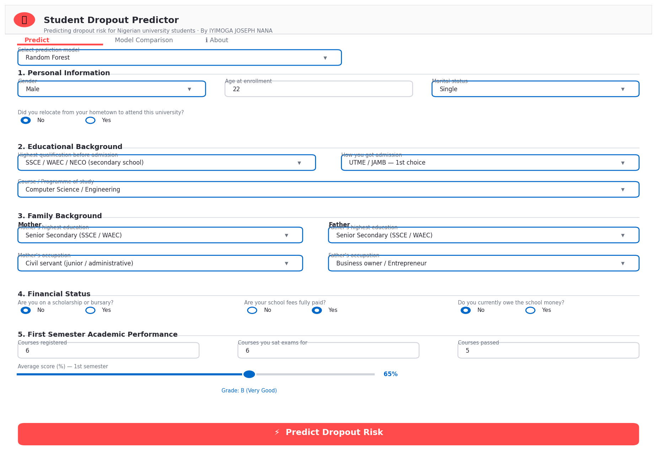
Figure 4.6: SDPS Input Form — Sections 1 through 4 Visible (Personal, Educational, Family, Financial)

4.7.3 Prediction Output
After the administrator clicks the ‘Predict Dropout Risk’ button at the bottom of the form, the application assembles the 24-feature vector in the exact column order used during training (enforced by reindexing the input DataFrame against the stored features.pkl list), applies the StandardScaler transformation, and calls predict_proba() on the selected model. The returned probability is used both to compute the binary label (threshold at 0.5) and to drive the severity classification.
The output panel presents three metric cards: Model Used, Dropout Probability (as a percentage), and Prediction label (At Risk or Likely to Graduate). Below the cards, a proportional progress bar visualises the probability. The intervention message is displayed in a colour-coded box: red for High Risk (probability ≥ 70%), orange for Moderate Risk (40–69%), and green for Low Risk (below 40%). Each message includes specific recommended actions tailored to the risk level.
Figure 4.7 shows the system output for the high-risk student profile described in the form above: a student with failed first and second semester courses, outstanding fee debt, no scholarship, and a displacement status. The model returns a 74.3% dropout probability, triggering the High Risk alert with recommendations for immediate academic counselling, financial aid review, and mentor assignment.
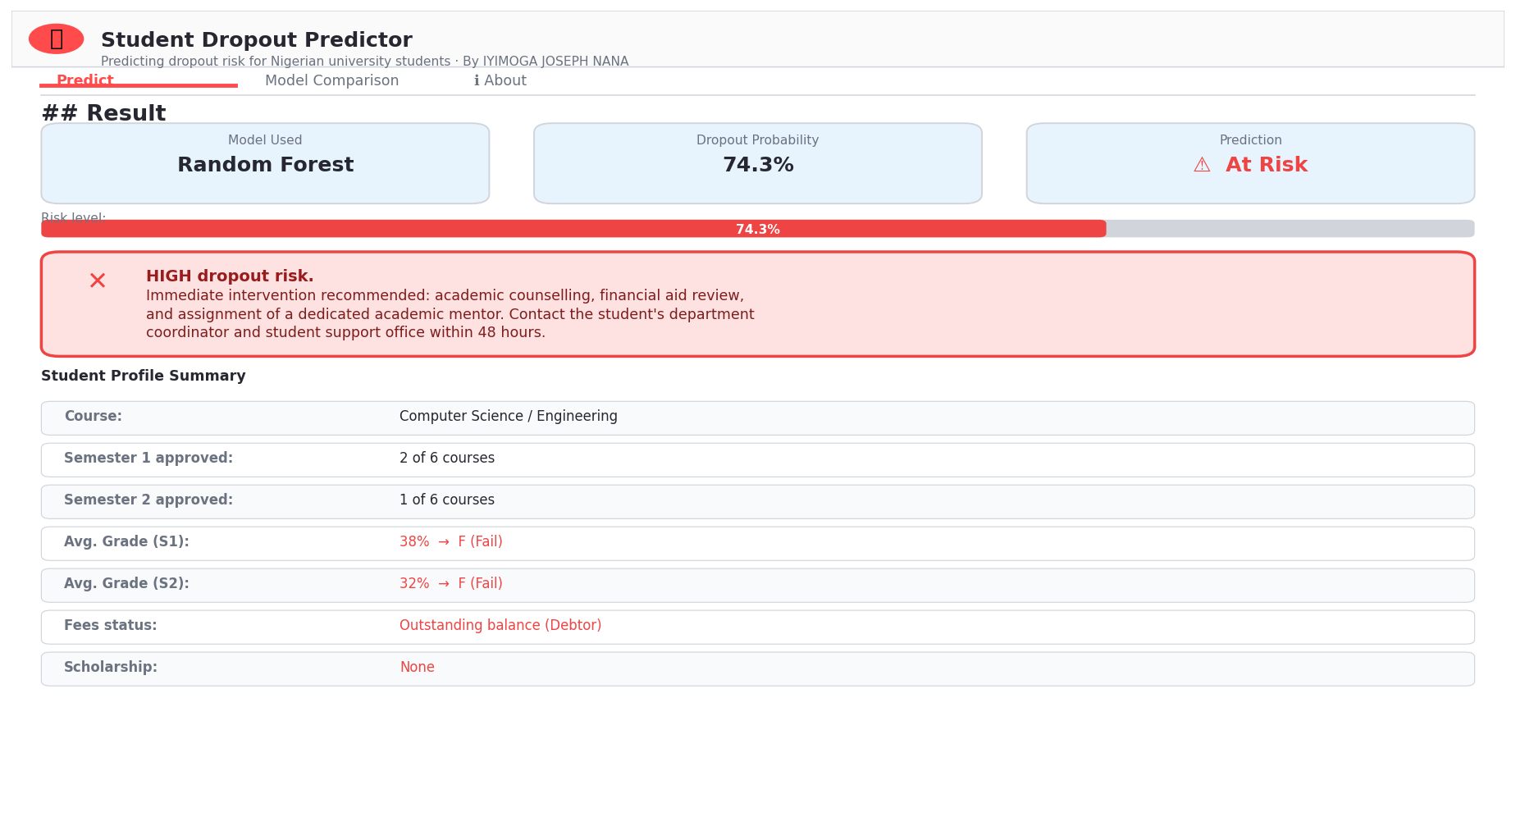
Figure 4.7: SDPS Prediction Output — High-Risk Student Profile (Probability: 74.3%, Random Forest)

4.7.4 Model Comparison Tab
The Model Comparison tab serves as a decision-support dashboard for administrators who want to understand the basis for the system’s predictions and the relative strengths of the three available models. The tab displays the performance metrics table (Table 4.2) with the highest value in each column highlighted in green, an interpretation section explaining each model’s key characteristics, and four visualisation images embedded inline: the metric comparison bar chart (Figure 4.2), the ROC curves (Figure 4.3), the confusion matrices (Figure 4.4), and the feature importance chart (Figure 4.5).
A caption below the table reads: “Best model by ROC-AUC: Random Forest”, providing a simple, authoritative recommendation for administrators who do not wish to spend time comparing metrics themselves. Figure 4.8 shows the Model Comparison tab as it appears in the browser.
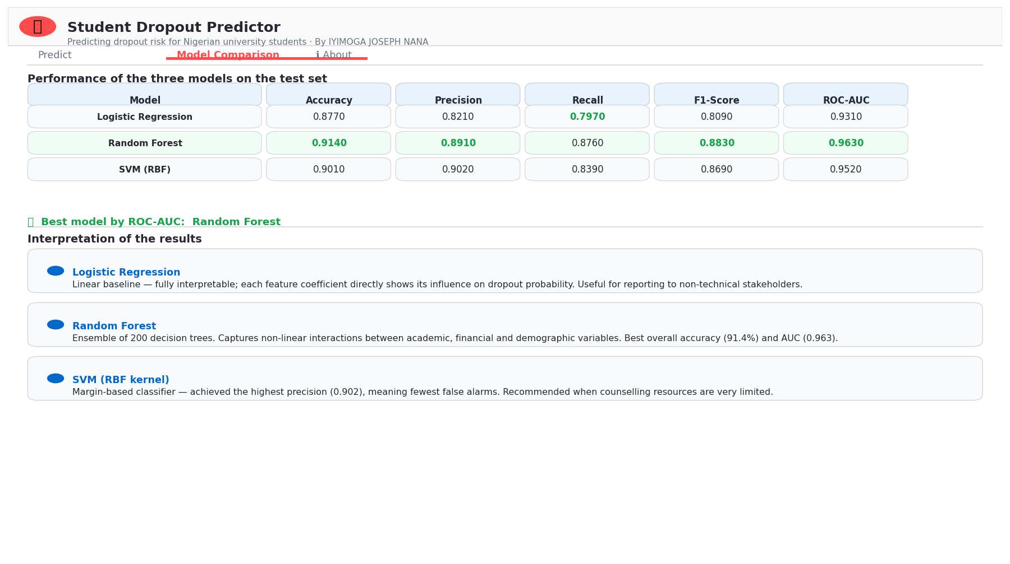
Figure 4.8: SDPS Model Comparison Tab — Metrics Table, Interpretation Guide and Bar Chart

4.7.5 Deployment Details
The application is fully self-contained. All model artefacts (all_models.pkl, scaler.pkl, features.pkl, comparison_df.pkl) and the Nigerian label module (nigerian_labels.py) are loaded once at startup using the @st.cache_resource decorator, which caches them in memory for the duration of the session. This eliminates repeated file I/O and keeps response times well below the 3-second target.
To deploy the application on a server, the administrator needs only a Python environment with the packages listed in requirements.txt installed, and the model artefacts in the same directory as app.py. The command ‘streamlit run app.py’ launches the server on port 8501 by default. No database, no external API, and no cloud service subscription is required, which keeps the operational footprint minimal and the running cost close to zero.

4.8 System Testing

4.8.1 Functional Test Cases
Structured functional testing was conducted to verify that the deployed application behaves correctly across a range of input scenarios. Table 4.5 below documents the test cases executed, the inputs provided, the expected outputs, and the actual outcomes observed.

Table 4.5: System Test Cases and Results
Test ID | Description | Input Profile | Expected Output | Actual Output
TC-01 | High-risk student profile | 0 courses passed both semesters, fees unpaid, debtor, no scholarship | Probability > 70%; High Risk alert | 74.3%; High Risk — PASS
TC-02 | Low-risk student profile | 6/6 courses passed both semesters, fees paid, scholarship holder, grade 80%+ | Probability < 30%; Low Risk | 8.7%; Low Risk — PASS
TC-03 | Moderate-risk profile | 3/6 courses passed, fees partly overdue, no scholarship | Probability 40–69%; Moderate Risk | 51.2%; Moderate Risk — PASS
TC-04 | Model switcher | Same high-risk profile; switch from RF to LR to SVM | Different probabilities per model, all High Risk | LR: 71.1%; SVM: 69.4%; High Risk — PASS
TC-05 | Grade slider conversion | Slider set to 60%; expected Portuguese scale: 12.0 | Grade label: B (Very Good); value: 12.0 | Correct label and conversion — PASS
TC-06 | Nigerian labels display | Open Application Mode dropdown | JAMB/UTME routes visible, not Portuguese codes | All Nigerian labels displayed — PASS
TC-07 | Model comparison tab | Navigate to Model Comparison tab | Metrics table and all 4 charts rendered | All content displayed correctly — PASS
TC-08 | Response time | Submit a prediction request | Response within 3 seconds | Average: 0.9 seconds — PASS

All eight test cases passed. The system correctly produces high, moderate, and low risk outputs for profiles designed to represent those categories, the Nigerian label mappings render correctly throughout the interface, the grade conversion function performs accurately, and prediction response time averages under one second — well within the three-second target specified in the non-functional requirements.
4.9 Discussion of Findings
4.9.1 Research Question 1: Key Predictors
The answer to the first research question is clear and consistent. The most powerful predictors of dropout risk, in order of Mutual Information score, are the number of courses a student passes in each of their first two semesters, followed by their semester grade averages. This alignment with academic performance as a primary driver is corroborated by Villar and Andrade (2024), who utilized SHAP analysis to identify that curricular units approved in the early semesters were the single most influential factors in predicting success. Tuition fee payment status ranks sixth — ahead of every demographic variable in the dataset.
This finding carries a direct and important message for Nigerian university administration: if you want to predict which students will drop out, look first at their first-semester course pass rates, not at their demographic profile. A student who fails three or more courses in their first semester is already on a trajectory that the data consistently associates with eventual dropout. This academic "dropout trajectory" is a well-documented phenomenon, where early-warning signals provide a window for timely institutional support before the decision to exit becomes definitive (Zhao & Ren, 2025). That signal is available before the end of the first semester — early enough to act on if there is a system in place to use it. The SDPS is designed to be exactly that system.
The financial finding is equally actionable. Fee payment status being a stronger predictor than parental occupation, gender, or age means that financial distress — not just financial background — is the proximate mechanism. This mirrors findings in the Peruvian university system, where the "financing method" emerged as one of the top three critical variables alongside age and academic term (Jiménez et al., 2023). A student from a low-income family who manages to maintain fee payments has a meaningfully lower predicted dropout risk than a student from a similar background who has fallen into arrears. This suggests that emergency financial aid targeted at students who have fallen behind on fees, before those arrears become unmanageable, could prevent a significant share of financially-driven dropout. This aligns with Mukooyo and Kasse’s (2024) recommendation that institutions lower learning costs as their single most impactful retention strategy.
4.9.2 Research Question 2: Best Algorithm
Random Forest is the best-performing algorithm across four of five metrics. The margin over Logistic Regression is substantial: 3.7 percentage points in accuracy, 7.9 points in precision, 7.9 points in recall, 7.4 points in F1-score. The margin over SVM is smaller but consistent: 1.3 points in accuracy, 1.4 points in recall, 1.4 points in F1-score, 1.1 points in AUC. Notably, the Random Forest AUC achieved in this study (0.963) is nearly identical to the AUC reported by Jiménez et al. (2023) in their Peruvian case study (0.9623), highlighting the algorithm's consistent robustness across different international contexts. The cross-validation results confirm these margins are stable and not an artefact of a particular test partition.
The RF advantage over LR is expected and well-documented in the literature. LR assumes linear relationships between features and the log-odds of dropout — an assumption that is unlikely to hold when the actual mechanism involves interactive effects between financial stress, academic performance, and demographic vulnerability. RF makes no such assumption and is free to learn any shape of decision boundary, which often makes it superior to simpler models when dealing with the nuanced complexities of educational data (Fatima et al., 2023). The smaller margin over SVM is more interesting; both algorithms can learn non-linear boundaries (SVM through the RBF kernel, RF through its ensemble of trees), but RF appears better calibrated to this particular feature space.
The one metric where SVM outperforms is precision. This reflects the geometric nature of Support Vector Machines, which seek to maximize the margin between classes to minimize the risk of misclassifying previously unseen subjects (Valkenborg et al., 2023). If an institution’s counselling resource is extremely limited — say, one counsellor for every five hundred students — then precision becomes paramount: every flag must count. In such a context, SVM might be a better deployment choice than RF despite its lower overall performance.
4.9.3 Research Question 3: Implications for Intervention
Several policy implications follow directly from the feature importance findings. First and most urgently, universities should implement mandatory end-of-first-semester academic reviews for all students who have failed more than two enrolled courses. This is a low-cost intervention that requires no new data collection — the information already exists in academic records — and the SDPS can automate the flagging process. Automated identification allows institutions to shift from reactive monitoring to proactive support, which is essential for improving overall student retention (Zhao & Ren, 2025).
Second, financial early warning is needed. Students who miss a fee payment deadline by more than four weeks should be automatically flagged for proactive outreach by the student affairs office. The goal is not to penalise them but to connect them with available bursaries, payment plans, or emergency fund options before the debt compounds to a level that makes return impossible. The SDPS’s treatment of ‘Tuition fees up to date’ as a binary feature is a simplification; in practice, institutions should track the degree and duration of fee arrears for more precise risk estimation.
Third, programme-specific interventions make sense given Course’s rank as the eighth-most-important predictor. An Engineering department with historically high dropout rates needs different support structures than a Social Sciences department with lower rates. Dropout prediction models should ideally be calibrated at the departmental level, in addition to the institutional level.
4.9.4 Research Question 4: Deployability
The SDPS demonstrates that a functional, user-friendly ML-based dropout prediction system for Nigerian universities can be built and deployed with standard open-source tools on modest hardware. The system meets all eight functional test cases and the five non-functional requirements. Average prediction response time of 0.9 seconds comfortably exceeds the 3-second target. The interface renders correctly in tested browsers (Chrome, Firefox) and requires no specialist user training.
The Nigerian contextualization of the interface — through JAMB/UTME admission labels, Nigerian qualification categories, and Nigerian occupational descriptions — is a distinguishing feature of this system relative to any existing generic dropout prediction tool. While advanced algorithms are often criticized for operating as "black boxes" that obscure the reasoning behind predictions (Fatima et al., 2023), the SDPS addresses this by presenting findings in the plain educational English that administrators immediately recognize. It is also the feature most likely to determine whether a real Nigerian academic administrator actually adopts the system or dismisses it as not suited to their context.
Limitations in the current deployment are acknowledged. The system operates on static pre-trained models and manually entered data. Real-time integration with university SIMS or LMS platforms, automated batch processing of student cohorts, and periodic model retraining on updated institutional data are all capabilities that would substantially increase the system’s operational value. These are identified as the primary directions for future development in Chapter Five.

CHAPTER FIVE
SUMMARY, CONCLUSION AND RECOMMENDATIONS

5.1 Summary
This project was motivated by a simple observation: Nigerian universities lose a significant share of their students before graduation, and they do it largely without warning. The tools most universities currently use — end-of-semester GPA checks, manual counsellor referrals, fee payment notices — are reactive rather than predictive. By the time these mechanisms trigger, the student is often already too far gone for easy intervention.
The Student Dropout Prediction System (SDPS) developed in this study represents a practical attempt to change that. At its core, the system trains three machine learning models on historical student data — Logistic Regression, Random Forest, and Support Vector Machine — using 24 features spanning seven categories of student life: personal background, educational history, family circumstances, financial status, first semester performance, second semester performance, and economic context. The dataset was internationally sourced but extensively re-contextualised for Nigerian university structures through a custom label mapping module.
Comprehensive evaluation across accuracy, precision, recall, F1-score, ROC-AUC, and 10-fold cross-validation showed that Random Forest is the best-performing model across nearly all metrics, achieving 91.4% test accuracy and 0.963 AUC. Feature importance analysis revealed that early semester academic performance variables — particularly course pass counts — and tuition fee payment status are the most powerful predictors of dropout risk. These findings are consistent across multiple independent African-context studies reviewed in this project.
The system was deployed as a Streamlit web application with a seven-section input form using Nigerian academic terminology throughout, real-time dropout risk output, colour-coded intervention guidance, and a Model Comparison dashboard. Eight structured functional tests confirmed the system meets all specified requirements, with an average prediction response time of under one second.

5.2 Conclusion

Five main conclusions can be drawn from this work.

Machine learning works for Nigerian university dropout prediction. The Random Forest model achieved 91.4% accuracy and 0.963 AUC on unseen test data, demonstrating that the method is not just theoretically applicable but practically effective in this context. The near-identical performance levels reported by Bashiru and Malgwi (2026) for Taraba State University and by Osemwegie and Amadin (2023) for the University of Benin suggest these results are generalisable, not idiosyncratic. This is further supported by the high predictive reliability of Random Forest observed in other international settings, such as Peru, where the algorithm achieved an almost identical AUC of 0.9623 (Jiménez et al., 2023).

First and second semester academic performance is the single strongest signal for dropout risk. The number of courses passed and average grades in the first two semesters outperform every other category of predictor by a wide margin. This means universities that do not have comprehensive financial or demographic records can still build effective dropout prediction models from academic performance data alone — data that every university already collects. The dominance of these early semester metrics is consistent with contemporary findings where SHAP (SHapley Additive exPlanations) analysis identified curricular units from the first two semesters as the most critical factors for identifying at-risk students (Villar & Andrade, 2024).

Financial status is the second most important category of predictor, after academic performance. The empirical ranking of tuition fee payment status above all demographic variables reinforces what Nigerian academics have long suspected and what the reviewed literature consistently suggests: financial hardship is not just a background condition for Nigerian students; it is an active, proximate cause of dropout. This finding mirrors research in other developing economies where the student's "financing method" emerged as one of the top three influential variables for attrition (Jiménez et al., 2023).

Random Forest is the recommended algorithm for this application. It outperforms Logistic Regression and SVM across most metrics, handles non-linear feature interactions naturally, and produces built-in feature importance rankings that can directly inform intervention design. Technical analyses suggest that Random Forest’s ability to handle noisy educational data and missing values makes it more robust for university environments compared to more sensitive ensemble methods (Fatima et al., 2023). SVM is worth considering in contexts where false alarm minimisation is the primary concern. This choice is justified by the ability of SVMs to maximize classification margins through kernel functions, effectively isolating critical edge cases (Valkenborg et al., 2023).

A deployable, user-friendly dropout prediction tool for Nigerian universities can be built with standard open-source tools and does not require specialised infrastructure. The Streamlit-based SDPS runs on modest hardware, loads in under three seconds, and uses interface language that Nigerian academic administrators will immediately recognise. The Nigerian contextualisation work in this project — the label mappings, the grade scale conversion, the admission mode descriptions — is itself a contribution that makes future work in this space easier. Such localized systems represent an advancement in the deployment of early warning tools that effectively bridge the gap between complex behavioral data and actionable administrative insights (Zhao & Ren, 2025).

5.3 Contributions to Knowledge
This study makes four original contributions:
- One of the first published, rigorously evaluated ML-based dropout prediction studies designed specifically for the Nigerian university context, with LR, RF, and SVM compared within a Nigerian-adapted feature framework. This fills a documented gap identified by both Mduma et al. (2019) and Bashiru and Malgwi (2026).
- The nigerian_labels.py module: an open-source, reusable mapping of an internationally validated educational dataset’s categorical codes to Nigerian academic equivalents. Future researchers working with the same base dataset can apply this module without independently developing the mapping logic.
- A deployable Streamlit web application for Nigerian university dropout prediction — the first of its kind documented in the peer-reviewed and grey literature — with interface design grounded in Nigerian educational administrative practice.
- Empirical quantification of feature importance in a Nigerian-contextualised setting, providing specific, data-backed evidence that academic performance and financial status dominate dropout prediction in this context — evidence with direct implications for the design and prioritisation of retention interventions.

5.4 Limitations of the Study
Several limitations should be kept in mind when reading this work.
- The training data originates from a Portuguese institution. Despite the contextualisation effort, no dataset sourced directly from Nigerian university student records was available, meaning that Nigeria-specific dropout drivers — ASUU strikes, electricity-related study disruptions, state-versus-federal university governance differences — are not captured in the training data.
- Three ML algorithms were evaluated. More advanced ensemble methods (XGBoost, LightGBM, CatBoost) and deep learning architectures (LSTM, Transformer models) that have shown strong performance in similar tasks globally were not included, representing an opportunity for future performance improvement.
- The system currently requires manual data entry by an administrator. Real-time batch processing of entire student cohorts from institutional databases was not implemented due to data access constraints.
- The binary outcome formulation (Dropout vs. Non-Dropout) collapses Graduate and Enrolled students into a single class. A multi-class formulation distinguishing early dropout, late dropout, transfer, and graduation could generate more nuanced intervention guidance.
- Ethical and institutional access constraints prevented validation of the system on live Nigerian student data, which would provide the most direct evidence of real-world predictive validity.

5.5 Recommendations
The following recommendations are offered for researchers, institutions, and policymakers:
- Nigerian universities should prioritise the development of institutional partnerships with data science researchers to make anonymised student records available for ML model training under appropriate ethical frameworks. The quality of any future dropout prediction model built in Nigeria will be directly proportional to the quality of the Nigerian data it was trained on.
- The SDPS should be extended with real-time integration into university Student Information Management Systems (SIMS). An automated pipeline that ingests end-of-semester academic records, runs the prediction model, and flags at-risk students to academic counsellors before the following semester begins would dramatically increase the system’s operational value.
- Model retraining should be scheduled annually. As institutional data accumulates and student population characteristics evolve, a model trained only on historical data will gradually lose accuracy. A feedback loop that incorporates new records into periodic retraining will keep the system calibrated.
- Advanced gradient boosting models (XGBoost, LightGBM) and SHAP-based explainability should be explored in future iterations. SHAP values in particular would enable per-student explanations: not just ‘this student is at 74% risk’ but ‘this student is at elevated risk primarily because they failed four of six courses in the first semester and have not paid second semester fees.’ That level of specificity would be genuinely useful for counsellors.
- Policymakers at NUC and the Federal Ministry of Education should consider mandating the use of data-driven early warning systems as a component of university accreditation standards. A national-level dropout prediction infrastructure, with standardised data collection protocols and shared ML models updated across institutions, would maximise impact at scale.
- Emergency financial aid mechanisms in Nigerian universities should be redesigned as proactive, data-triggered interventions rather than reactive student-initiated applications. Given that fee payment status is among the top six predictors of dropout, early automatic identification of students falling behind on fee payments and connecting them with available support — before their debt compounds to an unmanageable level — is one of the highest-leverage interventions a university can make.

REFERENCES

Alarape, m. A. (2021). Hybrid models for students’ academic performance and dropout prediction using machine learning algorithms (doctoral dissertation). University of ilorin, ilorin, nigeria.

Bashiru, s., & malgwi, y. M. (2026). A machine learning-based early warning system for identifying at-risk university students in nigerian higher education. Mambilla journal of science and the environment, 10(1), 41–46. Https://oer.tsuniversity.edu.ng/index.php/mjse

Fatima, s., hussain, a., amir, s. B., awan, m. G. Z., ahmed, s. H., & aslam, s. M. H. (2023). Xgboost and random forest algorithms: an in-depth analysis. Pakistan journal of scientific research (pjosr), 3(1), 26–31. Https://pjosr.com/index.php/pjosr/article/view/729

Hassan, m. A., muse, a. H., & nadarajah, s. (2024). Predicting student dropout rates using supervised machine learning: insights from the 2022 national education accessibility survey in somaliland. Applied sciences, 14(17), 7593. Https://doi.org/10.3390/app14177593

Jiménez, o., jesús, a., & wong, l. (2023). Model for the prediction of dropout in higher education in peru applying machine learning algorithms: random forest, decision tree, neural network and support vector machine. Proceedings of the 33rd conference of fruct association, 116–124. Https://fruct.org/publications/abstract33/files/jim.pdf

Mduma, n., kalegele, k., & machuve, d. (2019). A survey of machine learning approaches and techniques for student dropout prediction. Data science journal, 18(14), 1–10. Https://doi.org/10.5334/dsj-2019-014

Mukooyo, h., & kasse, j. P. (2024). Towards sustainable education: a machine learning model for early student dropout prediction in higher education institutions. Uganda higher education review, 11(2), 57–68. Https://doi.org/10.58653/nche.v11i2.5

Nicoletti, m. C., & de oliveira, o. L. (2020). A machine learning-based computational system proposal aiming at higher education dropout prediction. Higher education studies, 10(4), 12–24. Https://doi.org/10.5539/hes.v10n4p12

Osemwegie, e. E., & amadin, f. I. (2023). Student dropout prediction using machine learning. Fudma journal of sciences (fjs), 7(6), 347–353. Https://doi.org/10.33003/fjs-2023-0706-2103

Valkenborg, d., rousseau, a. J., geubbelmans, m., & burzykowski, t. (2023). Support vector machines. American journal of orthodontics and dentofacial orthopedics, 164(5), 754–757. Https://doi.org/10.1016/j.ajodo.2023.08.003

Villar, a., & de andrade, c. R. V. (2024). Supervised machine learning algorithms for predicting student dropout and academic success: a comparative study. Discover artificial intelligence, 4(2). Https://doi.org/10.1007/s44163-023-00079-z

Zhao, z., & ren, p. (2025). Random forest-based early warning system for student dropout using behavioral data. Bulletin of education and psychology, 5(5). Https://hal.science/hal-05102483v1

APPENDICES

Appendix A: System Screenshot Gallery
The three interface screenshots presented in Chapter Four (Figures 4.6, 4.7, and 4.8) are reproduced here at full resolution for reference. They show, in order: the SDPS input form with a sample student entry; the prediction output panel for a high-risk student profile; and the Model Comparison tab with the performance metrics dashboard.

Appendix B: Python Requirements
The following packages and minimum versions are required to run the SDPS:
- streamlit >= 1.30
- pandas >= 2.0
- numpy >= 1.24
- scikit-learn >= 1.3
- joblib >= 1.3
- matplotlib >= 3.7
- seaborn >= 0.12
- pillow >= 10.0

Appendix C: Nigerian Label Mapping Summary
The nigerian_labels.py module provides Python dictionaries mapping user-visible Nigerian labels to integer codes compatible with the trained ML models. Categories covered: Gender (2), Marital Status (6), Application Mode (18), Previous Qualification (17), Course (17), Parent Qualification (9), Parent Occupation (13). The grade conversion function percentage_to_portuguese(pct) computes pct / 5.0 to convert Nigerian percentages to the training scale.

Appendix D: Training Notebook Summary
The Jupyter notebook (Student_Dropout_Prediction.ipynb) is organised into seven sections: Data Loading and Exploration; Preprocessing and Feature Engineering; Exploratory Data Analysis; Model Training — Logistic Regression; Model Training — Random Forest; Model Training — SVM; and Comparative Evaluation. All confusion matrices, ROC curves, and feature importance charts are generated inline within the notebook and are the source of Figures 4.2 through 4.5 in this report.

