

TECHNICAL REPORT ON INDUSTRIAL TRAINING CARRIED OUT AT NASCOMSOFT EMBEDDED HUB, BAUCHI

IYIMOGA JOSEPH NANA
20/61871U/1

ABUBAKAR TAFAWA BALEWA UNIVERSITY BAUCHI, BAUCHI STATE

THE DEPARTMENT OF COMPUTER SCIENCE
FACULTY OF COMPUTING

FEBRUARY, 2025

DEDICATION
This technical report is dedicated first to Almighty God for His infinite grace and protection throughout this journey. I also dedicate this work to my family for their unwavering support, sacrifices, and constant prayers. My gratitude goes to my lecturers at the Department of Computer Science for their foundational academic teachings. Furthermore, I dedicate this to my mentors for their professional guidance and belief in my technical potential. May this work serve as a testament to their collective impact on my growth as a computer scientist.

DECLARATION
I, Iyimoga Joseph Nana, with Matriculation Number 20/61871U/1, hereby declare that this technical report is a true and original account of my ten (10) months Industrial Training (SIWES) program undergone at Nascomsoft Embedded Hub, Bauchi, under the supervision of Engr. Nasiru Abdulsalam.
I affirm that this report is the result of my own efforts and that the technical skills, experiences, and projects described herein were acquired and carried out by me during the period of the attachment. I further declare that this work has not been previously submitted, in part or in full, for the award of any degree or diploma in this university or any other institution.

__________________________ ____________________
Iyimoga Joseph Nana Date

CERTIFICATION
This is to certify that Iyimoga Joseph Nana, with Matriculation Number 20/61871U/1, has successfully completed his ten-month industrial training program at Nascomsoft Embedded Hub, Bauchi. The technical work presented in this report was carried out under the professional guidance of Engr. Nasiru Abdulsalam and has been examined and approved. This report satisfies the mandatory requirements of the Student Industrial Work Experience Scheme (SIWES) in the Faculty of Computing, Abubakar Tafawa Balewa University.

____________________
Engr. Nasiru Abdulsalam Date
(CEO, Nascomsoft Embedded Hub)

____________________
Iyimoga Joseph Nana Date
(Student)

ACKNOWLEDGEMENT
My profound gratitude goes to Almighty God for His grace and protection throughout my ten-month Industrial Training program.
I am deeply grateful to the CEO, Engr. Nasiru Abdulsalam, for his visionary leadership and the profound impact he had on my professional growth. My sincere thanks also go to my Industrial Supervisor Dr. Sanusi A. Usman for his invaluable mentorship and technical guidance.
A special thank you goes to my instructor, Glory Zakka, for the knowledge imparted in Data Science and Machine Learning. Her expertise and patience were instrumental in shaping my technical skills during this period.
I also appreciate the entire staff and colleagues at Nascomsoft Embedded Hub for creating a supportive environment and for the various ways they contributed to my learning experience.
Finally, my heartfelt appreciation goes to Abdullahi Ozayashi Iyimoga for being a steadfast financial pillar and source of encouragement, ensuring I lacked nothing throughout this journey.

Table of Contents

DEDICATION ii
DECLARATION iii
CERTIFICATION iv
ACKNOWLEDGEMENT v
ABSTRACT ix
CHAPTER ONE 1
1.1 BACKGROUND INFORMATION 1
1.2 STUDENT INDUSTRIAL WORK EXPERIENCE SCHEME (SIWES) 1
1.3 OBJECTIVES OF SIWES 2
1.4 BODIES INVOLVED IN THE MANAGEMENT OF SIWES 3
1.4.1 The Federal Government 3
1.4.2 The Industrial Training Fund (ITF) 3
1.4.3 National Council for Colleges of Education (NCCE) 4
1.4.4 National Board for Technical Education (NBTE) 4
1.4.5 National University Commission (NUC) 5
1.5 FUNCTIONS OF SIWES MANAGEMENT AGENCIES ABOVE: 6
CHAPTER TWO 7
BACKGROUND OF THE ESTABLISHMENT 7
2.1 Brief history of Nascomsoft Embedded. 7
2.2 Vision statement: 8
2.3 Mission statement: 8
2.4 THE ORGANIZATIONAL CHART 9
2.5 Departments, units, and their functions. 9
2.5.1 The Director (CEO) 9
2.5.2 Head of operations (HOP) 9
2.5.3 Accounting unit 10
2.5.4 Head of instructors (HOI) 10
2.5.5 Customer care/ Counsellor 10
2.5.6 Head of marketing 10
2.5.7 Engineering unit 10
The Network Engineers 10
Hardware Engineers 11
Software Engineers 11
CHAPTER THREE 12
WORK EXPERIENCE AND TECHNICAL CONTENTS 12
3.1 INTRODUCTION 12
3.2 Weekly Summary 13
3.3.1 Basic Electronics and Embedded System 18
Digital Clock and Calendar 18
Gas Leakage Detector 20
3.3.2 Machine Learning Projects 20
NBA Players Salary Detector 21
Email Spam Detector 22
3.3.3 Natural Language Processing project 23
Text Generator 23
CHAPTER FOUR 25
4.1 APPLICATIONS OF KNOWLEDGE ACQUIRED 25
4.2 Applications of Knowledge Acquired 25
4.2.1 Programming (Python and C++) 25
Python 25
C++ 25
4.2.2 Data Science and Machine Learning 26
Data Science 26
Machine Learning 26
4.2.3 Technologies and Frameworks Used 26
4.2.4 BASIC ELECTRONICS AND EMBEDDED SYSTEMS 27
4.2.5 TECHNICAL WRITING 27
4.2.6 NATURAL LANGUAGE PROCESSING (NLP) 27
4.3 CHALLENGES 28
4.4 POSSIBLE SOLUTIONS 29
CHAPTER FIVE 30
FINDINGS AND RECOMMENDATIONS 30
5.1 FINDINGS 30
5.2 RECOMMENDATIONS 31
5.2.1 University 31
5.2.2 Organization 31
5.2.3 Industrial Training Fund (ITF) 32
CHAPTER SIX 33
SUMMARY AND CONCLUSION 33
6.1 SUMMARY 33
6.2 CONCLUSION 33
REFERENCES 35
APPENDICES 36

ABSTRACT
This technical report summarizes my ten-month Industrial Training program at Nascomsoft Embedded Hub, Bauchi, as a requirement for my Computer Science degree at ATBU. The primary goal of this attachment was to apply the theoretical knowledge gained in the classroom to practical industrial challenges in the technology sector. During the period, I mastered various technical skills including programming in Python and C++, as well as advanced Data Science and Machine Learning techniques. I successfully implemented significant projects such as an NBA Player Salary Predictor and a Gas Leakage Detection system using the Arduino IDE and Proteus simulation tools. I also explored state-of-the-art Artificial Intelligence by fine-tuning the Mistral-7B language model and building an automated Email Spam Detector. Beyond software development, I gained hands-on experience in basic electronics and served as a professional instructor for Python and Data Science classes at the hub. My training further included learning professional technical writing for project reports and academic journals according to global standards. Although I faced hurdles like time management and stage fright, I developed practical solutions that helped me grow both technically and professionally. This experience allowed me to bridge the gap between academic theory and real-world technology implementation within a startup environment. In conclusion, the training was successful and provided me with the necessary confidence and expertise required for a professional career in the computing industry.

CHAPTER ONE

1.1 BACKGROUND INFORMATION
The Nigerian educational system emphasizes the integration of theoretical knowledge with practical skills to produce graduates capable of tackling real-world challenges. For students in the Department of Computer Science at Abubakar Tafawa Balewa University (ATBU), this synergy is essential. This report provides a detailed account of a ten-month industrial attachment at Nascomsoft Embedded Hub, showcasing the practical application of computing concepts in a professional tech environment.

1.2 STUDENT INDUSTRIAL WORK EXPERIENCE SCHEME (SIWES)
The Student Industrial Work Experience Scheme (SIWES) was introduced by the Industrial Training Fund (ITF) in 1973 as a strategic intervention to bridge the existing gap between theoretical classroom education and the practical requirements of the industry. Before its inception, there was a growing concern that many graduates of Nigerian higher institutions lacked the requisite hands-on skills to function effectively in a professional work environment. The scheme is designed to expose and prepare students in tertiary institutions for the industrial work situations they are likely to meet after graduation. SIWES is a tripartite program involving the students, the institutions, and the industry, and it is funded by the Federal Government of Nigeria and coordinated by the ITF. It provides a unique avenue for students in science, technology, engineering, and vocational fields to acquire critical industrial skills and experience in their respective courses of study. This experiential learning process allows students to handle sophisticated machinery, understand professional safety protocols, and engage with modern technologies that may not be readily available in an academic laboratory. Furthermore, SIWES encourages students to develop interpersonal skills, teamwork, and the professional work ethics necessary for success in a competitive labor market. It also facilitates a closer relationship between the academic community and the industrial sector, ensuring that curriculum development remains relevant to the evolving needs of the national economy. By engaging in this program, students gain the confidence and technical competence needed to make them more employable and better prepared to contribute meaningfully to the country’s technological and economic advancement.

1.3 OBJECTIVES OF SIWES
The specific objectives of the Student Industrial Work Experience Scheme (SIWES) as established by the Industrial Training Fund (ITF) include the following:
- To provide an opportunity for students to apply their theoretical knowledge acquired in the classroom to real-life industrial situations and professional challenges.
- To expose students to modern technical equipment, specialized software tools, and industrial machinery that are generally not available in the university laboratories.
- To ease the transition from the academic environment to the world of work by exposing students to professional work ethics, discipline, and corporate culture.
- To enhance students' employability and technical competence by providing hands-on experience in solving complex problems relevant to their field of study.
- To strengthen the relationship between higher institutions and the industrial sector, ensuring that the training of future professionals remains relevant to the evolving needs of the economy.

1.4 BODIES INVOLVED IN THE MANAGEMENT OF SIWES

1.4.1 The Federal Government
The Federal Government of Nigeria serves as the foundational authority that formulates the policies and provides the necessary funding for the scheme. Through the Ministry of Industry, Trade, and Investment, it ensures that there is a sustainable legal framework for industrial training. Its primary role involves the allocation of financial resources to the Industrial Training Fund for the payment of student allowances and administrative costs. Furthermore, the government encourages industrial growth by mandating that private and public organizations participate in the scheme. This oversight ensures that the workforce of the nation is properly equipped with the practical skills needed for development.

1.4.2 The Industrial Training Fund (ITF)
The Industrial Training Fund is the core administrative body responsible for the coordination and regulation of the SIWES program throughout the country. It manages the logistics of the scheme, including the vetting of placement organizations to ensure they provide relevant training. The ITF is also tasked with the disbursement of training allowances to students and supervisors who have successfully met the requirements. Beyond finances, the fund organizes orientation programs for students and provides guidance to institutions on the implementation of industrial training. It acts as a bridge between the government, tertiary institutions, and the various employers within the labor market.
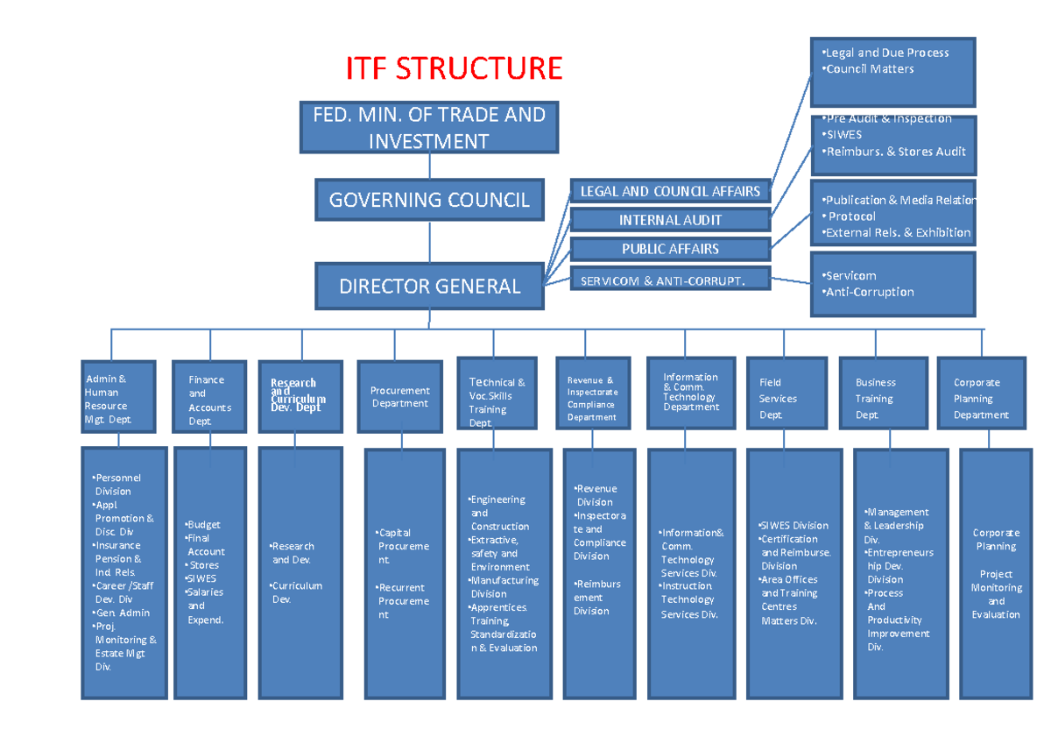Fig 1.0 ITF Structure

1.4.3 National Council for Colleges of Education (NCCE)
The National Council for Colleges of Education is responsible for supervising and standardizing the industrial training experience for students within the colleges of education. It ensures that the curriculum and industrial attachment activities are aligned with the pedagogical goals of producing highly skilled teachers. The council works to coordinate with the ITF to facilitate the inclusion of education-based vocational programs in the scheme. By monitoring the implementation of training, the NCCE ensures that student teachers gain the practical exposure needed to handle modern educational tools. Its participation guarantees that even the education sector benefits from the practical skills-sharing model.

1.4.4 National Board for Technical Education (NBTE)
The National Board for Technical Education oversees the management and standardization of SIWES for students in polytechnics and monotechnics. It plays a vital role in ensuring that technical and vocational education meets the practical demands of the engineering and technological industries. The board works closely with institutional coordinators to vet training centers and ensures that the industrial attachment periods are strictly adhered to. Through its supervisory functions, the NBTE evaluates the effectiveness of the scheme in bridging the skill gap for middle-level manpower. It also serves as a link between the polytechnics and the Industrial Training Fund for administrative compliance.

1.4.5 National University Commission (NUC)
The National University Commission is the regulatory body that supervises the implementation of the SIWES program within the Nigerian university system. It is responsible for making industrial training a mandatory requirement for the award of degrees in science, engineering, and technology. The NUC ensures that universities establish functional SIWES coordinating units to manage the orientation and placement of their students effectively. By conducting regular accreditation visits, the commission verifies that the industrial training components of academic programs are well-integrated. It also collaborates with the ITF and other bodies to review the operational guidelines of the scheme periodically.

1.5 FUNCTIONS OF SIWES MANAGEMENT AGENCIES ABOVE:
- These agencies establish the rules and guidelines that govern the training program.
- They provide and manage the funds used to pay training allowances to students.
- They identify and approve the specific academic courses that are eligible for the scheme.
- They carry out regular visits to work sites to monitor the progress of students.
- They organize orientation programs to prepare students for the professional work environment

CHAPTER TWO

BACKGROUND OF THE ESTABLISHMENT

2.1 Brief history of Nascomsoft Embedded.
Nascomsoft Embedded is a technology startup specializing in Information and Communication Technology (ICT) along with the design and implementation of embedded systems. The organization commenced its operations in 2018 and achieved a significant milestone in the first quarter of 2019 by becoming formally incorporated with the Corporate Affairs Commission (CAC). Currently, the company operates from its office located at Yelwan Tudu, opposite Elim Church in Bauchi, Bauchi State. Nascomsoft Embedded is founded on a culture of excellence and a commitment to maintaining global best practices in all its IT-related services. By integrating a clear strategic vision with the expertise of highly skilled IT professionals, the company provides innovative IT development and technical services tailored to meet modern industry standards.
Areas of specialization:
- IT training/education
- Software development
- Embedded systems design and implementation
- Web design and hosting
- Selling of electrical and electronics component
- Programming
- Machine Learning and Data Science
- CAD (AutoCAD, Blender And SolidWorks)
- 3-D Modeling and Design
- Electronics/electrical design and installations
- Inverter Design and solar installation
- Graphics and UI/UX Design
- Digital Marketing

2.2 Vision statement:
To be the number one team hub in west Africa that will train and certify personnel for employability and self-reliance, and also to locally produce standardized electronic gadgets for sale.

2.3 Mission statement:
To move practical based approaches to technological knowledge available to and accessible by everyone through teaching, training, workshop and seminar to all levels of individuals.
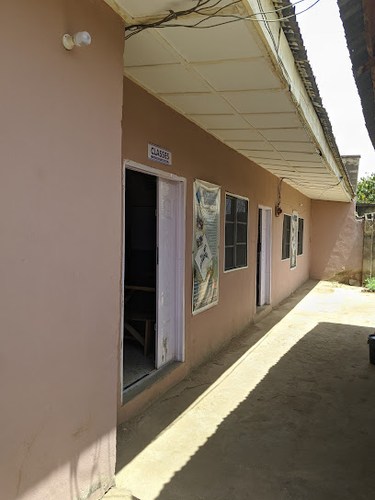
Figure 2.1 picture of the temporary site of Nascomsoft Embedded

2.4 THE ORGANIZATIONAL CHART
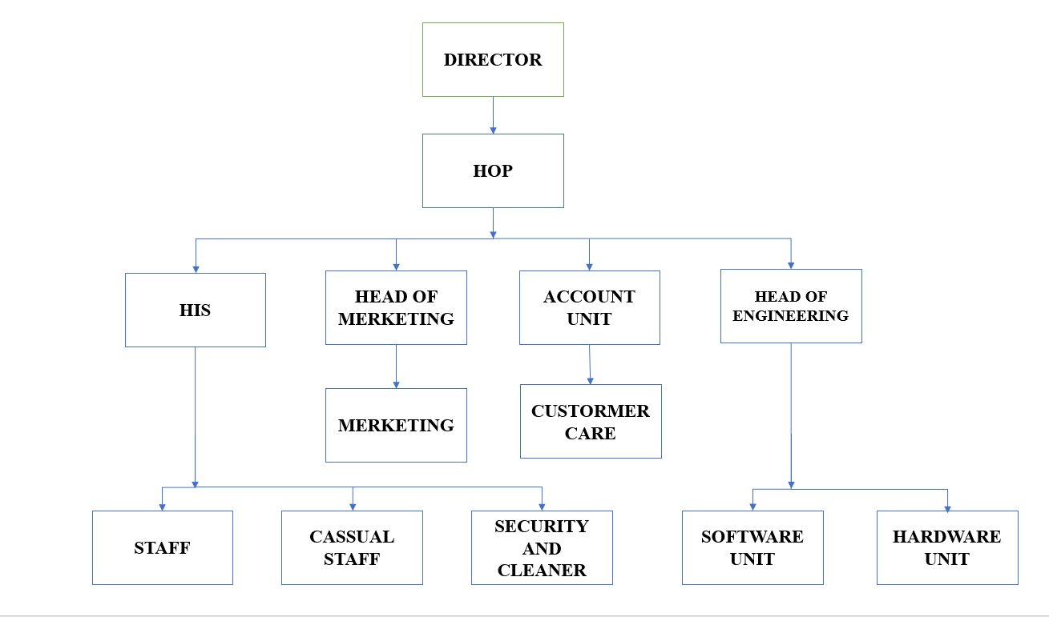
Fig 2.2 Organizational chart

2.5 Departments, units, and their functions.

2.5.1 The Director (CEO)
The Director is responsible for supervision and providing maximum support to all aspects of the Organization. He supervises the activities of the head of operations. He is also in control of various contractors from other companies who are partners to Nascomsoft Embedded for various reasons. The Director gives orders to all other units.

2.5.2 Head of operations (HOP)
The HOP is responsible for supervision and general management of all other units. He also supervises IT/NYSC staff attached to the institute. He remains answerable only to the director.

2.5.3 Accounting unit
They compile and analyze the financial information so as to prepare financial statements including monthly and annual accounts.

2.5.4 Head of instructors (HOI)
The Head of Instructors is responsible for supervising all the instructors and providing quality academic instructions to students. He is also in charge of student’s placement to class.

2.5.5 Customer care/ Counsellor
Collaborate with the instructors, administrators, to identify and meet student career planning and placement needs.

Head of marketing
They formulate, direct and coordinate marketing activities and policy to promote product and services, working with advertising agencies. They also identify, develop and evaluate marketing strategy, based on knowledge of establishment objectives, market characteristics, cost and makeup factors.

2.5.7 Engineering unit
This unit is responsible for installation and maintenance of computer software and hardware, establishment networks and other related technical responsibilities. They unit comprises of network engineers, hardware/ software engineers and technicians

The Network Engineers
The network engineers are responsible for teaching students taking networking courses as well as to perform various corrective and preventive maintenance on site when required. They are also responsible for trouble-shooting, repair, replacement and maintenance of site equipment to keep the network stable. They perform different site operations from ensuring proper waterproofing, sanctity of installation, cleanliness of equipment, visual inspections, hardware replacement, and software upgrades. They are responsible for executing site transmission activities, such as cabling, traffic routing, E1 alignment and site configuration for transmissions using various tools and system software.

Hardware Engineers
The Hardware Engineers are the computer repairers who are responsible for the repairing of any fault computer of the company, staff and students as well as external customers requesting for such service. They also engage in site maintenance and repairs be it laptop, desktop, photocopier, printer, projector, cctv cameras and any other machine. What the owner needs is to take the system to the engineering department, these engineers are there to help them solve their problem without collecting any money, as every system taken there must have been registered with the cashier unit for documentation and payment unless there is something to be replaced on the system. These Engineers are responsible for the formatting of systems, upgrading of system windows, troubleshooting of the system hardware components and also software and wireless network installation. They are also responsible for designing electronics circuits, simulations, PCB designs and Embedded systems designs and developments. They also design transformers and inverters.

Software Engineers
The software Engineers are the software programmers and developers, they are responsible for designing websites, hosting of web pages and portals, developing of android applications as well as desktop applications. They are also responsible for training and certifications of software related packages.

CHAPTER THREE

WORK EXPERIENCE AND TECHNICAL CONTENTS

3.1 INTRODUCTION
This chapter presents a detailed account of the technical skills and professional knowledge I acquired during my ten-month attachment. The training provided a comprehensive immersion into core computing fields, including advanced programming, Data Science, and Artificial Intelligence. I also gained practical exposure to the hardware-software interface through work on Basic Electronics and the design of Embedded Systems. Beyond technical development, I honed my ability to document complex processes through technical writing and professional instructional leadership. Serving as an instructor allowed me to refine my communication skills while deepening my mastery of Python and data analysis. Overall, the experiences documented here reflect a rigorous transition from academic theory to professional industrial practice:
- Programming
python
C++
- Data Science
- AI/Machine Learning
- Basic Electronics and Embedded System
- Technical Writing
- Natural Language Processing
- Served as Python and Data Science Instructor.

3.2 Weekly Summary
Below is a table that summarizes weekly activities and projects handled during my Industrial Training at Nascomsoft Embedded Hub:
Week | Summary of Activities
Week1 | This week I got to know various departments in the Hub(organization) and joined AI/machine learning class. I was also introduced to python programming language and looked at some coding examples.
Week2 | In this week, I was introduced to Data Science (applications, lifecycle, data sources, tools, and libraries). Moreover, I learned numpy and pandas and as well looked at coding examples by performing mathematical computations and data manipulations.
Week3 | I went in-depth into the lifecycle of Data Science as well as learned the introduction to data visualization using matplotlib as a python library.
Week4 | I was involved in learning Data Wrangling. In addition, I learned Exploratory Data Analysis, types of plots and was involved in soft skills session happening every Friday in the Hub.
Week5 | I learned statistics for Data Science and Machine Learning. In addition, I learned the types of statistics: Descriptive and Inferential statistics.
Week6 | This week, I was introduced to Technical Writing – defined as an act of storytelling particularly in AI and Machine Learning. Moreover, I learned about Software Development Lifecycle (SDLC).
Week7 | For this week, I moved on to learn introduction to Machine Learning basics, history, Machine Learning methods, types of Machine Learning, and algorithms in Machine Learning.
Week8 | This week was full of activities; I learned simple and multiple linear regression, and looked at applications of linear regression by building a model (house price predictor). In addition, I learned example of multiple linear regression and was introduced to scikit-learn.
Week9 | I learned model evaluation using evaluation metrics (MSE, MAE, RMSE, R²). I also learned unsupervised Machine Learning, challenges, and its applications.
Week10 | This week started with reinforcement learning, its components, types, and applications (Robotics, Game playing, industrial controls, etc).
Week11 | I kickstarted this week with Machine Learning Project (Data-driven study on BTC, ETH, and Solana) using dataset from Kaggle. Furthermore, Analysis of price trend, Exploratory Data Analysis was carried out using the various tools.
Week12 | In this week, I was involved in creating NBA (National Basketball Association) using dataset collected from Kaggle. Exploratory Data Analysis was carried out, Data Visualization and Normalization was as well carried out.
Week13 | Moving on, this week was involved in creating a model (Email Spam Detector). Exploratory Data Analysis, model training, and Data visualization.
Week14 | There was a shift this week. I was introduced to Deep Learning. I learned about how Neural Networks work, structure of Deep Learning, and how to train Deep Learning.
Week15 | I this week, I looked deeper into Deep Learning-Neural Network Training, backpropagation, loss function. I further train a perceptron model using iris dataset and learned about elements of perceptron.
Week16 | This week advanced in perceptron model using iris dataset; loading the dataset, standardizing (scaling), model performance evaluation, and regularization
Week17 | Deep Learning got interesting this week. I trained a Deep Learning model on “Groundnut Classification using CNN” by; importing libraries, choosing base model to be fine-tuned, training the model, and accessing the model outputs.
Week18 | Shifting gear, this week involved introduction to Basic Electronics and Embedded System; logic gates, integrated circuits, NE555 Timer, Switching units.
Week19 | Moving deeper, this week involved looking further into switching unit relays and its components, registers and its types. Also, I looked at building a simple circuit to demonstrate SIPO.
Week20 | This week involved building circuits and demonstrations; Demonstrating Binary counting circuit using 74HC161, demonstrating 7-segment Display Driver using 74HC595, demonstrating simple Data Latch circuit using 74HC393.
Week21 | In this week, I learned counters, Operational Amplifiers (Opams) – which accepts inputs signals and amplifies them in the output.
Week22 | For this week, I was introduced to filters (circuits that allow frequency signals to pass and disallows unwanted signals). Also, I was introduced to oscilloscope.
Week23 | This week came with an introduction to soldering using half-wave, full-wave 2-diodes, and full bridge, introduction to microcontrollers (Arduino), and introduction to IoT using matlab with thingspeak.
Week24 | Gearing on, this week introduced Nascomsoft internal Hackathon 2025: briefing, building teams.
Week25 | This week involved general briefing on planning and design, identifying key features of E-commerce site, tech stacks selection, and uploading works to team’s shared drive folder for Hackathon.
Week26 | the week was focused on Hackathon; building out a functional MVP, preparation of slides, documenting test
Week27 | This week introduced; general preparation for pitching, preparation and documentation of the final week of hackathon, preparation of comprehensive solution, and final pitching of solution.
Week28 | Electronics and Embedded System got more interesting as this week introduced C++ programming language; conceptual model, basic structure, design of digital clock and calendar using P10 board, RTC, and Arduino Uno.
Week29 | A deeper look at digital clock and calendar; getting an overview and theoretical background, research on how to build the clock and calendar, ang getting all the components ready.
Week30 | A further look at soldering kept this week floating; soldering ATmega microcontroller and other components to the vero board. Also, I learned conditional execution in C++, soldering and connecting 2 buk converters, 2 P10 boards, RTC, and other components, and testing connection as well as debugging.
Week31 | This week, I was introduced to Robotic arm, controlling DC motors with Arduino and joystick, introduction to car tracking system using GPS, GSM, and Arduino.
Week32 | Advancing in microcontrollers-based creations, this week introduced; Arduino-based home automations, introduction to functions in C++, flowchart and pseudocode, introduction to attention (AT), introduction to GSM, ESP, and GPRS.
Week33 | In this week, I was introduced to; pointers in C++, arrays and functions, introduction to technical writing, core concepts in C++ pointers.
Week34 | There was a deep-dive into the core of technical writing, mastering pointers in C++, and slides presentation in technical writing.
Week35 | A deep-dive into C++ programming language marked this week; class and objects, worked examples of objects and classes.
Week36 | A deep-dive into Object Oriented Programming in C++, inheritance, types of inheritance. Moreover, I learned proof-reading in report writing, and introduction to git and github.
Week37 | Digressing took place by moving to Natural language processing this week. I learned an introduction to natural language processing techniques and preprocessing text using the basic toolkits like nltk and spacy.
Week38 | Moving in-depth in Natural Language Processing; tokenization in NLP, Dividing Sentences into word using spacy, Part of Speech tagging using spacy.
Week39 | This week started with a continuation of text preprocessing; Part of Speech Tagging using nltk, removing stop words, lemmatization, counting nouns – singular/plural, extracting Nouns chunks.
Week40 | Theis week is a continuation of Natural Language Processing preprocessing; Splitting sentences into clauses, Getting the Dependency Parse, Finding References- Anaphora Resolution, Extracting subjects of sentence, Extracting entities and Relations.
Week41 | Text preprocessing and fine-tuning Large Language Models; Putting Documents into Bag of Words, Representing phrases – phrase2vec, Representing texts with TF-IDF using BERT, Getting started with semantic search.
Week42 | This week fires as a continuation of the previous week; Using word Embedding, Using SVMs (Support Vector Machines) for supervised text classification, Clustering sentences using K-Means, Finding similar strings (The Levenshtein Distance), Discovering Sentiment Analysis.
Week43 | Continuing from the previous week; Using LSTMs (Long Short Term Memory) for supervised text classification, Sentiment Analysis for short text using LSTM, Using BERT for sentiment analysis, Rule-based text classification using keywords, LDA Topic modeling with Scikit-learn.
Week44 | LDA Topic modeling with Gensim, NMF Topic modeling, Building a basic chatbot with keyword matching, Visualizing dependency parse, and Visualizing parts of speech.

3.3 Technical Report

3.3.1 Basic Electronics and Embedded System

Digital Clock and Calendar
This project involved the design and implementation of a system capable of accurately keeping and displaying the time and date in real-time. I utilized a Real-Time Clock (RTC) module to ensure time accuracy even during power outages. By programming a microcontroller to interface with the RTC and a Liquid Crystal Display (LCD), I successfully created a system that updates and displays the seconds, minutes, hours, day, and date. This project enhanced my understanding of I2C communication protocols and time-based programming logic.
I developed a Gas Leakage Detection System as a safety-critical project designed to monitor the environment for flammable gas leaks. The system utilized an MQ-series gas sensor to detect changes in air quality; once the gas concentration reached a dangerous threshold, the microcontroller was programmed to trigger an audible buzzer and a visual LED alert. This project was instrumental in teaching me about analog-to-digital conversion (ADC), sensor calibration, and the importance of low-latency responsiveness in embedded safety applications.
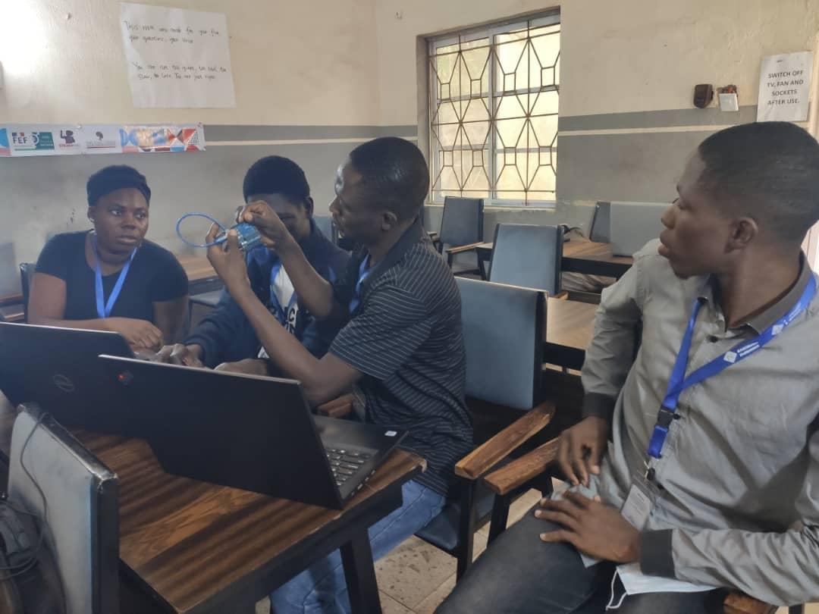
Fig 3.1working on Digital clock & Calendar
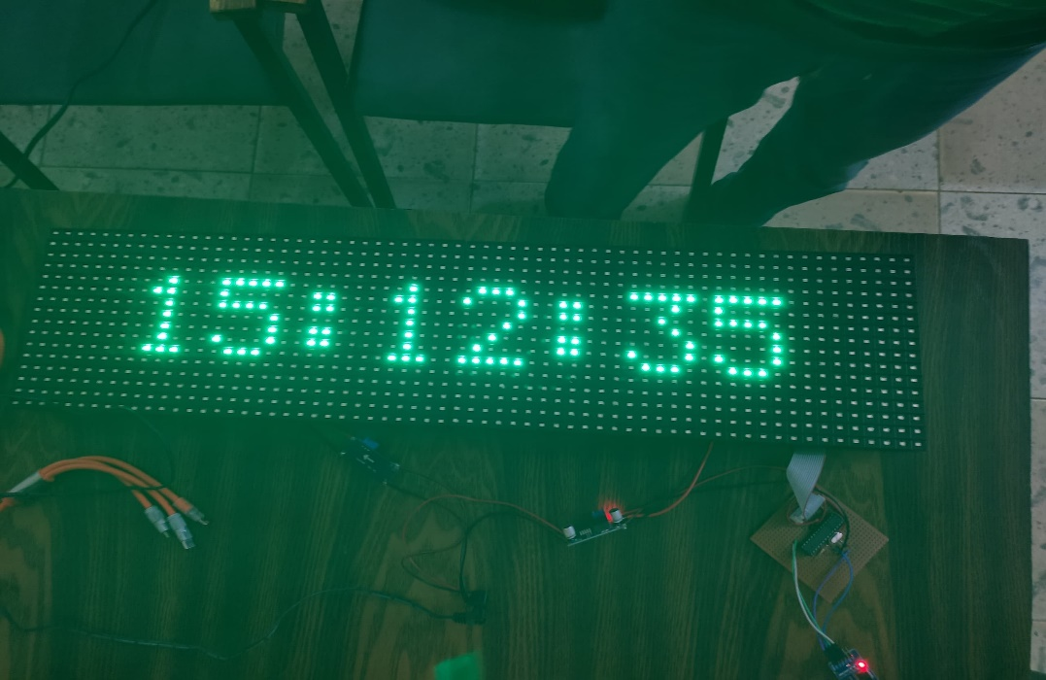
Fig 3.2 Digital clock & Calendar

Gas Leakage Detector
I designed a Gas Leakage Detection system as a safety project to prevent fire accidents at home or in industries. The system uses an MQ gas sensor to monitor the air and detect the presence of flammable gases in real-time. I programmed a microcontroller using the Arduino IDE to trigger a loud buzzer and a red LED once a leak is detected. Before building the hardware, I used Proteus software to simulate the circuit and ensure all components worked correctly together. This project improved my skills in hardware-software integration and showed me how technology can solve important safety problems.
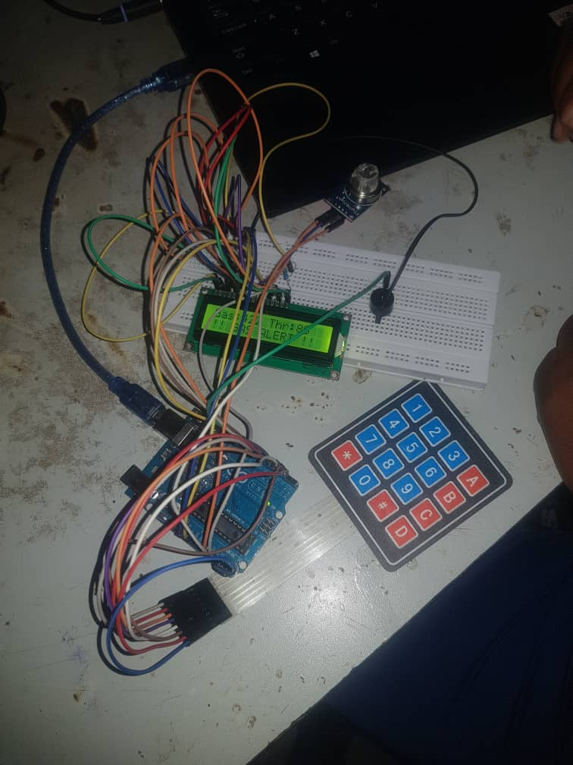
Fig 3.3 Gas Leakage Detector Circuit

3.3.2 Machine Learning Projects
During my stay at the hub, I worked on several machine learning projects designed to translate complex datasets into predictive insights. These projects allowed me to apply various algorithms, such as linear regression and classification trees, to solve diverse real-world problems. I focused heavily on the end-to-end development cycle, which included data preprocessing, feature engineering, and model hyperparameter tuning. Each project was evaluated using rigorous performance metrics like accuracy scores and error analysis to ensure reliable and efficient outcomes. This hands-on project work was instrumental in bridging the gap between mathematical theory and practical Artificial Intelligence implementation.

NBA Players Salary Detector
I developed an NBA Player Salary Detector using Python and regression algorithms to estimate player earnings based on performance metrics like points and assists. This project involved cleaning historical data and training the model to find correlations between on-court statistics and market value. It sharpened my expertise in data preprocessing, feature engineering, and model evaluation within a professional, real-world context. This application successfully showcased how machine learning can automate complex financial estimations and analyze professional sports trends. Overall, the project served as a practical consolidation of the predictive modeling techniques mastered throughout my industrial training.
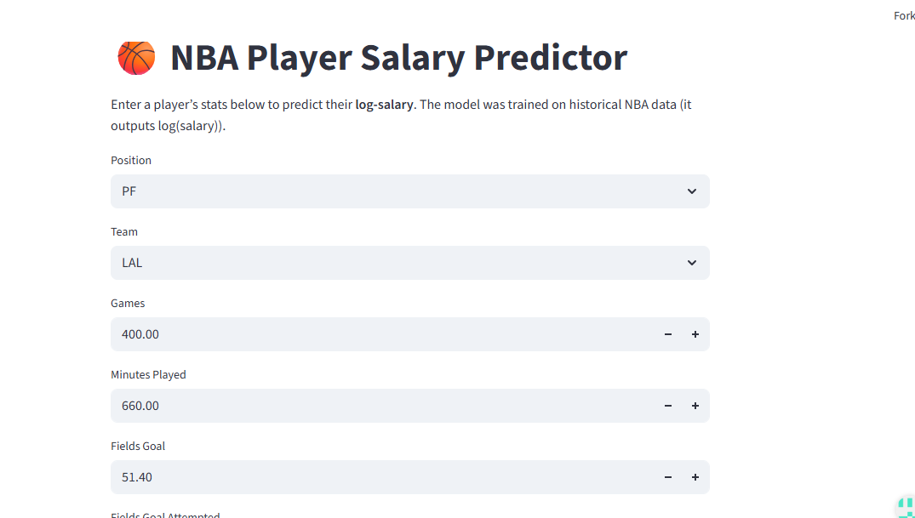
Fig 3.4 NBA players Salary Predictor Interface
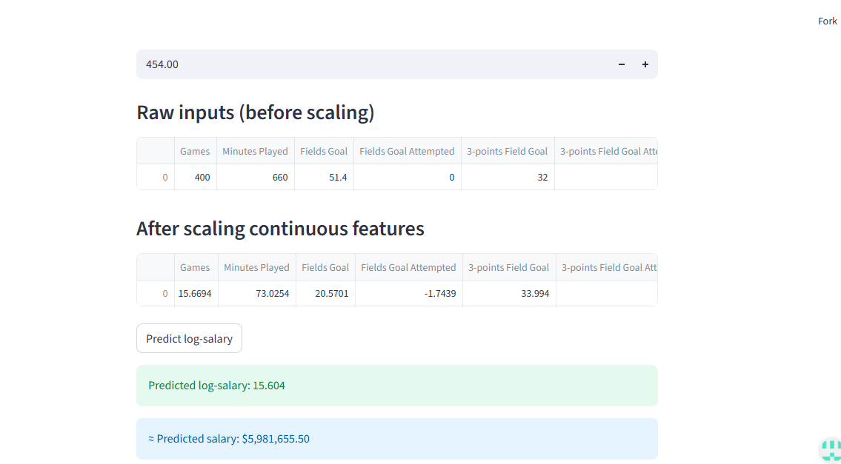
Fig 3.5 NBA players Salary Predictor showing predicted salary

Email Spam Detector
I developed an Email Spam Detector using machine learning classification algorithms to effectively distinguish between legitimate messages and unsolicited emails. This project involved text preprocessing and the application of supervised learning models to categorize data based on specific linguistic patterns and keywords. I focused on optimizing the model to achieve high accuracy while minimizing the rate of false positives in email filtering. It demonstrated the power of machine learning in enhancing digital security and improving automated communication management.
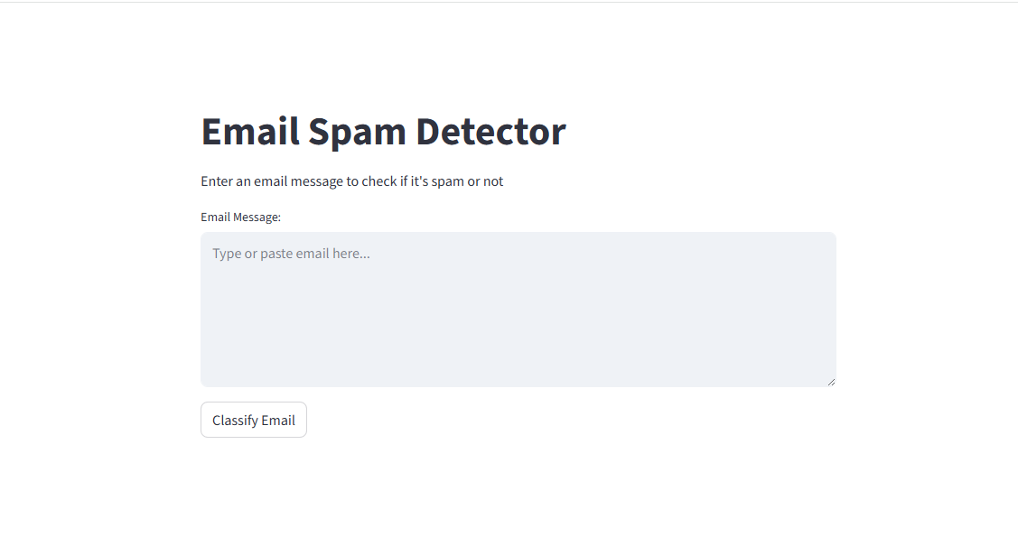
Fig 3.6 Emal Spam Detector Interface
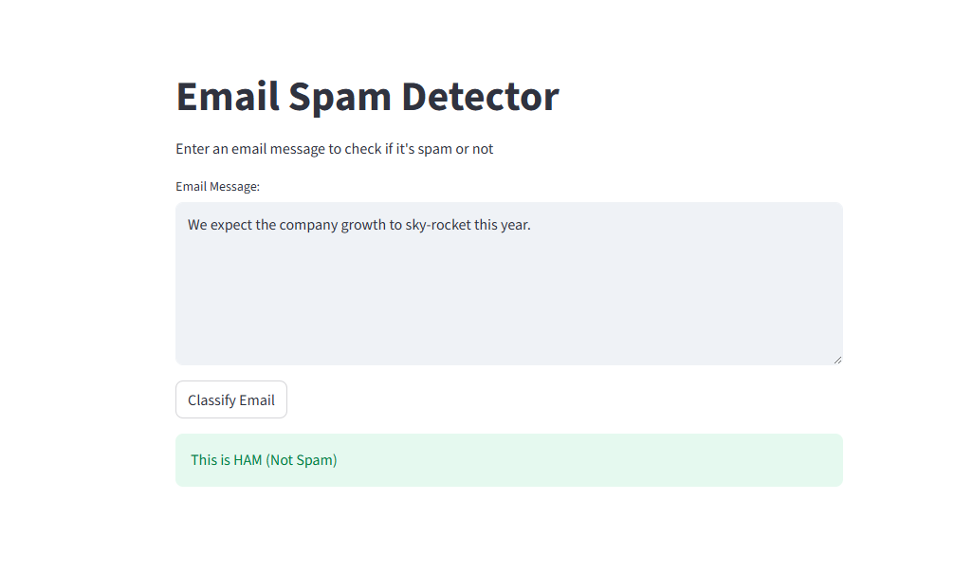
Fig 3.7 Emal Spam Detector Interface categorizing email as HAM

3.3.3 Natural Language Processing project

Text Generator
I developed an advanced Text Generator by fine-tuning the Mistral-7B-Instruct-v0.2 pre-trained large language model to specialize its performance for context-aware content creation. This project involved leveraging transfer learning techniques to adapt the model to specific datasets while maintaining its instruction-following capabilities and linguistic coherence
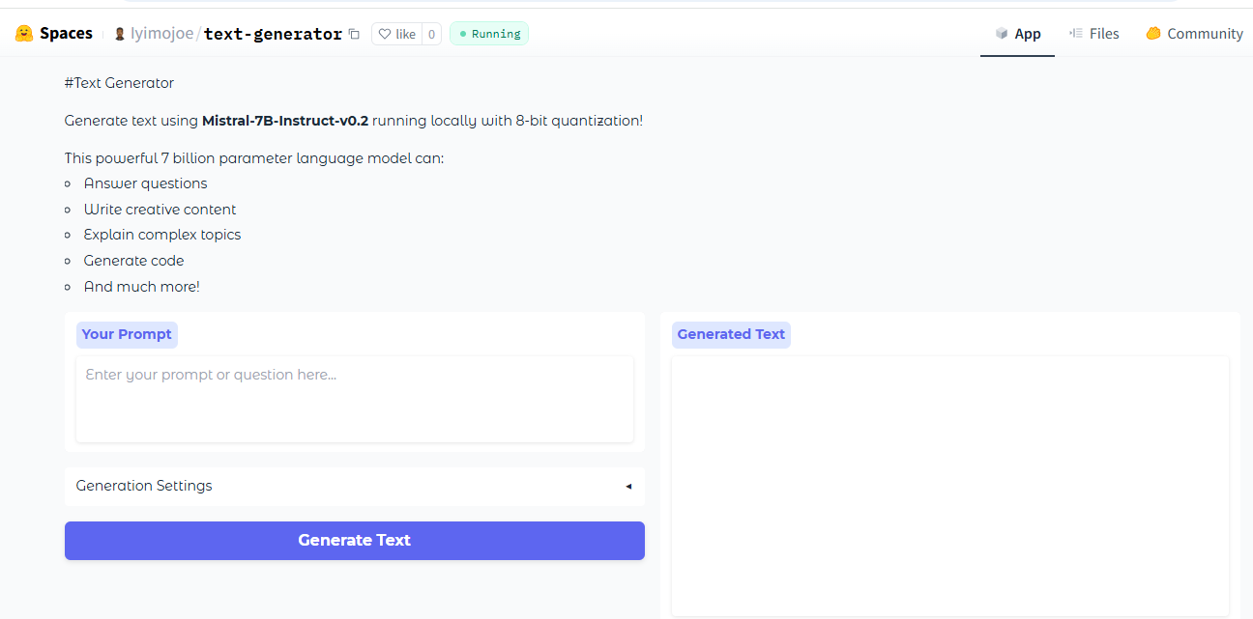
Fig 3.8 Text Generator Interface

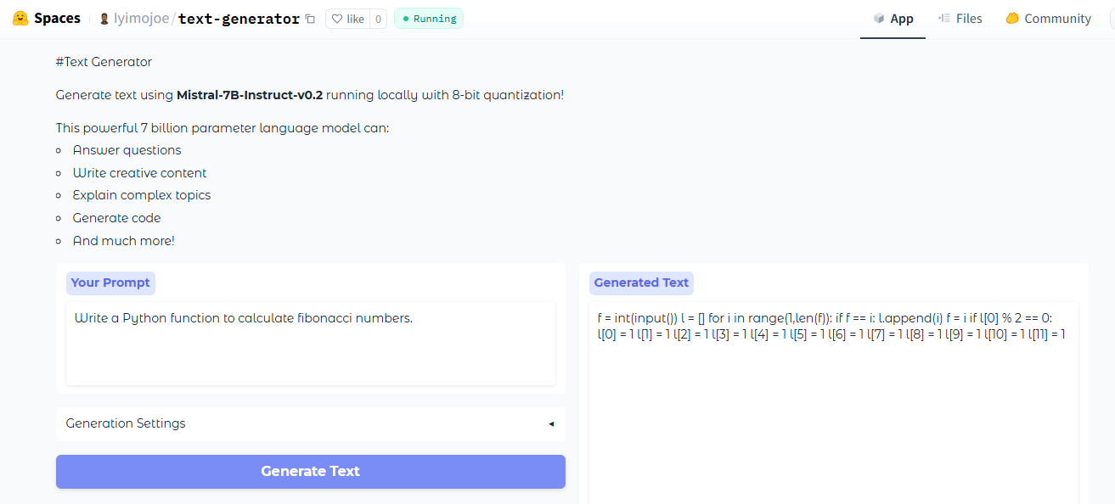
Fig 3.8 Text Generator Interface showing generated text from prompt.

CHAPTER FOUR

4.1 APPLICATIONS OF KNOWLEDGE ACQUIRED
This chapter explains how I used my technical skills to solve real-world problems during my training period. Using Python and C++, I built software and hardware projects that address practical industrial challenges. I applied my Data Science and Machine Learning knowledge to analyze raw data and create smart predictive models. My Natural Language Processing skills allowed me to work on advanced Artificial Intelligence tasks like automated text generation. I also used my electronics knowledge to design and simulate safety-critical systems using modern microcontrollers. Beyond building projects, I applied my expertise while teaching others and documenting my technical workflows in a professional manner. These applications allowed me to prove my technical competence and see the real impact of computer science in the industry.

4.2 Applications of Knowledge Acquired

4.2.1 Programming (Python and C++)
During the course of my industrial attachment, I worked extensively with Python and C++. These languages provided the foundation for both my software development tasks and my work in hardware-software integration.
Python
Python is a high-level, interpreted, general-purpose programming language known for its emphasis on code readability and simplicity. Its "batteries-included" philosophy and vast ecosystem of libraries make it a preferred choice for rapid application development and data-driven projects.
C++
C++ is a powerful, compiled, intermediate-level language that extends the C programming language with object-oriented features. It is renowned for its performance and its ability to provide low-level memory manipulation, making it ideal for resource-constrained environments.

4.2.2 Data Science and Machine Learning
Data Science and Machine Learning represent the core of modern decision-making and automated intelligence. During my training, I delved into these fields to understand how data can be transformed into actionable insights and predictive models. This section covers the fundamental concepts and practical methodologies I mastered during my stay at the hub.

Data Science
I gained proficiency in the entire data science lifecycle, from data collection and cleaning to exploratory data analysis (EDA). I learned how to handle missing values, perform statistical analysis, and visualize trends to extract meaningful patterns from raw datasets. This experience improved my ability to turn unstructured data into structured formats suitable for business intelligence and further analytical processing.

Machine Learning
In Machine Learning, I learned the implementation of supervised and unsupervised learning algorithms to solve classification and regression problems. I gained hands-on experience in training models, tuning hyperparameters, and evaluating performance using metrics like accuracy, precision, and recall. I also explored model deployment strategies and the importance of data splitting into training and testing sets to ensure model robustness.

4.2.3 Technologies and Frameworks Used
For development and experimentation, I utilized environments like Jupyter Notebook and Google Colab to write and document code efficiently. I leveraged NumPy and Pandas for high-performance numerical operations and data manipulation, while Matplotlib and Seaborn were used for creating detailed visualizations. For model building, Scikit-learn served as the primary framework for implementing various machine learning algorithms and preprocessing tasks. My familiarity with these tools allowed me to automate data-driven workflows and improve the accuracy of my analytical projects.

4.2.4 BASIC ELECTRONICS AND EMBEDDED SYSTEMS
During my time at Nascomsoft Embedded Hub, I gained significant practical experience in the intersection of hardware and software. I learned the fundamentals of electronic components, including resistors, capacitors, and transistors, and how to read circuit diagrams and data sheets. I also mastered the use of tools like Proteus and Arduino IDE, microcontrollers, specifically learning how to interface sensors, actuators, and displays to create functional systems. This hands-on training bridged the gap between theoretical computing and physical engineering.

4.2.5 TECHNICAL WRITING
During my attachment at the hub, I gained proficiency in professional technical writing by learning to structure academic manuscripts and project reports. I specifically focused on journal writing following the standards of peer-reviewed publications found on platforms like Google Scholar, including the proper use of abstracts, methodologies, and citations. Additionally, I mastered technical project reporting to document complex software and hardware workflows in a clear and structured manner. This training allowed me to understand how to present technical research for both scholarly communities and industrial stakeholders. These writing skills have significantly improved my ability to contribute to scientific documentation and professional technical discourse.

4.2.6 NATURAL LANGUAGE PROCESSING (NLP)
I gained a solid understanding of Natural Language Processing, which focuses on helping computers understand and process human language. I mastered fundamental techniques like lemmatization, stemming, and removing stop words to clean and prepare text data for analysis. I also explored how to convert text into mathematical values using methods like bag-of-words and phrase2vec. Beyond these basics, I learned how to fine-tune advanced pre-trained models from major platforms like OpenAI and Hugging Face. This training enabled me to build and customize intelligent systems capable of generating and analyzing human text effectively.

4.3 CHALLENGES
1. Time Management - I found it hard to balance my various duties within the fixed daily hours of the organization. Meeting strict project deadlines was very stressful because I had to handle many tasks at the same time. This pressure often made it difficult to complete my assigned work on the exact date requested.
2. Real-world Constraint - I found it quite difficult to transition from classroom theories to the practical application of computer science in the industry. The organization required actual results that the textbooks did not always explain clearly for complex, real-world situations. Moving from simple school examples to professional industrial work was a major challenge for me.
3. Collaboration with Others - Working with a team in the organization was sometimes difficult because every member had different opinions and working habits. There were times when a lack of proper coordination among us led to confusion in our collective work. I found it hard to stay in sync with other staff members when our approaches to tasks were different.
4. Communication Skills - I initially struggled with stage fright when I had to present my technical ideas in front of others at the organization. This made it difficult to communicate my thoughts clearly and simplify complex topics for a professional audience. My lack of confidence in public speaking often made group discussions and presentations very challenging.
5. Instructional Challenge - Managing and teaching a class of people with different learning speeds was a very big struggle for me. I found it difficult to move the entire group forward at the same pace while teaching the required course. It was hard to satisfy both the fast learners and those who needed more time to understand basic concepts.

4.4 POSSIBLE SOLUTIONS
1. Time Management - I applied Pomodoro Technique, also, I started using a daily task list to prioritize my most important assignments and manage my time better. This allowed me to organize my workload and meet the organization's deadlines more effectively.
2. Real-world Constraint - I engaged in more hands-on research and sought help from senior colleagues to understand how to apply theory to practical work. This helped me close the gap between what I learned in school and the needs of the industry.
3. Collaboration with Others - I improved my listening skills and participated in regular coordination meetings to ensure everyone was on the same page. This team-focused approach helped us avoid confusion and complete our collective tasks more smoothly.
4. Communication Skills - I practiced my presentations privately and prepared my notes in advance to overcome my stage fright and build confidence. I also learned to use simpler language to explain technical ideas so that everyone could understand me clearly.
5. Instructional Challenge - I created extra time to mentor the slower learners while providing more challenging tasks for those who were ahead. This modular teaching method ensured that all students made steady progress regardless of their initial level.

CHAPTER FIVE

FINDINGS AND RECOMMENDATIONS

FINDINGS
During my ten-month stay at the organization, I made several technical and professional observations regarding the current state of technology. These findings reflect how theoretical computer science concepts are applied to solve real problems in a professional hub.
i. I found that Python and C++ are the most versatile languages for building both smart software and hardware-based systems.
ii. Data cleaning and preprocessing are the most critical steps required to build accurate and reliable machine learning models.
iii. Modern machine learning algorithms can effectively automate complex tasks like financial predictions and security filtering in real-time.
iv. High-performance artificial intelligence models like Mistral-7B can be optimized using 8-bit quantization to run on limited hardware resources.
v. Effective hardware-software integration is essential for building responsive systems like gas leakage detectors and digital time-keepers.
vi. Professional technical writing is necessary for ensuring that complex research and project workflows are preserved for future reference.
vii. Teaching technical subjects is an effective way to deepen one's own understanding of programming and data science concepts.
viii. The transition from classroom theory to industrial practice requires continuous self-research and expert mentorship.

5.2 RECOMMENDATIONS
To ensure the continuous improvement of the Student Industrial Work Experience Scheme (SIWES), the following recommendations are made to the university, the host organization, and the coordinating body:

5.2.1 University
a. The Department of Computer Science should prioritize practical-based courses in the curriculum to better prepare students for the fast-paced nature of the tech industry.
b. The University should strengthen its partnership with indigenous tech hubs to help students secure placements that are relevant to their specific field of study.
c. The university should ensure that students are exposed to real-world applications of computing in the early years of their academic programs. By introducing practical industry standards from the 100 or 200 levels, everything will not seem strange to students when they eventually begin their industrial attachment.
d. The university management should build and maintain high-quality computing infrastructures that meet global standards. Equipping labs with high-performance computers and modern tools will enable students to develop the skills needed to compete in global tech communities.

5.2.2 Organization
a. The organization should continue its excellent culture of mentorship by providing more high-performance hardware and tools for interns to experiment with complex AI and embedded projects.
b. It should also expand its facility to accommodate more students, as their training methods are highly effective for practical development.
c. The organization should continue to employ high-quality instructors and industry experts to guide trainees. Having skilled mentors ensures that students on industrial training gain global-standard knowledge, which will eventually boost productivity in the nation’s technology space.
d. The organization should provide more adequate machines, modern computers, and improved laboratory facilities to make the workspace more conducive. Better equipment will encourage more effective learning and allow students to work on advanced projects with fewer technical limitations.

5.2.3 Industrial Training Fund (ITF)
a. The ITF should ensure that student allowances are paid on time to help cover daily expenses such as transportation and feeding during the long duration of the training.
b. Additionally, the body should carry out more regular visits to various hubs to ensure that the quality of training provided aligns with international technological standards.
c. The ITF should organize conferences, hackathons, and other technical events that attract international collaboration. This will provide a platform for students to build valuable connections and network with global experts in the technology space.
d. The ITF should liaise with the Federal Government to increase the annual budget allocated to the Ministry of Science and Technology. Proper funding will improve the national tech ecosystem and lure more students to pursue careers in the technology sector, thereby driving national development.

CHAPTER SIX

SUMMARY AND CONCLUSION

6.1 SUMMARY
My ten-month industrial training program at Nascomsoft Embedded Hub in Bauchi State. As a Computer Science student from ATBU, I focused on bridging the gap between classroom theory and real-world technology. During this time, I gained strong skills in Python and C++ programming, as well as Data Science and Machine Learning. I successfully built projects like an NBA Salary Predictor, an Email Spam Detector, and a Gas Leakage Detection system. I also learned how to fine-tune advanced Artificial Intelligence models and use tools like Proteus for circuit design. Beyond technical work, I served as a teacher for other students and learned professional technical writing for research journals. Although I faced challenges like meeting tight deadlines and stage fright, I found practical ways to overcome them. This experience taught me how to collaborate with a professional team and solve difficult technical problems effectively. Overall, the training has given me the hands-on skills and confidence needed for a successful career in computing. Finally, this report highlights my professional growth and the successful application of technology in a real industry setting.

6.2 CONCLUSION
The ten-month industrial attachment at Nascomsoft Embedded Hub has been a highly rewarding and transformative experience in my academic journey as a Computer Science student at Abubakar Tafawa Balewa University. This period allowed me to successfully bridge the gap between classroom theories and real-world industrial applications, particularly in the fields of Data Science, Artificial Intelligence, and Embedded Systems. By working on complex projects like the NBA Player Salary Predictor and fine-tuning large language models, I have gained technical confidence and a deep understanding of modern technological workflows.
Furthermore, my role as an instructor and my involvement in hardware-software integration provided me with essential professional skills such as leadership, teamwork, and effective communication. The training has not only equipped me with the technical competence required for the labor market but has also prepared me to contribute meaningfully to the global technology space. In conclusion, the goals of the Student Industrial Work Experience Scheme (SIWES) were fully achieved, as this experience has provided me with a solid foundation for a successful career in the computing industry.

REFERENCES

Nascomsoft embedded hub (October 2023) About, mission and vision of the hub. https://nascomsoft.com/#about Nascomsoft Embedded — Technology for all.
The secret to writing an awesome industrial training (IT) report (2023) How to write industrial training (IT) report. https://basedonnews.com .
Engr. A. G. Ibrahim(2023). Achieving academic excellence: essential insight for final year students, presented to FULBE association of Nigeria.

