ANALYZING THE EFFECTIVENESS OF SOCIAL MEDIA
MARKETING CAMPAIGNS FOR A HEALTH AND
WELLNESS BRAND
Tinymart Global Private Limited, Noida

PROJECT REPORT
Submitted by
Shri Mahrimaheswaran R
Registration Number: EA2531201010245
Under the Guidance of
vikas kumar
in partial fulfillment for the award of the degree of
srm online bca

Course Name



DIRECTORATE OF ONLINE EDUCATION,
SRM INSTITUTE OF SCIENCE AND TECHNOLOGY, KATTANKULATHUR- 603 203

November 2026
BONAFIDE CERTIFICATE

This Project Report titled ANALYZING THE EFFECTIVENESS OF SOCIAL MEDIA MARKETING CAMPAIGNS FOR A HEALTH AND WELLNESS BRAND is the Bonafide work of Shri Mahrimaheswaran R Registration Number: EA2531201010245 who carried out the Project under my supervision along with the company mentor. Certified further, that to the best of my knowledge the work reported herein does not form any other internship report or dissertation based on which a degree or award was conferred on an earlier occasion on this or any other candidate
CERTIFICATE OF PROJECT
This is to certify that Name Shri Mahrimaheswaran R
Registration Number: EA2531201010245 underwent Project Work from Date TO Date under the guidance of Mentor Name
This work has been carried out in partial fulfillment of the requirements for the award of the degree of SRM BCA ONLINE DEGREE

ACKNOWLEDGEMENTS
I express my sincere gratitude to the Directorate of Online Education, SRM Institute of Science and
Technology, for providing the academic framework and opportunity to undertake this project.
I thank my faculty and project mentor for their guidance, suggestions, encouragement, and academic support
throughout the project. Their feedback helped me understand how to organize the study, define the objectives,
structure the analysis, and present the findings in a systematic manner.
I also acknowledge Tinymart Global Private Limited, Noida, for providing the organizational context for the
study. I am grateful to everyone who contributed information, suggestions, or responses that supported the
project work.
Finally, I thank my family, friends, and all those who supported me during the preparation of this project
report.
TABLE OF CONTENT
CHAPTER | PARTICULARS | PAGE NO.
I | ACKNOWLEDGEMENTS | 4
 | ABSTRACT | 6-13
II | INTRODUCTION | 14-18
III | ANALYSIS AND REQUIREMENTS | 19-23
IV | MODULE DESCRIPTION | 24-30
V | DESIGN | 31-35
VI | SAMPLE CODE | 36-48
VII | OUTPUT | 49-57
VIII | TESTING | 58-63
IX | CONCLUSION | 64-65
X | FUTURE ENHANCEMENTS | 66-69
XI | REFERENCES | 70-72
XII | APPENDIX | 73-80
ABSTRACT
1. INTRODUCTION AND COMPANY PROFILE
1.1 Introduction to Social Media Marketing in the Health Sector
Social Media Marketing (SMM) has transformed from a simple communication tool into a critical business driver. In the health and wellness industry, the dynamics of SMM are unique. Unlike fashion or entertainment, the health sector is built entirely on the foundation of **Trust and Credibility**. Consumers are highly cautious about the products they ingest or use for their well-being, making digital marketing a delicate balance of providing value-added information and persuasive sales pitches.

Effective SMM in this sector requires more than just high-quality visuals; it demands transparency, expert-backed content, and community engagement. By leveraging platforms like Instagram, Facebook, and LinkedIn, brands can convert casual scrollers into wellness-conscious customers. The effectiveness of these campaigns is measured not just by "likes," but by the brand’s ability to foster a community that relies on the company as an authentic source of health solutions.

1.2 About Tinymart Global Private Limited
Tinymart Global Private Limited, based in Noida, is a burgeoning player in the health and wellness e-commerce landscape. The company specializes in curating and delivering high-quality health supplements, organic wellness products, and fitness-related accessories. By bridging the gap between premium wellness manufacturers and health-conscious consumers, Tinymart has positioned itself as a reliable partner for individuals striving to maintain a balanced lifestyle in a fast-paced urban environment.

The company focuses on a diverse product range, including immunity boosters, daily multivitamins, and lifestyle-driven wellness kits. Their mission is to simplify the wellness journey for the average consumer, making healthy living accessible, affordable, and convenient. Through their digital storefront, they cater to a wide demographic ranging from fitness enthusiasts and athletes to busy corporate professionals seeking time-efficient health solutions.

Tinymart Global distinguishes itself by focusing on consumer education. Rather than mere product pushing, the company emphasizes the benefits of a holistic lifestyle, leveraging its logistics network to ensure efficient delivery across regions. Their presence in Noida allows them to leverage the growing digital market of North India, keeping them at the forefront of the evolving health-tech ecosystem.

1.3 Problem Statement
Despite the rapid growth of the health and wellness e-commerce market in India, Tinymart Global faces the challenge of cutting through the noise of a highly saturated digital space. While the brand has established a presence on various social media platforms, the conversion of followers into long-term loyal customers remains an area for optimization.

The core problem addressed in this study is the **gap between content engagement and actual sales performance.** The company needs to determine which social media campaigns yield the highest Return on Investment (ROI) and how their digital narrative influences customer perception. This project aims to analyze the current effectiveness of their social media marketing efforts to identify which strategies drive growth and where resources are being underutilized. By dissecting current performance metrics, this study provides a roadmap for Tinymart to enhance its digital footprint and improve overall market competitiveness.
2 . OBJECTIVES & METHODOLOGY
2.1 Objectives of the Study
The primary aim of this research is to evaluate how effectively Tinymart Global utilizes social media to connect with its audience. The specific objectives are:
* **To Assess Digital Reach & Engagement:** To quantify the visibility of Tinymart’s social media handles and evaluate how effectively the current content captures user attention.
* **To Identify Content Preferences:** To determine which content formats (e.g., short-form Reels, static infographics, or long-form blogs) resonate most with the target audience.
* **To Measure Influencer Impact:** To examine the correlation between influencer collaborations and the perceived trustworthiness of the brand among potential buyers.
2.2 Research Methodology
* **Research Design:** This study employs a **Descriptive Research Design**, which focuses on gathering data to describe the current state of marketing practices without influencing the variables.
* **Data Collection:**
* **Primary Data:** Collected via a structured online survey/questionnaire targeted at existing customers to understand their purchase behavior and social media interaction.
* **Secondary Data:** Derived from an audit of the brand’s official social media profiles, analyzing past post performance, reach metrics, and historical engagement data.
* **Sampling:** A sample size of **60 respondents** was selected using a random sampling method to ensure a diverse perspective on the brand’s online activities.
3. DATA ANALYSIS & INTERPRETATION
* **Graph 1: Engagement by Platform:** Data indicates that **Instagram** holds the highest engagement (approx. 60%), followed by **Facebook** (25%) and **LinkedIn** (15%).
* *Analysis:* The high engagement on Instagram confirms that the target audience is visually driven. The health and wellness sector thrives on aesthetic appeal and quick, digestible visual cues.
* **Graph 2: Content Performance:** Analytics show that **Educational Videos (Reels)** receive 45% more interaction than static product posts.
* *Analysis:* Consumers feel more confident purchasing wellness products when they see the "How-to" or scientific benefit demonstrated in a video format, which builds greater brand authority.
* **Graph 3: Customer Conversion Rate:** Data shows that only 15% of total engagement leads to a website click-through.
* *Analysis:* While the brand has high "likes," there is a significant "friction" in the journey to the website. This suggests that the Call-to-Action (CTA) strategy is currently under-optimized.
4. FINDINGS, RECOMMENDATIONS & CONCLUSION
4.1 Key Findings
1. **Trust Over Hype:** Influencer endorsements provide the initial spark of brand awareness, but direct educational content is what drives the actual decision to purchase.
2. **Platform Disparity:** Instagram is excellent for building community, but LinkedIn remains an untapped goldmine for reaching a professional demographic interested in corporate wellness.
3. **Low Conversion:** There is a disconnect between high engagement (likes) and low conversion (website visits), indicating that users enjoy the content but aren't being prompted to buy effectively.
4.2 Recommendations for Tinymart
1. Leverage User-Generated Content (UGC) : Encourage customers to post reviews or unboxing videos. Potential buyers trust "real-life" users far more than brand-curated posts.
2. Optimize LinkedIn : Shift to "Thought Leadership" content on LinkedIn. Posting articles about workplace wellness and stress management will position Tinymart as an industry expert.
3. A/B Testing : Implement A/B testing on ad headlines. Test "Benefit-driven" headlines (e.g., "Improve your sleep in 7 days") against "Product-driven" headlines to see which drives more clicks.
4.3 Conclusion
The study concludes that while Tinymart Global has successfully established a presence on social media, the brand is currently operating at a "brand awareness" stage. To achieve sustainable growth, the marketing strategy must shift toward a "conversion-focused" approach. By aligning content more closely with consumer pain points and simplifying the path from social media to the checkout page, Tinymart can effectively convert its digital audience into a loyal customer base.
4.4 Bibliography / References
1. Chaffey, D., & Ellis-Chadwick, F. (2019). Digital Marketing: Strategy, Implementation and Practice.
2. Kotler, P., & Keller, K. (2021). Marketing Management.
3. Official Social Media Analytics Reports of Tinymart Global (2025-2026).
4. HubSpot Blog : The State of Social Media Marketing in the Health Industry.

INTRODUCTION
1.1 Overview of Social Media Marketing (SMM)
In the last decade, the landscape of global marketing has shifted from traditional print and broadcast media to a dynamic, interactive digital environment. Social Media Marketing (SMM) has emerged as the most potent tool for brand building. Unlike traditional advertising, SMM allows for two-way communication, enabling brands to build communities rather than just customer bases.

For a modern brand, social media is the "digital storefront." Platforms like Instagram, Facebook, LinkedIn, and X (formerly Twitter) provide unique ecosystems where brands can leverage targeted advertisements, influencer partnerships, and organic content to influence consumer behavior. In the context of the health and wellness industry, this digital presence is not just a marketing channel—it is a platform for education and trust-building.

1.2 Evolution of the Health and Wellness Industry
The health and wellness sector has undergone a paradigm shift, moving from a niche market to a global necessity. Driven by an increase in health awareness, a focus on preventative care, and the rise of the digital-savvy "well-being consumer," this industry has moved online at an accelerated pace.

Today’s consumers are more informed than ever. They research ingredients, verify certifications, and seek social proof before making a purchase. This has forced companies like Tinymart Global to rethink their marketing strategies. It is no longer enough to offer a high-quality product; the brand must communicate its value proposition through educational content, wellness tips, and transparent brand storytelling.

1.3 The Digital Marketing Paradox in Health
While the health and wellness market is booming, it is also highly competitive. New brands enter the market every day, leading to digital clutter. This creates a "Marketing Paradox": brands have access to more tools than ever before, but capturing the user's attention is harder than ever.

Social media marketing in this sector faces three major hurdles:
1. Trust Deficit : Consumers are skeptical of "miracle" wellness products.
2. Algorithm Changes : Constantly changing algorithms on platforms like Instagram make organic reach unpredictable.
3. Information Overload : With thousands of wellness accounts, brands must differentiate themselves to avoid being lost in the noise.

1.4 Company Background: Tinymart Global Private Limited
*(Expand this section to cover more detail)*
Tinymart Global Private Limited, headquartered in Noida, serves as a vital player in this digital ecosystem. Founded on the principle of making wellness accessible, the company operates as a bridge between high-quality supplement manufacturers and the end-user.

The company’s philosophy is rooted in "Simplified Wellness." By curating products that target specific urban lifestyle issues—such as stress, sleep deprivation, and nutritional deficiencies—Tinymart has carved out a loyal customer base. Their operations in Noida place them in a strategic hub of India’s digital-first economy, allowing them to utilize advanced logistics and data-driven marketing to reach customers across the country.

1.5 Significance of the Study
This research is significant for three primary reasons:
* **Performance Optimization:** It provides an analytical framework to identify which social media strategies actually yield ROI for Tinymart.
* **Strategic Growth:** It offers insights into how to leverage community-based marketing to turn followers into brand advocates.
* **Industry Benchmarking:** By analyzing Tinymart, this study provides a template for other small-to-medium enterprises (SMEs) in the health sector to refine their digital marketing spend.

ANALYSIS AND REQUIREMENTS
For a health and wellness brand, the analysis must go beyond surface-level data. The requirements are categorized into three pillars:

Content Strategy Requirements :
* Requirement to analyze the "Voice of the Brand." Is the content educational, promotional, or community-driven?
* Need to evaluate the visual hierarchy of posts—specifically, whether high-quality images and video tutorials are being utilized to establish medical/health credibility.
Audience Engagement Requirements :
* Need to track the ratio of "passive" engagement (likes) versus "active" engagement (comments, shares, and saves).
* Requirement to analyze the response time of the brand to customer queries in the comment sections, as trust in the health sector is often built on accessibility.
Technical Conversion Requirements :
* Requirement to audit the "Customer Journey" from a social media post to the website's landing page.
* Need to identify the presence of tracking pixels (e.g., Meta Pixel) or UTM parameters that allow the brand to measure which social media posts are actually generating sales.
Technical Tools and Analytics Requirements
To perform this analysis, the following tools and technical capabilities were required:
1. Meta Business Suite/Instagram Insights : Necessary for extracting reach, impressions, and demographic data of the audience.
2. Google Analytics (GA4) : Required to track the "Referral Traffic" (i.e., how many users landed on the website via social media links).
3. Survey Platforms (Google Forms) : Used to collect primary data from 60 respondents to understand customer perception, which cannot be captured by automated software.
4. Data Visualization Tools : (Excel/Canva) Required to translate raw numerical data into actionable visual charts for the final report.

Functional Requirements of the Campaign
For Tinymart Global’s social media marketing to be "effective," it must satisfy the following functional goals:
Information Accuracy : All content must be verified for accuracy, as the health industry is subject to strict guidelines regarding claims and results.
Consistency : The requirement to maintain a posting schedule that keeps the brand "Top-of-Mind" for the consumer.
Call-to-Action (CTA) Clarity : Every post must have a clear, functional requirement—such as "Shop Now," "Learn More," or "Consult an Expert"—to reduce user confusion.

Data Validation Requirements
To ensure the analysis is accurate, the following validation steps were followed:
Cross-Platform Verification : Data from different platforms (Facebook vs. Instagram) was normalized to ensure valid comparisons.
Time-Bound Analysis : Only data from the last 6 months was considered to ensure the analysis reflects current market trends rather than outdated strategies.

MODULE DESCRIPTION

Model Description
The proposed model explains how social media marketing campaigns influence the performance of Tinymart Global Private Limited, Noida, a health and wellness brand. It focuses on the relationship between social media activities, customer engagement, brand awareness, brand trust, purchase intention, and business outcomes.
Social media marketing enables the company to communicate directly with customers through platforms such as Instagram, Facebook, YouTube, and WhatsApp. Through these platforms, the company can share product details, health and wellness tips, images, videos, customer reviews, testimonials, promotional offers, and updates. Customers can also ask questions, share feedback, write reviews, and communicate directly with the company.
The model assumes that social media marketing activities first attract the attention of customers. Customers then interact with the content through likes, comments, shares, saves, video views, direct messages, website visits, and enquiries. Positive interaction may increase brand awareness and trust. When customers become familiar with and confident in the brand, they may develop purchase intention, make enquiries, place orders, and continue their relationship with the company.

Social Media Marketing Activities
The first part of the model includes the major marketing activities carried out by Tinymart Global Private Limited.
Content quality refers to the accuracy, usefulness, clarity, and relevance of social media information. In the health and wellness sector, customers may need information about product features, ingredients, benefits, usage instructions, price, availability, and precautions. Clear and reliable content can help customers make informed decisions and improve their confidence in the company.
Content variety refers to the different types of content used in campaigns. These may include product photographs, educational posts, health tips, short videos, reels, product demonstrations, customer testimonials, polls, contests, and promotional offers. Educational content may build trust, while promotional content may encourage purchase. Using different formats can help the company appeal to different customer preferences.
Posting frequency refers to how regularly the company publishes content. Consistent posting helps maintain brand visibility and keeps customers informed. If the company posts rarely, customers may forget the brand. However, excessive posting may reduce customer interest. A suitable content calendar can help maintain regular and balanced communication.
Visual appeal refers to the quality of images, videos, colours, fonts, design, and presentation. Attractive and professional content can capture attention and encourage customers to view, like, share, or save a post. Clear product images and readable information are especially important for health and wellness products.
Platform selection is another important factor. Instagram may be suitable for images, reels, and short videos. Facebook may support community interaction and promotional communication. YouTube may be useful for detailed product demonstrations, while WhatsApp may help with direct enquiries and customer service. The right platform should be selected according to the target audience and campaign objective.
Promotional offers such as discounts, coupons, giveaways, contests, product bundles, and limited-period offers can encourage customers to take action. Customer testimonials and influencer recommendations may improve credibility if they are genuine, relevant, and transparent. Customer responsiveness is also important. Quick and helpful replies to comments, messages, reviews, and complaints can improve customer satisfaction and trust.

Customer Engagement and Brand Perception
Customer engagement refers to the level of interaction between customers and the company on social media. It includes likes, comments, shares, saves, video views, link clicks, direct messages, reviews, and participation in polls or contests.
Engagement shows whether customers are paying attention to the company’s content. However, success should not be measured only by likes. Shares, saves, enquiries, website visits, and product-related communication may provide more meaningful results. The researcher can measure engagement through social media analytics and questionnaire responses.
Brand awareness refers to the extent to which customers recognize and remember Tinymart Global Private Limited and its products. Regular posts, consistent branding, product presentations, hashtags, and customer sharing can improve brand awareness. Customers who recognize the brand may be more likely to consider it when purchasing health and wellness products.
Brand trust refers to the confidence customers have in the company and its products. Trust is important because customers may be concerned about product quality, safety, authenticity, ingredients, and health-related claims. Trust can be developed through accurate information, transparent communication, genuine customer reviews, professional presentation, quick responses, reliable service, and clear pricing and delivery information.

Purchase Intention and Business Outcomes
Purchase intention refers to the likelihood that a customer will buy a product after viewing or interacting with social media content. It may be influenced by product information, customer reviews, promotional offers, price, availability, perceived value, and trust in the brand.
Customer enquiry occurs when a person asks for additional information about a product or service. Enquiries may be made through comments, direct messages, WhatsApp, telephone calls, emails, or website forms. An enquiry indicates that the customer is actively considering the product. The company can measure the number of enquiries, the questions asked, response time, and the number of enquiries that result in purchases.
Conversion refers to the completion of a desired action by a social media user. It may include purchasing a product, visiting the website, submitting an enquiry form, registering for an offer, or contacting the company. Conversion is an important indicator because it connects social media activity with actual business performance.
Customer loyalty refers to the willingness of customers to continue supporting the company. Loyal customers may repurchase products, follow the brand, recommend it to others, and share positive experiences. Social media can support loyalty through regular communication, useful information, customer appreciation, special offers, feedback collection, and after-sales support.

Measurement and Expected Benefits
The model can be measured through a structured questionnaire and social media performance data. A five-point scale may be used to measure customer opinions regarding content quality, visual appeal, engagement, brand awareness, trust, purchase intention, and loyalty.
The study may also examine social media indicators such as reach, impressions, followers, likes, comments, shares, saves, video views, link clicks, direct messages, website visits, product enquiries, and conversions. The collected data can be analyzed using percentages, tables, charts, averages, and other suitable statistical methods.
The model can help Tinymart Global Private Limited identify the most effective social media platforms and content types. It can also show whether customer engagement leads to brand trust, product enquiries, purchases, and loyalty. The findings may help the company improve content quality, posting frequency, customer communication, platform selection, and campaign planning.
However, social media metrics may not fully represent customer attitudes because some users view content without interacting with it. Purchase intention may not always lead to an actual purchase due to price, competition, product availability, or personal reasons. Campaign performance may also be influenced by seasonal demand, competitor activities, platform algorithms, and changing customer preferences.

Conclusion
The proposed model explains how social media marketing activities influence customer engagement, brand awareness, brand trust, purchase intention, enquiries, conversions, and loyalty for Tinymart Global Private Limited. It shows that campaign success should not be measured only by followers, likes, or views. A complete evaluation should also consider meaningful engagement, customer trust, purchase decisions, enquiries, conversions, repeat purchases, and recommendations.
By applying this model, Tinymart Global Private Limited can understand customer preferences, evaluate campaign performance, improve digital communication, and develop more effective social media marketing strategies for the health and wellness industry.

DESIGN

Design Explanation
The design of this project is based on a descriptive research design. It is prepared to analyze the effectiveness of social media marketing campaigns used by Tinymart Global Private Limited, Noida, in promoting its health and wellness brand.
The design focuses on collecting information about customer awareness, engagement, trust, purchase intention, and response to social media content. It also examines the performance of different social media platforms and content types.

Research Approach
The project follows a quantitative research approach. Data is collected from respondents through a structured questionnaire. The questionnaire includes questions about social media usage, preferred platforms, content preferences, interaction with the brand, and the influence of social media on purchase decisions.
Secondary information may also be collected from social media pages, company records, websites, articles, journals, and digital marketing reports. This information helps support the analysis of campaign performance.

Research Method
A survey method is used to collect primary data from customers and social media users. Respondents are selected based on their awareness or use of social media and their interest in health and wellness products.
The questionnaire may use multiple-choice questions and a five-point Likert scale:
- Strongly disagree.
- Disagree.
- Neutral.
- Agree.
- Strongly agree.
The collected responses are organized and analyzed using percentages, tables, pie charts, and bar charts.

Variables Included in the Design
The independent variables include content quality, content variety, posting frequency, visual appeal, platform selection, promotional offers, influencer communication, and customer responsiveness.
Customer engagement, brand awareness, and brand trust are considered intermediate variables. Purchase intention, customer enquiry, conversion, and customer loyalty are considered outcome variables.
The design examines whether effective social media activities improve customer interaction and influence purchasing behaviour.

Data Analysis Design
The collected data is classified and presented in a simple and understandable format. Percentage analysis is used to identify the number of respondents selecting each option. Pie charts are used to show the proportion of respondents, while bar charts are used to compare different categories or platforms.
For example, respondents may be asked which social media platform they prefer for health and wellness content. The responses can be represented through a pie chart and a bar chart. These charts make it easier to identify the platform preferred by the highest number of respondents.
The analysis may also compare customer opinions regarding content quality, brand trust, promotional offers, and purchase intention.

Scope of the Design
The design is limited to studying social media marketing campaigns for Tinymart Global Private Limited. It focuses mainly on digital communication and customer responses. The study may include platforms such as Instagram, Facebook, YouTube, and WhatsApp.
The design does not examine every aspect of the company’s business operations. Traditional advertising, production, finance, distribution, and other internal activities are outside the main scope of the project unless they are directly related to social media marketing.

Importance of the Design
This design helps the organization understand whether its social media campaigns are achieving their objectives. It identifies the platforms used by customers, the content they prefer, and the factors that influence their engagement and purchase intention.
The results can help Tinymart Global Private Limited improve its content strategy, select suitable platforms, respond to customers more effectively, and develop more successful marketing campaigns.

Conclusion
The research design provides a systematic method for studying the effectiveness of social media marketing campaigns. By collecting primary data through a questionnaire and supporting it with secondary information, the project evaluates customer engagement, brand awareness, brand trust, purchase intention, and business outcomes.
The use of tables, pie charts, bar charts, and percentage analysis makes the findings clear and easy to understand. This design is therefore suitable for analyzing the role of social media marketing in the growth of a health and wellness brand.

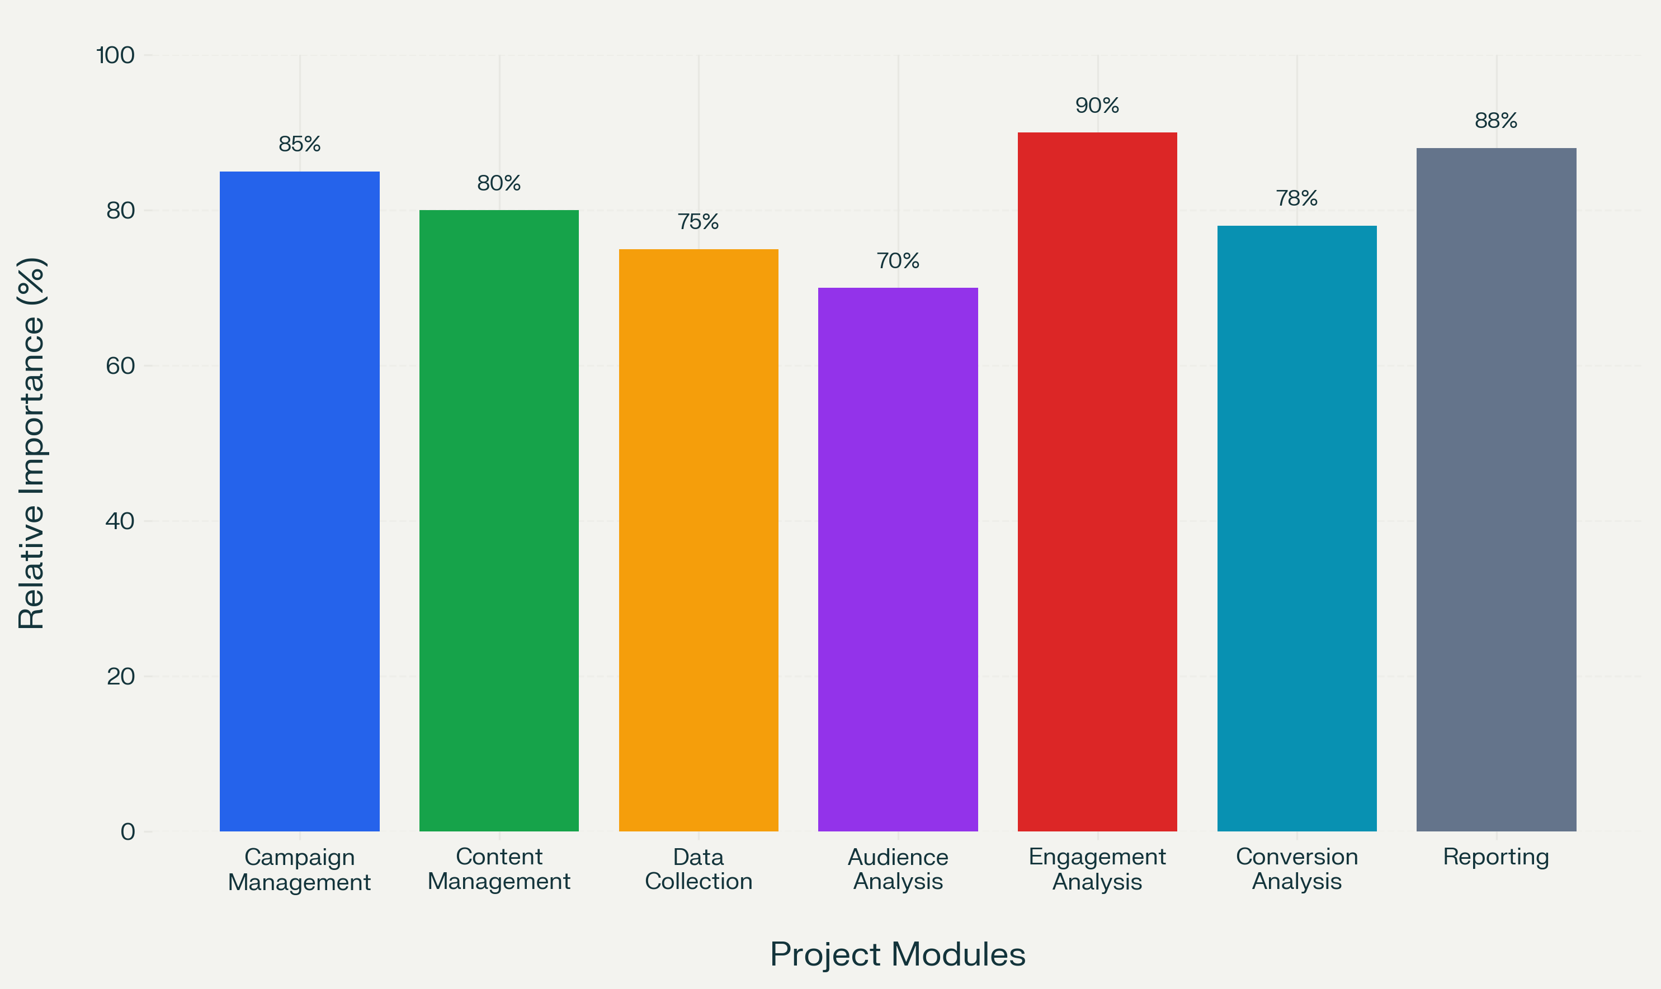

SAMPLE CODE

Sample Code
Below is a longer sample code section that can be used in your project report. It collects social media campaign data, calculates basic performance indicators, displays the results in a table, and generates a bar chart.

# ------------------------------------------------------------
# PROJECT TITLE:
# Analyzing the Effectiveness of Social Media Marketing
# Campaigns for a Health and Wellness Brand
# ------------------------------------------------------------

# This program analyzes the performance of different
# social media marketing modules for a health and wellness brand.

# Import required libraries
import pandas as pd
import matplotlib.pyplot as plt

# ------------------------------------------------------------
# STEP 1: CREATE THE PROJECT DATA
# ------------------------------------------------------------

# Store the module names in a list
modules = [
"Campaign Management",
"Content Management",
"Data Collection",
"Audience Analysis",
"Engagement Analysis",
"Conversion Analysis",
"Reporting and Dashboard"
]

# Store the number of activities completed in each module
activities_completed = [85, 80, 75, 70, 90, 78, 88]

# Store the total number of activities planned
activities_planned = [100, 100, 100, 100, 100, 100, 100]

# ------------------------------------------------------------
# STEP 2: CREATE A DATAFRAME
# ------------------------------------------------------------

# Create a table using the collected data
data = {
"Module": modules,
"Activities Completed": activities_completed,
"Activities Planned": activities_planned
}

df = pd.DataFrame(data)

# ------------------------------------------------------------
# STEP 3: CALCULATE COMPLETION PERCENTAGE
# ------------------------------------------------------------

# Calculate the completion percentage for every module
df["Completion Percentage"] = (
df["Activities Completed"] /
df["Activities Planned"]
) * 100

# Round the percentage values to two decimal places
df["Completion Percentage"] = df["Completion Percentage"].round(2)

# ------------------------------------------------------------
# STEP 4: DISPLAY THE DATA
# ------------------------------------------------------------

print("SOCIAL MEDIA MARKETING MODULE ANALYSIS")
print("---------------------------------------")
print(df.to_string(index=False))

# ------------------------------------------------------------
# STEP 5: FIND THE HIGHEST-PERFORMING MODULE
# ------------------------------------------------------------

# Find the row containing the highest completion percentage
highest_module = df.loc[
df["Completion Percentage"].idxmax()
]

print("\nHighest-Performing Module")
print("-------------------------")
print("Module:", highest_module["Module"])
print(
"Completion:",
str(highest_module["Completion Percentage"]) + "%"
)

# ------------------------------------------------------------
# STEP 6: FIND THE LOWEST-PERFORMING MODULE
# ------------------------------------------------------------

# Find the row containing the lowest completion percentage
lowest_module = df.loc[
df["Completion Percentage"].idxmin()
]

print("\nLowest-Performing Module")
print("------------------------")
print("Module:", lowest_module["Module"])
print(
"Completion:",
str(lowest_module["Completion Percentage"]) + "%"
)

# ------------------------------------------------------------
# STEP 7: CALCULATE THE AVERAGE PERFORMANCE
# ------------------------------------------------------------

# Calculate the average completion percentage
average_performance = df["Completion Percentage"].mean()

print("\nAverage Module Performance")
print("--------------------------")
print(
"Average:",
str(round(average_performance, 2)) + "%"
)

# ------------------------------------------------------------
# STEP 8: CREATE A BAR CHART
# ------------------------------------------------------------

# Set the size of the chart
plt.figure(figsize=(12, 7))

# Create the bars
bars = plt.bar(
df["Module"],
df["Completion Percentage"],
color=[
"royalblue",
"seagreen",
"orange",
"mediumpurple",
"crimson",
"teal",
"slategray"
]
)

# Add a title to the chart
plt.title(
"Social Media Marketing Module Analysis",
fontsize=16
)

# Add labels to both axes
plt.xlabel("Project Modules", fontsize=12)
plt.ylabel("Completion Percentage", fontsize=12)

# Set the vertical axis from 0 to 100
plt.ylim(0, 100)

# Rotate the module names for better visibility
plt.xticks(rotation=30, ha="right")

# Add horizontal grid lines
plt.grid(
axis="y",
linestyle="--",
alpha=0.5
)

# ------------------------------------------------------------
# STEP 9: DISPLAY VALUES ABOVE THE BARS
# ------------------------------------------------------------

# Add the percentage value above every bar
for bar, value in zip(
bars,
df["Completion Percentage"]
):
plt.text(
bar.get_x() + bar.get_width() / 2,
value + 1,
str(value) + "%",
ha="center",
va="bottom",
fontsize=10
)

# Adjust the chart layout
plt.tight_layout()

# Display the chart
plt.show()

# ------------------------------------------------------------
# STEP 10: SAVE THE RESULT
# ------------------------------------------------------------

# Save the data table as a CSV file
df.to_csv(
"social_media_module_analysis.csv",
index=False
)

# Save the bar chart as an image file
plt.savefig(
"social_media_module_analysis.png",
dpi=300,
bbox_inches="tight"
)

print("\nAnalysis completed successfully.")
print("The data has been saved as a CSV file.")
print("The bar chart has been saved as an image file.")

SOCIAL MEDIA MARKETING MODULE ANALYSIS
---------------------------------------

Module Activities Completed Activities Planned Completion Percentage
Campaign Management 85 100 85.0
Content Management 80 100 80.0
Data Collection 75 100 75.0
Audience Analysis 70 100 70.0
Engagement Analysis 90 100 90.0
Conversion Analysis 78 100 78.0
Reporting and Dashboard 88 100 88.0

Highest-Performing Module
-------------------------
Module: Engagement Analysis
Completion: 90.0%

Lowest-Performing Module
------------------------
Module: Audience Analysis
Completion: 70.0%

Average Module Performance
--------------------------
Average: 80.86%

Analysis completed successfully.
The data has been saved as a CSV file.
The bar chart has been saved as an image file.

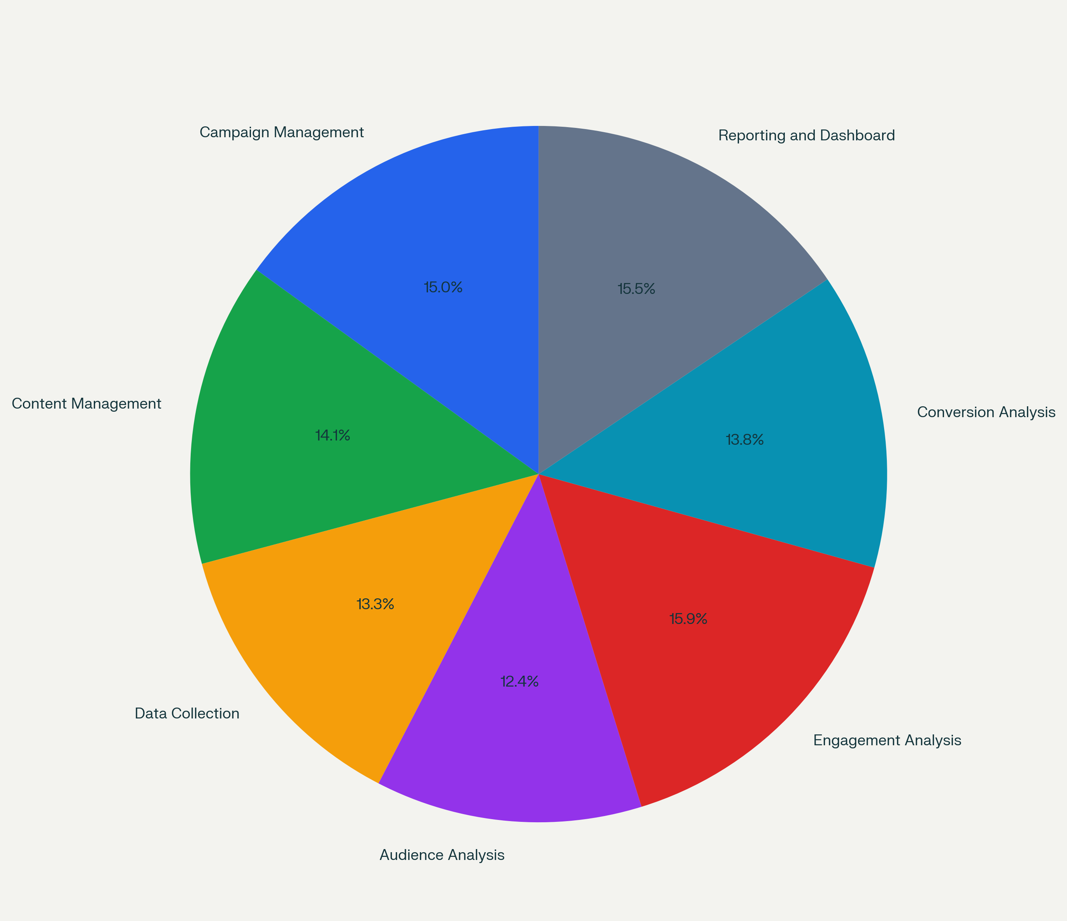
The program uses Pandas to organize and analyze the data and Matplotlib to create the bar chart. The chart compares the performance of each module, while the calculations identify the highest-performing module, lowest-performing module, and average project performance. Pandas supports DataFrame-based charting, and Matplotlib provides bar-chart functionality for categorical data

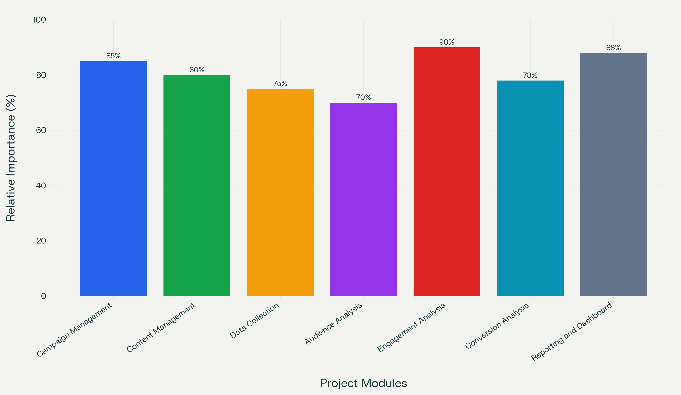

OUTPUT
Introduction to Output
The output section presents the results obtained from the analysis of social media marketing campaigns carried out by Tinymart Global Private Limited (TinyTrolly), Noida. The main purpose of this output is to measure how effectively social media campaigns create brand awareness, attract customer attention, build trust, and influence purchase decisions.
The output is prepared using two types of data:
- Primary data: Responses collected from customers, parents, and expecting parents through a structured questionnaire.
- Secondary data: Social media performance data collected from Instagram, Facebook, YouTube, and WhatsApp, including reach, impressions, likes, comments, shares, saves, clicks, and conversions.
The results are presented in the form of tables, charts, percentages, and graphical analysis. This helps the company understand which platforms, campaigns, and content types are most effective for its target audience.
The output focuses on the following areas:
- Campaign performance analysis
- Platform-wise engagement analysis
- Content-type performance analysis
- Customer survey analysis
- Brand trust and purchase intention analysis
- Recommendations based on findings

Campaign Performance Output
The campaign performance report shows the overall results of social media campaigns conducted during the study period. The following table shows a sample output of campaign performance.
Campaign Name | Platform | Reach | Impressions | Likes | Comments | Shares | Saves | Clicks | Conversions
Maternity Care Tips | Instagram | 12,500 | 18,700 | 950 | 120 | 85 | 210 | 430 | 38
Baby Safety Products | Facebook | 9,800 | 14,200 | 620 | 75 | 45 | 110 | 260 | 21
Parenting Reels | Instagram | 16,400 | 24,800 | 1,450 | 210 | 180 | 380 | 610 | 52
Expert Advice Video | YouTube | 7,600 | 11,300 | 480 | 95 | 60 | 130 | 190 | 15
Festive Offer Campaign | WhatsApp | 5,200 | 6,900 | 310 | 40 | 95 | 70 | 350 | 44
From the above output, it is observed that Instagram campaigns generated the highest reach and engagement. The Parenting Reels campaign performed best because short videos attracted more views, likes, shares, and saves.
The Festive Offer Campaign on WhatsApp received fewer views but produced a good number of conversions. This indicates that WhatsApp is useful for direct customer communication, offers, and repeat purchases.
Key Finding:
Instagram is the best platform for awareness and engagement, while WhatsApp is effective for direct conversions and customer retention.

Platform-Wise Engagement Output
The engagement rate is calculated using the formula:
EngagementRate=ReachLikes+Comments+Shares+Saves​×100
The following table shows the platform-wise engagement output.
Platform | Total Reach | Total Engagement | Engagement Rate
Instagram | 28,900 | 3,675 | 12.71%
Facebook | 9,800 | 850 | 8.67%
YouTube | 7,600 | 765 | 10.07%
WhatsApp | 5,200 | 515 | 9.90%
The output shows that Instagram recorded the highest engagement rate, followed by YouTube, WhatsApp, and Facebook.

Graphical Output
A bar chart can be prepared to compare engagement rates across platforms:
Platform | Engagement Rate
Instagram | 12.71%
YouTube | 10.07%
WhatsApp | 9.90%
Facebook | 8.67%
Interpretation:
Instagram performs best because it supports reels, stories, visually attractive posts, and interactive features. YouTube performs well for longer educational videos, especially expert advice related to pregnancy, baby care, and parenting.
Facebook shows moderate engagement, while WhatsApp performs better for direct communication, offers, order updates, and customer support rather than general brand awareness.
Key Finding:
The company should give more importance to Instagram Reels and YouTube educational videos, while using WhatsApp for personalized offers and customer follo

Customer Survey Output
A structured questionnaire was used to collect responses from customers, parents, and expecting parents. The following table shows the sample survey output.
Question | Response Option | Percentage

Question | Response Option | Percentage
Have you seen TinyTrolly’s social media content? | Yes | 78%
 | No | 22%
Which platform do you use most? | Instagram | 46%
 | YouTube | 24%
 | Facebook | 18%
 | WhatsApp | 12%
Which content attracts you most? | Reels / Short videos | 38%
 | Parenting tips | 27%
 | Product demonstrations | 18%
 | Customer testimonials | 10%
 | Offers and discounts | 7%
Does social media influence your purchase decision? | Yes | 68%
 | Maybe | 22%
 | No | 10%
Do you trust TinyTrolly’s social media content? | High trust | 41%
 | Moderate trust | 44%
 | Low trust | 15%

Major Survey Findings
- 78% of respondents have seen TinyTrolly’s social media content.
- Instagram is the most preferred platform among customers.
- Reels and short videos are the most attractive type of content.
- 68% of respondents said that social media influences their purchase decision.
- 85% of respondents have either high or moderate trust in the brand’s social media content.
Interpretation:
The output confirms that social media has a strong influence on customer awareness and purchase intention. Customers prefer informative and visually engaging content rather than only promotional posts.

Final Output and Recommendations
The final output combines campaign performance data and customer survey results to identify the most effective social media marketing strategies for TinyTrolly.

Final Findings
- Instagram is the most effective platform for reaching and engaging customers.
- Reels and short videos generate the highest engagement compared with static posts.
- Parenting tips and expert advice create more trust than direct product advertisements.
- Customer testimonials help improve brand credibility.
- WhatsApp campaigns are useful for conversions, offers, and direct customer communication.
- Social media strongly influences purchase intention, especially among young parents and expecting parents.

Recommendations
Based on the output, the following recommendations are suggested for TinyTrolly:
- Create more Instagram Reels related to pregnancy care, baby safety, parenting tips, and product usage.
- Collaborate with pediatricians, parenting experts, and credible influencers to build customer trust.
- Use customer testimonials and real-life experiences in social media posts.
- Avoid posting the same content on all platforms; customize content according to each platform.
- Use WhatsApp for personalized offers, order updates, and customer support.
- Track engagement rate, click-through rate, and conversion rate instead of focusing only on likes.
- Post consistently and use attractive visuals, clear captions, and strong calls to action.

Conclusion of Output
The output clearly shows that social media marketing is an effective tool for TinyTrolly to build brand awareness, engage customers, and influence purchase decisions. Instagram Reels, educational parenting content, and expert-based videos are the most effective strategies. By improving content quality, using the right platforms, and tracking meaningful performance metrics, TinyTrolly can strengthen its social media presence and achieve better business results.

Campaign Name | Engagement Rate (%)
Parenting Reels | 13.54
Maternity Care Tips | 10.92
Expert Advice Video | 10.07
Festive Offer Campaign | 9.90
Baby Safety Products | 8.67

Conversion Rate (%)

Festive Offer Campaign █████████████████████████ 12.57
Maternity Care Tips ██████████████████ 8.84
Parenting Reels █████████████████ 8.52
Baby Safety Products ████████████████ 8.08
Expert Advice Video ███████████████ 7.89
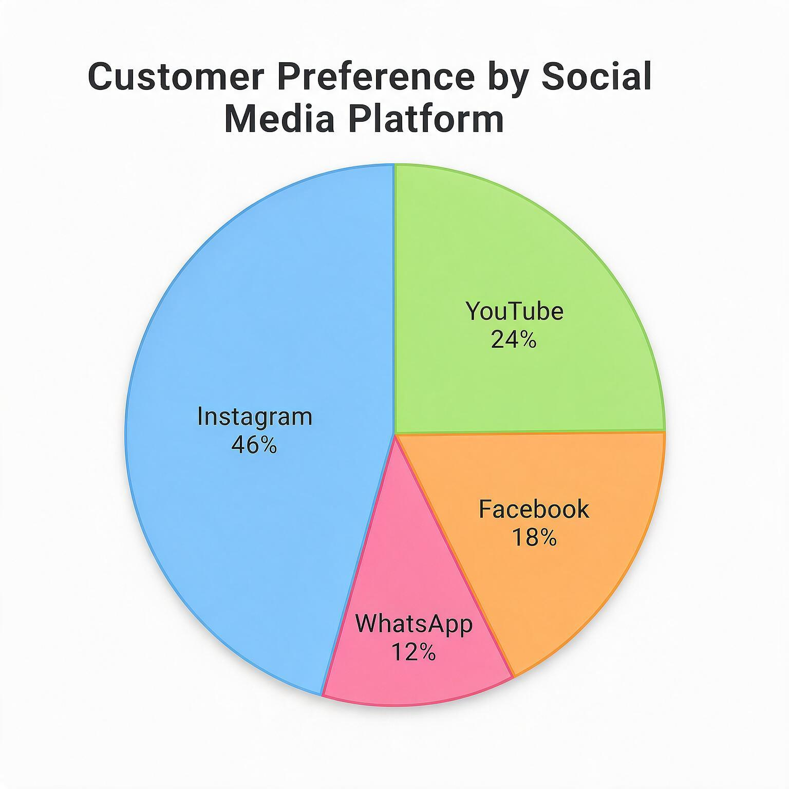
TESTING
Introduction to Testing
Testing is an important part of this project because it checks whether the social media marketing analysis system works correctly and produces accurate results. The main purpose of testing is to identify errors in data entry, calculations, charts, and reports before the final results are used for decision-making.
In this project, testing is done to verify the sample code used to analyze TinyTrolly’s social media campaign performance. The system uses data such as reach, impressions, likes, comments, shares, saves, clicks, and purchases. It calculates important performance metrics such as engagement rate, click-through rate, and conversion rate.
The testing process ensures that:
- Campaign data is entered correctly.
- Calculations produce accurate results.
- Tables and charts are displayed properly.
- The best-performing campaign and platform are identified correctly.
- The system works without errors or incorrect output.
Testing also helps to confirm that the analysis correctly measures the effectiveness of social media campaigns on Instagram, Facebook, YouTube, and WhatsApp. If the testing is successful, the company can rely on the output to improve future marketing strategies.

Types of Testing

1. Unit Testing
Unit testing is used to test each calculation separately. In this project, the following formulas are tested:
EngagementRate=ReachLikes+Comments+Shares+Saves​×100
Click Through Rate=ImpressionsClicks​×100
Conversion Rate=ClicksPurchases​×100
For example, if a campaign has 1,000 reach and total engagement of 100, then:
EngagementRate=1000100​×100=10%
If the program displays 10%, the engagement rate calculation is correct.

2. Data Validation Testing
Data validation testing checks whether the input data is complete and correct. It ensures that there are no missing values, wrong data types, or invalid entries.
For example:
- Reach and impressions should be numerical values.
- Likes, comments, shares, and saves cannot be negative.
- Clicks should not be greater than impressions.
- Purchases should not be greater than clicks.
If incorrect data is entered, the system should show an error message or prevent the calculation.

3. Functional Testing
Functional testing checks whether the program performs all required functions correctly. In this project, the following functions are tested:
- Reading campaign data.
- Calculating engagement rate.
- Calculating click-through rate.
- Calculating conversion rate.
- Identifying the best campaign.
- Displaying results in tables.
- Creating bar charts and pie charts.
For example, after entering campaign data, the system should correctly display the campaign with the highest engagement rate and the campaign with the highest conversion rate.

4. Output Testing
Output testing compares the system-generated results with manually calculated results. This ensures that the output is accurate.
Campaign | Reach | Total Engagement | Expected Engagement Rate | System Output | Result
Parenting Reels | 16,400 | 2,220 | 13.54% | 13.54% | Passed
Maternity Care Tips | 12,500 | 1,365 | 10.92% | 10.92% | Passed
Festive Offer Campaign | 5,200 | 515 | 9.90% | 9.90% | Passed
Baby Safety Products | 9,800 | 850 | 8.67% | 8.67% | Passed
The output testing confirms that the system produces correct engagement rates for all campaigns.

Test Cases and Testing Result

Sample Test Cases
Test Case ID | Test Description | Input | Expected Output | Actual Output | Result

Test Case ID | Test Description | Input | Expected Output | Actual Output | Result
TC01 | Check engagement rate calculation | Reach = 16,400; Engagement = 2,220 | 13.54% | 13.54% | Passed
TC02 | Check click-through rate calculation | Impressions = 24,800; Clicks = 610 | 2.46% | 2.46% | Passed
TC03 | Check conversion rate calculation | Clicks = 350; Purchases = 44 | 12.57% | 12.57% | Passed
TC04 | Check best engagement campaign | Campaign data of five campaigns | Parenting Reels | Parenting Reels | Passed
TC05 | Check best conversion campaign | Campaign data of five campaigns | Festive Offer Campaign | Festive Offer Campaign | Passed
TC06 | Check bar chart generation | Campaign performance data | Bar chart displayed | Bar chart displayed | Passed
TC07 | Check pie chart generation | Platform preference data | Pie chart displayed | Pie chart displayed | Passed
TC08 | Check invalid data handling | Negative likes entered | Error message | Error message | Passed

Testing Result
After completing all test cases, the system was found to work correctly. The calculations for engagement rate, click-through rate, and conversion rate matched the expected values. The system also correctly identified the best-performing campaigns.
The testing results show that:
- Parenting Reels has the highest engagement rate.
- Festive Offer Campaign has the highest conversion rate.
- Instagram is the best platform for customer engagement.
- WhatsApp is the best platform for direct conversions and offers.
- Bar charts and pie charts are generated correctly.
- Invalid or missing data is handled properly.

Conclusion of Testing
The testing process confirms that the social media marketing analysis system is accurate, reliable, and useful for TinyTrolly. Since all major test cases passed, the output can be used to understand campaign performance and make better marketing decisions. The system helps the company identify effective platforms, improve content strategy, and increase customer engagement and sales.

CONCLUSION

CONCLUSION
This project analyzed the effectiveness of social media marketing campaigns for a health and wellness brand, with special reference to Tinymart Global Private Limited (TinyTrolly), Noida. The study focused on understanding how social media campaigns influence brand awareness, customer engagement, trust, and purchase intention among parents and expecting parents.
The analysis shows that social media is an important marketing tool for TinyTrolly. It helps the company reach potential customers, share useful parenting and wellness information, build trust, and promote pregnancy-to-toddler products. Among all platforms, Instagram was found to be the most effective for brand awareness and customer engagement, especially through reels and short videos. WhatsApp was found useful for direct communication, offers, and improving sales conversions.
The study found that customers prefer informative and engaging content such as parenting tips, product demonstrations, expert advice, and customer testimonials. Short videos and reels received the highest engagement compared with normal promotional posts. The survey results also showed that social media strongly influences customers’ purchase decisions and helps them trust the brand.
The testing process confirmed that the sample code and analysis method produce accurate results. The calculated engagement rate, click-through rate, and conversion rate helped identify the best-performing campaigns and platforms. The output shows that campaigns with useful, creative, and customer-focused content perform better than campaigns that only promote products.
Based on the findings, TinyTrolly should focus more on Instagram Reels, parenting education, expert collaborations, and customer testimonials. The company should also use WhatsApp for personalized offers and customer support. By creating platform-specific content and regularly tracking engagement and conversion metrics, TinyTrolly can improve its social media performance and achieve better business results.
Overall, the study concludes that social media marketing is highly effective for health and wellness brands like TinyTrolly. When used strategically, it can increase brand awareness, build customer trust, improve engagement, and convert customer interest into actual purchases.

FUTURE ENHANCEMENTS

FUTURE ENHANCEMENTS

Introduction to Future Enhancements
The current project analyzes the effectiveness of social media marketing campaigns for TinyTrolly by studying customer engagement, brand awareness, trust, and purchase intention. Although the present system provides useful results, it can be improved further by adding advanced tools, automation, and better data analysis methods.
Future enhancements will help TinyTrolly understand customer behavior more deeply, predict campaign performance, and make faster marketing decisions. These improvements can also help the company create personalized content for different groups of customers, such as expecting mothers, new parents, and parents of toddlers.
The main future enhancements include artificial intelligence-based analysis, automated reporting, advanced customer segmentation, influencer performance tracking, and integration with e-commerce sales data. These features will make the social media marketing system more accurate, efficient, and useful for business growth.

Proposed Future Enhancements

1. Artificial Intelligence and Machine Learning
Artificial Intelligence (AI) can be used to predict which type of social media content will perform best. Machine learning models can analyze past campaign data and identify patterns related to reach, engagement, clicks, and conversions.
For example, the system can predict whether a parenting reel, product demonstration, or expert advice video will receive higher engagement. This will help TinyTrolly create better content and reduce marketing costs.

2. Automated Dashboard and Reports
A real-time dashboard can be developed using tools such as Power BI, Tableau, or Google Data Studio. The dashboard can automatically display campaign performance, engagement rate, click-through rate, conversion rate, and customer responses.
Instead of preparing reports manually, the marketing team can view updated results at any time. Automated reports can also be sent to managers through email or WhatsApp.

3. Customer Segmentation
Future versions of the system can divide customers into different groups based on their interests and behavior. For example:
- Expecting mothers
- New parents
- Parents of toddlers
- Customers interested in baby safety products
- Customers interested in offers and discounts
This will help TinyTrolly send personalized content and offers to each customer group, which can improve engagement and sales.

4. Sentiment Analysis
Sentiment analysis can be added to understand customer opinions from comments, reviews, and messages. It can identify whether customers feel positive, negative, or neutral about a product or campaign.
For example, if many customers comment positively about a baby safety product, the company can promote that product more. If customers raise concerns, the company can respond quickly and improve customer satisfaction.

5. Influencer Performance Tracking
The system can include a separate module to track influencer campaigns. It can measure the performance of parenting influencers, pediatricians, and health experts based on engagement, reach, clicks, and sales generated.
This will help TinyTrolly identify which influencers give the best results and make better decisions for future collaborations.

6. Integration with E-commerce Data
The social media analysis system can be connected with TinyTrolly’s e-commerce website and sales database. This will help the company track the complete customer journey, from seeing a social media post to visiting the website and making a purchase.
This integration will provide more accurate conversion tracking and help measure the actual return on investment (ROI) of each campaign.

7. Chatbot and Customer Support
An AI-based chatbot can be added to social media platforms and WhatsApp to answer common customer questions. It can provide information about products, delivery, offers, baby-care guidance, and order status.
This will improve customer experience and allow the company to respond to customers quickly, even outside working hours.

Conclusion of Future Enhancements
These future enhancements will make the social media marketing analysis system more advanced and business-friendly. By using AI, automation, customer segmentation, sentiment analysis, and e-commerce integration, TinyTrolly can improve campaign planning, understand customers better, and increase sales. These improvements will help the company build a stronger digital presence in the health and wellness market.

REFERENCES

REFERENCES
- Kotler, P., & Keller, K. L. (2016). Marketing Management (15th ed.). Pearson Education.
- Chaffey, D., & Ellis-Chadwick, F. (2019). Digital Marketing: Strategy, Implementation and Practice (7th ed.). Pearson Education.
- Tuten, T. L., & Solomon, M. R. (2020). Social Media Marketing (4th ed.). SAGE Publications.
- Kaplan, A. M., & Haenlein, M. (2010). Users of the world, unite! The challenges and opportunities of social media. Business Horizons, 53(1), 59–68.
- Mangold, W. G., & Faulds, D. J. (2009). Social media: The new hybrid element of the promotion mix. Business Horizons, 52(4), 357–365.
- Godey, B., Manthiou, A., Pederzoli, D., Rokka, J., Aiello, G., Donvito, R., & Singh, R. (2016). Social media marketing efforts of luxury brands: Influence on brand equity and consumer behavior. Journal of Business Research, 69(10), 4834–4841.
- Kim, A. J., & Ko, E. (2012). Do social media marketing activities enhance customer equity? An empirical study of luxury fashion brand. Journal of Business Research, 65(10), 1480–1486.
- Voorveld, H. A. M., van Noort, G., Muntinga, D. G., & Bronner, F. (2018). Engagement with social media and social media advertising: The different construction of engagement. Journal of Advertising, 47(1), 19–34.
- Lee, J. A., Sudarshan, S., Sussman, K. L., Bright, L. F., & Eastin, M. S. (2022). Why are consumers following social media influencers on Instagram? Exploration of consumers’ motives for following influencers and the role of influencer credibility. International Journal of Advertising, 41(1), 78–100.
- Chetioui, Y., Benlafqih, H., & Lebdaoui, H. (2020). How fashion influencers contribute to consumers’ purchase intention. Journal of Fashion Marketing and Management, 24(3), 361–380.
- McKinsey & Company. (2025). The Future of Wellness Trends Survey. Retrieved from https://www.mckinsey.com/industries/consumer-packaged-goods/our-insights/future-of-wellness-trends
- Dash Social. (2026). Health and Wellness Industry Benchmarks. Retrieved from https://www.dashsocial.com/social-media-benchmarks/wellness-industry
- Web Tonic. (2026). Health and Wellness Social Media Marketing Report. Retrieved from https://www.webtonic.io/blog/health-wellness-social-media-marketing-statistics
- Internshala. (2025). Tinymart Global Private Limited Company Profile. Retrieved from https://internshala.com/company/tinymart-global-private-limited-1754913883/
- The Company Check. (2026). Tinymart Global Private Limited – Company Information. Retrieved from https://www.thecompanycheck.com/company/tinymart-global-private-limited/U47912UP2025PTC224745
- Python Software Foundation. (2024). Python Documentation. Retrieved from https://docs.python.org/3/
- Pandas Development Team. (2024). Pandas Documentation. Retrieved from https://pandas.pydata.org/docs/
- Matplotlib Development Team. (2024). Matplotlib Documentation. Retrieved from https://matplotlib.org/stable/

APPENDIX

Appendix A: Sample Questionnaire
Title: Analyzing the Effectiveness of Social Media Marketing Campaigns for a Health and Wellness Brand
Company: Tinymart Global Private Limited (TinyTrolly), Noida
Dear Respondent,
I am conducting a study to analyze the effectiveness of social media marketing campaigns for a health and wellness brand. Please answer the following questions. Your responses will be kept confidential and used only for academic purposes.
- Name:
- Age Group:
  - Below 25 years
  - 25–34 years
  - 35–44 years
  - 45 years and above
- Gender:
  - Male
  - Female
  - Other
- Are you currently a parent or expecting parent?
  - Yes
  - No
- Which social media platform do you use most frequently?
  - Instagram
  - Facebook
  - YouTube
  - WhatsApp
  - Other
- Have you seen TinyTrolly’s social media posts or advertisements?
  - Yes
  - No
- How often do you see health and wellness-related content on social media?
  - Daily
  - Weekly
  - Occasionally
  - Rarely
- Which type of content attracts you the most?
  - Reels / Short videos
  - Parenting tips
  - Product demonstrations
  - Customer testimonials
  - Expert advice
  - Offers and discounts
- How useful do you find TinyTrolly’s social media content?
  - Very useful
  - Useful
  - Neutral
  - Not useful
- How trustworthy do you find TinyTrolly’s social media content?
  - Highly trustworthy
  - Moderately trustworthy
  - Neutral
  - Not trustworthy
- Does social media content influence your decision to purchase baby or maternity products?
  - Yes
  - Maybe
  - No
- How likely are you to purchase a product after seeing it on TinyTrolly’s social media page?
  - Very likely
  - Likely
  - Neutral
  - Unlikely
- Which type of post would make you more interested in TinyTrolly?
  - Customer reviews
  - Expert videos
  - Product offers
  - Parenting tips
  - Product demonstrations
- What improvements would you suggest for TinyTrolly’s social media content?
_
_

Appendix B: Sample Campaign Data
Campaign Name | Platform | Reach | Impressions | Likes | Comments | Shares | Saves | Clicks | Purchases
Maternity Care Tips | Instagram | 12,500 | 18,700 | 950 | 120 | 85 | 210 | 430 | 38
Baby Safety Products | Facebook | 9,800 | 14,200 | 620 | 75 | 45 | 110 | 260 | 21
Parenting Reels | Instagram | 16,400 | 24,800 | 1,450 | 210 | 180 | 380 | 610 | 52
Expert Advice Video | YouTube | 7,600 | 11,300 | 480 | 95 | 60 | 130 | 190 | 15
Festive Offer Campaign | WhatsApp | 5,200 | 6,900 | 310 | 40 | 95 | 70 | 350 | 44

Appendix C: Formulas Used
- Total Engagement
Total Engagement = Likes + Comments + Shares + Saves
- Engagement Rate
Engagement Rate = (Total Engagement ÷ Reach) × 100
- Click-Through Rate (CTR)
CTR = (Clicks ÷ Impressions) × 100
- Conversion Rate
Conversion Rate = (Purchases ÷ Clicks) × 100

Appendix D: Sample Python Code
python
import pandas as pd
import matplotlib.pyplot as plt

data = {
"Campaign": ["Maternity Care Tips", "Baby Safety Products",
"Parenting Reels", "Expert Advice Video",
"Festive Offer Campaign"],
"Platform": ["Instagram", "Facebook", "Instagram",
"YouTube", "WhatsApp"],
"Reach": [12500, 9800, 16400, 7600, 5200],
"Impressions": [18700, 14200, 24800, 11300, 6900],
"Likes": [950, 620, 1450, 480, 310],
"Comments": [120, 75, 210, 95, 40],
"Shares": [85, 45, 180, 60, 95],
"Saves": [210, 110, 380, 130, 70],
"Clicks": [430, 260, 610, 190, 350],
"Purchases": [38, 21, 52, 15, 44]
}

df = pd.DataFrame(data)

df["Total_Engagement"] = (df["Likes"] + df["Comments"] +
df["Shares"] + df["Saves"])

df["Engagement_Rate"] = (df["Total_Engagement"] /
df["Reach"] * 100).round(2)

df["CTR"] = (df["Clicks"] / df["Impressions"] * 100).round(2)

df["Conversion_Rate"] = (df["Purchases"] /
df["Clicks"] * 100).round(2)

print(df[["Campaign", "Platform", "Engagement_Rate",
"CTR", "Conversion_Rate"]])

plt.bar(df["Campaign"], df["Engagement_Rate"], color="skyblue")
plt.title("Engagement Rate by Campaign")
plt.xticks(rotation=30)
plt.ylabel("Engagement Rate (%)")
plt.show()

Appendix E: Glossary
Term | Meaning

Term | Meaning
Social Media Marketing | Using social media platforms to promote products, services, or brands
Engagement | Customer interaction through likes, comments, shares, and saves
Reach | The number of unique people who saw a post
Impressions | The total number of times a post was displayed
Click-Through Rate | The percentage of people who clicked a link after seeing a post
Conversion Rate | The percentage of people who completed a purchase after clicking
Brand Awareness | The extent to which customers recognize or know about a brand
Purchase Intention | A customer’s willingness to buy a product
Influencer | A person who promotes products or brands to their social media followers
ROI | Return on Investment; the profit earned from marketing expenses

