Assignment-16

1. What is a Macro? How is it useful in excel or in your daily work?  
A Macro is a set of instructions which we can run as many times as we require. It is used to execute repetitive task which will reduce the manual effect.

2. What is VBA? Write its full form and briefly explain why VBA is used in excel?  
  
VBA is Visual Basic for Application. It is a programming language used to create macros to automate the repetitive task. It can be used to automate the frequent tasks.

3. How do you record a macro? Write detailed steps to create a macro to automatically make the following table in bold and to create borders for it in excel.  
  
Go to view -> Macros -> Record Macro 🡪 Provide a name for macro and click Ok. Recording will be started at the backend in excel. We can perform the operation, making the table bold and create a border for it. Once the task is completed click on Ready option in the bottom left corner. Excel will stop recording the task and save it as Macros.   
  
We can view the macro by clicking on view macro.

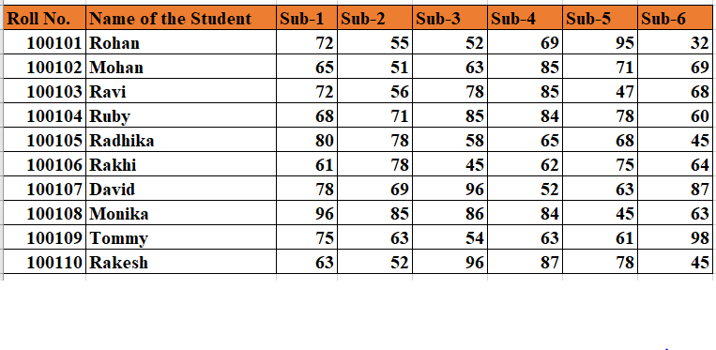  
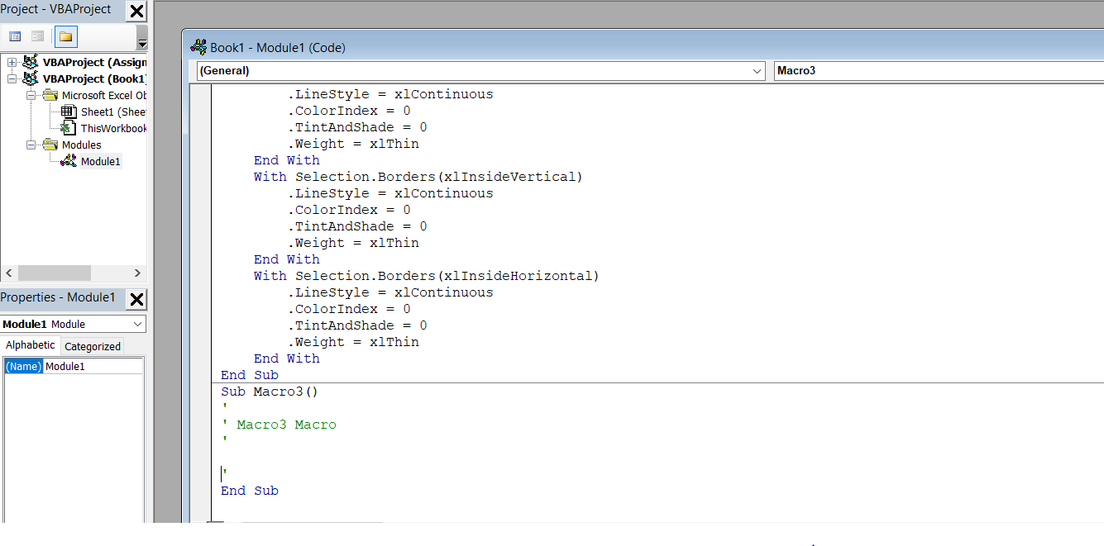

4. What do you mean when we say VBA Editor?  
  
VBA Editor is a inbuilt editor in excel which allows non-programmers to record, edit , create the macros to automate the repetitive tasks.

5. Briefly describe the interface of a VBA editor? What is properties window? And what is watch window? How do you display these windows?  
  
VBA editor has 6 components:

* Menu Bar
* Tool Bar
* Project window
* Property window
* Programming window
* Immediate window

Property window shows of the property of the selected objects. It also allows to edit the properties. F4 key can be used to make it visible. We can click on the property window under the view option.   
  
Watch window is used to monitor the code which is being executed. We can check on the watch expressions in the watch window. It can be displayed by clicking watch window under view option.

6. What is an immediate Window and what is it used for?  
  
Immediate window displays the information which is the result of debugging statements. It is used to identify the error in the code, checking or debugging the code.