Excel Assignment - 18

1. What are comments and what is the importance if commenting in any code?  
Comments are the annotation in the source code which involves placing human readable descriptions inside the code. It can help other programmers to understand the code efficiently and helps in code maintenance and bug debugging.

2. What is Call Statement and when do you use this statement?  
Call statement is used to transfer control to a Sub procedure, an intrinsic function, and a dynamic-link library (DLL) procedure.  
The Call statement can be used to call a dynamic link library procedure.

3. How do you compile a code in VBA? What are some of the problem that you might face when you don’t compile a code?  
We can compile the code by clicking Debug Menu → Compile VBA Project. The code cannot be executed without compilation. Compilation helps to identify the errors in the code.

4. What are hot keys in VBA? How can you create your own hot keys?  
A hot key is a combination of keys (shortcut keys) when pressed at one time can perform a task quickly.   
  
Hot keys can be created using below 2 methods :

* Creating macro with a keyboard shortcut using the macro recorder.
* Creating keyboard shortcut by customizing the quick access toolbar

5. Create a macro and shortcut key to find the square root of the following numbers 665, 89, 72, 86, 48, 32, 569, 7521

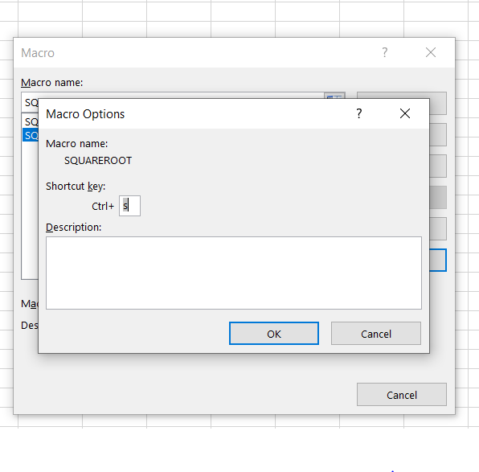

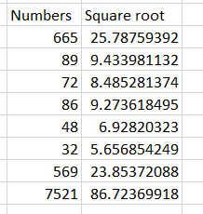

6. What are the shortcut keys used to

a. Run the code

b. Step into the code

c. Step out of code

d. Reset the code

**Shortcut keys:**

a. Run the code - F5

b. Step into the code – Shift+F8

c. Step out of code - Ctrl+Shift+F8

d. Reset the code – Alt+R+R