1. What are the various elements of the Excel interface? Describe how they're used.  
  
The various elements of the excel interface are :   
Quick Access toolbar - It will show the most recently used excel commands  
File tab – It is used to perform file related operations (open, save,… etc)  
Title Bar – It shows the name of the spreadsheet.   
Control Buttons – It is used to maximize, minimize , close, share the sheet.   
Menu Bar – It contains File, Insert, Page Layout, Formulas, Data, Review, View, Help, and a Search Bar with a light bulb icon to perform different operatons.   
Ribbon/Tool Bar – It is a set of commands. It has 3 sessions : Tabs, Groups, Commands  
Dialog Box Launcher – It is  present in the **lower-right** corner of a command group on the Ribbon. We can do more options related to the concerned group.  
cells -   
Name Box – It will show the location of cell, row or column.   
Formula Bar – It will help to do calculations by inserting / editing the cell.  
Scroll Bar – It is used to navigate the sheet horizontally or vertically.

2. Write down the various applications of Excel in the industry.  
Excel is used in Accounting , Finance, Data entry work, data visualization ( charting and graphing) , to maintain any organized data , performance reporting, business analysis , data tracking etc…

3. On the ribbon, make a new tab. Add some different groups, insert commands in the groups and name them according to their commands added. Copy and paste the screenshot of the steps you followed.

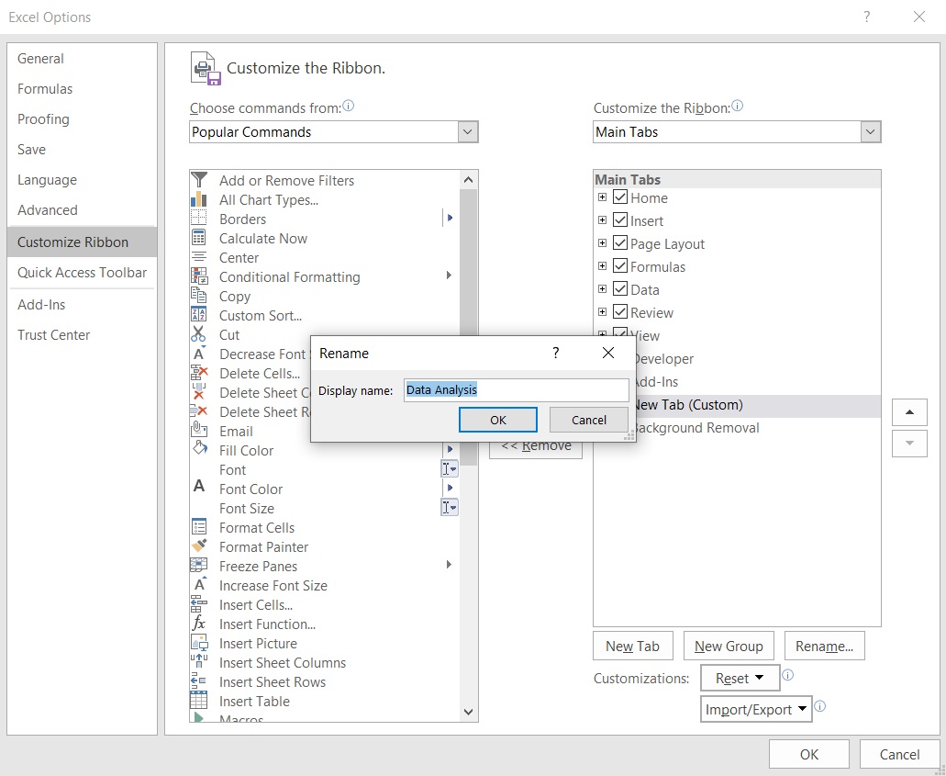

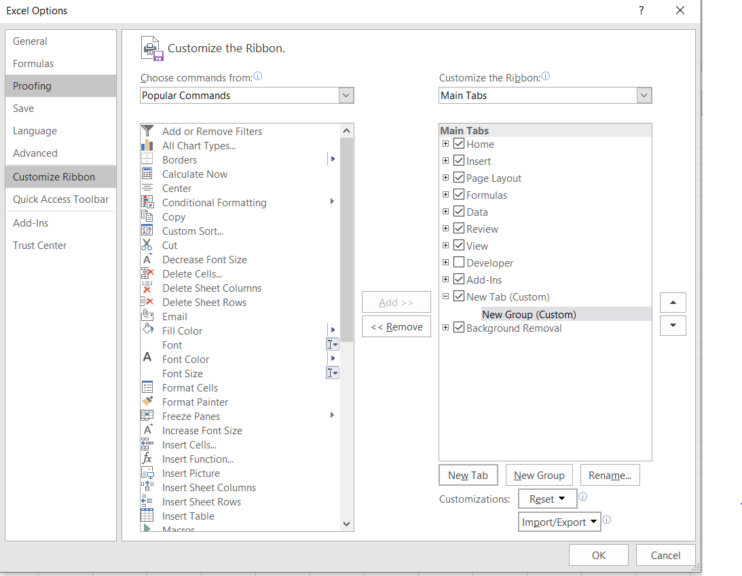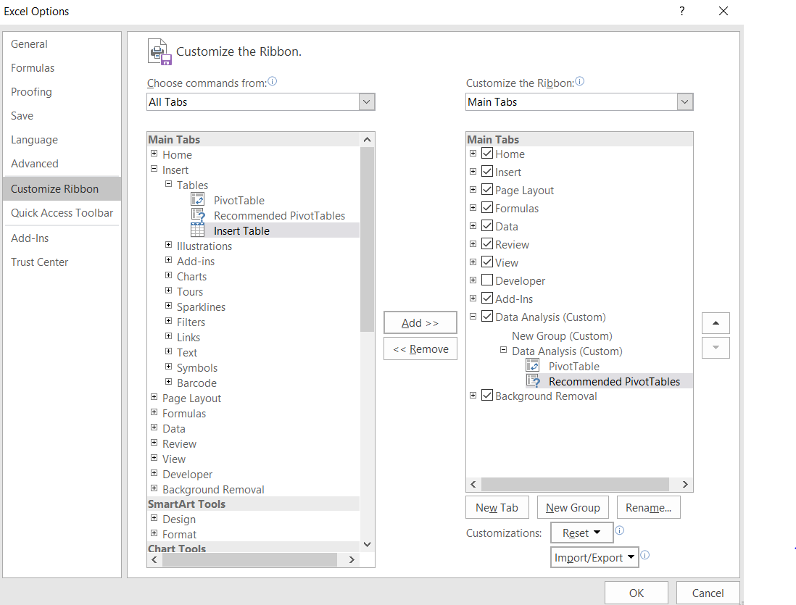

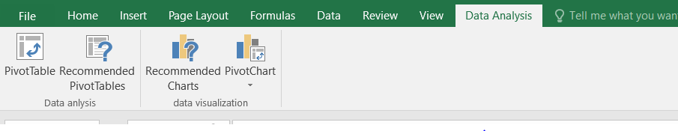

4. Make a list of different shortcut keys that are only connected to formatting with their functions.  
Ctrl+Shift+A → Format all letters as capitals.  
Ctrl+B → Applies or removes bold formatting.

5. What distinguishes Excel from other analytical tools?  
Excel provides better user interface to organize data , finding trends , visualize via charts. It is simple to use and it offers different functionality to explore data.

6. Create a table and add a custom header and footer to your table.  
  
