1. What are the different margins options and do we adjust the margins of

the excel worksheet?

Normal, wide/Narrow are the pre-defined margins. Based on our use case, we can change the margins of excel worksheet by clicking on custom margins.

2. Set a background for your table created.  
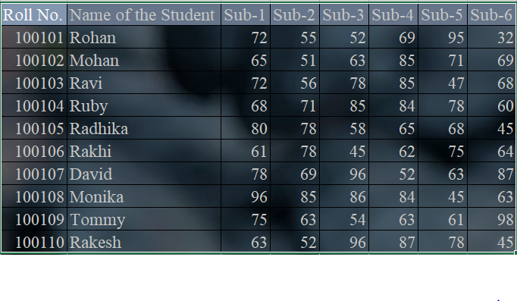

3. What is freeze panes and why do we use freeze panes? Give examples.  
Freeze panes helps to lock the specific row or column in place. The specified row / column will be locked and visible when we are scrolling to different area in excel.   
 eg: Selecting the table labels and freeze it can help to get the column values even though we are moving to last row values.

4. What are the different features available within the Freeze Panes command?  
Different features available within Freeze panes command are:

* Freeze Panes – It freeze rows / columns selected.
* Freeze top row – Freezes the topmost row.
* Freeze first column – Freezes the first column in excel

5. Explain what the different sheet options present in excel are and what they do?  
  
Different sheet options in excel are :

* Ribbon sheet option –Sheet options in page layout helps to show / hide gridlines, headlins.
* Right-click sheet option – It helps with different options like insert, delete, Move or copy, Rename, hide, unhide, Protect sheet etc..