

Computer Games Development CW208

GDD

Year IV

Izabela Zelek

C00247865

# [24/04/2023]

Contents

Game Overview 4

Feature Set 4

General Features 4

Level Editor 4

Gameplay 4

The Game World 6

Overview 6

Key Locations 6

Travel 6

Scale 6

Objects 6

Weather 6

Day and Night 6

Time 6

Rendering System 7

Overview 7

Camera 7

Overview 7

Blink Animation 7

Game Engine 7

Overview 7

Collision Detection 7

The World Layout 8

Overview 8

Player Farm 8

Town 8

Game Characters 9

Overview 9

Shop Keepers 9

Civilian NPCs 9

User Interface 9

Overview 9

Inventory System 9

Watch 9

Weapons 10

Overview 10

Sound Effects 10

Overview 10

3D Sound 10

Sound Design 10

Single-Player Game 11

Overview 11

Story 11

Hours of Gameplay 11

Victory Conditions 11

Character Rendering 11

Overview 11

World Editing 12

Overview 12

Environment Editing 12

NPC Editing 12

We would like to thank the following people who assisted in completing this project including;

John Doe of ACME who kindly agreed to …

I would also like to thank #### Solutions for use of ….

# Game Overview

Escape to a peaceful, idyllic world with Geo Vale, a virtual reality game that immerses players in the joys of farm life.

As the only farmer in this peaceful village, you will plant crops and sell them to the population, while also engaging in a variety of activities. You’ll have the freedom to customize your environment using the Level Editor, located inside your house. This Level Editor allows you to select and place objects, move and rotate existing objects, summon new NPCs, and create custom NPC paths. With its tranquil atmosphere and immersive gameplay, Geo Vale is the perfect escape from the stresses of real life.

# Feature Set

## General Features

* Day/Night Cycle – Time in Geo Vale is limited, as it is in the real world. All farm work must be done during the day, to allow the plants to have time to grow to their next growth stage overnight.

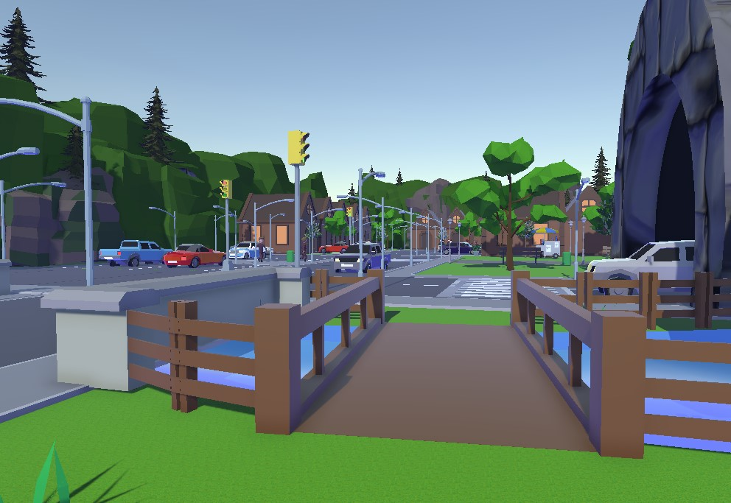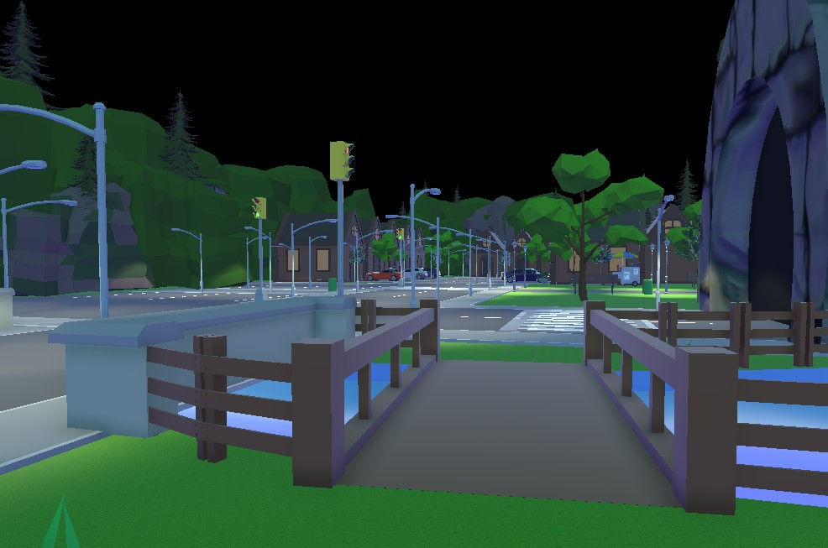

(Fig 1.1) (Fig 1.2)

* Shopkeeper NPC schedules – Each shop keeper has an assigned stall which they will arrive to at 7am most morning. All shopkeepers have an assigned day off, so make sure to learn their schedules. Once 5pm hits, all shopkeepers will close their shops and head home.

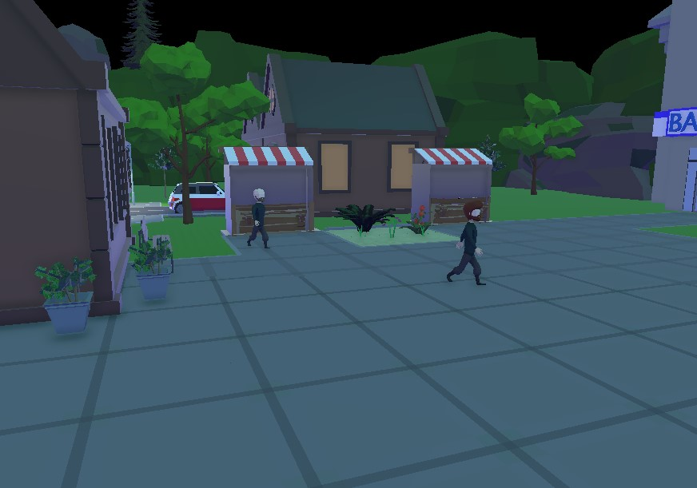

(Fig 2.1)

* NPC schedules – Each civilian will wake up at a randomly assigned time and spend their day walking around the village, entering shops and interacting with each other. No civilian likes hanging around at night, so once the world begins to go dark, all civilians will start making their way home.

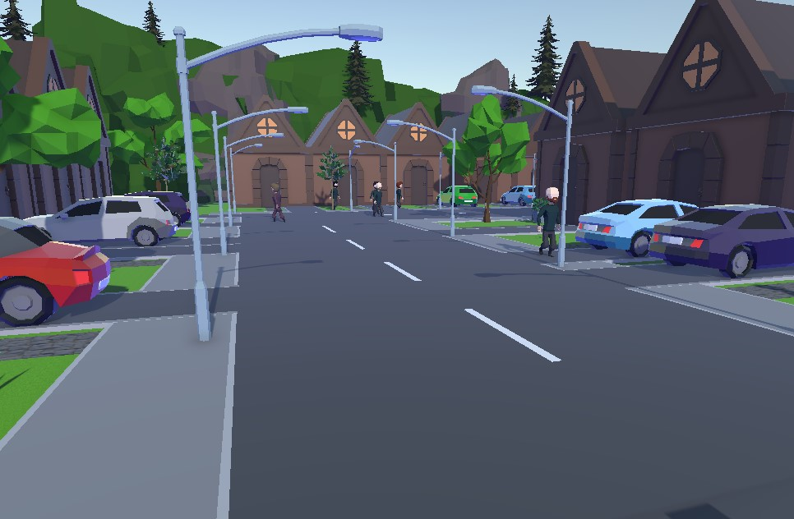

(Fig 3.1)

* NPC Movement – There are two distinct NPC behaviours. One is path following, an NPC will follow a previously created path. Once they reach the end of the path, they select a different path and find the closest point on the path to start at. The other behaviour is wandering, the NPC will walk around the area with no end goal.

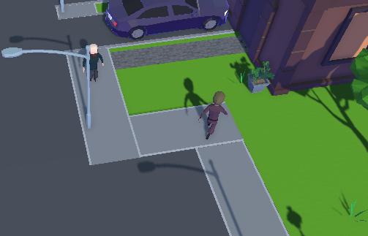

(Fig 4.1)

* Sleeping mechanic – Farming is a tiring but rewarding job. Once night time come, you begin to feel tired, and must head to bed to replenish your energy. Otherwise, you will pass out and a kind civilian will take you to your house, where you will wake up in the morning.
* Vehicles – The village is a small but beautiful area which attracts a lot of visitors. Cars often drive through the town, obeying the traffic light system, and often will take use of the offered parking to explore the village.
* Inventory System – Life is difficult for a farmer without a backpack. So take use of your 3 available pocket spaces to minimise the amount of trips you need to take.

## Level Editor

* Object Placing – With the Level Editor, you can choose out of the list of given objects and place them around the world. The world is your oyster, if you are a fan of a more green world, select one of the 3 available types of trees and decorate your area to your desires. If you desire to have neighbours on your farmland, select an NPC house and place it wherever you please.
* Object Rearranging – If you believe the placement of an object in the world is off, select it on the Level Editor and move and rotate it until it fits your ideal.
* NPC Spawning – If you desire a more populated town, summon more civilians to walk around and add life to the environment. You can assign them one of the default paths available.
* Custom NPC Path – You can create your own path for your new NPC friend. Simply create a custom path and save it for future use. Watch as the civilians take notice of your new path and decide to head on a journey to explore the new path.

## Gameplay

* Create Planting Fields – With your trusty hoe, you can turn any patch of land on your farm into a field. This field is now ready for planting.
* Plant Types – You will start off with one of each seed types. Each seeds grows it’s own, different produce. Take note of which seeds seem to be cheaper to grow.
* Plant Watering – All plants need water to thrive. Make sure to water your plants daily as they progress through the growth stages. A missed day of watering, is an extra day you have to wait for your plants to grow.
* Harvesting – Once your plant is fully grown and the produce are ready to be harvested, pick them and take them to the seeds shopkeeper. Drop them into the available box and wait for the shopkeeper to transfer your funds during the night.
* Buying More Seeds – The life of a farmer is cyclic. From buying seeds, to planting, to harvesting, to buying again. Take note of which plants seem to sell for the most and earn profit by buying only the best quality seeds.
* Tree Chopping – While pretty, trees also take of important farming space. With your trust axe, you can get rid of any tree in your way. You can also sell the logs for profit.
* Grass Collecting – Plant fibres may be of no use to you, but someone out there thrives off of the grass you sell. Instead of destroying the grass on your farm by placing farming fields, consider taking some time to collect them and sell them for an extra bit of money.
* Animals – Once you are well settled on your farm, invest in some animals. Milk, eggs and truffles can sell for a pretty penny with minimal extra work needed. Make sure to collect the items daily so as to not miss out. Each animal will produce one item daily, if an item is not picked up, the item will remain there the next day.

# The Game World

## Overview

The game world contains 3 main areas and a player house area. The world is surrounded by mountains and trees which close off the area to the player.

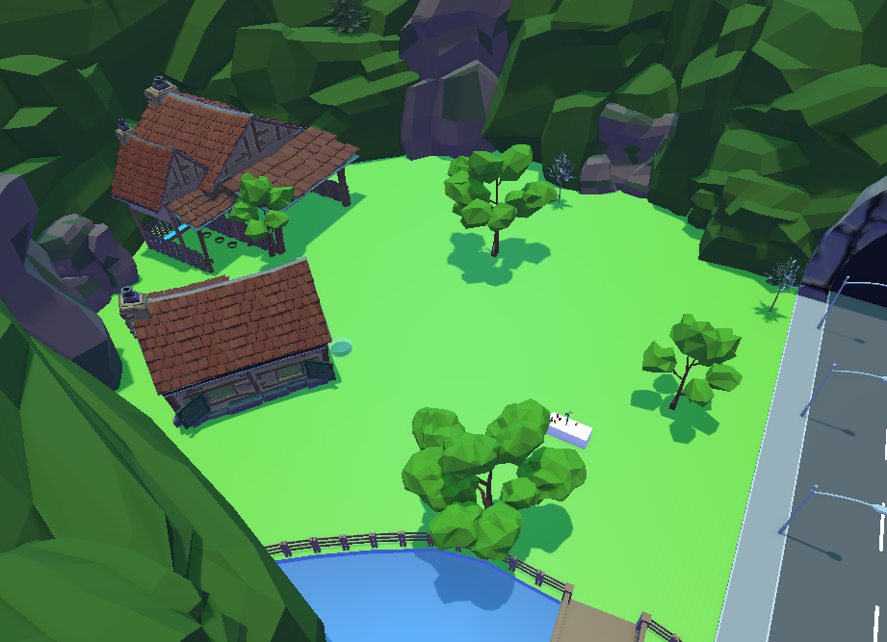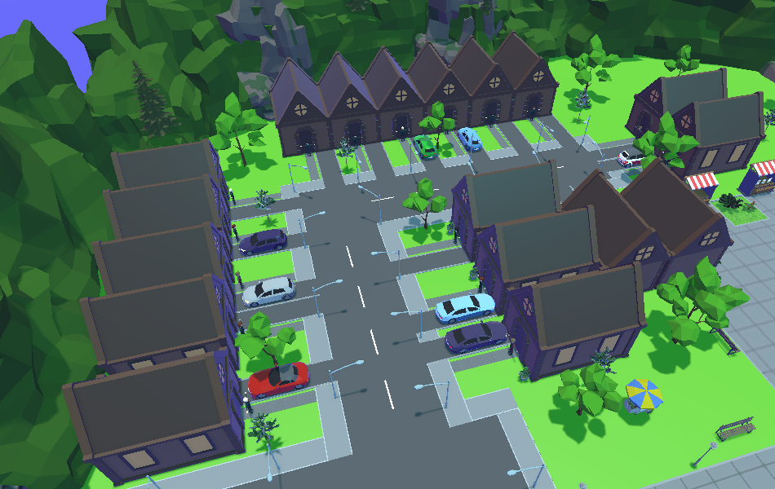

(Fig 16.1) (Fig 16.2)

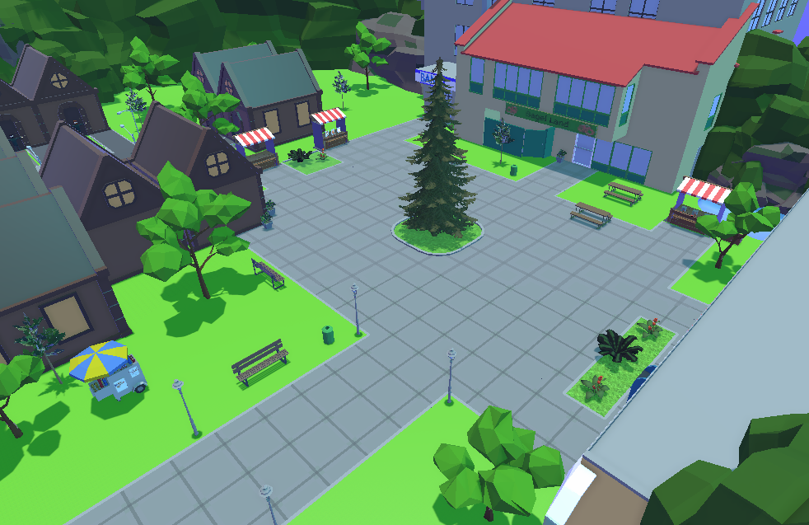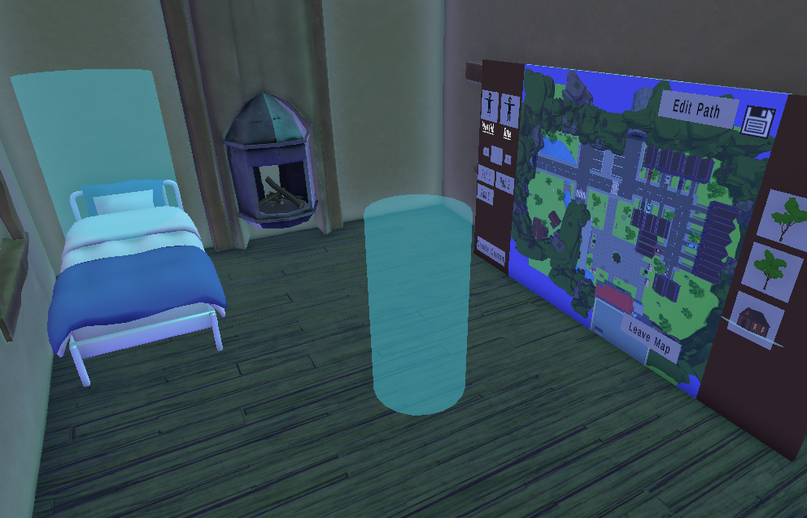

(Fig 16.3) (Fig 16.4)

### Key Locations

The world is split into three sections, the player’s farm, where they will spend most of their time farming, the NPC estate, where all of the NPC civilians and shopkeepers live, and the town, where the NPC houses and shop stalls are located. There is also a smaller area, the player house, which you can access through the teleporter in front of the house.

### Travel

There are two forms of travel. The first is by using the joystick to walk slowly around the area. The other being the teleporter that the player can use with the select button to quickly get from one area to another.

### Scale

Everything in the world is within walking distance. The scale of the world and the objects was set to mimic the size of them in the real world.

### Objects

Gardening utensils are given to the player at the start of the game. These utensils include a hoe, axe and watering can. They are the three main tools of the game, and the game cannot be played without them. The hoe is used for creating planting field, the axe is used to get rid of trees that are in the player’s way, and the watering can is used to water the plants to let them progress to the next growth stage.

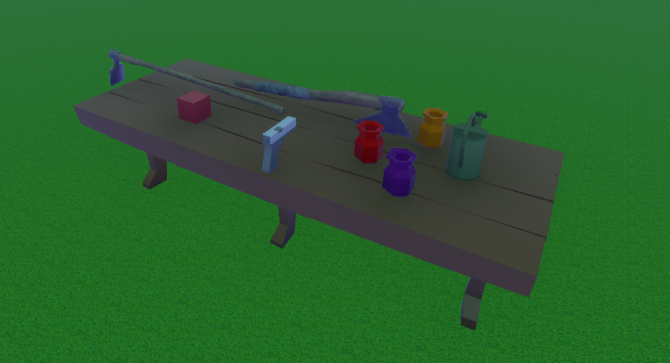

(Fig 16.5)

### Weather

The game weather is always sunny, and the game world is always bright during the daytime. Night-time weather is clear but dark.

### Day and Night

The majority of the game takes place during the day cycle, once night-time comes (See Fig 1.2), the player has to finish up their work in order to make it to bed by midnight. The sun can be seen moving across the screen (See Fig 1.1 and Fig 1.2), at 6pm the sun sets and the world turns darker, starting the night cycle.

### Time

The game starts off at 4am, 10 seconds of in-game town is equal to 1 second in real time.

# Rendering System

## Overview

All item models are low poly which helps the game run more smoothly. The most common objects, such as trees and grass, have different models based on how far away the player is. The further away, the less detailed the model.

## Camera

### Overview

The camera is stuck to the position of the player’s eyes. When the player turns their head, the camera turns with it and shows the correct part of the 3D world.

### Blink Animation

The only time the camera will go dark is when the player is falling asleep. When they are falling asleep, the camera will slowly go dark 2 times to simulate tired blinking and then afterwards the camera will go fully dark for 5 seconds to simulate sleep.

# Game Engine

## Overview

The game engine used is the Unity Engine. It is a cross-platform game engine which offers features such as audio, animation, and physics, among others. It allows for input from a mouse, keyboard, game controllers and also touch for mobile development.

### Collision Detection

The game uses the collision detection system built into Unity. The majority of the objects are colliders which use the collider enter and trigger enter system. The slots in the inventory uses the Trigger enter collision system to avoid pushing objects.

# The World Layout

## Overview

*The game is set in a flat, green world.* The world is split into two main parts, the player’s farm and the NPC town where the player can do their shopping. The game world is surrounded by tall trees and mountains which the player cannot access, but are there to limit the player’s movement to stay within the bounds of the village.

### Player Farm

Takes up approximately one third of the map. This is the only area in which the player can create their planting fields. This area contains the player house, a coop, a barn, multiple trees and grass and a table containing all of the necessary tools.

***NPC Estate***

This area contains all the houses belonging to the NPCs. Each NPC has an assigned house. Some of the houses have a car out front. The houses are lined up neatly along a road. The estate is decorated with grass, trees and functional streetlamps.

### Town

This area contains all the stalls and NPC shops. There is a small parking for the visiting NPCs. In the centre, there is a town plaza with a tree in the centre. Around the plaza, there are three stalls that the player can access to buy seeds and animals. There are also shop buildings which are only accessible to the NPCs. The town is decorated with streetlamps, plants, trees, grass, benches and bins.

***Player House***

This is a very small area. It is accessed by the player by entering the teleporter in front of the player house. Inside, there is a bed, for the player to use, and the map editor. This area can be exited by entering a transporter by the door which takes the player back to the farm.

# Game Characters

## Overview

The player is a farmer but the only part that can be seen are the player’s hands.

## Shop Keepers

These are NPC characters who’s only job is to head over to their assigned stall and open the shop. At 5pm, they close down the shop and head back to their assigned house.

## Civilian NPCs

These NPCs have a randomly generated time at which they wake up. They will then head to town and walk around until night time. Once it’s time for them to head back, they will drop what they’re doing and head back to their assigned house.

# User Interface

## Overview

There are 2 main parts of the User interface, the inventory system and the watch on the player’s hand.

### Inventory System

This only shows up when the player presses the correct button on their left controller. Once the player lets go of the button, the inventory will disappear but the object inside the inventory will still exist, just be inactive.

The inventory system UI shows 4 slots and the objects that are stored inside those slots, if any.

### Watch

The watch is always located on the player’s left wrist. It shows the current day, the time, and how much money the player currently has.

# Weapons

## Overview

The only weapon available in the game is a gun. This gun is used to shoot at birds flying over the world. The player can then sell the feathers for extra money.

# Sound Effects

## Overview

All sounds chosen are from copyright-free sources. There is no background music. The audio used adds to the immersion, such as : chopping, walking, animal noises, farming sounds.

### 3D Sound

The game uses Unity’s in-build audio system which allows for 3D audio to be used.

### Sound Design

The sounds used are not jarring but rather peaceful environmental sounds.

# Single-Player Game

## Overview

The player will get to escape to a simple world where they are a farmer working in an idealistic village. They will be able relax while growing plants and taking care of their animals. It is a single player game.

### Story

The story behind the game is that the player is a farmer living in a small countryside town/village. The player spends their time farming and taking care of the animals.

### Hours of Gameplay

The aim of the game is to provide a peaceful experience. It has no time sensitive quests. The player can spend as much time as they like, sitting around and caring for their plants.

### Victory Conditions

There are no victory conditions as the game is set to go on forever. This game will be a way for the player to escape the real world and immerse themselves into a cute simple life of a farmer.

# Character Rendering

## Overview

The only part of the body the player can see is their hands. When the player gets tired, their eyelids begin to blink rapidly as they fall asleep. No other body parts are rendered.

# World Editing

## Overview

The world can be edited from inside the player’s house. The player teleports into the capsule which allows the player to interact with the world map. This world map is how the player changes their environment and moves the buildings.

### Environment Editing

The player can change around the layout of the world by selecting an object and moving it or rotating it. New trees and houses can also be placed be selecting the desired option and selecting a point on the map.

### NPC Editing

The player can summon new NPCs. They have the option to, give them one of the default paths, letting them wander, or creating a custom path. This custom path can then be saved and loaded in.