Lappeenrannan teknillinen yliopisto

School of Business and Management

Sofware Development Skills

Izabela Szkaradek, 001101555

LEARNING DIARY, FRONT-END MODULE

**LEARNING DIARY**

2.11.2022  
I carefully read the information about the course and I’m very eager to learn what a front-end developer does. After that, I was getting started with Version Control – I installed Git, SourceTree and also created account in bitbucket. Then, I moved to recommended code editor and downloaded VS Code as well as its recommended extensions.

21.11.2022  
I have chosen VS Code as my code editor for this course, I watched the 1st video and learnt how to set up my environment. Watching the first part of the videos “Introduction to workflow and sass”, I also learnt what sass is – it is an extension of CSS which enables us to use extra things (such as variables and many more). In addition, it helps us keep our code organized.

23.11.2022

I watched the next video “Homepage and Core Sass/CSS” and created a part of my exercise project. I created the main webpage with my name and last name using html and css. I also learnt about variables and nesting which will be extremely helpful to do my final project.

25.11.2022

I watched and followed the 3rd part of the course which was about “Rotating Menu Button”. I added that to my exercise project and it looks stunning. In this task I created menu button using CSS and JavaScript code. It rotates

27.11.2022

I watched and also followed the 4th part of the course which was about “Page With CSS Grid”. I added that to my exercise project and it looks stunning. In this task I created menu button using CSS and JavaScript code.

29.11.2022

I watched the 5th video about “Menu Overlay & Responsiveness”. I created menu overlays as well as added media query in sass. Also, I added branding and navigation to the website and also learnt how to make my website responsive.

01.12.2022

I watched the next video which was about “Work and Contact Pages”. This video taught me about CSS grid and how I should use Flexbox. I updated my exercise project following the code.

03.12.2022

I watched the next video which was about “Website Deployment”. This video showed me how I could put my project on GitHub.

04.12.2022

I started doing my own project – I really like mathematical embroidery so I decided to create a website with courses. More or less I planned the appearance of the webpage in my mind. I decided to have 4 subpages which would be:

* “HOME” having most of the necessary information,
* “ABOUT” having information about me (as an owner of the company with the courses),
* “COURSES” having information about courses and their prices
* “CONTACT” having a form where you can fill in your name, last name, country as well as subject.

I also created the navigation where you can open any of the subpages. It is responsive – for devices with maximum width 700px the navigation menu changes.

08.12.2022

I found a tutorial on YouTube which I decided to follow and change according to my topic and preferences. The link to the tutorial - <https://www.youtube.com/watch?v=oYRda7UtuhA>.

I created the HOME page which I contains information about:

* what mathematical embroidery is,
* courses we offer – beginner, intermediate and advanced,
* 2 opinions about our course,
* a possibility to contact us in order to enroll for our courses or ask questions,
* a footer saying more “About us” as well as containing facebook, twitter and Instagram icons (which I will add everywhere).

The “HOME” webpage is responsive, meaning I took into account smaller devices which have max 700px screen.

11.12.2022

I created “ABOUT” subpage which shows a photo of me as an owner of the company as well as some additional information.

12.12.2022

I developed “COURSES” subpage which has the same information about courses as on the “HOME” webpage but I added prices of the courses. I also put the option of   
“Enroll for our various courses” which is also on the “HOME” webpage.

17.12.2022

I developed “CONTACT” subpage which has a form which you can fill in. I used the code from <https://www.w3schools.com/howto/howto_css_contact_section.asp> (I also put it into a comment in my code).

20.12.2022

I wanted to add a slider containing some of my mathematical embroidery’s examples. First, I decided to try creating the slider on its own, to check if it works for my images. It worked like I wanted but only when I didn’t put it in my project’s html and css code. When I added it to my project, something would go wrong and it wouldn’t work as it should have.

27.12.2022

Not being able to put my slider into my code, I decided to put the my mathematical embroidery projects below “What is mathematical embroidery”. I took into account smaller devices – screens with maximum width 992px have 2 columns of 2 images and also screens with maximum width 700px have 1 column of all the images.

31.12.2022

I recorded a video showing my website and also added everything on GitHub using the upload option, both my exercise task as well as my project.

Photos which I used were from:

* background of “Home”

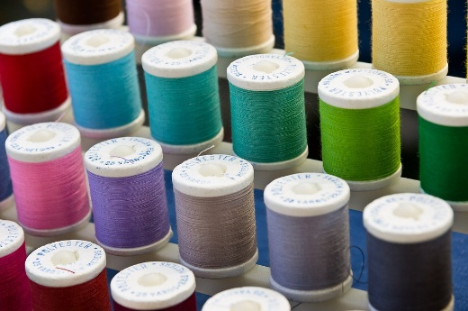

<https://pixabay.com/pl/photos/w%c4%85tek-kolor-szycie-3044044/>

* background of “About Us”



<https://www.freepik.com/free-photo/colorful-bright-papers-with-ragged-edges_1510552.htm#query=colorful%20pieces%20of%20paper&position=7&from_view=search&track=sph>

* background of “Courses”



<https://www.freepik.com/free-photo/composed-ripped-papers_1526607.htm#position=12&query=colorful%20pieces%20of%20paper>

* User 1 testimonials



<https://www.freepik.com/free-photo/portrait-cheerful-attractive-young-woman-longsleeve-standing-with-arms-crossed-smiling_10266368.htm#query=people&position=19&from_view=search&track=sph>

* User 2 testimonials



<https://www.freepik.com/free-photo/lifestyle-people-emotions-casual-concept-confident-nice-smiling-asian-woman-cross-arms-chest-confident-ready-help-listening-coworkers-taking-part-conversation_17096951.htm#query=people&position=25&from_view=search&track=sph>

* User 3 testimonials



<https://www.freepik.com/free-photo/portrait-handsome-bearded-european-man-with-grey-hair-beard-smiles-pleasantly-looks-directly-front-being-good-mood-has-lucky-day-wears-spectacles-sweater-isolated-blue-wall_13760058.htm#position=9&query=people>

* User 4 testimonials

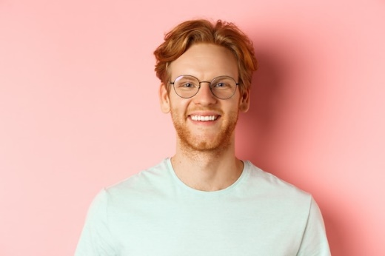

<https://www.freepik.com/free-photo/close-up-happy-redhead-man-face-smiling-with-white-teeth-camera-wearing-glasses-better-sight-t-shirt-standing-pink-background_18191552.htm#query=people&position=10&from_view=search&track=sph#position=10&query=people>

* contact me photo

 <https://www.google.com/url?sa=i&url=https%3A%2F%2Fwww.2berk.com%2Fcontact-me%2F&psig=AOvVaw0DcmyOFdfCg8sF5IZylzyY&ust=1672586162656000&source=images&cd=vfe&ved=0CBAQjRxqFwoTCJiX3ZOTpPwCFQAAAAAdAAAAABAI>