1. Open desktop postman.
2. Run the code.
3. We have 3 type of requests:
4. Start request = Post mode
5. End request = Put mode
6. Report request = Get mode
7. Start request should contain only username and the task:

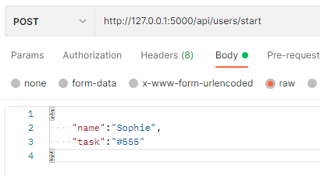

The output response for this request:

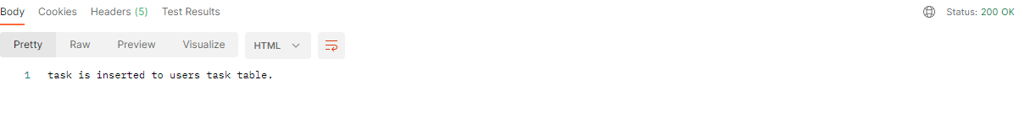

Sending another start request with the same username before sending end request will give the next response:



1. End request should contain only username:

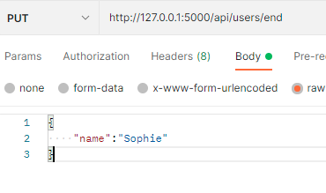

The output response:

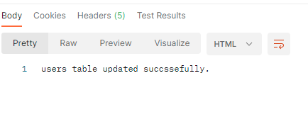

Sending another end request for the same username will give the next response:

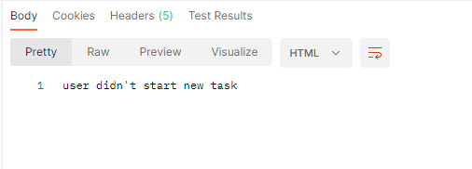

1. Report request: In this request there is no “body” part for the request.

Sending “Get” request to get the whole report for all the user ids in the database table:



The response:

