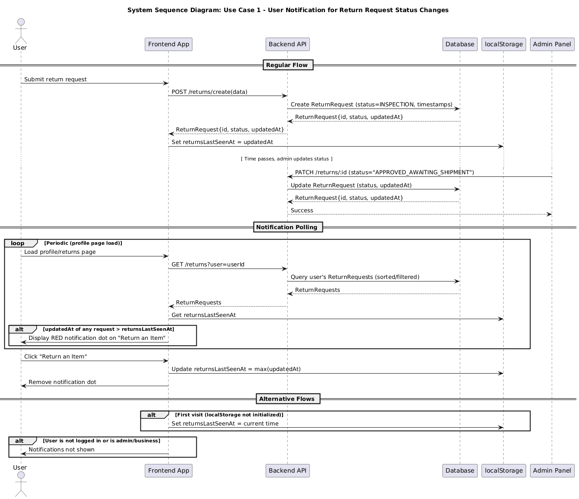
1: System Sequence Diagram for Return Request Status Change

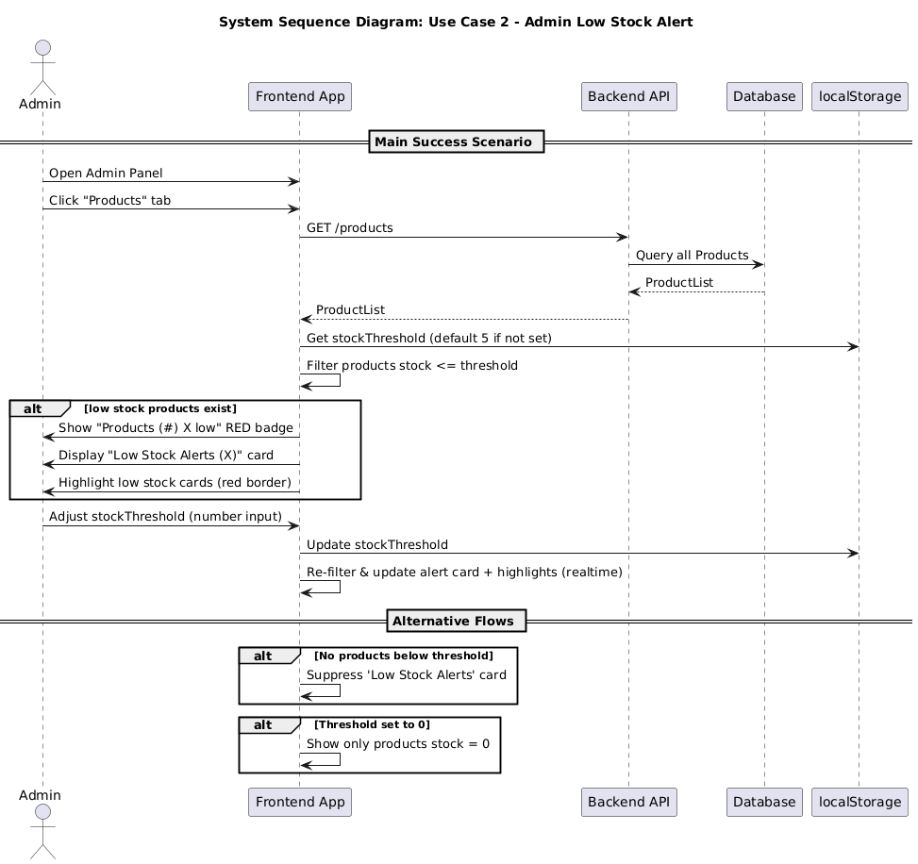
2: System Sequence Diagram for Low Stock Alert

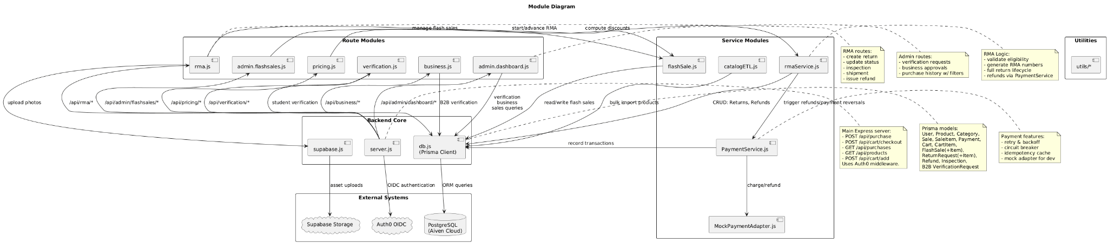

3: Module Diagram

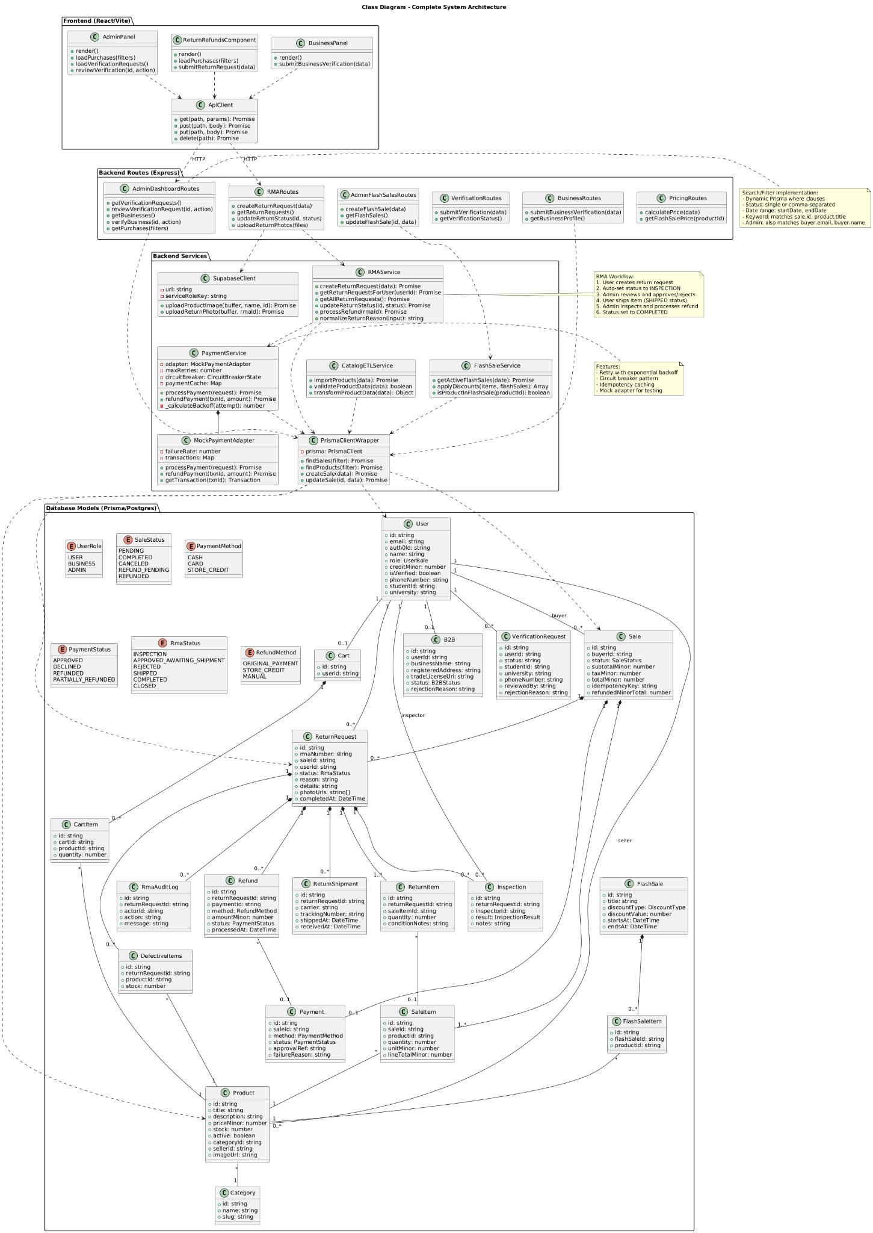
4: Class Diagram

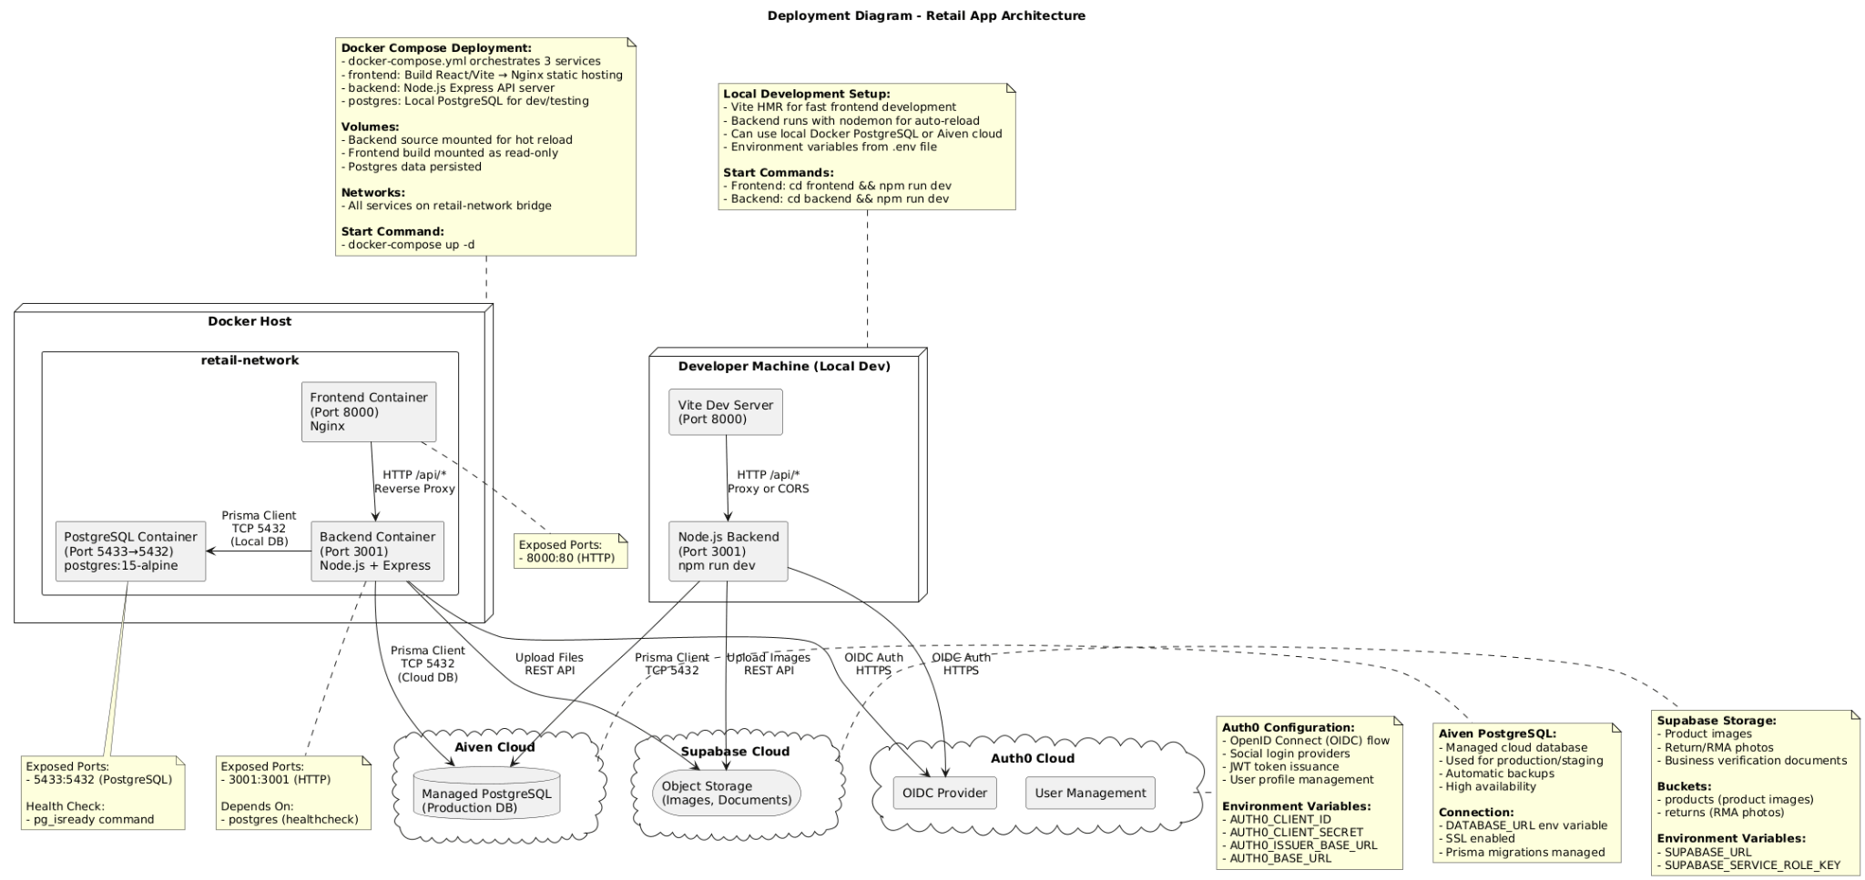5: Deployment Diagram

