Esquema RTL

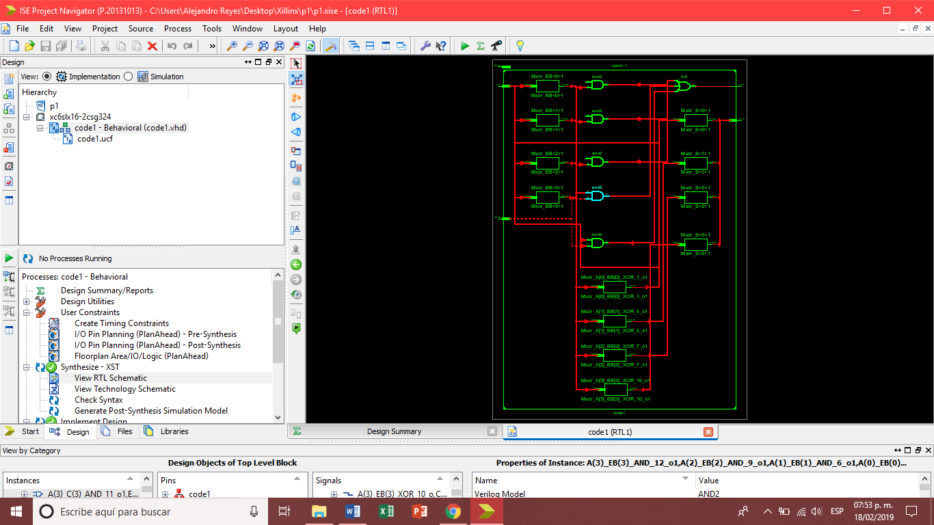

Simulaciones

|  |  |  |  |  |
| --- | --- | --- | --- | --- |
| Operación | A | B | Cout | S |
| Suma | 5 | 5 | 0 | 1010 (10) |
| Suma | 12 | 8 | 1 | 0100 (4 +16 = 20) |
| Suma | 9 | 5 | 0 | 1110 (14) |
| Resta | 10 | 9 | 1 | 0001 (1) |
| Suma | 4 | 2 | 0 | 1100 (6) |
| Resta | 7 | 9 | 0 | 1110 (-2)* |
| Resta | 15 | 15 | 1 | 0000 (0) |
| Resta | 11 | 8 | 1 | 0011 (3) |
| Resta | 1 | 4 | 0 | 1101 (-3)* |

*Por complemento a 2