Define an algorithm in Matlab based on dynamic programming for the following scheduling problem.

Schedule the following *n* jobs, where *pj* is the processing time, *Cj* is the completion time, *Lj* is the lateness, and *dj* is the due date for the *j*-th job on 1 machine.

|  |  |  |  |  |  |  |  |  |  |  |  |
| --- | --- | --- | --- | --- | --- | --- | --- | --- | --- | --- | --- |
| Job | J1 | J2 | J3 | J4 | J5 | J6 | J7 | J8 | J9 | J10 | J11 |
| *pj* | 7 | 3 | 6 | 8 | 3 | 12 | 12 | 5 | 3 | 1 | 1 |
| *dj* | 12 | 4 | 16 | 30 | 4 | 31 | 32 | 35 | 18 | 20 | 21 |
| *wj* | 1 | 1 | 1 | 1.5 | 2 | 1 | 2 | 1 | 1.2 | 1 | 2 |

The problem has job priorities defined by weights *wj* and constraints. The problem has the following objective (minimize the overall weighted tardiness)

with the preceding constraints

The tardiness is defined as

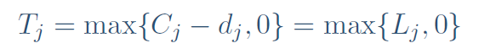

Verify that the solution that has been obtained is optimal comparing with the solution obtained in a mathematical programming problem defined in Lingo.

Generalize the problem to whatever input instance size, preceding constraints, and parameters (input defined on spreadsheet).