1. Case study description
Organization: Pigmenta Ltd
Nature of business: Paint manufacturing and distribution, specializing in acrylic paints, emulsion paints, and industrial coatings.
Database purpose: To develop a relational database system for managing products, suppliers, customers, inventory, and sales orders.
Database users:
- Administrators
- Inventory managers
- Sales personnel
- Procurement officers
Major database operations:
- Register and manage products.
- Categorize products.
- Maintain supplier records.
- Register customers.
- Create and manage customer orders.
- Track product quantities and stock levels.
- Retrieve sales and inventory information.
1.1 Entity Relationship Diagram (ERD)

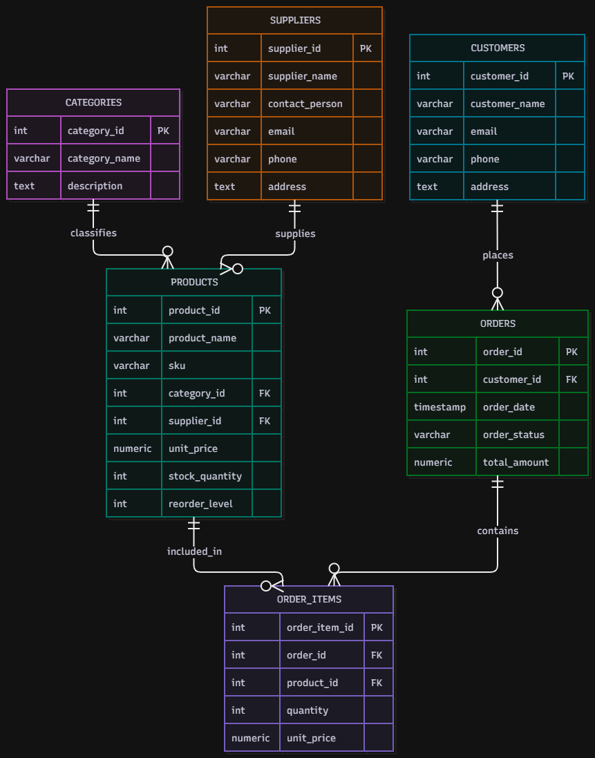
Figure 1: Entity Relationship Diagram for Pigmenta Ltd Database.

2. Relational schema
Document the six tables as follows:
Table | Primary key | Foreign keys
Categories | category_id | None
Suppliers | supplier_id | None
Products | product_id | category_id, supplier_id
Customers | customer_id | None
Orders | order_id | customer_id
Order_Items | order_item_id | order_id, product_id

3. Keys and constraints
Our implementation uses:
- Primary keys: Uniquely identify records.
- Foreign keys: Maintain relationships between tables.
- UNIQUE: Prevent duplicate SKUs, emails, and duplicate products within an order.
- NOT NULL: Require essential information.
- CHECK: Prevent negative prices and stock quantities, and invalid order quantities.
- DEFAULT: Automatically assign initial values and timestamps.
- ON DELETE CASCADE: Automatically remove order items when their parent order is deleted.

4. Normalization
First Normal Form (1NF): Each column contains atomic values. There are no repeating groups or multiple values stored in a single field.
Second Normal Form (2NF): Non-key attributes depend on their complete candidate keys. The order items table also has a unique combination of order_id and product_id.
Third Normal Form (3NF): Product categories, suppliers, and customers are maintained in separate tables. This reduces duplication and prevents unnecessary repetition of information.
Design consideration: total amount in the Orders table is a stored summary derived from order items. It must be kept synchronized with the order details; alternatively, it can be calculated when needed.
5. Database Implementation and Verification
The database was implemented using PostgreSQL 18 and managed through pgAdmin 4. Six relational tables were successfully created: Categories, Suppliers, Products, Customers, Orders, and Order_Items.
Sample records were inserted to demonstrate the database operations and relationships.
Database verification results
Table | Records
Categories | 3
Suppliers | 2
Products | 4
Customers | 3
Orders | 3
Order_Items | 3
Total | 18
A SQL verification query using COUNT (*) and UNION ALL was executed successfully to confirm the number of records in each table.


