**“The decline of the labor income share in Mexico, 1990–2015”**

**Sources-and-methods appendix**

*Contents*

A1. Measurement issues in estimating the labor income share

A2. Supplementary tables and figures

A3. Labor productivity in the wage-employment and self-employment subsectors

**A1. Measurement issues in estimating the labor income share**

The main issues involved in estimating the labor income share refer to the different concepts of labor income and employment and the different classification systems used by the National Accounts and the INEGI–KLEMS database, on the one hand, and the national employment surveys (ENE and ENOE) on the other. In addition, the classification systems of the two employment surveys are different.

The INEGI–KLEMS database contains for a large number of sectors at the two- and three-digit levels information on each sector’s wage bill (excluding self-employment income but including non-wage remuneration of subordinated workers), total value added, and total employment (including the self-employed and non-remunerated workers). The employment surveys include the Encuesta Nacional de Empleo (ENE, National Employment Survey), which is available for 1995–2004, and the Encuesta Nacional de Ocupación y Empleo (ENOE, National Survey of Occupation and Employment), which substitutes the former from 2005 onwards. Both surveys are quarterly surveys. From 1995 to 1999 the ENE is only available for the second quarter of the year, for 2000 for the last three quarters, and from 2001 the survey is available quarterly. These surveys provide information on earnings and the composition of employment that includes wage earners, subordinated and remunerated workers with non-wage remuneration, employers, self-employed (*trabajadores por cuenta propia* or freelance), and non-remunerated workers. For example, Table A1 shows ENOE data for the fourth quarter of 2015.

Table A1: Employment and its composition according to ENOE 2015 – IV

|  |  |  |
| --- | --- | --- |
|  | Millions | Percentage |
| Total employed population | 42.9 | 100 |
| Wage earners | 25.6 | 59.7 |
| Self-employed | 10.1 | 23.5 |
| Subordinated and remunerated workers with non-wage remuneration | 2.2 | 5.1 |
| Non-remunerated workers | 3.0 | 7.0 |
| Employers | 2.0 | 4.7 |

Source: Authors’ calculation based on data from ENOE.

The ENOE merged the Encuesta Nacional de Empleo Urbano (ENEU, National Urban Employment Survey) and the ENE, and replaced both surveys starting in 2005. In the ENOE the sectors are classified according to the SCIAN-Hogares classification, while in the ENE they are classified according to the Clasificación de Actividades Económicas de la Encuesta Nacional de Empleo Urbano (CAE-ENEU-94, Classification of Economic Activities of the ENEU) system. Due to these disparities in the classification systems it was necessary to homologate the employment series of the ENE and the ENOE to estimate employment series from 1995 to 2014. The homologation between the ENOE and ENE databases was made using the microdata available (see INEGI, n.d., a; n.d., b) and an INEGI comparative between sectors codes according to CAE-ENEU-94 and SCIAN-Hogares, based on an unpublished document provided by INEGI.

ENOE’s SCIAN classification was used as a reference for the homologation, and then this was matched with the SCIAN classification of the INEGI–KLEMS project. In both classifications there are 20 economic sectors. However, due to differences in the classification systems of ENE and ENOE, sectors 43 and 46 were combined into a single sector, Commerce, and sectors 53 and 55 were also combined, while sector 56 (Administrative and support, waste management, and remediation services) was dismissed for showing very erratic behavior of total employment. This left a classification system for the whole economy with 17 sectors (see Table A2).

Table A2: Economic sectors of the whole economy

|  |  |  |
| --- | --- | --- |
| SCIAN– ENOE | SCIAN–KLEMS | Sector |
| 1 | 11 | Agriculture, forestry, fishing, and hunting |
| 2 | 21 | Mining, quarrying, and oil and gas extraction |
| 3 | 22 | Utilities |
| 4 | 23 | Construction |
| 5 | 31–33 | Manufacturing |
| 6, 7 | 43 and 46 | Wholesale trade; retail trade |
| 8 | 48–49 | Transportation and warehousing |
| 9 | 51 | Information and cultural industries |
| 10 | 52 | Finance and insurance |
| 11, 12 | 53 and 55 | Real estate and rental and leasing; management of companies and enterprises |
| 13 | 54 | Professional, scientific, and technical services |
| 15 | 61 | Educational services |
| 16 | 62 | Health care and social assistance |
| 17 | 71 | Arts, entertainment, and recreation |
| 18 | 72 | Accommodation and food services |
| 19 | 81 | Other services, except public administration |
| 20 | 93 | Public administration |

Source: Authors’ elaboration based on information from ENOE and INEGI–KLEMS.

To estimate the labor share in the private business sector several activities, mostly government-related, were excluded from the whole economy. The sectors excluded are 21 (Mining, quarrying, and oil and gas extraction), 22 (Utilities), 53 and 55 (Real estate and rental and leasing), 61 (Education services), 62 (Health care and social assistance), and 93 (Public administration). In addition, subsector 324 (Petroleum and coal products manufacturing) was subtracted from 31–33 (Manufacturing). The resulting private business sector has 11 activities (see Table A3). Once the series from the ENE was homologated, the homologated 11-sector classification of INEGI (n.d., c) was used to calibrate (using the variable RAMA_EST2) and verify that there were no missing data. This classification is shown in Table A4.

Table A3: Economic activities of the private business sector

|  |  |
| --- | --- |
| SCIAN-KLEMS | Sector |
| 11 | Agriculture, forestry, fishing, and hunting |
| 23 | Construction |
| 31–33 | Manufacturing (less subsector 324, Petroleum and coal products manufacturing) |
| 43 and 46 | Commerce |
| 48–49 | Transportation and warehousing |
| 51 | Information |
| 52 | Finance and insurance |
| 54 | Professional, scientific, and technical services |
| 71 | Arts, entertainment, and recreation |
| 72 | Accommodation and food services |
| 81 | Other services, except public administration |

Source: Authors’ elaboration based on information from INEGI–KLEMS.

Table A4: Classification of economic sectors

|  |  |  |  |
| --- | --- | --- | --- |
| SCIAN–ENE | | Classification used to calibrate | |
| 11 | Agriculture, forestry, fishing, and hunting | 1 | Agriculture, forestry, fishing, and hunting |
| 21 | Mining, quarrying, and oil and gas extraction | 2 | Mining, quarrying, and oil and gas extraction and utilities |
| 22 | Utilities |
| 23 | Construction | 4 | Construction |
| 31–33 | Manufacturing | 3 | Manufacturing |
| 43 and 46 | Wholesale trade and retail trade | 6 | Commerce |
| 48–49 | Transportation and warehousing | 7 | Transportation and warehousing and information and cultural industries |
| 51 | Information and cultural industries |
| 52 | Finance and insurance | 8 | Finance and insurance; professional, scientific, and technical service; real estate and rental leasing and management of companies and enterprises; and administrative and support, waste management and remediation services |
| 53 and 55 | Real estate and rental and leasing; management of companies and enterprises |
| 54 | Professional, scientific, and technical services |
| 56 | Administrative and support, waste management and remediation services |
| 61 | Educational services | 9 | Social services |
| 62 | Health care and social assistance |
| 71 | Arts, entertainment, and recreation | 10 | Diverse services |
| 72 | Accommodation and food services | 6 | Restaurants and accommodation |
| 81 | Other services, except public administration | 10 | Diverse services |
| 93 | Public administration | 11 | Public administration |

Source: Authors’ elaboration based on information from ENE and INEGI–KLEMS.

**References**

INEGI (n.d., a). ENE data. Available at: http://www3.inegi.org.mx/sistemas/microdatos/encuestas.aspx?c=14649&s=est (accessed October 2017).

INEGI (n.d., b). ENOE data. Available at: http://www.inegi.org.mx/est/contenidos/proyectos/encuestas/hogares/historicas/enoe_historico/default.aspx (accessed October 2017).

INEGI (n.d., c). INEGI classification data. Available at: http://www3.inegi.org.mx/sistemas/biblioteca/ficha.aspx?upc=702825001944 (accessed October 2017).

**A2. Supplementary tables and figures**

Table A5: Wage share for the whole economy and its main sectors, 1990–2015

|  |  |  |  |  |  |  |  |  |  |  |  |  |  |  |  |  |  |  |  |  |  |  |  |  |  |  |
| --- | --- | --- | --- | --- | --- | --- | --- | --- | --- | --- | --- | --- | --- | --- | --- | --- | --- | --- | --- | --- | --- | --- | --- | --- | --- | --- |
|  | 1990 | 1991 | 1992 | 1993 | 1994 | 1995 | 1996 | 1997 | 1998 | 1999 | 2000 | 2001 | 2002 | 2003 | 2004 | 2005 | 2006 | 2007 | 2008 | 2009 | 2010 | 2011 | 2012 | 2013 | 2014 | 2015 |
| Total | 0.29 | 0.29 | 0.31 | 0.32 | 0.32 | 0.27 | 0.26 | 0.27 | 0.27 | 0.28 | 0.29 | 0.29 | 0.30 | 0.30 | 0.29 | 0.29 | 0.28 | 0.28 | 0.27 | 0.29 | 0.27 | 0.27 | 0.27 | 0.27 | 0.27 | 0.28 |
| Tradables | 0.20 | 0.21 | 0.22 | 0.23 | 0.23 | 0.19 | 0.17 | 0.18 | 0.19 | 0.19 | 0.21 | 0.22 | 0.21 | 0.22 | 0.20 | 0.19 | 0.18 | 0.17 | 0.16 | 0.17 | 0.16 | 0.14 | 0.14 | 0.15 | 0.15 | 0.16 |
| Non-tradables | 0.35 | 0.34 | 0.36 | 0.36 | 0.36 | 0.31 | 0.30 | 0.31 | 0.31 | 0.32 | 0.32 | 0.33 | 0.34 | 0.34 | 0.33 | 0.32 | 0.32 | 0.32 | 0.32 | 0.33 | 0.32 | 0.32 | 0.32 | 0.32 | 0.32 | 0.32 |
| Agriculture, forestry, fishing, and hunting | 0.16 | 0.16 | 0.17 | 0.17 | 0.18 | 0.17 | 0.14 | 0.14 | 0.15 | 0.16 | 0.17 | 0.17 | 0.18 | 0.18 | 0.18 | 0.19 | 0.18 | 0.17 | 0.16 | 0.17 | 0.17 | 0.16 | 0.16 | 0.16 | 0.17 | 0.17 |
| Mining, quarrying, and oil and gas extraction | 0.05 | 0.07 | 0.06 | 0.07 | 0.07 | 0.06 | 0.06 | 0.06 | 0.07 | 0.06 | 0.08 | 0.08 | 0.09 | 0.09 | 0.07 | 0.06 | 0.06 | 0.06 | 0.06 | 0.08 | 0.07 | 0.06 | 0.06 | 0.07 | 0.08 | 0.11 |
| Utilities | 0.24 | 0.25 | 0.25 | 0.30 | 0.27 | 0.23 | 0.21 | 0.21 | 0.21 | 0.20 | 0.22 | 0.23 | 0.23 | 0.21 | 0.21 | 0.20 | 0.20 | 0.20 | 0.19 | 0.19 | 0.18 | 0.21 | 0.24 | 0.23 | 0.20 | 0.20 |
| Construction | 0.46 | 0.46 | 0.46 | 0.47 | 0.41 | 0.42 | 0.45 | 0.50 | 0.51 | 0.51 | 0.48 | 0.48 | 0.47 | 0.46 | 0.45 | 0.45 | 0.45 | 0.45 | 0.45 | 0.44 | 0.43 | 0.43 | 0.43 | 0.43 | 0.42 | 0.42 |
| Manufacturing | 0.28 | 0.28 | 0.29 | 0.30 | 0.29 | 0.23 | 0.21 | 0.22 | 0.23 | 0.24 | 0.26 | 0.27 | 0.27 | 0.27 | 0.25 | 0.25 | 0.23 | 0.23 | 0.21 | 0.21 | 0.19 | 0.19 | 0.18 | 0.18 | 0.18 | 0.17 |
| Wholesale trade and retail trade | 0.21 | 0.23 | 0.26 | 0.27 | 0.26 | 0.19 | 0.16 | 0.17 | 0.17 | 0.18 | 0.18 | 0.20 | 0.21 | 0.21 | 0.19 | 0.19 | 0.19 | 0.19 | 0.18 | 0.19 | 0.18 | 0.16 | 0.16 | 0.16 | 0.16 | 0.15 |
| Transportation and warehousing | 0.31 | 0.30 | 0.35 | 0.38 | 0.38 | 0.33 | 0.31 | 0.30 | 0.30 | 0.31 | 0.32 | 0.33 | 0.33 | 0.34 | 0.33 | 0.33 | 0.31 | 0.32 | 0.32 | 0.33 | 0.31 | 0.31 | 0.30 | 0.30 | 0.30 | 0.29 |
| Information and cultural industries | 0.37 | 0.33 | 0.32 | 0.32 | 0.32 | 0.33 | 0.34 | 0.34 | 0.34 | 0.33 | 0.30 | 0.29 | 0.29 | 0.27 | 0.27 | 0.26 | 0.25 | 0.24 | 0.24 | 0.24 | 0.23 | 0.25 | 0.24 | 0.24 | 0.24 | 0.25 |
| Finance and insurance | 0.30 | 0.33 | 0.34 | 0.33 | 0.35 | 0.31 | 0.44 | 0.57 | 0.53 | 0.48 | 0.50 | 0.39 | 0.44 | 0.32 | 0.30 | 0.26 | 0.27 | 0.26 | 0.27 | 0.27 | 0.27 | 0.29 | 0.29 | 0.27 | 0.28 | 0.27 |
| Real estate and rental and leasing; management of companies and enterprises | 0.02 | 0.02 | 0.02 | 0.02 | 0.02 | 0.02 | 0.02 | 0.02 | 0.02 | 0.02 | 0.02 | 0.02 | 0.02 | 0.02 | 0.02 | 0.02 | 0.02 | 0.02 | 0.02 | 0.02 | 0.02 | 0.02 | 0.02 | 0.02 | 0.02 | 0.02 |
| Professional, scientific, and technical services | 0.57 | 0.52 | 0.50 | 0.47 | 0.50 | 0.46 | 0.41 | 0.40 | 0.38 | 0.35 | 0.33 | 0.32 | 0.32 | 0.30 | 0.28 | 0.28 | 0.28 | 0.28 | 0.27 | 0.28 | 0.29 | 0.29 | 0.28 | 0.29 | 0.30 | 0.30 |
| Educational services | 0.91 | 0.91 | 0.94 | 0.93 | 0.93 | 0.91 | 0.91 | 0.92 | 0.92 | 0.92 | 0.92 | 0.91 | 0.91 | 0.90 | 0.89 | 0.90 | 0.90 | 0.90 | 0.90 | 0.90 | 0.90 | 0.90 | 0.90 | 0.90 | 0.90 | 0.90 |
| Health care and social assistance | 0.90 | 0.87 | 0.84 | 0.81 | 0.80 | 0.79 | 0.77 | 0.75 | 0.76 | 0.76 | 0.76 | 0.75 | 0.74 | 0.75 | 0.75 | 0.75 | 0.73 | 0.73 | 0.75 | 0.76 | 0.77 | 0.78 | 0.78 | 0.79 | 0.80 | 0.80 |
| Arts, entertainment, and recreation | 0.41 | 0.36 | 0.35 | 0.34 | 0.32 | 0.32 | 0.31 | 0.27 | 0.26 | 0.25 | 0.24 | 0.26 | 0.25 | 0.24 | 0.23 | 0.23 | 0.23 | 0.22 | 0.22 | 0.23 | 0.24 | 0.24 | 0.24 | 0.24 | 0.25 | 0.25 |
| Accommodation and food services | 0.24 | 0.25 | 0.25 | 0.27 | 0.28 | 0.28 | 0.27 | 0.25 | 0.25 | 0.24 | 0.23 | 0.23 | 0.23 | 0.24 | 0.23 | 0.23 | 0.23 | 0.23 | 0.23 | 0.25 | 0.25 | 0.24 | 0.24 | 0.24 | 0.23 | 0.22 |
| Other services, except public administration | 0.41 | 0.40 | 0.40 | 0.41 | 0.42 | 0.39 | 0.38 | 0.38 | 0.39 | 0.38 | 0.38 | 0.38 | 0.38 | 0.37 | 0.36 | 0.37 | 0.38 | 0.38 | 0.38 | 0.38 | 0.38 | 0.38 | 0.39 | 0.39 | 0.39 | 0.40 |
| Public administration | 0.97 | 0.97 | 0.97 | 0.98 | 0.98 | 0.98 | 0.97 | 0.97 | 0.98 | 0.98 | 0.98 | 0.98 | 0.98 | 0.99 | 0.99 | 0.99 | 0.98 | 0.98 | 0.99 | 0.98 | 0.98 | 0.98 | 0.98 | 0.98 | 0.98 | 0.98 |

Source: Authors’ calculation based on data from INEGI. See Equation (1) in the text and section A1 in this appendix for details.

Table A6: Wage share for the private business sector and its main subsectors, 1990–2015

|  |  |  |  |  |  |  |  |  |  |  |  |  |  |  |  |  |  |  |  |  |  |  |  |  |  |  |
| --- | --- | --- | --- | --- | --- | --- | --- | --- | --- | --- | --- | --- | --- | --- | --- | --- | --- | --- | --- | --- | --- | --- | --- | --- | --- | --- |
|  | 1990 | 1991 | 1992 | 1993 | 1994 | 1995 | 1996 | 1997 | 1998 | 1999 | 2000 | 2001 | 2002 | 2003 | 2004 | 2005 | 2006 | 2007 | 2008 | 2009 | 2010 | 2011 | 2012 | 2013 | 2014 | 2015 |
| Total | 0.29 | 0.29 | 0.31 | 0.32 | 0.32 | 0.27 | 0.25 | 0.27 | 0.27 | 0.28 | 0.28 | 0.29 | 0.29 | 0.28 | 0.27 | 0.27 | 0.27 | 0.26 | 0.26 | 0.26 | 0.25 | 0.24 | 0.24 | 0.24 | 0.24 | 0.23 |
| Tradables | 0.25 | 0.26 | 0.27 | 0.28 | 0.28 | 0.22 | 0.20 | 0.21 | 0.22 | 0.23 | 0.25 | 0.26 | 0.26 | 0.25 | 0.24 | 0.24 | 0.23 | 0.22 | 0.21 | 0.20 | 0.19 | 0.18 | 0.17 | 0.18 | 0.18 | 0.17 |
| Non-tradables | 0.31 | 0.32 | 0.34 | 0.35 | 0.34 | 0.29 | 0.29 | 0.30 | 0.30 | 0.31 | 0.30 | 0.31 | 0.31 | 0.30 | 0.29 | 0.29 | 0.29 | 0.28 | 0.28 | 0.29 | 0.28 | 0.27 | 0.27 | 0.27 | 0.26 | 0.26 |
| Agriculture | 0.16 | 0.16 | 0.17 | 0.17 | 0.18 | 0.17 | 0.14 | 0.14 | 0.15 | 0.16 | 0.17 | 0.17 | 0.18 | 0.18 | 0.18 | 0.19 | 0.18 | 0.17 | 0.16 | 0.17 | 0.17 | 0.16 | 0.16 | 0.16 | 0.17 | 0.17 |
| Construction | 0.46 | 0.46 | 0.46 | 0.47 | 0.41 | 0.42 | 0.45 | 0.50 | 0.51 | 0.51 | 0.48 | 0.48 | 0.47 | 0.46 | 0.45 | 0.45 | 0.45 | 0.45 | 0.45 | 0.44 | 0.43 | 0.43 | 0.43 | 0.43 | 0.42 | 0.42 |
| Manufacturing | 0.29 | 0.29 | 0.30 | 0.31 | 0.30 | 0.24 | 0.22 | 0.23 | 0.23 | 0.25 | 0.26 | 0.27 | 0.27 | 0.27 | 0.25 | 0.25 | 0.23 | 0.23 | 0.21 | 0.21 | 0.19 | 0.18 | 0.18 | 0.18 | 0.18 | 0.17 |
| Commerce | 0.21 | 0.23 | 0.26 | 0.27 | 0.26 | 0.19 | 0.16 | 0.17 | 0.17 | 0.18 | 0.18 | 0.20 | 0.21 | 0.21 | 0.19 | 0.19 | 0.19 | 0.19 | 0.18 | 0.19 | 0.18 | 0.16 | 0.16 | 0.16 | 0.16 | 0.15 |
| Transportation and warehousing | 0.31 | 0.30 | 0.35 | 0.38 | 0.38 | 0.33 | 0.31 | 0.30 | 0.30 | 0.31 | 0.32 | 0.33 | 0.33 | 0.34 | 0.33 | 0.33 | 0.31 | 0.32 | 0.32 | 0.33 | 0.31 | 0.31 | 0.30 | 0.30 | 0.30 | 0.29 |
| Information | 0.37 | 0.33 | 0.32 | 0.32 | 0.32 | 0.33 | 0.34 | 0.34 | 0.34 | 0.33 | 0.30 | 0.29 | 0.29 | 0.27 | 0.27 | 0.26 | 0.25 | 0.24 | 0.24 | 0.24 | 0.23 | 0.25 | 0.24 | 0.24 | 0.24 | 0.25 |
| Finance and insurance | 0.30 | 0.33 | 0.34 | 0.33 | 0.35 | 0.31 | 0.44 | 0.57 | 0.53 | 0.48 | 0.50 | 0.39 | 0.44 | 0.32 | 0.30 | 0.26 | 0.27 | 0.26 | 0.27 | 0.27 | 0.27 | 0.29 | 0.29 | 0.27 | 0.28 | 0.27 |
| Professional, scientific, and technical services | 0.57 | 0.52 | 0.50 | 0.47 | 0.50 | 0.46 | 0.41 | 0.40 | 0.38 | 0.35 | 0.33 | 0.32 | 0.32 | 0.30 | 0.28 | 0.28 | 0.28 | 0.28 | 0.27 | 0.28 | 0.29 | 0.29 | 0.28 | 0.29 | 0.30 | 0.30 |
| Arts, entertainment, and recreation | 0.41 | 0.36 | 0.35 | 0.34 | 0.32 | 0.32 | 0.31 | 0.27 | 0.26 | 0.25 | 0.24 | 0.26 | 0.25 | 0.24 | 0.23 | 0.23 | 0.23 | 0.22 | 0.22 | 0.23 | 0.24 | 0.24 | 0.24 | 0.24 | 0.25 | 0.25 |
| Accommodation and food services | 0.24 | 0.25 | 0.25 | 0.27 | 0.28 | 0.28 | 0.27 | 0.25 | 0.25 | 0.24 | 0.23 | 0.23 | 0.23 | 0.24 | 0.23 | 0.23 | 0.23 | 0.23 | 0.23 | 0.25 | 0.25 | 0.24 | 0.24 | 0.24 | 0.23 | 0.22 |
| Other services | 0.41 | 0.40 | 0.40 | 0.41 | 0.42 | 0.39 | 0.38 | 0.38 | 0.39 | 0.38 | 0.38 | 0.38 | 0.38 | 0.37 | 0.36 | 0.37 | 0.38 | 0.38 | 0.38 | 0.38 | 0.38 | 0.38 | 0.39 | 0.39 | 0.39 | 0.40 |

Source: Authors’ calculation based on data from INEGI. See Equation (1) in the text and section A1 in this appendix for details.

Table A7: *LIS1* for the whole economy and its main sectors, 1995–2015

|  |  |  |  |  |  |  |  |  |  |  |  |  |  |  |  |  |  |  |  |  |  |
| --- | --- | --- | --- | --- | --- | --- | --- | --- | --- | --- | --- | --- | --- | --- | --- | --- | --- | --- | --- | --- | --- |
|  | 1995 | 1996 | 1997 | 1998 | 1999 | 2000 | 2001 | 2002 | 2003 | 2004 | 2005 | 2006 | 2007 | 2008 | 2009 | 2010 | 2011 | 2012 | 2013 | 2014 | 2015 |
| Total | 0.34 | 0.32 | 0.34 | 0.34 | 0.35 | 0.35 | 0.36 | 0.37 | 0.37 | 0.35 | 0.35 | 0.34 | 0.33 | 0.33 | 0.35 | 0.33 | 0.32 | 0.31 | 0.32 | 0.32 | 0.32 |
| Tradables | 0.24 | 0.22 | 0.23 | 0.24 | 0.25 | 0.25 | 0.27 | 0.27 | 0.28 | 0.25 | 0.24 | 0.22 | 0.21 | 0.20 | 0.22 | 0.19 | 0.17 | 0.17 | 0.18 | 0.18 | 0.20 |
| Non-tradables | 0.39 | 0.37 | 0.39 | 0.39 | 0.39 | 0.40 | 0.41 | 0.41 | 0.41 | 0.40 | 0.39 | 0.39 | 0.38 | 0.38 | 0.39 | 0.38 | 0.38 | 0.38 | 0.38 | 0.38 | 0.37 |
| Agriculture, forestry, fishing, and hunting | 0.39 | 0.31 | 0.31 | 0.34 | 0.37 | 0.37 | 0.38 | 0.39 | 0.41 | 0.41 | 0.41 | 0.38 | 0.35 | 0.33 | 0.34 | 0.34 | 0.32 | 0.30 | 0.32 | 0.32 | 0.31 |
| Mining, quarrying, and oil and gas extraction | 0.07 | 0.06 | 0.06 | 0.08 | 0.07 | 0.08 | 0.09 | 0.09 | 0.10 | 0.08 | 0.06 | 0.06 | 0.06 | 0.06 | 0.09 | 0.07 | 0.06 | 0.06 | 0.08 | 0.08 | 0.11 |
| Utilities | 0.23 | 0.21 | 0.21 | 0.21 | 0.20 | 0.22 | 0.23 | 0.23 | 0.22 | 0.21 | 0.20 | 0.20 | 0.20 | 0.19 | 0.19 | 0.18 | 0.21 | 0.24 | 0.23 | 0.20 | 0.20 |
| Construction | 0.54 | 0.60 | 0.67 | 0.66 | 0.67 | 0.65 | 0.64 | 0.61 | 0.59 | 0.58 | 0.56 | 0.55 | 0.53 | 0.53 | 0.53 | 0.50 | 0.52 | 0.50 | 0.52 | 0.51 | 0.50 |
| Manufacturing | 0.25 | 0.24 | 0.26 | 0.26 | 0.28 | 0.29 | 0.31 | 0.31 | 0.31 | 0.28 | 0.29 | 0.26 | 0.26 | 0.25 | 0.25 | 0.22 | 0.21 | 0.20 | 0.20 | 0.20 | 0.19 |
| Wholesale trade and retail trade | 0.36 | 0.28 | 0.32 | 0.30 | 0.31 | 0.31 | 0.35 | 0.36 | 0.36 | 0.34 | 0.33 | 0.32 | 0.31 | 0.30 | 0.33 | 0.29 | 0.27 | 0.26 | 0.27 | 0.26 | 0.24 |
| Transportation and warehousing | 0.40 | 0.38 | 0.36 | 0.38 | 0.37 | 0.41 | 0.41 | 0.42 | 0.43 | 0.42 | 0.42 | 0.41 | 0.40 | 0.40 | 0.43 | 0.39 | 0.39 | 0.37 | 0.37 | 0.37 | 0.36 |
| Information and cultural industries | 0.34 | 0.34 | 0.35 | 0.36 | 0.34 | 0.31 | 0.29 | 0.30 | 0.28 | 0.27 | 0.28 | 0.27 | 0.25 | 0.24 | 0.24 | 0.24 | 0.25 | 0.24 | 0.24 | 0.24 | 0.25 |
| Finance and insurance | 0.31 | 0.44 | 0.57 | 0.54 | 0.48 | 0.51 | 0.40 | 0.45 | 0.32 | 0.30 | 0.26 | 0.27 | 0.26 | 0.28 | 0.27 | 0.28 | 0.29 | 0.29 | 0.27 | 0.28 | 0.27 |
| Real estate and rental and leasing; management of companies and enterprises | 0.03 | 0.02 | 0.02 | 0.02 | 0.02 | 0.02 | 0.02 | 0.02 | 0.02 | 0.02 | 0.03 | 0.03 | 0.03 | 0.03 | 0.02 | 0.02 | 0.02 | 0.02 | 0.03 | 0.02 | 0.02 |
| Professional, scientific, and technical services | 0.64 | 0.64 | 0.57 | 0.55 | 0.49 | 0.47 | 0.47 | 0.48 | 0.45 | 0.42 | 0.40 | 0.38 | 0.40 | 0.39 | 0.41 | 0.42 | 0.40 | 0.39 | 0.42 | 0.42 | 0.42 |
| Educational services | 0.92 | 0.93 | 0.92 | 0.93 | 0.94 | 0.93 | 0.92 | 0.92 | 0.91 | 0.91 | 0.91 | 0.91 | 0.91 | 0.91 | 0.91 | 0.91 | 0.92 | 0.92 | 0.92 | 0.91 | 0.92 |
| Health care and social assistance | 0.86 | 0.84 | 0.86 | 0.83 | 0.85 | 0.83 | 0.82 | 0.82 | 0.84 | 0.84 | 0.84 | 0.81 | 0.80 | 0.82 | 0.84 | 0.85 | 0.86 | 0.86 | 0.87 | 0.86 | 0.88 |
| Arts, entertainment, and recreation | 0.38 | 0.38 | 0.33 | 0.34 | 0.34 | 0.31 | 0.34 | 0.32 | 0.32 | 0.29 | 0.31 | 0.30 | 0.29 | 0.29 | 0.31 | 0.31 | 0.32 | 0.30 | 0.30 | 0.30 | 0.30 |
| Accommodation and food services | 0.38 | 0.38 | 0.35 | 0.33 | 0.33 | 0.31 | 0.31 | 0.32 | 0.32 | 0.31 | 0.31 | 0.31 | 0.31 | 0.31 | 0.35 | 0.34 | 0.33 | 0.32 | 0.32 | 0.31 | 0.30 |
| Other services, except public administration | 0.51 | 0.49 | 0.49 | 0.50 | 0.49 | 0.49 | 0.49 | 0.49 | 0.48 | 0.48 | 0.48 | 0.48 | 0.49 | 0.48 | 0.49 | 0.48 | 0.48 | 0.49 | 0.49 | 0.49 | 0.50 |
| Public administration | 0.99 | 0.98 | 0.98 | 0.98 | 0.99 | 0.99 | 1.00 | 1.00 | 1.00 | 1.00 | 0.99 | 0.98 | 0.98 | 0.99 | 0.98 | 0.98 | 0.98 | 0.98 | 0.98 | 0.98 | 0.98 |

Source: Authors’ calculation based on data from INEGI. See Equation (1) in the text and section A1 in this appendix for details.

Table A8: *LIS1* for the private business sector and its main subsectors, 1995–2015

|  |  |  |  |  |  |  |  |  |  |  |  |  |  |  |  |  |  |  |  |  |  |
| --- | --- | --- | --- | --- | --- | --- | --- | --- | --- | --- | --- | --- | --- | --- | --- | --- | --- | --- | --- | --- | --- |
|  | 1995 | 1996 | 1997 | 1998 | 1999 | 2000 | 2001 | 2002 | 2003 | 2004 | 2005 | 2006 | 2007 | 2008 | 2009 | 2010 | 2011 | 2012 | 2013 | 2014 | 2015 |
| Total | 0.36 | 0.34 | 0.36 | 0.36 | 0.37 | 0.38 | 0.39 | 0.39 | 0.39 | 0.37 | 0.36 | 0.35 | 0.34 | 0.34 | 0.35 | 0.32 | 0.32 | 0.30 | 0.31 | 0.31 | 0.29 |
| Tradables | 0.29 | 0.26 | 0.27 | 0.28 | 0.30 | 0.31 | 0.32 | 0.33 | 0.32 | 0.31 | 0.31 | 0.29 | 0.27 | 0.26 | 0.26 | 0.24 | 0.23 | 0.22 | 0.22 | 0.22 | 0.21 |
| Non-tradables | 0.41 | 0.40 | 0.42 | 0.42 | 0.42 | 0.42 | 0.42 | 0.43 | 0.42 | 0.40 | 0.39 | 0.38 | 0.37 | 0.37 | 0.39 | 0.36 | 0.36 | 0.35 | 0.35 | 0.34 | 0.33 |
| Agriculture | 0.39 | 0.31 | 0.31 | 0.34 | 0.37 | 0.37 | 0.38 | 0.39 | 0.41 | 0.41 | 0.41 | 0.38 | 0.35 | 0.33 | 0.34 | 0.34 | 0.32 | 0.30 | 0.32 | 0.32 | 0.31 |
| Construction | 0.54 | 0.60 | 0.67 | 0.66 | 0.67 | 0.65 | 0.64 | 0.61 | 0.59 | 0.58 | 0.56 | 0.55 | 0.53 | 0.53 | 0.53 | 0.50 | 0.52 | 0.50 | 0.52 | 0.51 | 0.50 |
| Manufacturing | 0.26 | 0.25 | 0.26 | 0.26 | 0.28 | 0.30 | 0.31 | 0.31 | 0.31 | 0.29 | 0.29 | 0.27 | 0.26 | 0.25 | 0.24 | 0.22 | 0.21 | 0.20 | 0.20 | 0.20 | 0.19 |
| Commerce | 0.36 | 0.28 | 0.32 | 0.30 | 0.31 | 0.31 | 0.35 | 0.36 | 0.36 | 0.34 | 0.33 | 0.32 | 0.31 | 0.30 | 0.33 | 0.29 | 0.27 | 0.26 | 0.27 | 0.26 | 0.24 |
| Transportation and warehousing | 0.40 | 0.38 | 0.36 | 0.38 | 0.37 | 0.41 | 0.41 | 0.42 | 0.43 | 0.42 | 0.42 | 0.41 | 0.40 | 0.40 | 0.43 | 0.39 | 0.39 | 0.37 | 0.37 | 0.37 | 0.36 |
| Information | 0.34 | 0.34 | 0.35 | 0.36 | 0.34 | 0.31 | 0.29 | 0.30 | 0.28 | 0.27 | 0.28 | 0.27 | 0.25 | 0.24 | 0.24 | 0.24 | 0.25 | 0.24 | 0.24 | 0.24 | 0.25 |
| Finance and insurance | 0.31 | 0.44 | 0.57 | 0.54 | 0.48 | 0.51 | 0.40 | 0.45 | 0.32 | 0.30 | 0.26 | 0.27 | 0.26 | 0.28 | 0.27 | 0.28 | 0.29 | 0.29 | 0.27 | 0.28 | 0.27 |
| Professional, scientific, and technical services | 0.64 | 0.64 | 0.57 | 0.55 | 0.49 | 0.47 | 0.47 | 0.48 | 0.45 | 0.42 | 0.40 | 0.38 | 0.40 | 0.39 | 0.41 | 0.42 | 0.40 | 0.39 | 0.42 | 0.42 | 0.42 |
| Arts, entertainment, and recreation | 0.38 | 0.38 | 0.33 | 0.34 | 0.34 | 0.31 | 0.34 | 0.32 | 0.32 | 0.29 | 0.31 | 0.30 | 0.29 | 0.29 | 0.31 | 0.31 | 0.32 | 0.30 | 0.30 | 0.30 | 0.30 |
| Accommodation and food services | 0.38 | 0.38 | 0.35 | 0.33 | 0.33 | 0.31 | 0.31 | 0.32 | 0.32 | 0.31 | 0.31 | 0.31 | 0.31 | 0.31 | 0.35 | 0.34 | 0.33 | 0.32 | 0.32 | 0.31 | 0.30 |
| Other services | 0.51 | 0.49 | 0.49 | 0.50 | 0.49 | 0.49 | 0.49 | 0.49 | 0.48 | 0.48 | 0.48 | 0.48 | 0.49 | 0.48 | 0.49 | 0.48 | 0.48 | 0.49 | 0.49 | 0.49 | 0.50 |

Source: Authors’ calculation based on data from INEGI. See Equation (1) in the text and section A1 in this appendix for details.

Table A9: *LIS2* for the whole economy and its main sectors, 1995–2015

|  |  |  |  |  |  |  |  |  |  |  |  |  |  |  |  |  |  |  |  |  |  |
| --- | --- | --- | --- | --- | --- | --- | --- | --- | --- | --- | --- | --- | --- | --- | --- | --- | --- | --- | --- | --- | --- |
|  | 1995 | 1996 | 1997 | 1998 | 1999 | 2000 | 2001 | 2002 | 2003 | 2004 | 2005 | 2006 | 2007 | 2008 | 2009 | 2010 | 2011 | 2012 | 2013 | 2014 | 2015 |
| Total | 0.34 | 0.33 | 0.34 | 0.34 | 0.35 | 0.36 | 0.37 | 0.37 | 0.38 | 0.36 | 0.35 | 0.34 | 0.33 | 0.33 | 0.35 | 0.33 | 0.32 | 0.32 | 0.33 | 0.32 | 0.33 |
| Tradables | 0.22 | 0.21 | 0.22 | 0.23 | 0.23 | 0.24 | 0.25 | 0.25 | 0.26 | 0.23 | 0.22 | 0.20 | 0.20 | 0.18 | 0.20 | 0.18 | 0.16 | 0.16 | 0.17 | 0.17 | 0.18 |
| Non-tradables | 0.40 | 0.39 | 0.41 | 0.40 | 0.41 | 0.42 | 0.42 | 0.42 | 0.42 | 0.41 | 0.40 | 0.40 | 0.39 | 0.39 | 0.41 | 0.39 | 0.39 | 0.39 | 0.39 | 0.39 | 0.38 |
| Agriculture, forestry, fishing, and hunting | 0.29 | 0.28 | 0.27 | 0.28 | 0.28 | 0.28 | 0.29 | 0.29 | 0.29 | 0.28 | 0.27 | 0.26 | 0.23 | 0.22 | 0.23 | 0.23 | 0.21 | 0.21 | 0.21 | 0.22 | 0.21 |
| Mining, quarrying, and oil and gas extraction | 0.07 | 0.06 | 0.06 | 0.08 | 0.06 | 0.08 | 0.08 | 0.09 | 0.10 | 0.08 | 0.06 | 0.06 | 0.06 | 0.06 | 0.09 | 0.07 | 0.06 | 0.06 | 0.08 | 0.08 | 0.11 |
| Utilities | 0.23 | 0.21 | 0.21 | 0.21 | 0.20 | 0.22 | 0.23 | 0.23 | 0.22 | 0.21 | 0.20 | 0.20 | 0.20 | 0.19 | 0.19 | 0.18 | 0.21 | 0.24 | 0.23 | 0.20 | 0.20 |
| Construction | 0.59 | 0.63 | 0.70 | 0.68 | 0.70 | 0.67 | 0.67 | 0.64 | 0.62 | 0.62 | 0.58 | 0.57 | 0.55 | 0.55 | 0.55 | 0.52 | 0.54 | 0.52 | 0.54 | 0.53 | 0.52 |
| Manufacturing | 0.25 | 0.24 | 0.25 | 0.26 | 0.27 | 0.28 | 0.30 | 0.30 | 0.30 | 0.28 | 0.29 | 0.26 | 0.25 | 0.24 | 0.24 | 0.22 | 0.21 | 0.20 | 0.21 | 0.20 | 0.19 |
| Wholesale trade and retail trade | 0.32 | 0.28 | 0.31 | 0.30 | 0.31 | 0.33 | 0.35 | 0.36 | 0.36 | 0.34 | 0.33 | 0.32 | 0.32 | 0.31 | 0.34 | 0.30 | 0.28 | 0.27 | 0.28 | 0.27 | 0.25 |
| Transportation and warehousing | 0.45 | 0.43 | 0.38 | 0.41 | 0.38 | 0.43 | 0.43 | 0.44 | 0.46 | 0.44 | 0.44 | 0.42 | 0.42 | 0.41 | 0.44 | 0.40 | 0.40 | 0.38 | 0.38 | 0.38 | 0.38 |
| Information and cultural industries | 0.34 | 0.34 | 0.35 | 0.34 | 0.34 | 0.31 | 0.29 | 0.30 | 0.28 | 0.27 | 0.28 | 0.27 | 0.24 | 0.24 | 0.25 | 0.24 | 0.26 | 0.24 | 0.24 | 0.24 | 0.25 |
| Finance and insurance | 0.31 | 0.44 | 0.59 | 0.54 | 0.48 | 0.52 | 0.40 | 0.45 | 0.32 | 0.30 | 0.27 | 0.28 | 0.27 | 0.28 | 0.28 | 0.28 | 0.29 | 0.30 | 0.27 | 0.29 | 0.28 |
| Real estate and rental and leasing; management of companies and enterprises | 0.03 | 0.03 | 0.03 | 0.02 | 0.03 | 0.02 | 0.03 | 0.02 | 0.03 | 0.03 | 0.03 | 0.03 | 0.03 | 0.03 | 0.03 | 0.03 | 0.03 | 0.03 | 0.03 | 0.03 | 0.03 |
| Professional, scientific, and technical services | 0.73 | 0.76 | 0.64 | 0.61 | 0.56 | 0.53 | 0.55 | 0.55 | 0.51 | 0.47 | 0.45 | 0.43 | 0.45 | 0.44 | 0.47 | 0.47 | 0.45 | 0.45 | 0.48 | 0.48 | 0.48 |
| Educational services | 0.93 | 0.93 | 0.92 | 0.93 | 0.94 | 0.93 | 0.92 | 0.92 | 0.91 | 0.91 | 0.91 | 0.91 | 0.91 | 0.91 | 0.92 | 0.92 | 0.92 | 0.92 | 0.92 | 0.92 | 0.93 |
| Health care and social assistance | 0.90 | 0.90 | 0.92 | 0.88 | 0.86 | 0.86 | 0.86 | 0.86 | 0.89 | 0.86 | 0.86 | 0.85 | 0.84 | 0.85 | 0.86 | 0.87 | 0.87 | 0.90 | 0.89 | 0.89 | 0.90 |
| Arts, entertainment, and recreation | 0.39 | 0.40 | 0.39 | 0.39 | 0.36 | 0.40 | 0.40 | 0.37 | 0.36 | 0.32 | 0.35 | 0.35 | 0.33 | 0.34 | 0.34 | 0.33 | 0.38 | 0.34 | 0.33 | 0.34 | 0.34 |
| Accommodation and food services | 0.41 | 0.41 | 0.39 | 0.37 | 0.34 | 0.34 | 0.34 | 0.34 | 0.36 | 0.34 | 0.33 | 0.33 | 0.31 | 0.33 | 0.37 | 0.36 | 0.36 | 0.35 | 0.35 | 0.33 | 0.33 |
| Other services, except public administration | 0.59 | 0.54 | 0.55 | 0.55 | 0.53 | 0.54 | 0.52 | 0.53 | 0.52 | 0.53 | 0.52 | 0.52 | 0.53 | 0.52 | 0.51 | 0.52 | 0.52 | 0.52 | 0.53 | 0.52 | 0.52 |
| Public administration | 0.99 | 0.99 | 0.98 | 0.99 | 1.00 | 0.99 | 1.00 | 1.00 | 1.00 | 1.00 | 0.99 | 0.98 | 0.98 | 0.99 | 0.98 | 0.98 | 0.98 | 0.98 | 0.98 | 0.98 | 0.98 |

Source: Authors’ calculation based on data from INEGI. See Equation (1) in the text and section A1 in this appendix for details.

Table A10: *LIS2* for the private business sector and its main subsectors, 1995–2015

|  |  |  |  |  |  |  |  |  |  |  |  |  |  |  |  |  |  |  |  |  |  |
| --- | --- | --- | --- | --- | --- | --- | --- | --- | --- | --- | --- | --- | --- | --- | --- | --- | --- | --- | --- | --- | --- |
|  | 1995 | 1996 | 1997 | 1998 | 1999 | 2000 | 2001 | 2002 | 2003 | 2004 | 2005 | 2006 | 2007 | 2008 | 2009 | 2010 | 2011 | 2012 | 2013 | 2014 | 2015 |
| Total | 0.36 | 0.35 | 0.37 | 0.37 | 0.37 | 0.38 | 0.39 | 0.39 | 0.39 | 0.37 | 0.36 | 0.35 | 0.34 | 0.34 | 0.35 | 0.33 | 0.32 | 0.31 | 0.31 | 0.31 | 0.30 |
| Tradables | 0.27 | 0.25 | 0.26 | 0.26 | 0.27 | 0.29 | 0.30 | 0.30 | 0.30 | 0.28 | 0.28 | 0.26 | 0.25 | 0.24 | 0.24 | 0.22 | 0.21 | 0.20 | 0.20 | 0.20 | 0.20 |
| Non-tradables | 0.42 | 0.42 | 0.44 | 0.43 | 0.43 | 0.44 | 0.44 | 0.44 | 0.44 | 0.42 | 0.40 | 0.40 | 0.39 | 0.38 | 0.40 | 0.38 | 0.37 | 0.36 | 0.36 | 0.36 | 0.35 |
| Agriculture | 0.29 | 0.28 | 0.27 | 0.28 | 0.28 | 0.28 | 0.29 | 0.29 | 0.29 | 0.28 | 0.27 | 0.26 | 0.23 | 0.22 | 0.23 | 0.23 | 0.21 | 0.21 | 0.21 | 0.22 | 0.21 |
| Construction | 0.59 | 0.63 | 0.70 | 0.68 | 0.70 | 0.67 | 0.67 | 0.64 | 0.62 | 0.62 | 0.58 | 0.57 | 0.55 | 0.55 | 0.55 | 0.52 | 0.54 | 0.52 | 0.54 | 0.53 | 0.52 |
| Manufacturing | 0.26 | 0.25 | 0.26 | 0.26 | 0.27 | 0.29 | 0.30 | 0.30 | 0.30 | 0.28 | 0.28 | 0.27 | 0.25 | 0.24 | 0.24 | 0.22 | 0.21 | 0.20 | 0.20 | 0.20 | 0.19 |
| Commerce | 0.32 | 0.28 | 0.31 | 0.30 | 0.31 | 0.33 | 0.35 | 0.36 | 0.36 | 0.34 | 0.33 | 0.32 | 0.32 | 0.31 | 0.34 | 0.30 | 0.28 | 0.27 | 0.28 | 0.27 | 0.25 |
| Transportation and warehousing | 0.45 | 0.43 | 0.38 | 0.41 | 0.38 | 0.43 | 0.43 | 0.44 | 0.46 | 0.44 | 0.44 | 0.42 | 0.42 | 0.41 | 0.44 | 0.40 | 0.40 | 0.38 | 0.38 | 0.38 | 0.38 |
| Information | 0.34 | 0.34 | 0.35 | 0.34 | 0.34 | 0.31 | 0.29 | 0.30 | 0.28 | 0.27 | 0.28 | 0.27 | 0.24 | 0.24 | 0.25 | 0.24 | 0.26 | 0.24 | 0.24 | 0.24 | 0.25 |
| Finance and insurance | 0.31 | 0.44 | 0.59 | 0.54 | 0.48 | 0.52 | 0.40 | 0.45 | 0.32 | 0.30 | 0.27 | 0.28 | 0.27 | 0.28 | 0.28 | 0.28 | 0.29 | 0.30 | 0.27 | 0.29 | 0.28 |
| Professional, scientific, and technical services | 0.73 | 0.76 | 0.64 | 0.61 | 0.56 | 0.53 | 0.55 | 0.55 | 0.51 | 0.47 | 0.45 | 0.43 | 0.45 | 0.44 | 0.47 | 0.47 | 0.45 | 0.45 | 0.48 | 0.48 | 0.48 |
| Arts, entertainment, and recreation | 0.39 | 0.40 | 0.39 | 0.39 | 0.36 | 0.40 | 0.40 | 0.37 | 0.36 | 0.32 | 0.35 | 0.35 | 0.33 | 0.34 | 0.34 | 0.33 | 0.38 | 0.34 | 0.33 | 0.34 | 0.34 |
| Accommodation and food services | 0.41 | 0.41 | 0.39 | 0.37 | 0.34 | 0.34 | 0.34 | 0.34 | 0.36 | 0.34 | 0.33 | 0.33 | 0.31 | 0.33 | 0.37 | 0.36 | 0.36 | 0.35 | 0.35 | 0.33 | 0.33 |
| Other services | 0.59 | 0.54 | 0.55 | 0.55 | 0.53 | 0.54 | 0.52 | 0.53 | 0.52 | 0.53 | 0.52 | 0.52 | 0.53 | 0.52 | 0.51 | 0.52 | 0.52 | 0.52 | 0.53 | 0.52 | 0.52 |

Source: Authors’ calculation based on data from INEGI. See Equation (1) in the text and section A1 in this appendix for details.

Figure A1: *LIS2* and *LIS3* in the private business sector, 1995–2015

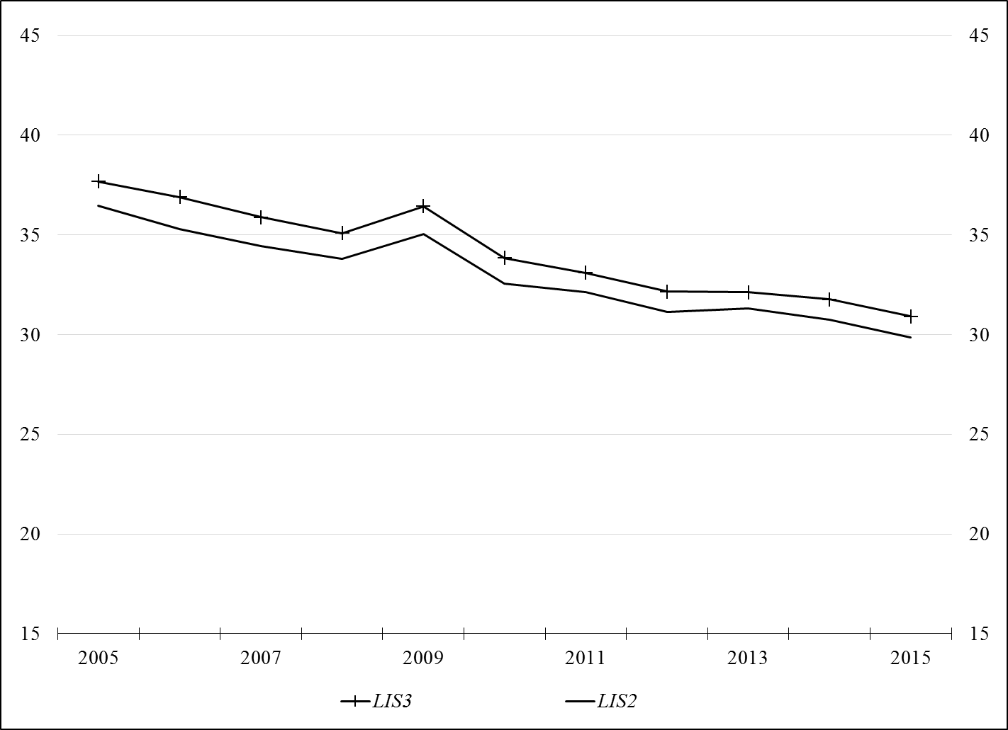

Source: Authors’ calculations based on data from INEGI. See Equation (1) in the text and section A1 in this appendix for details.

Figure A2: Adjusted wage share (*AWS*) and *LIS2* in agriculture, 1995–2015

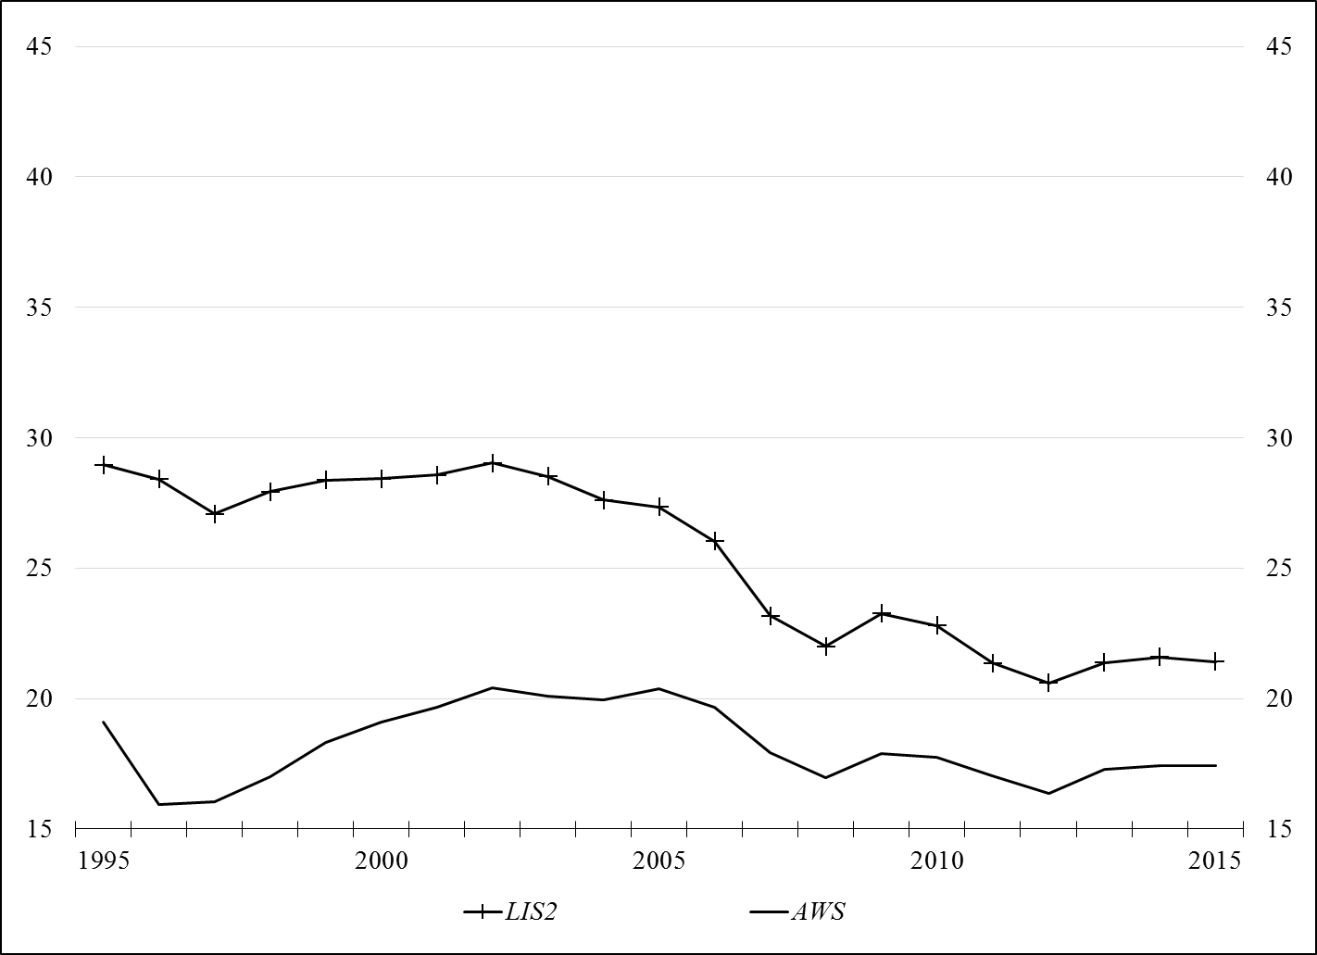

Source: Authors’ calculations based on data from INEGI. See Equation (3) in the text and section A1 in this appendix for details.

Figure A3: *AWS* and *LIS2* in commerce, 1995–2015

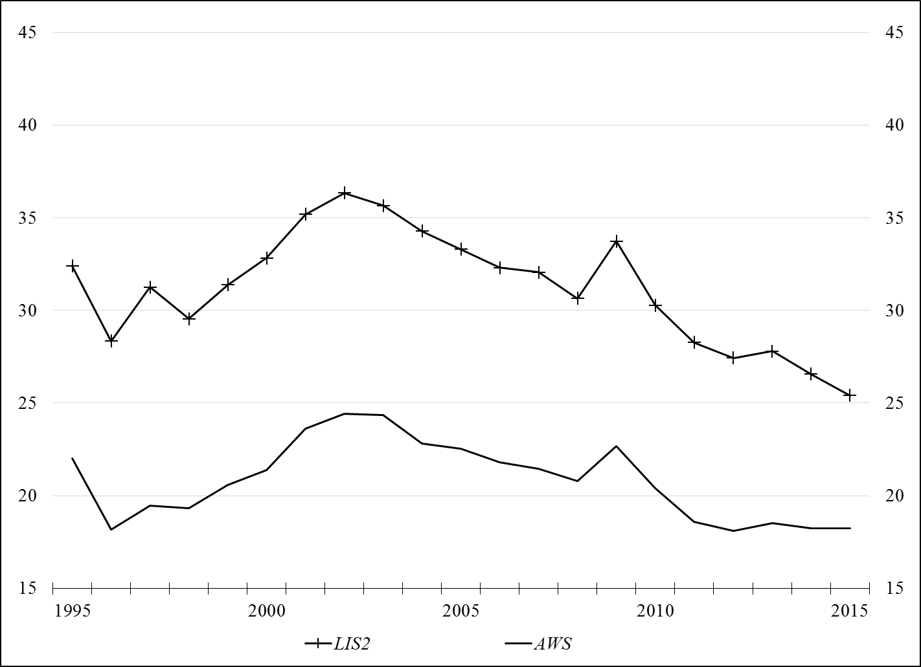

Source: Authors’ calculations based on data from INEGI. See Equation (3) in the text and section A1 in this appendix for details.

**A3. Labor productivity in the wage-employment and self-employment subsectors**

Labor productivity can be estimated for the wage-employment and self-employment subsectors in each economic activity. To obtain value added at constant prices for each wage-employment subsector, we estimate the share of this subsector in total value added at current prices (i.e. [*VA*− (*LI*− *W*)]/*VA*) and multiply this share by total value added at constant prices. This series is then divided by an estimate, based on ENOE, of the employment of subordinated workers obtained from the share of subordinated workers in total employment (adjusting for differences in hours worked per employee between subordinated workers and the average) and the INEGI–KLEMS estimate of total hours worked. Total employment here includes subordinated workers, self-employed and non-remunerated workers, and excludes employers.

Estimation of labor productivity in each self-employment subsector is symmetrical. To obtain value added at constant prices, we multiply the share of self-employment income in value added at current prices [i.e. (*LI*− *W*)/*VA*] by total value added at constant prices. This series is then divided by an estimate, based on ENOE and KLEMS, of self-employment and non-remunerated workers (assumed to be working primarily in the self-employment sector) obtained from multiplying total hours worked in INEGI–KLEMS by an estimate of the share of the self-employed and non-remunerated workers in total employment (defined as previously and adjusted for differences in hours worked per employee) according to ENOE.

Figure A4: *AWS* and productivity ratio in construction, 1995–2015

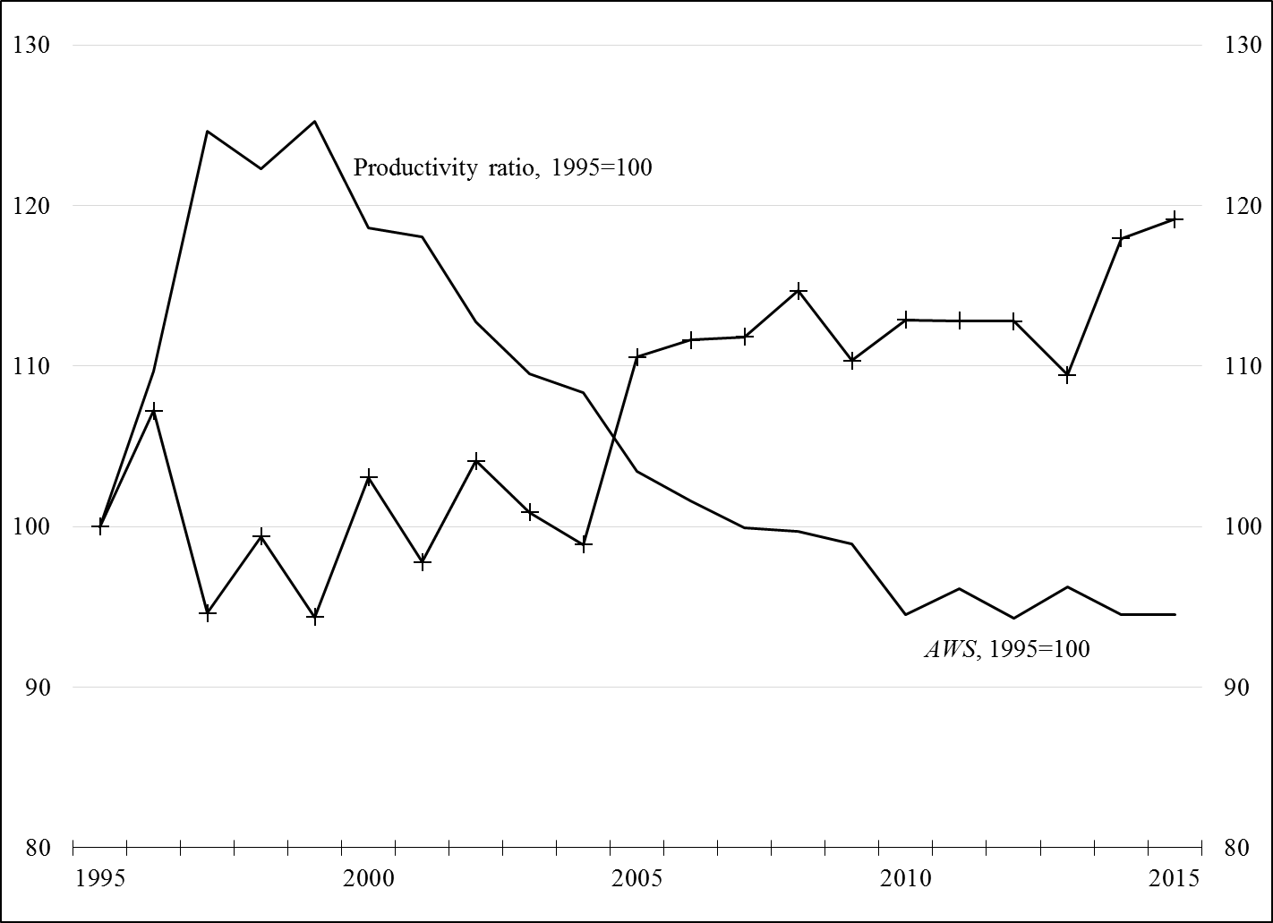

Note: Productivity ratio of wage-employment to self-employment subsector.

Source: Authors’ calculations based on data from INEGI. See Equation (3) in the text and sections A1 and A3 in this appendix for details.

Figure A5: *AWS* and productivity ratio in accommodation and food services, 1995–2015

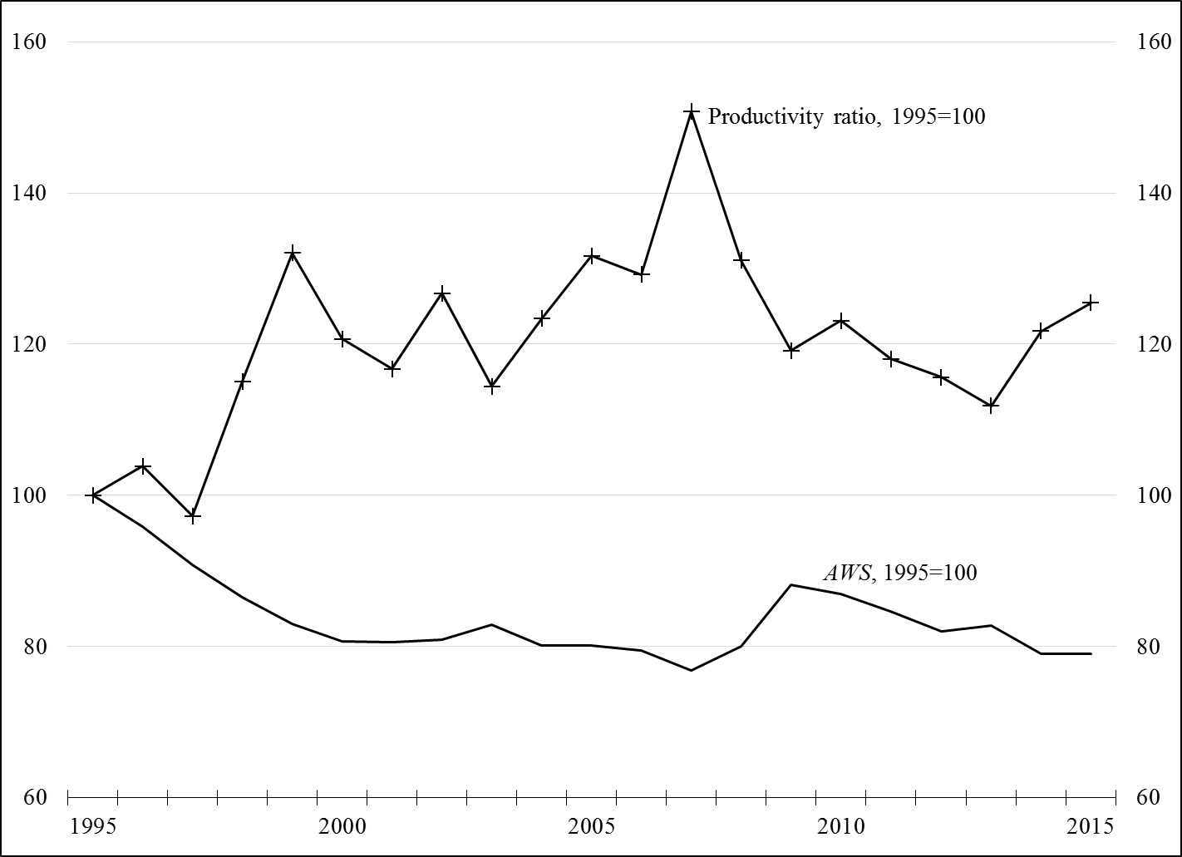

Note: Productivity ratio of wage-employment to self-employment subsector.

Source: Authors’ calculations based on data from INEGI. See Equation (3) in the text sections A1 and A3 in this appendix for details.

Figure A6: *AWS* and productivity ratio in professional, scientific, and technical services, 1995–2015

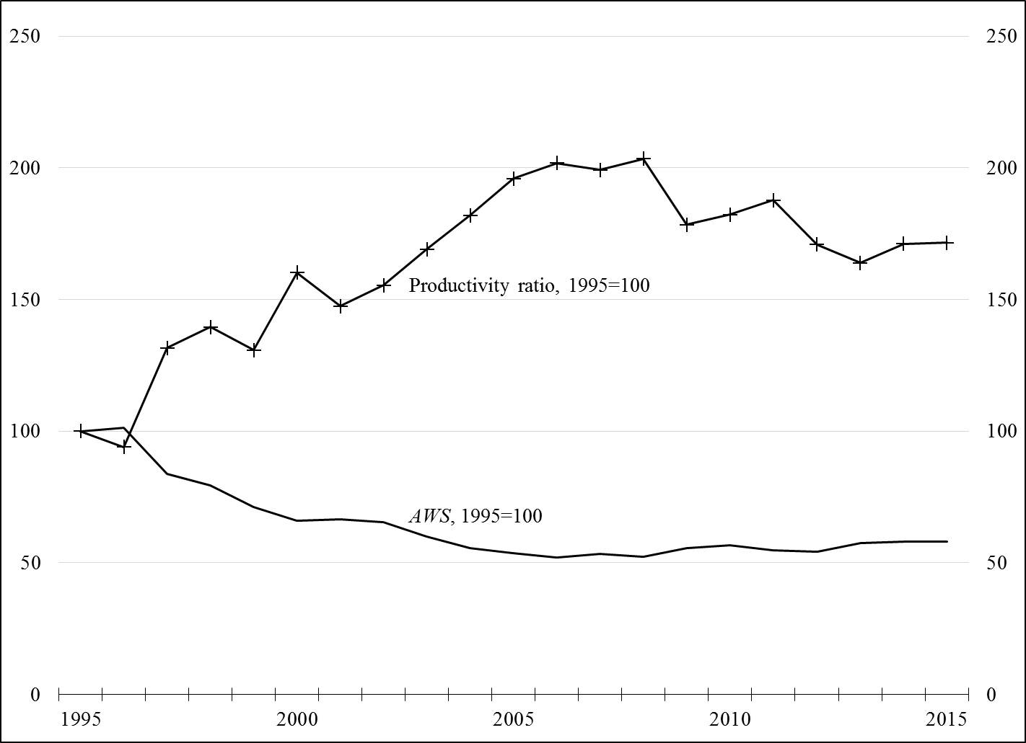

Note: Productivity ratio of wage-employment to self-employment subsector.

Source: Authors’ calculations based on data from INEGI. See Equation (3) in the text and sections A1 and A3 in this appendix for details.

Figure A7: *AWS* and productivity ratio in other services, 1995–2015

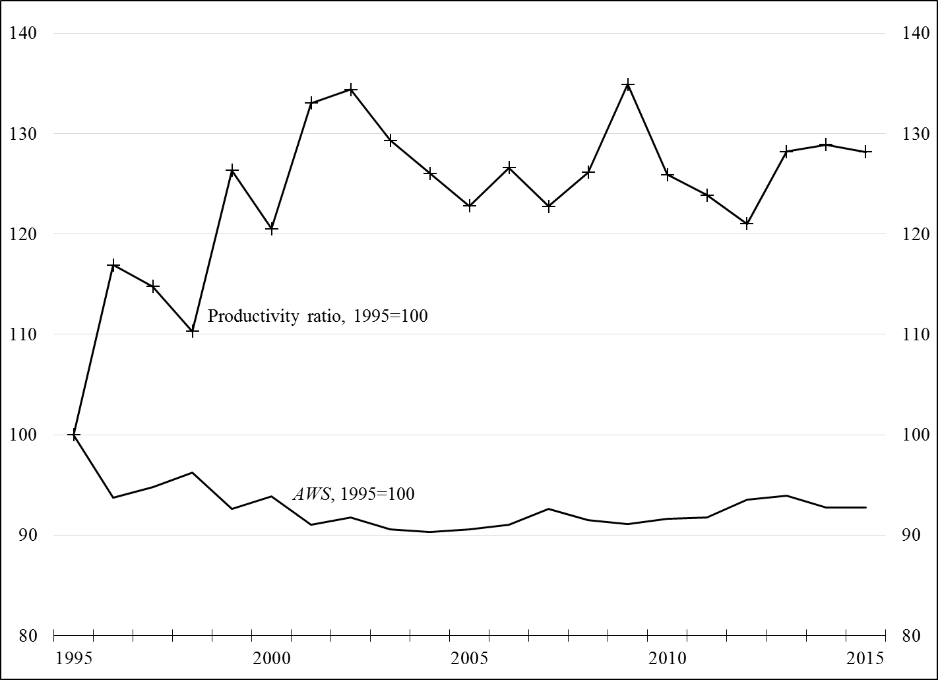

Note: Productivity ratio of wage-employment to self-employment subsector.

Source: Authors’ calculations based on data from INEGI. See Equation (3) in the text and sections A1 and A3 in this appendix for details.