AI Engineering Fundamentals Crash Course
Table of Contents
Theme 2
OpenAI Chat Completions 3
OpenAI API 3
How to Make a Request 3
URL 3
Headers 3
The Request Body (JSON) 3
Why need to send every message each time? 4
Non-Streaming Response 5
Response Structure Overview 5
Non-Streaming Summary 7
Streaming Response 7

Theme

OpenAI Chat Completions

OpenAI API
OpanAI API: The OpenAI API (Application Programming Interface) is a cloud-based service that allows developers to integrate OpenAI’s artificial intelligence models directly into their own applications, software, websites, or business workflows.
Chat Completions API: The Chat Completions API is OpenAI's HTTP endpoint for having conversations with AI models. The entire power of ChatGPT-level AI distilled into a single REST API call.
Think of it as a very simple contract:
- YOU SEND: "Here is a conversation so far..." (list of messages)
- YOU GET: "Here is the assistant's next reply..." (a completion)
Understanding the Chat Completions API is not just about OpenAI — it's about understanding the universal language for talking to LLMs.

How to Make a Request
At its core, calling the Chat Completions API is a simple HTTP POST request with a JSON body. No special SDK required, you can use curl, Python requests, or any HTTP client.

URL
https://api.openai.com/v1/chat/completions

Headers
Header | Value | Purpose
Content-Type | application/json | Tells the server we're sending JSON
Authorization | Bearer {API Key} | Your API key for authentication

The Request Body (JSON)
The body is a JSON object with the following fields:
- model (required): Which AI Model to Use.
- messages (required): The Conversation. This is the heart of the API. Messages is an array of objects, where each object represents one message in the conversation.
- Stream: False by default. If False, wait for the complete response, then return it all at once. If True, stream the response token-by-token as it's generated (like ChatGPT's typing effect).
Each message has two fields:
- Role:
  - Who should the model resemble?
  - What is the resembled entity’s purpose?
  - Roles:
    - System: The developer (you) sets the behavior, personality, rules for the AI. The AI follows these instructions throughout the conversation.
      - Example: "You are a helpful coding assistant. Be concise."
    - User: The end user. The human's questions or requests.
      - Example: "What is a REST API?"
    - Assistant: The AI model. Previous AI responses (for multi-turn conversations)"A REST API is..."
- Content: What they said (the actual text of the message).

Example Request
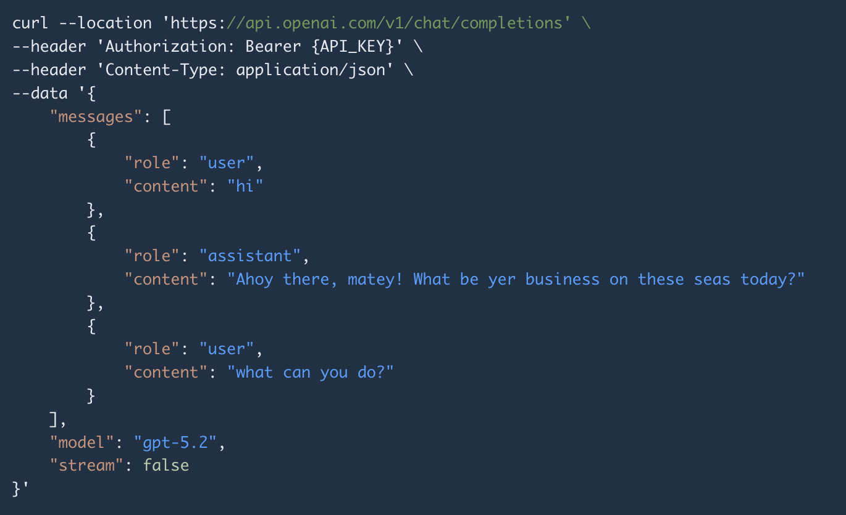

Why need to send every message each time?
The model has no memory between API calls. To have a multi-turn conversation, you must send the entire conversation history every time:
- Call 1: [system, user] → assistant replies
- Call 2: [system, user, assistant, user] → assistant replies
- Call 3: [system, user, assistant, user, assistant, user] → assistant replies

Non-Streaming Response
When stream property is false (or omitted), you receive the complete response as a single JSON object.
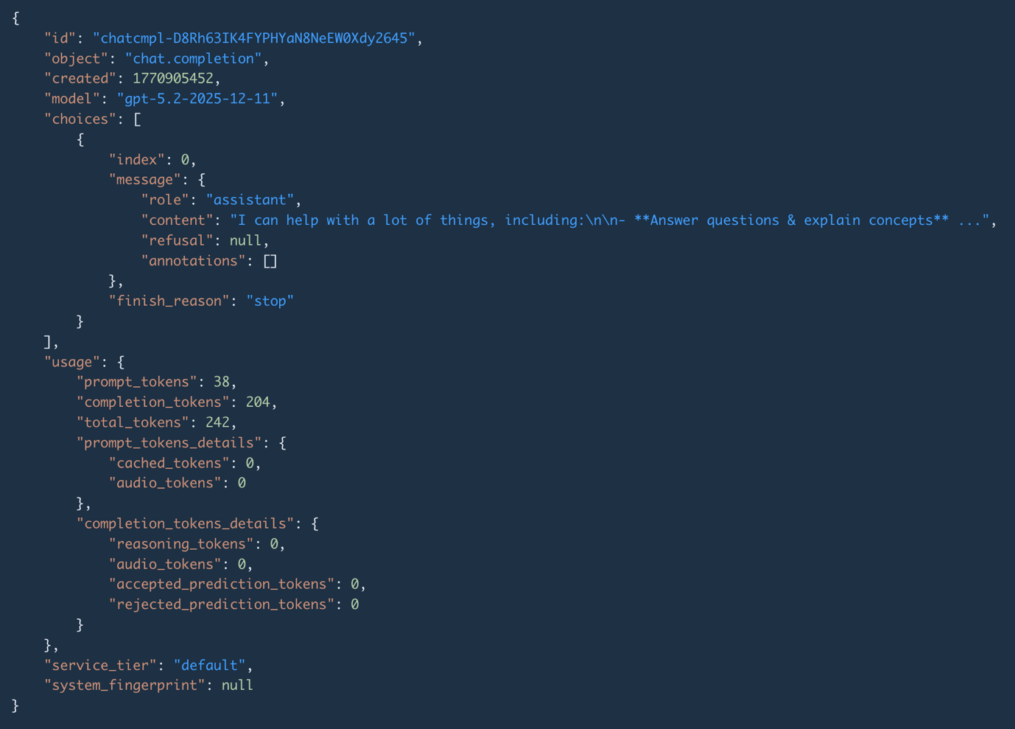

Response Structure Overview

The response JSON has these top-level fields
Field | Type | Description
id | string | Unique identifier for this completion (useful for logging/debugging)
object | string | Always "chat.completion" for non-streaming responses
created | integer | Unix timestamp of when the response was generated
model | string | The exact model version that generated the response (may include date snapshot like gpt-4.1-2025-04-14)
choices | array | The model's response(s). Usually contains 1 item.
usage | object | Token usage statistics — critical for cost tracking

Each choice contains
Field | Description
index | The position of this choice (0, 1, 2...)
message.role | Always "assistant"
message.content | The actual response text — this is what you want!
finish_reason | Why the model stopped generating
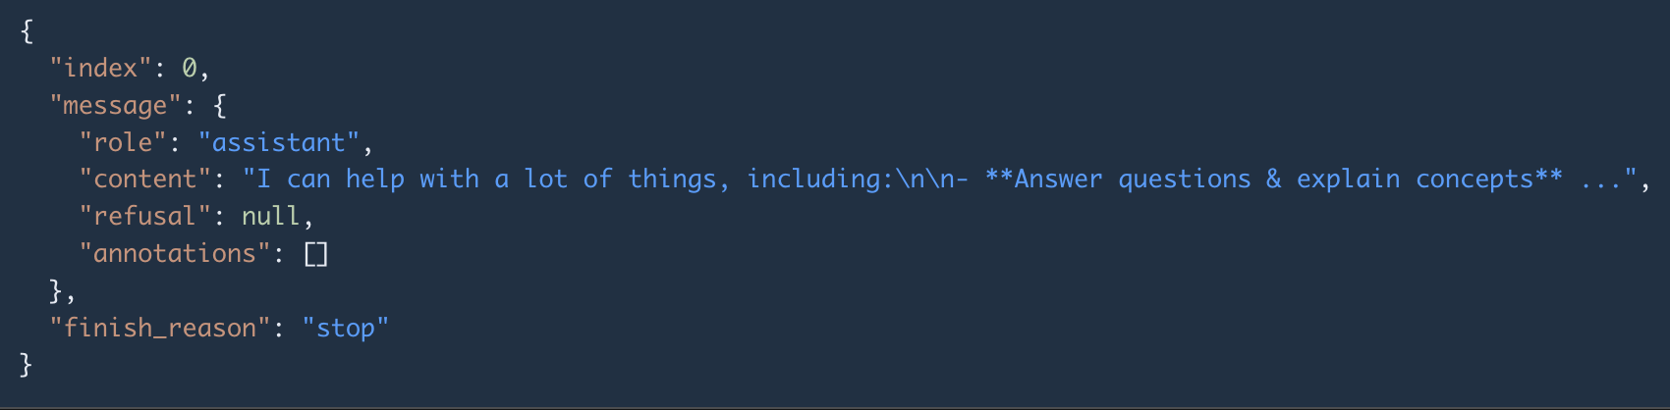

How to get the answer
Access choices[0].message.content, that's the text you'll display to the user.

finish_reason - Why Did the Model Stop?
Value | Meaning | Action
"stop" | The model finished naturally (complete response) ✅ | All good, use the response
"length" | The model hit max_completion_tokens limit (response was cut off) ⚠️ | Increase max_completion_tokens or make another request
"content_filter" | The response was blocked by content safety filters | Modify your prompt
"tool_calls" | The model wants to call a function/tool | Handle the tool call (advanced topic)

usage — Token Counting (Your Bill!)
Field | What It Counts
prompt_tokens | Tokens in your input (all messages combined)
completion_tokens | Tokens in the model's response
total_tokens | prompt_tokens + completion_tokens
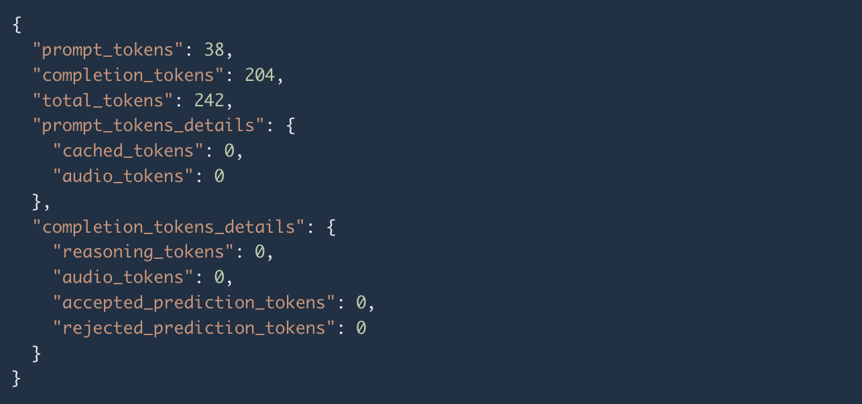
This is how you're billed. OpenAI charges per token, with different rates for input vs. output tokens. Always monitor this field to track costs.

Non-Streaming Summary
When you receive the response, here's what to do:
- Get the answer: Read choices[0].message.content
- Check completeness: Verify choices[0].finish_reason is "stop"
- Track costs: Read usage.prompt_tokens, usage.completion_tokens, usage.total_tokens
- Log metadata: Save id and model for debugging

Streaming Response

How to Enable Streaming?
Set "stream": true in your request body. Everything else stays the same.
To also receive token usage statistics in streaming mode, add "stream_options": {"include_usage": true}.
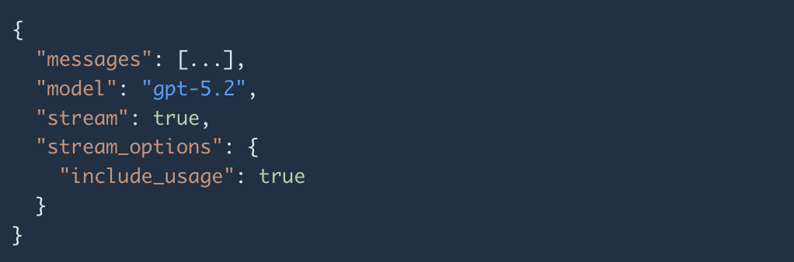

Server-Sent Events (SSE) - What You Receive
Instead of a single JSON response, you receive a stream of events using the Server-Sent Events (SSE) protocol. This is a standard web technology for server-to-client streaming over HTTP.
Each event is a text line starting with data: followed by a JSON object. Events are separated by blank lines. The stream ends with a special line: data: [DONE].
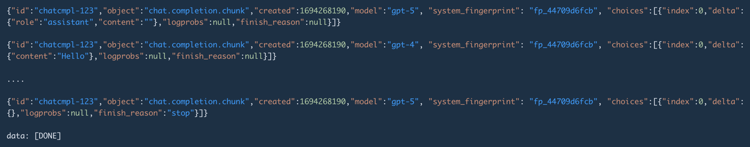

Anatomy of a Streaming Chunk
Aspect | Non-Streaming | Streaming Chunk
object field | "chat.completion" | "chat.completion.chunk"
Content field | message (complete text) | delta (incremental piece)
How content arrives | All at once | Token by token
finish_reason | Set on the response | null until the very last chunk, then "stop"
End signal | Response body ends | Special data: [DONE] line

delta – The key concept
Instead of message. Each chunk's choices[0].delta.content contains just a tiny piece of text (usually one or a few tokens). You concatenate all of them to build the full response.

The Three Phases of a Stream

Phase 1 — First chunk (role announcement)
The first chunk announces the role. delta contains {"role": "assistant", "content": ""}. Content is empty — it's just saying "I'm about to respond."

Phase 2 — Content chunks (the actual text, many of these)
Each subsequent chunk has delta containing {"content": "some text"}. These arrive one by one, each with a small piece of text. You print/display each piece as it arrives for the real-time typing effect.

Phase 3 — Final chunk + DONE signal
The last data chunk has an empty delta ({}) and finish_reason set to "stop". Then the stream sends data: [DONE] to signal the end.

How to Parse Streaming Responses
The algorithm for parsing a stream is:
- Read the HTTP response as a stream (line by line, not all at once)
- For each line, check if it starts with data:
- If the data is [DONE], stop — the stream is complete
- Otherwise, parse the JSON from the data
- Extract choices[0].delta.content — this is the new text piece
- Append it to your buffer and display it to the user
- Repeat until [DONE]
⚠️ Important: Always check for data: [DONE] before trying to parse JSON, otherwise you'll get a parse error.

Common mistakes to avoid
Mistake | What Happens | Fix
Forgetting Authorization header | 401 Unauthorized | Add Bearer YOUR_KEY
Using "message" instead of "messages" | 400 Bad Request | It's always messages (plural, array)
Not sending conversation history | Model "forgets" context | Resend all previous messages each call
Ignoring finish_reason: "length" | Truncated answers | Increase max_completion_tokens
Exposing API key in frontend | Key stolen, bill explodes | Keep key server-side only
Not handling streaming [DONE] | JSON parse error | Check for [DONE] before parsing

Useful link
https://developers.openai.com/api/reference/resources/chat/subresources/completions/methods/create

OpenAI Responses

About OpenAI Responses
OpenAI Responses API: The Responses API is OpenAI's next-generation endpoint for interacting with AI models. It's designed to be the successor to the Chat Completions API — more powerful, more flexible, and built for agentic workflows.

The Core Idea
The contract is similar to Chat Completions, but with important differences:
- YOU SEND: An input (text string or list of messages) + optional instructions
- YOU GET: A response object with an output array containing typed items (messages, tool calls, reasoning, etc.)

The key shift
Instead of a single message in choices[0], you get a rich output array where each item has a type, making it much easier to handle complex workflows like tool calls, reasoning chains, and multi-step agent loops.

Request

How to Make a Request
The Responses API follows the same HTTP pattern: a POST request with a JSON body and an Authorization header.

URL
https://api.openai.com/v1/responses

Headers
Header | Value | Purpose
Content-Type | application/json | Tells the server we're sending JSON
Authorization | Bearer {API_KEY} | Your API key for authentication

Request Body (JSON):
- model (required): Which AI Model to Use
- input (required): The Conversation. This is the equivalent of messages in Chat Completions, but more flexible. It accepts two formats:
  - Simple string format: You can pass a plain text string directly as input. The API treats it as a single user message. This is the simplest possible way to call the API.
  - Messages array format: Same structure as Chat Completions — an array of objects with role and content. Roles are the same: user, assistant, developer (replaces system).
- instructions (optional): System-Level Guidance. In Chat Completions, system instructions were embedded as a system role message inside the messages array. The Responses API separates them into a dedicated instructions field. This is equivalent to the system message but lives at the top level of the request. The model treats instructions as higher-priority guidance, similar to how the system role worked.
- stream (optional): Real-Time Streaming
- previous_response_id (optional): Stateful Conversations. This is the biggest convenience of the Responses API. Instead of resending the entire conversation history, you can pass the id of a previous response, and the API automatically includes all prior context. 💡 This requires store: true.
- store: true (the default). The server stores the conversation and reconstructs context automatically. You no longer need to manage message history yourself. You can still manage context manually by passing the full messages array in input — exactly like Chat Completions. Both approaches work.
- previous_response_id: If True (default), response is stored server-side, can be retrieved later, if False, response is not stored, stateless mode.

Example request
- Call 1: Send input: "What is Python?" → get response with id: "resp_abc123"
- Call 2: Send input: "Give me an example" + previous_response_id: "resp_abc123" → the model has full context
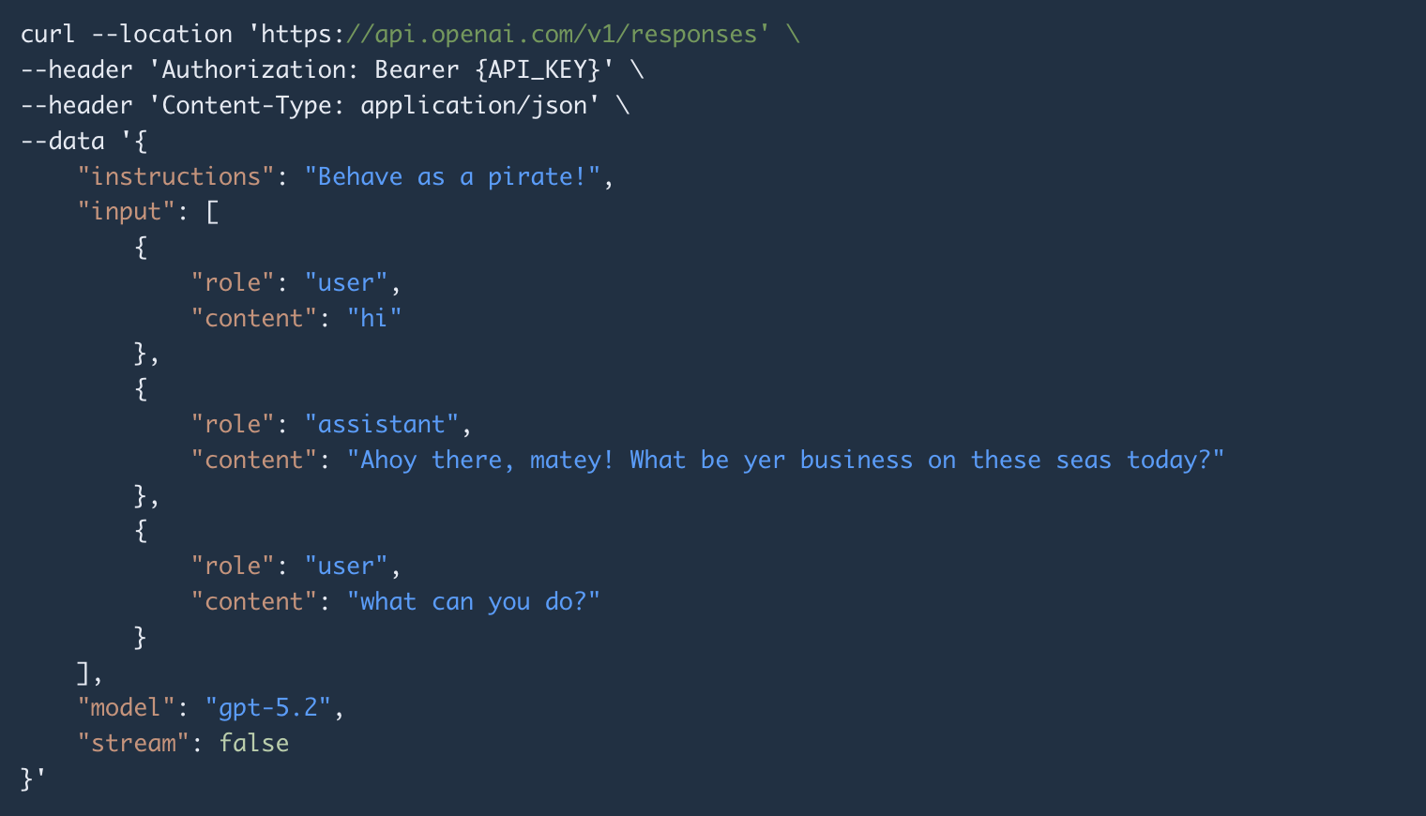

Non-Streaming Response
When stream is false (or omitted), you receive the complete response as a single JSON object.
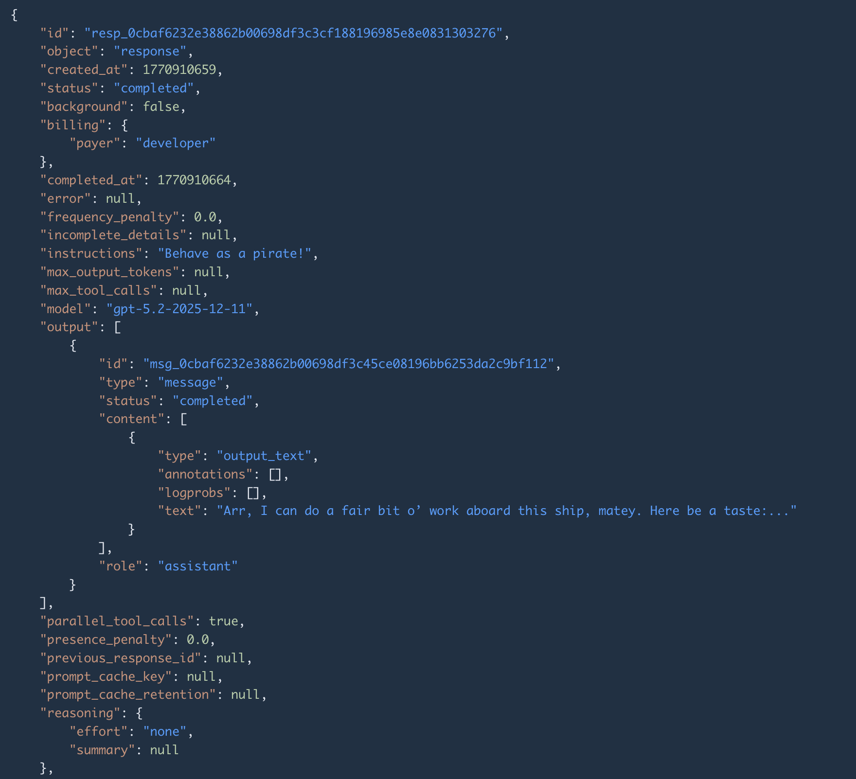
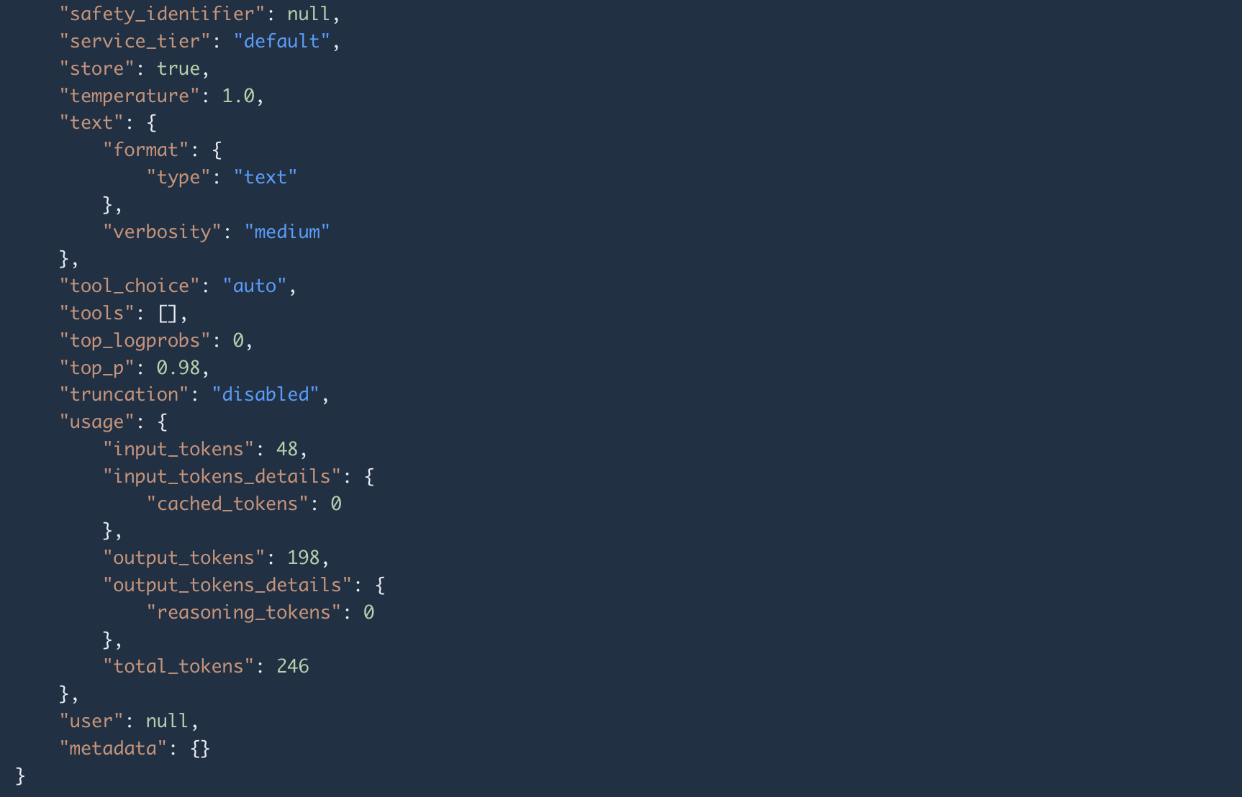

Response Structure Overview
The response JSON has these top-level fields:
Field | Type | Description
id | string | Unique identifier (e.g. "resp_abc123...") — use this for previous_response_id
object | string | Always "response"
created_at | number | Unix timestamp of when the response was created
model | string | The exact model version used
status | string | The completion status — this replaces finish_reason
output | array | The model's output items — this is the main content
usage | object | Token usage statistics
error | object/null | Error details if the response failed
incomplete_details | object/null | Why the response is incomplete (if status is "incomplete")
instructions | string/null | The instructions you provided
metadata | object | Custom key-value metadata you attached

The output Array — Typed Items
This is the biggest structural difference from Chat Completions. Instead of choices[0].message, you get an array of typed items. Each item has a type field that tells you what it is.
For a simple text response, the output array typically contains one item — a message:
Field | Value | Description
id | string | Unique ID of this output item
type | "message" | The type of item
role | "assistant" | Always assistant for model output
status | "completed" | Status of this specific item
content | array | The content parts of the message
The content array inside the message contains content parts, each with its own type:
Field | Value | Description
type | "output_text" | The type of content part
text | string | The actual response text — this is what you want!
annotations | array | Citations, file references, etc.
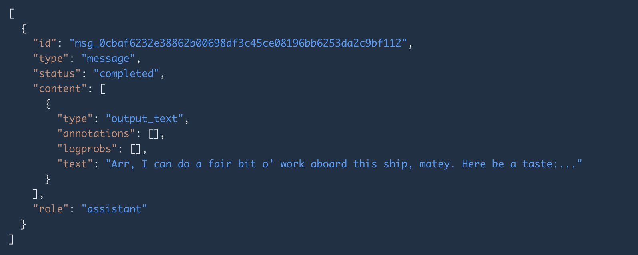

status — Did the Response Complete?
The Responses API uses a status field instead of finish_reason:
Value | Meaning | Action
"completed" | The model finished naturally ✅ | All good, use the response
"incomplete" | The model was cut off ⚠️ | Check incomplete_details.reason for why
"failed" | An error occurred ❌ | Check the error field
"in_progress" | Still generating (background mode) | Poll or wait
"cancelled" | You cancelled the response | —

usage — Token Counting (Your Bill!)
Field | What It Counts
input_tokens | Tokens in your input (renamed from prompt_tokens)
output_tokens | Tokens in the model's response (renamed from completion_tokens)
total_tokens | input_tokens + output_tokens
output_tokens_details.reasoning_tokens | How many output tokens were used for reasoning (for reasoning models)
input_tokens_details.cached_tokens | How many input tokens were served from cache (cheaper!)
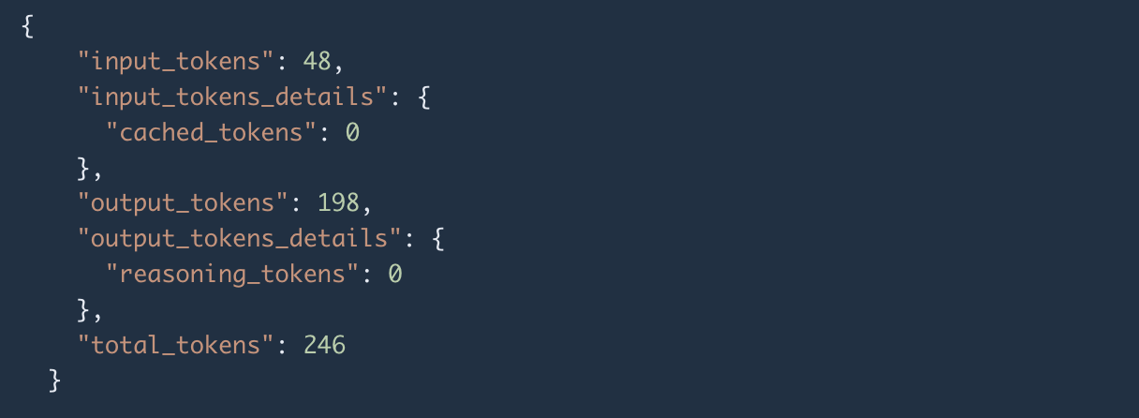

How to Get the Answer

Quick way
Read the top-level output_text field — this is a convenience helper that concatenates all text from all message items.

Detailed way
Navigate to output[N].content[0].text where the item has type: "message".
The output_text helper is the Responses API equivalent of choices[0].message.content. For simple text responses, just use output_text.

When Output Contains Multiple Items
For reasoning models the output array may contain multiple items:
Item Type | What It Is
"reasoning" | The model's chain-of-thought (reasoning tokens). Contains a summary field with human-readable reasoning summaries.
"message" | The assistant's actual response to the user. Contains the text you display.
"function_call" | A request to call one of your custom functions.
"web_search_call" | A call to the built-in web search tool.
"file_search_call" | A call to the built-in file search tool.
"code_interpreter_call" | A call to the built-in code interpreter.
"mcp_call" | A call to an MCP (Model Context Protocol) server.
For a typical non-reasoning model
You'll just see a single "message" item.
For reasoning models
You'll see a "reasoning" item followed by a "message" item.

Billing works the same way
You pay per token, with different rates for input vs. output. The reasoning_tokens sub-field helps you understand costs when using reasoning models, since reasoning tokens are billed as output tokens.

Parsing Summary (Non-Streaming)
When you receive the response, here's what to do:
- Get the answer: Read output_text (or navigate output[N].content[0].text)
- Check completeness: Verify status is "completed"
- If incomplete: Read incomplete_details.reason to understand why
- Track costs: Read usage.input_tokens, usage.output_tokens, usage.total_tokens
- Save the ID: Store id to use as previous_response_id for follow-up conversations
- Log metadata: Save id and model for debugging

Streaming Response

