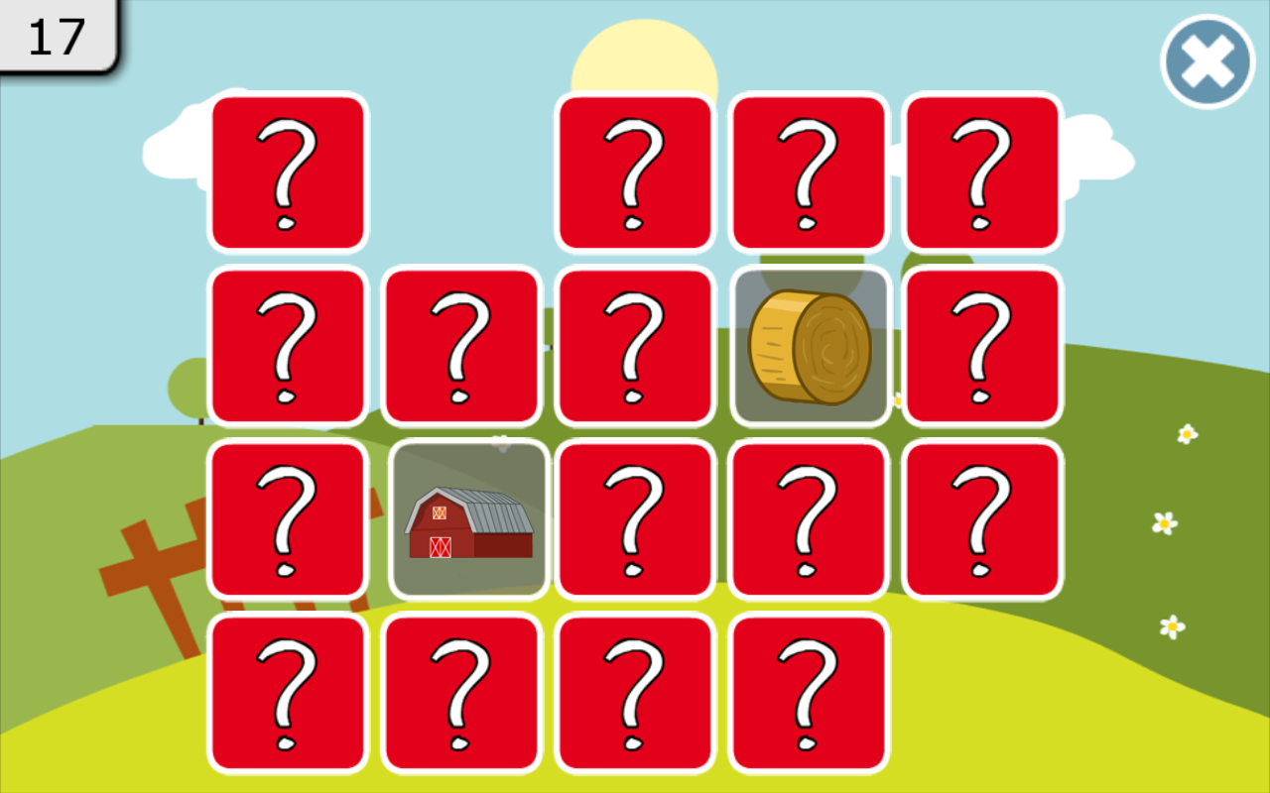

Description
A simple Matchmaker game built by using python.

 Languages or Frameworks Used
pip install tk

 How to run
Running the script is really simple! Just open a terminal in the folder where your script is located and run the following command:
python Matchmaker.py

Demo


