Marcin Słupek

**Multiscale Modelling Second Report**

**1. Introduction**

This application is extension to previous solution. It uses same technologies. The goal was to implement growth and static recrystallization using Monte Carlo Method.

**2. Interface**

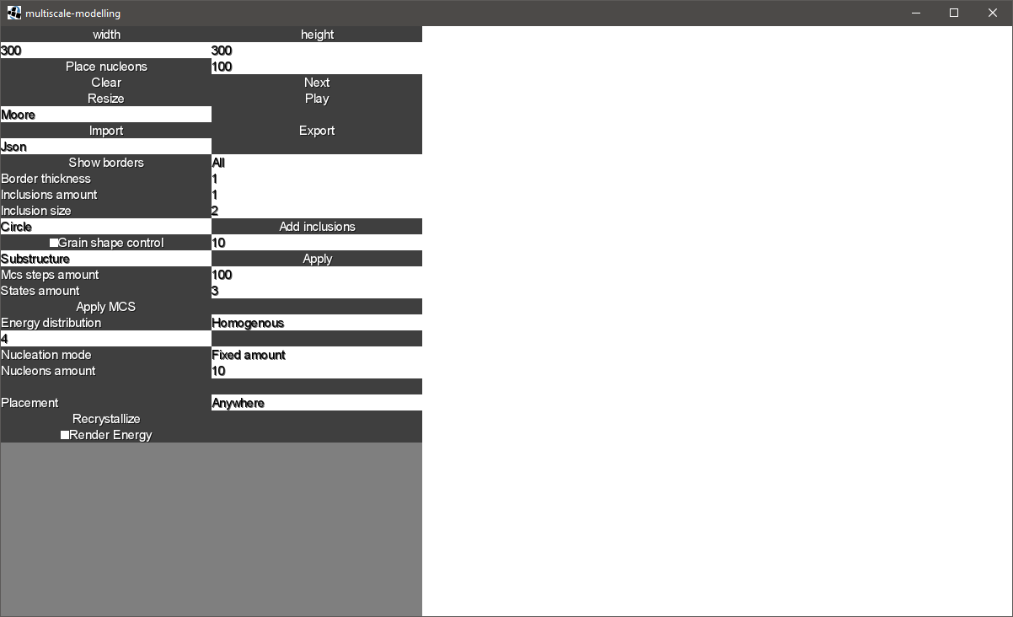

Figure 1 User interface

Controls described from top to bottom:

Mcs steps amount – how many iteration should be executed

States amount – how many colors should be initially placed in space

Apply MCS – create initial state of simulation

Energy distribution – used in recrystallization, can be homogenous or heterogenous

Nucleation mode – where to put recrystallization nucleon, grain boundaries or anywhere

Nucleons amount – how many recrystallization nucleons to place

**3. Implementation**

**3.1 Monte Carlo grain growth**

First step was to implement grain growth using Monte Carlo algorithm chart 1 represents example of microstructure. Figures 1,2,3,4 shows results of running method every 50 steps.

|  |  |
| --- | --- |
| Figure 2 Initial 3 states | Figure 2 after 50 steps |
| Figure 3 after 100 steps | Figure 4 after 150 steps |

*Chart 1. Microstructure generated using Monte Carlo method. Simulation parameters: width – 300, height – 300, initial states – 3.*

**3.2 Dual phase microstructure**

Next class included extension which contains dual phase microstructures with scenarios:

Simple grain growth to simple grain growth (Figure 5)

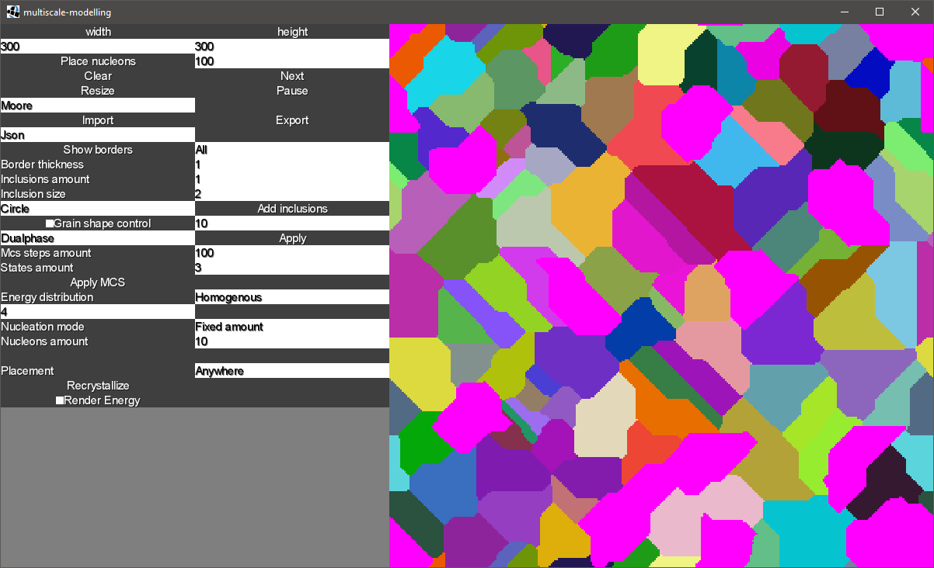

Figure 5 Result of generating microstructure with simple grain growth and simple grain growth again as second phase

Simple grain growth to Monte Carlo (Figure 6)

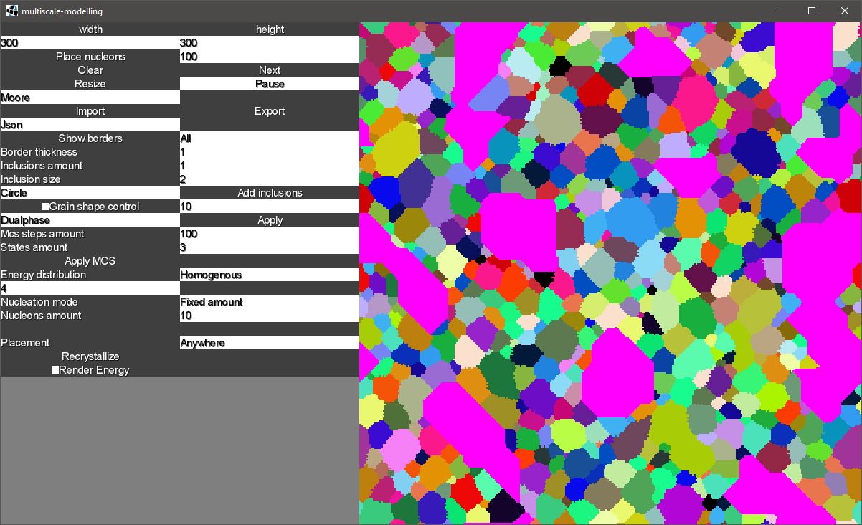

Figure 6 Result of generating microstructure with simple grain growth and Monte Carlo as second phase

Monte Carlo to Simple grain growth (Figure 7)

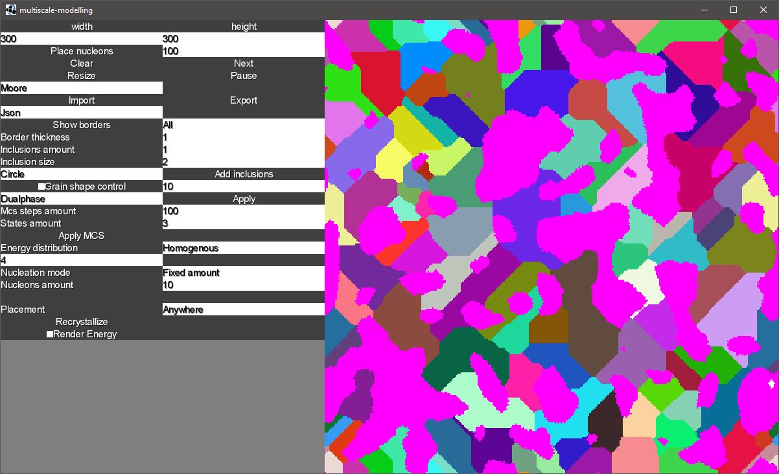

Figure 7 Result of generating microstructure with Monte Carlo and simple grain growth as second phase

Monte Carlo to Monte Carlo (Figure 8)

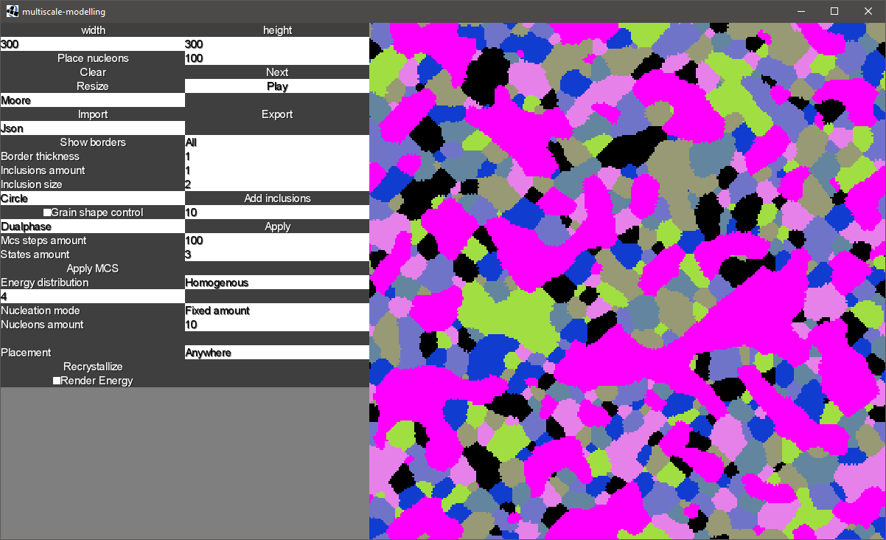

Figure 8 Result of generating microstructure with Monte Carlo and Monte Carlo again as second phase

**3.3 Energy Distribution**

This extension includes possibility to distribute energy to structure and render it. Figures 10 shows microstructure view mode and Figure 11 shows distributed energy.

|  |  |
| --- | --- |
| Figure 9 Generated microstructure with simple grain growth 300x300 size | Figure 10 Energy distributed to generated microstructure witinh range of 4 to 7. Blue color represents lesser values and green greater. Red color represents zero energy after recrystallization. |

**3.4 Nucleation and growth**

Last step was to implement static recrystallization algorithm. With given base structure there is possibility to simulate recrystallization using modified Monte Carlo method using cell energy as parameter. Chart 2 shows progress of static recrystallization algorithm.

|  |  |
| --- | --- |
|  |  |
|  |  |

*Chart 2 Progress of static recrystallization algorithm. Initial structure was size 300x300, 1000 nucleons placed for recrystallization, homogenous energy distribution and initial energy 5.*

**4. Comparison to real life scenarios.**

Generated microstructure using Monte Carlo method. Results shown on Figure 12 resembles Carbon steel shown on Figure 11. You can observe thin extended grains.

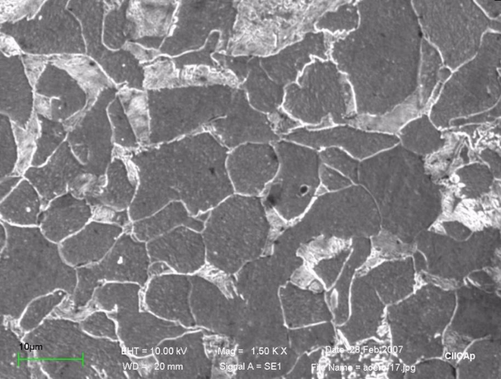

Figure 11 Microstructure of Carbon steel (https://www.researchgate.net/figure/Optical-images-of-the-microstructure-of-carbon-steel_fig1_266258854)

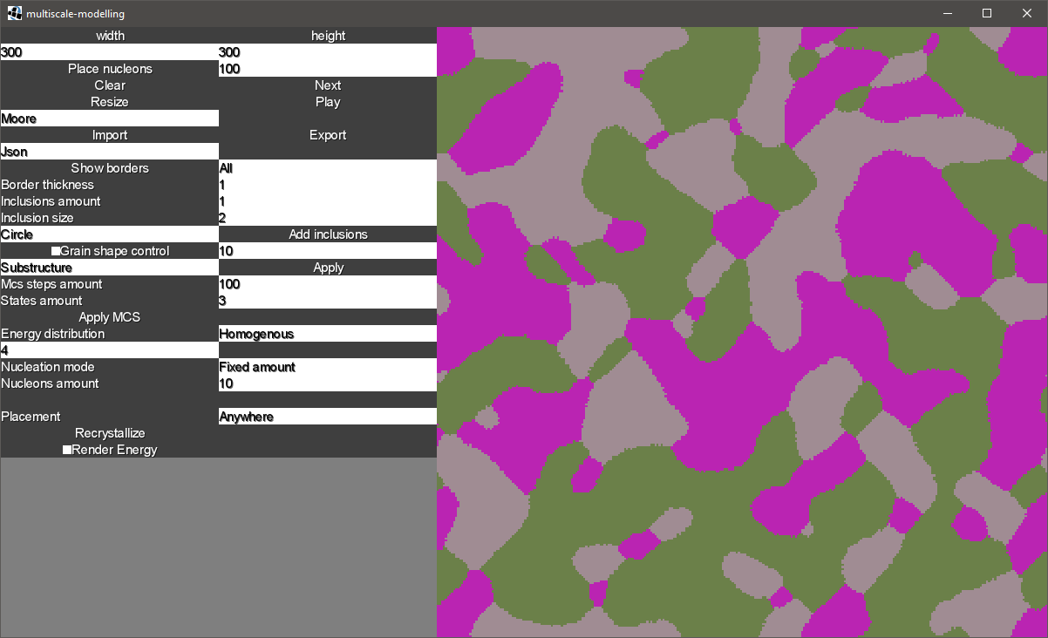

Figure 12 Microstructure generated with Monte Carlo method 300x300 size, 3 initial states and 300 steps

Second example includes use of static recrystallization method (Figure 14). It is similar to low carbon steel shown of Figure 15. You can observe small and cluttered grains in place of old grain boundaries.

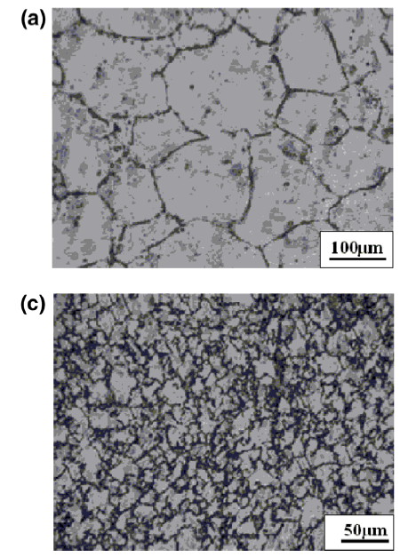

Figure 13 Recrystallized austenite in low carbon steel (http://www.amse.org.cn/article/2016/1006-7191/1006-7191-29-12-1127/img_33.png)

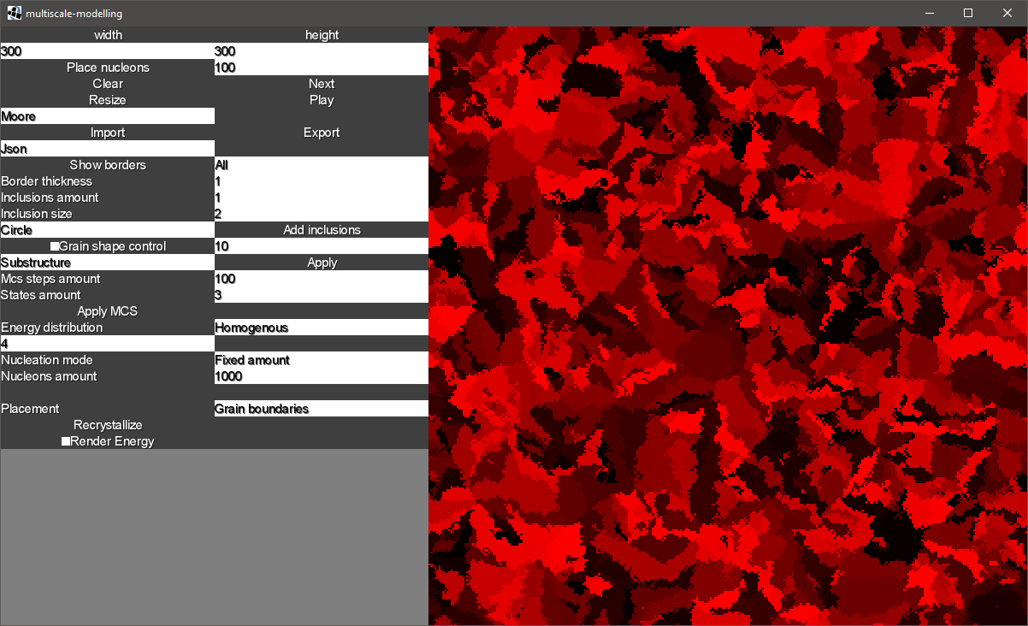

Figure 14 result of simulation with use of static recrystallization method (300x300 size, 1000 initial nucleons, homogenous energy value of 5).

**5. Conclusion**

Cellular automata is group of algorithms which gives you opportunity to implement various scenarios of simulation. Base rules can be easily modified or extended to create advanced microstructures. This group of method can share the same model and can be executed one after another.

Monte Carlo method is nice addition to Cellular automata. It enables you to specify more parameters of simulation and generate realistic microstructures. The downside od this method is that runs quite slow. There are some improvements like skipping cells with neighbors of same color and processing only cells that have not been changed yet. You have to pay attention to chosen number of iteration because Monte Carlo method does not have explicit stop condition, so running it infinitely will cause to create one big grain in whole space.

Static recrystallization gives very accurate results compared to real life recrystallization results. The algorithm minimizes cells energy and it can be observed in real scenarios.