**COMP4920**

**Senior Design Project 2, Spring 2019**

**Advisor: İbrahim Zincir**

**MYINFLATION: A Web Based Inflation Calculation System**

**Requirements Specifications Document**

**Revision 3.0**

**15.05.2019**

**By: Merve KONUK & Hatice İzel ATAY**

**Student ID Numbers: 16070001112 & 16070001100**

# Revision History

|  |  |  |
| --- | --- | --- |
| Revision | Date | Explanation |
| 1.0 | 26.11.2018 | Initial requirements |
| 2.0 | 28.12.2018 | Requirements Model |
| 2.0 | 30.12.2018 | Requirements and use case diagram are modified. Activity diagrams added. |
| 2.0 | 10.01.2019 | Requirements, use case diagram were modified. Contents changed. |
| 3.0 | 15.05.2019 | Requirements Model Improved  Detailed explanation of improvements here  Note that any revisions in the document body must clearly be marked, for example by graying them |

# Contents

Revision History 2

Contents 3

1. Introduction to MyInflation 4

2. Requirement List 5

3. Actors and Use Cases 6

3.1. Overall Use Case Diagram 6

3.2. Actors Table 7

3.3. Use Case Definitions 7

3.3.1. Use Case 1: Login 7

3.3.2. Use Case 2: Register 7

3.3.3. Use Case 3: User's Basket Processes 8

3.3.4. Use Case 4: Inflation Basket Processes 8

3.3.5. Use Case 5: Inflation Calculation Processes 8

3.3.6. Use Case 6: Update TUIK Data 9

3.3.7. Use Case 7: Monitoring Data from Database 9

3.3.8. Use Case 8: Basic Inflation Calculation 9

4. Glossary 9

5. References 10

# Introduction to MyInflation

Inflation is the continuous increase in the general price level and the decrease in the monetary value. The fact that total supply of goods and services cannot meet the total demand is the most important feature of inflation. Prices in the economy are only possible thanks to price indices. two kinds of price index in Turkey are used. These are the Consumer Price Index (CPI) and the Wholesale Price Index (WPI). It can be said that the fact that the CPI is higher than the WPI is due to the vitality of domestic demand. This situation, which is accepted as an indication of demand inflation, arises from the rise of money supply and revenues. Inadequate competition in the domestic market results in a consistently high price level. Monopolization and price agreements are the most important reasons for inflation. People affected by inflation may suffer large sums of money according to their status. These losses can sometimes be avoided with small losses, and sometimes the company can cause loss.

We have a lot of reasons in order to calculate the inflation ranges. These reasons are

• By calculating inflation, problems can be easily predicted and solved at low cost

• By calculating inflation, the company supplies stocks cost lower.

• Regular planning of future inflation due to the planned follow-up takes place.

MyInflation is a web-based personal inflation calculation system. The purpose of the software project is to develop the MyInflation Web Application in Java and in Windows and MySQL environment. By MyInflation, people can calculate their inflation according to their own forms of purchase. The system has different activites for admin, registered user and visitor user. Actors to do mainly the following;

Visitor users can indicate the total price of the products they buy and the time of purchase. They also indicate the time interval when they want to see the difference in inflation. Consequently, with a basic inflation calculation, visitor can only shows the general inflation result.

Users can search and select products in basket that they want to calculate the inflation rate. They also can select and add products in their basket. According to selected products, system calculates the inflation and returns the results. Also behind the screen, there is a huge database. If the user wants to see the old calculatios which they did, they can show and calculate the differences between them.

Admin is the bridge between MyInflation system and TUIK. The elementary calculation values supplies from TUIK. Admin follows that TUIK data changing and updates them to right inflation calulations. She can manage the registed accounts as creating, update, delete records. Admin manages the basket. She can lists, add and delete products from basket, monitors data from database.

Inflation difference between the desired dates, Turkey Statistics Institute (TSI), released by the consumer price index (CPI) is calculated using the data. It can be included in the calculations from the date of the announcement of the official inflation statistics of TURKSTAT. Personal Inflation Calculator enables individuals to predict CPI and inflation increases, decreases and view the desired time intervals at one time. Most investors evaluate this data and manage their investments by monitoring these data. In this way, they meet their expectations by taking advantage of price changes. They can benefit by forecasting future investment and job offers.

MyInflation is a web-based personal inflation calculation system. With this system, people indicate the total price of the products they buy and the time of purchase. They also indicate the time interval when they want to see the difference in inflation. Inflation difference between the desired dates, Turkey Statistics Institute (TSI), released by the consumer price index (CPI) is calculated using the data. It can be included in the calculations from the date of the announcement of the official inflation statistics of TURKSTAT. Personal Inflation Calculator enables individuals to predict CPI and inflation increases, decreases and view the desired time intervals at one time. Most investors evaluate this data and manage their investments by monitoring these data. In this way, they meet their expectations by taking advantage of price changes. They can benefit by forecasting future investment and job offers.

# 2. Requirement List

|  |  |  |
| --- | --- | --- |
| No | Requirements | Use Case(s) |
| 1 | To connect the website system as Website Manager. | Login |
| 2 | To use the website more efficiently for example, create basket, select, delete products, calculate inflation based on user request. | Register |
| 3 | To inflation calculation, users create own basket with selected products and arrange on that basket as search, select and insert operations. | User’s Basket Processes |
| 4 | To inflation calculation, website manager compose the inflation basket with according to published inflation data by TUIK. Modify created Inflation Basket as list, adding, deleting and updating operations. | Inflation Basket  Processes |
| 5 | To calculate inflation according to created basket’s products and entered time range. Inflation calculation differences by comparing two or more than two baskets which were created in different times. | Inflation Calculation  Processes |
| 6 | To find inflation calculation difference, website manager delete, create or update products according to setted time range by TUIK. | Update TUIK Data |
| 7 | To provide information created and updated baskets and the system will display products and TUIK data which are being updated. | Monitoring Data from  Database |
| 8 | To inflation calculation, visitor user enter the wanted price amount and time interval without create own inflation basket. Visitor can only shows the general inflation result. | Basic Inflation Calculation |

# Actors and Use Cases

## **3.1. Overall Use Case Diagram**

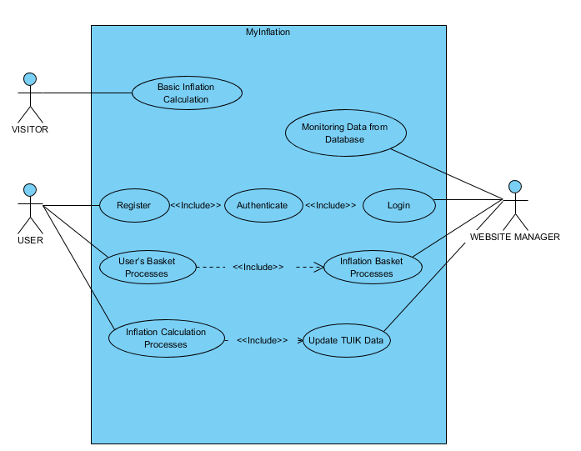

## **3.2. Actors Table**

|  |  |  |
| --- | --- | --- |
| No | Actor | Description |
| 1. | Website Manager | Website Manager follows that TUIK data changing and updates  them to right inflation calculations. She can manage the  registered accounts as creating, update, delete records. She  manages the basket. |
| 2. | User | Users can search and select products in basket that they want to  calculate the inflation rate. They also can select and add  products in their basket. According to selected products, system  calculates the inflation and returns the results and they can  show and calculate the differences between them. |
| 3. | Visitor | Visitor users can indicate the total price of the products they  buy and the time of purchase. Basic inflation calculation, visitor  can only shows the general inflation result. |
| 4. | Staff | Any member of staff working in MyInflation. |

# Use Case Definitions

## Use Case 1: Login

|  |  |  |
| --- | --- | --- |
| No | Use Case | Description |
| 1. | Login | A Login is the entering of identifier information into a system as website manager in order to access that system. |

## Use Case 2: Register

|  |  |  |
| --- | --- | --- |
| No | Use Case | Description |
| 2. | Register | Each user will have their own username and password. The main calculation page can be accessed with the correct username and password, but if the wrong information is  entered, it returns to the home page. |

## 3.3.3. Use Case 3: User's Basket Processes

|  |  |  |
| --- | --- | --- |
| No | Use Case | Description |
| 3. | User's Basket  Processes | User creates own inflation basket according to his/her select products.  Search and Select products in basket: Registered users can search product to find the product that user want to add in basket that will be calculated to inflation. Registered users can select products in basket that they want to calculate the inflation.  Delete Products in Basket: Delete the products which is unwanted to added to old inflation calculations that were saved in database. |

## 3.3.4. Use Case 4: Inflation Basket Processes

|  |  |  |
| --- | --- | --- |
| No | Use Case | Description |
| 4. | Inflation Basket  Processes | The website manager creates a basket for inflation calculations according to products which published by TUIK.  List Products in Basket: Listing products to display the inflation basket according to TUIK data.  Add Products in Basket: Adding products to basket that products going to be used while the inflation calculation with using TUIK data.  Update Products in Basket: Update products to be shown in the inflation basket because of to calculate different products inflation. |

## 3.3.5. Use Case 5: Inflation Calculation Processes

|  |  |  |
| --- | --- | --- |
| No | Use Case | Description |
| 5. | Inflation Calculation Processes | The registered user creates own basket that basket includes the products which will be used to calculated the basket’s inflation. While the inflation calculation, according to the inflation basket and time interval that user entered, the result shows.  User wants to see the old calculations which they  did, they can show and calculate the differences  between them. |

## 3.3.6. Use Case 6: Update TUIK Data

|  |  |  |
| --- | --- | --- |
| No | Use Case | Description |
| 6. | Update TUIK  Data | TUIK changes the TUIK data two times in every year. Update products data according to setted time range which published by TUIK. |

## 3.3.7. Use Case 7: Monitoring Data from Database

|  |  |  |
| --- | --- | --- |
| No | Use Case | Description |
| 7. | Monitoring Data from  Database | The system provides information about existing,  created and updated baskets. Baskets in database, can be shown and used to new calculations. |

## 3.3.8. Use Case 8: Basic Inflation Calculation

|  |  |  |
| --- | --- | --- |
| No | Use Case | Description |
| 8. | Basic Inflation  Calculation | If there is no registering, Visitor user, can just calculate inflation result by entering the wanted price amount and a time range. |

1. **Glossary**

|  |  |
| --- | --- |
| Term | Description |
| Website Manager | Manager provide administrative support that enables the work of the staff to take place. Also he/she creates data with staff together and manages. |
| MyInflation | It is a website where users make their own inflation calculations with their chosen products and time interval. |
| Staff | Any member of staff in MyInflation. |
| Inflation(TUFE) | Inflation is the continuous increase in the general level of prices of goods and services. Inflation is not an increase in the price of a single product or a rise in prices once. In the overall economy, when prices are constantly increasing inflation is the case. |
| TUIK | Turkish Statistical Institute. General census, national income forecasts, inflation calculation, producer and consumer price index are the main tasks. |

# 5. References

1. CPI Definiton retrieved from: (Date of access 14.11.2017)

[1] https://www.bls.gov/cpi

1. BLS Handbook of Methods

[2] <https://www.bls.gov/opub/hom/pdf/homch17.pdf>

3. TURKSTAT

[3] <http://www3.tcmb.gov.tr/enflasyoncalc/formul.htm>

4. [4]

[https://www.gcmforex.com/egitim/makale-arsivi/enflasyon-nedir-enflasyon-nasil-](https://www.gcmforex.com/egitim/makale-arsivi/enflasyon-nedir-enflasyon-nasil-                           hesaplanir/)

[hesaplanir/](https://www.gcmforex.com/egitim/makale-arsivi/enflasyon-nedir-enflasyon-nasil-                           hesaplanir/)

1. [5] <http://sbolat.weebly.com/uploads/2/4/0/5/24055490/6._enflasyon.pdf>