

SZABIST

FINALPROJECT

Page | 1

IZHAN ATIF | 2012353

SARIM KHAN | 2012355

TAHA ALI | 2012356

HAMZA RIZWAN | 2012342

Database Systems

M. FAIZAN TAHIR & M. HASSAN

TABLEOFCONTENT



*Project Description . . . . . . . . . . . . . . . . . . . . . . . . . . . . . . . . . . . . . . . . . . . 3 - 4 Screen Short Of Outputs . . . . . . . . . . . . . . . . . . . . . . . . . . . . . . . . . . . . . .5 - 10 Database Queries . . . . . . . . . . . . . . . . . . . . . . . . . . . . . . . . . . . . . . . . . . . 11 - 14 Database ERD Diagram . . . . . . . . . . . . . . . . . . . . . . . . . . . . . . . . . . . . . . 15*

Page | 2

Project Description



JOB PORTAL

A job portal, sometimes known as a career portal, is a modern term for an online job board that assists job seekers in finding opportunities and businesses in locating perfect individuals. Job portals on websites like Monster, Indeed, and SimplyHired offer a diverse choice of employment in a variety of sectors.

This project was created using the high-level language PYTHON and the DJANGO web framework. It has a variety of choices, such as login, creating jobs, managing users, and much more. All of these tasks are handled with the help of a database called phpMyAdmin.

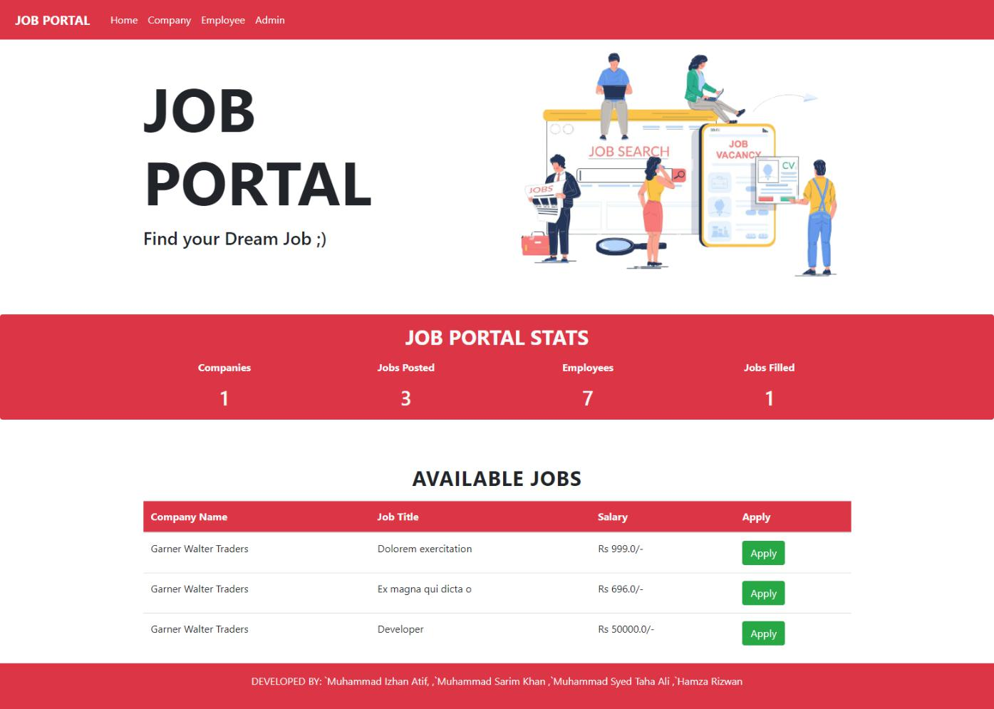

Page | 3

This website is divided into three Interfaces:

1. User Interface
2. Company Interface
3. Administration

In the first section, "User Interface," a user may register by navigating to the signup page and filling out all of the relevant information. After registering, the user may go to the job listing page, where he can simply examine all of the available jobs based on his choices. To apply for any available position, a user must first upload their résumé. Further a user may go to his or her profile to add more information.

In the second section, "Company Interface," any company may register by filling out a signup page that is specifically developed for them. They must have their identity confirmed by the administrator after submitting it. After completing the verification process, a corporation may go into its account and conduct three actions: list positions, see previously posted jobs, and view application information.

An employee from administration may access and control all of the information on this website, including listed positions, job availability, total firms registered, and so on, under the last section, "Administration."

Page | 4

Screen Shots Of Output



Company Login Page:

* A firm can logon to this portal by submitting its secret information.

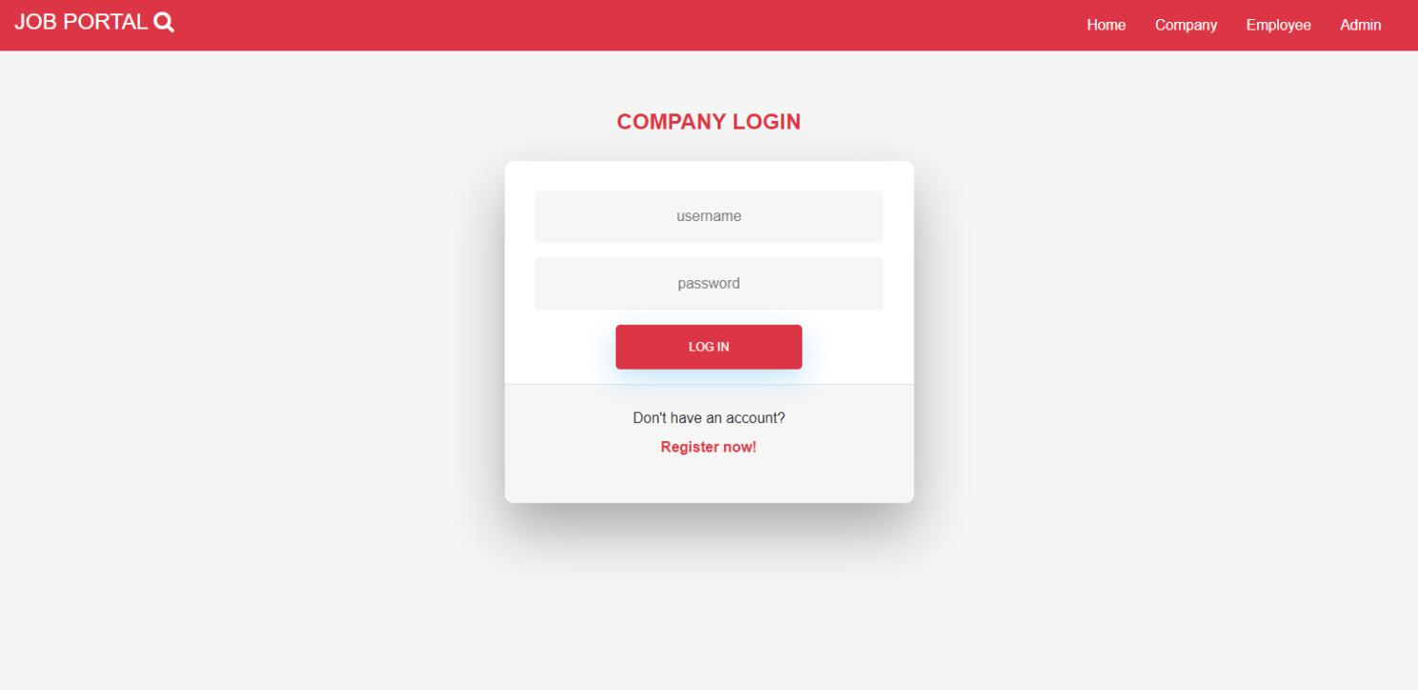

Company Register Page:

* A firm can register on this page by submitting all of the relevant information.

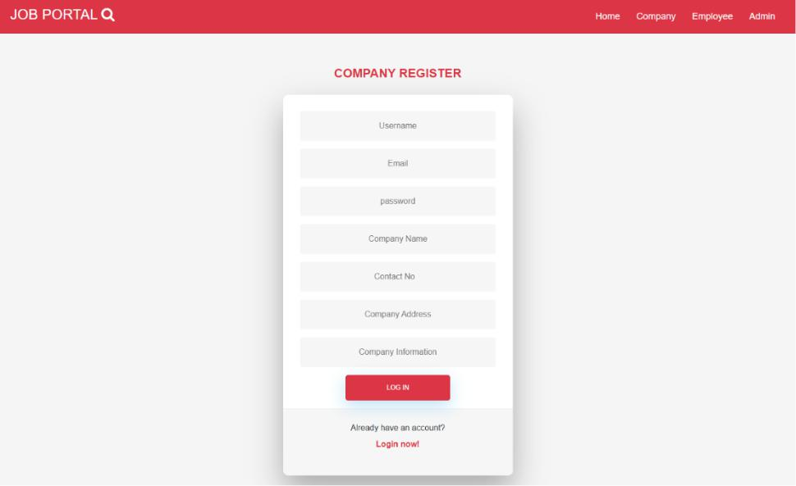

Page | 5

Screen Shots Of Output



Page To Add Job Tile And Its Description:

* This page is where the firm must disclose all of the job's specifics.

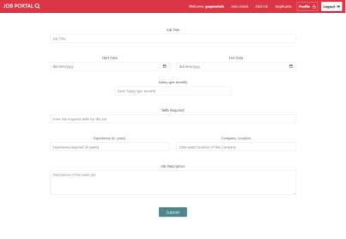

Page To Add Company Profile:

* Page for firm to add information about themselves in order to gain administration approval.

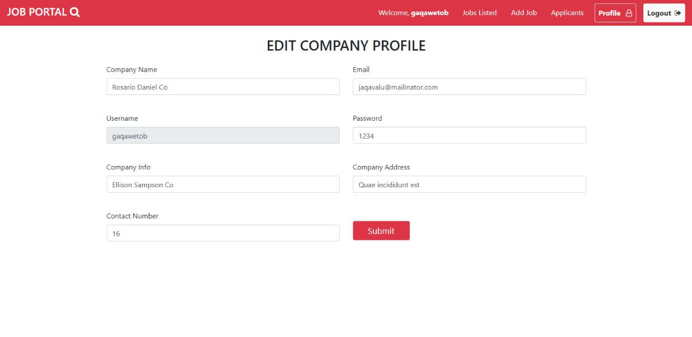

Page | 6

Screen Shots Of Output



Page For The Administration To Accept Firms Profile:

* On this page, an administration employee may read all of the firm's information and select whether or not to approve it.

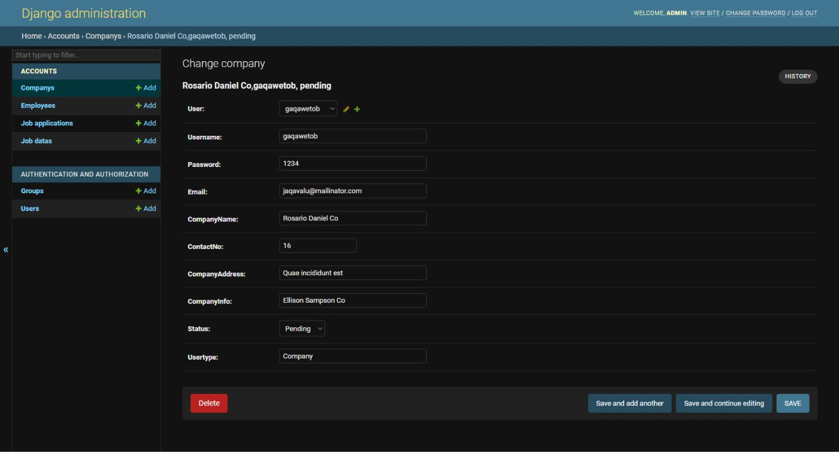

Page for employee to login into admin:

* Employees can access admiration by entering the password they were given.

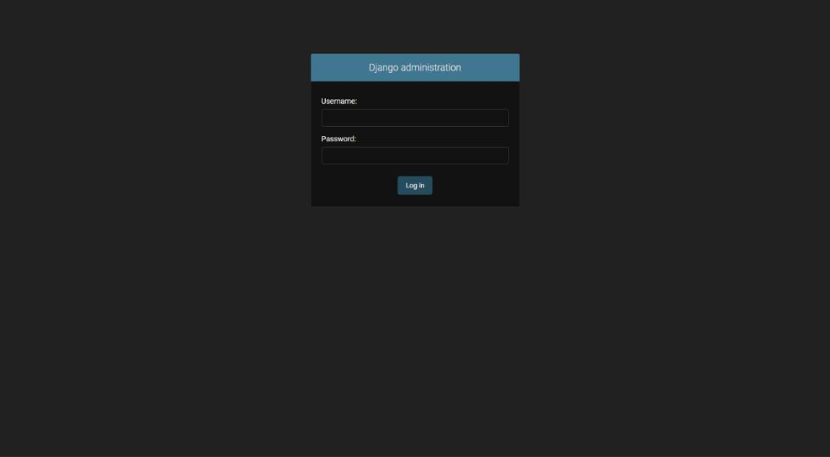

Page | 7

Screen Shots Of Output



Page Of Listed Jobs:

* This page shows the user all the job listed in the data base.

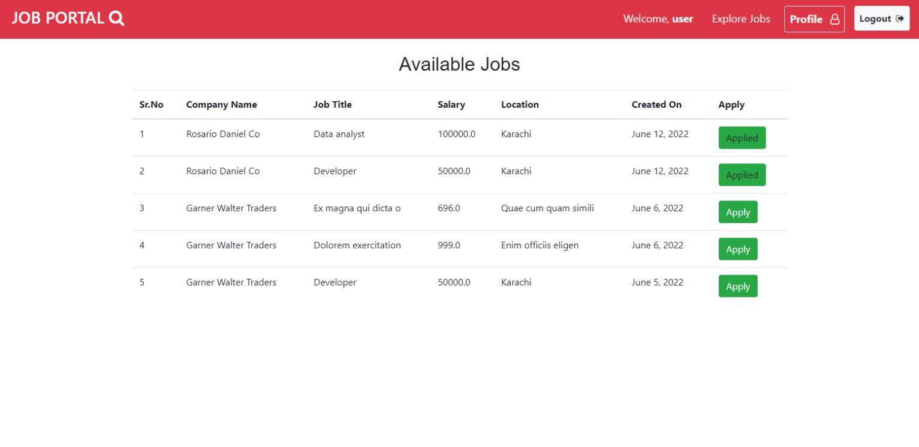

Page to upload resume:

* This page allows the user to upload its resume to apply for the job.

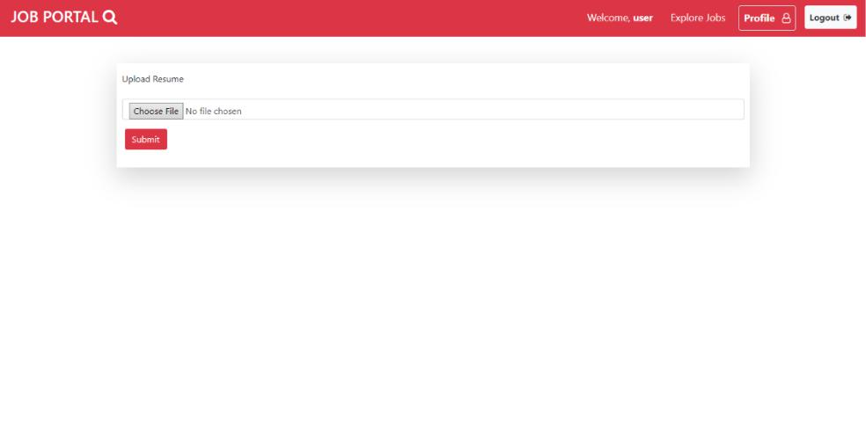

Page | 8

Screen Shots Of Output



Page To View Jobs Listed:

* This page is for the company to see its previous listed jobs

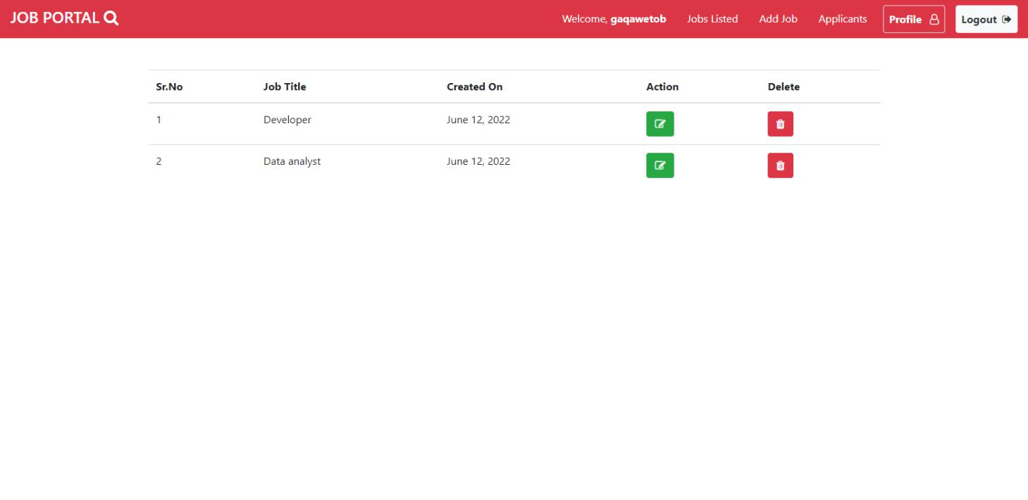

Page To View Applicant Details:

* This page is for the company to know details of the applicants

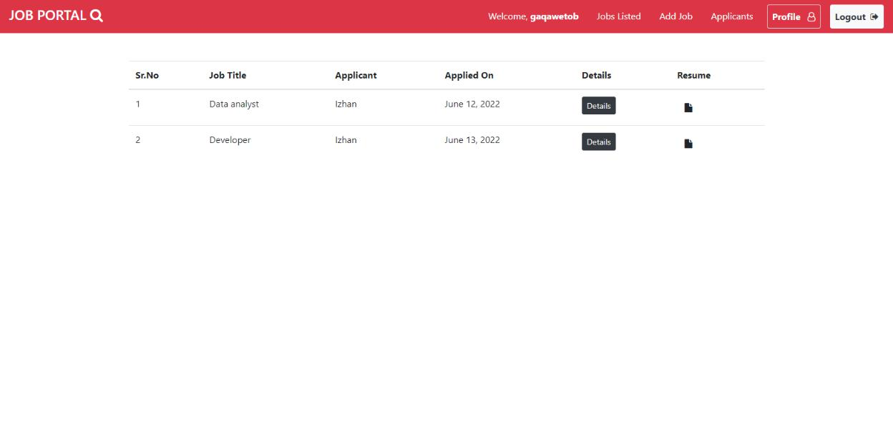

Page | 9

Screen Shots Of Output



Admin Page To Change Job Application:

* This page allow the employee to change job applications

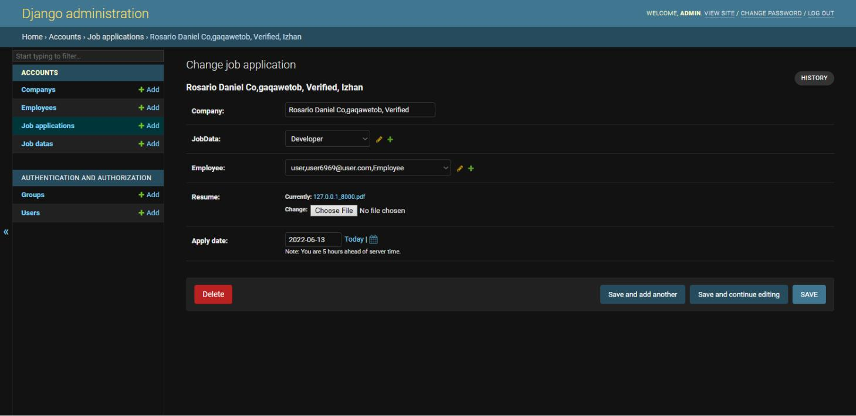

Page Of Administration:

* This is the front page of what employee see when he gets login.

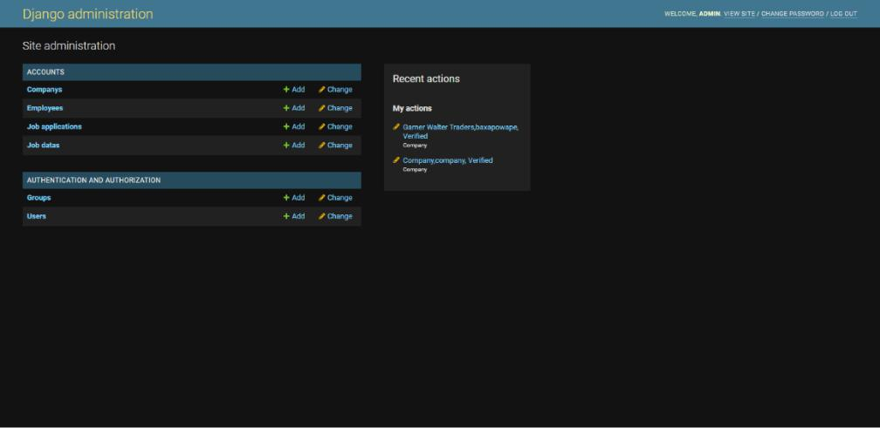

Page | 10

Screen Shots Of Output



Page Of Applicant Details

* This page shows the details of applicant to company.

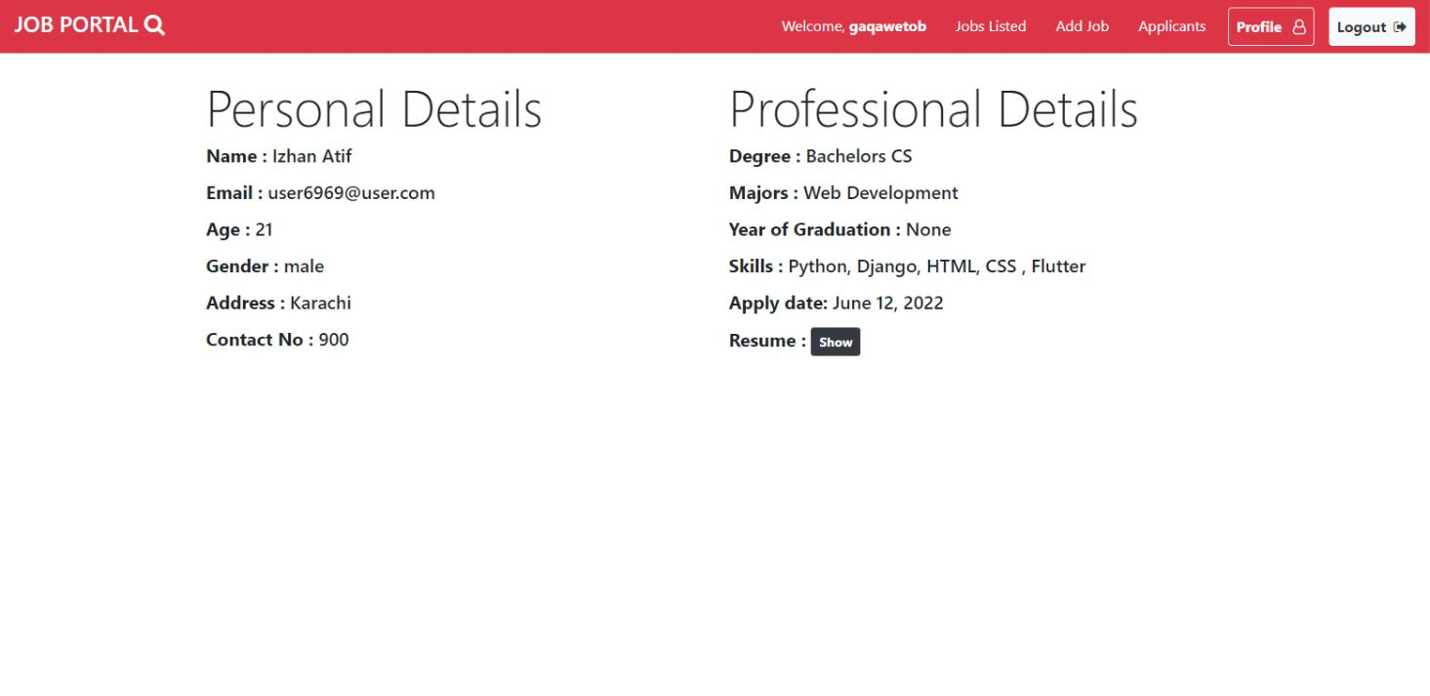

Page | 11

Database Queries

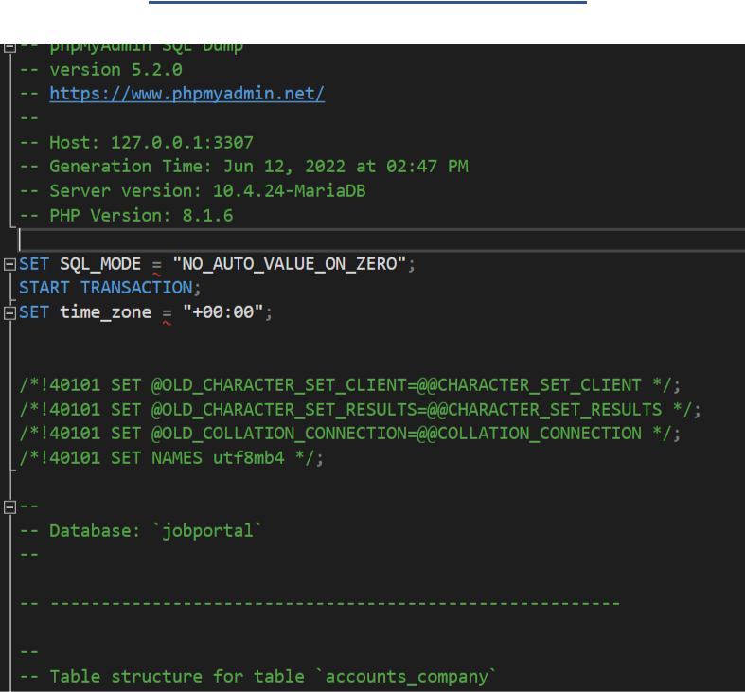

Page | 12

Database Queries

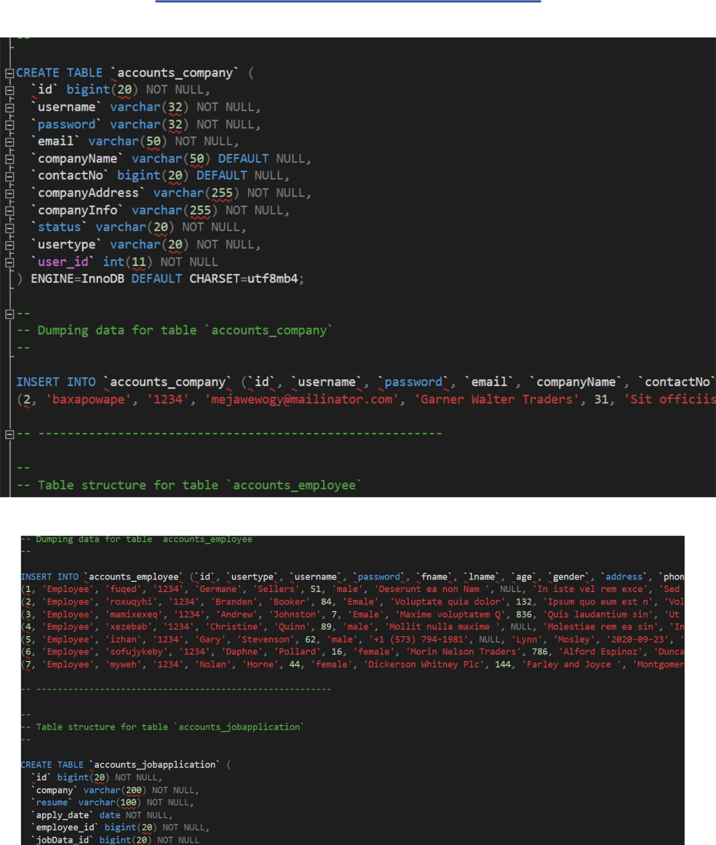

Page | 13

Database Queries

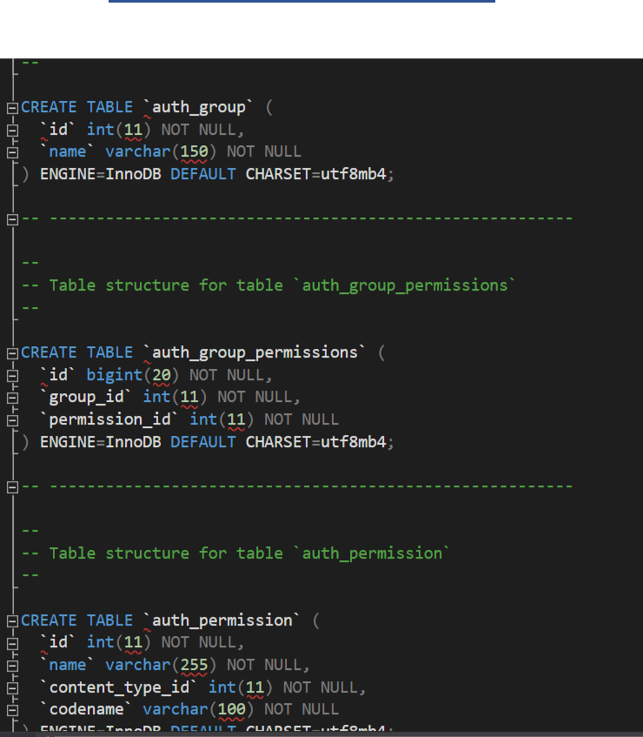

Page | 14

Database Queries

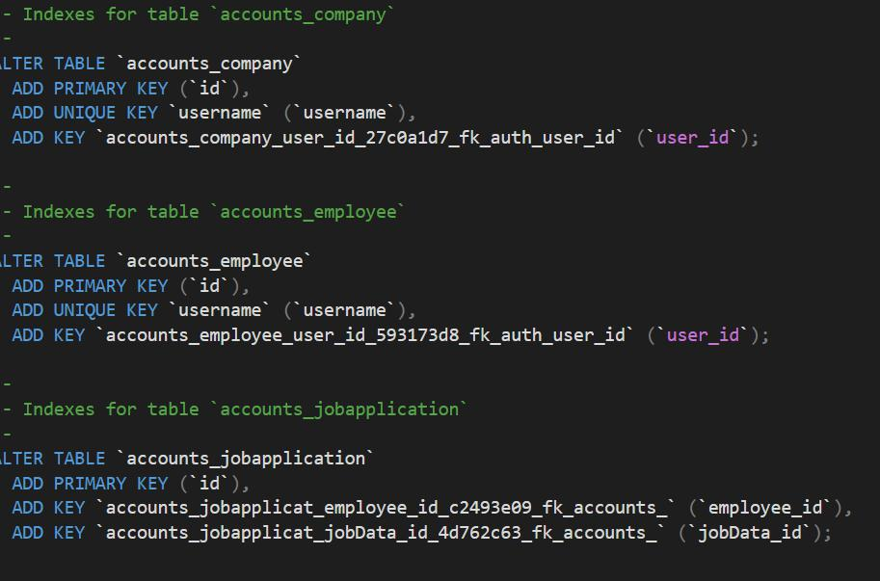

Page | 15

ERD Diagram

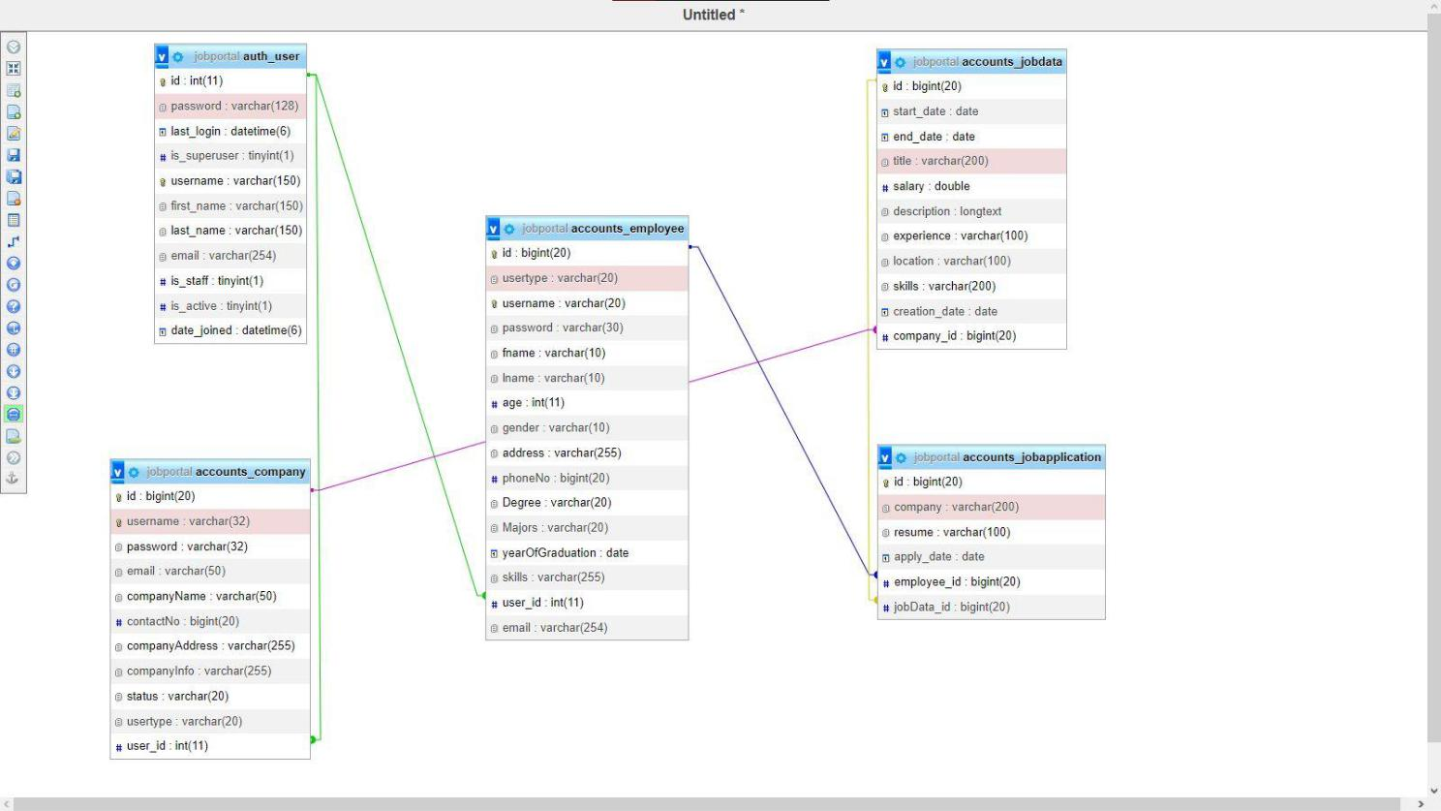

Page | 16

Conclusion



The broader scope of job searching makes it easier to find prospects quickly. More individuals are looking for better jobs, and businesses are looking for better potential, thanks to the expanding work prospects and changing business climate. This predicament has caused many people to turn to job portals in quest of generally approved and completely functional job search methods. In this view, job portals take on increased significance, and we may be able to create an effective system that is used by a large number of job seekers and employers.

Page | 17