PHASE II — BUSINESS PROCESS MODELING
E-Commerce Retail Sales, Inventory & Audit Management System | 30848_2025_Izihirwe_ECommerce_DB | DPR400210
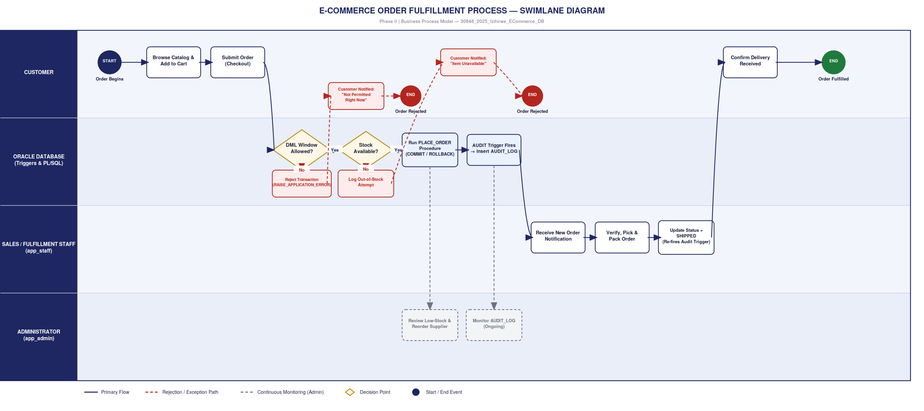
Process Overview  ● A customer order moves left to right through four swimlanes — Customer, Oracle Database (Triggers & PL/SQL), Sales/Fulfillment Staff, and Administrator — from checkout to delivery.  ● Every write to the database, whether from a customer order or a staff status update, passes through the same two System-lane checkpoints before it is allowed to execute.  Key Decision Points  ● DML Window Allowed? — the security trigger built in Phase VII evaluates business hours, weekday, and public-holiday rules before any INSERT/UPDATE/DELETE is permitted to run.  ● Stock Available? — the PLACE_ORDER procedure checks INVENTORY before committing an order, preventing overselling at the source rather than after the fact. | Exception Handling (red, dashed)  ● A denied write is never silently dropped: it is rejected with RAISE_APPLICATION_ERROR, logged to AUDIT_LOG as a denied attempt, and the customer is notified — the same forensic standard applies to a blocked transaction as to a successful one.  Continuous Oversight (gray, dashed)  ● The Administrator lane runs in parallel to individual orders, not inside the order flow itself: it continuously reviews AUDIT_LOG for anomalies and INVENTORY for low-stock thresholds, triggering supplier reorders independently.  Why This Matters for Later Phases  ● This diagram is the functional spec for Phase VI (PL/SQL procedures), Phase VII (security trigger + AUDIT_LOG design), and the ERD in Phase III — every box here becomes a table, procedure, or trigger.

