MALAWI UNIVERSITY OF BUSINESS AND APPLIED SCIENCES
School of Engineering — Department of Electrical Engineering
Bachelor of Engineering in Computer Engineering (BECE)

ELE-OPS-411: Operating Systems for Engineers
Class Project — Full Progress Report
Bare-Metal Operating System Kernel for x86_64

Team Members
Isaac Ndoka | Promise Harare

Instructor: S. Mbewe (sambewe@mubas.ac.mw)
Academic Year 2026

1. Introduction
This report documents the complete progress made by Isaac Ndoka and Promise Harare in designing and implementing a bare-metal operating system kernel for the ELE-OPS-411 Operating Systems for Engineers class project at the Malawi University of Business and Applied Sciences (MUBAS).

The kernel targets the x86_64 architecture, is written in C with x86 assembly stubs, and runs on QEMU virtual hardware. It is loaded by GRUB using the Multiboot specification and runs in 32-bit protected mode. The project demonstrates the core OS mechanisms covered in this course: boot process, memory segmentation, interrupt handling, and preemptive multitasking.

Isaac works on a Windows 11 machine running WSL2 (Ubuntu), while Promise works on a native Ubuntu Linux installation. This report covers Phases 1 through 3 of the implementations, with Phase 4 (system calls and shell) as the next target.

2. Development Environment

2.1 Tools and Platforms
- Development Host: Isaac — Windows 11 + WSL2 (Ubuntu); Promise — Native Ubuntu Linux
- Compiler: GCC with -m32 flag for 32-bit x86 cross-compilation
- Assembler: NASM (Netwide Assembler) for all x86 assembly files
- Linker: GNU ld (binutils) with a custom linker script (linker.ld)
- Virtual Machine: QEMU (qemu-system-x86_64) for kernel testing
- Bootloader: GRUB with grub-mkrescue and xorriso for bootable ISO creation
- Version Control: Git with GitHub for team collaboration and submission
- Editor: Visual Studio Code with WSL Remote Extension

2.2 Project Directory Structure
myos/
src/boot/ boot.asm, isr_stub.asm
src/kernel/ kernel.c, gdt.c/.h, idt.c/.h
src/drivers/ vga.c/.h, pic.c/.h, timer.c/.h, keyboard.c/.h
src/proc/ process.c/.h, switch.asm
iso/boot/grub/ grub.cfg
linker.ld kernel memory layout
Makefile automated build system

3. Phase 1 — Boot & VGA Console

3.1 Multiboot Entry Point
Phase 1 established the entire kernel foundation. The file boot.asm contains the Multiboot magic header (magic number 0x1BADB002, flags, and checksum) in a dedicated. multiboot section. GRUB scans the first 8 KB of the kernel binary for this header. On finding it, GRUB loads the ELF binary at physical address 0x100000 (1 MB) and jumps to _start. The entry point sets the ESP register to the top of a 16 KB stack reserved in. bss, then calls kernel_main() in C. A halt loop after the call prevents the CPU executing garbage if kernel_main ever returns.

3.2 Linker Script
A custom GNU ld linker script (linker.ld) controls the memory layout. The kernel loads at 0x100000 to avoid the first megabyte used by the BIOS and GRUB. The .multiboot section is forced first within .text so GRUB always finds the header. All sections are page-aligned (4 KB boundaries) for future memory management compatibility.

3.3 VGA Text Mode Driver
The VGA text framebuffer is memory-mapped at physical address 0xB8000. Each of the 80x25 character cells is 2 bytes: the ASCII code and a color attribute byte (foreground in bits 0-3, background in bits 4-7). The driver implements vga_clear(), vga_putchar(), vga_print(), vga_print_int(), and an internal scroll() function that shifts all rows up when the cursor reaches row 24.

3.4 Phase 1 Results — Screenshots

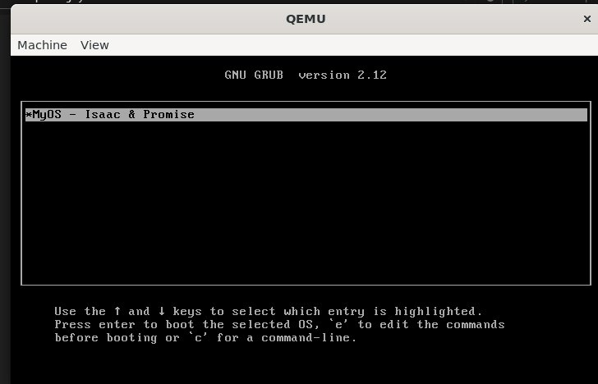
Figure 1: GRUB boot menu displaying 'MyOS - Isaac & Promise' entry — confirms Multiboot header is correctly detected

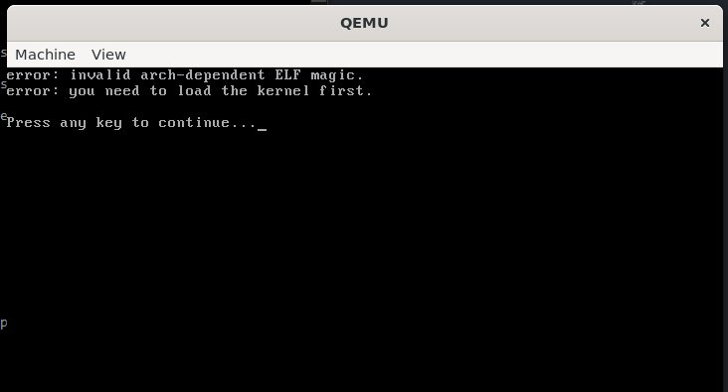
Figure 2: GRUB error 'invalid arch-dependent ELF magic' — occurred when kernel was linked as raw binary instead of ELF

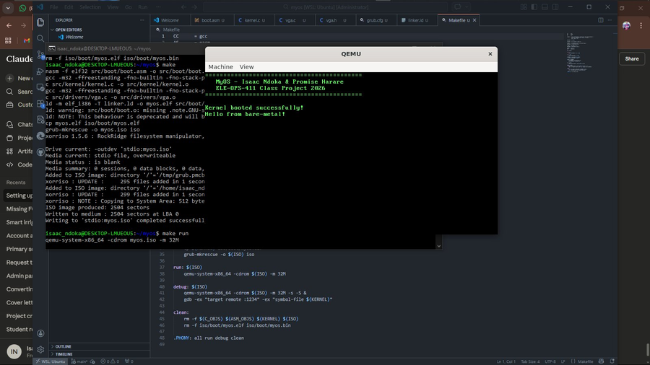
Figure 3: Phase 1 complete — kernel boots successfully and prints banner + 'Hello from bare-metal!' via VGA driver

4. Phase 2 — Interrupts, GDT, IDT, PIC, Timer & Keyboard

4.1 Global Descriptor Table (GDT)
The GDT defines three 8-byte segment descriptors: a mandatory null descriptor, a kernel code segment (ring 0, executable, readable, base=0, limit=4 GB), and a kernel data segment (ring 0, writable, base=0, limit=4 GB). The flat model means all segments span the full address space — segmentation is effectively disabled, which is the standard approach for modern 32-bit kernels. The gdt_flush() function in boot.asm loads the GDTR register with lgdt and performs a far jump to reload the CS register, which cannot be changed with a plain mov.

4.2 Interrupt Descriptor Table (IDT)
The IDT contains 256 8-byte gate descriptors. Each descriptor stores the handler's address split into two 16-bit halves, segment selector 0x08 (kernel code segment), a zero byte, and flags 0x8E (present, ring 0, 32-bit interrupt gate). Entries 0-31 cover CPU exceptions; entries 32-47 cover remapped hardware IRQs. The idt_set_handler() function allows drivers to register C-level callback functions at any vector at runtime. The IDTR is loaded with lidt via idt_flush() in boot.asm.

4.3 Assembly ISR/IRQ Stubs
isr_stub.asm provides one assembly stub per interrupt vector using NASM macros. The ISR_NOERR macro pushes a dummy zero error code (for exceptions that don't push one automatically) and the interrupt number, then jumps to isr_common. ISR_ERR skips the dummy push. The IRQ_STUB macro handles hardware interrupts. The shared isr_common handler saves all general-purpose registers with pusha, saves and reloads the data segment, calls the C dispatcher, restores the data segment, restores registers with popa, cleans 8 bytes from the stack (error code + interrupt number), and returns with iret.

4.4 PIC Remapping
The 8259A PIC maps hardware IRQs 0-7 to CPU interrupt vectors 8-15 by default — exactly overlapping the CPU's own exception vectors. The kernel sends the PIC a 4-step initialisation sequence (ICW1 through ICW4) to remap: master PIC IRQs 0-7 move to vectors 32-39, and slave PIC IRQs 8-15 move to vectors 40-47. After every IRQ handler executes, pic_send_eoi() writes command 0x20 to the master PIC (and the slave if the IRQ originated there) to re-arm that interrupt line.

4.5 Timer Driver
The Intel 8253/8254 PIT is programmed with divisor 11932 (1,193,180 / 100) to generate IRQ0 at 100 Hz — one tick every 10 ms. The timer handler increments a global tick counter and calls pic_send_eoi(0) to acknowledge the interrupt.

4.6 Keyboard Driver
The PS/2 keyboard fires IRQ1 (vector 33) on every key event. The driver reads the scancode from I/O port 0x60. Bit 7 distinguishes key-press (0) from key-release (1); only presses are processed. A 128-entry lookup table maps US QWERTY scancodes to ASCII characters. Matched characters are echoed to the VGA screen with vga_putchar() and stored in a last_key variable for future use by the shell.

4.7 Phase 2 Results — Screenshots

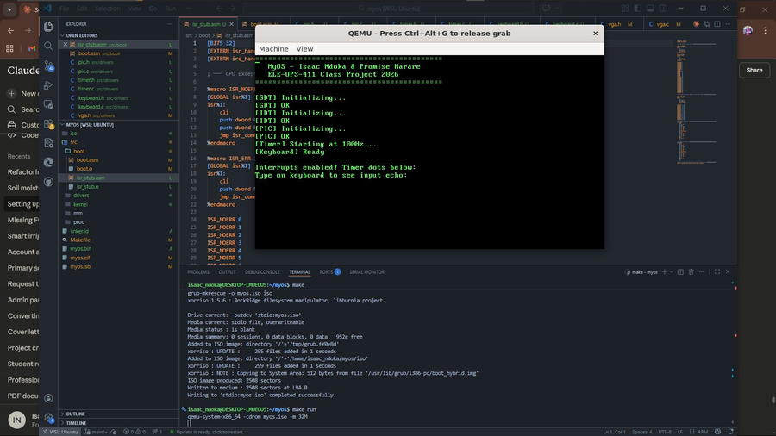
Figure 4: Phase 2 complete — GDT, IDT, PIC, Timer and Keyboard all initialised successfully with confirmation messages

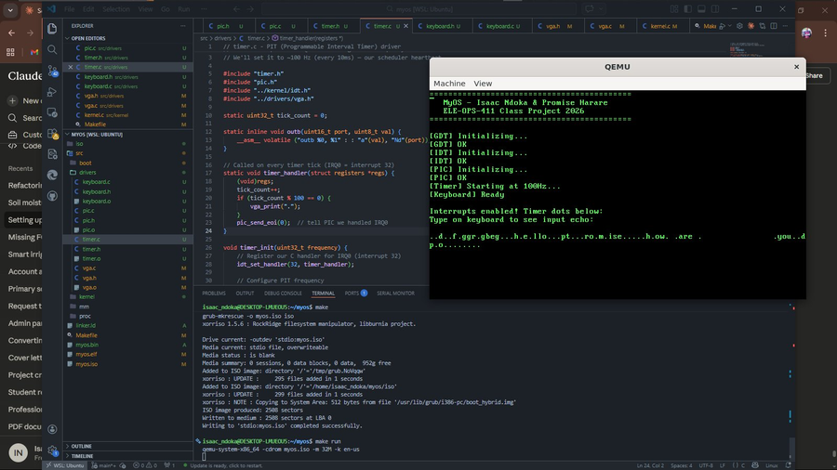
Figure 5: Keyboard input working — typed characters echo to VGA screen, interleaved with timer dots (every 100 ticks)

5. Phase 3 — Preemptive Round-Robin Scheduler

5.1 Process Control Block (PCB)
Each task is represented by a task_t struct (the PCB) containing: a PID, a human-readable name (32 chars), a state enum (UNUSED/READY/RUNNING/DEAD), a saved ESP value, a private 8 KB kernel stack array, a tick counter for statistics, and an entry function pointer. The kernel supports up to 8 concurrent tasks. Slot 0 is reserved for the idle task which runs when nothing else is ready.

5.2 Context Switch (switch.asm)
The function do_switch(uint32_t *old_esp, uint32_t new_esp) performs the actual register swap. It saves the four callee-saved registers (ebp, ebx, esi, edi) onto the current stack, writes the current ESP into *old_esp, loads new_esp into ESP, restores the four registers from the new stack, and executes ret. The return address on the new task's stack determines where execution continues. For a newly created task, this address is task_entry_point(); for a previously preempted task it is the instruction after the do_switch call site.

5.3 Task Initialisation Stack
task_create() builds an initial stack frame so that the first context switch into a new task looks identical to resuming a previously preempted one. The stack is built from the top downward: task_entry_point address (the ret target), then four zero words for edi, esi, ebx, and ebp. ESP is saved pointing at the edi slot. task_entry_point() enables interrupts with sti, reads the entry function from the PCB, calls it, and calls task_exit() if it returns.

5.4 Key Architectural Decision — EOI Before schedule()
The critical fix that made Phase 3 work was sending the End-Of-Interrupt signal to the PIC BEFORE calling schedule(). When schedule() calls do_switch(), execution transfers to the new task and never returns to the timer handler on the old stack. If EOI is sent after the switch (as was originally coded), the PIC never receives the acknowledgement and blocks all future timer IRQs — the scheduler fires only once and then stop. Sending EOI first guarantees the PIC is re-armed regardless of which task runs next.

5.5 Round-Robin Scheduler
The timer handler calls schedule() on every tick. The scheduler marks the current task READY, then performs a round-robin search starting one position past the current index and wrapping around. Slot 0 (idle) is skipped unless no other task is READY. The first READY slot found becomes the new current task (marked RUNNING), and do_switch() transfers execution. The timer runs at 2 Hz for the demonstration, giving each task a visible 500 ms time slice.

5.6 Phase 3 Results — Screenshot

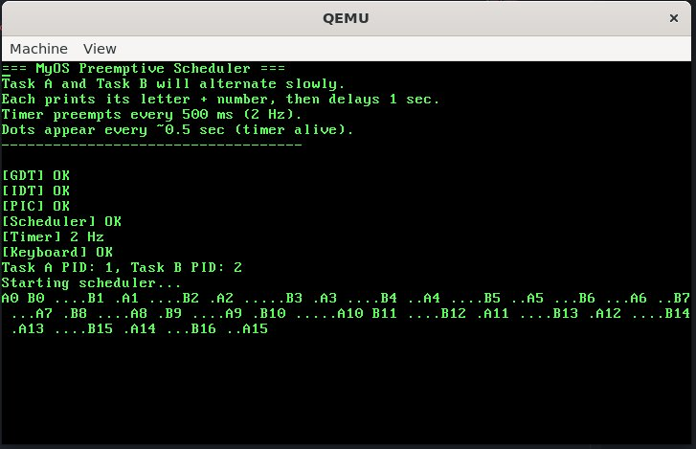
Figure 6: Phase 3 complete — Task A and Task B alternating under the preemptive round-robin scheduler. Each prints its letter and counter on a new line.

The output shows A0, B0, A1, B1, A2, B2... with timer dots between them confirming the 2 Hz timer is firing and the scheduler is switching correctly between the two tasks. This demonstrates genuine preemptive multitasking — neither task explicitly yields; the timer forces the switch.

6. Challenges Encountered and Resolutions
Challenge | Root Cause | Resolution
Curly quotes in linker.ld | Copying linker.ld from a web page caused the editor to substitute typographic quote characters. GNU ld does not recognise them. | File recreated using a terminal heredoc (cat > linker.ld << EOF) which bypasses editor smart-quote substitution.
GOT reference errors (-fPIC conflict) | GCC on modern Ubuntu defaults to position-independent code which references the Global Offset Table — not present in a bare-metal kernel. | Added -fno-pic and -fno-pie to CFLAGS to generate fixed-address code with no GOT references.
GRUB ELF magic error | Using --oformat binary in LDFLAGS produced a raw flat binary. GRUB Multiboot loader expects a proper ELF executable. | Removed --oformat binary so the linker outputs a standard ELF. Updated grub.cfg to reference myos.elf.
IRQ stubs undefined reference | The IRQ macro used %2 as the label suffix (producing irq32, irq33...) but idt.c declared extern irq0 through irq15. | Renamed macro to IRQ_STUB and used %1 as the suffix, producing irq0-irq15 matching the extern declarations.
Keyboard not responding in QEMU | QEMU was not capturing keyboard events. Also pic_send_eoi() was missing, blocking all further keyboard IRQs. | Added -k en-us to QEMU command. User clicks inside QEMU window to grab keyboard focus. Added pic_send_eoi(1) at end of handler.
mem_set zeroing entry pointer | mem_set() called on the whole task struct zeroed t->entry after it was set, causing every task to immediately exit with a NULL function call. | Changed to only zero t->stack array. All PCB fields are set individually after the zero operation.
EOI must precede schedule() | Sending EOI after do_switch() meant the PIC never received the acknowledgement because execution transferred to the new task and never returned to the handler. | Moved pic_send_eoi(0) to before the schedule() call in the timer handler. This re-arm the PIC regardless of which task runs next.
Context switch stack corruption | Calling do_switch() inside the IRQ handler while the interrupt frame was still on the stack caused iret to execute on the wrong stack after the switch. | Separated trigger from switch: timer sends EOI then calls schedule() which performs do_switch(). The switch now completes before iret has a chance to corrupt state.

7. Current Progress Summary
Component | Phase | Status
Boot — Multiboot entry, stack, C runtime | Phase 1 | Complete
VGA text driver — 80×25, color, scrolling | Phase 1 | Complete
Build system — Makefile, GRUB ISO | Phase 1 | Complete
GDT — flat 32-bit protected mode | Phase 2 | Complete
IDT — 256 interrupt gate descriptors | Phase 2 | Complete
Assembly ISR/IRQ stubs | Phase 2 | Complete
PIC remapping (IRQs 0-15 → vectors 32-47) | Phase 2 | Complete
PIT timer at 100 Hz / 2 Hz demo | Phase 2 | Complete
PS/2 keyboard driver (IRQ1, US QWERTY) | Phase 2 | Complete
PCB struct + task_create() | Phase 3 | Complete
do_switch() assembly context switch | Phase 3 | Complete
Preemptive round-robin scheduler | Phase 3 | Complete
Two-task alternation (Task A + Task B) | Phase 3 | Complete
System calls (write, spawn, exit) | Phase 4 | Pending
Interactive shell (help, clear, tasks) | Phase 4 | Pending
Physical page allocator | Phase 4 | Pending

8. Reflection
Phase 1 gave the team a concrete understanding of the boot process that is normally completely hidden. Writing the Multiboot header and watching GRUB recognize and execute our code was a significant milestone. The linker script work clarified how a kernel binary maps to physical memory addresses — knowledge that cannot be gained from high-level programming.

Phase 2 was technically demanding but rewarding. The most instructive lesson was discovering that the PIC must receive an End-Of-Interrupt signal after every IRQ handler. When this was missing the PIC silently stopped delivering further interrupts of that type — a subtle bug that would be extremely hard to find without understanding the hardware.

Phase 3 was the most challenging phase of the project. The scheduler required understanding several interacting systems simultaneously: the timer IRQ, the PIC, the C calling convention, x86 stack mechanics, and the ELF memory layout. The critical discovery — that EOI must be sent before calling the scheduler, not after — revealed how a single line of code can determine whether multitasking works or not. Debugging this required reasoning carefully about what happens to the stack when execution is transferred mid-interrupt.

Working across WSL and native Ubuntu environments throughout the project reinforced the importance of a clean, portable build system. The Makefile compiles and creates the bootable ISO identically on both platforms without any platform-specific changes.

9. Next Steps — Phase 4
Phase 4 will complete the minimum required features for project submission:
- System call interface using software interrupt int 0x80 with syscall number in EAX register
- sys_write (EAX=1) — write a null-terminated string to the VGA console
- sys_spawn (EAX=2) — create a new kernel thread from a function pointer
- sys_exit (EAX=3) — terminate the current task and trigger rescheduling
- Interactive shell — reads keyboard input, parses command strings, executes built-in commands: help, clear, tasks (show PCB table), reboot
- Physical page allocator — bitmap-based allocator managing 4 KB page frames

References
- OSDev Wiki — https://wiki.osdev.org (Multiboot, GDT, IDT, PIC, PIT, Context Switching)
- Intel 64 and IA-32 Architectures Software Developer Manuals, Volume 3A — System Programming Guide
- GNU Binutils ld Documentation — Linker Script Reference
- NASM Manual — https://www.nasm.us/doc/
- QEMU Documentation — https://www.qemu.org/docs/master/
- ELE-OPS-411 Class Project Specification — Instructor S. Mbewe, MUBAS 2026

