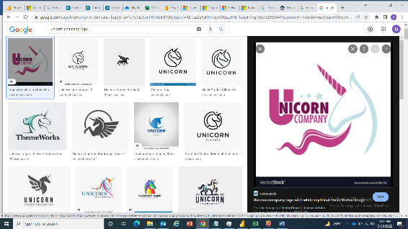

**World’s 1072 Unicorn Companies Analysis**

**ASSIGNMENT NO. 4**

**Business Intelligence Report**

Platform: Microsoft PowerBI

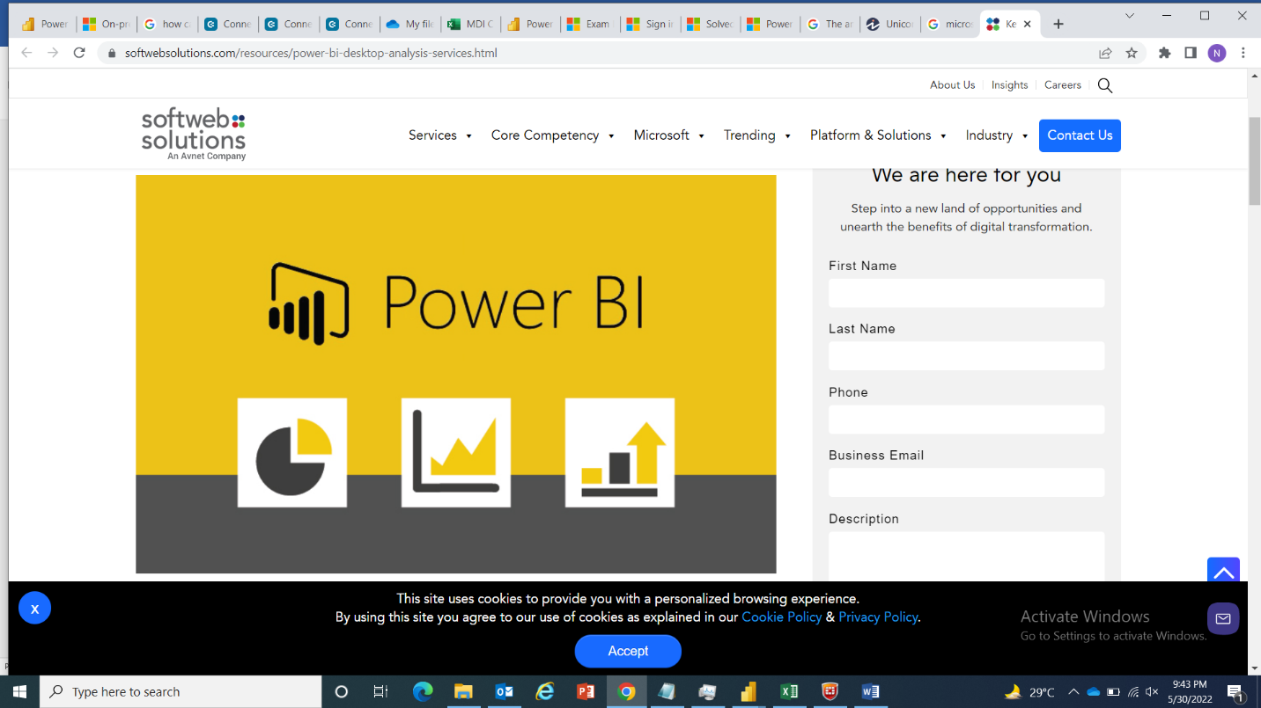

**Submitted by:**

Izma Aziz

Date

Signature

**Submitted to:**

Nazish Javed

Date

Signature

**CONTENTS**

Acknowledgement 1

Introduction: 2

Information Gathered: 2

Technology: 2

Visualizations: 2

**ANALYSIS BY VALUATION 2**

**1. UNICORN COMPANIES BY VALUATION: 2**

**2. VALUATION OF CONTINENTS: 2**

**3. DISTRIBUTION OF INDUSTRIES: 2**

**4. COUNT OF UNICORN COMPANIES BY YEAR 3**

**ANALYSIS BY FUNDING** 3

**1.** **FUNDING BY CONTINENT:** 3

**2.** **FUNDING IN INDUSTRY:** 3

**3.** **FUNDING OF UNICORN COMPANIES:** 3

Data Transformations: 4

Summary: 4

**Report View:** 5

# Acknowledgement

I would like to express my sincere gratitude to my supervisor Mr.Rabi Bin Mazhar & Ms. Nazish Javed for providing her invaluable guidance , comments and suggestions throughout the course of the project.

Also I would like to thank Muller and Phipps for providing a great learning environment . The internship opportunity I had with Muller and Phipps was a great chance for learning and professional development. Therefore, I consider myself as a very lucky individual as I was provided with an opportunity to be a part of it.

# Introduction:

In business, a unicorn is a privately held startup company valued at over US$1 billion. The term was first popularized in 2013 by venture capitalist Aileen Lee, choosing the mythical animal to represent the statistical rarity of such successful ventures.

# Information Gathered:

* From: Kaggle/Maven

# Technology:

* Microsoft Power BI

# Visualizations:

## **ANALYSIS BY VALUATION**

### **UNICORN COMPANIES BY VALUATION:**

This graph shows the distribution of unicorn companies by valuation. From this graph it can be analyzed that which company has highest valuation. A tooltip is also used in the visual to indicate the investors of the company as well as it indicates the date on which the company reached $1 billion in valuation.

### **VALUATION OF CONTINENTS:**

This visual shows the distribution of valuation by continent. It can be seen that according to the data given North America has the highest valuation. In this visual tooltip is used to indicate the top 5 unicorn companies present in the continent and the valuation generated by the companies present in countries of that subcontinent.

### **DISTRIBUTION OF INDUSTRIES:**

This pie chart shows the percentage distribution of unicorn companies according to the industry.

### **COUNT OF UNICORN COMPANIES BY YEAR**

Count of unicorn companies by year shows the total count of unicorn companies in a specific year. It shows the number of companies reaching $1 billion in valuation in a particular year.

## **ANALYSIS BY FUNDING**

### **FUNDING BY CONTINENT:**

This visual shows the funding of unicorn companies according to the continent in which it is present. A tooltip is used to indicate the funding receive by the country of a specific continent and the funding received by the top 5 unicorn companies present in that continent.

### **FUNDING IN INDUSTRY:**

The bar chart indicates the amount of funding received by the industry. According to the dataset provided Fintech receive the highest funding.

### **FUNDING OF UNICORN COMPANIES:**

This graph shows the funding received by the unicorn companies. It also indicates the investors of the companies and the date on which it reached $1 billion in valuation.

# Data Transformations:

Table of unicorn companies contains:

|  |  |
| --- | --- |
| Field | Description |
| Company | Company name |
| Valuation | Company valuation in billions (B) of dollars |
| Date Joined | The date in which the company reached $1 billion in valuation |
| Industry | Company industry |
| City | City the company was founded in |
| Country | Country the company was founded in |
| Continent | Continent the company was founded in |
| Year Founded | Year the company was founded |
| Funding | Total amount raised across all funding rounds in billions (B) or millions (M) of dollars |
| Select Investors | Top 4 investing firms or individual investors (some have less than 4) |

* We transform the columns Valuation and Funding from a string type data to numeric data to analyze the given data.

# Summary:

In this Analysis we can see different relationships of unicorn companies with respect to valuation and funding. There are total 1027 unicorn companies from which Bytedance Company has the highest valuation according to the given dataset which is present in Asia and the continent that generate the highest valuation is North America. In terms of funding Juuls Labs received most funding which is present in North America, that is the continent having largest funding.

# **Report View:**



