**Mexico Toy Shop Analysis**

**ASSIGNMENT NO. 5**

**Business Intelligence Report**

Platform: Microsoft PowerBI

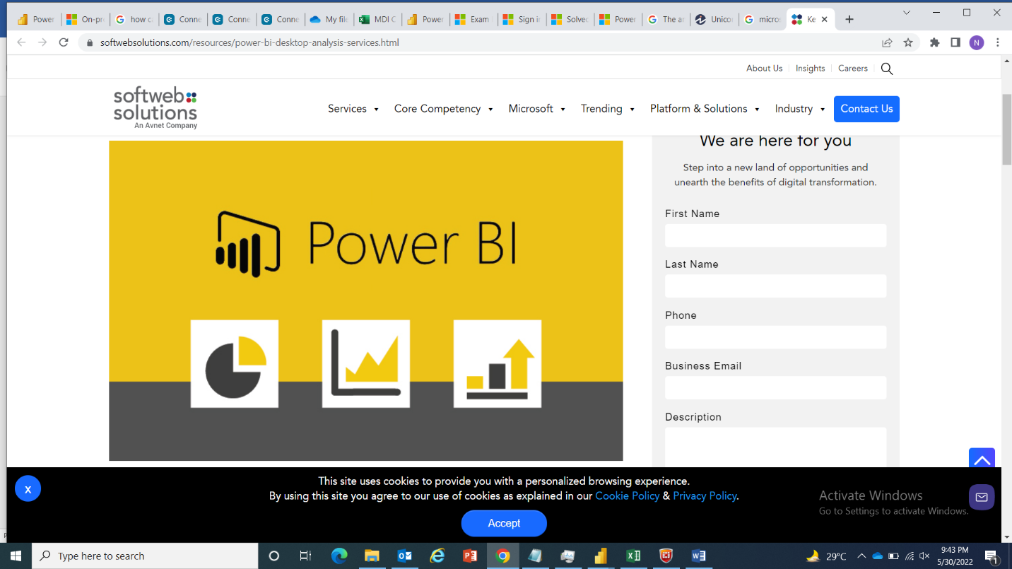

**Submitted by:**

Izma Aziz

Date

Signature

**Submitted to:**

Nazish Javed

Date

Signature

**CONTENTS**

Acknowledgement 1

Introduction: 2

Information Gathered: 2

Technology: 2

Visualizations: 2

**1.** **DISTRIBUTION OF PRODUCTS BY CATEGORY:** 2

**2.** **TOP 5 STORES BY UNIT OF PRODUCT SOLD:** 2

**3.** **AVAILABLE STOCK OF PRODUCTS:** 2

**4.** **UNIT OF PRODUCT SOLD:** 2

**5.** **DISTRIBUTION OF STORES BY LOCATION:** 2

Data Transformations: 3

**1.** **PRODUCTS** 3

**2.** **STORES** 3

**3.** **INVENTORY** 3

**4.** **SALES** 4

Summary: 4

**Report View:** 5

# Acknowledgement

I would like to express my sincere gratitude to my supervisor Mr.Rabi Bin Mazhar & Ms. Nazish Javed for providing her invaluable guidance , comments and suggestions throughout the course of the project.

Also I would like to thank Muller and Phipps for providing a great learning environment . The internship opportunity I had with Muller and Phipps was a great chance for learning and professional development. Therefore, I consider myself as a very lucky individual as I was provided with an opportunity to be a part of it.

# Introduction:

The dataset used in this analysis Sales includes information about products, stores, daily sales transactions, and current inventory levels for fictitious chain of toy stores in Mexico.

# Information Gathered:

* From: Kaggle/Maven

# Technology:

* Microsoft Power BI

# Visualizations:

## **DISTRIBUTION OF PRODUCTS BY CATEGORY:**

This visual shows the distribution of product by category. From this graph it can be analyzed that 25.7% of the products are toys in the given shops.

## **TOP 5 STORES BY UNIT OF PRODUCT SOLD:**

The bar chart indicates the top 5 stores which sold maximum units of products.

## **AVAILABLE STOCK OF PRODUCTS:**

It shows amount of stock of the product that is currently available in the shop. A tooltip is used to indicate the date of transactions of a specific product and the total units of the product sold.

## **UNIT OF PRODUCT SOLD:**

It shows the units of the product sold. A tooltip is used to indicate the category of the product, the expense incurred for making a product and the amount a customer is willing to pay for a product.

## **DISTRIBUTION OF STORES BY LOCATION:**

This graph shows the location of the stores in Mexico. For example, 58% stores are in downtown.

# Data Transformations:

The dataset of toy shop is composed of multiple tables listed as follows:

## **PRODUCTS**

|  |  |  |
| --- | --- | --- |
| Field | Description | |
| Product_ID | | Product ID |
| Product_Name | | Product name |
| Product_Category | | Product Category |
| Product_Cost | | Product cost ($USD) |
| Product_Price | | Product retail price ($USD) |

## **STORES**

|  |  |
| --- | --- |
| Field | Description |
| Store_ID | Store ID |
| Store_Name | Store name |
| Store_City | City in Mexico where the store is located |
| Store_Location | Location in the city where the store is located |
| Store_Open_Date | Date when the store was opened |

## **INVENTORY**

|  |  |
| --- | --- |
| Field | Description |
| Store_ID | Store ID |
| Product_ID | Product ID |
| Stock_On_Hand | Stock quantity of the product in the store (inventory) |

## **SALES**

|  |  |
| --- | --- |
| Field | Description |
| Sale_ID | Sale ID |
| Date | Date of the transaction |
| Store_ID | Store ID |
| Product_ID | Product ID |
| Units | Units sold |

* We transform the columns Product_Price and Product_Cost from a string type data to numeric data to analyze the given data.
* Use Incremental refreshing technique which extends scheduled refresh operations by providing automated partition creation and management for dataset tables that frequently load new and updated data.

# Summary:

In this Analysis we can see relationships of toy shops with respect to different parameters. There are total 50 shops from which PlayDoh Can is most sold product which belong to art and craft products. Maven Toys Ciudad de Mexico 1 sold the most units of products. The most available product present in the inventory is Deck of Cards, the report also shows that most of the shops are located in Downtown in Mexico.

# **Report View:**

